Smart Energy Management Systems for Optimizing Solar Power Storage and Utilization in Household Applications

Yu-Jhu,Chen*1*, Tsung-Hung Lin*1*, Ming-Chu Hsieh*2*& Chia-Hung Lai*3*

*1Dept. of CSIE, Nat. Chin-Yi Univ. of Tech., Taiwan.*

*2Dept. of Mech. Eng., Nat. Chin-Yi Univ. of Tech., Taiwan.*

*3 Dept. of Intell. Auto. Eng., Nat. Chin-Yi Univ. of Tech., Taiwan.*

*Corresponding Author: Chia-Hung Lai*

*ABSTRACT: With the rapid changes in global environmental climate, the intensification of the greenhouse effect, climate change, and global warming, the world faces an urgent climate crisis. Countries around the globe are shifting their energy structures to develop low-carbon energy. Additionally, with rising fuel and electricity prices, solar energy, a green energy source, offers humanity versatile and convenient applications. Solar power directly converts sunlight into heat and electricity, creating more business opportunities and boosting industrial growth. Among renewable energies, solar power generation stands out as a key player. In this paper, we explore the use of solar energy to generate electricity for household appliances. We selected a 5V 100W monocrystalline silicon solar panel, which harnesses sunlight, converts it into electrical energy, and stores it, providing green energy. Using a multimeter, we recorded the conversion efficiency under different weather conditions. We then tested the solar energy's conversion into electricity and its input into various appliances, recording the time required to charge them. It was found that the performance of solar energy is significantly enhanced between 11 AM and 2 PM. If conversion efficiency can be improved, the energy storage efficiency of solar power can also increase substantially, further confirming the future potential of the entire industry.*

***KEY WARDS: Greenhouse Effect, Monocrystalline Silicon Solar Panel, Solar Energy Conversion***

---------------------------------------------------------------------------------------------------------------------------------------

Date of Submission: xx-xx-xxxx Date of acceptance: xx-xx-xxxx

---------------------------------------------------------------------------------------------------------------------------------------

# INTRODUCTION

With the ongoing global climate crisis, solar energy, a renewable and inexhaustible source, has become a critical topic in the global energy transition. As various industries expand, non-renewable coal resources can no longer reliably supply the world, and their use results in significant carbon emissions. Understanding the trends in global energy issues is essential for determining the future development of energy. Some scholars have predicted that if the solar energy conversion rate can exceed 20%, an area the size of Spain would be sufficient to power the entire world by 2030. For example, in the European Union, in addition to developing low-carbon technologies with cost advantages, regulations have been enacted to encourage energy transition efforts, fostering low-carbon industries and buildings. Economic and technological developments must also be aligned with societal acceptance of these transformations and policies [1]. With the government's strong promotion of renewable energy, it is projected that by 2030, renewable energy will account for 27.1% of all installed power generation capacity [2]. According to data analysis on Taiwan's energy policy, solar thermal energy in Taiwan is primarily used for household water heating, accounting for 99.1% of all subsidized projects (with a 94.4% area ratio). Other uses, such as dormitory water heating, account for only 4.6% of the area (0.83% of projects). Thus, the rapid and large-scale growth in the construction of solar photovoltaic systems has significantly contributed to the technology required by the industry [3].

***1.1 Research Motivation and Objectives***

The aim of this research is to find the most efficient conversion rate for solar panels to generate electricity. We explore how a small solar panel can effectively convert sunlight into electrical energy, store it in a portable power bank, and make it available for use in household appliances. The stored energy can be used when needed, allowing the portable power bank to demonstrate its utility when immediate access to power is not available. By storing the converted solar energy, it can then be transferred to devices such as fans, enabling the use of environmentally friendly solar energy while also solving the power supply issues for household appliances. This approach promotes energy savings and efficiency, thereby effectively supporting the daily electricity needs.

***1.2 Literature Review***

Solar thermal power generation plays a crucial role in constructing new energy-based power systems. The typical working principles of thermal storage devices, numerical modeling, and performance optimization methods are explored. For instance, a coupled system involving a tower solar thermal collector and a new supercritical carbon dioxide power cycle is presented, which provides a comprehensive model for the integration of solar thermal power systems, multi-parameter, multi-objective optimization, and performance evaluation. The future development and predictions of solar thermal power generation technology are also discussed [4].

According to the latest World Energy Outlook (WEO) report, by 2030, the number of electric vehicles globally is expected to increase tenfold compared to the present. At that time, solar photovoltaic power generation will exceed the current entire power generation capacity of the United States. Renewable energy's share in the global electricity structure will rise from the current 30% to nearly 50%. The global sales of heat pumps and other electric heating systems will surpass fossil fuel boilers, and investments in new offshore wind power projects will be three times that of new coal and gas power plants [5].

In the U.S., the installed capacity in states such as Texas, Florida, and California accounts for 54% of the national total [6]. In terms of energy storage, the newly installed energy storage capacity in the U.S. from 2012 to 2020 reached 3.5 GW, with nearly 40% of that installed in the second half of 2020. Residential storage capacity dominates the market, and California is the largest energy storage market in the U.S., accounting for 80% of the total installed capacity, as shown in Figure 1.

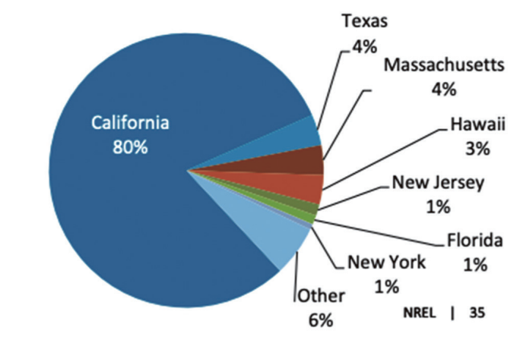

**Figure 1: Energy Storage Capacity in the U.S. in 2020**

***1.3*** ***Design Concept and Direction***

The design concept focuses on analyzing the differences in charging efficiency of consumer electronics to develop a solar charging conversion efficiency monitoring device. The primary research equipment consists of commonly used consumer electronics: small solar panels and a fan. The study involves measuring and analyzing the conversion efficiency during sunlight exposure and investigating the differences in charging times. The goal is to identify the optimal conversion power and the most efficient solar panels, paving the way for future research on larger appliances and practical applications. The setup for the research tools is described as follows:

1. Research Tools: Solar panels, a small fan, and a portable power bank.
2. Construction of a Suitable Base: A platform to hold both the fan and the portable power bank.
3. Multimeter: To measure the current and voltage.
4. Design a Platform and Base: To simultaneously hold the solar panels, small fan, and portable power bank.
5. Record Voltage and Current: Produced by the solar panel under various weather conditions during energy conversion.
6. Calculate Power Absorbed by the Solar Panel: Estimate the conversion efficiency as an approximate value.
7. Test the Time Required: To fully charge different devices using the solar panel.

# DESIGN METHODS

To create a platform and base that can accommodate both the fan and the portable power bank, we needed to design a base that allows the fan to stand securely. We used discarded wood as the material and built a two-layer adjustable platform by inserting pegs, allowing the fan's height to be adjusted for optimal positioning. A small compartment was added beneath the base to store the portable power bank, making the design both space-efficient and environmentally friendly, as shown in Figure 2.

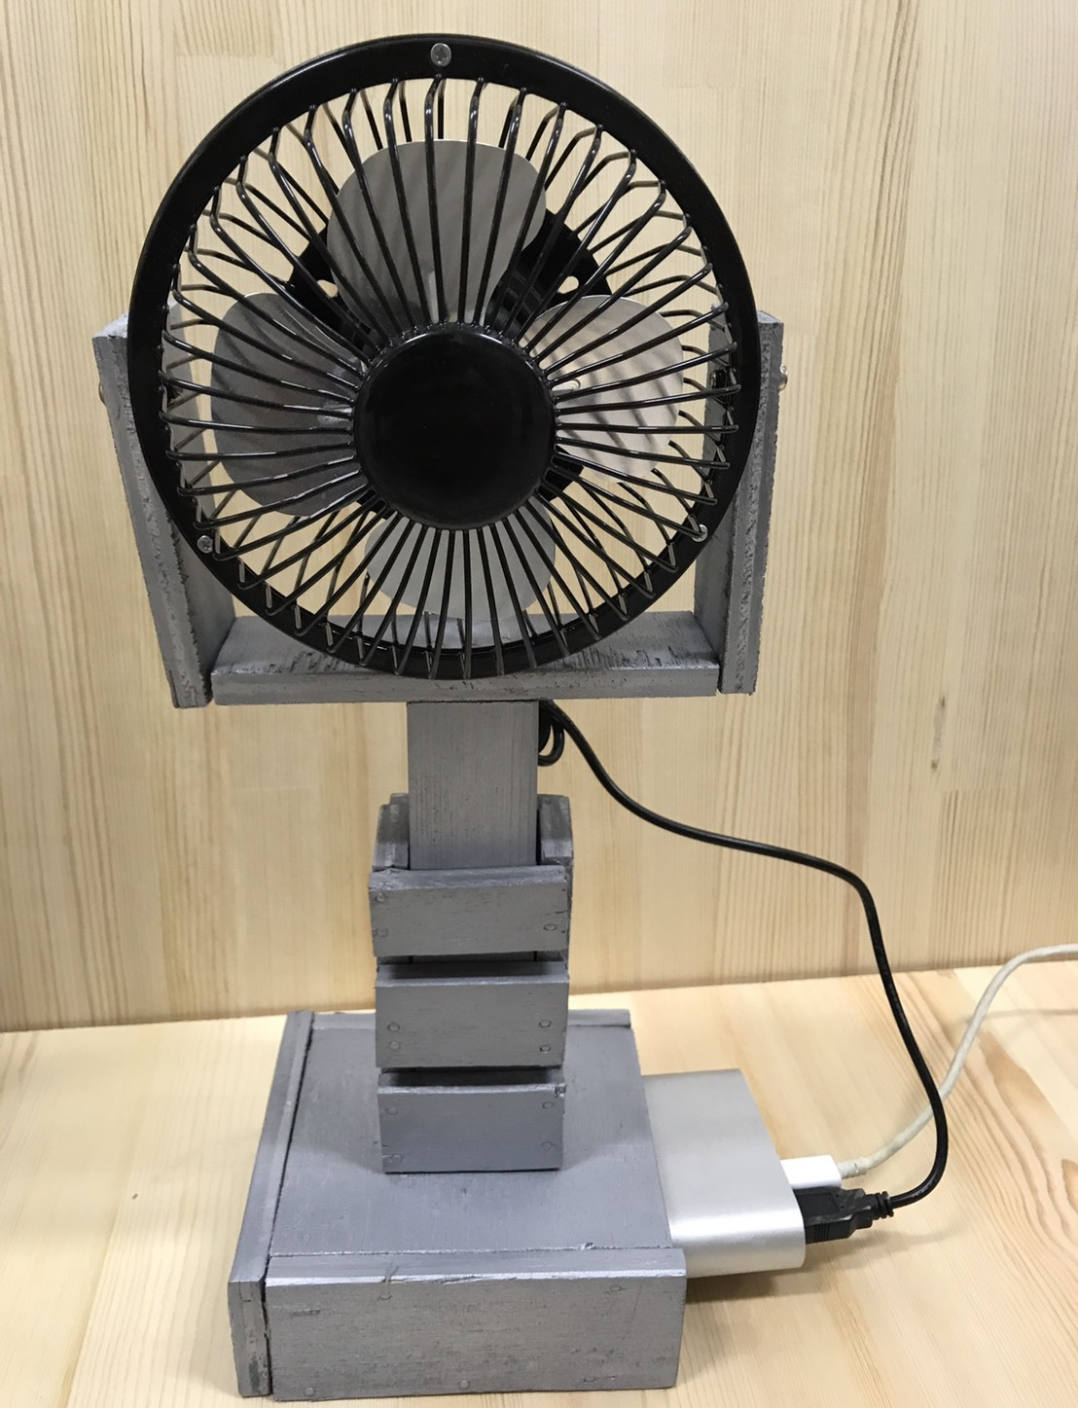

**Figure 2. Platform for placing the fan and portable power bank**

Based on the position of the sun and weather conditions, the intensity of solar radiation changes over time. We recorded the current and voltage generated by the solar panel and calculated the conversion efficiency. The solar panel and portable power bank were tested under direct sunlight to ensure the devices were charging, as shown in Figures 3, 4, and 5. Using a multimeter, we measured the direct current (DC) and direct voltage (DV) values during charging. Power (P) is calculated by multiplying the voltage (V) by the current (A) to get the wattage (W) (i.e., P=V×A). Then, dividing the wattage by the wattage rating of the monocrystalline silicon solar panel gives the approximate conversion efficiency percentage, though there may be slight discrepancies from the actual efficiency.

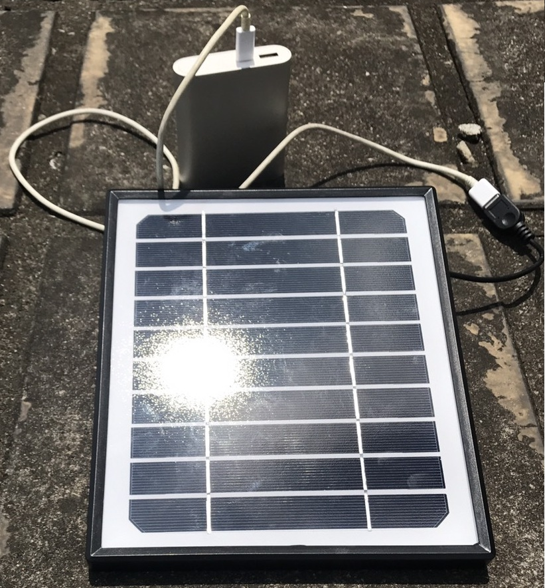

**Figure 3. Charging the portable power bank using the solar panel**

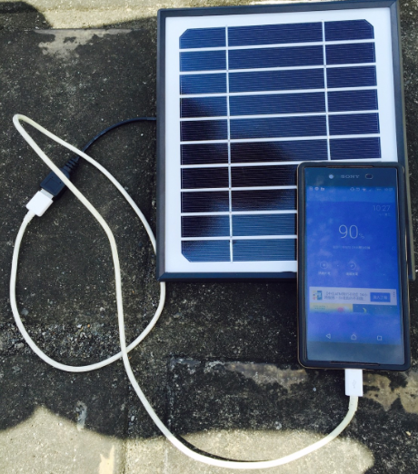

**Figure 4. Charging a mobile phone using the solar panel**

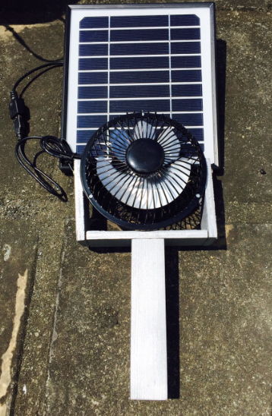

**Figure 5. Charging a mobile phone using the solar panel**

# RESULTS AND DISCUSSIONS

The test was conducted over eight days to record the efficiency’s continuous variation and determine whether it follows a regular pattern. Measurements were taken at each hour using a multimeter, with multiple readings at each time to calculate an average and improve reliability. It was observed that the highest conversion efficiency occurred around 1 PM, with an efficiency of about 20%. The difference in conversion efficiency between cloudy and sunny days was significant. The variable weather conditions indicate that choosing the right time and location for solar power generation is crucial. A comparison of time and conversion efficiency is shown in Figure 6.

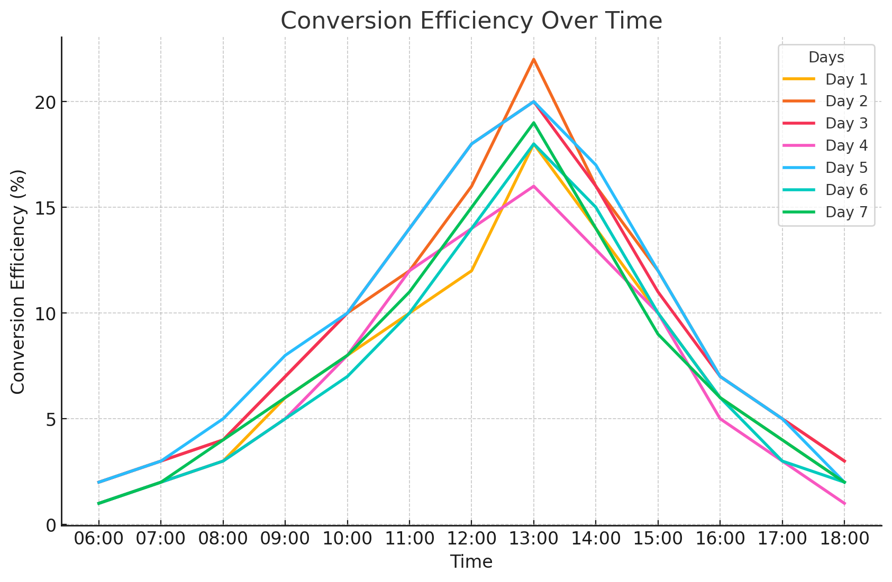

**Figure 6. Comparison of time and conversion efficiency**

# CONCLUSIONS AND RECOMMENDATIONS

This experiment aimed to discover environmentally friendly, green energy solutions that help reduce the pace of environmental degradation. We used discarded wood to build the materials for this project, aligning with our goal of sustainability. Instead of relying on traditional power sources, we sought to utilize solar energy to generate electricity, adhering to the concept of green energy. Through testing and analyzing the solar panels, we identified optimal times for power generation and the time required to fully charge devices. Our goal was to make effective use of solar energy. Additionally, we aim to further investigate the internal components of solar panels, including identifying the best materials for efficiently absorbing sunlight and improving conversion efficiency. Over the course of eight days, we used a multimeter to record the conversion efficiency under different weather conditions and tested the time required to charge various appliances using solar-generated power. We also estimated the future potential of the solar energy industry based on these findings. From the power generation efficiency table and the aforementioned tests, it is clear that the period between 11 AM and 2 PM saw a significant increase in solar energy performance. If conversion efficiency can be greatly improved, solar energy storage efficiency will also increase substantially. Comparing the experimental results with theoretical and simulated values can help assess the reliability of the experiment and provide a basis for further understanding the mechanisms behind solar energy conversion, as well as optimizing solar panel designs.

Based on the findings of this study, several recommendations can be made to further improve solar energy utilization. First, future research should focus on optimizing the materials used in solar panels to enhance solar energy absorption and conversion efficiency. Extending the peak performance time of solar panels, which was observed between 11 AM and 2 PM, could be achieved by implementing tracking systems or advanced coatings. Additionally, improving energy storage solutions is essential for making solar power more reliable, allowing excess energy generated during peak times to be stored for later use. Expanding the study to larger-scale solar panel systems could provide insights into how solar energy can be optimized for commercial and industrial applications. Smart energy management systems should also be developed to efficiently control the distribution of solar energy, especially during peak demand. Moreover, governments should be encouraged to introduce policies that promote widespread solar adoption through subsidies, tax incentives, and low-interest loans. Finally, exploring hybrid renewable energy systems that combine solar with other sources, such as wind or hydropower, could provide more consistent power generation and reduce reliance on non-renewable energy sources. These strategies would enhance the practicality and efficiency of solar energy systems while contributing to a more sustainable energy future.

**REFERENCES**

1. Tagliapietra, S., Zachmann, G., Edenhofer, O., Glachant, J., Linares, P., & Loeschel, A. (2019). The European Union energy transition: Key priorities for the next five years. *Energy Policy, 132*(C), 950-954.
2. Bureau of Energy, Ministry of Economic Affairs. (2016). *Renewable energy development policy* (in Chinese).
3. Li, C. A., Zhang, K. Q., & Zhong, G. M. (2018). Review of the second phase of the domestic solar water heating system subsidy program (2000–2018). *Energy Center Report, National Cheng Kung University* (in Chinese).
4. He, Y. L., Qiu, Y., Tao, Y. B., & Wang, K. (2023). *Solar thermal power generation principles, technology, and numerical analysis*. Science Press (in Chinese).
5. International Energy Agency. (2023). *World Energy Outlook 2023*.
6. Feldman, D., & Margolis, R. (2021). H2 2020: Solar industry update. Golden, CO.