Performance Analysis of the Vapor Compression System Heat Pump Bench-Top Refrigerating Unitas a Cooler and Heater

Djuanda 1, Andi Muhammad Irfan 2, Rahmat Ramadan3

*1,2,3Engineering Faculty, Makassar State University, Makassar, Indonesia*

*Corresponding Author: djuanda@unm.ac.id*

*ABSTRACT: This research is a descriptive study which aims to obtain the performance of the TD254 heat pump Bench-Top Refrigerating Unit as a heater and cooler. The test was carried out for 120 minutes by measuring energy consumption, pressure and temperature at several points of the TD254 heat pump Bench-Top Refrigerating Unit. The system works with 4 modes, namely cooling, heating, cooling-heating, and heating-cooling. Testing was carried out two times, namely morning and afternoon. The research results show: (1) Testing in the morning obtained an average COP of 5.00 with an average energy consumption of 1.199 kWh in cooling mode, heating mode obtained an average COP of 6.75 with an average energy consumption of 1.217 kWh, cooling and heating mode obtained an average COP of 5.70 with an average energy consumption of 1.167 kWh, heating-cooling mode obtained an average COP of 6.33 with an average energy consumption of 1.220 kWh. (2) Testing during the day obtained an average COP of 4.84 with an average energy consumption of 1.210 kWh in cooling mode, heating mode obtained an average COP of 6.83 with an average energy consumption of 1.215 kWh, cooling and heating mode obtained an average COP of 5.21 with an average energy consumption of 1.208 kWh, heating-cooling mode obtained an average COP of 5.80 with an average energy consumption of 1.237 kWh.*

***KEY WARDS:*** *heat pump, performance, TD254, cooler, heater.*

---------------------------------------------------------------------------------------------------------------------------------------

Date of Submission: xx-xx-xxxx Date of acceptance: xx-xx-xxxx

---------------------------------------------------------------------------------------------------------------------------------------

# INTRODUCTION

Heat pumps are one of the air conditioning system applications. A heat pump is a device used to distribute air with a certain temperature to a place. The heat pump is an air system that can be adjusted into two modes, namely cooling mode and heating mode by reversing the direction of refrigerant circulation. The temperature produced by the heat pump can be adjusted to the desired setting. The heat pump has the same main components as the refrigeration system, namely the compressor, condenser, expansion valve and evaporator. To change the heating function to cooling or vice versa, requires a four-way reversing valve.

The type of heat pump system that is widely commercialized is the vapor compression system. The vapor compression system is the system most commonly encountered in everyday life. The advantage of the vapor compression system is its very high performance coefficient. This is why this technology cannot be replaced by other technologies.

In the field of space and water heating, heat pump systems provide efficient and energy-saving technology. This system has also been proven to contribute to reducing gases that cause global warming [1]. Heat pumps offer technology that can utilize heat sources available in the environment, such as air, land, water, sun and other sources. By using a small amount of energy, heat pumps can increase room and water temperatures to desired levels [2].

Heat pumps have also been proven to reduce CO2 gas emissions. Data for 1997 shows total global CO2 emissions of 22 billion tons [3]. Of this amount, energy use for space heating produces 30% CO2 emissions, while industrial activities produce 35% emissions. By using a heat pump, CO2 emissions from the space heating sector are reduced by 31% compared to using space heating using an oil-fired boiler. In 2002 the total savings in CO2 emissions by using heat pumps amounted to 1.2 billion tonnes, this means around 6% of total CO2 emissions. Reducing these emissions is the largest reduction in global warming-causing emissions offered by a single technology. By increasing the efficiency of power plants and heat pumps, it is hoped that in the future the reduction in CO2 emissions can reach 20%.

Seeing the various advantages of heat pumps compared to other systems, the development of heat pump technology has good prospects. Heat pump technology in four-season countries has two functions, heating and air conditioning. There is an additional device in the form of a valve to regulate the direction of refrigerant flow. In the summer (cooling function) the refrigerant flow transfers heat from the room to the outside. Meanwhile, in the heating function, the direction of the refrigerant is reversed so that heat from outside the room is transferred into the room. In the cooling function, the indoor unit functions as an evaporator, while the outdoor unit functions as a condenser. On the other hand, in the heating function, the inside unit functions as a condenser and the outside unit functions as an evaporator. The use of space heaters is usually used in a room that requires a maintained temperature. Maintained in the sense of being stable, not changing easily to maintain the warmth of the objects/objects inside.

In Indonesia, as a country with a tropical climate, there are two seasons, namely the dry season and the rainy season. In the current summer season in Indonesia, the earth's temperature is very unfriendly to humans, namely around 30-35 degrees Celsius, while in the rainy season the temperature in Indonesia is quite varied, and where in mountainous areas the temperature can reach 5-10 degrees Celsius [4]. For this reason, the Indonesian population really needs a heat pump, where when the heat pump is operating in cooling mode it is used as an air conditioner and when it is in heating mode it is intended to function as a water heater and is applied in the process of drying agricultural products and is used for offices, hotels and industry.

he performance or performance of the heat pump system air conditioning machine has a major impact on thermal efficiency. This is in line with the views of Muhsin Z, et al. [5] who stated that the performance of a heat engine can be described as thermal efficiency. Performance of work cooling machines and heat pumps can be expressed by the ratio of working heat usage, or it can also be called the energy ratio or coefficient of performance (COP).

TD254 Bench-Top Refrigerating Unit is a vapor compression system heat pump found in the refrigeration engineering unit laboratory of the Mechanical Engineering Education Department, Faculty of Engineering, Makassar State University. TD254 Bench-Top Refrigerating Unit aims to introduce the study of heat pumps as coolers and heaters as well as the determination of unit operating parameters depending on the two types of modes used in the process. These units can have different applications, depending on the type of cold focus or hot focus used in the evaporation and condensation processes.

In the compressor, the compression process takes place. The refrigerant vapor from the suction line is compressed so that the pressure of the refrigerant vapor will increase to the condensation pressure followed by an increase in the saturation temperature of the refrigerant vapor. The ideal compression process takes place under constant entropy conditions (isentropic process), the refrigerant does not experience friction during the compression process so the entropy of the refrigerant will be the same at when entering and exiting the compressor.

The vapor compression system is the most widely used basic refrigeration system, with the main components being the compressor, evaporator, and expansion device *(Throttling Device),* and condenser. These four components carry out interconnected processes and form a vapor compression refrigeration cycle [6].

# MATERIAL AND METHODS

This research uses a TD 254 vapor compression heat pump with a capacity of 1 kW. The refrigerant used is R-134a. The system works with 4 modes, namely cooling, heating, cooling-heating, and heating-cooling. Testing was carried out two times, namely morning and afternoon. The system schematic can be seen in Figure 1.

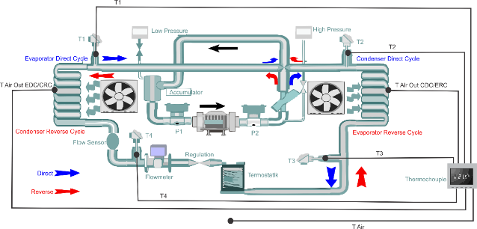

**Figure 1: Heat pump system schematic**

The research procedure begins at the preparation stage, implementation stage, and reporting stage with data collection techniques using literature studies and field studies (*field research).* Data analyses is carried out by collecting all data obtained from measurements using DAQ Express then do the calculations using CoolPac*k software* to determine the performance of the vapor compression system heat pump*.*

Determining the performance number of a heat pump can be obtained based on measuring the performance coefficient and energy consumption in cooling mode and heating mode. The performance of a heat pump in the use of cooling and heating is expressed in Coefficient of Performance (COP) and energy consumption (kWh).

# RESULTS AND DISCUSSIONS

1. **Cooling Mode**

Comparison of the coefficient of performance (COP) of the TD254 Bench-Top Refrigerating Unit heat pump in cooling mode in the morning and afternoon can be seen in Fig. 2.

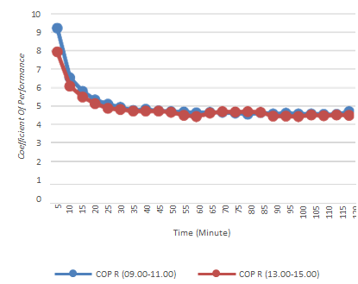

**Figure 2: COP Comparison Chart for TD254 Heat Pump Cooling Mode Bench-Top Refrigerating UnitAgainst Time in Morning and Afternoon Testing**

1. **Heating Mode**

Comparison of the coefficient of performance (COP) of the TD254 Bench-Top Refrigerating Unit heat pump in cooling mode in the morning and afternoon can be seen in Fig. 3.

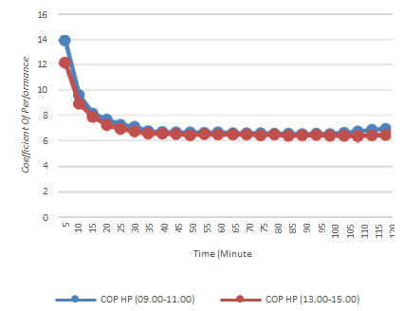

**Figure 3: COP Comparison Chart for TD254 Heat Pump Heating Mode Bench-Top Refrigerating Unitagainst Time in Morning and Afternoon Testing**

1. **Cooling-Heating Mode**

Comparison of the coefficient of performance (COP) of the TD254 Bench-Top Refrigerating Unit heat pump in heating-cooling mode in the morning and afternoon can be seen in Fig. 4.

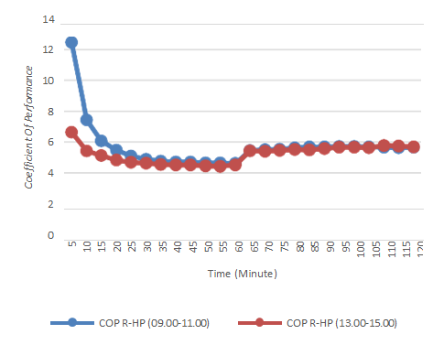

**Figure 4: COP Comparison Chart for TD254 Heat Pump Cooling-Heating Mode Bench-Top Refrigerating Unitagainst Time in Morning and Afternoon Testing**

1. **Heating-Cooling Mode**

Comparison of the coefficient of performance (COP) of the TD254 Bench-Top Refrigerating Unit heat pump in cooling-heating mode in the morning and afternoon can be seen in Fig. 5.

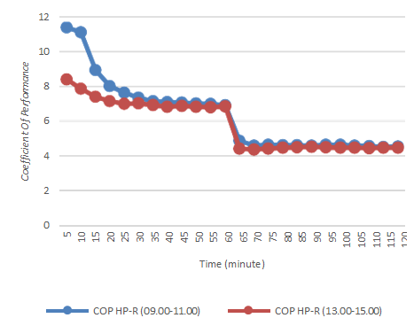

**Figure 5: COP Comparison Chart for TD254 Heat Pump Heating-Cooling Mode Bench-Top Refrigerating Unitagainst Time in Morning and Afternoon Testing**

COP (Coefficient of Performance) is an indicator to determine the work performance of the TD254 Bench-Top Refrigerating Unit heat pump engine. The results of the COP data analysis are described in a statistical graph of the coefficient of performance (COP) of the TD254 Bench-Top heat pump refrigerating unit. The average coefficient of performance of heat pump unit can be seen in fig. 6.

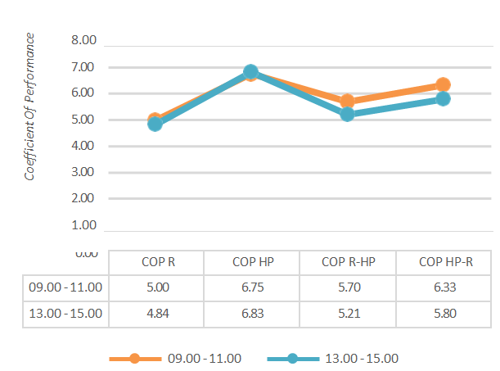

**Figure 6: The average coefficient of performance of heat pump unit**

The data above shows statistics on the results of achieving COP values ​​based on the time period of operation of the TD254 Bench top Refrigerating Unit heat pump machine. In the morning test for 120 minutes, the cooling mode got a COP value of 5.00, the heating mode got a COP value of 6.75, the cooling-heating mode got a COP value of 5.70, and the heating-cooling mode got a COP value of 6.33. Meanwhile, in testing during the day for 120 minutes, the cooling mode got a COP value of 4.84, the heating mode got a COP value of 6.83, the cooling-heating mode got a COP value of 5.21, and the heating-cooling mode got a COP value, namely of 5.80. This shows that the COP of the TD254 Bench-Top Refrigerating Unit heat pump engine is more optimal in the morning.

Energy consumption is the amount of energy used in the TD254 Bench-Top Refrigerating Unit heat pump engine. The results of the energy consumption comparison data analysis are described in a comparison graph of the average energy consumption of the TD254 Bench-Top Refrigerating Unit heat pump. The average energy consumption of heat pump unit can be seen in fig. 7.

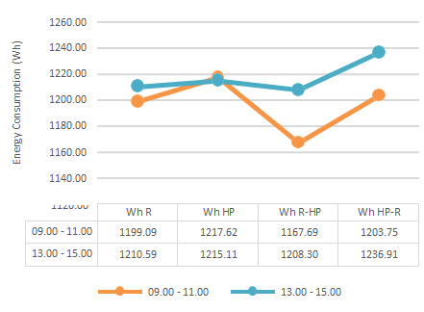

**Figure 7: The average energy consumption of heat pump unit**

The data above shows statistics on the results of achieving energy consumption values ​​based on the time period of operation of the TD254 Bench-Top Refrigerating Unit heat pump engine. It can be concluded that the results of the statistical data analysis of the average energy consumption difference test from the operation of the TD254 Bench-Top Refrigerating Unit heat pump engine show that the average energy consumption in the 120 minute test in the morning in cooling mode was 1.199 kWh, in heating mode an average of 1.217 kWh, the cooling-heating mode obtained the lowest energy consumption value of 1.167 kWh, and the heating-cooling mode obtained an energy consumption value of 1.203 kWh. Meanwhile, in testing during the day for 120 minutes, the cooling mode was 1.210 kWh, in the heating mode the average was 1.215 kWh, the cooling-heating mode obtained the lowest energy consumption value of 1.208 kWh, and the heating-cooling mode obtained energy consumption value of 1.236 kWh. Data shows that energy consumption is more efficient in morning testing.

# CONCLUSIONS AND RECOMMENDATIONS

Based on the results of research that has been carried out to see the performance coefficient of the heat pump, it can be concluded that the average COP of the heat pump for heating mode is greater than when the system works in cooling mode. Apart from that, energy consumption for heating mode is also greater than when the system operates in cooling mode. The difference between operation in the morning and afternoon does not really affect the system performance coefficient.

Researcher fully aware that research into the performance of the TD254 Bench-Top Refrigerating Unit heat pump as a cooler and heater is still not perfect enough, therefore in the next research the author suggests that this research be further developed according to technological developments and that a partition be made between the indoor unit and the outdoor unit of the pump machine heat of the TD254 Bench-Top Refrigerating Unit vapor compression system so that measurement results are maximized.

**REFERENCES**

1. Djuanda, Suwono, A., Pasek, A.D., Tandian, N.P, Muharram, Pompa Kalor Temperatur Tinggi Berbantuan Energi Surya: Desain dan Pengujian, Prosiding Seminar Nasional Tahunan Teknik Mesin (SNTTM) ke-9, 2010.
2. Djuanda, Pasek, A.D., Tandian, N.P., Modeling and Simulation of High-Temperature Heat Pump Combined with Solar Energy, Proceeding IOP Conf. Series: Earth and Environmental Science, 1209 (2023) 012026.
3. Halozan, H., Rebierer. R. and Gassler M. 2002. Control Of CO2 Heat Pump. Institute of Thermal Engineering Graz University of Technology Inffeldgasse 25/B, A 8010 Graz, Austria.
4. Kusnandar dan Gusniawan. 2016. Analisa Performansi Heat Pump Menggunakan Counter Flow Heat Exchangers. Jurnal Teknologi Terapan Vol2, No 2, September 2016, 27-31.
5. Muhsin Z, Djuanda, A. Ramli Rasyid, Munandar. 2017. Analisis Unjuk Kerja (COP) Mesin Pendingin Hibrid dengan Menggunakan Refrigeran R-22. Jurnal Teknik Mesin Teknologi Vol 17, No 1 Okt 2017, 49-58.
6. Cakra M.A. dkk. 2016. Karakteristik Laju Pengeringan Pada Mesin Pengering Pakaian Sistem Pompa Kalor. Jurnal Dinamis, Vol. 4, No. 3, September 2016, 1-13.
7. Kurniawan, Untung dan Maryadi. 2020. Unjuk Kerja Heat Pump Water Heater Dengan Daya Kompresor 0,25 HP. Jurnal Baut dan manufaktur Vol. 02, No. 02, Oktober 2020. 31-39.
8. Kusnandar, Sunanto, Hadi Tardi. 2015. Kajian Eksperimen Pada Heat Pump Menggunakan Refrigeran Propane. Jurnal tekno Insentif. Vol. 9, No. 2, Oktober 2015. 206-211