Economic Load Dispatch using Chicken Swarm Optimization Algorithm

Onah, C. O.1, Antem, R. L.2 and Kpochi, K. O.3

1,2,3Department of Electrical and Electronics Engineering, Joseph Sarwuan Tarka University, Makurdi, Nigeria

1[okoko.onah@uam.edu.ng](mailto:okoko.onah@uam.edu.ng), +234-8038179738

***ABSTRACT:*** *Economic Load Dispatch (ELD) is one of the fundamental optimization problems in power system analysis, operation, and planning. The key objective of ELD is to determine the electrical power output generated by the committed generating units in a power system so as to minimize the total cost of generation while satisfying the load demand and without violating the system constraints. The focus of this paper is on the application of the chicken swarm optimization (CSO) algorithm to solve the economic load dispatch problem using the Egbin thermal power station in Nigeria as a case study. The CSO program was developed using MATLAB to provide a solution to a six-unit plant and the result compared to that of the particle swarm optimization (PSO) algorithm. The CSO and PSO were analyzed considering variable load demands of 90MW, 950MW, 1000MW, 1050MW, and 1100MW. The total generation costs obtained from the CSO algorithm for the corresponding load demands were 20600.379 N/hr, 20610.379 N/hr, 20620.379 N/hr, 20630.379 N/hr, and 20640.379 N/hr. While, the cost values using the PSO algorithm were obtained as 50754.544 Nhr, 54445.5862 Nhr, 58307.7079 Nhr, 62341.514 N/hr, and 66547.5878 N/hr. The comparison between the two algorithms revealed that CSO performed better than PSO as it produced minimal values of generation cost and losses while meeting the load demands. This implies that the CSO algorithm is a superior tool for solving ELD problems due to its ability to produce minimal generation costs and reduced transmission losses, accuracy and high efficiency of generation, fast convergence, and easy implementation while meeting the various load demands within a short period and within the limits of the generators.*

**Keyword**: Optimization, generation cost, chicken swarm optimization, algorithm, thermal power plant,

transmission loss

*Kuwait*

# INTRODUCTION

The electrical energy demand is on the increase due to its flexibility in the operation of many devices. The primary function of an electrical power system is to ensure that the electrical energy demand is economically and adequately supplied. Hence, for the economic operation of the system, the total load demand must be appropriately dispatched among the generating units with the objective to minimize the total generation cost of the system subject to the system constraints [1].

Economic load dispatch is a procedure to determine the electrical power to be generated by the committed generating units in a power system so that the total cost of the system is minimized while satisfying the load demand. It is the process of allocating generating levels to the different generating units so that the system load demand is met economically [2]. The aim is to minimize an objective function usually the total generation cost while satisfying both the equality and inequality constraints. Economic load dispatch is one of the fundamental problems in power system operation and planning. To address this problem, optimization is important in solving the cost minimization problem. Power system optimization is a significant factor in the operation, planning, and control of the power system. Many modern heuristic techniques have been utilized to resolve complex power system optimization problems, each having a different method of representation, implementation, and solution procedure [3].

The process of economic load dispatch started far back as the early 1920’s when engineers were concerned with the problem of economic allocation of generation or the problem of sharing load among the available generating units [4]. Methods such as the base load, base point loading, and incremental method were used to solve the economic load dispatch problem. Economic load dispatch is a constrained multi-objective problem that can be solved by both mathematical optimization and heuristic algorithms. Mathematical optimization techniques are the analytical and lambda iteration methods [5].

There are several techniques in literature used for solving economic load dispatch problems, which are either conventional or non-conventional and the choice of an optimization technique depends on the type of objective function. Some conventional methods include Lambda iteration method, base-point and participation factor method, Gradient method, Newton-based method, Linear programming, Quadratic programming, mixed programming, etc. These methods represent cost in the form of quadratic or cubic functions and require incremental fuel cost curves. There are some limitations in conventional methods but have been mitigated by the introduction of meta-heuristic methods such as Artificial Bee Colony (ABC), Ant Colony Optimization (AC), Differential Evolution (DE), Particle Swarm Optimization (PSO), Chicken Swarm Optimization (CSO), etc., which are used for solving economic load dispatch problems involving linear, convex and smooth functions [6].

**2. FORMULATION OF ECONOMIC LOAD DISPATCH PROBLEM**

The total cost of operating generators includes fuel, labour, and maintenance costs, however, fuel cost is considered in this case since it is the major cost. The ELD problem can be mathematically formulated as a single objective cost function of the power-generating unit in non-convex quadratic form. The quadratic cost function is the objective function to be minimized subject to equality and inequality constraints.

Considering a system with n number of committed generators and a known total load demand, the power generated by each generator unit can be determined at a minimum cost to meet the load demand while satisfying the necessary system constraints. Hence, the ELD problem can be defined as a nonlinear constrained single objective optimization problem as presented in equation (1), [2, 7].

Minimize: $C_{T}\left(P\right)$

Subjectto: $x\left(P\right)=0, and y\left(P\right)≤0$ (1)

where, $C_{T}$ is the total cost of fuel, $P$ is the real power generated, *x* is the equality constraint representing the power balance equation, and *y* is the inequality constraint representing the capacity of generating units.

***2.1 Objective Function***

The main objective of an ELD problem is to minimize the total cost of fuel used for generation by efficiently scheduling the output of each available unit to meet the load demand. The objective function of an ELD problem is represented by the sum of the quadratic cost model for each generator as given by equation (2).

$C_{T}=\sum_{i=1}^{n}{C_{i}\left(P_{i}\right) }$ (2)

where, $C_{i}$ is the cost function of the *ith* generating unit in Naira per hour (₦/h), $P_{i}$ is the real output power of the *i-th* generating unit in MW and *n* is the total number of generators in the power system [2,7,8]. The cost function of a power generating unit in equation (2) can be expressed in quadratic function form as equation (3).

${ C}_{i}{(P}_{i})=α_{i}+β_{i}P_{i}+γ_{i}P_{i}^{2}$ (3)

where ${ α}_{i}$, $β_{i}$ and $γ_{i}$ are the cost coefficients of the ith generator.

***2.2 Equality Constraint***

The equality constraint (power balance equation) is considered in two scenarios of considering transmission losses and neglecting transmission losses. In the case of neglecting losses, balance is reached when the total generation output is equal to the sum of the load demand assuming that there are no losses in the system [8]. It is as shown in equation (4).

$\sum_{i=1}^{n}{P_{i}=P_{D} }$ (4)

In the second scenario, balance is attained when the total power generated is equal to the load demand plus the total transmission losses in the system. In a practical power system, the effect of losses cannot be neglected since it occurs between the generating station and the load centers. If power is generated without considering losses, the power at the receiving end will not be enough to meet the load demand [2, 7]. The power balance equation considering transmission losses is as given in equation (5).

$\sum_{i=1}^{n}{P_{i}=P_{D}+P_{L} }$ (5)

where, $P_{D}$ is the system load demand and $P_{L}$ is the total transmission losses in MW.

The system power losses can be determined by means of power balance equation which is expressed in krons loss formula in equation (7)

$P_{L}=\sum_{i=1}^{n}{\sum_{j=1}^{n}{P_{i}}}B_{ij}P_{j}$ (6)

where, $P_{i}$ and $P_{j}$ are the generator power for the *ith* and *jth* generating units respectively and $B_{ij}$ is the element of the B-matrix between *ith* and *jth* generating units.

***2.3 Inequality Constraint***

Every generator has limits in which it can operate efficiently. The inequality constraint is also known as the power generator capacity constraint. For economic operation of a thermal station, every generating unit must be operated within its limits [2, 7]. The inequality constraint is defined by equation (7).

$P_{i}^{min}≤P_{i}≤P_{i}^{max}, i=1, 2, …, n$ (7)

where $P_{i}^{min}$ and $P_{i}^{max}$ represent the minimum and maximum power output of the ith generator. Similarly, for stable operation, the generator reactive powers should be within the range stated by the inequality constraint. This is shown in equation (8).

$Q_{i}^{min}≤Q_{i}≤Q_{i}^{max}, i=1, 2, …, n$ (8)

where $Q_{i}^{min}$ and $Q_{i}^{max}$ represent the minimum and maximum reactive power output of the ith generator.

1. **CHICKEN SWARM OPTIMIZATION**

The chicken swarm algorithm is an optimization algorithm to simulate the hierarchal order in the chicken and the behaviours of the chicken swarm. The chicken swam can be divided into several groups, each group is made up of a dominant rooster, many hens and chicks. The identity of all the chickens depends on their fitness values. The chickens with the best fitness values would be acted as roosters while the ones with the worst fitness values would be regarded as chicks. The others would be hens, which can choose randomly which group to live in. The mother-child relationship between the hen and the chicks is randomly established. The hierarchal order, dominance relationship and mother-child relationship in a group remain constant and update every G time step. The value of G has a great effect on the convergence of the problem either to a global or local optimum. This swarm intelligence is associated with the objective problem to be optimized and inspires the design of a chicken swarm optimization algorithm [9]

All N virtual chickens are depicted by their position x_ij^t (i∈[1,…N],j∈[1,…D]) at time step t search for food in a D- dimensional space. In this paper, the best number of roosters corresponds to the ones with minimal fitness values since the optimization problem is a minimal one. The CSO algorithm uses a swarm consisting of a number of chickens to search for an optimal solution. Each chicken position represents a candidate solution to the the optimization problem. Each chicken is initialized with a random position to search for an optimal solution within a range. A fitness evaluation function is used to assign the fitness value of each chicken with the best position among all the chickens assigned. For every iteration, each chicken updates its position based on its own best position Pbest and the swarm's overall best position called Gbest [9].

***3.1 Basic Chicken Swarm Optimization Model***

The CSO model is basically developed by considering the flock structure, setting fixed identities for all the chickens, establishing the mathematical model by chickens’ identities and their foraging laws and finally setting a particular interval to update the relationship between the chickens frequently [10].

**Group Structure**: it comprises the number of roosters, hens, chicks and mother hens in a group. Assuming a total number of N chickens in a group, the proportion of the roosters and hens is RP and HP respectively. In hens, the proportion of mother hens is MP. Assuming that RN, HN, CN, MN represents the number of rosters, hens, chicks and mother hens respectively. The relationship among them can be expressed in equations (9-12).

$RN=NXRP$ (9)

$HN=NXHP$ (10)

$CN=N-RN-HN$ (11)

$MN=HNXMP$ (12)

The sizes of the number of roosters (RN), number of hens (HN), number of chicks (CN), and number of mother hens (MN) directly decide the group structure, which is one of the main factors that affects the performance of CSO. The number of hens should be greater than the number of roosters according to the optimization goal and the natural law because hens are considered to bring more benefits than roosters. Also, the number of hens should be more than the number of mother hens because not all hens feed chicks. The model sets the number of adult chickens to be more than the number of chicks [10].

**Identity of Chickens**: with the assumption that all the chickens are shown by their fitness and proportion, the model is built using equation (13).

$\left\{\begin{aligned}f_{i}^{t} \\ x_{i,j}^{t} \end{aligned}, i∈\left[1, N\right], j∈\left[1, D\right] \right.$ (13)

where *t*, represents time step, *N* is the total number of chickens in the group, *D* represents the dimension of the space in which the chickens can search for food, *f* represents the fitness value which corresponds to the value of the objective function, *x* represents the position, which corresponds to the decision variables in the optimization problem to be solved. The aim of this optimization is to obtain the minimum values. Hence, the smaller the fitness value *f*, the better the chickens’ fitness.

***Foraging Law***: based on the foraging law and the identities of the chickens, [10] proposed the basic part of the CSO, which is the movement of the chickens.

***Roster Model***: The rooster model is built by the truth that the roosters with better fitness values have the ability to search for food in a wider dimensional space than those with the worst fitness values. This is formulated in equations (14) and (15).

$X_{i,j}^{t+1}=X_{i,j}^{t}*\left(1+Randn\left(0,σ^{2}\right)\right)$ (14)

$σ^{2}=\left\{\begin{aligned}1 if f_{i}≤f_{k} \\ \exp\left(\frac{f_{k}-f_{i}}{\left|f_{i}\right|+ε}\right) otherwise\end{aligned}k=\left[1,RN\right], k≠i \right.$ (15)

where, $Randn\left(0,σ^{2}\right)$ is a Gaussian distribution with mean 0 and standard deviation $σ^{2}$, $ε$ is the smallest constant in the computer, which is used to avoid zero division error,

$X_{ij}$ is the position of $j^{th}$ dimension of rooster *i*,

*RN* is the number of roosters,

*k* is a rooster’s index and is randomly selected from the rooster’s group,

$f_{i}$ and $f_{k}$ are the fitness values of rooster particle *i* and *k*.

***Hen Model:*** Hens can follow their group-mates, roosters, to search for food or search for food individually. Hens would randomly steal the good food found by others. The more dominant hens in the group have a better advantage in searching for food. Also, some of the hens will raise their own chick. These conditions are represented in equations (16 -19)

$X_{i,j}^{t+1}=X_{i,j}^{t}+C_{1}*Rand*\left(X_{r1,j}^{t}-X_{i,j}^{t}\right)+C_{2}*Rand*\left(X_{r2,j}^{t}-X_{i,j}^{t}\right)$ (16)

$C_{1}=\exp\left(\frac{f_{i}-f_{r1}}{\left|f_{i}\right|+ε}\right)$ (17)

$C_{2}=\exp\left(f_{r2}-f_{i}\right)$ (18)

where, Rand is a uniform random number over [0, 1], $r_{1}=\left[1…RN\right]$ is an index of the rooster which is the *i-th* hens group-mate, while $r_{2}=\left[1…RN\right]$ is an index of the chicken (rooster or hen) which is randomly selected from the group, $r_{1}≠r_{2}$.

***Chick Model****:* The chicks usually move around their mother to search for food. This is formulated in equation (19).

$X_{i,j}^{t+1}=X_{i,j}^{t}+F_{M}*\left(X_{m,j}^{t}-X_{i,j}^{t}\right)$ (19)

where, $X_{m,j}$ is the position of the $i^{th}$ chicks’ mother in the *j* dimension, m = [1, *N*],

FM = [0,2] is a parameter which indicates that the chick would follow its mother to search for food. The *FM* of each chick would randomly choose between 0 and 2 considering individual difference

Relationship Update: There are two key parameters in the CSO in addition to the model described above. That is the total number of iterations M and the interval of the relationship update *G*. The values of *M* and *G* are suitably selected based on a particular problem. If the value of *G* is too large, it is not conducive to converge to global optimum.

* 1. ***Chicken Swarm Optimization Algorithm***

**STEP 1**: Form an initial generation of chickens in a random manner respecting the limits of search space. Each chicken swarm is a vector of all control variables (Pg). For a system with five generators, a candidate is a vector of size 1x5

**STEP 2:** Calculate the best values of all chicken solution by running the number of rooster load flow. The control variable values taken by different rooster are incorporated in the system data and load flow is run. The total generation cost of each unit is calculated.

**STEP 3**: Determine the best hens, which have the best food searching ability fitness value. The rooster, hen and chick are arranged in the ascending order and the first hen will be considered the candidate with the best food searching ability (minimum cost) and give the best global index value.

**STEP 4**: Generate new rooster around the global swarm by adding/subtracting a normal random number. It should be ensured that the control variables’ limits are maintained, otherwise adjust rand and the values of chicken swarm group.

**STEP 5:** Hen, rooster, chicks are given the best global fitness value until this process takes place within a number of iterations. Repeat step 2-4 until the stopping criteria, which is the maximum number of iterations is reached [11].

1. **RESULTS**

The analysis for the economic load dispatch was carried out using the six generating units with the transmission line losses taken into consideration. Different load demands were considered along with the total cost of real power generation. The cost of real power generation for the optimal dispatch of each generating unit was determined and it was confirmed if all the generating units satisfied their equality and inequality constraints.

The economic load dispatch problem for Egbin power station with six generating units was solved using chicken swarm optimization (CSO) algorithm and the result compared to that of Particle Swarm Optimization (PSO). Table 1 represents the minimum and maximum generator limits of Egbin Thermal power plant. While Table 2 shows the generating capacities and fuel coefficients values for four thermal stations in Nigeria as well as the real power operating limits. The data from the two tables were used in the simulation of the formulated load dispatch problem and the results are presented in this section.

**Table 1: Minimum and Maximum Generator Limits of Egbin Thermal Power Plant [13]**

|  |  |  |
| --- | --- | --- |
| Unit | Minimum Power ( $P_{min})$ (MW) | Maximum Power ( $P_{max})$ (MW) |
| 1 | 55 | 220 |
| 2 | 55 | 220 |
| 3 | 55 | 220 |
| 4 | 55 | 220 |
| 5 | 55 | 220 |
| 6 | 55 | 220 |
| Total | 330 | 1320 |

**Table 2: Nigeria Thermal Stations Generating Capacity and Cost Coefficients [13]**

|  |  |  |  |  |  |
| --- | --- | --- | --- | --- | --- |
| Power Station | $$P_{gmin}$$ (MW) | $$P_{gmax}$$ (MW) | a  (N/h) | b  (N /MWh) | c  (N MW2h) |
| Egbin | 275.00 | 1100.00 | 12787.00 | 13.10 | 0.031 |
| Sapele | 137.50 | 555.00 | 6929.00 | 7.84 | 0.130 |
| Delta | 75.00 | 300.00 | 525.74 | -6.13 | 1.200 |
| Afam | 135.00 | 540.00 | 1998.00 | 56.00 | 0.092 |

The result obtains from the simulation for the cost of generation of real power scheduled for different load demand using chicken swarm optimization algorithm is presented in table 3. While the result obtained using the particle swarm optimization algorithm is presented in table 4. Table 5 shows the combined CSO and PSO results of total power output, total generation cost and losses at different load demands.

**Table 3: CSO Power Output, Generation Cost and Transmission Losses of Six Generating Units at Different Load Demands.**

|  |  |  |  |  |  |
| --- | --- | --- | --- | --- | --- |
| Power Demand (MW) | 900 | 950 | 1000 | 1050 | 1100 |
| P1 (MW) | 117.0180 | 123.5190 | 130.0200 | 136.5210 | 143.0220 |
| P2 (MW) | 158.5980 | 167.4090 | 176.2200 | 185.0310 | 193.8420 |
| P3 (MW) | 157.0635 | 165.7892 | 174.5150 | 183.2408 | 191.9665 |
| P4 (MW) | 157.5090 | 166.2595 | 175.0100 | 183.7605 | 192.5110 |
| P5 (MW) | 158.5980 | 167.4090 | 176.2200 | 185.0310 | 193.8420 |
| P6 (MW) | 159.4395 | 168.2972 | 177.1550 | 186.0128 | 194.8705 |
| Total Output Power (MW) | 908.2260 | 958.6829 | 1009.1400 | 1059.5970 | 1110.050 |
| Transmission Loss (MW) | 8.2260 | 8.6829 | 9.1400 | 9.5971 | 10.0540 |
| Total Generation Cost (N/hr) | 20600.3790 | 20610.3790 | 20620.3790 | 20630.3790 | 20640.3790 |

**Table 4: PSO Power Output, Generation Cost and Transmission Losses of Six Generating Units at Different Load Demands**

|  |  |  |  |  |  |
| --- | --- | --- | --- | --- | --- |
| Power Demand (MW) | 900 | 950 | 1000 | 1050 | 1100 |
| P1 (MW) | 124.3215 | 130.1910 | 135.9569 | 141.6281 | 147.1949 |
| P2 (MW) | 160.8227 | 170.2543 | 179.7281 | 186.2309 | 198.7866 |
| P3 (MW) | 155.7956 | 164.6602 | 173.5461 | 182.4608 | 191.3915 |
| P4 (MW) | 155.7266 | 164.5949 | 173.6716 | 182.3780 | 191.2847 |
| P5 (MW) | 155.8901 | 164.7774 | 173.6790 | 182.6124 | 191.5339 |
| P6 (MW) | 160.2829 | 169.6350 | 179.0445 | 182.4698 | 197.9759 |
| Total Output Power (MW) | 912.8395 | 964.1128 | 1015.4261 | 1066.7800 | 1118.1677 |
| Transmission Loss (MW) | 12.8395 | 14.1128 | 15.4261 | 16.7800 | 18.1677 |
| Total Generation Cost (N/hr) | 50754.5400 | 54445.5862 | 58307.7097 | 62341.5140 | 66547.5878 |

**Table 5: Combined CSO and PSO Total Power Output, Total Generation Cost and Transmission Losses at Different Load Demands**

|  |  |  |  |  |  |  |
| --- | --- | --- | --- | --- | --- | --- |
| Power Demand (MW) | | 900 | 950 | 1000 | 1050 | 1100 |
| Total Output Power (MW) | **CSO** | 908.2260 | 958.6829 | 1009.1400 | 1059.5970 | 1110.050 |
| **PSO** | 912.8395 | 964.1128 | 1015.4261 | 1066.7800 | 1118.1677 |
| Transmission Loss (MW) | **CSO** | 8.2260 | 8.6829 | 9.1400 | 9.5971 | 10.0540 |
| **PSO** | 12.8395 | 14.1128 | 15.4261 | 16.7800 | 18.1677 |
| Total Generation Cost (N/hr) | **CSO** | 20600.3790 | 20610.3790 | 20620.3790 | 20630.3790 | 20640.3790 |
| **PSO** | 50754.5400 | 54445.5862 | 58307.7097 | 62341.5140 | 66547.5878 |

Figure 1 to Figure 10 show the CSO and PSO plots for the optimized fitness against the number of iterations showing convergence for different load demands. Simulated result depicts optimal reduction in the fitness level of the particle or generation cost for 1000 iterations.

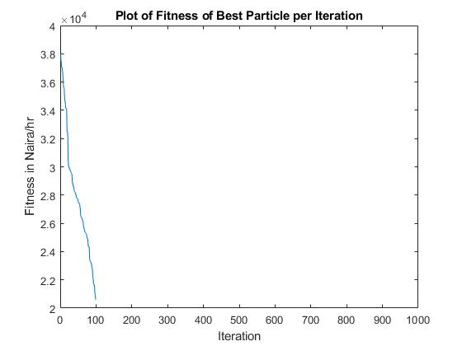

Figure 1: CSO Plot of Fitness against Number of Iterations at 900 MW Load Demand

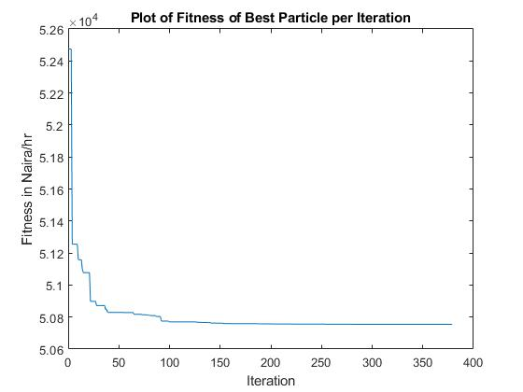

Figure 2: PSO Plot of Fitness against Number of Iterations at 900 MW Load Demand

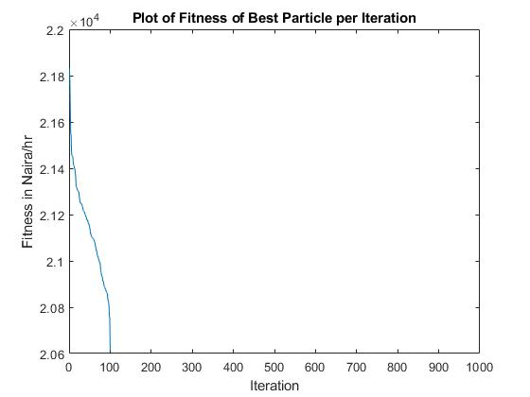

Figure 3: CSO Plot of Fitness against Number of Iterations at 950 MW Load Demand

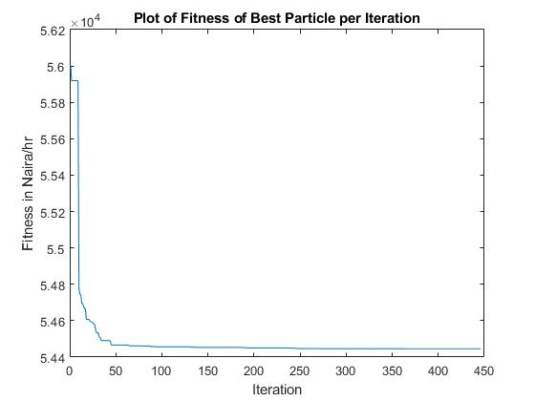

Figure 4: PSO Plot of Fitness against Number of Iterations at 950 MW Load Demand

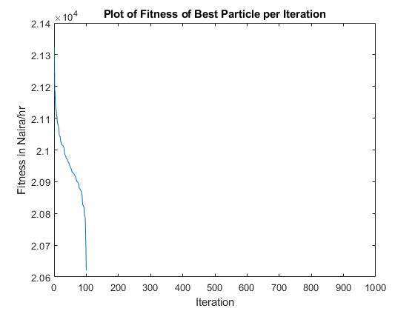

Figure 5: CSO Plot of Fitness Against Number of Iterations at 1000 MW Load Demand

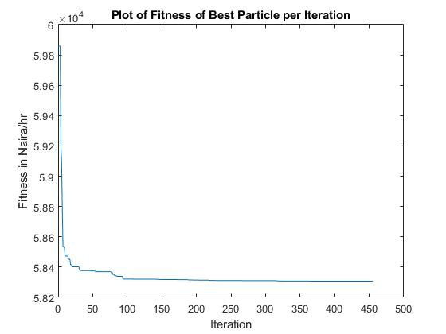

Figure 6: PSO Plot of Fitness Against Number of Iterations at 1000 MW Load Demand

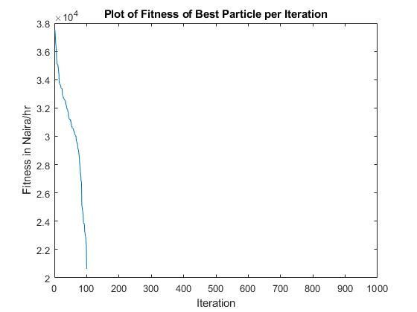

Figure 7: CSO Plot of Fitness Against Number of Iterations at 1050 MW Load Demand

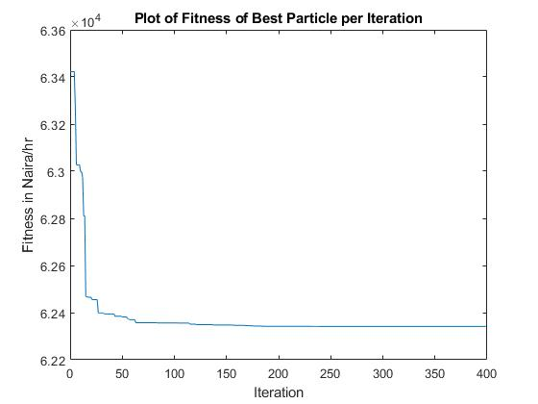

Figure 8: PSO Plot of Fitness Against Number of Iterations at 1050 MW Load Demand

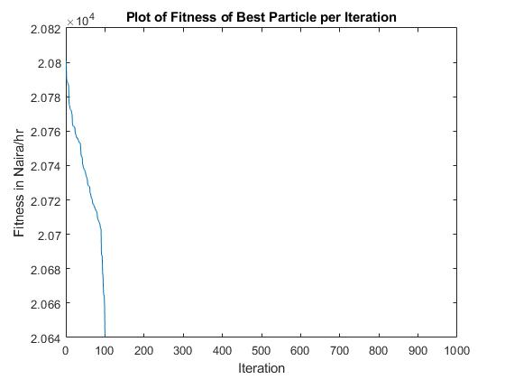

Figure 9: CSO Plot of Fitness Against Number of Iterations at 1100 MW Load Demand

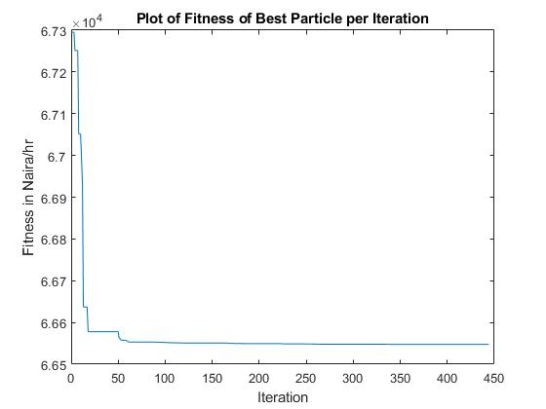

Figure 10: PSO Plot of Fitness Against Number of Iterations at 1100MW Load Demand

**3. DISCUSSION**

Egbin thermal power station located at Ijede town in Lagos state, Nigeria is a gas-fired plant with six independent boiler turbine units of 220MW each. The total installed capacity is 1320MW. The power generated is sent to the national grid through three main transmission lines; Ikeja West (330 kV), Aja (330 kV) and Ikorodu (132 kV) respectively.

Load flow analysis using Newton Raphson technique is used to obtain the unknown bus voltages, phase angles and the generator reactive power. The complex voltage obtained from Newton Raphson technique, active and reactive power, line and bus data of Egbin Thermal power station are needed by the bus admittance matrix program to generate the loss coefficient used in calculating the transmission loss in the power network.

During CSO analysis, population size of roosters, hens and mother hens was set at 0.15%, 0.7% and 0.5% respectively. The dimension was 6 while the parameter that determines how often the particles update is set at 10. The lower bounds which represent the lower limits of the installed generators was 55 while the upper bound representing the upper limits of the generators is set at 220. The program is simulated at 900MW, 950MW, 1000MW, 1050MW and 1100MW load demands respectively.

Throughout the PSO analysis, the inertial weight was set to decrease linearly from 0.9 to 0.4 to enable the particles search in a larger space, enhance convergence process and obtain optimal solution within a short period. The acceleration C1 and C2 were both set at 2.

The summary of results presented in Table 5 shows that the CSO is able to meet the load demand at minimal cost as compared to the PSO algorithm. The CSO shows a greater reduction in transmission losses than the PSO. The performance of the proposed CSO algorithm is capable of reaching a high efficient solution, minimizing fuel cost, reducing transmission losses, economically sharing the load demand across the six generating units, short computation time and fast convergence, to cope with the non-linearity and non-differentiability of the economic load dispatch problem of Egbin thermal power station.

1. **CONCLUSION**

This paper sought to develop and implement a Chicken Swarm Optimization-based algorithm to solve the economic load dispatch problem of the Egbin thermal power station. The algorithm was implemented and the performance was compared with that of a particle swarm optimization algorithm. The simulation results clearly show that the proposed algorithm, CSO performs better than PSO in terms of the ability to produce minimal generation cost, reduced fuel consumption and transmission losses, fast convergence and easy implementation of the code while meeting the load demand within a short period. Furthermore, the results reveal that the generators operated within their limits, which is a necessary condition for optimal performance in economic load dispatch.

**REFERENCES**

1. Kumar, C. and Alwarsamy T. (2012). Solution of Economic Load a dispatch Problem Using Differential Evolution Algorithm, International Journal of Soft Computing and Engineering, Vol. 22, pp. 152-159.
2. Nwohu, M. N., and Osaremwinda, O. P. (2017). Evaluation of Economic Load Dispatch in Power Generating Station by the Use of Ant Colony Search Algorithm. International Journal of Research Studies in Electrical and Electronics Engineering, Vol.3, Issue 1, pp.20-29.
3. Ismail, M., Hasima, F. I., Rozely, K., Muhammad, K. I., Titik, k. A., Rafi A. (2008). Ant colony Optimization (ACO) Technique in Economic Power Dispatch Problems. Proceedings of the International Multi Conference of Engineers and Computer Scientist, Vol. II.
4. Narasimha, L.V. (2014). PSO Technique for Solving the Economic Dispatch Problem Considering the Generator Constraints. International journal of Advance Research in Electrical, Electronics and Instrumentation Engineering, Vol.3, issue 7, ISSN (online): 2278-8875
5. Vairamuthu, S., Kaaviya K. and Jeevitha B. (2015). Analysis and Comparison of Conventional Methods and Artificial Intelligence Techniques to Solve the Economic Load Dispatch Problem, International Journal of Innovative Research in Science, Engineering and Technology, Vol. 22, pp.153-159.
6. Satheesh, A. P., Kanakavalli, Y., Sahithi, A., Dr. Kesava Rao, G. (2017). Economic Load Dispatch Using Particle Swarm Optimization. International Journal of Pure and Applied Mathematics, Vol. 9, Pp. 247-355
7. Onah, C. O., Agber J. U. and Ikule F. T. (2016). Optimal Dispatch of Real Power Generation Using Particle Swarm Optimization Algorithm: A Case Study of Egbin Thermal Station, International Journal of Modern Trends in Engineering and Research, Vol. 3, pp. 1-9.
8. Tasrif, S., Hadi H. and Rini N. (2018). Economic Dispatch in 150kV Sulselrabar Electricity System Using Ant Colony Optimization, IOSR Journal of Electrical and Electronics Engineering, Vol. 13, Issue 3, pp. 28-35.
9. Nursyiva, I., Aris T., and Dian E. W. (2017). Chicken Swarm as a Multi-step Algorithm for Global Optimization. International Journal of Engineering Science Invention, Vol.6, pp.8-14
10. Xianbing, M., Yu L., Xiaozhi G. and Hengzhen Z. (2014). A New Bio-inspired Algorithm: Chicken Swarm Optimization, Springer International Publishing Switzerland, Part I, LNCS 8794, pp. 86-94.
11. Sivasakthi, S. and Muralikrishnan, N. (2016). Chicken Swarm optimization for Economic Dispatch with Disjoint Prohibited Zones Considering Network losses, Journal of Applied Science and Engineering Methodologies, Vol.2, Pp.25