**FUND MISAPPROPRIATION MANAGEMENT IN THE FARM TO FORK VALUE CHAIN**

Author

*1Mridula Vinod, B.Tech Information Technology, MSEC, Chennai.*

*2Gayathri R, Asst. Prof., Dept. of Information Technology, MSEC, Chennai.*

***ABSTRACT****: Counterfeiting of funds within the farm-to-fork value chain poses a significant threat to the financial integrity of this critical sector, jeopardizing sustainable agriculture practices and the stability of food supply systems. This abstract emphasizes the urgency of addressing financial counterfeiting in the agricultural sector to uphold financial integrity, encourage sustainable agriculture practices, and ensure the stability of the farm-to-fork value chain. Through collaborative efforts and a commitment to transparency, it is possible to mitigate the risks associated with counterfeit funds and build a more resilient and financially secure agricultural ecosystem.*

*Future Prospects/Enhancements: Insights into emerging technologies and innovative financial solutions that can bolster efforts to combat counterfeiting of funds and promote transparency and accountability.*

***KEYWORDS:*** *Blockchain, transparency, on-chain and off-chain storage, farm to fork, value chain management.*

1. **INTRODUCTION**

The repercussions of counterfeit funds extend beyond mere economic implications, affecting the promotion of sustainable farming practices and food security. Funds intended for research and development in agriculture, implementation of eco-friendly technologies, and the adoption of innovative farming methods may be siphoned off, hampering progress in these critical areas. Sustainable farming practices are crucial for mitigating environmental degradation, conserving natural resources, and ensuring the long-term viability of agriculture.

In 2018, the Union Minister, Jual Oram said there is an urgent need to bridge the "stark differences" between the prices farmers get for their produce and the prevailing market rates.

He cited the example of tomato prices in the country, saying while a kilo in his village cost just 25 paise, the same quantity would cost ₹ 25 in Delhi. "In my village, one kg of tomatoes cost 25 paise. The price in Delhi is ₹ 25 per kg. The country is grappling with this disparity. There's a need to bridge this price gap and we are making efforts in this regard," Mr Oram said.

1. **EXISTING SYSTEM**

The challenges in agricultural food supply chains include numerous participants, inconvenient communication due to long supply chain cycles, and data distrust between participants and the centralized system. These challenges hinder effective tracking of product safety and quality issues. Blockchain technology is presented as a solution to address the challenges in traceability within agricultural food supply chains.

The proposed framework is based on a consortium approach, where multiple parties collaborate in a decentralized manner, and smart contracts are employed to automate and enforce the terms of agreements. The framework aims to achieve traceability and shareability in supply chains, breaking down information silos between enterprises. The objectives of the framework include disintermediation, eliminating the need for central institutions and agencies. This implies reducing reliance on intermediaries and promoting a more direct and transparent interaction between participants in the supply chain. Blockchain plays a crucial role in the framework by improving the integrity of transaction records. The decentralized and immutable nature of blockchain ensures that once information is recorded, it cannot be altered or tampered with. This enhances the security and reliability of the information recorded in the system.

1. **PROPOSED SYSTEM**

The proposed framework revolutionizes esteem chain frameworks by improving security, actualizing a secure traceability framework, and giving a peer-to-peer arrange for effective and straightforward exchanges. It offers expanded control over individual information, decreases costs, and progresses privacy.

The key components of the proposed framework include:

* Peer-to-Peer Network
* Blockchain Technology
* Smart Contracts
* Decentralized Character Solutions
* Seamless Integration

IoT innovation naturally collects and stores data, makes strides the unwavering quality of data and upgrades nourishment security. Blockchain can guarantee that information will not be altered with, after the chain, which moves forward the genuineness of the traceability information.

***Blockchain Concept***:

Blockchain is a disseminated record innovation that empowers the secure and straightforward recording of exchanges over different members in an organization. It is regularly related with cryptocurrencies like Bitcoin, but its applications expand past computerized currencies.

At its center, a blockchain comprises a chain of pieces, where each square contains a list of exchanges. These exchanges are assembled together, timestamped, and cryptographically connected to the past piece, shaping an unchanging and chronological sequence.

Blockchain innovation is a sort of disseminated record that records exchanges over numerous computers so that the record cannot be changed retroactively, without the change of all ensuing squares and the agreement of the arrangement. This permits members to confirm and review exchanges freely and generally inexpensively.

Blockchain’s plan addresses a few challenges related with advanced exchanges, such as twofold investing and belief. It’s this imaginative approach to recording and confirming exchanges that has started intrigued in blockchain’s potential in different areas past cryptocurrency, such as back, supply chain administration, and indeed voting frameworks. The innovation offers a way to increment straightforwardness and diminish costs in these regions, which is why it’s considered a noteworthy advancement in the computerized age.

1. **ALGORITHM**

***1. System Initialization:***

Establish a blockchain network with predefined roles for participants (farmers, transporters, distributors, retailers, etc.).Configure IoT devices with QR code scanning capabilities at each checkpoint.

***2. QR Code Assignment:***

Generate unique QR codes for each batch of agricultural goods. Affix the QR codes to the goods or their containers.

***3. Scanning Process at Checkpoints:***

Transporters scan the QR code using IoT devices at each checkpoint. The scanner captures the QR code image and sends it for processing.

***4. Image Processing:***

The QR code image is processed to detect the three square corner patterns. The image is normalized to correct for perspective distortion.

***5. Decoding the QR Code:***

The normalized image is decoded to extract the encoded information. The information typically includes a unique identifier for the batch and possibly other metadata.

***6. Data Encryption:***

Encrypt the decoded information along with additional data such as timestamp, location, and handler ID.

***7. Blockchain Transaction Creation:***

Create a new transaction with the encrypted data. Sign the transaction with the transporter's private key to ensure authenticity.

***8. Transaction Validation:***

Submit the transaction to the blockchain network. Network nodes validate the transaction using consensus algorithms.

***9. Block Creation:***

Once validated, the transaction is included in a new block. The block is proposed to the network for addition to the blockchain.

***10. Block Addition:***

Network nodes reach consensus to accept the new block. The new block is appended to the blockchain, providing a tamper-proof record.

***11. Update Notification:***

Stakeholders are notified of the update through a secure communication channel. The system logs the update event for audit purposes.

***12. Data Retrieval and Verification:***

Authorized stakeholders can retrieve and verify the transaction data using dedicated interfaces. The system supports queries for specific batches or checkpoints.

***13. Continuous Monitoring and Auditing:***

The system continuously monitors for anomalies or discrepancies. Regular audits are conducted to ensure compliance and integrity of the data.

***14. Repeat for Each Checkpoint:***

The scanning process through block addition is repeated at each checkpoint. The blockchain ledger is updated with each scan, providing a real-time traceability record.

***15. Final Verification:***

Upon final delivery, a comprehensive verification is performed to ensure all data matches the blockchain records. Any discrepancies are flagged for investigation.

***16. Reporting (optional):***

Generate reports for stakeholders detailing the journey of the goods. Provide insights into the efficiency and security of the transportation process.

1. **ARCHITECTURE DIAGRAM**

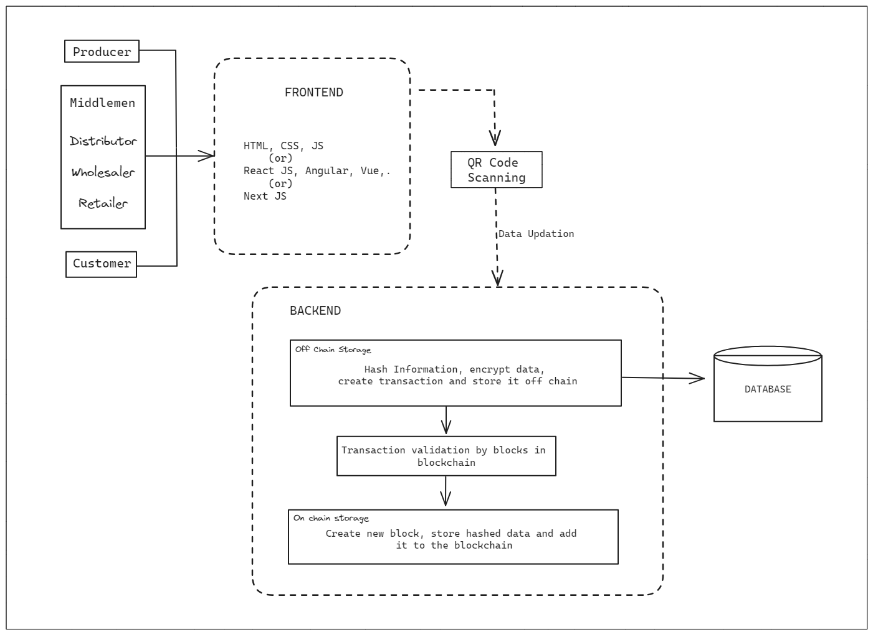

**Figure 1: Architecture diagram of flow of data through the application and business logic layers.**

1. **MODULE DESCRIPTION**
2. ***Traceability Module Begin Phase:***

* System Setup: The traceability module is initialized with a comprehensive setup that includes the integration of IoT devices and blockchain technology.
* Stakeholder Registration: All stakeholders, including farmers, processors, distributors, and retailers, are registered on the blockchain network, ensuring that each entity is authenticated and authorized to participate in the product’s journey.
* Product Registration: Each product or batch is registered with a unique digital identifier that can be a QR code, RFID tag, or barcode. This identifier holds product information such as origin, batch number, and date of processing.

1. ***Detection of the Product Transfer Stage:***

* Stage Identification: The system uses the digital identifiers to automatically detect the current stage of the product within the supply chain.
* Real-Time Monitoring: IoT devices scan the identifiers at various checkpoints to track the movement and condition of the product, updating the blockchain with real-time data.
* Data Synchronization: The collected data from IoT devices is synchronized across the blockchain network, ensuring that all stakeholders have access to the same information.

1. ***Updating the Fund Information Based on Government Policies:***

* Policy Integration: Government policies related to agricultural subsidies, grants, and financial support are encoded into smart contracts on the blockchain.
* Transaction Execution: As the product moves through each stage, the smart contracts automatically execute transactions that update the flow of funds in accordance with the encoded policies.
* Audit Trail: The blockchain provides a complete audit trail of all financial transactions, which can be used for compliance checks and financial reporting.

**VII. PERFORMANCE ANALYSIS**

| **Aspect** | **Without IoT (Blockchain only)** | **With IoT (QR codes + Blockchain)** |
| --- | --- | --- |
| **Data Accuracy and Integrity** | Relies on manual input or system integration, prone to human error or manipulation before blockchain entry. | Real-time data capture and entry through IoT devices (QR codes), significantly reducing manual errors and tampering. |
| **Transaction Speed** | Transactions may take longer due to manual processes for data entry and validation. | Faster transaction processing as data is automatically captured and recorded, reducing processing time. |
| **Cost Efficiency** | Lower initial investment; ongoing operational costs may be higher due to manual processes and potential errors. | Higher upfront costs for device implementation and setup, but long-term cost savings through process streamlining and error reduction. |
| **Scalability** | May face scalability challenges as manual processes become cumbersome with increased transaction volume. | Easier scalability due to automated processes handling higher transaction volume without significant manual intervention. |
| **Security** | Blockchain provides security, but vulnerability exists at data entry points without IoT. | Enhanced security through real-time data capture and secure entry into the blockchain, reducing the risk of tampering or unauthorized access. |

**Table 1: Performance Analysis**

**VIII. FUTURE ENHANCEMENTS AND CONCLUSION**

***Artificial Intelligence (AI) and Machine Learning:*** Implement AI and machine learning algorithms to detect patterns and anomalies in financial transactions.

***IoT and Sensor Integration:*** Expand the use of the Internet of Things (IoT) and sensor technology to monitor and record financial transactions and the movement of products in real-time.

***Mobile Payment Solutions:*** Promote the adoption of secure mobile payment solutions tailored to the agricultural sector.

***Data Analytics and Predictive Modeling:*** Utilize advanced data analytics and predictive modeling to identify potential areas of vulnerability to fund counterfeiting and fraud within the supply chain.

In conclusion, the abstract underscores the critical importance of addressing the issue of financial counterfeiting within the farm-to-fork value chain. It is clear that counterfeit funds, encompassing a range of fraudulent activities such as embezzlement, money laundering, and misappropriation of subsidies, have far-reaching and detrimental effects on the agricultural sector.

In sum, addressing financial counterfeiting is not merely an economic imperative; it is a crucial step towards upholding the financial integrity of the agricultural sector, encouraging sustainable farming practices, and ensuring the stability of the farm-to-fork value chain. Through proactive and cooperative measures, we can mitigate the risks associated with counterfeit funds and build a more resilient and financially secure agricultural ecosystem for the benefit of all stakeholders.

**XI. REFERENCES**

[1]. <https://ieeexplore.ieee.org/stamp/stamp.jsp?tp=&arnumber=9317793>

[2]. <https://www.ijisrt.com/assets/upload/files/IJISRT20APR1014.pdf>

[3]. <https://icmai.in/upload/Institute/Journal/TMA_May_2023.pdf>

[4]. <https://www.mdpi.com/1234206>

[5]. <https://www.researchgate.net/publication/371003379_BLOCKCHAIN_BASED_TRUST_SYSTEM_FOR_COUNTERFEIT_PRODUCT_DETECTION>

[6]. <https://www.sciencedirect.com/science/article/pii/S2452414X22000498>

[7]. <https://ijariie.com/AdminUploadPdf/ECONOMICALLY_GROWTH_ON_FARMERS%E2%80%99_BY_USING_THE_SCHEME_OF_UZHAVAR_SANTHAIS_IN_MADURAI_DISTRICT_c_1167.pdf>

[8]. <https://www.sciencedirect.com/science/article/pii/S2352914822002623/pdfft?md5=f413826832fb25c28c6a08e02fa54363&pid=1-s2.0-S2352914822002623-main.pdf>

[9]. <https://ieeexplore.ieee.org/document/9402666?denied=>

[10]. <https://media-publications.bcg.com/Indian-Agribusiness.pdf>