**Impact of stone crusher Dust on leaves and Chlorophyll production in *Annona squamosa* and *Cassia siamea*.**

**S. Santhi, A.V.V.S Swamy, V. Subhashini and CH. Prasanna**

**Department of Environmental Sciences, Acharya Nagarjuna University,**

**Nagarjuna Nagar, Guntur, Andhra Pradesh, India.**

**Corresponding Author e mail id:-arzavvsswamy1962@gmail.com**

**Abstract**: Foliar surface of plant is continuously exposed to the surrounding atmosphere and is the main receptor of dust. Dust affects the photosynthesis, respiration, transpiration and allows the penetration of phytotoxic gaseous pollutants. The present exploration was undertaken to study the seasonal variation in dust deposition on leaves and its impact on chlorophyll content of two common tree species namely Annona squamosa and Cassia siamea. This research was conducted during May 2019 to April 2020, on both these plant species in the region of stone crusher area. Authors found that crusher dust had a significant effect on the photosynthetic pigments such as chlorophyll 'a', chlorophyll 'b' and total chlorophyll content. Maximum dust deposition occurred during winter followed by summer and rainy season in both plant species. The authors reported a significant negative correlation between dust load and chlorophyll content in all the three seasons. *Annona squamosa* showed more dust deposition rates in comparison to *Cassia siamea*. Thus, plants can be used in the abatement of dust pollution as they act as natural filters.

**Keywords**: Air pollution, crusher dust, Chlorophyll, Seasonal variation.

**INTRODUCTION:**

Dust is a general name for solid particles having diameters >500 µm but particles of 2.5 -10 µm in atmospheric are of great concern for health of local public (Borja-Aburto, et al., 1998; Beckett, et al.,1998). Windblown dust is a common feature of arid ecosystems as soils remain dry and serve as a major source of small particulate matter (Sharifi, et al., 1997). In addition, agricultural activities and fast moving traffic also generate high dust concentrations (Leys, et al., 1998; Manins, et al., 2001). A report has been revealed that approximately 30 million of tons of dust go into air all over the world

Green plants have always played an important role to determine the status of the environment. Many green plants act as an environmental indicator (Joshi et al., 1997). Kabir and Madugu (2010) found that dust pollution is an important factor near roads, quarries, cement works and other industrial areas. According to Shah et al. (2020), chronic exposure to cement dust induced novel damage in plant leaves, which affects the foliar surfaces of leaves. These undesirable effluents changed cellular morphology and modulated the biochemical constituent and pigment content of leaves, resulting in massive damage owing to the persistent presence of the pollutants. Chlorophyll measurement is an important tool to evaluate the effects of air pollutants on plants as it plays a major role in plant metabolism and any reduction in chlorophyll content directly affects the plant growth (Joshi and Swami, 2009).

**MATERIALS AND METHODS**:

Study Site: The current study was conducted in Martur City of Bapatla district ,Andhra Pradesh, , which is the service road beside the National highway Andhra Pradesh state, India. The most populated city of the state lies at 80.112042° N longitude and 16.001139° E latitude, is distributed around stone crusher separated by distance of approximately 1 km of the area.

**Sample collection**:

Leaves of Annona squamosa and Cassia siamea growing in study area at Martur were plucked carefully and kept in separate polythene bags for the study.

**Dust load accumulation:**

Ten leaves were taken from both tree species for the estimation of dust load and total leaf area. These leaf samples were washed in petridish containing 50 ml of distilled water with the help of brushes and forceps. The amount of dust was calculated by taking the initial and final weight of petridish in which the leaf samples were washed. Dust load was calculated by using this formula:

Dust content (mg/cm) = W 2-W1/A.

Where, W1 = weight of petridish without dust,

W2 = weight of petridish with dust,

A = Total area of leaf in cm2For the calculation of total leaf area,

**Extraction of Chlorophyll:**  Chlorophyll extraction was done as per method of Arnon (1949). One gram of finely cut fresh leaves was taken and ground with 20-40 ml of 80% acetone. It was then centrifuged at 5000-10000 rpm for 5minutes. The supernatant was transferred and the procedure was repeated till the residue becomes colourless. The absorbance of solution was red at 645 nm and 663 nm against the solvent (acetone) blank.

**Estimation of chlorophyll content:** The estimation of concentration of chlorophyll 'a', chlorophyll 'b' and total chlorophyll were done by using equations:

Chlorophyll 'a': 12.7(A663) – 2.69(A 645)

Chlorophyll 'b': 22.9(A 645) – 4.68(A663)

Total chlorophyll: 20.2 (A645) + 8.02 (A663).

**RESULTS AND DISCUSSION:** The monthly mean of dust concentration in study period may 2019 to April 2020 showed a wide range of concentrations. The minimum concentration of dust was recorded in June (0.6 mg/cm2) and the maximum was recorded in February 2023 (4.1mg/cm2) while the mean concentration of dust for the whole study period was (1.7975mg/cm2). The summer season showed moderate concentration of dust and rainy season showed the lowest concentrations while highest concentration of the dust were during winter season.

**Table 1:Dust Accumulation (mg/cm2) In leaves of *Annona squamosa***

|  |  |
| --- | --- |
| Month | Dust mg/cm2 |
| May-19 | 1.55 |
| June | 0.6 |
| July | 0.9 |
| August | 1.05 |
| September | 1.25 |
| October | 1.8 |
| November | 2.05 |
| December | 2.82 |
| Jan-20 | 3.15 |
| February | 4.1 |
| March | 0.8 |
| April | 1.5 |
| Mean | 1.7975±1.06527 |

**Fig.1: Seasonal variation of dust accumulation (mg/cm2) in *Annona squamosa***

**Table 2:** **Dust Accumulation (mg/cm2 ) on leaves**

**of *Annona squamosa* in Winter season**

|  |  |
| --- | --- |
| Month | Dust mg/cm2 |
| November | 2.05 |
| December | 2.82 |
| Jan-20 | 3.15 |
| February | 4.1 |
| Mean | 3.03±0.849274 |

**Fig 2: Seasonal variation of dust (mg/cm2) in**

***Annona squamosa***

**Table 3:** **Dust Accumulation (mg/cm2 ) In leaves**

**of *Annona squamosa* in summer season**

|  |  |
| --- | --- |
| Month | Dust mg/cm2 |
| March | 0.8 |
| April | 1.5 |
| May-19 | 1.55 |
| June | 0.6 |
| Mean | 1.1125±0.483692 |

**Fig.3: Seasonal variation of dust accumulation**

**(mg/cm2) in Annona squamosa**

**Table 4:** **Dust Accumulation (mg/cm2 ) In leaves**

**of *Annona squamosa* In rainy season**

|  |  |
| --- | --- |
| Month | Dust mg/cm2 |
| July | 0.9 |
| August | 1.05 |
| September | 1.25 |
| October | 1.8 |
| Mean | 1.25±0.3937 |

**Fig4: Seasonal variation accumulation**

**(mg/cm2) in *Annona* *squamosa.***

The dust concentration range between(0.32mg/cm2 to 2.05mg/cm2) the Mean concentration of whole study period was 0.761667 mg/cm2 .the seasonal variation in the concentration of dust are not significant the concentration of dust were considered as negligible as the recorded concentration were less than of standard deviation.

|  |  |
| --- | --- |
| Month | Dust mg/cm2 |
| May | 1.03 |
| June | 0.01 |
| July | 0.15 |
| August | 0.35 |
| September | 0.45 |
| October | 1.04 |
| November | 1.19 |
| December | 1.4 |
| Jan-20 | 2.05 |
| February | 0.32 |
| March | 0.45 |
| April | 0.7 |
| Mean | 0.761667±0.595587 |

**Table 5:** **Dust Accumulation (mg/cm2) In leaves of *Cassia siamea***

**Fig 5: Seasonal variation of dust accumulation (mg/cm2) in *Cassia siamea***

**Table 6:** **Dust Accumulation (mg/cm2) on leaves**

**of *Cassia siamea* in Winter season**

|  |  |
| --- | --- |
| Month | Dust mg/cm2 |
| November | 1.19 |
| December | 1.4 |
| Jan-20 | 2.05 |
| February | 0.32 |
| Mean | 1.24±0.714283 |

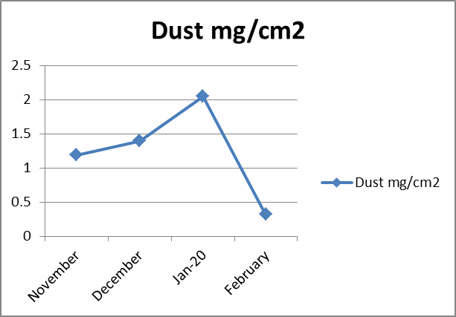

**Fig.6: Seasonal variation of dust accumulation**

**(mg/cm2) in *Cassia siamea* .**

**Table 7:** **Dust Accumulation (mg/cm2 ) on leaves**

**of *Cassia siamea* In summer season**

|  |  |
| --- | --- |
| Month | Dust mg/cm2 |
| March | 0.7 |
| April | 1.087755 |
| May | 1.03 |
| June | 0.01 |
| Mean | 0.706939±0.495029 |

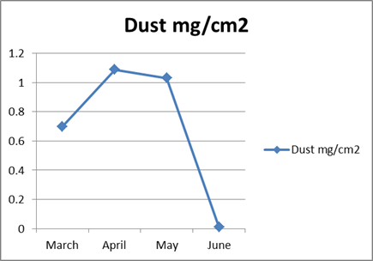

**Fig.7: Seasonal variation of dust accumulation**

**( mg/cm2) in *Cassia siamea***

**Table 8:** **Dust Accumulation (mg/cm2 ) on leaves of**

***Cassia siamea* In summer season**

|  |  |
| --- | --- |
| Month | Dust mg/cm2 |
| July | 0.15 |
| August | 0.35 |
| September | 0.45 |
| October | 1.04 |
| Mean | 0.4975±0.382568 |

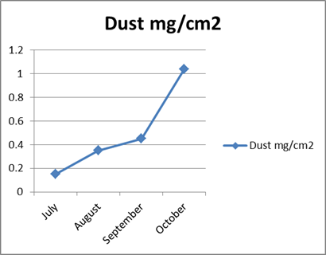

**Fig.8: Seasonal variation of dust accumulation**

**( mg/cm2) in *Cassia siamea***

***Annona Squamosa* total chlorophyll production**

The concentration of chlorophyll ‘a’ content for study period May 2019 to Apr 2020. A wide range of Chl ‘a’ content. The Minimum Chl ’a’ content recorded October 2021 (5.01 mg/g) and Maximum was recorded in September 2022 (6.09mg/g). While the Mean Content of chlorophyll ‘a’ recorded 5.3840 mg/g.

The Content of chlorophyll ‘b’ in the study period vary Minimum was recorded in October 2021 (3.01 mg/g) and Maximum recorded in September 2022 (3..092 mg/g). The Mean value 2.463 mg/g was recorded.

The total chlorophyll content Minimum was recorded in November (7.037 mg/g) and Maximum was recorded in July 2022 (11.130 mg/g). While the winter has low content. The Summer season showed Moderate content. While the highest chlorophyll in winter

**Table 9: Chlorophyll production(mg/g) in leaves of *Annona squamosa***

|  |  |  |  |
| --- | --- | --- | --- |
| Month | Chl a | Chl b | Total Chl mg/g |
| May-19 | 5.07 | 2.045 | 7.115 |
| June | 6.044 | 3.06 | 9.104 |
| July | 6.06 | 3.07 | 11.130 |
| August | 6.085 | 3.081 | 9.166 |
| September | 6.09 | 3.092 | 9.182 |
| October | 5.01 | 3.01 | 9.020 |
| November | 5.022 | 2.015 | 7.037 |
| December | 5.031 | 2.027 | 7.058 |
| Jan-20 | 5.045 | 2.035 | 7.08 |
| February | 5.047 | 2.037 | 7.084 |
| March | 5.050 | 2.041 | 7.091 |
| April | 5.055 | 2.043 | 7.098 |
| Mean | 5.384083±0.506757 | 2.463±0.529691 | 8.097083±1.36924 |

**Fig.9: Seasonal variation of chlorophyll 'a', 'b' and total chlorophyll (TC) content (mg/g)**

**in leaves of *Annona squamosa.***

**Table.10:The total chlorophyll content in leaves of *Annona squamosa* in winter season**

|  |  |  |  |
| --- | --- | --- | --- |
| Month | Chl a | Chl b | Total Chl mg/g |
| November | 5.022 | 2.015 | 7.037 |
| December | 5.031 | 2.027 | 7.058 |
| Jan20 | 5.045 | 2.035 | 7.08 |
| February | 5.047 | 2.037 | 7.084 |
| Mean | 5.03625±0.011871 | 2.0285±0.009983 | 7.06475±0.021747 |

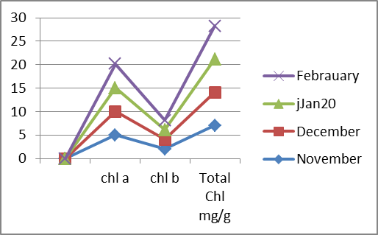

**Fig.10: Seasonal variation of chlorophyll 'a', 'b' and total chlorophyll (TC) content (mg/g) in leaves of *Annona squamosa***

**Table.11:The total chlorophyll content in leaves of *Annona squamosa* in summer season**

|  |  |  |  |
| --- | --- | --- | --- |
| Month | Chl a | Chl b | Total Chl mg/g |
| March | 5.050 | 2.041 | 7.091 |
| April | 5.055 | 2.043 | 7.098 |
| May-19 | 5.07 | 2.045 | 7.115 |
| June | 6.044 | 3.06 | 9.104 |
| Mean | 5.305 ±0.492907 | 2.29725±0.508503 | 7.602 ±1.001384 |

**Fig.11: Seasonal variation of chlorophyll 'a', 'b' and total chlorophyll (TC) content (mg/g) in leaves of *Annona squamosa.***

**Table.12:** **The total chlorophyll content in leaves of *Annona squamosa* in Rainy season**

|  |  |  |  |
| --- | --- | --- | --- |
| Month | Chl a | Chl b | Total Chl mg/g |
| July | 6.06 | 3.07 | 11.130 |
| August | 6.085 | 3.081 | 9.166 |
| September | 6.09 | 3.092 | 9.182 |
| October | 5.01 | 3.01 | 9.020 |
| Mean | 5.81125±0.534328 | 3.06325±0.036619 | 9.625 ±1.00631 |

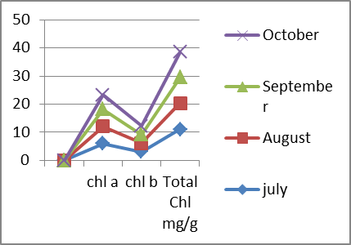

**Fig.12:Seasonal variation of chlorophyll 'a', 'b' and total chlorophyll (TC) content (mg/g) in leaves of *Annona squamosa***

Cassia siamea Total chlorophyll production:

The total content of Chlorophyll ’a’ the whole study period ranged between the1.01mg/g to 2.052 mg/g the monthly mean of chlorophyll ’a’ 1.4252mg/g .the concentration of chlorophyll ’a’ content during summer was moderate, the winter season showed lower content were higher in rainy season .

The chlorophyll ‘b’ content in the study period in two years showed a marginal range between 0.06mg/g to 0.175 mg/g. while the mean 0.1424 mg/g was recorded for the whole study period .

Whole the maximum total chlorophyll content recorded in (2.360 mg/g) in December , minimum recorded (1.23 mg/g) in April While the seasonal variation in the chlorophyll content low in winter season while moderate in summer and high chlorophyll content in rainy season was recorded.

**Table.13: Chlorophyll production (mg/g) In leaves of *Cassia siamea***

|  |  |  |  |
| --- | --- | --- | --- |
| Month | Chl a | Chl b | Total Chl mg/g |
| May-19 | 1.19 | 0.165 | 1.355 |
| June | 2.01 | 0.175 | 2.185 |
| July | 2.025 | 0.19 | 2.215 |
| August | 2.04 | 0.201 | 2.241 |
| September | 2.052 | 0.21 | 2.262 |
| October | 1.01 | 0.112 | 1.122 |
| November | 1.11 | 0.12 | 3.340 |
| December | 1.135 | 0.125 | 2.360 |
| Jan-20 | 1.12 | 0.145 | 1.265 |
| February | 1.125 | 0.151 | 1.276 |
| March | 1.116 | 0.055 | 1.171 |
| April | 1.17 | 0.060 | 1.23 |
| Mean | 1.42525±0.450039 | 0.142417±0.050525 | 1.835167±0.696601 |

**Fig.13: Seasonal variation of chlorophyll 'a' , 'b' and total chlorophyll (TC) content (mg/g) in leaves of *cassia siamea***

**Table.14:** **The total chlorophyll content in leaves of *Annona squamosa* in winter season**

|  |  |  |  |
| --- | --- | --- | --- |
| Month | Chl a | Chl b | Total Chl mg/g |
| November | 1.11 | 0.12 | 3.340 |
| December | 1.135 | 0.125 | 2.360 |
| Jan-22 | 1.12 | 0.145 | 1.265 |
| February | 1.125 | 0.151 | 1.276 |
| Mean | 1.1225±0.010408 | 0.13525±0.015064 | 2.060 ±0.995838 |

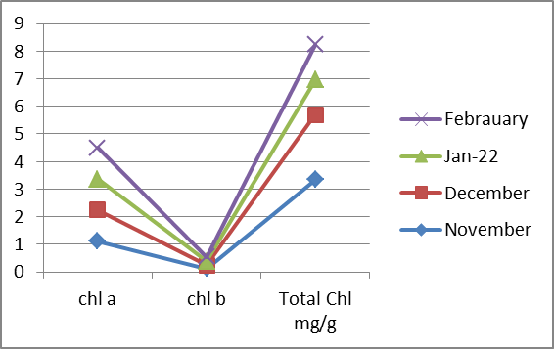

**Fig.14: Seasonal variation of chlorophyll 'a' , 'b' and total chlorophyll (TC) content (mg/g) in leaves of *cassia siamea.***

**Table.15:** **The total chlorophyll content in leaves of *cassia siamea*  in summer season**

Summer: total chlorophyll content suddenly increased in the month of June(2.185mg/g)

|  |  |  |  |
| --- | --- | --- | --- |
| Month | Chl a | Chl b | Total Chl mg/g |
| March | 1.116 | 0.055 | 1.171 |
| April | 1.17 | 0.060 | 1.23 |
| May | 1.19 | 0.165 | 1.355 |
| June | 2.01 | 0.175 | 2.185 |
| Mean | 1.3715±0.426813 | 0.11375±0.065112 | 1.48525±0.409427 |

**Fig.15: Seasonal variation of chlorophyll 'a' , 'b' and total chlorophyll (TC) content (mg/g) in leaves of *cassia siamea***

**Table.16:** **The total chlorophyll content in leaves of *Cassia siamea* in Rainy season**

|  |  |  |  |
| --- | --- | --- | --- |
| Month | Chl a | Chl b | Total Chl mg/g |
| July | 2.025 | 0.19 | 2.215 |
| August | 2.04 | 0.201 | 2.241 |
| September | 2.052 | 0.21 | 2.262 |
| October | 1.01 | 0.112 | 1.122 |
| Mean | 1.78175±0.514619 | 0.17825±0.044918 | 1.96±0.484106 |

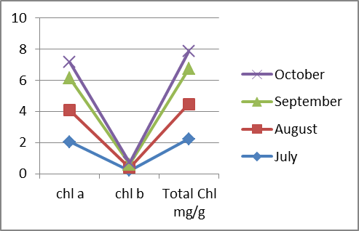

**Fig.16: Seasonal variation of chlorophyll 'a' , 'b' and total chlorophyll (TC) content (mg/g) in leaves of *cassia siamea***

Seasonal variation in the chlorophyll pigments i.e. chlorophyll 'a', chlorophyll 'b' and total chlorophyll in the leaves of *Annona squamosa* and *Cassia siamea* are presented in table 2 and table 3. The result showed that both the tree species exhibited maximum pigment contents during rainy season followed by summer and winter. Generally, in all plants chlorophyll 'a' is present in the higher quantity in comparison to chlorophyll 'b'.

The present study showed a clear cut change in the levels of total chlorophyll content in the trees exposed to atmospheric dust fall. In both tree species, chlorophyll 'a', chlorophyll 'b' and total chlorophyll in all the seasons. Higher concentration of chlorophyll pigments was found in Annona squamosa (7.602 mg/g) and lower in cassia siamea (1.835167 mg/g) during rainy season.

The Pearson correlation coefficient (r) values of dust deposit with total chlorophyll content in study area. It shows significant negative correlations between dust load and pigment content i.e. –1.36924 at study area for Annona squamosa. Similarly –0.696601 at study area.for Cassia siamea. Almost similar finding was obtained by some researchers who concluded that pollution by the stone crusher dust has caused adverse effects on the photosynthetic pigments, the pH of cell sap and soluble sugars (Abdel-Rahman and Ibrahim, 2012).

Foliar surface of plant is continuously exposed to the surrounding atmosphere and is therefore the main receptor of dust (Rai and Panda, 2014). Leaves act as pollution receptors and decrease the dust load of the air. A large number of trees and shrubs have been identified and leaf traits can be used as dust filter to check the rising urban dust pollution (Lorenzini et al., 2006). The variation in dust deposition in different season is well known and plant with short height presented more dust load than taller plants. Higher dust accumulation on Annona squamosa leaves may be due to their rough foliar surfaces with depression in the middle of the leaves; small petioles that reduce movement of leaves in wind and shortness of the plants also must be taken into account. This tree is well known for its medicinal properties (Arya, 2019). Lower dust accumulation on Cassia siamea may be due to medium height of the plants. The influence of plant height and leaf characteristics on dust accumulation have also been observed by Vora and Bhatnagar (1986), Somashekar et al. (1999), Singh (2000) and Singh et al. (2002). Maximum dust load was noticed in winter season (due to wet surface of leaves that help in dust capturing, preventing particulate dispersion) followed by summer and lowest in rainy season (due to washing of leaves). Dust deposition on leaf surfaces may also reduce the synthesis of chlorophyll 'a' due to a shading effect and photosynthesis (Singh et al., 2002). The decrease of chlorophyll contents occurs in winter season (due to maximum dust accumulation on leaf surface and its interference with incident light intensity leading to reduction in net photosynthesis) while highest chlorophyll content occur in rainy season (due to least dust accumulation). Dust accumulation in different plant species not only depends upon the sources and amount of pollutants in the environment but also depends on morphological characters of plants like leaf size, texture, hair, length of petiole, weather condition and wind direction (Prajapati and Tripathi, 2006). Thus, it can be concluded that cement industry is one of the highly pollution causing industries and exerts adverse effect on atmosphere, plants, animal as well as human beings.

REFERENCES

1. Abdel-Rahman Amal M. and Ibrahim M.M. (2012). Effect of cement dust deposition on physiological behaviours of some halophytes in the salt marshes of Red Sea. Egyptian Academic Journal of Biological Sciences, H. Botany. 3(1):1-11.10.21608/EAJBSH. 2012. 17001

2. Beckett, K.P., Freer-Smith, P. H., & Taylor, G. (1998). Urban woodlands: Their role in reducing the effects of particulate pollution. Environ. Pollut.99, 347–360. 4. Beckett, K.P., Freer-Smith, P. H., & Taylor, G. (2000). Particulate pollution capture by urban trees: Effect of species and windspeed. Glob. Change Biol. 6, 995–1003.

3. Borja-Aburto, V.H., Castillejos, M., Gold, D. R., Bierzwinski, S., & Loomis, D. (1998). Mortality and ambient fine particles in southwest Mexico city, 1993–1995. Environ. Health Perspect. 106, 849–855.

4. Sharifi, M. R., Gibson, A.C., & Rundel, P.W. (1997). Surface dust impacts on gas exchange in Mojave Desert shrubs, Journal of Applied Ecology, 34, 837–846.

5. Leys, J.F., Larney, F. J., Muller, J. F., Raupach, M. R., McTainsh, G. H., & Lynch, A. W. (1998). Anthropogenic dust and endosulfan emissions on a cotton farm in northern New South Wales, Australia. Sci. Total Environ. 220, 55–70.

6. Manins, P., Allan, R., Beer, T., Fraser, P., Holper, P., Suppiah, R., & Walsh, K. (2001). Atmosphere. Australia State of the Environment Rep. 2001 (Theme Rep.). CSIRO Publ., Melbourne.

7. Joshi P. and Swami A. (2009). Air pollution induced changes in the photosynthetic pigments of selected plant species. J. Environ. Biol. 30: 295-298.

8. Joshi O. P., Wagela D. K. and Pawar K. (1997). Urban air pollution effect on two species of cassia. Poll .Res.16. (1):1-3.

9. Kabir G. and Madugu A. I. (2010). Assessment of environmental impact on air quality by cement industry and mitigating measures: a case study. Env. Monit. Assess. 160: 91-99.10.1007/s10661-008-0660-4.

10. Khan A. M., Pandey V., Yunus M. and Ahmad K. J. (1989). Plants as dust scavengers: A case study. The Indian Foresters.115(9):670-672.

11.Lorenzini G., Grassi C., Nali C., Petiti A., Loppy S. and Tognotti L. (2006). Leaves of Pittosporum tobira as indicators of air borne trace element and PM 10 distribution in central Italy. Atmospheric Environment. 40(22): 4025-4036. 10.1016/ j.atmosenv. 2006.03.032

12. Nirbhay S. P. (2017). Adverse effect of air pollutants on the chlorophyll content in leaves from Pune, Maharashtra (India). Int. J. Pharm. Sci. Rev. Res. 44 (2): 131-135.

13. Prajapati S. K. and Tripathi B. D. (2008). Seasonal variation of leaf dust accumulation and pigment content in plant species exposed to urban particulates pollution. Journal of Environmental Quality.37:865-870.

14. Rai P. K. and Panda L. L. S. (2014). Leaf dust deposition and its impact on biological aspect of some roadside plants of Aizawl, Mizoram, North East India. Int. Research Journal of Environmental Sciences. 3(11):14-19.

15. Shah K., An N., Ma W., Ara G., Ali K., Kamanova S., Zuo X., Han M., Ren X. and Xing L. (2020). Chronic cement dust load induce novel damages in foliage and buds of Malus domestica. Scientific Reports. 10:12186.https://doi.org/10.1038/s41598- 020-68902-6

16. Singh R. B. (2000). Monitoring of dust pollution by higher groups of plants around dust polluted habitats in Sonebhadra, UP. Ind. J. Env. & Ecoplan. 3(1):163-166.

17. Singh R. B., Das U.S., Prasad B. B. and Jha S. (2002). Monitoring of dust pollution by leaves. Poll. Res. 21(1):13-16.

18. Somashekar R.K., Kumar R. R. and Ramesh A. M. (1999). Impact of granite mining on some plant species around quarries and crushers of Bangalore District. Pollution Research. 18(4):445-451.

19. Tajudeen Y. and Joy O. (2011). Variation in exposure to cement dust in relation to distance from Cement Company. Research Journal of Environmental Toxicology. 5(3): 203-212.

20. Verma A. K. and Prakash S. (2020). E-wastes and their impact on environment and public health. International Journal of Applied Research. 6(9):164-168.

21. Vora A. B. and Bhatnagar A. R. (1986). Comparative study of dust fall on the leaves in high pollution and low pollution areas of Ahmedabad. Pollution Research. 5:153-157.