A Test Rig Setup for Performance Evaluation of Power Transmission Elements

Mohamed F. Nasr, Karam Y. Maalawi, Khaled A. Yehia and Amr A. Elfeky

*Department of Mechanical Engineering, National Research Centre, Giza, Egypt*

*Corresponding Author: Mohamed F. Nasr*

E.mail: [mf_nasr@yahoo.com](mailto:mf_nasr@yahoo.com)

*ABSTRACT: Power transmission elements are machine elements like gears, shafts, clutches, brakes, pulleys, belts, chain and sprocket, which are used to transmit power from one place to another. This paper presents a design and manufacturing of a test rig for measuring the parameters that can affect the performance of power transmission elements. A T-Slot base plate has been designed and manufactured to be used in the test rig. A Planetary gearbox has been chosen as a prototype model for power transmission elements; it was designed and manufactured for small industrial applications with gear ratio 4.5 and input speed of 1500 rpm. Also a base for carrying the test rig units was designed and manufactured. An electrical control unit has been* *assembled and fastened to control the speed of the electrical motor. An experimental work has been implemented for testing the performance of the gearbox with different input speeds*

***KEY WORDS:*** *Power transmission elements – Planetary gearbox – Design – Manufacturing – Test rig*

---------------------------------------------------------------------------------------------------------------------------------------

Date of Submission: xx-xx-xxxx Date of acceptance: xx-xx-xxxx

---------------------------------------------------------------------------------------------------------------------------------------

# INTRODUCTION

Power transmission elements test rig is such arrangement which achieve the inspection and performance evaluation of power transmission elements so easy that it can be performed within few minutes. Simultaneously it saves the labor time and cost associated. Transmission Test rigs are designed for different types of transmission testing and manufacturing standard tests. The whole transmission testing system controls and measures all kinds of transmission parameters such as Rotating Speed, Torque, Power, Efficiency, Noise, Vibration and Temperature [1, 2].

Test Rig comprises Dynamometer, Computerized Control Panel with Data acquisition, to monitor Input Electric Power and Output Mechanical Power, with Efficiency measurement.

Gearbox is an important element in many mechanical systems such as automobiles, cranes and machinery. Now a day’s gearbox is used almost everywhere. Basic function of gearbox is to increase or decrease the torque effectively as per requirement. The main function of automobile gearbox is to transmit the torque and motion between prime mover and driven pieces of automobile at acceptable level of noise, vibration and temperature [3]

Planetary gear train is a form of gearbox structures. It consists of four elements: sun gear, planet gears, ring gear and arm (planet carrier) as shown in Figure 1. Sun gear is located at the center and transmits torque to planet gears orbiting around the sun gear. The planet gears are mounted on an arm or carrier (inside the ring gear) that fixes the planets in an orbit relative to each other [4, 5]. Planetary gears are found in many variations and arrangements in order to meet a broad range of speed ratios in the design requirements. Different configurations can be easily obtained by re-arranging input member, outer member and stationary member.

Planetary gearboxes have a wide application in various mechanical systems, such as industrial drives, rotorcraft, automobiles, wind turbines, etc., where they can offer compact dimensions, less noise and higher torque-to-weight ratios, especially compared to standard parallel axis gear trains [6, 7, 8].



**Figure 1: Planetary Gear train**

Yixuan Hou et al [9] designed a test rig to measure the TE of automobile gearbox, which is based on electrically closed method, the detailed structure and working principle of the test rig is introduced. A multi-function test rig was designed to facilitate experimental studies for journal bearing boundary lubrication behavior improvement, Nour Marey et al [10] have designed and manufactured a test rig components, it consisted of drive motor, drive shaft, bearing assembly, foundation, automatic control and data acquisition system. S.B. Nandeppagoudar, et al [11] designed a 3 stage planetary gearbox suitable for machine tool application. Bansidhar Gouda et al [12] designed and fabricated a test setup for measuring frictional torque, film formation, vibrations, and temperature rise in ball bearings. Sayali Shinde et al [13] developed a transmission test bench, design and development of Gearbox tester is carried out for measuring the torque and rpm of the gearbox in different conditions, the test rig is calibrated with theoretical values, synchromesh, driving and dragging tests are carried out. S.S.Khodwe et al [3] presented the design of a test bench for gearbox to test a gearbox at the end of assembly line to check leakage, noise, gear shifting feeling and shift load in driving and dragging condition, this includes design of fixture for gearbox, clamping arrangement, gear shifting arrangement, design of oil dispensing, extraction and filtration unit, also the FEA of fixture components has been carried out

# MATERIAL AND METHODS

This study is directed to choose one type of means of power transmission, such as gearboxes, serving in different ranges for commercial applications. This aims to develop industrial technological knowledge in the field of gearbox manufacturing. A Planetary gearbox has been chosen as a prototype model for power transmission elements

* 1. ***Planetary Gearbox***

A Planetary gearbox has been designed and manufactured for small industrial applications with gear ratio 4.5 and input speed of 1500 rpm. The basic equations and formula that determine the different parameters of the gear geometry are used. The housing of the gearbox has been designed and manufactured and the gearbox components have been assembled with the gearbox as shown in Figure 2.

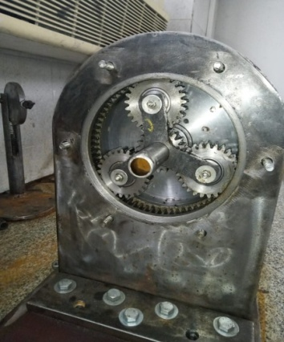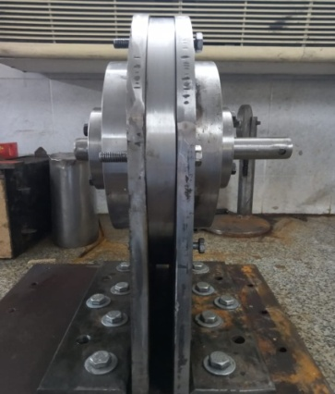

**Figure 2: Planetary gearbox**

* 1. ***T-Slot base plate***

A T-Slot base plate has been designed and manufactured using grey cast iron to be used in the gearbox test rig

The detailed dimensions of the T-Slot plate and the photos after manufacturing are shown in Figures (3 and 4)

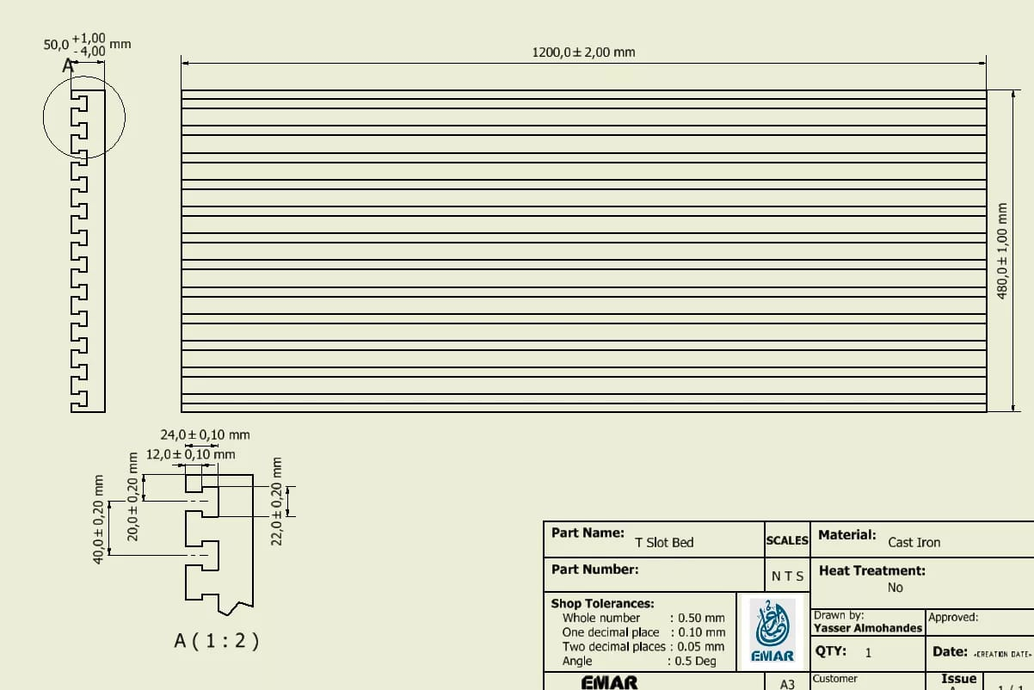

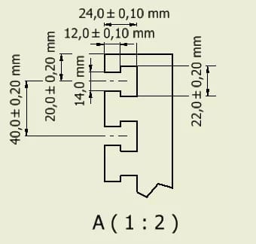

**Figure 3: T-Slot base plate schematic drawing**

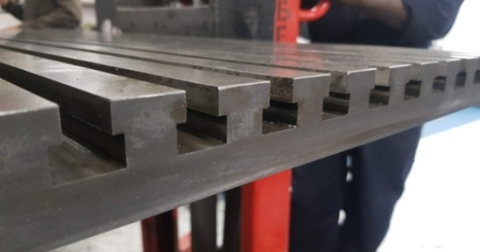

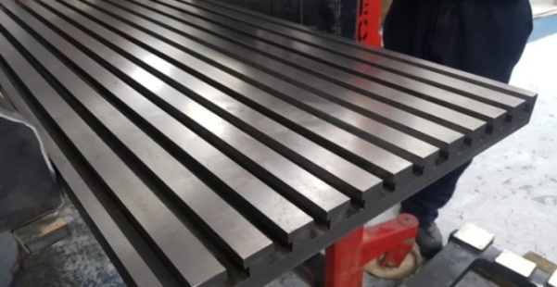

**Figure 4: Manufactured T-Slot base plate**

The design of the T-Slot base plate has been done carefully to permit fastening adequate number of instruments required for achieving the testing of different parameters during operation of power transmission elements.

The T-Slot plate has been tested for any bubbles or cracks inside the material after manufacturing

Also a steel base for carrying the T-Slot base plate has been designed and manufactured.

* 1. ***Electrical control unit***

An electrical control unit has been assembled and fastened to control the operation of the drive motor and varies its speed using inverter as illustrated in Figure 5. An electrical motor of 5 KW has been used as the driving source in the test rig.

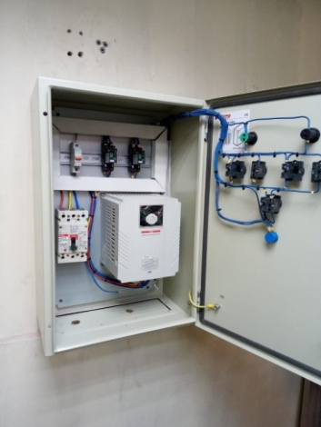

**Figure 5: Control unit**

# RESULTS AND DISCUSSIONS

The T-Slot base plate has been improved carefully for balancing through fastening on the base so it has accurate horizontal and flat surface.

The planetary gearbox has been assembled and tested for any leakage by filling it with lubricant oil for more than one time to check it for any leakage and it was proof that the gearbox is completely accurate and has no leakage.

The electrical motor has been fastened on its base and fastened on the T-slot base plate, and then it has been connected to the electrical control unit then checked for working by applying different speed from the control unit then checked with a Tachometer

The gearbox has been connected to the electrical motor with a coupling, the alignment of the two shafts of motor and gearbox has been checked with a dial indicator as shown in Figure 6. The gearbox has been tested for rotating with variable speeds using tachometer. Experimental work has done to check the work of the gearbox and gear ratio

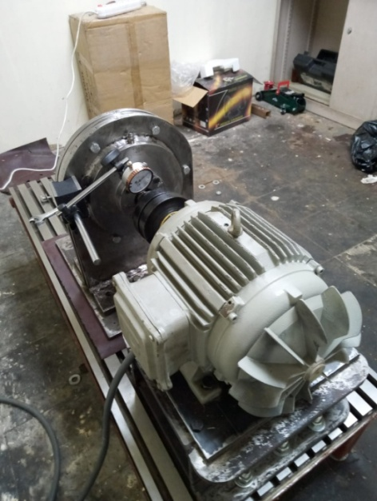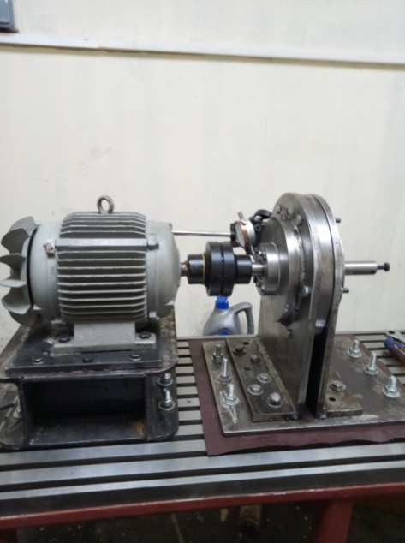

**Figure 6: Alignment of connecting shafts of planetary gearbox**

The following Figure 7 illustrates the power transmission elements test rig after constructing

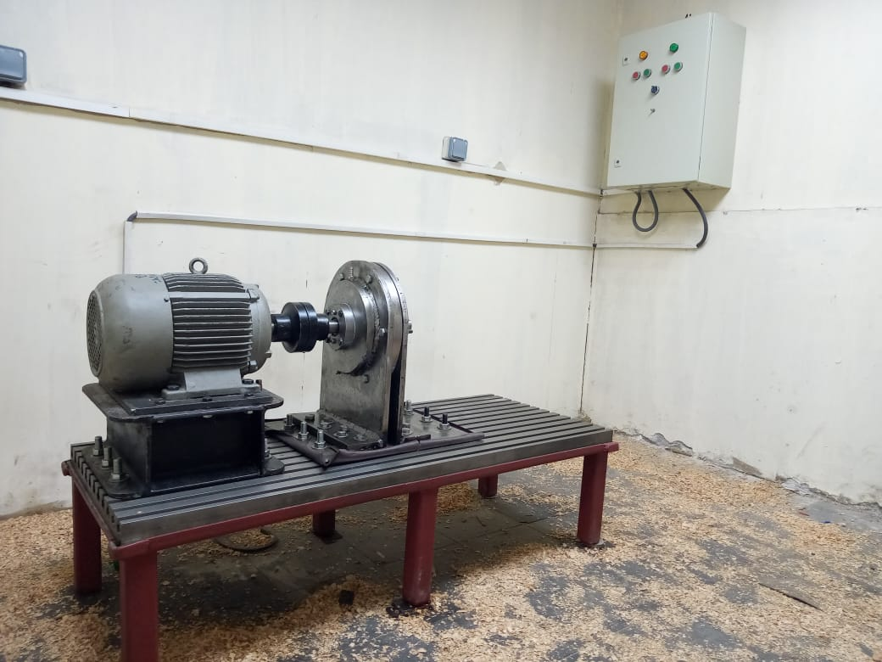

**Figure 7: Power transmission elements test rig**

The test rig is ready for testing power transmission elements for required performance parameters

# CONCLUSIONS AND RECOMMENDATIONS

A Planetary gearbox has been designed and manufactured for small industrial applications with gear ratio 4.5 and input speed of 1500 rpm. The basic equations and formula that determine the different parameters of the gear geometry are used.A T-Slot base plate has been designed and manufactured using grey cast iron to be used in the test rig for the gearboxes**.** An electrical control unit has been assembled and fastened to control the operation of the drive motor and varies its speed. The gearbox has been connected to the electrical motor with a coupling upon text rig T-slot plate

**REFERENCES**

1. Yaguo Lei , Jing Lin , Zhengjia He and Detong Kong, (2.012), "A Method Based on Multi-Sensor Data Fusion for Fault Detection of Planetary Gearboxes", Sensors.

# Zhiliang Liu a,b,n, MingJ.Zuo a,c, YaqiangJin a, DengPan a, YongQin, (2017), "Improved local mean decomposition for modulation information mining and its application to machinery fault diagnosis", Journal of Sound and Vibration, 397, 266–281.

1. S.S.Khodwe1and S.S. Prabhune, (2015), "Design and Analysis of Gear Box Test Bench to Test Shift Performance and Leakage", IJARIIE-ISSN(O)-2395-4396, Vol-1 Issue-2.
2. Hüseyin Filiza, S. Olgunera, and E. Evyapanb, (2017), "A Study on Optimization of Planetary Gear Trains", Special issue of the 3rd International Conference on Computational and Experimental Science and Engineering, Vol. 132.
3. Stephen P. Radzevich, (2012), " Practical Gear Design and Manufacture", Second Edition, Stephen P. Radzevich, Taylor & Francis Group.
4. Milos Sedak, and Bozidar Rosi, (2021), "Multi-Objective Optimization of Planetary Gearbox with Adaptive Hybrid Particle Swarm Differential Evolution Algorithm", Appl. Sci.
5. Martin Jonsson, (2020), "Planetary Gear Analysis–deformation induced misalignment and optimization", Master of Science Thesis, Stockholm.
6. G Pardhiv and P Srinivas, (2019), "Material Selection for Optimum Design of Planetary Gear Train used in Automobile Gear Box", International Journal for Modern Trends in Science and Technology, ISSN: 2455-3778, Volume 5.
7. Yixuan Hou1, Xiaoqin Zhou1, Xiuzhi He1, Zufei Liu1 and Qiang Liu, (2008), "A New Design of the Test Rig to Measure the Transmission Error of Automobile Gearbox", IOP Conf. Series: Materials Science and Engineering 280 (2017) 012008 doi:10.1088/1757-899X/280/1/0.
8. Nour Marey, El-Sayed Hegazy and Amman Ali, (2018), "Design and Setup for a Journal Bearing Universal Test Rig", PORT SAID ENGINEERING RESEARCH JOURNAL Faculty of Engineering - Port Said University Volume 22 No. 1, pp. 101:106.
9. S.B.Nandeppagoudar, S.N.Shaikh, S. R. Gote, S. P. More, A. S. Chaudhari, N. R. Borse, and S.H.Gawande, (2017), "Design and Numerical Analysis of Optimized Planetary Gear Box", Journal of Mechanical and Civil Engineering (IOSR-JMCE).
10. Bansidhar Gouda, N. Tandon, R. K. Pandey and C. K. Babu, (2023), "Design and development of a test rig for performance evaluation of ball bearings", AIP Conf. Proc. 3006, 020006.
11. Sayali Shinde1 and Sourabh Kulkarni, (2017), "Transmission Test Bench", International Journal of Computational Intelligence Research ISSN 0973-1873 Volume 13, Number 6, pp. 1557-1561.