Plotting Equation of State for Real Gas

S W Anwane and R S Anwane

Department of Physics, Shri Shivaji Education Society Amravati’s Science College, Congress Nagar, Nagpur 440012 (e-mail: [swanwane2000@yahoo.com](mailto:swanwane2000@yahoo.com), [www.physicsdegree.in](http://www.physicsdegree.in))

Abstract

Almost all text books deal with the Van der waals equation and is riddling in literature since 1870. This equation is widely appreciated. For beginners the difficulties in assimilation are appreciated and addressed for in-depth understanding. Graphical visualization along with analytical approach is used in a collective way.

Keywords

Real gas equation, cubics, equation of state, analytical solution, iteration etc.

## Introduction

The subject Kinetic Theory of Gases is popular in undergraduate Physics curriculum. Van der Waal’s equation of state is well familiar. The present work attempts an approach to enhance assimilation.

## Van der Waals’ equation of state for real gas

Van der Waals’ equation is

$\left(P+\frac{a}{V^{2}}\right)\left(V-b\right)=RT$………..(1)

where *P* is the pressure, *V* is the volume, *T* is the absolute temperature, *R* is the gas constant, and *a* and *b* are constants that depend upon the gas.

In the usual situation *a* and *b* are known and can be found in tables. One must watch the units used though. Usually *a* is in liter2 atm mole−2. Similarly *b* is most often in liter mole−2. Thus it is usually convenient to work in liter-atm and to take *R*=0. 0820578 liter-atm/mole-kelvin.

In a problem, if the volume and temperature were known and the pressure were needed, we simply use (1) in form

$P=\frac{RT}{\left(V-b\right)}-\frac{a}{V^{2}}$………………*.* (2)

Or if the pressure and volume were known and the temperature were needed:

$T=\frac{1}{R}\left(P+\frac{a}{V^{2}}\right)\left(V-b\right)$………..(3)

The issue turns really troublesome when pressure and temperature are known and the volume is required to be found. A look at equation (1) shows that *V* occurs in two different places. It is not *linear* in *V*. A closer look reveals it to be cubic in *V*.

Solving cubics is not as simple as solving quadratics. There is a "cubic formula", but it is quite messy and takes a large amount of work. (See Appendix A for readily understanding cubic messy behavior.)

Van der Waals’ equation for the volume is a cubic and cubics may have three roots. If exists, one is guaranteed to be real and hence meaningful; the other two can be either real or complex. We are not concerned with the imaginary root as it is of less physical meaning as leads to complex volume.

## Solving van der Waals’ Equation for the Volume − The General Problem

We can re-write equation (1)

$\left(P+\frac{a}{V^{2}}\right)\left(V-b\right)-RT=0$………..(4)

Now finding a value of *V* that fits with given values of *P* and *T* for a given gas is the problem of finding a *V* that makes the left-hand side of equation (4) equal zero. In a more standard mathematical notation we can call the right-hand side of equation (4) *f* (*V*). Then what we want is to find a *V* such that

$f(V)=0$……………………..*.* (5)

This sort of problem is well-known in mathematics. It is the problem of finding a *root* of equation (5). In the general case *f* (*V*) could be any function. In some few of these cases (linear equations, quadratic equations) an analytic solution can be obtained easily. In others (cubics, quartics), analytic solutions are known, but they are often too messy to use. And in most cases, *there is no analytic solution at all*. Appendix A presents three roots. In turn it depicted to show how messy it is!

Here a mathematical modeling tool Maple 14 is used to deal with the problem to support our analytical approach that can get a meaningful insight and assimilate the Van der waals equation.

Let us consider following substitutions to re-form Van der waals equation;

$P=y,$

$\frac{V}{b}=x,$

……………………(6)

$$\frac{RT}{b}=t,$$

$$\frac{a}{b^{2}}=w$$

This will simplify the form of equation;

$$y=\frac{t}{x-1}-\frac{w}{x^{2}}……………(7)$$

Above equation (7) can be solved in form (5) to obtain three roots. The family of equations and corresponding curves depends upon parameters *t* and *w*. These in turn play a vital role in deciding roots like; real OR complex. These two parameters depend upon temperature and constants for gas species respectively. Here follows Table 1 that depicts arbitrary choices that yield interesting results. Effect of parameter *t* and *w* on roots and trend of reduced variables *x* and *y* are presented in Fig.1.

## Table 1

|  |  |  |  |  |
| --- | --- | --- | --- | --- |
| Sr  No | *t* | *w* | Type | Roots |
| 1 | 1.0000 | 1.0000 | 2 Complex | $$(1±i\sqrt{3})/2$$ |
| 2 | 0.5000 | 0.5000 | 2 Complex | $$0.5±i 0.866$$ |
| 3 | 0.1250 | 0.1250 | 2 Complex | $$0.5±i 0.866$$ |
| 4 | 0.0100 | 0.0005 | 2 Complex | $$0.025±i 0.2222$$ |
| 5 | 0.0005 | 0.0005 | 2 Complex | $$0.5±i 0.866$$ |
| 6 | 1.0000 | 5.0000 | 2 Real | $$(5±\sqrt{5})/2$$ |
| 7 | 1.0000 | 7.5000 | 2 Real | $$6.311, 1.188$$ |
| 8 | 1.0000 | 10.0000 | 2 Real |  |

|  |  |
| --- | --- |
|  |  |
|  |  |
|  |  |
|  |  |

**Fig1.: Plot of eq (7) for a variety of *t* and *w* parameters**

### Case 1

Let us analyze last equation (7) and its 1st, 2nd order differentiation in a graphical (visual) way for arbitrary constants, say $t=w=1$.



**Fig.2 : A Plot of Function $y=f\left(x\right)=\frac{1}{x-1}-\frac{1}{x^{2}}$, its derivatives 1st and 2nd order**

This form has two complex roots $x=\frac{1±\sqrt{-3}}{2}$ and is asymptotic to x-axis. This solution has no physical significance in reference to finding volume of the gas that we really intend to do. Its 1st and 2nd order derivatives are also present in the Fig.2. Appendix 2 deals with a cubic function that has a maxima and minima analytically found and graphically visualized.

The literature has dealt with approach of iteration methods (*numerical approximation*) like Newton’s [1,2] and is capable of practically estimating *V*. Arbitrary starting proposed is required to be proposed in Newton-Rapson’s method. Here, one can use ideal gas expression to obtain first guess instead of random choice. More closer point to the root can be found using equation (8).

$V_{i+1}=V_{i}-\frac{f(V)}{f^{'}(V)}$………………………………(8)

A couple of such steps help one reaching root or at-least fairly closer to the root that can solve a practical purpose.

## Inflation Point in van der Waals’ Equation

Van der Waals’ equation (7) being cubic it turns complicated as we seek roots. Some mathematical modeling packages facilitates in generating roots but yet redundant-not practical for use.

Now we shall look for inflation point arriving in plot of equation (7) that probably readers might have overlooked in Fig.1. At inflation, 1st and 2nd order derivative of equation (7) should vanish out. Let us search such point analytically and then try locating it.

$$y=\frac{t}{x-1}-\frac{w}{x^{2}}$$

Finding 1st and 2nd order derivative and equating it to zero as we are working out equations at a point of inflation we get;

$\frac{dy}{dx}=0 \underset{→}{yields} \frac{t}{{(x-1)}^{2}}=\frac{2w}{x^{3}}$………………..(10)

$\frac{d^{2}y}{dx^{2}}=0 \underset{→}{yields} \frac{t}{{(x-1)}^{3}}=\frac{3w}{x^{4}}$………………..(11)



**Fig. 3: A plot of $y=\frac{1.5}{x-1}-\frac{5.05}{x^{2}}$**  **depicting inflation at** *x*=3**.**

Last two equations can be simultaneously processed to eliminate parameters *t* and *w* and finally find the x-value of point of inflation. A simple processing gives $x=3$.

Fig. 3 represents a plot showing an inflation point $x=3$ at preferred values of parameters t-1.5 and w=5.05. The inflation is irrespective of the parameters *t* and *w*. However a visualization effect is prominent for these preferred values. In rest cases it is present but visual effects seems to be masked. Reader must have noticed from the analytical approach of eliminating *t* and *w* yields the inflation point $x=3$. Hence it is independent of *t* and *w*.

One may press following command in Maple 14 to see the same graph and may play with various values of the parameters *t* and *w* to notice that inflation is independent of which was analytically noticed.



## Conclusion

Roots of equation and its type (real/complex) depend upon parameters *t* and *w* in reduced form of van der waals equation. However, inflation point is irrespective of these parameters. Using mathematical modeling tool Maple 14 has been used for equation manipulation and visualization.

## References

1. **Paul J. Gans** V25.0651 - Physical Chemistry I, September, 1993
2. **S W Anwane** Vol 25 No.9 - bulletin of *Indian Association of Physics Teachers* Nov 2008*.*
3. **Andre Heck 2nd** Edition Introduction to Maple 1996

## Acknowledgement

The author gratefully acknowledge **University Grants Commission**, New Delhi for financial assistance under Minor Research Project No.F.47-1233/09(WRO).

## Biography of Authors

**Dr S W Anwane** is working as Assistant Professor in Department of Physics at Shri Shivaji Education Society Amravati’s Science College, Congress Nagar, Nagpur. He obtained Ph D in Physics from Nagpur University in 2000 for thesis entitled *Development of silver sulphate based solid electrolytes from electrochemical gas sensor point of view****.*** He was recipient of Senior Research Fellowship twice by Council of Scientific and Industrial Research, New Delhi during his doctoral research. He has interest in Materials Science, Electromagnetic fields, Computer Programming and Simulation. He has published two books on national level and one on international level and a few research papers in the journals of national and international repute.

# Appendix 1

**> **













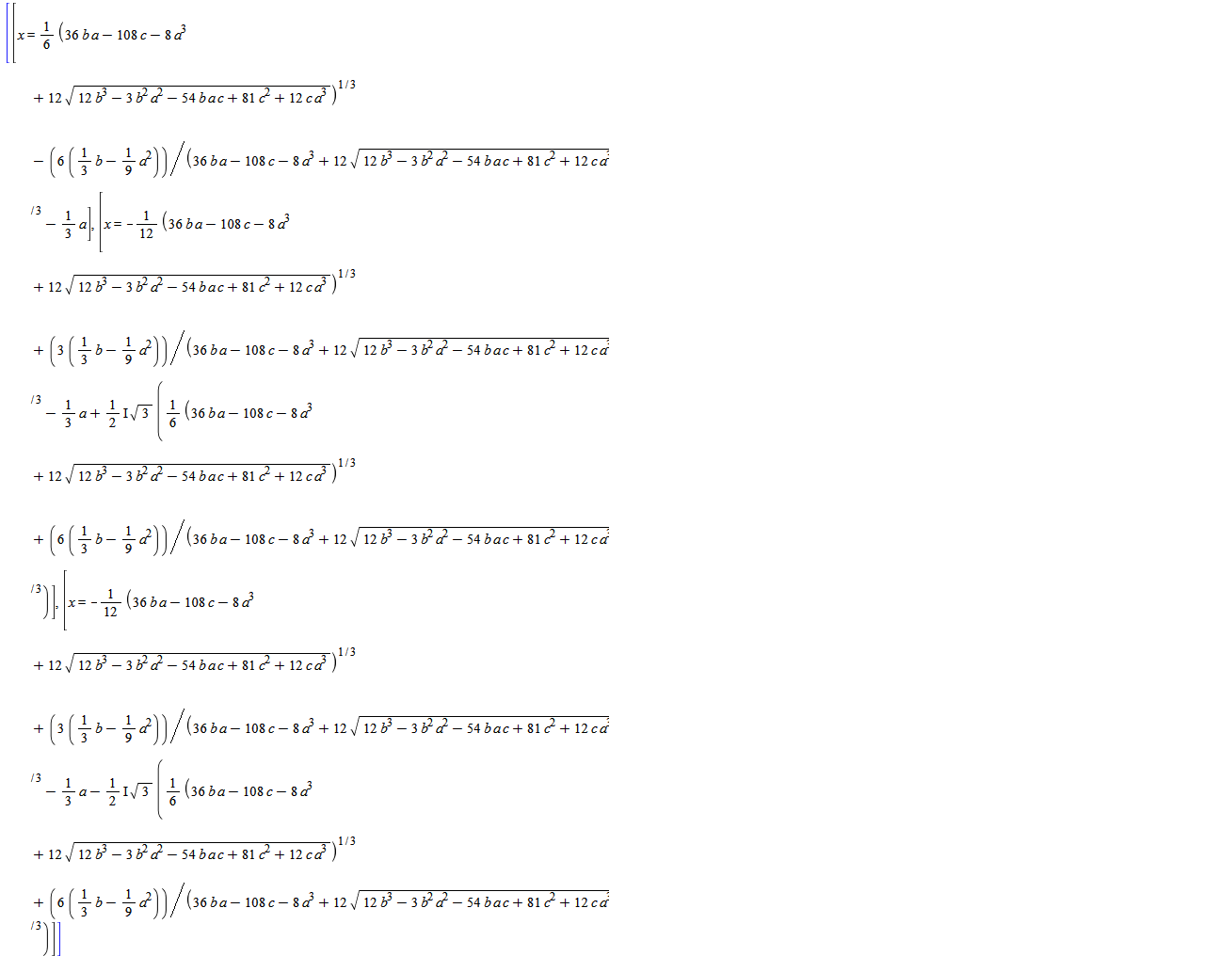

## Appendix 2

Here, we display a simple cubic function that one deals in preliminary mathematics. Along with its 1st and 2nd order derivative is also depicted. The 1st order derivative vanishes at maxima and minima  respectively. Its 2nd order derivative has negative value at maxima and positive at minima.

**> **



**> **



It posses three real roots that appears as; $x=-1,$ $x=\frac{-3±\sqrt{13}}{2}$. Numerical set that can be verified in the graph are; $(-1,-3.302,0.302)$.