**ROLE OF MECHANICAL ENGINEERING ASPECTS AND THEIR OVERVIEW**

Sachin Dhull1

1Assistant Professor, Maharaja Surajmal Institute of Technology

**Abstract:**

The role of mechanical engineering concepts in practical life is a vital one, without which basic manufacturing and working of worldly affairs is not possible. It includes automobile sector, thermal power plants for production of electricity of households and commercial purpose, building construction materials, etc. The hydro-power production and renewable energy sources also come under this category. In addition fluid flow characteristics, their rheological behaviour, heat and mass transfer as well as strength of materials, their characterization is also dealt with in detail.

**1. BASIC MANUFACTURING, MATERIAL STUDY AND INDUSTRIAL ASPECTS:**

First of all the basic knowledge of simple bravais lattice structure of materials is needed to understand the character and also miller indices study is essential for recognising planar and line lattices. The unit cell study includes simple cubic, body centred and face centred structure in which with the help of Avogadro concept and relation between unit cell side and radius of atom, the planar density is calculated.

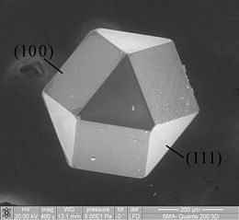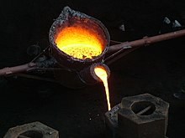

Fig.1. (a) A [diamond](https://en.wikipedia.org/wiki/Diamond) [cuboctahedron](https://en.wikipedia.org/wiki/Cuboctahedron" \o "Cuboctahedron) showing seven [crystallographic](https://en.wikipedia.org/wiki/Crystallographic) planes [1], (b) cast iron casting

The next step is to understand the imperfections i.e. point, line and surface. The iron carbon diagram includes peritectic, eutectic reactions and the TTT diagram is used to find composition by tie line method.

The basic manufacturing processes include casting, welding, forming, sheet metal operations and powder metallurgy. In addition, polymer manufacturing and advanced manufacturing processes like electron beam, electrolytic, electric discharge and ultrasonic machining are used in industries. The casting includes shell, investment, gravity die casting, centrifugal and various casting defects like misrun, cold shut, mould wash are encountered during the process.

**2. MECHANICS OF MATERIALS**:

In engineering mechanics, force is understood in detail which comprises of statics, dynamics in rectilinear, curvilinear, rotation and plane motion using concept of D Alembert principle. The applications of friction in wedge, vehicles motion is encountered and projectile motion. The conservation of momentum both linear and angular by lagrange equation and virtual work methods.

The strength of materials include basic stress tensor, bending, torsion, types of beams and shera force and bending moment diagrams and in addition slope and deflection curves. The principal stress and strains with the help of Mohr circle to finally utilize theories of failure. Various columns and struts work on Euler buckling load calculations. In machine design, various clutches, brakes, gears and variable fluctuation stresses in shafts by Goodman, Gerber and Soderberg criteria is found. Springs and bearings characteristics is found by sommerfield number.

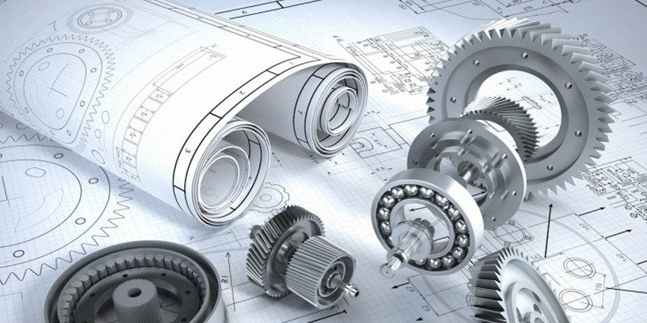

Fig.2. Special purpose machine design [2]

**3. FLUID MECHANICS AND MACHINES:**

The basic fluid properties which include Newton law of viscosity, pressure measurement, fluid kinematics by eulerian and lagrangian approach to find velocity potential and stream functions. The different instruments like pitot tube to fnd velocity and orifice and venturimeters to find discharge of flow of fluid. Different boundary layer phenomena play important role and darcy weisbach equation to find head loss due to friction in the pipe flows.

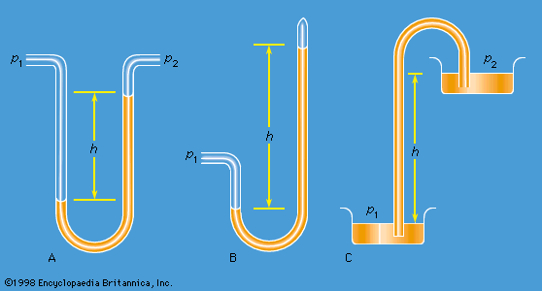

Fig.3. Piezomter and siphon tube [3]

The fluid machines is used to find impact of fluid jet, different turbine like impulse, Kaplan, recaton and propeller and in addition centrifugal and reciprocating pumps construction details and their velocity triangles.

**4. THERMAL, HEAT TRANSFER, REFRIGERATION, POWER PLANTS AND IC ENGINES:**

In thermal engineering, basic thermometers, types of processes viz reversible and irreversible, first law of thermodynamics i.e. conservation of heat and work, second law including Kelvin planck and clausius statements to find carnot efficiencies. Then entropy calculations and availability in closed and open systems is done and finally mixture of ideal gases and various thermodynamic relations are found.

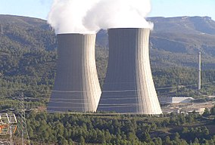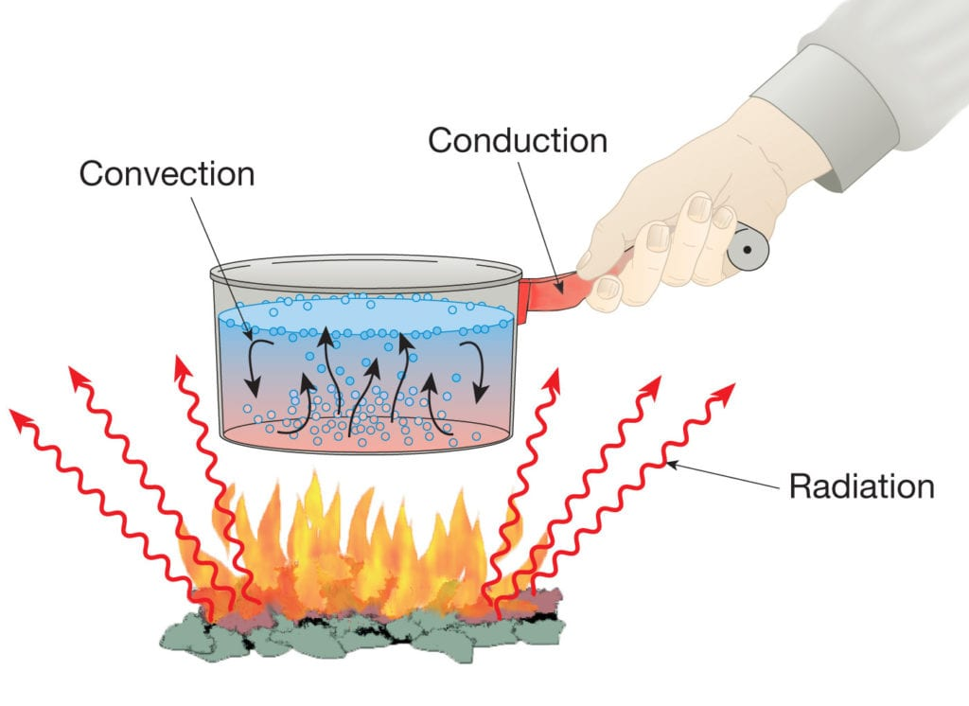

Fig.4 (a) Cooling tower at nuclear power plant [4], (b) heat transfer modes [5]

Table 1. Comparison of thermal processes:

|  |  |  |  |
| --- | --- | --- | --- |
| **Heat transfer** | **Power plants** | **IC Engines** | **Refrigeration and air conditioning** |
| Different modes of heat transfer are conduction, convection and radiation. In addition heat exchangers are used to find logarithmic mean temperature difference. | In power plants, rankine cycle, brayton cycle, steam turbines in vapour power cycles | Otto cycle, diesel cycle and dual cycle to find air standard efficiency is used. | Vapour compression cycles to find refrigeration effect and psychrometric relations are utilised in air conditioning. |

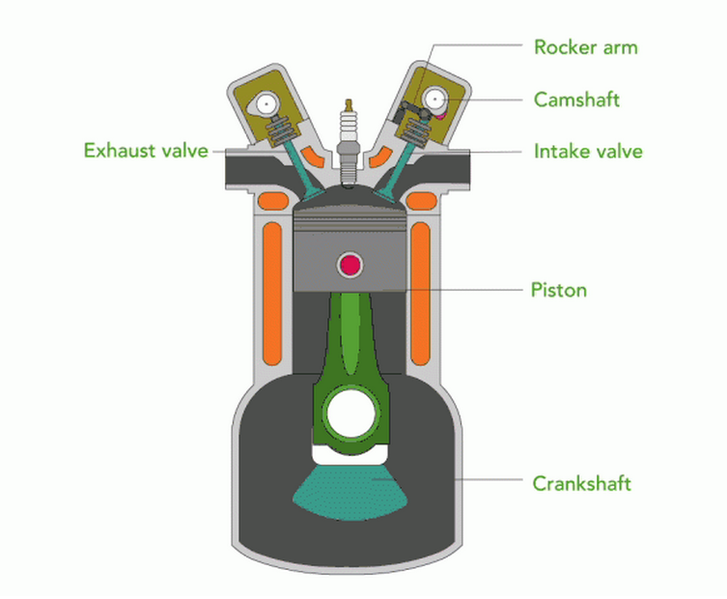

Fig.6. Internal combustion engine sectional details [6]

**5. CONCLUSION:**

It can be concluded that the effects of various mechanical and manufacturing processes is deep and everlasting in day to day life. The manufacturing processes like casting, welding and forming are primary requirements for product design and development. In order to study forces acting on components and parts, strength of materials, mechanics, design of machine components is done. For the heat and fluid flow aspects, thermal engineering is understood in detail.

**References:**

[1] <https://en.wikipedia.org/wiki/Materials_science>

[2] <https://www.nuclear-power.com/nuclear-engineering/materials-science/material-properties/strength/>

[3] <https://www.britannica.com/science/fluid-mechanics>

[4] <https://en.wikipedia.org/wiki/Power_plant_engineering>

[5] <https://www.simscale.com/docs/simwiki/heat-transfer-thermal-analysis/what-is-heat-transfer/>

[6] <https://www.energy.gov/eere/vehicles/articles/internal-combustion-engine-basics>