**“Enhancing the Implementation of Town Planning Schemes in Bangalore Metropolitan Region (BMR): Challenges, Strategies, and Policy Implications”**

**Sannappaiah H.V.** (Research Scholar)¹, **Prof. Dr. H. N. Nagendra** (Professor)¹,

**Dr. Goutham Konikar S. M.** (Faculty)¹, and **Ar. Kavyashree U. A.** (Faculty)²

***¹*** *Department of Urban and Regional Planning, School of Planning & Architecture, University of Mysore, Mysuru, Karnataka, India.****²*** *Department of Architecture, School of Planning & Architecture, University of Mysore, Mysuru, Karnataka, India.*

**Corresponding Author:** Sannappaiah H.V.

**Email:** [gouthamsmkonikar@gmail.com](mailto:gouthamsmkonikar@gmail.com)

**ABSTRACT**

*Urbanization has been a defining characteristic of the 21st century, with metropolitan regions experiencing rapid growth. According to the United Nations (2021), urban populations are expected to account for nearly 68% of the world’s population by 2050, necessitating strategic planning interventions. India’s urban population is projected to reach 40% by 2030 (MoHUA, 2020), creating challenges for governance, land management, and infrastructure provision.*

*Bangalore Metropolitan Region (BMR), as one of India’s fastest-growing urban areas, faces significant planning challenges due to unplanned expansion. While regulatory frameworks exist, the fragmented nature of governance and regulatory overlaps among multiple agencies often delay project execution. Town Planning Schemes (TPS) have emerged as an effective tool for structured urban growth, particularly in rapidly urbanizing areas. TPS enables planned urban development by integrating infrastructure provisioning with equitable land redistribution. However, despite its potential, the implementation of TPS in BMR has been hindered by institutional bottlenecks, legal complexities, landowner resistance, and financial constraints.*

*This paper examines the implementation of TPS in BMR, focusing on issues affecting its execution, strategic approaches for enhancement, and policy recommendations. The study draws from global and national urbanization trends, governance frameworks, and case studies of successful TPS implementation. The findings underscore the need for robust institutional coordination, legal clarity, financial sustainability, and community participation to ensure effective TPS implementation in BMR. The paper concludes with policy recommendations for integrating TPS into metropolitan planning to promote sustainable urban development.*

**Keywords:** Town Planning Schemes (TPS), Bangalore Metropolitan Region (BMR), Urbanization, Sustainable Planning, Land Management, Policy Implementation.

**I. INTRODUCTION**

Urbanization has become a defining feature of global development, with cities acting as economic and social engines. According to the United Nations (2021), more than 55% of the world's population currently resides in urban areas, and this number is expected to increase to 68% by 2050. Rapid urbanization presents numerous challenges, including inadequate infrastructure, environmental degradation, and land-use conflicts (UN-Habitat, 2016). Developing nations, including India, face additional hurdles such as informal settlements, congestion, and inefficient land management, which necessitate robust planning mechanisms (NITI Aayog, 2019).

India has experienced significant urban growth, with its urban population projected to increase from 31.2% in 2011 to approximately 40% by 2030 (MoHUA, 2020). Cities such as Delhi, Mumbai, and Bangalore have expanded beyond their administrative limits, creating pressures on land, housing, and infrastructure (World Bank, 2022). As metropolitan regions grow, managing urban expansion in a structured and sustainable manner becomes imperative.

Bangalore Metropolitan Region (BMR) spans 8,005 sq. km and includes Bangalore Urban, Bangalore Rural, and Ramanagara districts (BMRDA, 2016). Rapid economic development, driven by the IT sector, has led to significant land-use changes, unregulated urban sprawl, and increased demand for infrastructure (Revised Structure Plan 2031). This unplanned expansion has resulted in inefficient land utilization, traffic congestion, and loss of green spaces, posing severe challenges for sustainable growth.

Several planning instruments have been deployed to address these challenges, including Master Plans, Zoning Regulations, and Development Control Rules (MoHUA, 2019). Among these, Town Planning Schemes (TPS) have emerged as a viable mechanism for ensuring structured urban expansion. TPS is a participatory planning approach where landowners contribute land for public infrastructure in exchange for serviced plots. This method has been successfully implemented in Gujarat and Maharashtra, reducing land acquisition disputes and enabling planned growth (NIUA, 2018).

Despite its benefits, TPS implementation in BMR faces numerous obstacles, including fragmented governance, slow approvals, financial constraints, and resistance from landowners (BMRDA, 2016). This paper aims to assess these challenges and propose strategic measures to enhance TPS adoption in BMR. The study focuses on analyzing governance frameworks, identifying key impediments, and recommending policy interventions to strengthen TPS execution.

**The primary objectives of this research are:**

1. *To evaluate the governance and institutional framework influencing TPS implementation in BMR.*
2. *To identify the key challenges and barriers in executing TPS.*
3. *To propose policy interventions and strategic measures for improving TPS adoption.*

By addressing these objectives, this study aims to contribute to the discourse on urban land management and provide actionable insights for policymakers, urban planners, and stakeholders involved in metropolitan planning.

**II. LITERATURE REVIEW**

Urbanization has been extensively studied as a global phenomenon, with metropolitan regions emerging as focal points for economic activity and population concentration (UN-Habitat, 2016). Scholars have highlighted that effective urban governance and structured planning interventions are essential to managing rapid urban growth (World Bank, 2022). Internationally, cities such as Tokyo, London, and Singapore have adopted comprehensive land-use policies and transit-oriented development to curb unplanned sprawl and enhance livability (NITI Aayog, 2019).

In India, urbanization trends indicate a significant shift towards metropolitan expansion, with cities absorbing rural areas into their urban footprint (MoHUA, 2020). Studies show that while master plans provide a broad planning framework, their implementation remains weak due to regulatory gaps and institutional fragmentation (NIUA, 2018). The 74th Constitutional Amendment Act mandates the establishment of Metropolitan Planning Committees (MPCs) to oversee regional planning; however, their limited role has affected coordinated urban development (NITI Aayog, 2021).

BMR has experienced rapid demographic and spatial growth, leading to challenges such as land encroachment, infrastructure deficits, and environmental degradation (BMRDA, 2016). The Revised Structure Plan 2031 identifies the need for better land management strategies, highlighting the limitations of conventional land acquisition methods. Town Planning Schemes (TPS) have been proposed as an alternative approach that allows planned expansion while ensuring landowners receive equitable compensation (MoHUA, 2019).

TPS involves land readjustment, where landowners contribute a portion of their land for roads, parks, and public utilities in exchange for serviced plots. Studies from Gujarat and Maharashtra demonstrate that TPS reduces legal disputes, promotes infrastructure-led development, and improves land value (NIUA, 2018). However, in BMR, implementation challenges persist due to delays in approval, lack of stakeholder awareness, and financial constraints (BMRDA, 2016).

Case studies from Ahmedabad and Pune indicate that TPS success depends on institutional capacity, streamlined regulatory mechanisms, and stakeholder participation (MoHUA, 2019). Internationally, countries like the Netherlands and Singapore have leveraged similar participatory planning tools to integrate infrastructure development with land management (World Bank, 2022). Lessons from these case studies suggest that TPS can be effectively implemented in BMR with appropriate policy interventions and governance reforms.

**III. METHODOLOGY**

This study adopts a qualitative approach, focusing on governance frameworks, policy interventions, and stakeholder perspectives to analyze the implementation of Town Planning Schemes (TPS) in Bangalore Metropolitan Region (BMR). The methodology includes an extensive review of policy documents, legal frameworks, and institutional structures governing urban planning in BMR. The study also incorporates comparative analysis with TPS models in other Indian states and international best practices.

Primary data sources include structured interviews with key stakeholders, such as urban planners, municipal officials, and landowners, to gain insights into the practical challenges of TPS execution. The interviews focus on governance barriers, policy gaps, and institutional limitations hindering TPS implementation. Secondary data is collected from planning reports, government publications, and academic studies to evaluate the regulatory and financial aspects of TPS.

**The research methodology is structured around the following objectives:**

a) **Assessing governance structures** – This involves an in-depth analysis of existing planning laws, institutional mechanisms, and coordination between agencies such as BMRDA, BBMP, and ULBs. Policy document analysis and institutional mapping help identify governance inefficiencies affecting TPS implementation.

b) **Identifying key impediments** – Through stakeholder consultations and case study reviews, the study examines the primary barriers to TPS adoption, including legal challenges, financial constraints, and public resistance.

c) **Proposing policy recommendations** – Drawing from best practices in Gujarat and international experiences from Japan and the Netherlands, the study provides recommendations to improve the TPS framework in BMR.

By integrating policy analysis, institutional review, and stakeholder engagement, this study aims to provide actionable insights for strengthening TPS execution in BMR and ensuring a more efficient urban land management system.

**IV. PROFILE OF BMR**

Bangalore Metropolitan Region (BMR) is one of the largest urban agglomerations in India, covering approximately 8,005 sq. km. It encompasses Bangalore Urban, Bangalore Rural, and Ramanagara districts, forming a vital economic and administrative hub in Karnataka. The region includes diverse administrative jurisdictions, comprising the core metropolitan area under the Bruhat Bengaluru Mahanagara Palike (BBMP), multiple urban local bodies (ULBs), town municipal councils, and gram panchayats, leading to complex governance structures (Revised Structure Plan 2031). (Figure 1)

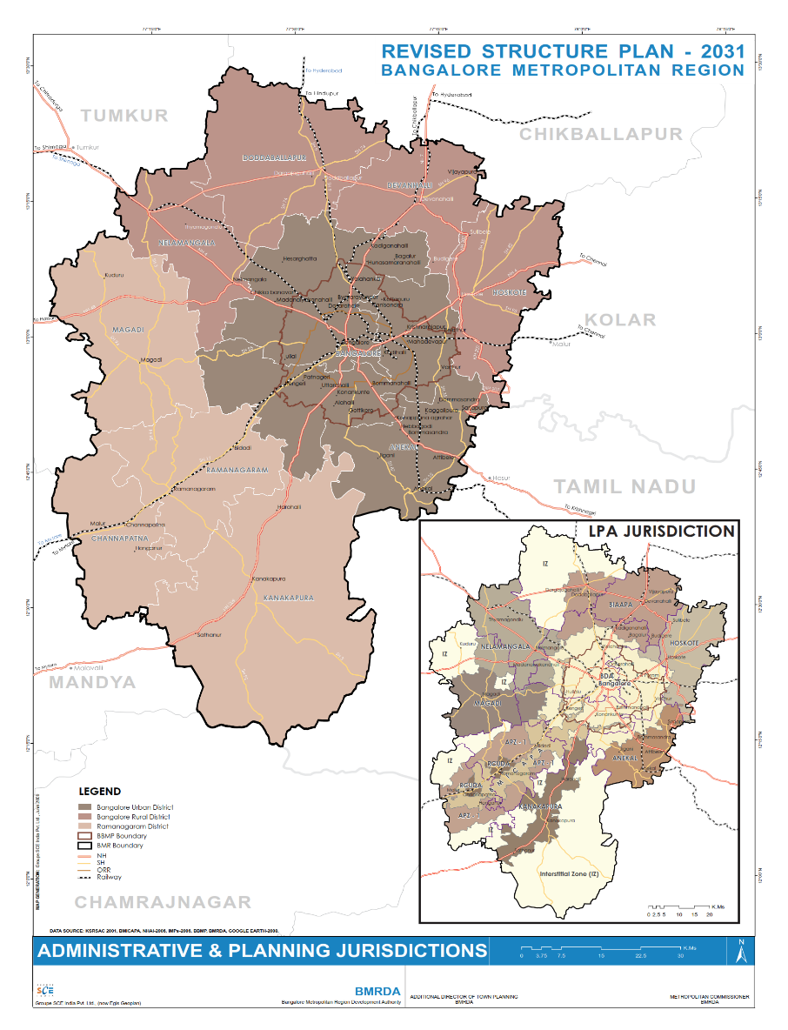

**Figure 1: Administrative and Planning Jurisdictions of BMR**

(Source: BMR Revised Structure Plan, 2016)

**4.1 Demographic Profile**

According to the Census of India (2011), BMR had a population of over 12 million, with an annual growth rate exceeding 3%. Bangalore Urban district alone accounted for over 9.6 million people, making it the dominant population center within the region. The region has experienced rapid migration-driven urbanization, primarily due to employment opportunities in the IT and service sectors. Projections indicate that the population of BMR may reach 16 million by 2031, necessitating enhanced urban planning interventions.(Figure 2)

The population density varies significantly across BMR, with central Bengaluru exhibiting densities exceeding 10,000 persons per sq. km, while peri-urban areas like Hoskote, Nelamangala, and Ramanagara have lower densities ranging from 500 to 2,000 persons per sq. km. The urban expansion of Bengaluru has resulted in the emergence of satellite townships, increasing the demand for planned urban growth (Census, 2011).

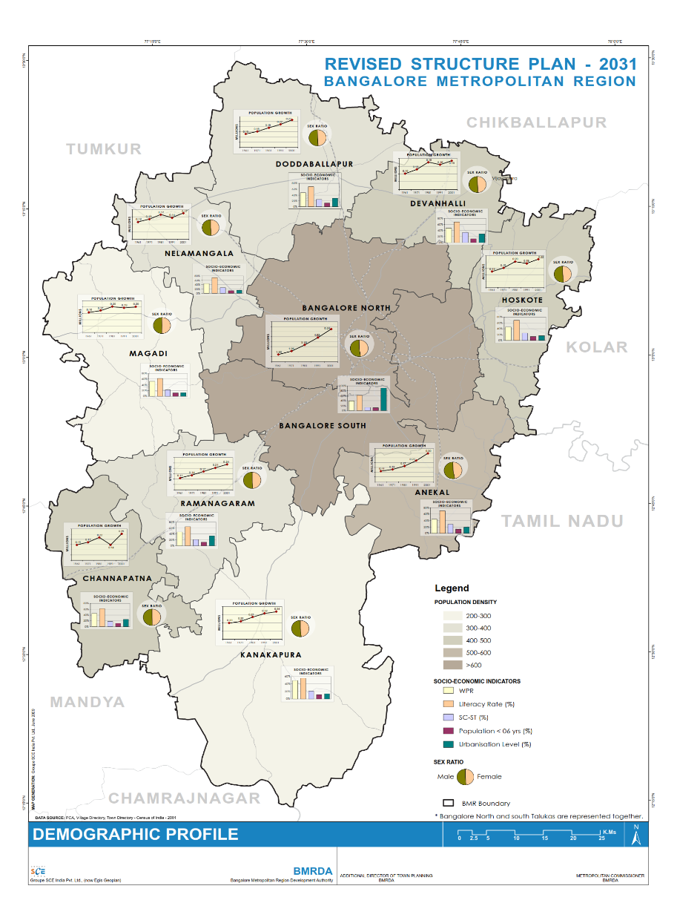

**Figure 2: Demographic Profile of BMR**

(Source: BMR Revised Structure Plan, 2016)

**4.2 Socio-Economic Profile**

BMR is an economic powerhouse, contributing significantly to Karnataka’s GDP. The region hosts a robust IT sector, with major technology parks such as Electronics City, Whitefield, and Manyata Tech Park acting as employment centers. Additionally, manufacturing, biotechnology, and research institutions contribute to economic growth. The per capita income in Bengaluru is among the highest in India, reflecting the economic prosperity of the region.

However, socio-economic disparities persist. While the urban core enjoys high levels of infrastructure, education, and healthcare services, peripheral areas lack adequate facilities. Informal settlements and slums continue to expand, highlighting concerns related to affordable housing and equitable urban development. The Revised Structure Plan 2031 emphasizes the need for integrated development strategies to bridge these disparities.

**4.3 Land Use and Spatial Structure**

Land use in BMR has undergone significant transformation due to urban expansion. According to the Revised Structure Plan 2031, built-up areas have increased exponentially, consuming agricultural and open lands.

Key land-use classifications as given in figure 3 include:

1. **Built-Up Areas** – Covering over 2,000 sq. km, built-up areas have expanded along major transport corridors such as Tumkur Road, Mysore Road, and Hosur Road.
2. **Agricultural Land** – Though shrinking, agriculture still occupies substantial portions of Bangalore Rural and Ramanagara districts, supporting horticulture, floriculture, and dairy farming.
3. **Industrial Zones** – The region includes major industrial clusters like Peenya, Bidadi, and Jigani, with upcoming industrial corridors planned to enhance economic growth.
4. **Green Spaces and Lakes** – BMR historically had extensive green cover and water bodies, but rapid urbanization has led to lake encroachments and deforestation. Conservation efforts, including the revival of lakes like Bellandur and Varthur, have been initiated (BMRDA, 2016).

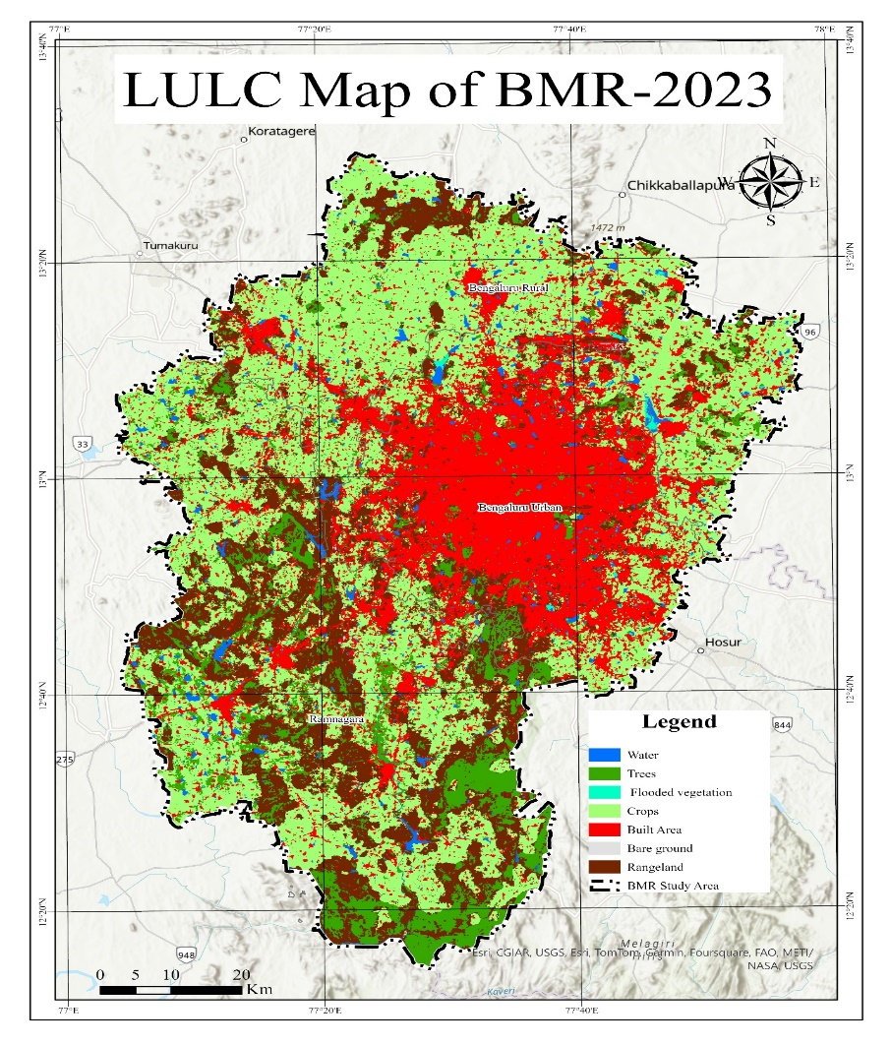

**Figure 3: Land Use Land Cover of BMR-2023**

(Source: Author using GIS)

**4.4 Urbanization Trends and Planning Challenges**

BMR's rapid growth has caused traffic congestion, inadequate public transport, and infrastructure strain. The Revised Structure Plan 2031 promotes polycentric development to decongest Bengaluru, but progress has been slow due to fragmented governance and lack of coordination. Strategic urban planning through TPS is essential to manage land use effectively, ensuring sustainable growth, environmental protection, and infrastructure integration (BMRDA, 2016).

**V. CHALLENGES IN IMPLEMENTING TPS IN BMR**

1. **Environmental Conflicts and Land Use Constraints** – The Conflict Map from the Revised Structure Plan 2031 highlights significant environmental and land-use conflicts within BMR, where urban expansion intersects with protected forests, water bodies, and valley systems. Many TPS areas overlap with flood-prone zones and ecologically sensitive regions, particularly in Anekal, Kanakapura, and Bidadi, leading to increased flooding, pollution, and habitat degradation. These conflicts pose regulatory challenges, requiring stricter environmental compliance, delaying TPS approvals, and increasing costs. Without land suitability assessments and ecological protection measures, TPS projects face resistance from environmental groups and regulatory agencies, complicating implementation and necessitating mitigation strategies to ensure sustainable urban growth.

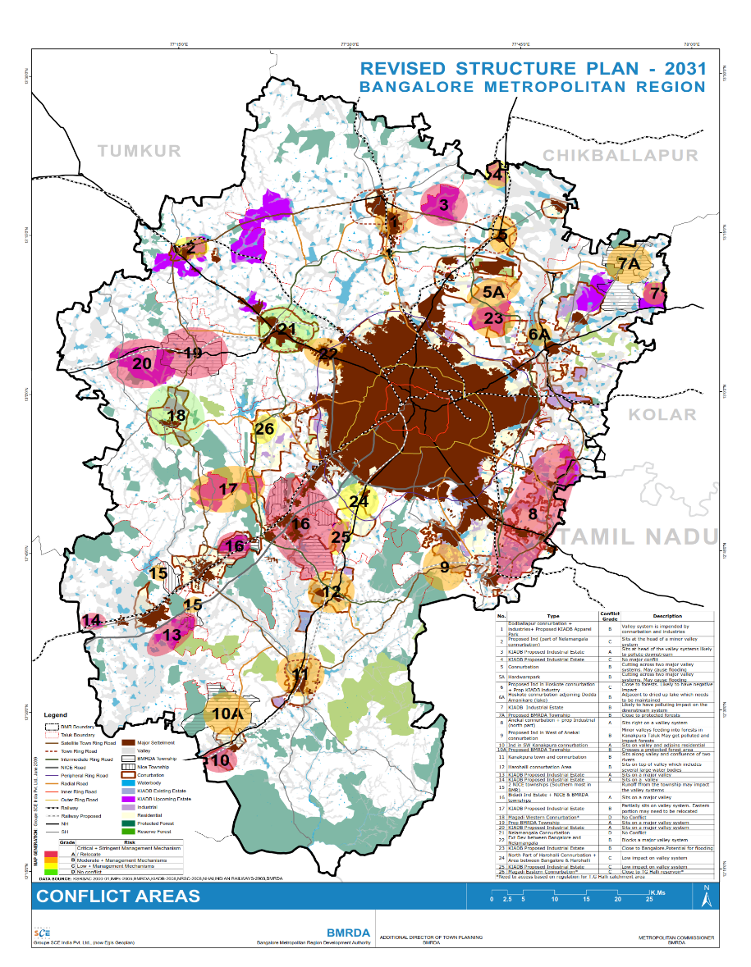

**Figure 4: Conflict Areas of BMR**

(Source: BMR Revised Structure Plan, 2016)

1. **Fragmented Governance and Institutional Barriers** – Multiple agencies such as BMRDA, BBMP, and ULBs operate without a unified framework, leading to delays in TPS implementation. The lack of coordination hinders decision-making and results in policy inconsistencies.
2. **Legal and Regulatory Hurdles** – Complex land acquisition laws, overlapping jurisdictional responsibilities, and slow approval processes create roadblocks for TPS projects. The absence of clear legal mechanisms to streamline TPS execution further complicates planning efforts.
3. **Financial Constraints** – Funding limitations pose a significant challenge for TPS execution. Many urban local bodies lack the financial resources to undertake large-scale land development projects, making it difficult to provide basic infrastructure under TPS.
4. **Landowner Resistance** – Due to misconceptions regarding land redistribution and valuation, many landowners are reluctant to participate in TPS. The prolonged duration of TPS execution also discourages participation, leading to fragmented urban expansion.
5. **Lack of Public Awareness** – The absence of awareness campaigns and stakeholder engagement programs results in limited public participation in TPS. Without community involvement, securing land for urban development becomes more challenging.
6. **Delays in Implementation** – Bureaucratic red tape, slow project approvals, and inadequate institutional capacity contribute to lengthy implementation timelines. The delayed execution of TPS projects affects planned urbanization and leads to increased land speculation. The various Conflict Areas with BMR are illustrated in Figure 4.

**VI. STRATEGIES FOR EFFECTIVE TPS IMPLEMENTATION**

A structured approach is required to improve the implementation of Town Planning Schemes (TPS) in Bangalore Metropolitan Region (BMR). The following strategies focus on short-term and operational measures that enhance TPS execution and efficiency:

1. **Land Zoning and Planned Urban Expansion** – The Proposed Land Utilization Plan - 2031 emphasizes the need for a structured urbanization approach by demarcating clear urbanizable zones (UZ-1 and UZ-2), industrial zones, and conservation areas within BMR. TPS should align with this framework to ensure orderly growth and prevent ad-hoc land use conversions. Specific TPS projects should be designated within the identified urbanizable zones, integrating residential, commercial, and mixed-use areas based on demand projections. Additionally, the protection of Agricultural Conservation Zones (ACZ-1 and ACZ-2) must be legally enforced to prevent uncontrolled urban sprawl. This approach ensures planned expansion while preserving ecological and agricultural land, facilitating a balanced urban-rural transition. (Figure 5)
2. **Enhancing Institutional Coordination** – Establishing a dedicated TPS cell within BMRDA can improve inter-agency coordination. This unit should oversee TPS execution, liaise with BBMP, ULBs, and BDA, and ensure streamlined approval processes. A single-window clearance system can reduce bureaucratic delays and improve efficiency.

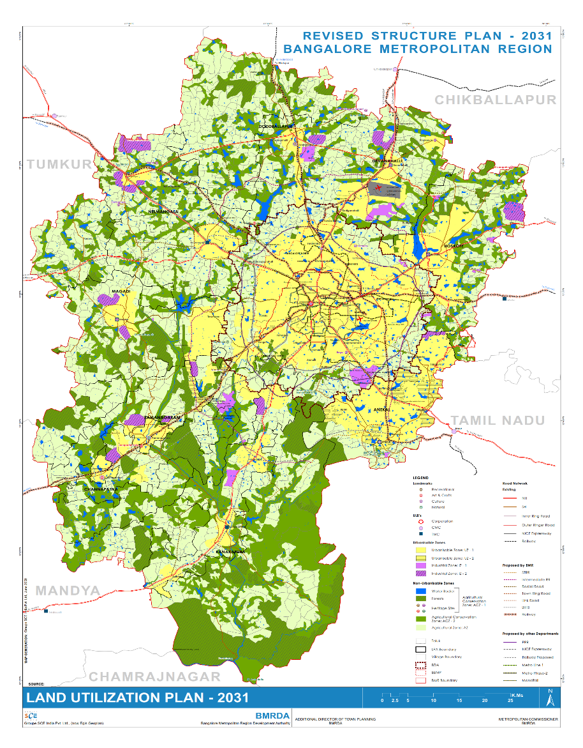

**Figure 5: Land Utilisation Plan of BMR**

(Source: BMR Revised Structure Plan, 2016)

1. **Legal Reforms for Simplified Approvals** – Reducing legal complexities by revising the Karnataka Town and Country Planning Act, 1961, is crucial for efficient TPS execution. Amendments should clarify land pooling mechanisms, dispute resolution frameworks, and approval processes. A fast-track approval mechanism for TPS-related projects will prevent prolonged delays.
2. **Flexible Financial Mechanisms** – Exploring alternative financing models such as land value capture, municipal bonds, and public-private partnerships (PPP) can help local authorities fund TPS development. Encouraging financial autonomy for local bodies through revenue-sharing models will ensure sustained funding for infrastructure.
3. **Stakeholder Engagement through Participatory Planning** – Increasing landowner participation through structured consultations and incentive-driven approaches will improve public acceptance of TPS. Transparent land reallocation mechanisms and clearly communicated benefits, such as increased land value post-development, can help mitigate resistance.
4. **Infrastructure-Driven Land Use Planning** – TPS should align with existing city infrastructure plans to avoid land-use conflicts. Integrated spatial planning that ensures connectivity to major transit hubs and public amenities is essential for seamless urban expansion.
5. **Capacity Building and Skill Development** – Training programs for urban planners, municipal officials, and land surveyors can improve TPS execution. Institutional strengthening through continuous learning programs and the recruitment of dedicated TPS experts within planning bodies will enhance decision-making and technical expertise.

**VII. POLICY IMPLICATIONS AND RECOMMENDATIONS**

Beyond operational strategies, long-term policy reforms are essential to institutionalizing TPS as a viable planning tool for sustainable urban development. The following policy recommendations address governance, regulatory, and institutional transformations required for effective TPS execution:

1. 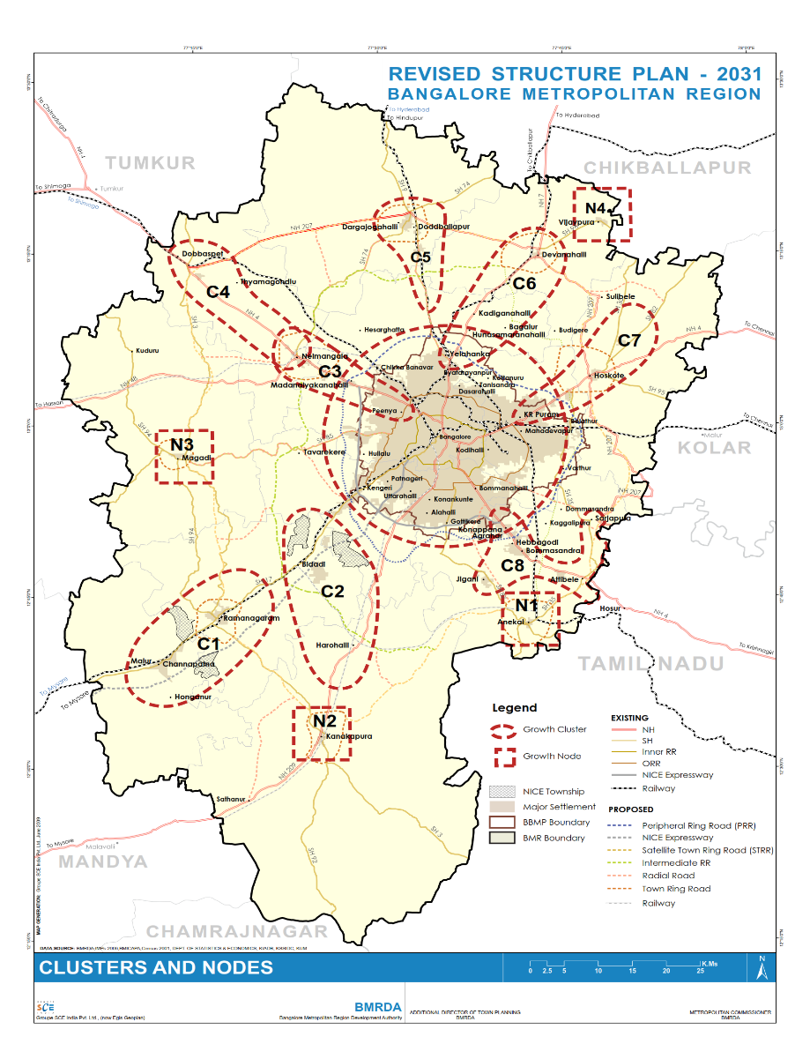**Promoting Polycentric Development and Cluster-Based Urbanization** – The Revised Structure Plan 2031 highlights the need for decentralized growth by developing regional clusters and nodes outside Bengaluru’s core. Instead of uncontrolled peripheral sprawl, a structured polycentric development model should be institutionalized within TPS. Growth nodes such as Nelamangala, Devanahalli, Ramanagara, and Hoskote must be strengthened with adequate infrastructure, industrial zones, and transit linkages to reduce pressure on the urban core. A legally binding cluster-based land use strategy should be adopted to direct TPS implementation within these identified nodes, ensuring balanced development across the BMR.(Figure 6)

**Figure 6: Proposed Cluster and Nodes of BMR**

(Source: BMR Revised Structure Plan, 2016)

1. **Institutionalizing TPS within Metropolitan Planning Frameworks** – TPS must be legally mandated as a primary urban expansion tool within BMR’s metropolitan planning framework. The Revised Structure Plan 2031 highlights the need for polycentric urban growth, and TPS should be integrated as a mechanism for achieving balanced development across satellite towns and peri-urban areas.
2. **Strengthening the Legal Framework for Land Pooling and Readjustment** – Amendments to the Karnataka Town and Country Planning Act should formalize TPS processes, establish clear compensation mechanisms, and ensure equitable distribution of land benefits. Standardizing TPS regulations across Karnataka will bring uniformity and reduce uncertainty for stakeholders.
3. **Financial Sustainability through Dedicated Urban Development Funds** – A dedicated TPS Development Fund should be established to support infrastructure projects within TPS areas. This fund should be capitalized through a combination of government grants, private sector investments, and land monetization strategies to ensure long-term financial sustainability.
4. **Mandating Public Participation in TPS Planning** – To address landowner resistance, TPS execution should include legally mandated public hearings, participatory workshops, and structured negotiation platforms. Gujarat’s TPS model demonstrates how community-led processes can enhance acceptance and reduce disputes.
5. **Leveraging Digital Land Management Systems for Transparency** – Establishing a unified digital platform that integrates land records, TPS boundaries, and real-time tracking of project approvals can improve governance efficiency. Singapore’s digital land registry model serves as an example of how technology-driven governance can reduce corruption and improve land use planning.
6. **Developing a National Policy Framework for TPS** – The success of TPS in Gujarat, Maharashtra, and other states highlights the need for a national-level regulatory framework for TPS execution. The Ministry of Housing and Urban Affairs (MoHUA) should issue standardized TPS guidelines, ensuring that metropolitan regions across India can adopt best practices in land pooling and urban expansion.

**VIII. CONCLUSION**

The effective implementation of Town Planning Schemes (TPS) in Bangalore Metropolitan Region is essential for addressing challenges posed by rapid urbanization. As highlighted in this study, unregulated expansion has resulted in inefficient land use, infrastructure deficits, and governance fragmentation. Strategically implemented TPS can offer a participatory, equitable, and financially sustainable approach to urban growth management. The primary barriers to its success include fragmented governance, legal ambiguities, financial constraints, landowner resistance, and limited public awareness. The Revised Structure Plan 2031, URDPFI guidelines, and insights from national and international case studies provide a structured roadmap for improving TPS execution. Strengthening institutional coordination, reforming legal frameworks, enhancing financial sustainability, promoting stakeholder participation, integrating sustainable infrastructure, leveraging technology, and building institutional capacity are key policy interventions that can support TPS implementation.

Moving forward, integrating TPS with broader regional planning objectives will be crucial to accommodating Bangalore’s urban expansion in a sustainable manner. If effectively implemented, TPS can play a transformative role in shaping BMR’s growth by ensuring planned urbanization while protecting stakeholder interests. Urban planners, policymakers, and governance bodies must work collaboratively to address existing barriers and create an enabling environment for TPS execution. This study’s findings provide a foundation for future research on innovative TPS models, monitoring mechanisms, and long-term urban development strategies for metropolitan regions.

**REFERENCES**

1. Bangalore Metropolitan Region Development Authority (BMRDA). (2017). *Revised Structure Plan – 2031: Bangalore Metropolitan Region (Final Report).* Bangalore: BMRDA.
2. Census of India. (2011). *Provisional Population Totals, Census 2011 – Karnataka (Series 30).* Office of the Registrar General & Census Commissioner, India.
3. Dehingia, H., Das, R. R., Rahaman, S. A., Surendra, P., & Hanjagi, A. D. (2022). Decadal transformation of land use-land cover and future spatial expansion in Bangalore Metropolitan Region, India: Open-source geospatial machine learning approach. *International Archives of the Photogrammetry, Remote Sensing and Spatial Information Sciences, XLIII-B3-2022*, 589–596.
4. Government of India. (2015). *Smart Cities Mission: A step towards Smart India.* Ministry of Housing and Urban Affairs, New Delhi. Retrieved from <https://www.india.gov.in/spotlight/smart-cities-mission-step-towards-smart-india>.
5. Janaagraha Centre for Citizenship and Democracy. (2021). *Annual Survey of India’s City-Systems 2020.* Bangalore: Janaagraha.
6. McKinsey Global Institute. (2010). *India’s urban awakening: Building inclusive cities, sustaining economic growth.* McKinsey & Company.
7. National Institute of Urban Affairs (NIUA). (2022). *About NIUA – Shaping India’s Urban Future.* New Delhi: NIUA. Retrieved from <https://niua.in>.
8. NITI Aayog. (2021). *Reforms in Urban Planning Capacity in India (Report of the Advisory Committee).* New Delhi: NITI Aayog.
9. Ramachandra, T. V., & Aithal, B. H. (2016). Bengaluru’s reality: Towards unlivable status with unplanned urban trajectory. *Current Science, 110*(12), 2207–2208.
10. Ramachandra, T. V., Mondal, T., Setturu, B., & Aithal, B. H. (2023). Environmental consequences in the neighbourhood of rapid unplanned urbanisation in Bangalore City. *Advances in Environmental and Engineering Research, 4*(4), 052.
11. Sudhira, H. S., Ramachandra, T. V., & Jagadish, K. S. (2004). Urban sprawl: metrics, dynamics and modeling using GIS. *International Journal of Applied Earth Observation and Geoinformation, 5*(1),
12. Sundaresan, J. (2019). Urban planning in vernacular governance: Land use planning and violations in Bangalore, India. *Progress in Planning, 127*, 1–23.
13. United Nations, Department of Economic and Social Affairs (UN DESA). (2018). *World Urbanization Prospects: 2018 Revision – Press Release.* New York: United Nations.
14. United Nations, General Assembly. (2015). *Transforming our world: the 2030 Agenda for Sustainable Development (A/RES/70/1).* New York: United Nations.
15. UN-Habitat. (2017). *New Urban Agenda.* Quito: United Nations Conference on Housing and Sustainable Urban Development.
16. UN-Habitat. (2022). *World Cities Report 2022: Envisaging the Future of Cities.* Nairobi: United Nations Human Settlements Programme.
17. World Bank. (2013). *Urbanization beyond municipal boundaries: Nurturing metropolitan economies and connecting peri-urban areas in India.* Washington, DC: World Bank.
18. World Bank. (2016). *Leveraging Urbanization in South Asia: Managing Spatial Transformation for Prosperity and Livability.* Washington, DC: World Bank.
19. World Bank. (2024). Kouamé, A. T. *Gearing up for India’s rapid urban transformation.* Retrieved January 30, 2024, from <https://www.worldbank.org/en/news/opinion/2024/01/30/gearing-up-for-india-s-rapid-urban-transformation>.
20. Times of India. (2024, March 6). *Why Bengaluru is facing acute water shortage.* Times News Network. Retrieved from <https://timesofindia.indiatimes.com>.

**************