**Soret effect of MHD Nanofluid flow over an inclined stretching sheet with Darcy dissipation and heat source**

**Satyabrat Kar****\***

Department of Mathematics

DRIEMS University, Cuttack, Odisha, India.

**Corresponding Author:**-Email Id [-satyabratkr@gmail.com](mailto:-satyabratkr@gmail.com)

**Abstract**:-An analysis has been made to illuminate the unsteady MHD slip flow of Nano fluid over an inclined stretching sheet. The heat transfer has been analysed incorporating Darcy dissipation and heat source. The presence of Soret effect makes the study more interesting. Using Similarity transformation technique, the governing partial differential equations are converted into a system of ordinary differential equations. The reduced system is dealt with 4th order Runge-Kutta method with shooting technique. The comparison with earlier results gives a reliability of present outcomes.

**Keywords:-**Darcy dissipation, MHD, Boundary layer flow, Shooting Technique, Soret effect.

**Nomenclature:-**

$B_{0}$ Magnetic induction; T Temperature of the species;

𝐶 Concentration of the species; $T_{∞}$ Uniform temperature far from the sheet;

$C_{∞}$ Uniform concentration far from the sheet; ${T }_{w}\left(x,t\right)$ Temperature of the sheet;

𝐶𝑝 Specific heat at constant pressure; $u_{w} \left(x,t\right)$ Velocity of the stretching sheet;

$C_{w}\left(x,t\right)$ Concentration of the fluid at the wall; V Velocity along the 𝑦-direction;

$C_{f}$ Skin friction coefficient; $V_{0}$ Constant;

𝐷 Molecular diffusivity; $v_{w}\left(t\right)$ Velocity of the mass transfer;

$D_{∞}$ Diffusion coefficient of the ambient; 𝑥 Coordinate along the stretching sheet;

𝐸c Eckert number; y Distance normal to the stretching sheet;

F Force applied along the 𝑥-axis; $f_{w}$ Suction/Injection parameter;

𝑔 Acceleration due to gravity; 𝐺 Thermal Grashof number;

𝐺𝑐 Solutal Grashof number; ${ h}_{m}$ Mass flux from the sheet;

${ k}_{1}$ Coefficient of absorption; 𝐾r Chemical reaction parameter;

$K_{∞}$ Thermal conductivity of the ambient; 𝑀 Magnetic parameter;

${Nu}_{x}$ Nusselt number; $q_{w}$ Heat flux;

Pr Prandtl number;

𝑅 Thermal Radiation parameter; ${Sh}_{x}$ Sherwood number;

So Soret number; 𝑆𝑐 Schmidt number;

***Greek Symbols:-***

𝛼 Inclination angle; 𝜆 Constant;

𝜓 Stream function; 𝜎∗ Stefan- Boltzmann constant;

$β_{1}$ Variable thermal conductivity; $β_{2}$ Variable diffusion coefficient;

𝜏𝑤 Shear stress; Kp Porous medium parameter;

Δ Delta; 𝜅∗ Permeability;

∗ Kinematic viscosity; 𝜇 Coefficient of viscosity;

𝜙 Dimensionless concentration functions; $β_{T}$ Coefficient of thermal expansion;

$β_{C}$ Volumetric concentration coefficient; Dimensionless temperature function;

𝜂 Dimensionless space variable; 𝜌 Fluid density;

Electrical conductivity.

***Subscripts:-***

∞ Condition at the free stream; 𝑤 Condition at the surface.

**Introduction:-**

The concerned study with the analysis of unsteady MHD fluid flow in a boundary-layer over a stretching sheet has created enormous applications in engineering and industrial fields. Despite of those things, it has more pivotal perspectives according to a hypothetical perspective as well as their down to earth applications in the polymer business, expulsion of plastic sheets, polymer preparing, paper creation, food handling, precious stone developing, crystal growing, design of heat exchangers, transpiration cooling of a surface, chemical vapour deposition of solid layer, nuclear reactor, and many manufacturing processes like hot rolling, hot extrusion, wire drawing, continuous casting and fiber drawing etc.

The numerical solution with asymptotic boundary conditions of the couple of nonlinear equations with boundary layer problem has experimented by Nachtsheim PR and Swigert P [1]. Effects of heat and mass transfer on MHD free convection flow over an inclined plate in a porous medium have been studied by eminent researchers ([2]-[4]). T. Hayat et al. [5] have introspected the diffusion of chemically reactive species in third grade flow over an exponentially stretching sheet assumed magnetic field. Experimental and practical studies have established that the numerical and semi-analytical approaches on MHD natural convection inside a sinusoidally heated lid-driven square cavity filled with Fe3O4-water nanofluid in the presence of Joule heating as presented by scientists ([6]-[8]).M. Sheikholeslami et al. [9] have investigated the nanofluid flow with heat transfer between parallel plates considering Brownian motion.

Considering the importance of the MHD effect mixed convection of a Jeffrey fluid over a stretching sheet with power law heat flux with joule heating studied have been made by many authors ([10]-[12]) by formulating simple models. S.S Nourazar et al. [13] have premeditated the thermal-flow boundary layer analysis of nanofluid over a porous stretching cylinder under the magnetic field effect. When heat and mass transfer occurred in a moving fluid, heat flux generated in presence of the dufour or diffusion thermo effect. A numerical study of magneto hydrodynamics flow in Casson nanofluid combined with Joule heating and slip boundary conditions was investigated by the researchers ([14]-[17]).Due to fascinating behaviours of magnetic nanofluid, M. Sheikholeslami et al.[18] have studied the special characteristic of Magneto hydrodynamic nanofluid in a porous media. Recently, the huge development with greater impact of magnetic field on nanofluids has also been investigated by other eminent researchers (S.Nadeem et al. [19], C.S.K. Raju et al. [20], Kai-Long Hsiao [21], and S.S. Ghadikolaei et al. [22]).

In Magnetohydrodynamics (MHD) with electrically conductive fluid flows, due to its frequent application in various fields like science, engineering and industrial sectors. It has been used in MHD power generation, MHD pumps, MHD flow in nanofluids, manufacturing and heterogeneous composition in food, atmospheric density stratification etc. In view of these widely applications drawn the attentions of some researchers (D.D. Ganji et al.[23], M. Hatami et al.[24], S.M. Ibrahim et al. [25], S.S. Ghadikolaei et al. [26] and Umar Khan et al.[27]) to explore their perceptions, pondering, speculation and ideas in these directions. A prodigious significance of thermophoresis with Brownian motion of nanosized particle in liquids with constant pressure gradient. Mahanthesh et al. [28], Ramesh GK et al. [29], O.D Makinde et al. [30] and E.Haile et al. [31] have developed a nanofluid model for analyzing the thermophoresis diffusion, thermal energy transport etc.with the Brownian motion of nanofluids.

One of the most constructive and reliable techniques in order to solve the high nonlinear problems ,the governing partial differential equations are transformed into ordinary differential equations by using similarity transformation and the numerical solutions of the problems are obtained by using fourth order Runge-Kutta method with shooting technique. This method has employed to obtain numerical solutions of non-linear problems. Kar S. Senapati N., Swain B.K [32] in their study the effects of viscous dissipation, chemical reaction and thermal radiation on heat and mass transfer of MHD free convective flow through a porous medium observed that as the thermal radiation increases, it causes diminish the temperature, Also, as the chemical reaction parameter increases, the concentration of fluid decreases in the boundary layer flow.

Further, Chen [33] has observed the analysis of fluid flow over an inclined plate with wall temperature and concentration. S. Ahmed et al.[34] have studied the on MHD free convection flow in a porous medium past an infinite vertical plate with heat and mass transfer effects. S Ahmed et al.[35] and Senapati .N et al.[36] while performing their research on the effect of thermal radiation and inclined magnetic field on MHD fluid flow experimented that the increase in magnetic field inclined angle, resulting which decreasing the Nusselt number.

Most recently, a research article encountered the heat and mass transfer for Soret and Dufour effects on mixed convection boundary layer flow over a vertical surface in a porous medium with a visco-elastic fluid is reported by Paul A [37] and T. Hayat et al. [38]. Moreover, Yih KA [39] has considered the effect of transpiration on coupled heat and mass transfer in mixed convection over a vertical plate embedded in a saturated porous medium. Srihari K et al. [40] in their experimental research based on the various numerical as well as analytical methods for the solutions on MHD flow of an incompressible viscous dissipative fluid in an infinite vertical oscillating plate with constant heat flux have been duly examined.

Experimental investigation have prevailed that the physical properties of MHD free convective fluid flow past an infinite vertical porous plate with variable suction,soret and dufour effects as analysed by Seethamahalakshmi et al.[41] and Sankar Reddy et al.[42]. Samad, M. A et al.[43] in their study on the effects of magnetic field over a stretching surface concluded that momentum boundary layer thickness decreases as the magnetic parameter increases. For this reason some eminent researchers, for instance, O. A. Beg et al.[44] and K. Srihari et al.[45] have investigated the soret and dufour effects of a steady flow due to a rotating disk in presence of viscous dissipation and joule heating .

The most prominent motive behind our problem is to investigate the behaviour of boundary layer flow over an inclined permeable stretching sheet in the presence of thermal radiation and chemical reaction assuming Soret effect and joule heating .The best numerical shooting technique with fourth order Runge-Kutta scheme will be employed to obtain numerical solutions of this particular physical model. The effects of different involved non-dimensional parameters such are diffusion coefficient, thermal conductivity, magnetic field parameter, radiative heat flux, chemical reaction, porous media, unsteadiness parameter, Schmidt number, Prandtl number, Eckert number, thermal Grashof number, Solutal Grashof number, Soret number, velocity, temperature, concentration as well as skin friction and Nusselt and Sherwood numbers are presented and discussed extensively with the help of graphs and tables.

**Mathematical Formulation**:-

In this problem we assume an unsteady two-dimensional MHD free convective flow of a viscous, incompressible and radiating fluid over a stretching sheet surface in presence of external magnetic and electric field, heat generation/absorption, thermal radiation, chemical reaction, viscous dissipation and joule heating. It is considered that the influence of variation of density with temperature and concentration occurs only on the body force and hence forth the changes in both temperature and concentration by inducing buoyancy force. A uniform magnetic field is applied normal to the surface of the stretching sheet. It is assumed that a first order chemical reaction with thermal radiation is taking into

x X

F $u_{w}$

$B_{0}$ $T_{w},C_{w}$ g

α $T_{∞}$

$C_{∞}$ y

Y

**Fig.1.Flow Geometry**

account in this flow. Let $u_{w}\left(x,t\right)$ be the velocity of the stretching sheet in the direction force F applied along in x-axis and the mass transfer $v_{w}\left(t\right)$ normal to the stretching sheet. We also assumed that surface temperature and concentration of the sheet are $T_{w}\left(x,t\right)$ and $C_{w}\left(x,t\right)$ respectively, in addition with $T_{∞}$ and $C_{∞}$ are the uniform temperature and concentration far from the sheet. The fluid thermal conductivity and molecular diffusivity are taken into account as a linear function of temperature and the characteristics of Soret effects are described.

The governing boundary layer equations are given below:-

$\frac{∂u}{∂x}+\frac{∂v}{∂y}=0$ (1)

$\frac{∂u}{∂t}+u\frac{∂u}{∂x}+v\frac{∂u}{∂y}= ν^{*}\frac{∂^{2}u}{∂y^{2}}-\frac{ν^{*}}{k^{*}}u-\frac{σB_{0}^{2}}{ρ}u+gβ_{T}\left(T-T_{∞}\right)cosα+ gβ_{C}\left(C{-C}_{∞}\right)cosα$ (2)

$\frac{∂T}{∂t}+u\frac{∂T}{∂x}+v\frac{∂T}{∂y}$ = $\frac{1}{ρC_{P}}\frac{∂}{∂y}\left(K\left(T\right)\frac{∂T}{∂y}\right)-\frac{1}{ρC_{P}}\frac{∂q_{r}}{∂y}$ $+\frac{μ}{ρC_{P}}{\left(\frac{∂u}{∂y}\right)}^{2}+\frac{μ}{ρC_{P}}\frac{u^{2}}{k^{*}}+Q^{*}\left(T-T_{∞}\right)$ (3)

$\frac{∂C}{∂t}+u\frac{∂C}{∂x}+v\frac{∂C}{∂y}= \frac{∂}{∂y}\left(D\left(T\right)\frac{∂C}{∂y}\right)-K_{C}\left(C-{ C}_{∞}\right)+D_{1}\frac{∂^{2}T}{∂y^{2}}$ (4)

By using Boundary conditions

$u=u_{w}\left(x,t\right)=\frac{cx}{1-λt}$,

$v=v_{w}\left(t\right)$,

$T=T_{w}\left(x,t\right)$,

$C=C_{w}\left(x,t\right)$, $at y=0$

$u→0$,

$T→T_{∞}$,

$C→C_{∞}$, $as y→∞$ (5)

The radiation heat flux ($q_{r}$) is modelled by using the Roseland’s approximation given in below:

${ q}_{r}=-\left(\frac{4σ^{*}}{3k_{1}}\right)\frac{∂T^{4}}{∂y}$ (6)

Now, $T^{4}$ can be expressed as a linear combination of the temperature by expanding $T^{4}$ by Taylor’s series about $T_{∞}$ to obtain (7):

$T^{4}$ = $T_{∞}^{4}+4T_{∞}^{3}\left(T-T_{∞}\right)+6T_{∞}^{2}{\left(T-T_{∞}\right)}^{2}+…$ (7)

$T^{4}≈ -3T_{∞}^{4}+4TT_{∞}^{3}$ (8)

Substituting, the result of $T^{4}$ from equation (8) into equation (6)

${ q}_{r}=-\left(\frac{4σ^{*}}{3k_{1}}\right)\frac{∂T^{4}}{∂y}$ = $-\left(\frac{4σ^{*}}{3k_{1}}\right)$ $\frac{∂}{∂y}$ $\left(-3T_{∞}^{4}+4TT_{∞}^{3}\right)$

= $-\left(\frac{16T_{∞}^{3}σ^{*}}{3k_{1}}\right)\frac{∂T}{∂y}$ (9)

$\frac{∂q_{r}}{∂y}=$ $-\left(\frac{16T_{∞}^{3}σ^{*}}{3k_{1}}\right)\frac{∂^{2}T}{∂y^{2}}$ (10)

Substituting equation (10) into equation (3),it becomes

$\frac{∂T}{∂t}+u\frac{∂T}{∂x}+v\frac{∂T}{∂y}$ = $\frac{1}{ρC_{P}}\frac{∂}{∂y}\left(K\left(T\right)\frac{∂T}{∂y}\right)+\frac{1}{ρC_{P}}$ $\left(\frac{16T_{∞}^{3}σ^{*}}{3k_{1}}\right)\frac{∂^{2}T}{∂y^{2}}+\frac{μ}{ρC_{P}}{\left(\frac{∂u}{∂y}\right)}^{2}+\frac{μ}{ρC_{P}}\frac{u^{2}}{k^{*}}+Q^{*}\left(T-T_{∞}\right)$

(11)

The temperature of the fluid at the surface of the sheet $T_{w}\left(x,t\right)$ and concentration of the fluid at the surface of the sheet $C_{w}\left(x,t\right)$.

$T_{w}\left(x,t\right)$ = $T_{∞}+\frac{bx}{{\left(1-λt\right)}^{2}}$

$C_{w}\left(x,t\right)$ = $C_{∞}+\frac{bx}{{\left(1-λt\right)}^{2}}$ (12)

***Similarity Transformation* *technique:*** The partial differential equations (2), (4) and (11) are transformed into ordinary differential equations by introducing the dimensionless parameters are given by:-

$η= \sqrt{\frac{c}{ν^{*}\left(1-λt\right)} } y$, $ψ$ = $\sqrt{\frac{ν^{*}c}{\left(1-λt\right)} }$ $xf\left(η\right)$

$θ\left(η\right)= \frac{T-T_{∞}}{T_{w}-T_{∞}}$, $ϕ\left(η\right)= \frac{C-C_{∞}}{C_{w}-C_{∞}}$ (13)

and the relations given by (14):

$T\left(x,t\right)$ = $T_{∞}+\frac{bx}{{\left(1-λt\right)}^{2}}$ $θ\left(η\right)$

$C\left(x,t\right)$ = $C_{∞}+\frac{bx}{{\left(1-λt\right)}^{2}}$ $ϕ\left(η\right)$ (14)

Where $ν^{*}= \frac{μ}{ρ}$ is the free stream kinematic viscosity, $ψ\left(x,y\right)$ is a stream function which defines the velocity components in the form $u= \frac{∂ψ}{∂y}$ = $\frac{cx}{{\left(1-λt\right)}^{ }}$ $f^{'}\left(η\right)$,

$v= -$ $\frac{∂ψ}{∂x}$ = $- \sqrt{\frac{ν^{*}c}{\left(1-λt\right)} }$ $f\left(η\right)$ by using those results, continuity equation (1) satisfied.Where as $f\left(η\right)$ represents injection and suction with the dimensionless space variable.

$θ\left(η\right)$ And $ϕ\left(η\right)$ are also dimensionless of temperature and concentration of the fluid respectively.

The thermal conductivity of nanofluid K(T) can vary linearly with temperature via a function shown in (15) :

K (T) = $K_{∞} \left(1+\frac{β_{1}}{ΔT}\left(T-T_{∞}\right)\right)$ (15)

and in terms of dimensionless temperature equation (15) reducing to equation (16) :

K ($θ$) = $K_{∞}$ $\left(1+β_{1}θ\right)$ (16)

Where K($θ$) is the variation thermal conductivity with regard to dimensionless temperature.

$K_{∞}$ is the thermal conductivity of the fluid far away from the heated sheet, and $β_{1}$ is a small parameter that depends on the nature of the fluid and it measures the rate of change of thermal conductivity with temperature.

Now the diffusion coefficient D (T) as a linear function of temperature shown below:

D (T) = $D_{∞} \left(1+\frac{β_{2}}{ΔT}\left(T-T_{∞}\right)\right)$ (17)

It may also be written in the form of dimensionless temperature as below:

D ($θ$) = $D_{∞}$ $\left(1+β_{2}θ\right)$ (18)

Where D ($θ$) is the variation diffusion coefficient with regard to dimensionless temperature.

$D_{∞}$ is the diffusion coefficient of the fluid far away from the heated sheet and $β_{2}$ is a small parameter that depends on the nature of the fluid and it measures the rate of change of chemical diffusivity with temperature.

Now substituting the equations (12)-(14), (16) and (18), in equations (2), (4), (11) and (5) the following ordinary differential equations are obtained:

$f^{'''}=A\frac{η}{2} f^{''}+\left[A+Kp+M\right]f^{'}+{\left(f^{'}\right)}^{2}-ff^{''}-Grθ-Gcϕ$ (19)

$θ^{''}= \frac{-β_{1}{θ^{'}}^{2}+P_{r}[A\left(\frac{η}{2}\right)θ^{'}+2Aθ+f^{'}θ-fθ^{'}-Ec{\left(f^{''}\right)}^{2}-EcKp{f^{'}}^{2}-Qθ]}{\left(1+R+β_{1}θ\right)}$ (20)

$ϕ^{''}= \frac{-β_{2}\left(θ^{'}ϕ^{'}\right)+S_{c}[A\left(\frac{η}{2}\right)ϕ^{'}+2Aϕ+f^{'}ϕ-fϕ^{'}+Krϕ-Soθ^{''}]}{\left(1+β_{2}θ\right)}$ (21)

The initial and boundary conditions in dimensionless forms are

$f\left(0\right)$ = $f_{w}$, $f^{'}\left(0\right)=1$, $θ\left(0\right)=1$, $\left(0\right)=1$, at $η=0$

$f^{'}\left(η\right) ⟶0$, $θ\left(η\right) ⟶0$, $ϕ\left(η\right)⟶0$, as $η⟶∞$ (22)

Introducing the following non-dimensional parameters A, Kp, M, Gr, Gc, Pr ,R, Ec, Kr, Sc and So are the unsteadiness parameter, porous medium parameter, magnetic parameter, thermal Grashof number, solutes Grashof number, Prandtl number, thermal radiation parameter, chemical reaction parameter, Eckert number, Schmidt number and Soret number respectively are defined in

A = $\frac{λ}{C}$, Kp = $\frac{ν^{*}\left(1-λt\right)}{k^{*}c}$, M = $\frac{σB_{0}^{2}(1-λt)}{ρc}$, Gr = $\frac{gβ_{T}x\left(T_{w}-T_{∞}\right)cosα}{u_{w}^{2}}$, Sc = $\frac{ν^{*}}{D_{∞}}$,

Gc = $\frac{gβ_{c}x\left(C_{w}-C_{∞}\right)cosα}{u_{w}^{2}}$, Pr = $\frac{μCp}{K_{∞}}$, R = $\frac{16T_{∞}^{3}σ^{*}}{3k_{1}K_{∞}}$, Kr = $\frac{Kc\left(1-λt\right)}{c}$,

Ec = $\frac{u_{w}^{2}}{Cp\left(T_{w}-T_{∞}\right)}$, Q = $\frac{Q^{'}(1-λt)}{c}$, So = $\frac{D_{1}\left(T_{w}-T_{∞}\right)}{ν^{*}\left(C_{w}-C_{∞}\right)}$, (23)

**Numerical Solution by Runge-Kutta Scheme:-**

By employing the most efficient method i.e, fourth order Runge-Kutta scheme with shooting technique, from eqn. (19)-(21) we have a set of first order differential equations with seven initial problems of seven unknowns. Possible substitutions are as follows

$f=y_{1}$, $f^{'}=y_{2}$, $f^{''}=y_{3}$, $f^{'''}=y_{3}^{'}$

$θ=y_{4}$, $θ^{'}=y_{5}$, $θ^{''}=y_{5}^{'}$,

$φ=y_{6}$, $φ^{'}=y_{7}$, $φ^{''}=y_{7}^{'}$,

The reduced equations are

$y_{3}^{'}$ = A $\frac{η}{2}$ $y_{3}$ + [A+Kp+M] $y_{2}$ + $y_{2}^{2}$ $-$ $y_{1}y_{3}$–Gr ${ y}_{4}$– Gc ${ y}_{6}$ (24)

$y_{5}^{'}$ = $\frac{-β_{1} y_{5}^{2} + Pr [A(η/2)y_{5} + 2Ay_{4} + y_{2}y_{4} – y_{1}y_{5}- Ec y_{3}^{2}-Ec Kp y_{2}^{2}-Qy_{4}]}{(1+R+β_{1}y_{4})}$ (25)

$y_{7}^{'}$ = $\frac{-β_{2}(y_{5}y_{7}) + Sc [ A\left(\frac{n}{2}\right)y_{7}+2Ay_{6}+y_{2}y_{6}-y_{1}y_{7}+Kry_{6}-Soy_{5 }^{'}]}{(1+β_{2}θ)}$ (26)

Corresponding Boundary conditions are given by

$y_{1}$ = 0, $y_{2}$ =1, =?

=1, =? , =1, =?

=0, =1, =? , y4 =1, =1, =? , =? at =0

0, $y_{4}→$ 0, $y_{6}→$ 0, at $η$ $→∞$

**Results and Discussion**:**-**

This segment deals with graphical and numerical results of the pertaining non-dimensional physical parameters in the governing boundary value flow problem.

All the computational work is performed with the help of ‘MATLAB’ Software. The transformed differential equation can be solved numerically by employing most effective numerical shooting technique with fourth order Runge-Kutta Scheme.

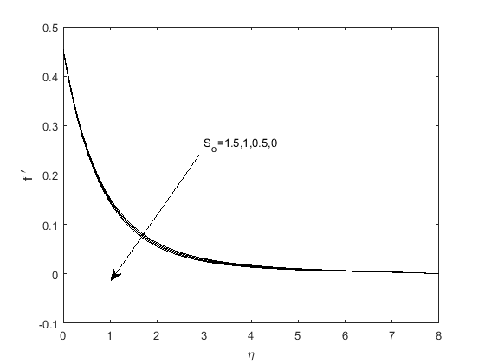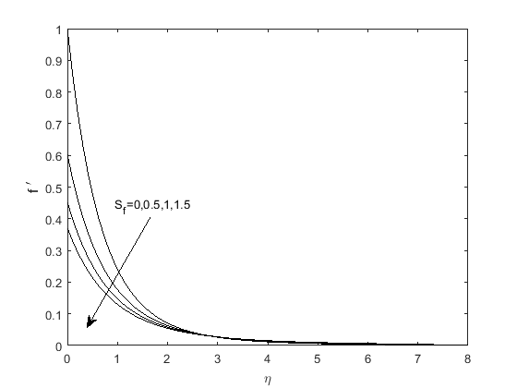

**Fig.1.Effects of So on Velocity profiles Fig.2. Effects of Sf on Velocity profiles. When A=0.5,** **Kp=0.5,M=0.5,Gr=0.01,Gc=0.1 when A=0.5,** **Kp=0.5,M=0.5,Gr=0.01,Gc=0.1**

Soret number (S0) is the rate of temperature difference to the concentration. Larger Soret number stands for a higher temperature difference and precipitous gradient.

In present Fig.1.Velocity of the flow increase with increase in soret number. Physically, we can say that due to higher temperature difference fluid flows with higher velocity.

Again it can be noticed that the change in velocity for different values of soret number is more significant at $η$ =1 to $η$ =3.

Fig.2.represents the velocity distribution with respect to velocity slips parameter ‘Sf’. It is clearly observed that velocity of the flow decelerates for higher values of 1st order slip parameter. Therefore slip factor is very much interest whenever a low velocity finds is a requirement.

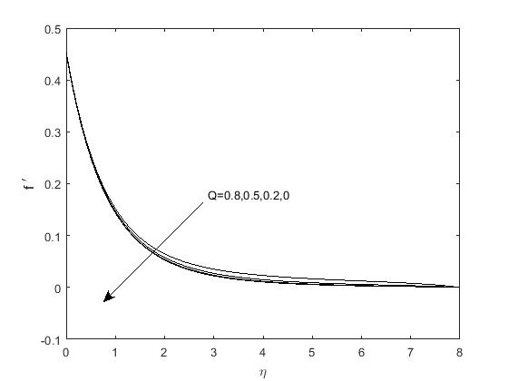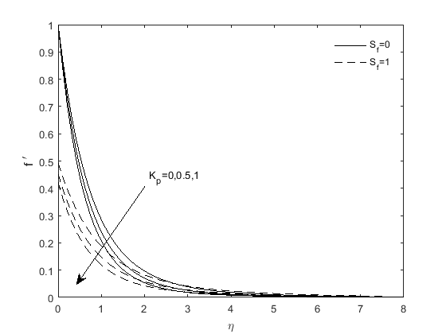

**Fig.3.Effects of Thermal radiation Fig.4. Effects of Porous medium parameter**

**Parameter on Velocity profiles. Velocity profiles.**

In Fig. 3, velocity profiles are depicted for ravines values of heat source parameter ‘Q’. Initially it is not clear but after $η$ =1, a significant increase in velocity is found for larger heat source. More is the heat source; more is the velocity that makes heat source act as an aiding force.

Fig. 4 shows the variation of velocity profiles for different values of magnetic parameter ‘M’ with (Sf=1) and without (Sf=0) velocity slip. Hence increase in magnetic parameter reduces the velocity of the fluid flow. So magnetic force acts as a resistive force. For scientifically or physically need, magnetic force can be applied to reduce the flow velocity. Further, it is observed that the presence slip factor (Sf=1) significantly reduces the velocity in comparison to flow without slip.

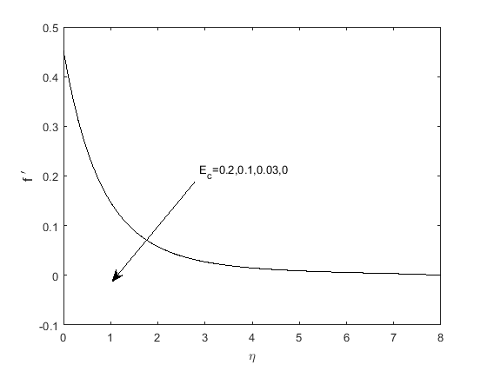

**Fig.5. Effects of Porous medium Fig.6. Effects of Eckert number**

**Parameter on Velocity profile on Velocity profiles.**

Fig.5 indicates the velocity profiles for various values of porosity parameter kp Some trend is noticed as in fig.4 i.e. increasing values of kp reduces the flow velocity.

Fig.6 exhibits velocity profiles for different values of Eckert number. Ec’ it is found that higher value of Eckert number enhances the velocity. But it is not so significant.

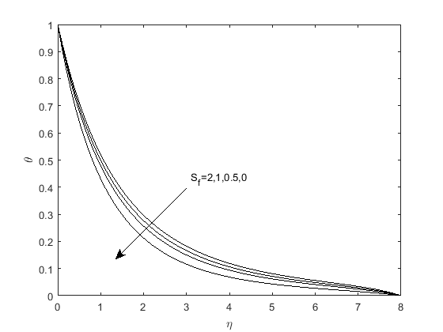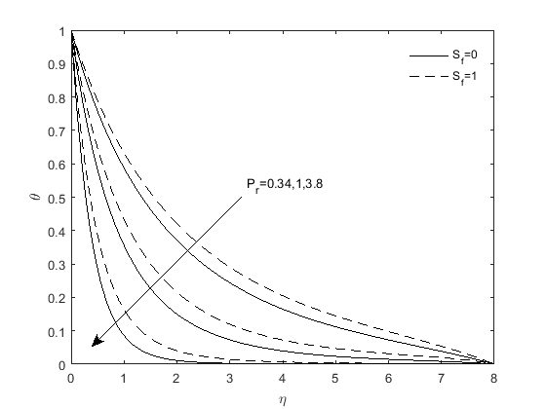

**Fig.7. Effects of Slip condition on Fig.8. Effects of Prandtl number on**

**Temperature profiles Temperature profiles**

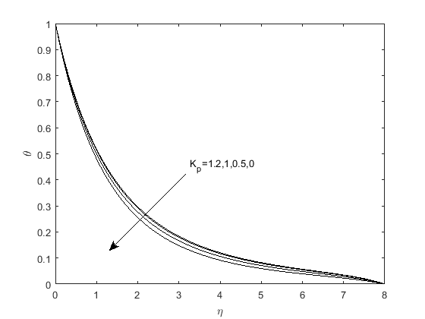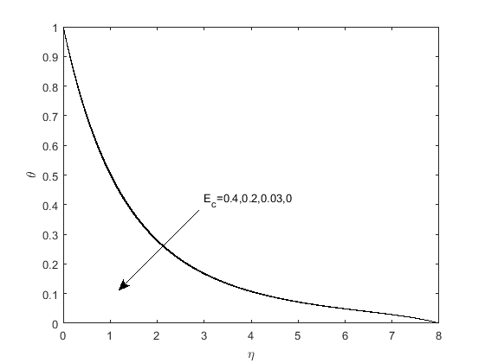

**Fig.9. Effects of Porous medium parameter Fig.10. Effects of Eckert number**

**on Temperature profiles on Temperature profiles.**

Fig.7 illustrates the temperature distribution for the different values of prandtl number (Pr) with and without velocity slip. It is found that increasing values of prandtl number decreases the temperature with or without velocity slip. Prandtl number is the ratio of momentum diffusivity to the thermal diffusivity.

So it assesses the reaction between momentum transport and thermal transport capacity of a fluid.

Higher values of Prandtl number represents lower thermal diffusivity and also the momentum transport dominates over the heat transport, which makes the fluid a poor choice for heat conduction. Therefore, lower temperature is obtained.

Further, it is clearly noticed that in presence of velocity slip, the temperature is more as compared to temperature without the slip factor. Therefore; velocity slip can be neglected when a cooling system is required.

From Fig. 8 and Fig. 9, it is observed that increasing values of both porosity parameter (kp) and Eckert number (Ec) reduce the temperature. In case of Ec, reduction of temperature is not so significant.

Fig.10 depicts the temperature profiles for some values of heat source parameter. As the heat source parameter increases, temperature increases, which is obvious.

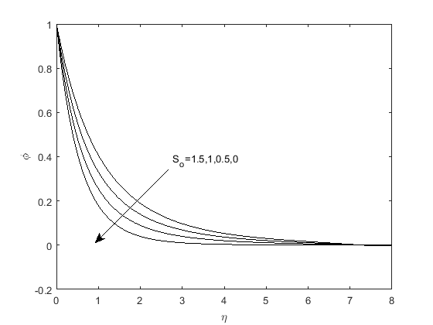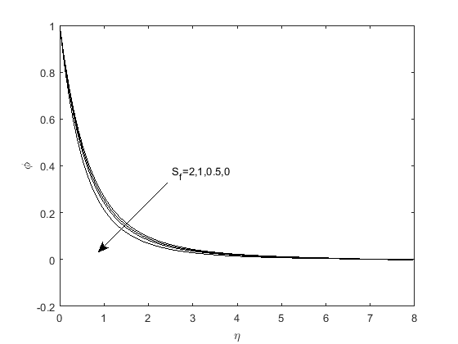

**Fig.11. Effects of Soret number on Fig.12. Effects of Slip condition on**

**Concentration profiles. Concentration profiles.**

Fig. 11 illustrates the concentration profiles for some values of Soret number (So). From this figure, it is pointed out that concentration of the fluid increases with increase in the value of Soret number because of the involvement of temperature gradient.

Fig.12. Elucidates the concentration profiles for different values of chemical reaction parameter (Kr) with and without velocity slip. It is found that increasing values of chemical reaction parameter lead to lower concentration in both the cases i.e. with or without velocity slip. But concentration in the presence of slip factor (Sf=1) is found more as compared to the concentration profile without velocity slip factor (Sf=0).

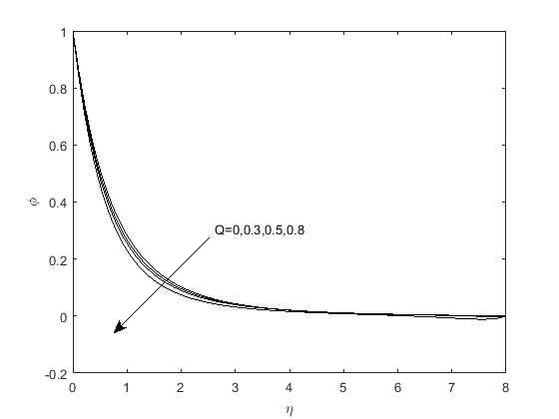 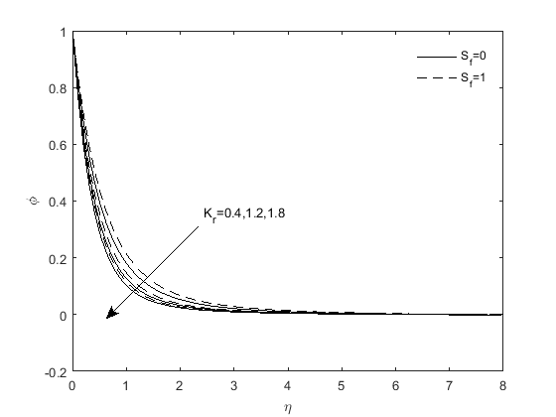

**Fig.13. Effects of Thermal radiation Fig.14. Effects of Chemical reaction**

**Parameter on Concentration profiles. Parameter on Concentration profiles.**

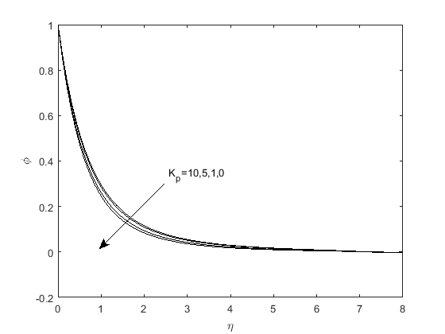 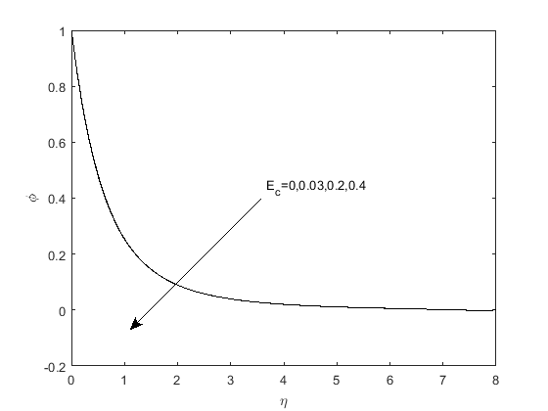

**Fig.15. Effects of Porous medium parameter Fig.16. Effects of Eckert number on**

**on Concentration profiles. Concentration profiles.**

Fig.13 and Fig.15 depict the concentration profiles for different values of heat source parameter ‘Q’ and porosity parameter ‘Kp’ respectively. Heat source parameter is inversely proportional to concentration whereas porosity parameter is directly proportional to the concentration.

The effect of Eckert number (Ec) on concentration profile is presented in Fig. 16. It is noticed that increase in Eckert number improves the concentration.

**TABLE-I**

Comparison of $θ'$ (0) when values of Kp = M =0.5, Gr=0.1, Gc=0.1, $β_{1}$ =0.012, $β_{2}$ =0.01,Pr =0.72,

R =0.01, Kr=0.1, Ec=0.03, Sc=2.

|  |  |  |  |  |  |  |  |
| --- | --- | --- | --- | --- | --- | --- | --- |
| **A** | $f_{w}$ | **Pr** | **Gr** | **Ishank et.al [46]** | **Sandeep**  **et.al [47]** | **Mjankwi**  **et.al [48]** | **Present Study** |
| 0 | -1.5 | 0.72 | 0 | 0.4570 | 0.4566 | 0.4570 | 0.4537 |
| 0 | -1.5 | 1 | 0 | 0.5000 | 0.5001 | 0.5001 | 0.5002 |
| 0 | -1.5 | 10 | 0 | 0.6452 | 0.6451 | 0.6451 | 0.6451 |
| 0 | 0 | 0.01 | 0 | 0.0197 | 0.0192 | 0.0197 | 0.1774 |
| 0 | 0 | 0.72 | 0 | 0.8086 | 0.8082 | 0.8086 | 0.8120 |
| 0 | 0 | 1 | 0 | 1.0000 | 1.0001 | 1.0000 | 1.0004 |
| 0 | 0 | 3 | 0 | 1.9237 | 1.9231 | 1.9239 | 1.9234 |
| 0 | 0 | 10 | 0 | 3.7207 | 3.7202 | 3.7207 | 3.7204 |
| 0 | 1.5 | 0.72 | 0 | 1.4944 | 1.4945 | 1.4944 | 1.4945 |
| 0 | 1.5 | 1 | 0 | 2.0000 | 2.0001 | 2.0000 | 2.0000 |
| 0 | 1.5 | 10 | 0 | 16.0842 | 16.0837 | 16.0842 | 16.0841 |
| 1 | 0 | 1 | 0 | 1.6820 | ---------- | 1.6820 | 1.6819 |
| 1 | 0 | 1 | 1 | 1.7039 | ----------- | 1.7037 | 1.7039 |

**CONCLUSION:-**

* Velocity of the flow increase with increase in Soret number. Physically, we can say that due to higher temperature difference fluid flows with higher velocity. it can be noticed that the change in velocity for different values of Soret number is more significant at $η$ =1 to $η$ =3.
* Velocity of the flow decelerates for higher values of 1st order slip parameter. Therefore slip factor is very much interest whenever a low velocity finds is a requirement.Increase in magnetic parameter reduces the velocity of the fluid flow. So magnetic force acts as a resistive force. For scientifically or physically need, magnetic force can be applied to reduce the flow velocity**.** It is found that higher value of Eckert number enhances the velocity. But it is not so significant.
* Increasing values of prandtl number decreases the temperature with or without velocity slip. Prandtl number is the ratio of momentum diffusivity to the thermal diffusivity.
* Higher values of prandtl number represents lower thermal diffusivity and also the momentum transport dominates over the heat transport.
* Increasing values of both porosity parameter (Kp) and Eckert number (Ec) reduce the temperature. In case of Ec, reduction of temperature is not so significant.
* Concentration of the fluid increases with increase in the value of Soret number because of the involvement of temperature gradient.
* It is found that increasing values of chemical reaction parameter lead to lower concentration in both the cases i.e. with or without velocity slip. But concentration in the presence of slip factor (Sf=1) is found more as compared to the concentration profile without velocity slip factor (Sf=0).
* Heat source parameter is inversely proportional to concentration whereas porosity parameter is directly proportional to the concentration.

**REFERENCES:-**

[1] Nachtsheim PR, Swigert P. Satisfaction of the asymptotic boundary conditions in numerical solution of the system of nonlinear equations of boundary layer type. *NASA TND*-3004; 1965.

[2] Ali F, Khan I, Samiulhaq, Shafie S. Conjugate effects of heat and mass transfer on MHD free convection flow over an inclined plate embedded in a porous medium. *PLoS ONE 2013*;8(6): e 65223

.

[3] Ismail Z, Khan I, Nasir NM, Jusoh R, Salleh MZ, Shafie S. Rotation effects on coupled heat and mass transfer by unsteady MHD free convection flow in a porous medium past an infinite inclined plate. *In: Proceedings of AIP conference,* vol. 1605; 2014. p. 410.

[4] Khan A, Khan I, Ali F, Shafie S. Effects of wall shear stress on MHD conjugate flow over an inclined plate in a porous medium with ramped wall temperature. *Hindawi Publishing Corporation, Mathematical Problems in Eng;* 2014 [Article ID 861708, 15pages].

[5] T. Hayat, M.I. Khan, M. Waqas, A. Alsaedi, T. Yasmeen, Diffusion of chemically reactive species in third grade flow over an exponentially stretching sheet considering magnetic field effects, *Chin. J. Chem. Eng.* (2016).

[6] M. Sheikholeslami, D.D. Ganji, Nanofluid convective heat transfer using semi analytical and numerical approaches: a review*, J. Taiwan Inst. Chem. Eng.* 65 (2016) 43–77,

[7] O. Ghaffarpasand, Numerical study of MHD natural convection inside a sinusoidally heated lid-driven cavity filled with Fe3O4-water nanofluid in the presence of Joule heating,

*Appl. Math. Model*. (2016),

[8] B. Mahanthesh, B.J. Gireesha, R.S.R. Gorla, Unsteady three dimensional MHD flow of a nano Eyring-Powell fluid past a convectively heated stretching sheet in the presence of thermal radiation, viscous dissipation and Joule heating, *J. Ass. Arab Univ. Bas. Appl. Sci*. (2016),

[9] Mohsen Sheikholeslami, Davood Domiri Ganji, Nanofluid flow and heat transfer between parallel plates considering Brownian motion using DTM, *Comput. Methods Appl. Mech. Eng.* 283 (2015) 651–663.

[10] D. Harish Babu, P.V. Satya Narayana, Joule heating effects on MHD mixed convection of a Jeffrey fluid over a stretching sheet with power law heat flux: a numerical study, *J. Magn. Mater.* 412 (2016) 185–193.

[11] H. Upreti, A.K. Pandey, M. Kumar, MHD flow of Ag-water nanofluid over a flat porous plate with viscous-Ohmic dissipation, suction/injection and heat generation/absorption*, Alexa dria Eng. J*. (2017).

[12] Kh Hosseinzadeh, A. Jafarian Amiri, S. Saedi Ardahaie, D.D. Ganji, Effect of variable lorentz forces on nanofluid flow in movable parallel plates utilizing analytical method, Case Stud. *Therm. Eng.* 10 (2017) 595–610.

[13] S.S. Nourazar, M. Hatami, D.D. Ganji, M. Khazayinejad, Thermal-flow boundary layer analysis of nanofluid over a porous stretching cylinder under the magnetic field effect, *Powder Technol*. 317 (2017) 310–319.

[14] G. Janardhana Reddy, Bhaskerreddy Kethireddy, J.C. Umavathi, Mikhail A. Sheremet, Heat flow visualization for unsteady Casson fluid past a vertical slender hollow cylinder, Therm. Sci. Eng. Prog. 5 (2018) 172–181.

[15] J.V. Ramana Reddy, V. Sugunamma, N. Sandeep, Enhanced heat transfer in the flow of dissipative non-Newtonian Casson fluid flow over a convectively heated upper surface of a paraboloid of revolution, *J. Mol. Liq.* 229 (2017) 380–388.

.

[16] Ibukun Sarah Oyelakin, Sabyasachi Mondal, Precious Sibanda, Unsteady Casson nanofluid flow over a stretching sheet with thermal radiation, convective and slip boundary conditions*, Alex. Eng. J*. 55 (2016) 1025–1035.

[17] A. Kamran, S. Hussain, M. Sagheer, N. Akmal, A numerical study of magneto hydrodynamics flow in Casson nanofluid combined with Joule heating and slip boundary conditions, Results Phys. 7 (2017) 3037–3048.

[18] M. Sheikholeslami, Z. Ziabakhsh, D.D. Ganji, Transport of Magneto hydrodynamic nanofluid in a porous media, Colloids Surf. A: *Physicochem. Eng. Asp.* 520 (2017) 201–212.

[19] S.Nadeem, Rashid Mehmood, S.S. Motsa, Numerical investigation on MHD oblique flow of Walter's B type nanofluid over a convective surface, *Int. J. Therm.Sci.* 92 (2015)

162–172.

[20] C.S.K. Raju, N. Sandeep, V. Sugunamma, M. Jayachandra Babu, J.V. Ramana Reddy, Heat and mass transfer in magneto hydrodynamic Casson fluid over an exponentially permeable stretching surface, *Eng. Sci. Technol. Int. J.* 19 (2016) 45–52.

[21] Kai-Long Hsiao, Micropolar nanofluid flow with MHD and viscous dissipation effects towards a stretching sheet with multimedia feature, *Int. J. Heat Mass Transf.* 112 (2017) 983–990.

[22] S.S. Ghadikolaei, Kh Hosseinzadeh, M. Yassari, H. Sadeghi, D.D. Ganji, Boundary layer of micropolar dusty fluid with Tio2 nanoparticles in a porous medium under the effect of magnetic field and thermal radiation over a stretching sheet*, J. Mol. Liq.* 244 (2017) 374-389.

[23] S.S. Ghadikolaei, Kh Hosseinzadeh, D.D. Ganji, M. Hatami, Fe3O4–(CH2OH)2 nanofluid analysis in a porous medium under MHD radiative boundary layer and dusty fluid, *J. Mol. Liq.* 258 (2018) 172–185.

[24] M. Hatami, Kh Hosseinzadeh, D.D. Ganji, M.T. Behnamfar, Numerical study of MHD two-phase Couette flow analysis for fluid-particle suspension between moving parallel plates, *J. Taiwan Inst. Chem. Eng.* 45 (2014) 2238–2245.

[25] S.M. Ibrahim, G. Lorenzini, P. Vijaya Kumar, C.S.K. Raju, Influence of chemical reaction and heat source on dissipative MHD mixed convection flow of a Casson Nanofluid over a nonlinear permeable stretching sheet, *Int. J. Heat Mass Transf.* 111 (2017) 346–355.

[26] S.S. Ghadikolaei, Kh Hosseinzadeh, D.D. Ganji, Analysis of unsteady MHD Eyring-Powell squeezing flow in stretching channel with considering thermal radiation and Joule heating effect using AGM, Case Stud. *Therm. Eng.* 10 (2017) 579–594.

[27] Umar Khan, Naveed Ahmed, Syed Tauseef Mohyud-Din, Numerical investigation for three-dimensional squeezing flow of nanofluid in a rotating channel with lower stretching wall suspended by carbon nanotubes*, Appl. Therm. Eng.* 113 (2017) 1107–1117.

[28] B. Mahanthesh, B.J. Gireesha, R.S.R. Gorla, Nonlinear radiative heat transfers in MHD three dimensional flow of water based nanofluid over a non-linearly stretching sheet with convective boundary condition, *J. Niger. Math. Soc.* 35 (2016) 178–198.

[29] Ramesh GK, Prasannakumara BC, Gireesha BJ, Rashidi MM. Casson fluid flow

near the stagnation point over a stretching sheet with variable thickness and radiation. *J Appl Fluid Mech* 2016; 9(3):1115–22.

[30] O.D Makinde and W.N Mutuku, Hydro magnetic thermal boundary layer of nanofluids over a convectively heated flat plate with viscous dissipation and ohmic heating. *UPB Scientific Bulletin, Series A: Applied Mathematics and Physics*, vol.76, no.2,pp. 181-192,2014.

[31] E.Haile and B.Shankar. Heat and mass transfer through a porous media of mhd flow of nanofluids with thermal radiation, viscous dissipation and chemical reaction effects. *American Chemical Science Journal,* vol.4, pp.828-846, 2014.

[32] Kar S. Senapati N. Swain B.K. Effect of chemical reaction on MHD flow with heat and mass transfer past a vertical porous plate in the presence of viscous dissipation. *Bulletin of Pure and Applied Sciences,* Vol. 38E (Math & Stat.), No.1:2019.P.450-465.

[33] Chen CH. On the analytic solution of MHD flow and heat transfer for two types of viscoelastic fluid over a stretching sheet with energy dissipation, internal heat source and thermal radiation*. Int.J.Heat Mass Transfer* 2010; 53:4264-73.

[34] S. Ahmed, A. Batin and A.J Chamkha, Finite Difference Approach in porous media transport modelling for Magneto hydrodynamic unsteady flow over a vertical plate: Darcian Model, *Int. J. of Numerical Methods for Heat and Fluid Flow*, 24(5)(2014), 1204-1223.

[35] S Ahmed and A.J. Chamkha, Hartmann Newtonian Radiating MHD flow for a rotating vertical porous channel immersed in a Darcian porous regime: An exact solution, *Int. J. of Numerical Methods for Heat and Fluid Flow,* 24(7)(2014), 1454-1470.

[36] Senapati .N, Dhal R.K, Das T.K, Effects of chemical reaction on mass and heat transfer on MHD free convection flow of fluids in vertical plates and in between parallel plates for slips flow regions, *American Journal of Computational and Applied mathematics*, 2012, 2(3), 124-135.

[37] Paul A., Transient free convective MHD flow past an exponentially accelerated vertical porous plate with variable temperature through a porous medium, *International Journal of Engineering Mathematics,* (2017), Article ID2981071, 1-9.

[38] T. Hayat, M. Mustafa and I. Pop**:** Heat and mass transfer for Soret and Dufour effects on mixed convection boundary layer flow over a stretching vertical surface in a porous medium filled with a visco-elastic fluid, *Communications in Nonlinear Science and Numerical Simulation,* 15 (5), (2010**) ,**1183 – 1196

[39] Yih KA: The effect of transpiration on coupled heat and mass transfer in mixed convection over a vertical plate embedded in a saturated porous medium. *International Communications in Heat and Mass Transfer,* 24(2):(1997)**,** 265–275.

[40] Srihari K, Anand Rao J and Kishan N.**:** MHD free convection flow of an incompressible viscous dissipative fluid in an infinite vertical oscillating plate with constant heat flux*. J. Energy, Heat and Mass Transfer*, 28: (2006),19-28.

[41] Seethamahalakshmi, B. D. C. N. Prasad and G. V. Ramana Reddy**:** MHD free convective mass transfer flow past an infinite vertical porous plate with variable suction and Soret effect, *Asian Journal of Current Engineering and Maths,* 1 (2) .(2012) ,49 – 55 .

[42] Sankar Reddy, T.V.Ramachandra Prasad, P.Roja and N.Bhaskar Reddy:Radiation effects on MHD mixed convection flow of a micropolar fluid past a semi-infinite vertical plate in a porous medium with heat absorption, *Int. J. of Appl. Math. and Mech.,* Vol. 6, No. 18, .( 2010), pp. 80 – 101.

[43] Samad, M. A. and M. Mobebujjaman **:** MHD heat and mass transfer free convection flow along a vertical stretching sheet in presence of magnetic field with heat generation, *Research Journal of Applied Sciences, Engineering and Technology*, Vol. 1, No. 3,(2009), pp. 98 – 106.

[44] O. A. Beg, J. Zueco and H. S. Takhar.:Unsteady magneto hydrodynamic Hartmann – Couette flow and heat transfer in a Darcian channel with Hall current, ion slip, viscous and Joule heating effects: network numerical solutions, *Communications Nonlinear Science Numerical Simulation*, 14 (4) , .(2009),1082 – 1097.

[45] K. Srihari, J. Anand Rao and N. Kishan :MHD free convection flow of an incompressible viscous dissipative fluid in an infinite vertical oscillating plate with constant heat flux, Journal of Energy, Heat and Mass Transfer, 28,(2006), pp.19 – 28.

[46] A.Ishank, R.Nazar and I. Pop: Heat transfer over an unsteady stretching permeable surface with prescribed wall temperature, *Nonlinear Analysis: Real World Applications*, vol.10, no.5, pp.2909-2913, 2009.

[47] N.Sandeep, C.Sulochana, C.Raju, M.J.Babu and V.A.Sugunamma: Unsteady boundary layer flow of thermophoretic mhd nanofluid past a stretching sheet with space and time dependent internal heat source/sink.*Applied Mathematics,* vol.10, no.1, pp. 312-327, 2015.

[48] M.A Mjankwi,V.G Manjusa,E.W Mureithi and M.N James :Unsteady MHD flow of nanofluid with variable properties over a stretching sheet in the presence of thermal radiation and chemical reaction, *International journal of Mathematics and Mathematical Sciences,* Vol.2019Article ID 7392459,14 pages*.*

[49] B.K.Swain,S.Kar :Dissipative MHD flow of ternary-hybrid nanofluid over an inclined stretching sheet with heat source and mass flux due to temperature gradient, Journal of applied mathematics and Mechanics, *Z Angew Math Mech.* 2024;e202200360. https://doi.org/10.1002/zamm.202200360.