Fourier Transform Based IR Spectroscopy
Apodization effect and Resolution aspects
Anjesh Kumar¹, Deepak Kumar²,Het ram Swami³, Prakash Singh⁴, Nil Ratan Das⁵,Punit Vashisth⁶ , Ajay Kumar⁷
Instruments R & D Establishment, Raipur Dehradun
Abstract: Optical spectroscopy deals in quantification of parameters pertaining to absorption and emission of light by a substance. Spectroscopic based sensing and measurement has become the integral part of almost every field ranging from civil to defence application. There is a broad spectrum of optical spectroscopic techniques and find their application in almost every field. In FTIR spectroscopy, interferometry technique is used for analyzing the type of chemical and its quantity in a sample. FTIR spectroscopy system comprises a Michelson interferometer, optical detectors, single-frequency mode laser (SFML) to generate reference beam and embedded electronics controller/processor to process the acquired data. Present paper highlights the developmental issues and challenges faced in implementation of Fourier Transform infrared (FTIR) spectroscopy. Aim of the paper is to study the apodization effect and resolution aspects associated with FTIR system.
- Introduction
FTIR spectroscopy generates the absorption and emission spectrum of interacting substance in liquid, gas or powder form mainly [1]. IR source of particular wavelength band, interact with the sample. This spectral information is extracted from interacting IR light signal by interfering two time delayed light signal generated by splitting the IR light signal in the Michelson interferometer. This interference involves a mechanized/motorized movable mirror to generate a time delayed version of IR light. This mirror motion generates interferogram of unequal temporal spacing. Unequal temporal spacing is the result of the to and fro movement of movable mirror, mainly at starting and stopping position while reversing the direction. A very basic requirement for Fourier transform is to capture equally spaced samples. To overcome this issue, A single frequency mode laser (SFML) of lower frequency is used to generate spatially equal distant points located a wavelength distance apart. This SFML laser is co-aligned with IR source to generate IR and reference (visible) interferograms on same temporal scale. Both interferograms are acquired simultaneously using analog to digital converter (ADC) of suitable resolution and bandwidth. To generate FTIR spectrum, a series of different processing steps is applied to extract the spectral information [2].
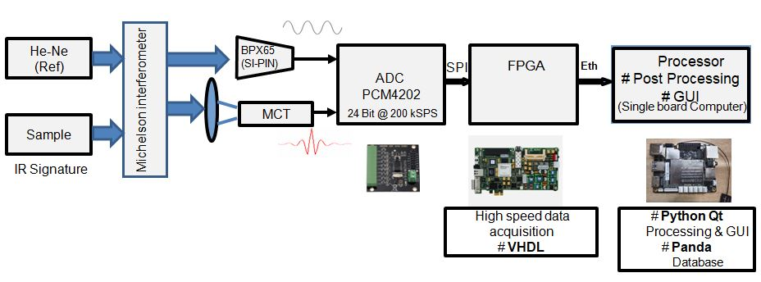
- System Overview: To study the Apodization effect and resolution aspects associated with a FTIR system, the electronics hardware and software has been realized using various components shown in figure 1.
Optical signal
Fig.1: Electronics Hardware of FTIR system
Here He-Ne laser act a SFML reference laser to generate equally spaced (λ/2) spatial points. Mercury Cadmium telluride (MCT) detector is used to capture IR signature of sample and Si detector (BPX65) is used to capture reference interferogram from SFM reference laser. The output of Si detector (BPX65) and MCT detector are acquired using analog to digital converter (PCM4202). FPGA (Artix-7) formats the captured data and feed the processing unit/Single board computer (Latte-panda). Algorithm to process the captured signal and generation of its spectral signature python Qt and Panda package have been utilized.

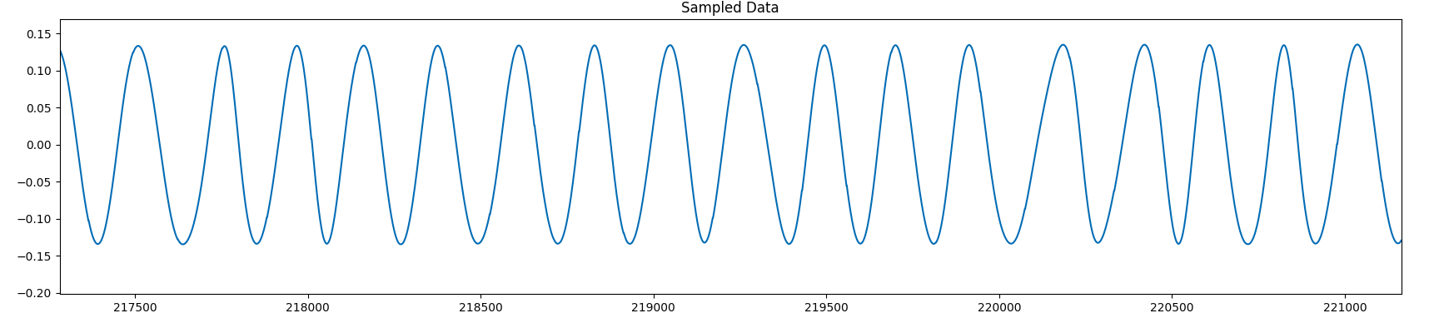
3. Algorithm implementation: FTIR spectrum generation involves series of complex processing steps. The crucial point for carrying out FFT is to generate equally spaced sample of IR interferogram captured using MCT. To double the numbers of sampling points, reference signal, a varying frequency sine wave, captured through Si detector is sampled twice at zero crossing points in a single time period. IR interferogram is sampled at these crossing locations. These temporal zero crossing sampling locations are mapped into spatial sampling points separated by a distance of λ/2(λ of reference laser). Re-sampled individual IR interferogram is multiplied by a suitable apodization function to define sample points associated with each interferogram recorded in one movable mirror cycle. Digital Fourier transform (DFT) algorithm is applied to individual apodized interferogram and recorded. Point averaging of all recorded spectra is carried out to generate resultant spectrum. A Normalization of the resultant spectrum limits its amplitude range between 0 to 1. Normalization is an important step to apply thresholding operation on peak/dip to quantify its value. A 3 to 5 points averaging function is applied on normalized resultant interferogram to remove high frequency noise. This smoothening operation helps in removing spurious peaks/dips. Using above mentioned steps a background spectrum is recorded without sample and stored. Now required sample is put in path of optical beam and MCT detector to record sample signature. To generate the final signature of sample, a background spectrum is subtracted from recorded sample spectrum. Captured Signal from Silicon detector, MCT detector and generated spectrum are shown in fig.2a, 2b and 2c. Overall algorithm is shown in fig 3.
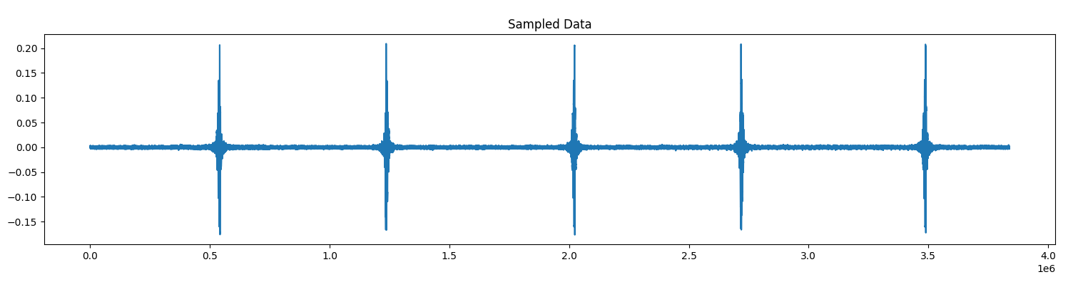
Fig. 2a: Recorded interferogram from Si detector
Fig. 2b: Recorded interferogram from MCT detector

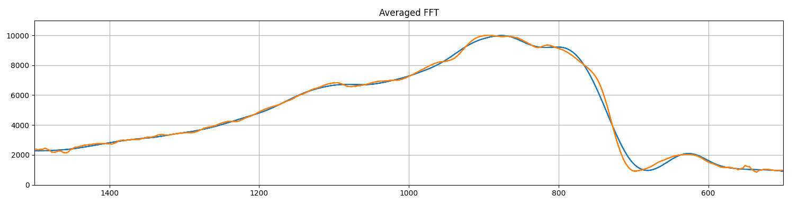
Fig. 2c: Recorded interferogram from MCT detector
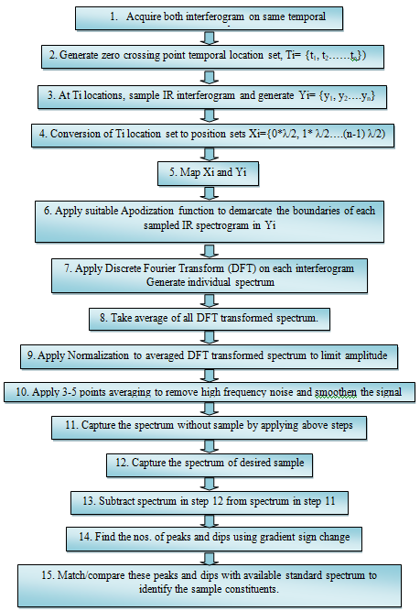

Fig 3: Algorithm steps to extract spectral information

- Apodization width selection and its effect: There are numbers of Apodization windows like Hann window, Rectangular windows, Triangular windows, Parzen windows and Welch window [5]. In present paper triangular window is applied as apodization function to demarcate data points associate with each interferogram. Figure 4, explains three different situations of Apodization window with no overlapping, slight overlapping and highly overlapped window. Overlapping lead to sharing of same data points by two consecutive interferograms. This phenomenon generates false frequency ringing noise in final averaged spectrum.
Fig. 3: Implementation steps of FTIR Algorithms
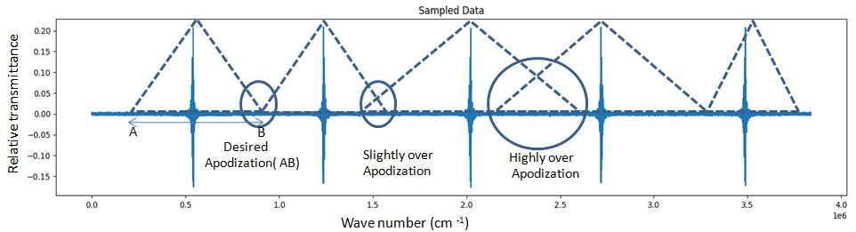
Fig.4: Triangular Apodization Window
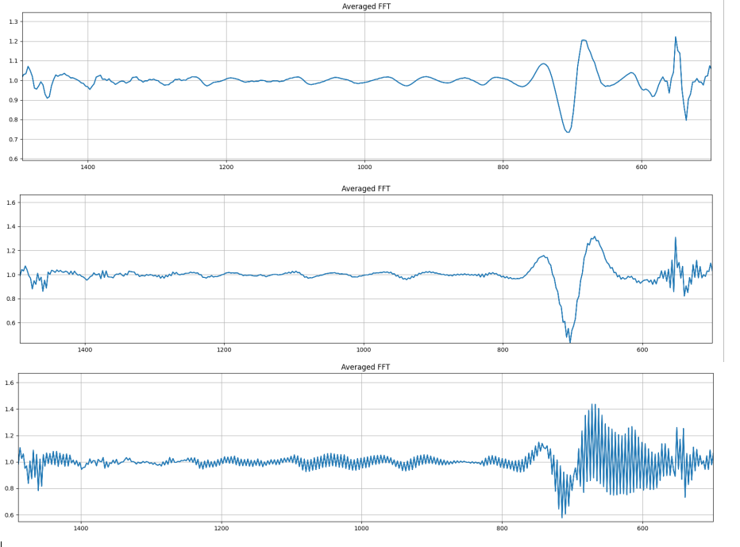
Figure 5: Effect of Apodization width
Ringing effect is shown in Figure 5. It shows three plots , First plot demonstrate the correct non overlapped Apodization window, Second plot demonstrates the slight overlapping of apodization
window and third plot demonstrates highly overlapped Apodization window. This ringing may distort the extracted information from DFT transformed spectrum. To deal with this effect two position demarcation sensors may be employed to set correct window.

Resolution of a FTIR system: Resolution of FTIR is system is expressed in cm⁻¹, a typical FTIR system has resolution between 0.1 to 4 cm⁻¹. Resolution of the system is very crucial to differentiate two closely spaced spectral peaks or dips. To generate high spectral contrast between spectrum peaks and dips, Resolution needs to be enhanced. In present system, user may select resolution for 0.1 cm⁻¹ to 4 cm⁻¹ as per requirement. Resolution can be varied by varying overall travel of movable mirror. This conclusion may be derived from standard Discreet Fourier transform equation 1 mentioned below

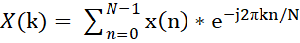 ………1
Here k/N is frequency factor, where N is sample length of IR interferogram signal and k is the k^{th} frequency. Δf between two consecutive frequency is given by equation 2
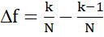 ……..2
From equation 2, it can be concluded that more the sample length, better is the resolution. In FTIR system, as speed of movable mirror increases, temporal frequency of reference laser (632nm) also increase. This increase in frequency of reference signal enhances the number of zero crossing points. Zero crossing points are sampling location of IR interferogram. This increase in zero crossing points of reference signal result in higher IR interferogram sample length. This increase will enhance the resolution of FTIR system.

Conclusion: FTIR is the forerunner technique to generate the spectral signature of different chemicals in different forms [6]. It employs Michelson interferometer to extract the spectral information of composite IR interferogram. Basically, DFT transform is used in implementation, Fast Fourier Transform (FFT) is algorithm to implement Discrete Fourier Transform (DFT) to transform equally spaced spatial data in FTIR spectrum. Speed of moving mirror in Michelson interferometer controls the resolution of closely spaced peaks/dips of FTIR spectrum. Higher speed will enhance the number of sampling points and more is sampling point higher is the resolution. Apodization is also a crucial parameter to demarcate sample points associated with each IR interferogram. Incorrect apodization generates spurious spectral components in FTIR spectrum. Sampling of IR interferogram at zero crossing points of reference signal is key factor to generate equidistant spatial points.

References

1. Active and passive infrared spectroscopy for the detection of environmental threats,
Erik R. Deutsch, Petros Kotidis, Ninghui Zhu. Anish K. Goyal, Jim Ye, Alex Mazurenko, Mark Norman, Kostas Zafiriou, Mark Baier, and Ray Connors, SPIE 9106, PP 91060A-1-10, 2014
2. Chemical warfare agent detection: a review of current trends and future perspective Frontiers in Bioscience, Eden Joy Pacsial-Ong, Zoraida P. Aguilar, Front. Biosci. (Schol Ed), 5(2), 516-543, 2013
3. Remote Measurement of Highly Toxic Vapours by Scanning Imaging Fourier- Transform Spectrometry, Roland Harig, Peter Rusch, Chris Dyer, Anita Jones, Richard Moseley, and Benjamin Truscott Hamburg, SPIE, 5995, PP599510, 2005
4. E J Pacsial-ong, “Chemical warfare agent detection: a review of current trends and future perspective Frontiers in Bioscience”, Front Biosci (Schol Ed), 5, 516, 2013
5. Quantitative infrared spectroscopy in challenging environments: applications to passive remote sensing and process monitoring, Qiaohan Guo, PhD thesis, Uni. of Iowa, 2012
6. D. Bergstrom, I. Renhorna, T. Svenssona, R. Perssona, T. Hallberga, R. Lindella and G. Boreman, “Noise properties of a corner-cube Michelson interferometer LWIR hyperspectral imager”, Proc. SPIE 7660 , 8, 2010

