EARLY DETECTION AND PREVENTION OF VARICOSE VEINS, THERAPEUTIC DEVICE

T.Arachelvi
Associate Professor – Dept.of Electronics and Communication
Tamilnadu College of Engineering
Coimbatore, India
arachelvi@gmail.com

PM.Manopragathesh
Student – Dept.of Electronics and Communication
Tamilnadu College of Engineering
Coimbatore, India
manomadhesh31@gmail.com
T.Thambidurai
Student – Dept.of Electronics and Communication
Tamilnadu College of Engineering
Coimbatore, India
thambidurait610@gmail.com

S.Sushma
Student – Dept.of Electronics and Communication
Tamilnadu College of Engineering
Coimbatore, India
sushmasathiyaseelan20022gmail.com

Abstract—Blood arteries called veins transport blood with little oxygen to the heart. However, leg veins struggle against gravity to force blood up towards the heart. Varicose veins are enlarged and twisted veins found in the subcutaneous tissues of the legs. Often, the blood valves in these veins are ineffective, resulting in blood reflux and symptoms of venous hypertension. Varicose veins are a chronic condition caused by improper blood circulation in the leg veins, disrupting the flow of blood from the legs to the heart. Usually present in the damaged blood arteries of the lower extremities, varicose veins are convoluted, swollen veins that cause swelling. Obesity and prolonged standing are the main causes of varicose vein disease. This project implements different ways in which varicose veins can be analyzed and how pain can be reduced in patients with varicose veins. A new system is needed to address the pain caused due to varicose veins in which the positional data are analyzed using various sensors and this data is processed in the microprocessor. The output of this system is detecting and combined heat and vibration therapy to the patient to reduce pain in a non-invasive way. IoT plays a significant role in the early detection of this condition by identifying using sensor values and real-time updates are then transmitted to the relevant persons through the application of Internet of Thing.
Keywords-ESP32, IoT, Force sensor, Vibration Motor, Blood Pressure Sensor, Temperature Sensor.

Introduction
varicose veins, a prevalent vascular condition, affect millions globally, primarily in the lower extremities, causing discomfort, pain, and cosmetic concerns. These enlarged and twisted veins disrupt normal blood flow, often leading to symptoms associated with venous insufficiency. Despite their prevalence and impact on individuals' well-being, varicose vein management has traditionally focused on symptom alleviation through surgical interventions, such as vein stripping and ligation.
Factors contributing to varicose vein development include genetics, prolonged standing or sitting, obesity, hormonal fluctuations, and pregnancy. While surgical interventions have been the standard of care for severe cases, recent advancements in medical technology and understanding of venous physiology have prompted a shift towards early detection and non-invasive treatments.
The integration of sensor technology, data analytics, and IoT connectivity offers new avenues for timely identification and intervention in varicose vein cases. Early detection plays a crucial role in mitigating complications like venous ulcers and deep vein thrombosis. Innovative therapies like heat and vibration therapy provide non-invasive options for managing symptoms and enhancing patient well-being.

Literature Survey

[1] Title: Early detection and prevention of varicose veins using embedded automation and internet of things
Author: Ashwin Das. M, Anand. I
Year: 2022
Description: Varicose veins are enlarged and twisted veins found in the subcutaneous tissues of the legs. Often, the blood valves in these veins are ineffective, resulting in blood reflux and symptoms of venous hypertension. Varicose veins are a chronic condition caused by improper blood circulation in the leg veins, disrupting the flow of blood from the legs to the heart. This occurs when blood accumulates in the leg veins, a condition called stasis, which causes blood to clot in the wrong direction and damages the inlet valve.

[2] Title: Varicose Veins Chronic Venous Diseases Image Classification Using Multidimensional Convolution Neural Networks
Author: Roshni Thanka. M, Bijolin Edwin. E, Priscilla Joy. R, Jeba Priya. S, Ebenezer.V
Year: 2022
Description: Varicose veins are enlarged and twisted veins found in the subcutaneous tissues of the legs. Often, the blood valves in these veins are ineffective, resulting in blood reflux and symptoms of venous hypertension. Varicose veins are a chronic condition caused by improper blood circulation in the leg veins, disrupting the flow of blood from the legs to the heart. This occurs when blood accumulates in the leg veins, a condition called stasis, which causes blood to clot in the wrong direction and damages the inlet valve.

[3] Title: The Efficiency of Use of a Thermal Imager in Telemedicine Planning of Treatment for Venous Patients
Author: Tatyana Rostovskaya, Dmitrii Rosukhovskii
Year: 2021
Description: The study simulates a telemedicine consultation, in which a phlebologist from a specialized center is provided with information about a patient by a general practitioner in the provinces, where there are no special methods of vascular examination, except thermography. The hypothesis is that thermography will help improve telemedicine counseling outcomes.

[4] Title: Air Compression Massage System for Chronic Vein Disorders
Author: Deekshita. R, Priscita. K, Shruthi Ram. R, Vigneshwari. N, Anisha. M, Gokul M
Year: 2022
Description: Pneumatic air compression massaging system widely helps to reduce the appearance and painful symptoms associated with chronic veins in some people. Compression stockings are frequently advised by medical professionals to enhance circulation, stop varicose veins from getting worse, and alleviate pain or discomfort. Leg chronic venous illness affects a large portion of the world's population.

[5] Title: Analysis of Varicose Veins of Lower Extremities Based on Vascular Endothelial Cell Inflammation Images and Multi-Scale Deep Learning
Author: Ruizong Zhu
Year: 2019
Description: This paper proposes a varicose vein recognition algorithm based on vascular endothelial cell inflammation images and multi-scale deep learning, called MSDCNN. First, we obtained images of vascular endothelial cells in patients with varicose veins of the lower extremities and normal subjects. Second, multiple convolution layers extract multi-scale features of vascular endothelial cell images.

Existing System
- In this system, the thermostat is used to detect the abnormality and given the treatment without human help.
- It is a non-invasive diagnostic & therapeutic solution for varicose veins using thermal & vibration therapy. Can be used wireless.
- The research has two major modules. The first module helps in monitoring and transmitting the upper body temperature of the patient.
- While the second module, monitors and calculates the temperature difference between upper and lower body with the temperature read from the legs and the temperature received from the first device.
- Combining the temperature difference and a force sensor, the device decides when to turn on the vibration motors and when to turn it off.

Disadvantages:
- The usage of same sensor multiple times in order to monitor the upper body and lower body temperature seems to have no purpose.
- There are still improvements that can be made especially when the current domain is improving rapidly.
- It consists of two modules which is expensive compared to our model. Non - intravenous way of measuring temperature and massaging the veins can also be improved with the developments in that respective field.

Proposed System
- The aim of this project is to gather the real-time data of the patient through different sensors on the patient body. Several biosensors are used to collect the data like pressure sensor, blood level, temperature, and oxygen level of the patient.
- Blood level sensor is used to monitor the blood level of a patient, any deviation in these data, it is alerted using buzzer and can be monitored via Mobile remotely by the doctors, caretaker or family members with the help of Blynk app which works on IOT technology.
- Pressure sensor is a sensor which calculates the force applied by the person or pressure that is exerted due to prolonged standing or sitting.
- Temperature sensor is used to monitor the body heat of the person and it is very much sensitive and react to small changes in temperature.
- If the temperature value changes or drops down then, it turns on the Vibration Motor to gently massage the affected area to restore the blood flow and Peltier crystal is used to provide heat along with the vibration therapy.

Advantages:
- IOT integrates medical devices with the internet and provides/updates the real-time health status of patients to the consulting doctors.
- It also promotes self-monitor and share key physiological parameters, gaining more knowledge and control over their personal health status.
- Furthermore, the home-care environment includes also a set of environmental sensors installed in each room of the house, to sense the movements of the users during the day, thus giving authorized informal care-givers a means to access the data collected and understand possible anomalies.

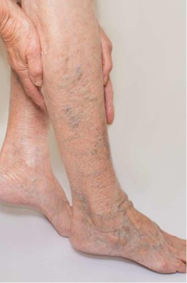

Fig 1: Varicose Veins Patient

System Architecture
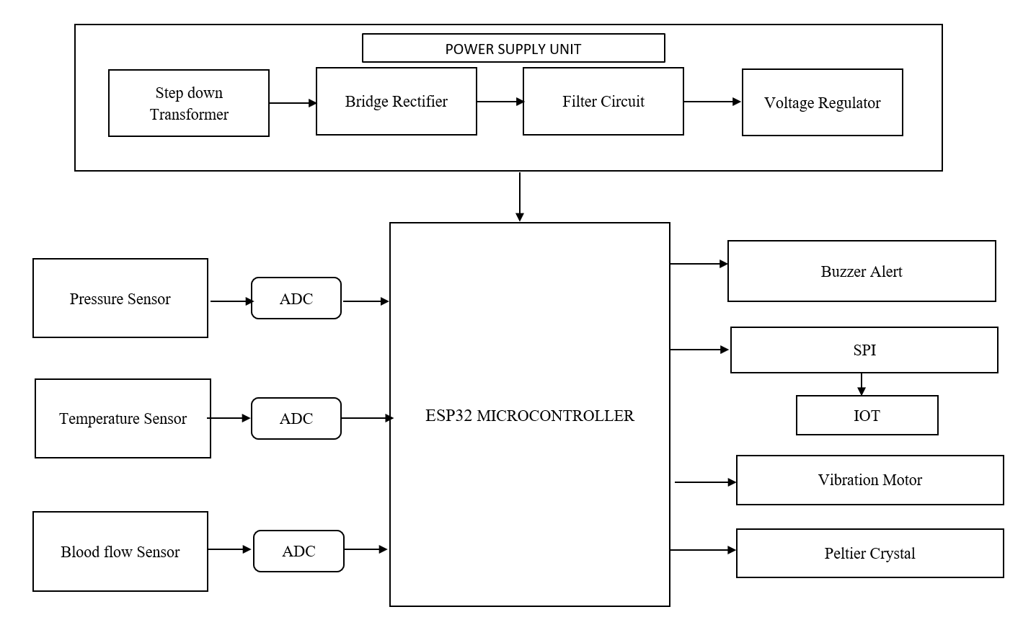
Fig 2: Architecture Diagram

Implementation
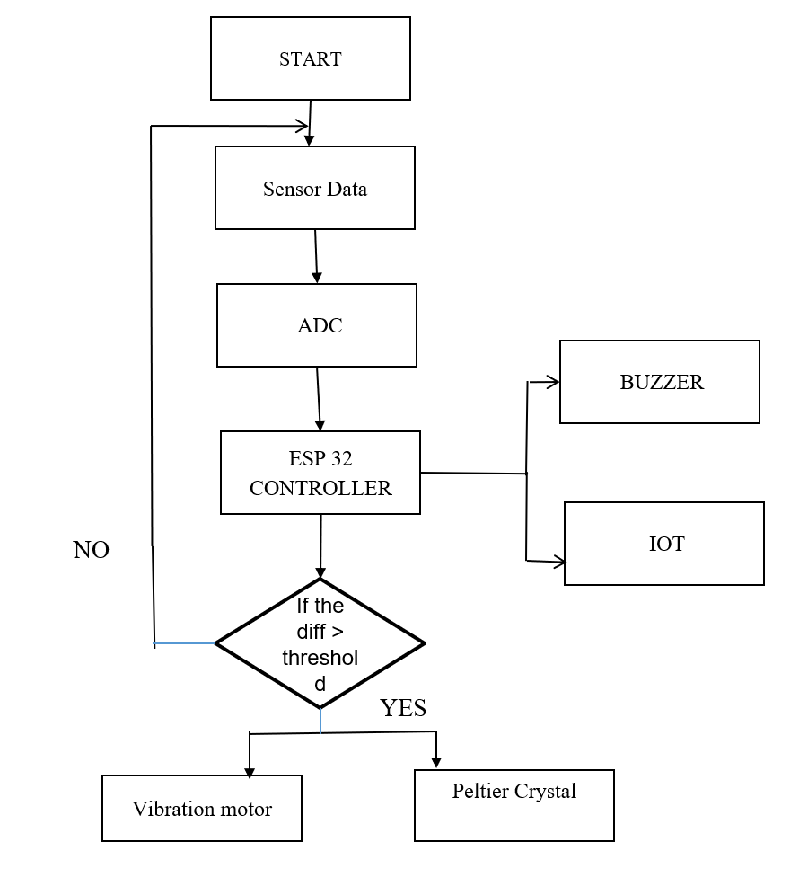
Fig 3: Flow Chart

Components Used

ESP32 Controller
ESP32 is a series of low-cost, low-power system on a chip microcontrollers with integrated Wi-Fi and dual-mode Bluetooth. The ESP32 series employs either Tensilica Xtensa LX6 microprocessor in both dual-core and single-core variations, XtensaLX7 dual-core microprocessor or a single-core RISC-V microprocessor and includes built-inantenna switches, RF balun, power amplifier, low-noise receive amplifier, filters, and power-management modules. ESP32 is created and developed by Espressif Systems, a Shanghai based Chinese company, and is manufactured by TSMC using their 40 nm process. It is a success or to the ESP8266 microcontroller.
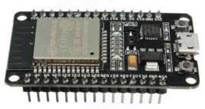
Fig 4: ESP32 Controller

Force Sensor
Force Sensing Resistors (FSR) are a kind of polymer thick film (PTF) gadget that diminishes opposition as the power applied to the dynamic surface increments. FSRs are a type of polymer thick film (PTF) gadget that decreases opposition as the power applied to the dynamic surface rises. FSRs share comparable qualities, however are not load cells or strain measures. FSRs are not reasonable for accuracy estimations.

FSRs are essentially resistors that change their resistance value (in ohms) based on how far they're pressed. These sensors are minimal expense, and smooth to apply anyway they're barely ever exact. They likewise differ from one sensor to another, maybe 10%. In this way, while utilizing FSRs, you ought to just expect to get reaction ranges. FSRs can detect weight, but they aren't the best way to figure out how many pounds are on them. For the great majority of touch sensitive applications, such as "has this been squeezed or pressed and by how much?”
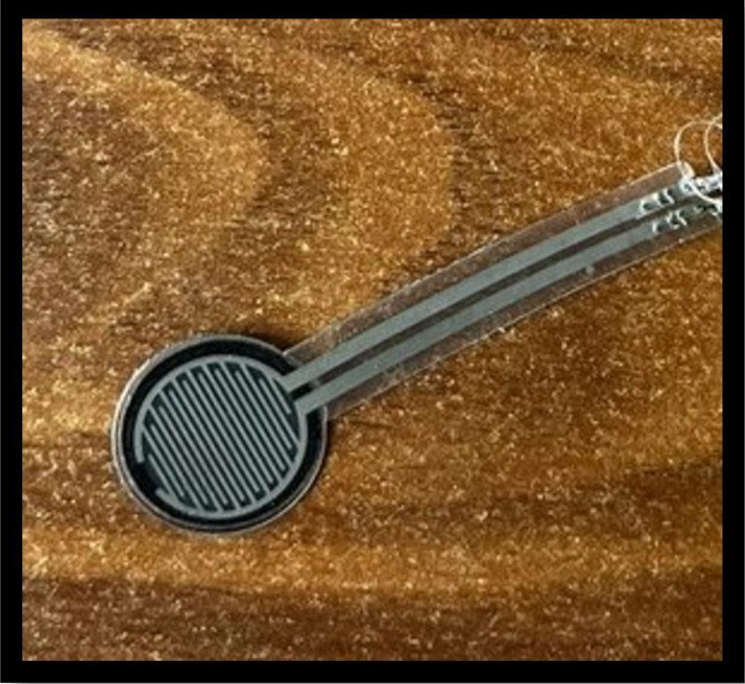

Fig 5: Force Sensor

Temperature Sensor
The first slave connected to a temperature sensor LM35. This senses the temperature of an engine and provides the level of temperature.

The LM35 series are precision integrated-circuit temperature sensors, whose output voltage is linearly proportional to the Celsius (Centigrade) temperature. The LM35 thus has an advantage over linear temperature sensors calibrated in Kelvin, as the user is not required to subtract a large constant voltage from its output to obtain convenient Centigrade scaling.
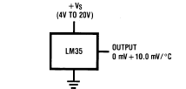

Fig 6: Temperature Sensor

Blood Pressure Sensor
Blood pressure (BP) is the pressure exerted by circulating blood upon the walls of blood vessels. When used without further specification, "blood 30 pressure" usually refers to the arterial pressure in the systemic circulation. It is usually measured at a person's upper arm. Blood pressure is usually expressed in terms of the systolic (maximum) pressure over diastolic (minimum) pressure and is measured in millimeters of mercury (mm Hg). It is one of the vital signs along with respiratory rate, heart rate, oxygen saturation, and body temperature. Normal resting blood pressure in an adult is approximately 120/80 mm Hg.

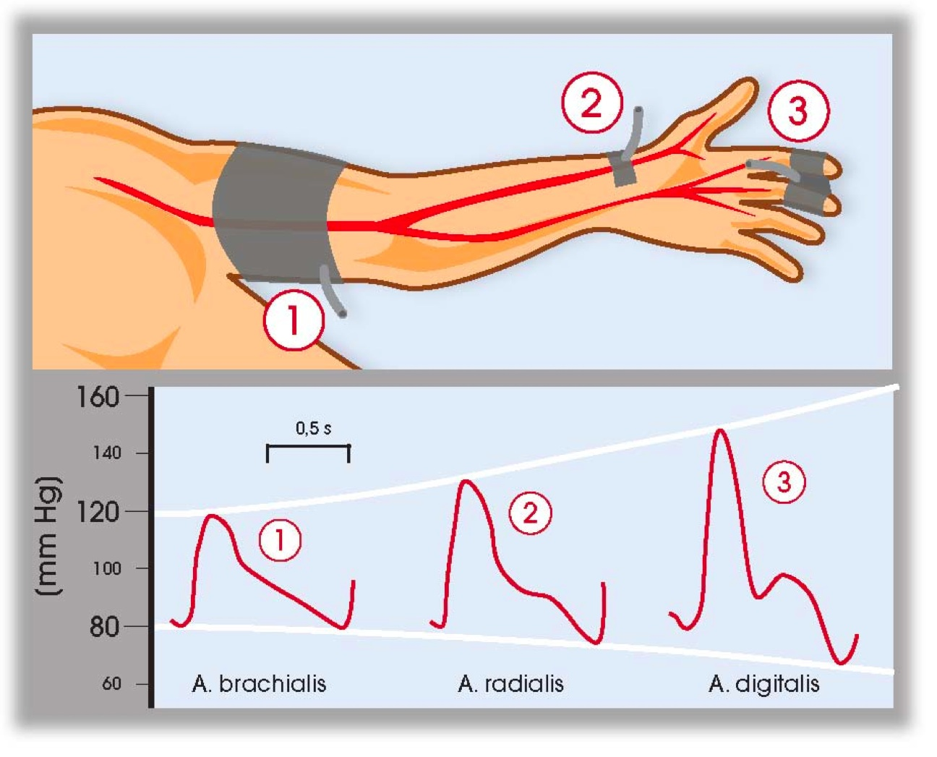
Fig 7: Blood Pressure Sensor

Vibration Motor
Coin-operated vibration motors, also known as shaftless or pancake vibration motors, are currently manufactured by precision microdrives, and the PicoVibe line typically has diameters ranging from 8mm to 12mm. The pancake motor is small and simple to operate. They feature no moving parts and may be attached with a strong, permanent self-adhesive fastening mechanism, allowing them to be used in a variety of designs. Enclosures for shaftless vibration motors may be simply moulded to accept the coin form. Wired, spring-loaded, and pad-mountable variants of coin motors are available. It is a delight for the changes of the base design, as it is with all of vibration motors. It alters the length and connection of the cable.

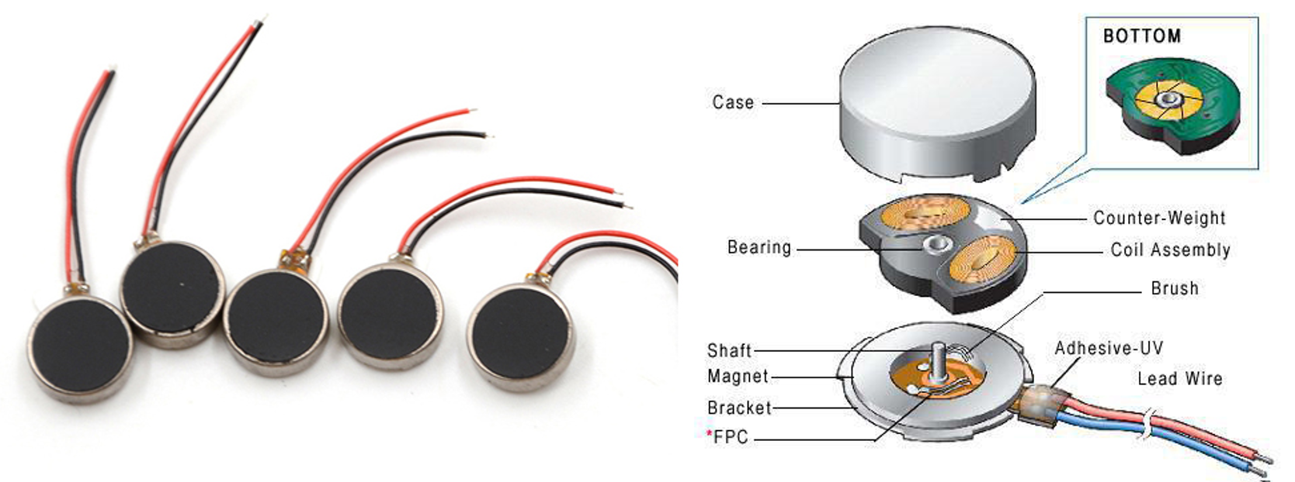
Fig 8: Exploded coin motor

Conclusion
The Our project is one such attempt in taking a stride to improve the current pain relief process for varicose veins patients. This system suggests a simple idea to monitor the patients’ health parameters related to varicose veins. Non - intravenous way of measuring temperature and massaging the veins are also an improvement with the developments in this respective field. The massage results in restoring the blood flow to the affected area. In conclusion, our project represents a significant advancement in the management of varicose veins, offering a comprehensive solution for monitoring patients' health parameters and providing non-invasive pain relief. By harnessing innovative sensor technology and therapeutic modalities, we have developed a system that not only detects varicose vein-related abnormalities early but also delivers targeted heat and vibration therapy to alleviate discomfort and improve blood flow. The simplicity and effectiveness of our approach make it a promising tool for enhancing the quality of life for varicose vein patients. By enabling continuous monitoring and intervention, our system empowers individuals to take proactive steps in managing their venous health, potentially preventing the progression of varicose veins and associated complications. Furthermore, the non-invasive nature of our therapeutic interventions offers a significant advantage over traditional treatment modalities, minimizing discomfort and downtime for patients. By incorporating massage therapy to stimulate blood flow, we address the root cause of varicose veins, promoting circulation and reducing symptoms in a natural and holistic manner.

References

- M Vignesh, C Kotheswaran, P Subash and M Yogeswari, "Evaluation of varicose vein prediction and accumulation reduction using artificial pressure generation", International Journal for Scientific Research & Development (IJSRD), vol. 10, pp. 284-287, 2022.
- J Rajeswari, A Shunmugalatha, S Indumathi, Vikasini. R. M Sanju and T Rajapandi, "Therapeutic prevention of varicose veins and deep vein thrombosis", International Research Journal Of Modernization In Engineering Technology And Science (IRJMETS), vol. 03, no. 3, pp. 1241 1246, March 2021.
- Abinya Chandramohan, Anju Sasi, Suresh Venkatesh and A Mohanarathinam, "Varicose veins controlling system using EMG signals", International Conference on Novel Approaches and Developments in Biomedical Engineering Journal of Physics: Conference Series, vol. 1937, April 2021.
- B Campbell, I J Franklin and M Gohel, "The choice of treatments for varicose veins: A study in trade-offs", Phlebology., vol. 35, no. 9, pp. 647 649, 2020.
- Fan Ma, Huimin Xu, Jiantao Zhang, Shyamal Premaratne, Hongxia Gao, Xiaorong Guo, et al., "Compression Therapy Following Endovenous Thermal Ablation of Varicose Veins: A Systematic Reviewand Meta Analysis", Annals of Vascular Surgery, vol. 80, pp. 302-312, 2022, ISSN 0890-5096.
- R. Zhu, H. Niu, N. Yin, T. Wu and Y. Zhao, "Analysis of Varicose Veins of Lower Extremities Based on Vascular Endothelial Cell Inflammation Images and Multi-Scale Deep Learning", IEEE Access, vol. 7, pp. 174345-174358, 2019.
- G Varadharajan and J. Anish Kumar, "Smart therapeutic treatment for varicose disease", International Journal For Research In Applied Science & Engineering Technology (IJRASET), vol. 9, pp. 161-168, January 2021.
- M. R. Thanka, E. B. Edwin, R. P. Joy, S. J. Priya and V. Ebenezer, "Varicose Veins Chronic Venous Diseases Image Classification Using Multidimensional Convolutional Neural Networks", 2022 6th International Conference on Devices Circuits and Systems (ICDCS), pp. 364-368, 2022.

