Implementation of TPM for Machine Performance Improvement
Zied KTARI* ^{(1), (2)}
- DGM, Institut Supérieur des Etudes Technologiques de Ksar Hellal (ISET KH), DGET
- Laboratoire de Génie Mécanique (LGM), Ecole Nationale des Ingénieurs de Monastir (ENIM)-Université de Monastir
zied.ktari@enim.u-monastir.tn

Abstract
Quality management and maintenance management of production systems are closely linked functions in modern enterprises. Over time, various improvement concepts have emerged, such as Total Productive Maintenance (TPM) and Total Quality Management, along with other concepts aimed at achieving high-level performance. In this paper, the experience of implementing Total Productive Maintenance in a hygiene and cosmetic product manufacturing company is illustrated and studied. The TPM project was implemented in the cotton swab manufacturing workshop, which is equipped with a critical automated production machine named STREMA. The losses associated with equipment efficiency were identified. Most of the TPM pillars were progressively implemented, aiming to eliminate sources of waste and improve preventive maintenance. The Overall Equipment Effectiveness (OEE) of the equipment is used to measure the degree of success in TPM implementation and to identify future improvement paths.
Keywords: TPM, availability, PM, 5S, SMED, OEE

Introduction
In the current industrial context, enormous losses/waste occur in the production workshop. These time losses are due to operators, maintenance personnel, process problems, tooling issues, and machine unavailability, among others. Other forms of losses include idle machines, inactive labor, machine breakdowns, non-conforming and rejected parts, etc. Quality-related non-conforming parts are of significant importance as they cost the company in terms of time, materials, and hard-earned reputation. There are also other invisible sources of losses such as machines operating below their rated speed, startup losses, machine breakdowns, and ongoing bottlenecks. Zero-oriented concepts like zero waste, zero defects, zero breakdowns, and zero accidents are becoming prerequisites in the manufacturing and assembly industry. In this situation, a revolutionary concept of Total Productive Maintenance (TPM) has been adopted in many industries worldwide to address the aforementioned issues. The goal of any TPM program is to improve productivity and quality, as well as employee morale and job satisfaction. Previously, preventive maintenance was considered a non-value-added process, but it is now an essential requirement for a longer machine lifecycle in an industry. TPM is an innovative maintenance approach that optimizes equipment efficiency, eliminates breakdowns, and promotes operator-driven maintenance through daily activities involving the entire workforce. Nakajima S.[1] pioneered this field and provided the basic definition of TPM, its importance, objectives, benefits and drawbacks, and the steps to follow during TPM implementation. The author also described the challenging obstacles to TPM implementation and the method for calculating the Overall Equipment Effectiveness (OEE) of machines by precisely identifying sources of time waste. Ahuja et al.[2] presented an extensive literature review of the TPM method, summarizing eight pillars for successful TPM implementation, as shown in fig. 1. On the other hand, Ireland et al.[3] conducted a study on the implementation of Total Productive Maintenance in three companies, focusing on the seven steps of autonomous maintenance proposed by Nakajima. Kennedy et al.[4] introduced the concept of TPM3, which stands for third-generation TPM and includes eight pillars instead of seven. TPM3 is an enhanced Australian approach applying the principles and practices of the Toyota Production System and the Toyota Way - Lean and TPM. Jeong et al.[5] provided a detailed classification scheme of losses for OEE calculation. Chan et al. [6] implemented the concept of TPM in the semiconductor industry, noting an 83% improvement in equipment yield. Marcelo Rodrigues et al. [7] discussed the reasons for TPM implementation failure and concluded that low involvement from individuals at different levels is the primary reason for TPM's failure. Chand et al. [8] deployed the TPM concept in a cellular manufacturing company, finding an availability rate of 62% and concluding that sustained TPM implementation is necessary to achieve an availability rate of over 85%. Eti et al. [9] implemented the TPM method in the Nigerian industry, emphasizing the importance of operator training for the successful application of the method. Manu Dogra et al. [10] detailed the implementation of TPM to improve the performance of a cold rolling mill. In this article, the experience of implementing the TPM concept in a hygiene product manufacturing company (Groupe SOTUPA, located in Bouhjar, Route de Sousse, TUNISIA) for a particular machine is illustrated and discussed succinctly. The fundamentals of TPM are progressively implemented, leading to continuous improvement in machine performance. In section 2, various TPM concepts are explained, and the approach adopted for implementation is also mentioned. Section 3 discusses the performance measurement of the machine after TPM implementation. Section 4 provides the conclusion of this work.

Methodology

Total productive maintenance
The TPM concept is progressively implemented in a workshop to improve the productivity of a cotton swab production machine called STREMA (see Fig. 1). Fig. 2b) presents the main function as well as the input and output materials of the STREMA machine.
Fig. 2: a) STREMA cotton swab production machine, b) Main function of the machine.

The machine is classified as critical for production. The effectiveness of the TPM approach will be measured by calculating the Overall Equipment Effectiveness (OEE) of the machine (STREMA). The OEE is an indicator that accounts for all time losses affecting the performance of a production line.
OEE=TP×TQ×TD (1)
Where TP is the performance rate, TQ is the quality rate, and TD is the availability rate. Considering the time definitions described in Fig. 3, the OEE is given by the formula in equation (2).
OEE = (TF/TR)×(TN/TF)×(TU/TN) (2)
The operation time (TF) is the required time minus the proper stops (breakdowns) and the induced stops mainly related to tool changes, machine adjustments, lack of upstream raw materials, etc. The net time (TN) is the operation time excluding unplanned stops and speed variances. The useful time (TU) corresponds to the duration of producing conforming parts.
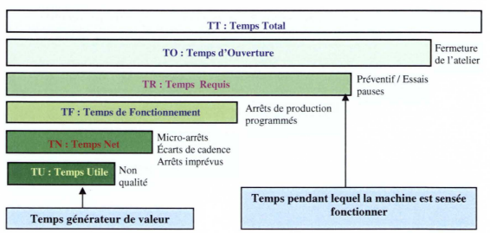
Fig. 1 Les différents temps pour le calcul du TRS
The implementation approach for each pillar is discussed in the following subsections.

Failure History Analysis
Table 1 lists the most frequent failures recorded in the history of the STREMA machine over one year. A descending classification according to the criterion "total technical repair time (TTR)" is presented. It can be noted that the failure of the cotton scrolling system is the most detrimental.
Table 1: FAILURE RECORD
Failures | ∑TTR (hours) | % of ∑TTR | Cumulative % of ∑TTR
Cotton scrolling system stop | 124.04 | 33% | 33%
Rod blockage | 81.21 | 22% | 55%
Electrical failure | 55.49 | 15% | 70%
Various mechanical failures | 48.22 | 13% | 83%
Table adjustment | 41.03 | 11% | 94%
Labeling failure | 16.5 | 4% | 98%
Glue circuit blockage | 6.62 | 2% | 100%

Cause-Effect Analysis (Ishikawa Diagram)
The cause-effect diagram was used to determine the causes of a very frequent problem encountered on this machine, which is the tearing of the cotton wick.
Fig. 2 Diagramme causes-effet

5S
TPM begins with the 5S methodology. The 5S can be considered the cornerstone of TPM implementation. It is a Japanese way of housekeeping. Problems cannot be recognized if the workplace is not organized. Cleaning and organizing the workplace helps us to better identify problems, providing an opportunity for improvement. If the 5S is not taken seriously, it leads to 5D, which stands for delays, defects, dissatisfied customers, declining profits, and demoralized employees. The meaning of each "S" is explained in Table 2. The 5S concept and its benefits were presented to the production workshop operators.
Tableau 1 signification des termes 5S
Terme en japonais | Traduction française | Equivalent en terme ”S”
Seiri | Ranger | Supprimer l’inutile
Seiton | Ordre | Situer les choses
Seiso | Nettoyage | Scintiller
Seiketsu | Propre | Standardiser les règles
Shitsuke | Education | Suivre et progresser

According to this method, the application of the "Seiri" concept involves keeping only what is strictly related to the execution of the production task and is of constant use at the workstation. Table 3 shows the frequency of use of items at the machine. Based on the scoring grid presented in Table 4, we were able to determine what should indeed be present at the workstation, what can be moved away, and what should be discarded.
Table 2: frequency of the use of each item near the STERMA machine
Items | Type | Frequency | Score
Cartons | MP | Very High | 5
Scale | EQ | High | 3
Label Roll | MP | Very High | 5
Cellophane Roll | MP | Very High | 5
Cotton | MP | Very High | 5
Cart | EQ | High | 3
Chairs | EQ | Low | 1
Table | EQ | Low | 1
Calculator | EQ | High | 2
Cleaning Kit | EQ | Very High | 4
Trash Bin | EQ | High | 3
Air Hose | EQ | Very High | 4
Toolbox | EQ | High | 2
Rance | EQ | Low | 1
Rod Basket | EQ | High | 3
Rod Cartons | MP | Very High | 5
Lift | MP | Very High | 5
Legend:
- MP: Frequently used for Production
- EQ: Equipment or Tools
Table 3 : Frequency of Use ponderation
Frequency of Use | Remark
4/5 | Necessary
2/3 | Moderately Necessary
0/1 | Low

The application of the "Seiton" concept is the most visible and sensitive step of all work processes, as it highlights the entire process. The goal is to make our environment visually appealing, prevent breakdown risks, and reduce accident hazards, while also aiding in preventive maintenance. Table 5 shows the impact of applying the 5S method on work processes. The current work environment is arranged according to the layout plan, as illustrated in Fig. 5.
Table 4: Application example of 5S
Report | Before | After
2S
4S | 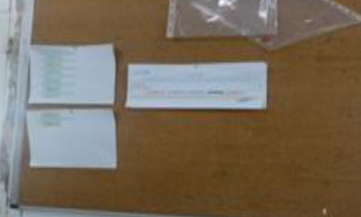
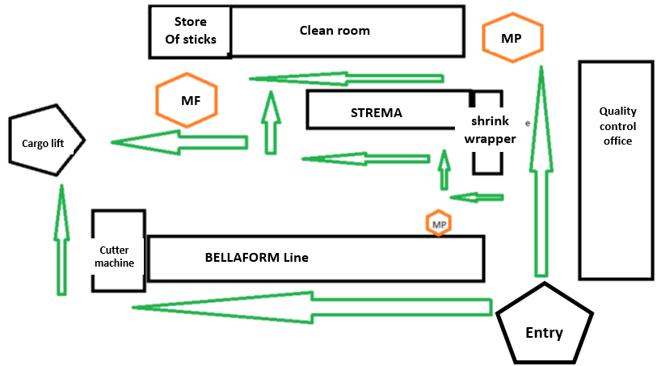
a) before
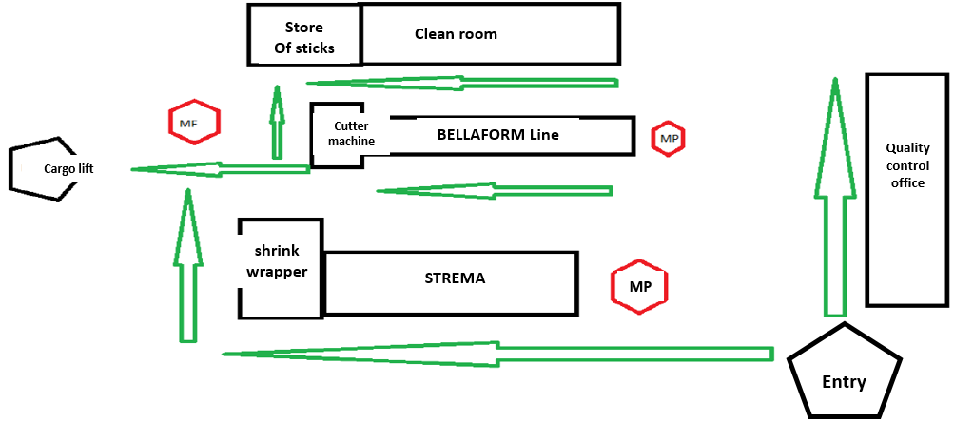
(b) After
Fig. 3 Workshop Layout Arrangement (a) Before 5S (b) After 5S

SMED Application
The SMED (Single Minute Exchange of Die) method is a tool for analyzing and optimizing setup times. The company produces two types of cotton swabs with either round or square stems. The SMED method was implemented to reduce the setup and adjustment time of the machine between format changes. This was achieved by identifying operations that were being performed incorrectly. Following the SMED implementation, we succeeded in reducing the setup time for the round format from 296.05 minutes to 217 minutes. For the square format, the setup time was reduced from 50 minutes to 27 minutes. This improvement enhanced the quality of technical procedures, making them more readable and understandable. Additionally, we combined operations and provided operators with more efficient maintenance and adjustment tools to further reduce assembly and disassembly time.

Autonomous Maintenance
Autonomous maintenance empowers operators by assigning them the responsibility for their machines. This involves tasks such as maintenance, machine inspections, or simple interventions for changing components. By improving equipment reliability, this approach enhances operator versatility, increases responsiveness to issues, and "relieves" maintenance technicians. Its deployment generally occurs in 7 steps: Cleaning and inspection, Eliminating sources of contamination and inaccessible areas, Establishing cleanliness and lubrication standards, Conducting general inspections, Performing autonomous inspections, Maintaining gains, and Continuing improvement. Fig. 6 illustrates an example of a standard sheet (NIL: Cleaning, Inspection, Lubrication) that was developed and implemented to apply autonomous maintenance to the STREMA machine.
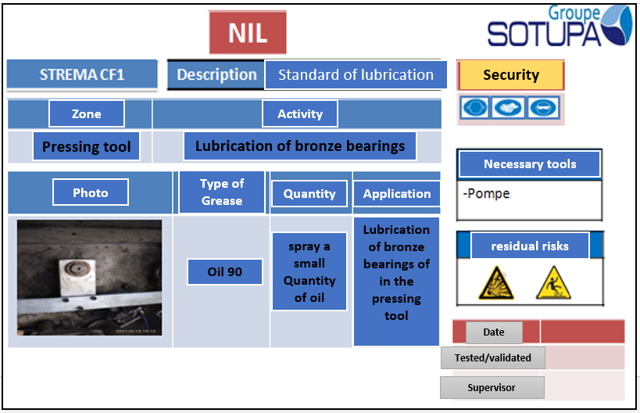
Fig. 4 Example of a NIL (Cleaning, Inspection, Lubrication) Standard Sheet

Preventive Maintenance
Preventive maintenance can be performed in three forms: systematic, conditional, or predictive. The goal of preventive maintenance is to increase machine availability, achieve optimal maintenance costs, improve reliability (reducing breakdowns) and maintainability (increasing repair rates), and ensure effective maintenance logistics (stock management for spare parts, qualified personnel, CMMS, etc.). We established FMEA (Failure Modes and Effects Analysis) tables for the components of the machine's subsystems to identify all possible failures and plan corresponding corrective actions.

PERFORMANCE MEASUREMENT: TRS CALCULATION
Fig. 7 shows the evolution of various rates of quality, availability, and effective operation over time. The graph also includes the evolution of TRS, which is the product of these three rates. It shows that the rate varies between 69% and 79%. The performance measured by the company before implementing TPM was evaluated at 83%. The observed discrepancy is due to the rigorous measurement of time losses and cycle time. The goal is to increase the TRS by first improving the performance rate, then the quality rate, and finally the availability rate.
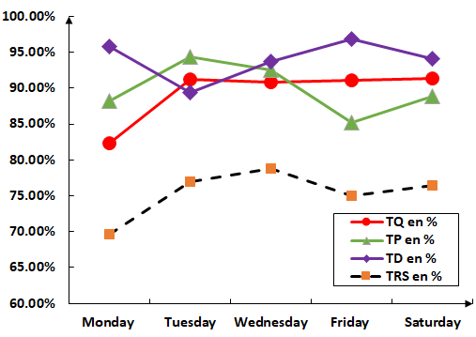
Fig. 5 Evolution of different performance rates TQ, TP, TD, and TRS Over Time

Conclusion

This paper presents the implementation of a performance improvement approach for a machine based on a modern technique known as TPM (Total Productive Maintenance) practiced within the company SENSEA. We started with the implementation of the 5S and SMED methods, which are fundamental for the success of any TPM initiative. We developed standards for monitoring the autonomous maintenance of the STREMA machine. Data collection sheets for time losses were created to accurately calculate the machine's Overall Equipment Effectiveness (OEE). The actual performance measurement of the machine shows instability, primarily due to quality issues repetitive minor stops, and autonomous maintenance, which will be the focus areas for TPM method improvement.

References
- S. Nakajima, 1988, Introduction to Total Productive Maintenance, Productivity press, Cambridge, MA.
- I. P. S. Ahuja & J. S. Khamba, 2008, “Total productive maintenance: literature review and directions”, International Journal of Quality & Reliability Management, Vol. 25 No. 7, p. 709-756
- F. Ireland & B.G. Dale, 2001 “A study of total productive maintenance implementation”, Journal of Quality in Maintenance Engineering, Vol. 7 No.3, p. 183-191
- Ross Kennedy, Larry Mazza, 2010 “5S and TPM: working together as one in TPM3”, CTPM
- Ki-Young Jeong & Don T. Phillips, 2001 “Operational efficiency and effectiveness measurement”, International Journal of Production and management, Vol. 22 No.11, p. 1404-1416
- F. T. S. Chan, H. C. W. Lau, R. W. L. Ip, H. K. Chan & S. Kong, 2005 “Implementation of total productive maintenance: A case study”, Int. J.Production Economics, Vol. 95, p. 71-94
- Marcelo Rodrigues & Kazuo Hatakeyama, 2006 “Analysis of the fall of TPM in companies”, Journal of Materials Processing Technology, Vol. 176, p.276-279.
- G. Chand & B. Shirvani, 2000 “Implementation of TPM in cellular manufacture”, Journal of Materials Processing Technology, Vol. 103, p. 149-154
- M.C. Eti, S.O.T. Ogaji, & S.D. Probert, 2004 “Implementing total productive maintenance in Nigerian manufacturing industries”, Applied Energy,Vol.79, p. 385-40
- Manu Dogra, Vishal Sharma, Anish Sachdeva “TPM-A key strategy for productivity improvement in process industry”, JEST (2011). Harsha G. Hegde

