Development of Wireless Power Transfer and Energy Harvesting Algorithms for Powering IoT Devices and Sensor Networks in Telecommunication Applications.

Jane Chinedu Adinnu1 Collins Iyaminapu Iyoloma2, Tamunotonye Sotonye Ibanibo3

1, 2 & 3Dept. of Electrical Engineering, Rivers State University, Port Harcourt, Nigeria

# Introduction

The convergence of wireless power transfer (WPT) and energy harvesting technologies marks a significant advancement in the field of telecommunication applications, particularly for the Internet of Things (IoT) and sensor networks. With the explosive proliferation of connected devices, the demand for efficient and sustainable energy solutions has intensified. Traditional power supply methods often prove inadequate due to the constraints of battery life and the logistical challenges of maintenance in remote locations. Consequently, innovative algorithms for energy conversion and distribution have emerged to facilitate the autonomous operation of IoT devices, enabling them to harness ambient energy sources effectively. This research aims to explore the development of such algorithms, elucidating their potential to revolutionize power delivery systems, enhance operational efficiency, and foster the scalability of sensor networks across various telecommunication infrastructures. Ultimately, this inquiry seeks to bridge the gap between theoretical advancements and practical implementations in sustainable energy solutions for IoT.

## Overview of Wireless Power Transfer and Energy Harvesting in IoT

The advancement of Wireless Power Transfer (WPT) and energy harvesting technologies represents a significant paradigm shift in the Internet of Things (IoT) landscape, facilitating enhanced operational efficiency and longevity of devices. WPT methods, such as resonant inductive coupling and radio frequency harvesting, enable the transmission of energy without the need for wired connections, thereby addressing one of the primary limitations of IoT devices—battery dependency. In conjunction with WPT, energy harvesting systems optimize the capture of ambient energy sources, such as solar, thermal, or vibrational energy, rendering IoT devices more autonomous and sustainable (Darus et al.). These innovations are particularly critical in the context of next-generation networks, including the anticipated evolution to sixth-generation (6G) technologies, which will demand higher performance standards and energy efficiency metrics to support emerging applications and user requirements (De Alwis et al.). Consequently, the integration of these technologies germinates a fertile ground for developing robust algorithms aimed at enhancing energy management in sensor networks.

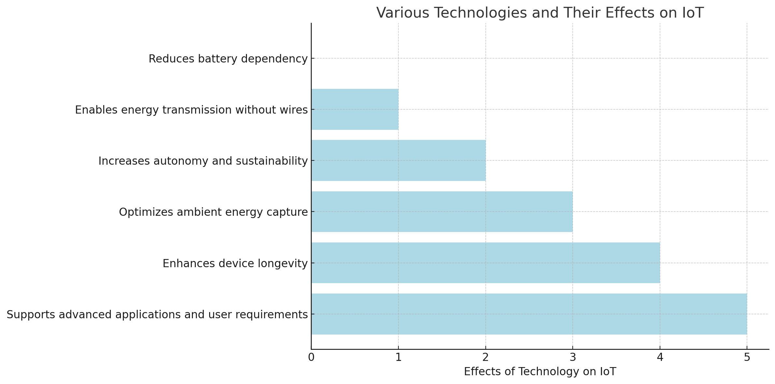

*The bar chart illustrates the effects of various technologies on the Internet of Things (IoT). Each bar represents a different technology method, showcasing how they contribute to IoT functionality and development. The insights range from reducing battery dependency to enhancing device longevity and supporting advanced applications.*

# Wireless Power Transfer Technologies

The evolution of Wireless Power Transfer (WPT) technologies is reshaping the operational landscape of Internet of Things (IoT) devices, particularly in telecommunication applications. By enabling efficient energy transfer without the reliance on traditional wiring systems, WPT addresses the prevalent challenges of limited battery life and maintenance in wireless sensor networks. This technology fosters the potential for continuous operation of devices in remote or inaccessible locations, which is crucial for applications such as environmental monitoring and infrastructure management. Moreover, as stated in the APACE project, Our APACE project aims to create a new type of laser powered by sunlight, underscores the innovative approaches being utilized to augment energy sources and ensure sustainability in energy harvesting (quote3). As researchers continue to explore regulatory frameworks and integration strategies, leveraging WPT technologies will emerge as paramount in enhancing the efficiency and sustainability of IoT systems and networks.

## Comparative Analysis of Different Wireless Power Transfer Methods

In the pursuit of optimizing energy resources for IoT devices, a comparative analysis of various wireless power transfer (WPT) methods is paramount. Each technique, including resonant inductive coupling, magnetic resonance, and radiofrequency (RF) harvesting, presents distinct advantages and limitations concerning efficiency, range, and application feasibility. Resonant inductive coupling, while noted for its effectiveness in short-range applications, struggles with scalability in extensive sensor networks due to its spatial constraints. Conversely, RF harvesting demonstrates promising scalability; however, it often yields lower efficiency in power conversion, particularly in environments dense with obstacles (Martínez Rosabal et al.). Energy harvesting techniques, crucial for sustainable IoT device operations, leverage environmental energy sources like solar and kinetic energy (Atek S. et al.). Identifying the optimal WPT method involves a nuanced understanding of the trade-offs related to energy density, operational cost, and environmental adaptability, ultimately guiding developments in energy harvesting algorithms essential for powering advanced IoT networks.

|  |  |  |  |  |  |
| --- | --- | --- | --- | --- | --- |
| **method** | **efficiency_percentage** | **typical_range_meters** | **applications** | **advantages** | **disadvantages** |
| Inductive Coupling | 80 | 0.1 | Smartphones, electric toothbrushes | High efficiency, established technology | Limited range, alignment sensitivity |
| Resonant Inductive Coupling | 90 | 0.5 | Electric vehicles, medical implants | Greater range than inductive coupling, high efficiency | Complex design, potential interference |
| Microwave Power Transfer | 75 | 1 | Space solar power, remote sensors | Long-range capabilities, able to penetrate obstacles | Safety concerns, complex technology |
| Laser Power Transfer | 70 | 1.5 | Drones, remote device charging | High energy density, focused beam | Requires line of sight, safety and regulatory issues |
| Capacitive Coupling | 50 | 0.05 | Low-power devices, RFID systems | Simplicity, low cost | Very short range, limited power transfer |

*Comparative Analysis of Wireless Power Transfer Methods*

# Energy Harvesting Algorithms

The development of energy harvesting algorithms is crucial for enhancing the sustainability and efficiency of Internet of Things (IoT) devices and sensor networks, particularly within telecommunication applications. These algorithms facilitate the conversion of ambient energy sources, such as solar, thermal, or kinetic energy, into usable electrical power, thus enabling devices to operate independently of traditional energy grids. Advances in non-orthogonal multiple access (NOMA) technologies have indicated their enhanced spectrum efficiency (SE), which can be leveraged to improve energy efficiency (EE) in wireless communications ((Darus et al.)). Moreover, as demand for real-time monitoring systems increases, particularly in critical infrastructures like water quality management, the integration of IoT frameworks reinforced by energy harvesting techniques can mitigate environmental impacts and reduce operational costs ((Radhakrishnan et al.)). Consequently, ongoing research aimed at refining these algorithms holds significant potential for advancing energy autonomy in diverse telecommunication applications.

## Development and Optimization of Energy Harvesting Algorithms for IoT Devices

Innovations in energy harvesting algorithms stand as a cornerstone for the sustainable deployment of Internet of Things (IoT) devices, particularly in the context of wireless power transfer systems. The evolving landscape of IoT necessitates the development of algorithms that not only optimize energy acquisition but also enhance the operational efficiency of embedded systems, which are pivotal for achieving reliable connectivity. As articulated in recent findings, Embedded systems are at the core of IoT applications, ensuring efficiency, connectivity, and reliability "Embedded systems are at the core of IoT applications, ensuring efficiency, connectivity, and reliability. They play a critical role in ensuring the seamless functionality of IoT applications across industries." (SmartSoC Team). A nuanced understanding of energy harvesting techniques—ranging from photovoltaic to thermoelectric methods—is critical for enhancing the performance and longevity of these systems. Moreover, integrating machine learning approaches can foster intelligent optimization of energy allocation, dynamically adapting to varying environmental conditions. This multifaceted focus on algorithmic development is essential for bolstering the sustainability and efficacy of power supply solutions in IoT applications.

# Conclusion

In conclusion, the advancement of wireless power transfer (WPT) and energy harvesting algorithms is imperative for the sustainable proliferation of Internet of Things (IoT) devices and sensor networks within telecommunication applications. As current technologies face limitations in data rate, reliability, and processing capabilities, particularly in the context of burgeoning demands from IoE applications, a paradigm shift toward more efficient power solutions is essential (Chamitha de Alwis et al., p. 836-886). The anticipated development of sixth-generation (6G) networks further underscores the urgency, as these networks must accommodate an expansive increase in smart devices while ensuring low-latency communication (Muntadher Alsabah et al., p. 148191-148243). By focusing on novel WPT techniques and innovative energy harvesting methods, this research contributes to addressing not only the immediate energy demands of IoT devices but also the broader challenges posed by future telecommunication systems. Therefore, continued interdisciplinary inquiry and investment in these areas will be crucial for advancing the technological ecosystem that supports IoT innovations.

## Future Directions and Implications for Telecommunication Applications

As the landscape of telecommunication applications evolves, the integration of advanced wireless power transfer (WPT) and energy harvesting algorithms becomes paramount for the sustained functionality of Internet of Things (IoT) devices and sensor networks. Future directions in this domain must emphasize enhancing the efficiency and scalability of energy harvesting systems, particularly in heterogeneous environments where device density and energy demands vary significantly. Moreover, the development of adaptive algorithms that dynamically allocate power based on real-time demand and environmental conditions is critical to ensure reliability and longevity of IoT applications. Convergence of artificial intelligence with energy management systems holds promise for predictive capabilities, enabling preemptive adjustments to optimize power utilization. Additionally, regulatory frameworks and standardization will play a pivotal role in facilitating widespread adoption of these technologies, ultimately shaping a more resilient and energy-efficient telecommunication infrastructure that can support the burgeoning IoT ecosystem.

# References

* Darus, Muhamad Firdaus, Hashim, Norlezah, Idris, Fakrulradzi, "Energy-efficient non-orthogonal multiple access for wireless communication system", 'Institute of Advanced Engineering and Science', 2023
* Radhakrishnan, Varsha, Wu, Wenyan, "IoT technology for smart Water system", 2018
* Copeland, Rebecca, Crespi, Noel, Rehmani, Mubashir Husain, Saleem, Yasir, "Internet of Things-aided Smart Grid: Technologies, Architectures, Applications, Prototypes, and Future Research Directions", 2019
* Leung, Victor C M, Mahapatra, Chinmaya, Sheng, Zhengguo, Zhu, Chunsheng, "Recent advances in industrial wireless sensor networks towards efficient management in IoT", 'Institute of Electrical and Electronics Engineers (IEEE)', 2015
* Darus, Muhamad Firdaus, Hashim, Norlezah, Idris, Fakrulradzi, "Energy-efficient non-orthogonal multiple access for wireless communication system", 'Institute of Advanced Engineering and Science', 2023
* Fagas, Giorgos, Gallagher, John P., Luca, Gammaitoni, Paul, Douglas J., "Energy challenges for ICT", Intech, 2017
* Darus, Muhamad Firdaus, Hashim, Norlezah, Idris, Fakrulradzi, "Energy-efficient non-orthogonal multiple access for wireless communication system", 'Institute of Advanced Engineering and Science', 2023
* De Alwis, Chamitha, et al., Kalla, Anshuman, Liyanage, Madhusanka, Pham, Quoc-Viet, "Survey on 6G Frontiers: Trends, Applications, Requirements, Technologies and Future Research", 'Institute of Electrical and Electronics Engineers (IEEE)', 2021
* Martínez Rosabal, O. (Osmel), "Power Beacon’s deployment optimization for wirelessly powering massive Internet of Things networks", University of Oulu, 2021
* Atek S., Elahi H., Eugeni M., Gaudenzi P., Munir K., "Energy harvesting towards self-powered iot devices", 'MDPI AG', 2020
* Chamitha de Alwis, Anshuman Kalla, Quoc‐Viet Pham, Pardeep Kumar, Kapal Dev, Won‐Joo Hwang, Madhusanka Liyanage, "Survey on 6G Frontiers: Trends, Applications, Requirements, Technologies and Future Research", 2021, pp. 836-886
* Muntadher Alsabah, Marwah Abdulrazzaq Naser, Basheera M. Mahmmod, Sadiq H. Abdulhussain, Mohammad R. Eissa, Ahmed Al-Baidhani, Nor Kamariah Noordin, Sadiq M. Sait, Khaled A. Al-Utaibi, Fazirul Hashim, "6G Wireless Communications Networks: A Comprehensive Survey", 2021, pp. 148191-148243