Design of human-machine collaborative robot workstation based on security

Shunping Ji, Qianxin Xu

(School of Mechanical and Electrical Engineering, Sanjiang University, Nanjing 210012, China)

Abstract: The safety of personnel in the production system is crucial. Based on the types of contact between people and the production system, this article divides them into three categories and proposes corresponding safety measures for different types of contact to ensure the safety of personnel in the production process. Based on the principle of safety, this article discusses in detail the layout design, robot selection, and auxiliary equipment design of human-machine collaborative robot workstations, and provides practical cases for reference.

Key words: security; man-machine collaboration; robot system

1. **Background**

With the changes of today’s market economy, consumers demands are more and more diverse, and new products developed according to consumer hobbies emerge in an endless stream. In order to expand their market share, enterprises must adapt to such changes in the market. In order to adapt to these changes, more and more manufacturing enterprises have joined the ranks of practicing lean, automation, information and intelligent transformation and upgrading.

Collaborative robot is a relatively representative automation equipment at this stage, which is more flexible and more intelligent. Compared with the traditional robot collaboration robot is generally installed anti-collision controller, is able to adapt to the requirements of high fine work without security fence can effectively avoid injured staff, production line change flexibility greatly increased, at the same time with safe human-computer interaction collaboration interface, make the personnel and robot in response to different job requirements of complementary functions.

This article proposes design guidelines for enhancing cognitive ergonomics in the application of human-machine collaborative robots through expert investigation, aiming to optimize user interaction, reduce cognitive load, improve system efficiency, and better support human operators [1]. The human-machine hybrid working environment is complex and dynamic, and human behavior is difficult to predict, manifested as both group characteristics and individual differences. At present, the "collaboration" between operators and collaborative robots is mostly sequential actions, lacking the task execution of synchronous coexistence between humans and robots [3]. So the design of this robot workstation also needs to be applied to all types of interactions between humans and robots in the design and manufacturing system, such as coexistence, synchronization, collaboration, and collaboration [4]. To achieve this challenge, a perception system is needed to monitor human presence, and appropriate programs should be designed to select appropriate robot behaviors to maintain high levels of productivity and safety among collaborators. Machine learning technology based on multi module perception and a new sensor can be used for human trajectory tracking to detect real-time proximity and velocity interactions between operators and robots [5]. For the safety of operators, high-performance automated machines mainly avoid contact between human and robot operating components, including complete insulation. The main solutions are physical or optical obstacles [6]. In addition, by controlling power and limiting, optimizing the geometry of the moving surface, safety risks can be effectively reduced to ensure collaborative safety [7]. It is worth noting that attention should also be paid to the working posture of the robot. It is not to calculate safety risks, but to evaluate which tasks of the operator's production cycle are not suitable from the perspective of biomechanical overload [8]. By reducing human workload and optimizing ergonomics, collaborative robots can effectively cope with increasing work risks while improving productivity, especially in terms of human cognition and rapid response capabilities [9]. In order to achieve the safest working conditions, focus on eliminating harmful and unsafe work areas, study the abilities and limitations of operators in industrial environments, and use this knowledge to minimize operator fatigue [10]. By equipping independent collaborative robots with sensors, they can autonomously perform tasks and slow down or stop when obstacles are detected, ensuring the safety of human collaborators. [11] . At the beginning of the project, the team identified variability and challenges in operational tasks through observation, interviews, and document analysis, in order to develop effective management strategies [12]. By studying the contact scenarios between the human body and robots, and analyzing the collision effects of different contacts on various parts of the human body based on joint coordinate models [13]. Before practical application, the accuracy of task execution is ensured through the training phase, while laying the foundation for identifying innovative features of human-machine collaborative workstations, which are expected to enhance safety, user experience, and acceptability [14]. A research collaboration with a furniture manufacturing company aims to create a new assembly workstation that enhances safety and ergonomics, particularly designed for workers with musculoskeletal issues, while complying with standardization, legal, and safety requirements [15].

To sum up, the safety of the robot workstation is determined by many factors. If the safety of the workstation is to be effectively improved, it is necessary to improve and upgrade the personnel themselves, robot selection, auxiliary equipment and production line environment. In this paper, the type of contact between human and production system is defined and divided into three different categories. In view of the different contact types, the corresponding measures and methods are proposed to ensure the safety of personnel in the production process. For human-machine cooperative robot workstations, different areas of the production system are identified as different contact types. Based on safety considerations, different effective measures will be taken for different contact types. In addition, this paper also lists the examples of the production line layout design, robot selection and auxiliary equipment design of human-machine cooperative robot, which provides a reference for the design of human-machine cooperative robot workstation.

1. **The Concept and Design of Robot Man-Machine Collaborative Production Line Safety (Principles)**

**2.1 Definition and determination criteria of safety**

Definition 1: The safety of man-machine cooperative robot workstation includes personnel safety, equipment safety, working environment safety and other aspects, which is a comprehensive concept to ensure the safe and efficient collaboration of man-machine in the shared space.

In this paper, the safety of man-machine collaboration production line is mainly divided into three aspects, namely, personal safety, robot workstation safety and equipment safety.

1. Personal safety means that people are not injured by robots and other equipment while working on the production line;

2. The safety of the robot workstation refers to the behavior that the robot will not cause collision and exceeding the limit;

3. Equipment safety means that there is no short circuit, open circuit and abnormal communication caused by external influence when other equipment is working.

When the production on the production line, the working scope of the robot will not affect the normal work of personnel or cause personnel injury is high safety. In the whole production process, the working scope of the robot will have a certain impact on the personnel work and even have safety accidents. The production line is the low safety production line. For the low safety production line, some safety measures are needed to improve safety, so as to meet the requirements of fewer accidents or even zero accidents in the production line.

**2.2 Concept of contact and accidents**

In order to ensure the safety in the production process, the contact types and accident types in the workflow are designed and defined.

2.2.1 Definition of the contact type

Definition 2: In the category of human-machine cooperative robot workstation, "contact" mainly involves the key concept of physical contact. From a mechanical point of view, is the end of the robot actuator or other parts and the workstation in the workpiece, tools, equipment, such as physical touch, in this process, the size of the contact force is restricted by a variety of factors, including the robots own movement speed, acceleration, as well as the material characteristics, shape of the contact object, etc. From the perspective of safety, due to the involvement of human-machine cooperation, the contact between the robot and human operators has special requirements, that is, the contact force must be controlled within a certain safety threshold, so as to ensure that in the human-machine close cooperation, even if the accidental contact, will not cause harm to the human body.

Description: (1) divide the contact of categories 0,1 and 2 according to the degree of contact;

(2) Category 0 contact: under normal circumstances (under the operating procedures), it is impossible for robots and personnel to have contact, which is called Category 0 contact, such as personnel and robots in the safety fence;

(3) class 1 contact: under normal circumstances (under the operating procedures), personnel outside the line operation through the robot or other collaborative equipment working range may contact, called the class 1 contact, but through the lights, cordon and the robot working limits of additional rules can avoid dangerous contact, such as logistics to take the stack of products and are working robot;

(4) Type 2 contact: under normal circumstances (under the operating procedures), the intersection with the working range of the robot during the line production is called Type 2 contact. Such contact can be used with sensors to avoid safety accidents.

The degree of safety requires by different contact types, and the trend is shown in Figure 1. In general, the combination of type 1 contact and type 2 contact is used for safety protection.

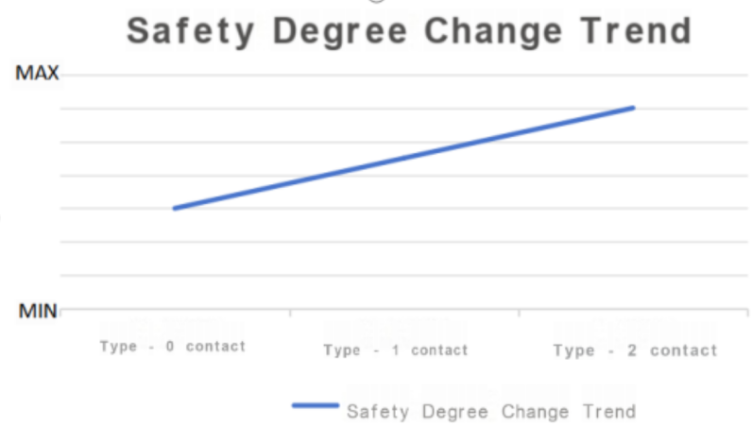

Figure 1 Trend diagram of safety degree change

2.2.2 Definition of accident type

Definition 3: Man-machine cooperative robot workstation accident refers to the accident occurring during the normal operation. In the level of personnel safety, the collision, squeezing, dragging and dragging of the equipment damage, the accident refers to the damage of itself or other equipment caused by the collision between the robot and other equipment in the station.

Note: (1) Type 1 accident: under normal circumstances, in the process of the robot moving from one point to another, the collision friction caused by the internal reasons of the robot, such as trajectory planning, is called type 1 accident;

(2) Category 2 accident: under normal circumstances, the robot injury event occurs without any instructions or pause for the robot to enter the working range of the current work of the robot, which is called Category 2 accident;

(3) Category 3 accident: in the process of production, due to the failure of sensor auxiliary equipment, other equipment or robot body, it is called category 3 accident.

In the normal production of the production line, we should avoid type 1 accidents to the greatest extent, so as to avoid the increased cost or greater disasters caused by the robot failure; Class 2 and 3 accidents are strictly prohibited in the production line, thus conducting regular safety training for staff and regular testing and replacement of robots and other equipment.

**2.3 General ideas of measures and methods**

Different types of exposure, with different levels of risk. For the contact type 0 contact, To avoid the corresponding accidents by developing safety guidelines for human-computer collaboration workstations, That is, to avoid the occurrence of category 1 accidents; For contact type 1 contact, To add some safety warning facilities to the safety measures for type 0 contact, Such as signal lights and warning lines to improve the warning, To avoid the occurrence of safety accidents, That is, to avoid the occurrence of type 2 accidents; For contact type 2 contact, Add auxiliary devices to the first two types of contact to improve safety, For example, sensors, To avoid robot injuries, That is, to avoid the occurrence of category 3 accidents. Overall, the higher the contact level, the more safety measures are required, as shown in Table 1.

|  |  |  |  |
| --- | --- | --- | --- |
| measure | Type 0 contact | Type 1 contact | Type 2 contact |
| Guidelines(general warning) | √ | √ | √ |
| Safety warning facilities, such as signal lights, warning lines, etc. (improved warning) |  | √ | √ |
| Auxiliary equipment, such as sensors, etc. (prohibitive warning) |  |  | √ |

Table 1. Measures corresponding to the contact type

**3. Safety design method of robot man-machine cooperative production line**

1. **1. Production line layout design to improve safety**

Contact type design of industrial L-shaped production line is shown in Figure 2, in which the blue dotted line is the range of the human arm, the green is the working range of the robot arm, and the range of the intersection of the two lines is the common working range of the human and the robot. In order to avoid injuries, the measures to improve safety are mostly set in the category 1 and category 2 contact areas.

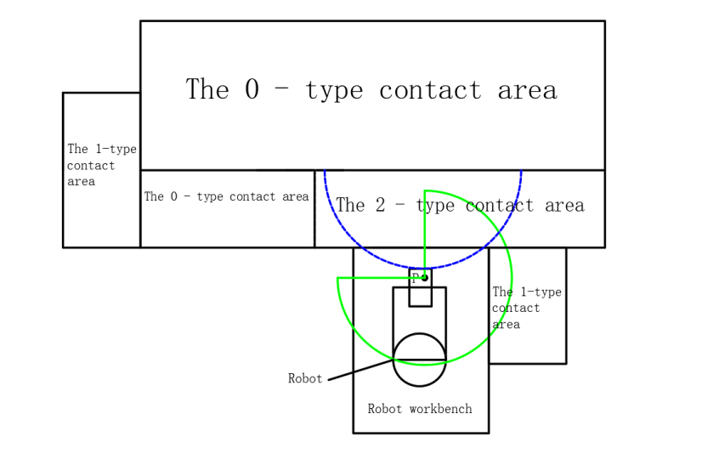

Figure 2 Layout diagram contact type

**3.2 Selection of robot ontology to improve safety**

3.2.1 Robot Type Selection

Robots generally choose collaborative robots, because compared with other industrial robots, do not need a security fence; high security, equipped with advanced sensors, can sense the surrounding environment, can automatically slow or stop in contact risk, reduce the possibility of injury; its flexibility is simple, can be operated through teaching or graphical programming interface, can quickly adapt to production tasks and process changes, and small size, light weight, easy to move and reinstall, convenient adjustment and deployment. In terms of improving production efficiency, it can work continuously and is not affected by fatigue and other factors, which can ensure the completion of tasks on time, and also the accurate operation, and reduce the product defect rate. From the perspective of cost benefit, although there is capital investment in the initial stage, it can reduce the labor cost in the long term, and the human resources can be redistributed, and its structure is simple and the maintenance cost is low. In addition, it helps to enhance the corporate image and competitiveness, reflect the enterprise technology innovation and production modernization, can better meet the market demand.

3.2.2 Program protection

Restricted the motion range of the cooperative robot end-effector by the program can significantly improve the operation safety. Specifically, the programmer accurately sets the motion boundary of the end effector in the direction of each coordinate axis according to the safety boundary of the working space and the area where the personnel may appear. When the robot is running, its control system will monitor the position of the end effector at all times according to the program instructions. Once its movement is close to or beyond the preset range, the system will immediately trigger the safety mechanism. Therefore, the end effector is effectively prevented from collision with surrounding personnel and equipment beyond the expected range, ensuring the safe and orderly operation of the whole operation process. The procedure is set as shown in Figure 3.

Figure 3. Program diagram of setting the working scope

**3.3 Design of additional safety facilities**

3.3.1 Methods for the protection of additional safety facilities

The cooperative robot can connect with external sensors. During the operation, the infrared sensor continuously emits infrared signals and receives reflected signals in real time. Whenever someone close to or into the collaborative robot working space is detected by sensor, reflected signal will change, sensor through a specific communication interface will contain personnel close information signal feedback to the cooperative robot control system, then, the robot will alarm or stop working, to ensure the safety of people and collaboration robot. In the production line design, the photoelectric sensor is fixed on the positioning plate as shown in Figure 4.



Figure 4. Sensor position diagram

3.3.2 Photoelectric sensor

The common photoelectric sensor model is E33Z-D61, support voltage 24DC. The placement position of the sensor is shown in Figure 4. The photoelectric sensor and the relay are connected into a complete device, which is connected to the robot control cabinet, and the wiring diagram is shown in Figure 5. When the sensor does not feel that the person is in its detection area, the relay is in the state of power suction, the whole circuit maintains the path, and the robot can operate normally. However, once the sensor detects that the person is in its monitoring range, its internal circuit will immediately respond and the normally closed contact will disconnected. Because the normally closed contact is connected to the SAFTY2 line in the robot control cabinet, the disconnection of the normally closed contact will break the SAFTY2 in the robot control cabinet. In this case, the robot receives the safety signal and stops working before blocking, effectively ensuring the safety of personnel and the production environment.

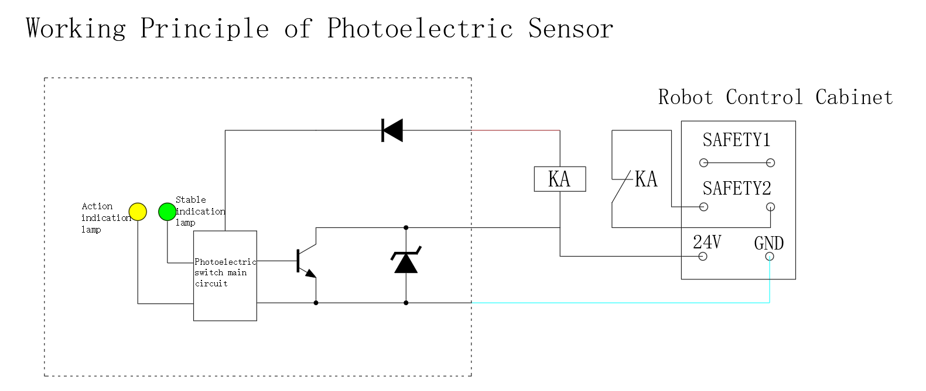

Figure 5 Sensor principle and wiring diagram

3.3.3 Rating protection

In the normal production process, when the product is full of the stack board, the logistics staff needs to take the goods from the stack board filled with the product. At this time, the cooperative robot may also perform the palletizing task in this area. There is a potential conflict risk in this situation of man-machine working together. In order to effectively avoid the conflict between the normal working process of the robot and the operation of the logistics personnel, and to ensure the safety of the personnel, a grating can be used for protection in the operation area. As a high-precision photoelectric induction device, the grating is reasonably installed in the critical position of the robot working area and the logistics man pickup channel. It can continue to transmit and receive light, forming an invisible but reliable protective barrier. When the logistics is close to the robots operating range to take the product from the stack, once the body blocks the light of the grating, the grating will quickly transmit the signal to the robot control system. After receiving the signal, the robot control system will immediately suspend the current work, so as to avoid collisions or other injuries that may cause to the logistics staff. The guarantor and the robot can operate safely and efficiently in the complex logistics working environment.

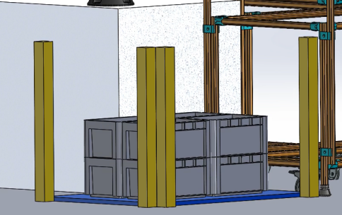

Figure 6. Raster position diagram

**4. Design cases**

4.1 The floor plan of the production line

The following is the production line plane layout design of the cooperative robot assembly production line, as shown in Figure 7. In the production of the production line, the personnel are responsible for material assembly, machining of raw materials, taking empty boxes for product packaging and taking the products filled in the stack area, while the robot is responsible for the stacking of the products through visual identification. The production line follows the rules of contact and accident types and the normal production procedures, where the machining and stack areas are the Category 1 contact area, the Material Zone 2, packaging area and defective area are the Category 2 contact area. The sensor is placed in the stack area and the packaging area in the packaging area because, when the assembled product is packed in an empty box in the packaging area.

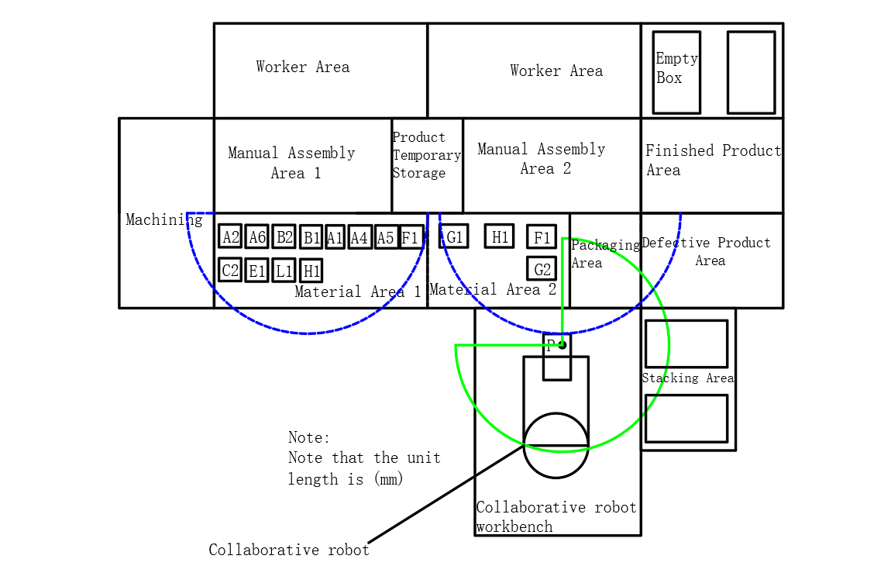

Figure 7. Layout plan of the production line

4.2 Space diagram of the production line

Figure 8 shows the spatial layout diagram of the production line, which is consistent with the flat production line layout. In the picture, the photoelectric sensor is placed on the positioning board near the person, and the grating is placed around the stacking plate in the stacking area.

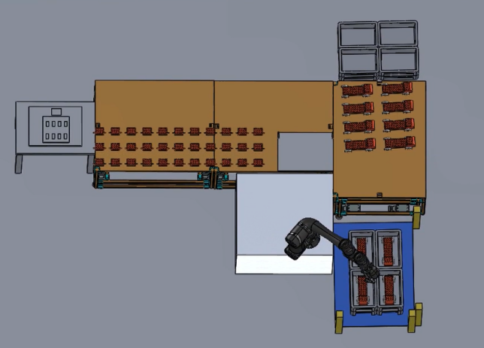

Figure 8. Space layout diagram of the production line

**5. Summary**

This article systematically analyzes the safety issues of human-machine collaborative robot workstations, and proposes relevant design solutions from multiple perspectives such as contact types, accident types, and safety measures. Firstly, different types of contacts (Type 0, Type 1, and Type 2 contacts) and corresponding safety measures were defined and classified to ensure safe collaboration between personnel and robots. Secondly, a reasonable design approach was proposed for the layout design, robot selection, and auxiliary equipment configuration of the human-machine collaborative robot workstation, with a focus on how to improve safety through a reasonable production line layout and selection of collaborative robots and auxiliary equipment.

In terms of safety assurance, this article emphasizes the application of technologies such as sensors and grating protection to ensure that the robot can automatically stop working when personnel enter the robot's work area, avoiding the occurrence of injury accidents. At the same time, it is pointed out that although current security mechanisms can effectively reduce incidents of robot injuries, attention still needs to be paid to the limitations of technology, sensor failures, and unpredictability of personnel behavior. Therefore, to ensure continuous security, it is necessary to regularly maintain and optimize workstations, and strengthen safety training for operators.

In summary, this study provides theoretical basis and practical guidance for the safe design of human-machine collaborative robot workstations, which is of great significance for improving production line safety and reducing accidents.

**References**

[1]Gualtieri L, Fraboni F, Brendel H, et al. Updating design guidelines for cognitive ergonomics in human-centred collaborative robotics applications: An expert survey[J]. Applied Ergonomics, 2024, 117: 104246. DOI:10.1016/J.APERGO.2024.104246

[2]Wang X , Setchi R , Mohammed A .Modelling Uncertainties in Human-Robot Industrial Collaborations[J]. 2022.DOI:10.1016/j.procs.2022.09.425.

[3]Bejarano R , Ferrer B R , Mohammed W M ,et al.Implementing a Human-Robot Collaborative Assembly Workstation[C]//2019 IEEE 17th International Conference on Industrial Informatics (INDIN).IEEE, 2019.DOI:10.1109/INDIN41052.2019.8972158.

[4]Ore,Jiménez Sánchez,Wiktorsson,et al.Design method of human–industrial robot collaborative workstation with industrial application[J].International Journal of Computer Integrated Manufacturing, 2020.DOI:10.1080/0951192X.2020.1815844.

[5]Costanzo M , Maria G D , Lettera G ,et al.A Multimodal Approach to Human Safety in Collaborative Robotic Workcells[J].IEEE Transactions on Automation Science and Engineering, 2021, PP(99):1-15.DOI:10.1109/TASE.2020.3043286.

[6]Suh N P .Axiomatic Design of Mechanical Systems[J].Journal of Vibration & Acoustics, 1995, 117(B):2-10.DOI:10.1115/1.2836467.

[7]Ciccarelli M , Moschini S , Palpacelli M ,et al.Design of Human-Robot Collaborative Workstation for the Packaging of Kitchen Furniture[J].Volume 2B: Advanced Manufacturing, 2022.DOI:10.1115/imece2022-95452.

[8]Gualtieri L , Palomba I , Merati F A ,et al.Design of Human-Centered Collaborative Assembly Workstations for the Improvement of Operators' Physical Ergonomics and Production Efficiency: A Case Study[J].MDPI AG, 2020(9).DOI:10.3390/SU12093606.

[9]Cunha J G , Faria C , Colim A ,et al.From Handcrafting to a Certified and Ergonomic Collaborative Workstation: the Digital Transformation Process[C]//IEEE International Conference On Intelligence And Safety For Robotics.IEEE, 2021.DOI:10.1109/ISR50024.2021.9419376.

[10]Cardoso, A.; Colim, A.; Bicho, E.; Braga, A.C.; Menozzi, M.; Arezes, P. Ergonomics and Human Factors as a Requirement to Implement Safer Collaborative Robotic Workstations: A Literature Review. Safety 2021, 7, 71. https://doi.org/10.3390/safety7040071

[11]Pizzagalli S L , Kuts V , Otto T .User-centered design for Human-Robot Collaboration systems[J].IOP Conference Series: Materials Science and Engineering, 2021, 1140(1):012011 (6pp).DOI:10.1088/1757-899X/1140/1/012011.

[12]Hager G , Padoy N .HUMAN-MACHINE COLLABORATIVE ROBOTIC SYSTEMS:WO2011US60638[P].WO2012065175A2[2024-11-22].DOI:US20130218340 A1.

[13]Lemmerz K , Glogowski P , Kleineberg P ,et al.A Hybrid Collaborative Operation for Human-Robot Interaction Supported by Machine Learning[C]//2019 12th International Conference on Human System Interaction (HSI).2019.DOI:10.1109/HSI47298.2019.8942606.

[14]Rossato C , Orso V , Pluchino P ,et al.Adaptive Assembly Workstations and cobots: a qualitative assessment involving senior and adult workers[C]//ECCE 2021: European Conference on Cognitive Ergonomics 2021.2021.DOI:10.1145/3452853.3452883.

[15]Colim A , Faria C , Cunha J ,et al.Physical Ergonomic Improvement and Safe Design of an Assembly Workstation through Collaborative Robotics[J].Safety, 2021, 7(1):14.DOI:10.3390/safety7010014.