A Consideration of Whole-Life Carbon Emissions by Indiana Manufacturers in Efforts to Gauge Lifecycle Sustainability Records in the Multinational Automobile Industry

**Abstract**

The Ricardo Report (2020) recommends a holistic analysis of the effects of the global auto industry on sustainability by assessing the impacts of automobiles on the environment throughout their lifecycle. Much of the literature on sustainability in the transportation sector focuses on vehicle exhaust emissions and their contribution to urban smog, and there has been little consideration of emissions produced during the automobile manufacturing process itself. This study builds on the lifecycle emissions approach recommended by the Ricardo Report. Specifically, data on the pounds of pollution emitted was collected from the Toxic Release Inventory report of major multinational automobile producers and analyzed via piecewise linear regression analyses to provide insight about the pollution emitted during a vehicle’s production. The findings in this study will fill a gap in Ricardo’s “birth to grave” proposal to quantify whole-life carbon emissions in the automobile sector.

**Literature Review**

Air pollution has been the subject of scientific study for centuries (Pott, 1775; Carson, 1962; Perkins, 1974; Stern et al., 1984). In particular, research has shown that exposure to poor air quality results in deteriorated health. Munzel et al. (2017) concluded that air pollution, when added to usual loud noise, contributes to more than 75% of general human environmental stressors and disease in urbanized societies. The United Nations (2019) stated that poor air quality is lowering global life expectancy, causing long-term health problems, and killing 7 million people per year. Governments around the world have taken action or been called on to take action to address poor air quality (Taylor, 2008; Gardiner, 2019; Issitt, 2019). International institutions have implemented broad air quality policies with varied success, such as the Kyoto Protocol (1997), the Paris Climate Agreement (2015), and the COP28 (2023). The United States federal government became active in regulating air pollution in the twentieth century with the enactment of the 1963 Clean Air Act (Davidson & Norbeck, 2011; Carlson & Burtraw, 2019).

Air quality advocates have often focused on organizations involved in logistics such as the aerospace and combustion engine sectors. Through all its modes, the transportation sector (also referred to as the transport sector in the literature from Europe) accounts for about a quarter of global CO2 emissions, mainly from passenger vehicle emissions (Solaymani, 2019). The literature and political discourse have addressed the pollution caused by these vehicles, particularly the exhaust they produced (Faiz et al., 1996; Innes, 1996; Rhys-Tyler et al, 2011; Dey & Mehta, 2020; Kalghatgi et al., 2023). Broadcast media stories in this realm have often focused on bad actors such as case of the Volkswagen emissions scandal (Ewing, 2017; Siano et al., 2017; Li et al., 2018; Jung & Sharon, 2019).

In the United States, air quality alerts have become increasingly common means of warning about the poor quality of local air. These alerts play a meaningful role in quality-of-life factors in communities across America (Chen et al., 2018; Sachdev, 2022; Schulte, 2022). Poor air quality is often associated with smog or air pollution, defined as “pollutants that contribute to poor air quality including particulate matter (PM), nitrogen oxides (NOx), and volatile organic compounds (VOCs)” (EPA, 2024, para. 2). Recent warnings have taken into account the wind drifting from the Canadian wildfires in the summer of 2023 (Kekatos, 2023; Savage, 2023). Another factor contributing to poor air quality is the downwind pollution from the Rust Belt to the northeast. Concerns about this drifting pollution prompted the implementation of the 2011 Cross-State Air Pollution Rule (CSAPR) (Rapp, 2015; Jeffrey, 2016). As of this writing, levels of air toxins are being commonly measured, including mobile compounds such as benzene, formaldehyde, and diesel particulate matter that are known or suspected to cause cancer or other serious health and environmental effects.

Sustainability efforts for regulations and other means of limiting pollution originating from the transportation sector have often focused on the grey/black smoke emitted from vehicle tail pipes (Yanowitz & McCormick, 2009; Zhang et al., 2015; Anenberg et al., 2019; Giechaskiel et al, 2019; Bej & Chattaraj, 2023). Legislation limiting tailpipe emissions has evolved through milestones in regulatory enforcement history, but it is often based on historical precedents such as catalytic converter innovations, engine standards, and tailpipe filters (Regulatory Timeline. 2024).

Stakeholders have recently argued that more factors should be considered, and new proposals have sprung up related to the quantifying of carbon emissions. In particular, the seminal Ricardo Report, published in 2020, outlined the impacts of pollution produced across the entire lifecycle of the vehicle. “With the shift to new fuels and powertrain electrification it is more important to use lifecycle assessment (LCA) approaches in assessing the relative impacts of different options on a holistic basis” (Ricardo Energy & Environment, 2020, para. 2). The Ricardo Report recommends cradle-to-grave LCA analyses starting from the extraction of raw materials that form the components and energy for the creation of the automobile through to the “end-of-life”, or disposal of the vehicle and/or its parts.

Tan et al. (2011) initially recommended a concept involving “whole-lifecycle automotive manufacturing”, an accounting method for the emissions processes throughout the entire auto industry from raw material melting to “recycling” that could then become standardized. Lee (2012) proposed a standardized process of measuring emissions across the automobile supply chain. Similarly, Lisowski et al. (2020) recommended an agreed-upon series of environmental standards and criteria including more than just emissions during use of the vehicle that could assess progress in the industry as a framework for sustainability across global stakeholders.

Berners-Lee and Clark (2010) initially reported about the pollution emitted during the production of a vehicle and found that a small vehicle emits 6 metric tons of CO2 equivalent, whereas an SUV produced 35 metric tons of CO2 equivalent. Campbell (2022) later reported that about 10% of a vehicle’s lifelong CO2 emissions occur during its production, equating to about 5.6 tons of CO2 being released during the manufacture of a gasoline- or diesel-powered vehicle, whereas about 5% of emissions comes from the disposal process. Low Carbon Vehicle Partnership (2020) attempted to quantify emissions across the lifecycle of a vehicle or an automobile’s “Whole-Life Carbon Emissions Analysis” and conceded that “Life cycle analysis is still in its infancy, with few defined process and standards” (p. 3). As such, their report estimates that the manufacture of standard (traditional) gasoline-powered vehicles produces 5.6 metric tons of CO2 equivalent pollution with higher amounts of CO2 emitted during the manufacture of hybrids (6.5), plug-in hybrids (6.7), and battery-electric vehicles (8.8).

There are gaps in the literature in regard to whole-life carbon emissions in the multinational automobile industry, but buoyed by the Ricardo Report (2020), more recent focus is directed at pollution emitted during the manufacture of vehicles. Berners-Lee and Clark (2010) noted the difficulty in quantifying total pollution when calculating a vehicle’s carbon footprint because the electricity used by all the supply chain vendors in extracting the metals must be considered. Els (2021) surmised that “the carbon footprint of making a car is immensely complex to track. Ores have to be dug out of the ground and the minerals extracted” (para. 2), creating additional emissions. Electric vehicles (EVs) are responsible for more emissions during production compared to combustion-engine vehicles. Manufacturing EVs adds 8.8 tons of CO2, 43% of which occurs during the production of the electric battery, compared to 5.6 tons during the manufacture of a diesel- or gasoline-powered vehicle (Campbell, 2022).

The Ricardo Report (2020) conceded that additional methodologies should be developed and standardized by governments and/or global institutions for comparing various automobile life cycle stages to provide a framework for emissions standards. However, because sustainability in the multinational automobile industry has often been reactive to regulations and edicts of international institutions (Iguchi, 2015; Selim et al., 2020), quantifying carbon emissions via whole-life carbon emissions and setting standards in the industry is truly central to future quality-of-life issues due to increased salience related to air quality standards.

Answering the call from the Ricardo Report to develop a method of measuring emissions throughout the automobile lifecycle, this study aims to fill the void in the literature by ascertaining the rates of pollution produced in the manufacture of vehicles. In particular, whole-life carbon emissions in the automobile industry will be analyzed by assessing emissions rates of the Toyota, Subaru, and Honda factories in the state of Indiana. The automotive industry is a disproportionately high contributor to the Indiana economy (employing 459% higher than the national average) (IEDC Automotive Council, 2016) as well as a main contributor to carbon emissions. This study will compare trends in these Indiana-based automakers’ emissions rates via key points in regulatory enforcement history, including when strict emissions edicts affected model years 2012, 2013, 2017, and 2018 and beyond (Regulatory Timeline, 2024).

**Methodology**

Each year, the United States Environmental Protection Agency (EPA) publishes the Toxic Release Inventory (TRI), a publicly available database containing information on the release of toxic chemicals (Antisdel, 2017), including those emitted into the air and water/ground. Data from the TRI were mined for the purposes of this study. Various chemicals covered include those that cause significant chronic, acute, and adverse health effects (including cancer). Data about chemicals released during the production process were analyzed using a cross-sectional analysis and included total on-site releases, total pounds of chemicals transferred off-site for recycling, total pounds transferred off-site for disposal, and total pounds transferred off-site for energy recovery (see Appendix A).

The three largest multinational automobile factories in Indiana are Honda, Subaru, and Toyota. A search of the TRI found five facilities in Indiana that included “Honda”, “Toyota”, or “Subaru” in their names (see Appendix B for the process utilized to filter). Two more were found that included “Honda”, “Toyota”, or “Subaru” in their parent company names.  The EPA also performed a manual search to confirm that there were no more or less of those listings (Swenson, 2023), showing that seven reports appeared with Honda, Subaru, and Toyota in the facility or parent company names appear in the TRI from 2010-2022 (see Table 1 below).

Table 1.

*TRI Listings of Auto Factories in Indiana Emitting Pollution*

|  |  |  |  |
| --- | --- | --- | --- |
|  | TRI_FACILITY_ID | FACILITY_NAME | STANDARDIZED_PARENT_COMPANY |
| 1 | 4631WHSTLF447RA | HOIST MATERIAL HANDLING INC. | TOYOTA INDUSTRIES NORTH AMERICA |
| 2 | 47202TYTND5555I | TOYOTA MATERIAL HANDLING INC. | TOYOTA INDUSTRIES NORTH AMERICA |
| 3 | 47670TYTMT4000T | TOYOTA MOTOR MANUFACTURING INDIANA INC | TOYOTA MOTOR ENGINEERING & MANUFACTURING NORTH AMERICA INC |
| 4 | 4724WHNDMN2755N | HONDA DEVELOPLEMENT & MANUFACTURING LLC - IAP | AMERICAN HONDA MOTOR CO INC |
| 5 | 47903SBRSZ5500S | SUBARU OF INDIANA AUTOMOTIVE INC | SUBARU CORP |
| 6 | 4767WTYTBS733S1 | TOYOTA BOSHOKU INDIANA LLC | TOYOTA BOSHOKU AMERICA |
| 7 | 4613WPRMMC211CM | PREMIUM COMPOSITE TECHNOLOGY NA | TOYOTA TSUSHO AMERICA INC |

Of the seven companies listed in Table 1, #1 and #7 were excluded because Hoist was determined to be based in East Chicago IN, and Premium Composite was found to be based in Franklin IN, rather than in the cities where the factories are located. From subsequent research, these organizations were determined to not to be associated with vehicle production. However, further investigation should ascertain whether they produced direct components that were then shipped those to factories, thus potentially meriting inclusion in the emissions totals. The two additional affiliated organizations with “Toyota” in the parent company names - #3 (Toyota Motor Manufacturing Indiana Inc) and #6 (Toyota Boshoku Indiana LLC) - were found to be based in Princeton, IN (the factory site of Toyota) and were included in the pollution total for Toyota because they were deemed to be producing a component of the final vehicle on-site.

It was presumed that most if not all the emitted pounds of total on-site and off-site disposal or releases of chemicals (total reported, composite pollution) were due to pollution emitted during a part of the vehicle’s production process since no other products beyond the automobiles were produced at those facilities and as such were included. This assumption was especially relevant for Toyota Boshoku (#6 in Table 1), a separate entity but still located in Princeton, IN and presumably on site. There is a caveat in the “total pollution” column “TOTAL_ON_OFF_SITE_RELEASE~” (see appendix F) for Toyota Boshoku, which stood out as an outlier because other years’ annual total pollution was just 12% of this annual amount. After inquiry, the EPA noted that “I did look up this facility’s 2010 reporting form for toluene, and it does show 8,839 pounds being transferred off site for ‘other waste management” (Swenson, 2023). Since the global “great recession” was generally fully recovered economically by 2010 that was the first year in which data was mined. The rest was reported as on-site stack air releases” (Swenson, 2023). Since this unique amount of pollution was presumed to originate on site, was included as part of the production process for the final vehicle and included for purposes of this experimental design.

The total vehicles produced was the independent variable, which was utilized to more precisely analyze the total percentage of changes in pollution being emitted from those factories during a calendar year. Internal information related to the production of units of vehicles per year was not available for all model years, so this study utilized total American vehicle sales for each of those models as the independent variable. A limitation of this approach is that some of the vehicles produced in those factories might ultimately have been sold in Canada or Mexico, or some might have been manufactured outside of the US and sold in the US.

Model years were confirmed for manufacture in those factories and were identified by the average number of pounds each vehicle weighed. Honda Civics, CR-Vs, and Acura ILXs were manufactured in Greensburg, IN. Toyota produced Highlanders, Siennas, and Sequoias (note that production of vehicles changed during that timeframe when Highlanders shifted to being produced at Toyota’s Texas facility) at their Princeton IN factory. Subaru was dismissed from further analysis in the study due to lack of available public data for annual vehicles produced during those years. As such, the independent variable was annual unit sales of those models of Honda and Toyota vehicles, multiplied by their weights to equal total pounds of vehicles produced (see Appendices D and E). As such, the final data output utilized emissions per pound based on pounds of vehicles manufactured.

With the independent variable in this study as pounds of vehicles produced during a calendar year and the dependent variable as total pollution/emissions (by pound), a cross-sectional analysis focused on any significant change point in the time series, particularly in relation to any of the regulatory enforcement milestones from the (2024) Regulatory Timeline. Figure 1 shows the experimental design with the transformation with the formula weighted annual total emissions (*a*) by the annual total weights of vehicles produced; because the weighted values were too small, they were multiplied by 105, yielding *105a/(wb).*

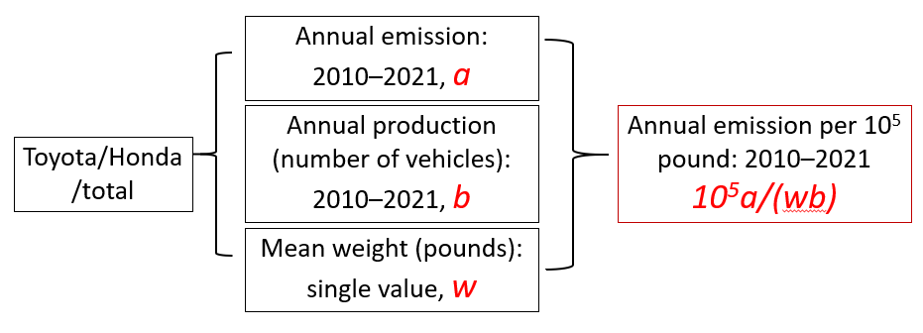

Figure 1.

*Experimental Design (Piecewise Linear Regression Analyses) for This Cross-sectional Study*

Piecewise linear regression analyses (PLRA) were performed for both the total (raw) emissions and the weighted emissions. PLRA is a distinctive quantitative approach used to ascertain potential significant change points over time (the point at which any changes occur in the time series; in this case, if Honda and/or Toyota witnessed a shift in the weighted or raw emissions). PLRA involves a process based on iteratively searching for the years both before and after. The models were segmented and the *R*-squared and mean squared error (MSE) were calculated for purposes of assessing variation, whereas the larger *R*-squared and the smaller MSE, the better the model fit or goodness-of-fit statistics (a technique to assess the result of a primary or secondary outcome variable). The cross-section of data was iteratively filtered to locate which model was the best fit so that any statistically significant change points could be identified (Muggeo, 2008; Crawley, 2012).

**Results**

Figure 2 shows the time series from 2010-2021 for Toyota’s raw emissions (2022 was not included since the model was not able to determine changes in the year after because 2023 was not yet included in the TRI database). Graphs b and c summarize the results of *R*-squared and MSE from the PLRA each year. *R*-squared is the largest (Graph b) and MSE is the smallest (Graph c) in 2011. Thus, it can be concluded that Toyota’s total raw emissions decreased significantly in 2011 and again in 2012. Graph d illustrates how the piecewise regression model provides the change point.

Figure 2.

*Toyota Total Raw Emissions*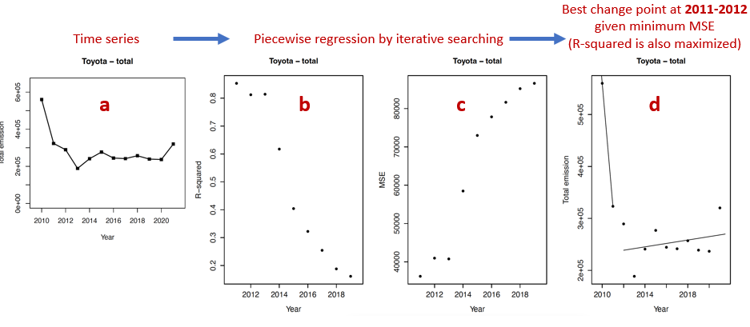

Figure 3 shows the time series of annual total emissions from 2010-2021 for Honda’s raw emissions with the same processes of PLRA being applied. Graphs b and c summarize the results of *R*-squared and MSE for each year, showing that *R*-squared is the largest and MSE is the smallest in 2016. This indicates that Honda’s total emissions in 2016 increased at a noteworthy level, and a similar trend occurred in 2017. Graph d illustrates the PLRA’s results in 2016 and into 2017.

Figure 3.

*Honda Total Raw Emissions*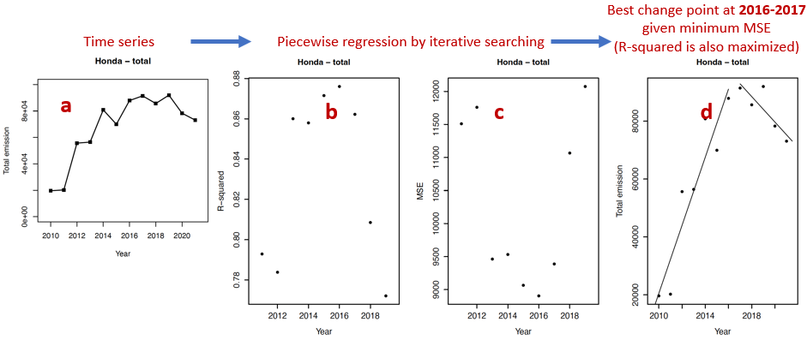PLRA was performed for Toyota for weighted emissions, which additionally factored in annual pounds of vehicles produced. Figure 4 shows the time series for annual weighted emissions. Graphs b and c summarize the results of *R*-squared and MSE from the PLRA. *R*-squared is the largest and MSE is the smallest in 2011, suggesting that Toyota’s weighted emissions decreased at a significant rate in 2011 (and also into 2012). Taking into consideration vehicles produced (by pound) resulted in the same output. Graph d additionally shows the visual illustration of that change point.

Figure 4.

*Toyota Total Weighted Emissions*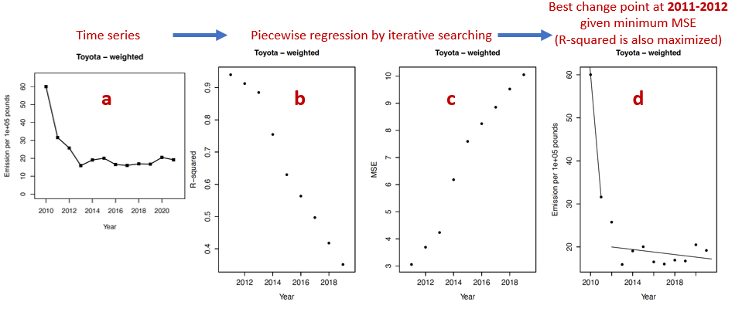The same analysis was performed for Honda’s weighted emissions. The results are illustrated in Figure 5. Graphs b and c summarize the results of *R*-squared and MSE; *R*-squared is the largest and MSE is the smallest in 2014. Thus, Honda witnessed significantly higher weighted emissions in 2014. Graph d shows the PLRA model for 2014, with similar results for subsequent years. As such, factoring in vehicles produced (by pound), Honda increased their weighted emissions in 2014 and continued to do so into 2015.

Figure 5.

*Honda Total Weighted Emissions*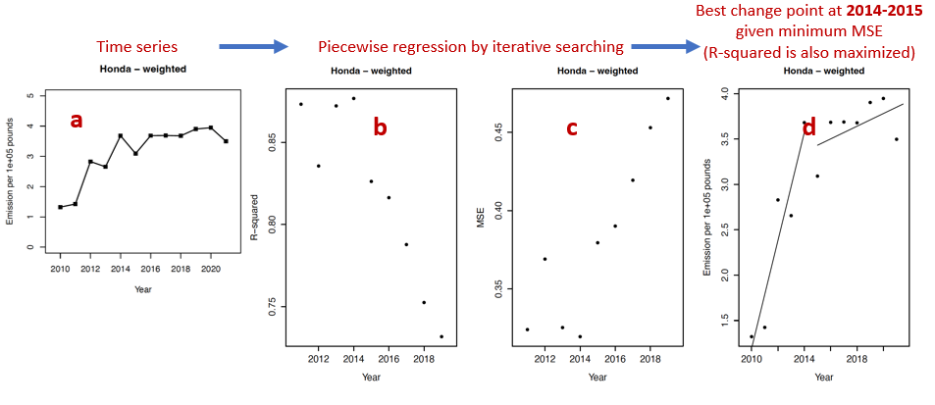Since southern Indiana air quality is impacted by total emissions from both factories, Toyota and Honda totals were combined. The analysis was run again and produced a still-statistically significant change point around 2012 and 2013, as seen in the time series graphs on the far right of both the top and bottom rows of Figure 6 marked by the red circles. Since air quality was the initial purview of this study, it can be claimed that 2012 witnessed significantly decreased raw and weighted emissions from these combined (Toyota plus Honda) southern-Indiana automakers, contributing to cleaner air in that region. Future studies should be conducted of southern-Indiana’s air quality records before and after 2012 to observe if any changes occurred, but since Greensburg is on the east side of the state, Ohio air quality records (the state to the east) might be more relevant for an analysis of the effects of the CSAPR.

Figure 6.

*Summary: Total Emissions and Weighted Emissions*

The difference in Honda’s emissions change points between raw emissions and weighted emissions is worthy of further analysis. Raw emissions increased in 2016 and into 2017, but weighted emissions increased in 2014 and into 2015, indicating that Honda factories were not able to produce additional vehicles at the same emissions rate per pound during that timeframe. Honda’s relatively stable emissions trend beyond 2017 for weighted emissions should be noted as well as the decrease in weighted emissions in 2021, indicating emissions per pound of vehicles produced remained consistent.

Toyota’s raw emissions and weighted emissions had similar change points (but at decreasing pollution levels), so the period of relative stability from 2014-2020 is worthy of note. In addition, the most common hazardous chemicals emitted from the factories by pounds were trimethyl benzene, butyl alcohol, and certain glycol ethers, so the effects of these three chemicals and trends related to them should be investigated further. Further inquiry should assess the two facilities associated with Toyota as a parent company that were not based near Princeton. Another topic of future research is to determine how much if any of the reported pollution was contamination of soil rather than the air. For 2017 and 2018, Honda’s raw emissions increased, and any rationale would be noteworthy to consider.

Whether the change point shifts were the results of proactive internal processes or reactions to current or future external issues such as regulations, the Toyota shift resulted in better air quality and the Honda shift resulted in worse air quality, although Honda’s has remained stable recently. It is possible that these two organizations made conscious decisions to alter the trajectories of their emissions rates through strategic or accidental changes in internal processes, but questions might arise regarding any practical significance of the changes in emissions vis-à-vis the Regulatory Timeline (2024) (determined to be in 2012, 2013, 2017, and 2018). Whereas Toyota’s change point in emissions coincided with the period 2012/2013, in 2012 the EPA extended the federal program to extend “fuel economy” for medium-duty passenger vehicles (which the Sienna would be classified as) in model years 2017 through 2025. Particularly if internal processes were proactive, Toyota’s Princeton IN factory could very well provide a template for regulatory compliance if its leaders had planned for regulatory changes ahead of time. Another possible precipitator of change in Toyota’s internal processes might be the 2011 CSAPR, which was the impetus for further legislation directed at fossil fuels in the federal energy sector and fully took effect in 2013. Toyota’s change point could be critically analyzed from the perspective of any proactive measures taken in the lead-up to the implementation of the CSAPR to mitigate penalties for contaminated air from its factories floating with wind patterns north-east-east to Ohio and other states.

As the automotive market continues to evolve, it is important to analyze automobile whole-life carbon emissions rather than just what comes out of the tailpipe. This consideration should be utilized in assessing and judging the holistic impact of the multinational automobile industry on air quality and overall climate change. Global footprints have been a focus of legislation and international institutions advocating for sustainability, and the study from the Low Carbon Vehicle Partnership (2020) can be utilized as a template for identifying the variables for analyses of whole-life carbon emissions of vehicles including emission rates for both disposal and production.

As it relates to the goal to assess whole-life carbon emissions of vehicles, the pollution emitted during the entire lifecycle of the vehicle itself is of paramount importance. It is especially relevant if EVs are responsible for more emissions in their manufacture and disposal. Attention to whole-life carbon emissions should continue in literature, academia, and the global multinational automobile industry.

Appendix A.

*Variables Mined from TRI*

|  |  |  |  |  |  |  |  |  |  |
| --- | --- | --- | --- | --- | --- | --- | --- | --- | --- |
| TRI_FACILITY_ID | FACILITY_NAME | STREET_ADDRESS | CITY_NAME | STATE_ABBR | ZIP_CODE | CHEM_NAME | TRI_CHEM_ID | REPORTING_YEAR | TOTAL_ON_OFF_SITE_RELEASE~ |

Appendix B.

*TRI Filtering Process*

Appendix C.

*Dependent Variable, TOTAL_ON_OFF_SITE_RELEASE, 2010-2021, Honda and Toyota*

Appendix D.

*

Appendix E.

*Independent Variable, Model and Pounds per Vehicle, Toyota*

Appendix F.

*Miscellaneous Row Depicting Toyota Boshoku’s Total on/off-site Release from 2010*

**References:**

Anenberg, S., Miller, J., Henze, D., Minjares, R., & Achakulwisut, P. (2019). The Global Burden of Transportation Tailpipe Emissions on Air Pollution-related Mortality in 2010 and 2015.  *Environmental Research Letters*, *14*(9), 094012.

Antisdel, T. (2017). Specialist/Database Administrator for the United States EPA; personal communication.

Bej, D., & Chattaraj, N. (2023). Air Pollution from Vehicle-tailpipe Emissions and Diagnostic Approaches Through Cyber-physical Platform-a review.  *Microprocessors and Microsystems*, 104805.

Berners-Lee, M., and Clark, D. (2010). What’s the Carbon Footprint…of a new car? *The Guardian.* <https://www.theguardian.com/environment/green-living-blog/2010/sep/23/carbon-footprint-new-car>.

Campbell, R. (2022). Car Pollution Facts: From production to disposal, what impact do our cars have on the planet? Retrieved from: <https://www.autoexpress.co.uk/sustainability/358628/car-pollution-production-disposal-what-impact-do-our-cars-have-planet>.

Carlson, A., & Burtraw, D. (2019). *Lessons from the Clean Air Act: Building durability and adaptability into US climate and energy policy.* New York, NY: Cambridge University Press.

Carson, R. (1962). *Silent Spring*. Boston, MA: Houghton Mifflin Company.

Chen, H., Li, Q., Kaufman, J., Wang, J., Copes, R., Su, Y., & Benmarhnia, T. (2018). Effect of Air Quality Alerts on Human Health: A regression discontinuity analysis in Toronto, Canada.  *The Lancet Planetary Health*, *2*(1), e19-e26.

COP 28. (2023, December). United Nations Climate Change Conference taking place in Dubai, United Arab Emirates.

Crawley, M. (2012).  *The R Book*. Hoboken, NJ: John Wiley & Sons.

Davidson, J., & Norbeck, J. (2011). *An Interactive History of the Clean Air Act: Scientific and policy perspectives.* Philadelphia, PA: Elsevier Publishing.

Dey, S., & Mehta, N. (2020). Automobile Pollution Control Using Catalysis.  *Resources, Environment and Sustainability*, *2*, 100006.

Els, P. (2021). The Truth About The Carbon Footprint Of A New Car That No One’s Talking About. Retrieved from: <https://www.hotcars.com/the-truth-about-the-carbon-footprint-of-a-new-car-that-no-ones-talking-about/>.

EPA. (2024). Smog, Soot, and Other Air Pollution from Transportation. Retrieved from: <https://www.epa.gov/transportation-air-pollution-and-climate-change/smog-soot-and-other-air-pollution-transportation>.

Ewing, J. (2017).  *Faster, Higher, Farther: The inside story of the Volkswagen scandal*. New York, NY: Random House.

Faiz, A., Weaver, C., & Walsh, M. (1996).  *Air Pollution from Motor Vehicles: Standards and technologies for controlling emissions*. Washington, DC: World Bank Publications.

Gardiner, B. (2019). *Choked: Life and breath in the age of air pollution.* Chicago, IL: University of Chicago Press.

Giechaskiel, B., Lähde, T., & Drossinos, Y. (2019). Regulating Particle Number Measurements from the Tailpipe of Light-duty Vehicles: The next step?  *Environmental research*, *172*, 1-9.

Iguchi, M. (2015). *Divergence and Convergence of Automobile Fuel Economy Regulations A Comparative Analysis of EU, Japan and the US*. Hanover, PA: Springer International Publishing A&G.

Innes, R. (1996). Regulating Automobile Pollution Under Certainty, Competition, and Imperfect Information.  *Journal of Environmental Economics and Management*, *31*(2), 219-239.

Issitt, M. (2019). *Opinions Throughout History: The environment*. Amenia, NY: Gray House Publishing.

Jeffrey, M. (2016, September 10). Doesn't the Obama EPA's $68 Billion Assault on the Rust Belt Make Your Stomach Turn? Retrieved from: https://www.conservativereview.com/commentary/ 2016/09/doesnt-the-obama-epas-68-billion-assault-on-the-rust-belt-make-your-stomach-turn.

Jung, J., & Sharon, E. (2019). The Volkswagen Emissions Scandal and its Aftermath.  *Global Business and Organizational Excellence*, *38*(4), 6-15.

Kalghatgi, G., Agarwal, A., Leach, F., & Senecal, K. (2023). *Engines and Fuels for Future Transpor*t. Hanover, PA: Springer Publishing.

Kekatos, M. (2023). Toxic Smoke from Canadian Wildfires Could Impact Health of Millions in the US. *ABC News.* Retrieved from: <https://abcnews.go.com/Health/toxic-smoke-canadian-wildfires-impact-health-millions-us/story?id=99837839>.

Kyoto Protocol to the United Nations Framework Convention on Climate Change, Dec. 10, 1997. 2303 U.N.T.S. 162.

Lee, K. (2012). Carbon Accounting for Supply Chain Management in the Automobile Industry.  *Journal of Cleaner Production*, *36*, 83-93.

Li, L., McMurray, A., Xue, J., Liu, Z., & Sy, M. (2018). Industry-wide Corporate Fraud: The truth behind the Volkswagen scandal.  *Journal of Cleaner Production*, *172*, 3167-3175.

Lisowski, S., Berger, M., Caspers, J., Mayr-Rauch, K., Bäuml, G., & Finkbeiner, M. (2020). Criteria-based Approach to Select Relevant Environmental SDG Indicators for the Automobile Industry.  *Sustainability*, *12*(21), 8811.

Low Carbon Vehicle Partnership. (2020). Lifecycle Emissions from Cars. Retrieved from: [BOARD-P-05-00X (zemo.org.uk)](https://www.zemo.org.uk/assets/workingdocuments/MC-P-11-15a%20Lifecycle%20emissions%20report.pdf).

Muggeo, V. (2008). Segmented: An R package to fit regression models with broken-line relationships.  *R News*, *8*(1), 20-25.

# Munzel, T., Sorensen, M., Gori, T., Schmidt, F., Rao, X., Brook, J., Chen, L., Brook, R., & Rajagopalan, S. (2017, February). Environmental Stressors and Cardio-metabolic Disease: Part I–epidemiologic evidence supporting a role for noise and air pollution and effects of mitigation strategies. European Heart Journal, *38*(8), 550-556.

Paris Agreement to the United Nations Framework Convention on Climate Change, Dec. 12, 2015, T.I.A.S. No. 16-1104.

Perkins, H. (1974). *Air Pollution, International Edition*. New York, NY: McGraw-Hill Publishing.

Pott, P. (1775). *Chirurgical Observations: Cancer…* Farmington, Hills, MI: Gale ECCO, Print Editions.

Rapp, V. (2015). *Protecting Earth’s Air Quality.* Minneapolis, MN: LernerClassroom Publishing.

Regulatory Timeline. (2024). Transportation, Air Pollution, and Climate Change. Retrieved from <https://www.epa.gov/transportation-air-pollution-and-climate-change/timeline-major-accomplishments-transportation-air>.

Rhys-Tyler, G., Legassick, W., & Bell, M. (2011). The Significance of vehicle Emissions Standards for Levels of Exhaust Pollution from Light Vehicles in an Urban Area.  *Atmospheric Environment*, *45*(19), 3286-3293.

Ricardo Energy & Environment. (2020, September). Ricardo Delivers Major European Report on the Lifecycle Impacts of Road Vehicles. Retrieved from: <https://www.ricardo.com/en/news-and-insights/press-releases/2020/ricardo-delivers-major-european-report-on-the-lifecycle-impacts-of-road-vehicles>.

Ricardo Report. (2020). Determining the Environmental Impacts of Conventional and Alternatively Fuelled Vehicles Through LCA. *European Commission.* Retrieved from: <https://climate.ec.europa.eu/system/files/2020-09/2020_study_main_report_en.pdf>.

Sachdev, P. (2022, June). 10 Worst Smog Cities in America. *WebMD,* Asthma Guide. Retrieved from: <https://www.webmd.com/asthma/ss/slideshow-worst-smog-cities>; <https://www.stateofglobalair.org/resources/health-in-cities>; <https://www.c40knowledgehub.org/s/article/Why-clean-air-is-vital-for-your-city-s-health-and-prosperity?language=en_US>.

Savage, C. (2023). Unhealthy Air Quality Lingers Across Parts of U.S. from Drifting Canadian Wildfire Smoke. *AP News.* Retrieved from: <https://apnews.com/article/air-quality-smoke-fire-hazy-canada-bd2cb7203ab4e22249ecf68a374b4bfc>.

Schulte, K. (2022). ‘Real-time’ Air Quality Channels: A technology review of emerging environmental alert systems.  *Big Data & Society*, *9*(1), 20539517221101346.

Selim, T & Gad ElRab, M. (2020). The Global Auto Industry Self-Driving, Artificial Intelligence, and Autonomous Vehicles. World Economic Forum- Global Agenda Council on Fourth Industrial Revolution, World Economic Forum.

Siano, A., Vollero, A., Conte, F., & Amabile, S. (2017). “More Than Words”: Expanding the taxonomy of greenwashing after the Volkswagen scandal.  *Journal of Business Research*, *71*, 27-37.

Solaymani, S. (2019). CO2 emissions patterns in 7 top carbon emitter economies: The case of transport sector.  *Energy*, *168*, 989-1001.

# Stern, A., Turner, B., Boubel, R., Vallero, D., & Fox, D. (1984). *Fundamentals of Air Pollution.* Cambridge, MA: Academic Press.

Swenson, S. (August-October, 2023). Email conversations and workshops administered. TRI Program Communications Lead, Stakeholder Engagement Branch, Office of Chemical Safety and Pollution Prevention, US Government.

Tan, X., Mu, Z., Wang, S., Zhuang, H., Cheng, L., Wang, Y., & Gu, B. (2011). Study on Whole-life Cycle *Automotive Manufacturing Industry CO2 Emission Accounting Method and Application in Chongqing. Procedia Environmental Sciences,* *5*, 177-172.

Taylor, T. (2008, May). From Georgia v. Tennessee Copper Co. to Massachusetts v EPA: An overview of America’s history of air pollution regulation and its effect on future remedies to climate change. *The University of Memphis Law Review, 38*(3), 763-797.

United Nations Press Release. (2019, May). UN Secretary-General António Guterres’ message for World Environment Day. Retrieved from <https://www.un.org/press/en/2019/sgsm19607.doc.htm>.

Yanowitz, J., & McCormick, R. (2009). Effect of E85 on Tailpipe Emissions from Light-duty Vehicles.  *Journal of the Air & Waste Management Association*, *59*(2), 172.

Zhang, W., Lu, J., Xu, P., & Zhang, Y. (2015). Moving Towards Sustainability: Road grades and on-road emissions of heavy-duty vehicles-a case study.  *Sustainability*, *7*(9), 12644-12671.