**Effects of Mould Moisture Content on the Tensile Properties of Locally Produced Aluminium Cast Products using Green, Skin-Dried and Dried Mould**

**By**

**SALIHU B. T. and NASIRU M. S.**

* Mechanical Engineering Department, College of Engineering, Umaru Ali Shinkafi Polytechnic, Sokoto, P.M.B. 2356, Sokoto State, Nigeria.
* Corresponding Author: [salihutbala@gmail.com](mailto:salihutbala@gmail.com) +2348069679353

**ABSTRACT**

The quality of any manufactured products is often affected by some certain factors, which at times devalued the product. Cast products are also affected by some certain factors which result to some certain defects there by rendering the cast products useless. Among the factors that can affect the quality of a cast product, depending on the metal, is the moisture content of the mould. This Paper studied the tensile properties of some aluminium cast using three sand moulds with varied moisture contents. Base on the moisture content, sand mould can be wet or green, skin-dry and dry, according to decrease in moisture content. Three different pouring temperatures were chosen: 700, 720, and 750OC for the three categories of mould. From these we have D700, D720 and D750 as cast specimens for dry mould samples for 700, 720 and 750‑C respectively. For skin dry mould, we have S700, S720, S750 and G700, G720 and G750 for green mould. The samples were prepared for tensile testing and microstructural examination. The results of the test show that the first three samples with the highest values of ultimate tensile strength are D750 (84.40MPa); D700 (77.44MPa) and D720 (75.56MPa), Basically, owing to their high ductility as shown from the coarse grain sizes which provide easy flow on addition of load and resistance to breaking upon addition of load. They also have highest values of percentage elongation (9.80% for D700; 9.62% for D750 and 8.00% for D720) and reduction in area (20.30% for D720; 19.02% for D700 and 17.64% for D720). On the other hand, the three with the least values of UTS are S700 (56.58MPa); G700 (69.64MPa) and S750 (70.12MPa). These are slightly related to their percentage elongation and reduction in area, since there are some other samples that have less percentage elongation and reduction in area than the three. Their characteristics are mainly due to the nature of their crystal structures, which are dendritic in nature as compared to others. These grain structures resist extension as a result of their being brittle so the elongation will be minimal. In conclusion, if a better strength is required for aluminium metal, dry sand mould will give better results, which will lead to the achievement of the strength, because the product cool slower, leading to coarser grain that facilitate easy flow on loading.

**KEYWORDS:** *Aluminium, Green, Mould, Sand, Silica, Skin-dry, Strength, Tensile,*

**INTRODUCTION**

Sand is the principal moulding material in the foundry shop where it is used for all types of casting, irrespective of whether the cast material is ferrous or non-ferrous. This is because it possesses the properties vital for foundry purposes. It most important properties include its refractory nature, which enable it to easily withstand the high temperature of the molten metal and it will not get fused. It’s chemical resistivity, which help it not to chemically react or combine with molten metal and therefore can be used repeatedly and its high degree of permeability, which allows gas and air to escape from the mould when molten metal is poured without interfering with the rigidity and strength of the mould. Foundry sand consist primarily of clean, uniformly sized high proportion of quality silica and its bonding quality will depend on the presence of some kind of clay material or lake sand that is bonded to form moulds for ferrous (iron and steel) and non-ferrous (copper, aluminium, brass etc) metal casting. Finally, they must not contain impurities which might cause scabbing of the casting surfaces (Wasiu *et al.*, 2012 and Abolarin *et al.*, 2010).

Clays (binders) are added to give cohesion to moulding sands and it provide strength to the moulding sand and enable it to retain its shape as moulding cavity. The principal mineral constituent of clays is kaolinite it is relatively plentiful as the major constituent of china and ball clays and when fired, clay has high alumina content that makes those clay reasonably refractory. Water exists in many forms in clay (as combined, absorbed, free or hydrated). When clay is dissolved in free water, it forms a suspension called colloidal solution. But the clay particles flocculate (clump) and settle quickly in saline water. Clays are easily moulded into a form that they retain water when dry, and they become hard and lose their plasticity when subjected to heat (Vaishnav and Patel, 2016 and Abolarin *et al.*, 2010).

Sand casting is widely used because this process is simple, and almost any material can be cast, no limit to size, shape or weight, low tooling cost. The basic steps of sand-casting process are (Taryaman *et al.*, 2018 and John *et al.*, 2011):

1. Selection suitable sand to create sand mould and to control on quality of casting.
2. Put pattern from wood or metal in sand to create mould cavity.
3. Do small hammering on the sand to make stability of the pattern.
4. Remove the pattern.
5. Fill the mould cavity with molten metal.
6. Allow the molten article to cool.
7. Break the sand mould and remove the casting product.

The sand-casting process is usually economical for small batch size production, but with small limitations, some finishing required, small coarse finish, wide tolerances. The quality of the sand casting depends on the quality and uniformity of green sand material that is used for making the mould. Figure 1, schematically show a two of parts of sand mould, also referred to as a cope and drag sand mould. The molten metal is poured through the pouring cup and it fills the mould cavity after passing through down sprue, runner and gate. The core refers to loose piece which are placed inside the mould cavity to create internal holes or open section. The riser is used as a container or reservoir to excess molten metal that facilities additional filling of mould cavity to compensate for volumetric shrinkage during solidification. Sand castings process provides several advantages. It can be employed for all types of metal. The tooling cost is low and can be used to cast very complex shapes. However, sand castings offer poor dimensional accuracy and surface finish (Qosim *et al.*, 2020 and John *et al.*, 2011).

**Moulding Sand Composition**

The main components of any moulding sand are (Jatimurti *et al.*, 2019): (a) Silica sand (SiO2) 80.8%; (b) Alumina (Al2O3) 14.9%; (c) Iron oxide (Fe2O3) 1.3%; (d) Combined water 2.5%; (e) Other inert materials 1.5%.

**Aluminium and its Properties**

Characterizing the mechanical properties of metals and alloys is fundamental for multiple technological applications. It is essential to depict the responses of structural components to external mechanical loadings (Mostafa *et al.*, 2021; Evrandonea *et al*., 2020 and Straumal *et al.*, 2019). Of particular interest, the investigation of titanium (Smith *et al.*, 2017) and aluminium alloys’ behaviours is essential, because they are broadly used by the aerospace industry (Mostafa *et al.*, 2021). Aluminium and its alloys are among the most in demand engineering materials for structural applications in many industries, because of their various positive attributes, such as high strength-to-weight ratio, good corrosion resistance and excellent thermal and electrical conductivities (Li *et al.*, 2016). Aluminium properties are governed by the grain size, which is one of the important microstructural features as described by the Hall–Petch relationship (Mostafa *et al.*, 2021). Fine-grained structures usually show high yield strength, high toughness, good formability, improved machinability and uniform distribution of the secondary phases (Mohd and Ahmad, 2015 and Zhang *et al.*, 2006).

**Materials Selection**

The following materials were used for the research:

1. **Direct materials:** These are Moulding Sand, Clay, Water, Parting powder, Pattern, Aluminium metal.
2. **Equipment:** The following are the equipment used for the research; moulding box (Cope and Drag), Drying Oven, Melting Furnace, Crucible, Ladle, Tensile testing machine, Metallurgical microscope, Etching Reagents, Etching machine, Polishing machine.

Sand mould was sourced from Sokoto with the assistance of the local Foundry men in Kara Market area in Sokoto State, so also was the clay that was used as binder. Water was fetched from the Bore-hole at the college of engineering of the Umaru Ali Shinkafi Polytechnic, Sokoto. While the aluminium cables were purchased from Emir Yahaya Area of Sokoto State.

**Experimental Procedure**

Three pouring temperatures of 700oC, 720oC and 750oC will be chosen for each of the three mould conditions as shown on table 2. The total specimens that will be needed for the experiment are 18 for both the tensile test and microscopic examination.

**Table 2: Pouring Temperatures Chosen for the Melting and Casting Process**

|  |  |  |  |  |  |
| --- | --- | --- | --- | --- | --- |
| **S/N** | **Mould Condition (%moisture content)** | **Pouring Temperature (oC)** | | | |
| **Test to be Conducted** | **700** | **720** | **750** |
| **1** | **10% water content (Green Mould)** | **Tensile Strength** | **1** | **1** | **1** |
| **Microscopic** | **1** | **1** | **1** |
| **2** | **5% water content (Skin Dry Mould)** | **Tensile Strength** | **1** | **1** | **1** |
| **Microscopic** | **1** | **1** | **1** |
| **3** | **3% water content (Dry Mould)** | **Tensile Strength** | **1** | **1** | **1** |
| **Microscopic** | **1** | **1** | **1** |

A scanning electron microscope (SEM, FEI) equipped with energy dispersive X-ray spectrometer (EDS) was used to determine the chemical composition of the aluminium and the sample of the sand as shown below:

**Table 3: Composition of the Aluminium Metal used**

|  |  |  |  |  |  |  |  |  |  |
| --- | --- | --- | --- | --- | --- | --- | --- | --- | --- |
| **S/N** | **1** | **2** | **3** | **4** | **5** | **6** | **7** | **8** | **9** |
| **Chemical Constituent** | **Si** | **Mg** | **Fe** | **Zn** | **Ti** | **B** | **V** | **Cu** | **Al** |
| **Percentage Composition** | **0.02** | **0.0015** | **0.022** | **0.003** | **0.002** | **0.0005** | **0.001** | **0.01** | **99.95** |

The aluminium composition is within the commercially pure composition range. As such it was suited for the purpose of the experiment.

**Table 4: Constituent of the Sand used for the Moulding**

|  |  |  |  |  |  |  |
| --- | --- | --- | --- | --- | --- | --- |
| **S/N** | **1** | **2** | **4** | **5** | **6** | **7** |
| **Chemical Constituent** | **SiO2** | **Al2O3** | **Fe2O3** | **TiO2** | **MgO** | **CaO** |
| **Percentage Composition** | **85.75** | **4.45** | **5.12** | **0.43** | **1.63** | **2.62** |

The sand constituents are the basic for composition of naturally bonded moulding sand used in foundry for casting of metals like aluminium.

**Moulding Process**

The cope and drag arranged separately initially and sand of known specification was prepared by adding some quantity of water. The drag of the mould box was placed on the floor and then a cylindrical pattern was placed on the floor inside the drag. The cylindrical pattern was used because the specimens to be produced are of cylindrical shapes. Then the prepared moulding sand was then added to the pattern and rammed, properly. When it was properly rammed, the mould box containing the pattern was turned upside down and the parting sand was applied before placing the other box (i.e. cope). The moulding sand was then added, but before the moulding sand was added, pipes were placed to locate the position of the gate and the riser. The sand was then rammed. When it was properly rammed, the cope was removed and then the pattern was removed. At the sprue the cross-sectional area of the pouring cup was 400mm2, and at the cavity the cross-sectional area was 100mm2.

The aluminium was heated to melting mostly at 670oC and to additional temperatures for pouring compensation of 700oC, 720oC and 750oC.The molten aluminium was well stirred and then transferred into the mould and allow to solidified in the mould cavity. The mould was broken and the cast removed. The cast product is with diameter of 20mm and 200mm long. It was further shaped into a proper shape for convenience tensile testing with the grip of the tensile testing machine.

**Tensile Testing Procedure**

The castings were machined to the required shape using lathe machine. The equipment used for the tensile testing is a universal testing machine, Model: CL-03, WUXI OKE ELECTRONIC CO LTD, with digital indicating system. The machine is hydraulically operated. The machined test specimen was then fed into a locking socket which provided grip of the specimen at the base and at the top. With the press loosened to release the extension to allow for easy monitoring on the tensile test piece alongside the socket in which it is fitted, the test piece was held at both end as made to be tensioned slightly and the meter was set to zero with the pump handle in the down position and locked. The pump handle was raised and pressed down so as to apply the load. The load was increased uniformly and the corresponding extension was noted. This process was repeated for other specimens.

**Microscopic Examination**

Slices from the cast products were taken using by cutting slowly with a sharp hacksaw to avoid overheating and to prevent any microstructural changes. The slices were mounted in cold epoxy blocks, ground gradually from 240 up to 1200 grit using SiC sand papers and polished using 1μm diamond paste. The microstructures of the various specimens were studied after polishing and etching. A microstructural test piece of 30 mm x 30 mm x 30 mm was cut from each of the as-cast samples. These pieces were successively ground using 80; 200; and 600 microns grades of emery papers. The ground surfaces were washed with water, polished on a rotating cloth pad with diamond paste and etched for 2 minutes in a solution containing mixture of 10g Ferric chloride, 30cm3 HCl and 120cm3 of distilled-water for 1 hour 30 minutes and cleaned in fast moving water. Photomicrographs of etched test pieces were taken using a Digital Metallurgical Microscope at x 100 magnification. The scanning electron microscope (SEM) (TESCAN ORSAY HOLDING, Brno, Czech Republic) was used to study the grain structure and orientation of the sample surface.

**Results and Discussions**

**Tensile Test Results**

**Table 5: Dimensions and Extension Parameters of Tensile Specimens**

|  |  |  |  |  |  |  |  |  |
| --- | --- | --- | --- | --- | --- | --- | --- | --- |
| **Specimens** | **Do** | **Df** | **Go** | **Gf** | **∆A** | **∆L** | **%∆A** | **%∆L** |
| **D700** | **5.50** | **4.95** | **25.50** | **28.00** | **4.52** | **2.50** | **19.02** | **9.80** |
| **D720** | **5.60** | **5.00** | **25.00** | **27.00** | **5.00** | **2.00** | **20.30** | **8.00** |
| **D750** | **5.40** | **4.90** | **26.00** | **28.50** | **4.04** | **2.50** | **17.64** | **9.62** |
| **S700** | **5.30** | **4.90** | **26.00** | **27.50** | **3.21** | **1.50** | **14.55** | **5.77** |
| **S720** | **5.50** | **5.20** | **26.50** | **28.50** | **2.52** | **2.00** | **10.61** | **7.55** |
| **S750** | **5.60** | **5.30** | **25.80** | **27.50** | **2.57** | **1.70** | **10.43** | **6.59** |
| **G700** | **5.50** | **5.00** | **26.00** | **27.50** | **4.12** | **1.50** | **17.34** | **5.77** |
| **G720** | **5.30** | **5.10** | **25.50** | **27.50** | **1.63** | **2.00** | **7.39** | **7.84** |
| **G750** | **5.50** | **5.20** | **25.50** | **27.00** | **2.52** | **1.50** | **10.61** | **5.88** |

From the table 5, the bar chart of figure 3(a) and (b) were obtained. It can be observed on figure 3(a) that dry mould specimen with 700OC pouring temperature (D700) has the highest percentage elongation followed by the dry mould specimen with 750OC pouring temperature (D750). The closer one is the green mould speciment with 720OC pouring temperature (G720) and the least is the skin dry mould cast with pouring temperature of 700OC (S700). With regard to reduction in area, the Dry mould cast, D720 specimens has the highest value followed by D700 and then D750, the next is the green mould cast G700, while skin dry mould cast specimn S750 is the one with the least value. This is an indication that those specimens have higher ductility properties than others due to reduction in the rate of solidification, which results in coarser garins.

**(a) Percentage Elongation (b) Percentage Reduction in Area**

**Figure 3: Relationship of Tensile Properties with Treatment type**

**Table 6: Tensile Properties of the various Specimens**

|  |  |  |  |  |  |
| --- | --- | --- | --- | --- | --- |
| **Specimen** | **U.T.S (MPa)** | **B.S (MPa)** | **P.S (MPa)** | **Ɛ** | **E (GPa)** |
| **D700** | **77.44** | **77.44** | **0.051** | **0.0178** | **4.35** |
| **D720** | **75.56** | **75.56** | **0.093** | **0.0143** | **5.28** |
| **D750** | **84.40** | **84.40** | **0.084** | **0.0178** | **4.74** |
| **S700** | **56.58** | **56.58** | **0.081** | **0.0109** | **5.19** |
| **S720** | **71.06** | **71.06** | **0.090** | **0.0137** | **5.19** |
| **S750** | **70.12** | **70.12** | **0.069** | **0.0118** | **5.94** |
| **G700** | **69.64** | **69.64** | **0.071** | **0.0105** | **6.63** |
| **G720** | **71.19** | **71.19** | **0.092** | **0.0148** | **4.81** |
| **G750** | **71.19** | **71.19** | **0.087** | **0.0107** | **6.65** |

Table 6 was used to obtain the graphs in figure 4(a) Ultimate Tensile Strength and (b) maximum strain. Figure 4 (a) reveal that dry mould specimens D750 has the highest UTS followed by D700 and then D720. The least value of UTS is S700 as can be observed from the figure 4 (a). This revealed that dry mould produce a more ductile cast product compared to green mould, while the skin dried mould cast product is less ductile than the two categories.

As for the figure 4 (b), D700 has the highest maximum strain, which is an indication of high ductility. It is followed closely by D750 specimen and then G720. The specimen with least maximum strain is G700. Strain is as well determined by the ductility of the material, as such Dry mould specimens are more ductile compared to other specimens.

**(a) Ultimate Tensile Strength (b) Maximum Strain**

**Figure 4: Comparative Bar Charts of Tensile Properties of the Specimens**

From figure 6, there are three graphs (a) for dry mould specimens; (b) for skin dry mould specimens and (c) for green mould specimens. It can be observed that in the figure 6 (a), the specimen with the highest breaking point is the D750, which value of breaking stress is about 84.40MPa at a strain level of 0.0178. the next one is the D700 specimen, with breakin stress of 77.44MPa at a strain level of 0.0178 as well. While the D720 has the least value of breaking stress of 75.56MPa at strain level of 0.0143. Indicating that for the dry mould 750OC pouring temperature, favour better strength than 700OC and 720OC.

For the skin dry mould sample, it can be observed from figure 6 (b) that S720 has the highest breaking stress of 71.06MPa at strain level of 0.0137, followed by S750 of value 70.12MPa at strain level of 0.0118, while S700 is the least, with value of 56.58MPa at 0.0109. In the case of the skin dry mould the pouring at 720OC favour better stte\ngth than the others.

According to figure 6 (c), the G720 produce better strength with breaking stress of 71.10MPa at a strain level of 0.0148, the G750 specimen has breaking stress of 71.19MPa at strain level of 0.0107. The least is the G700, with breaking stress of 69.64MPa at a strain level of 0.0105. This as well indicate that for a green mould casting the specimen produce with pouring temperature of 720OC favour better strength that the two.

In general the dry mould casting favour better strength than the ski dry and green mould castings, as can be seen from the values of the breaking strength and the strain levels. D750, D700 and D720 respectively have breaking stress of 84.40, 77.44 and 75.56MPa and strain levels of 0,0178, 0.0143 and 0.0178 respsectively. The green mould has less breaking stress than others with the exception of G720, which is higher than the skin dy mould specimens, indication the less ductility display by the specimen.

**(a) Dry Mould specimens (b) Skin Dry Mould Specimens**

**(C) Green Mould Speimens**

**Figure 5: Graphs of Stress against Strain for the three sets of Samples**

Plate 7 represent the micrograph of the dry mould cast specimens as viewed under the microscope. It can be observed that the grains idiomorphs in nature with some intergranullar widmanstatten plates widely spread through the matrix. Widmanstatten sawteeth are found more in plate 8 (c) than in other two. Throughout the matrix also there is existence of intercrystalline crakcs for the three plates. This may be connnected with the slower cooling rate of the cast aluminium in the mould owing to the higher temperature retentive capacity of the dry mould.

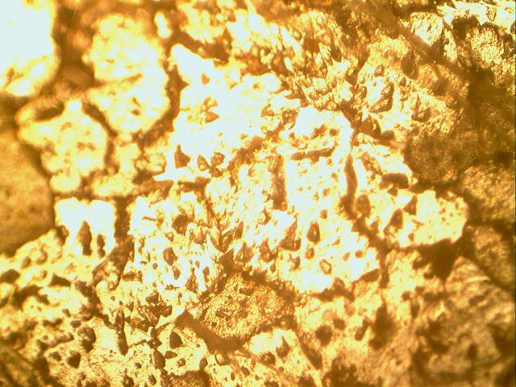 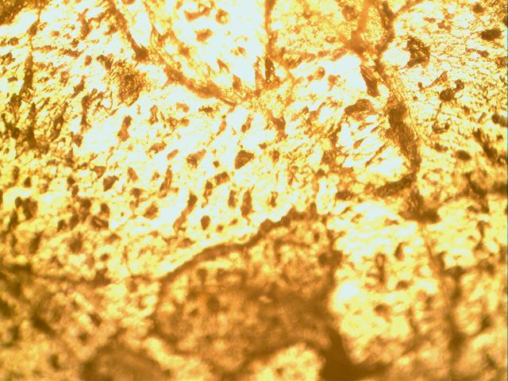 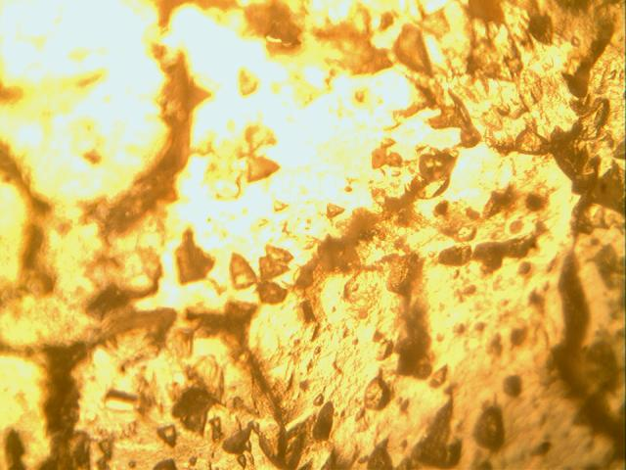

**(a) Sample Poured at 700OC (b) Sample Poured at 720OC (c) Sample Poured at 750OC**

**Plate 7: The Micrograph of the Specimens from Dry Mould**

With regard to plate 8, it can be observed that the three plates contain dendritic structures wide spread throughout the matrix of the samples. The dendrites are more closely packed in plate 8 (a) than in the other two samples, followed by 8 (b), while 8 (c) is coarser than the other two. At some part of the specimen there appear some acicular structures mostly towards the edge of the samples. The appearance of the dendritic structures is owing to the quick solidification of the cast sample in the mould as a result of the mould being wet internally which contributed to the extraction of temperature from the cast product. Sample 8 (a) is finer than the two due to the pouring temperature of the sample (700OC), the sample 8 (b) with pouring temperature (720OC) is finer than 8 (c) with pouring temperature of 750OC but coarser than 8 (a).

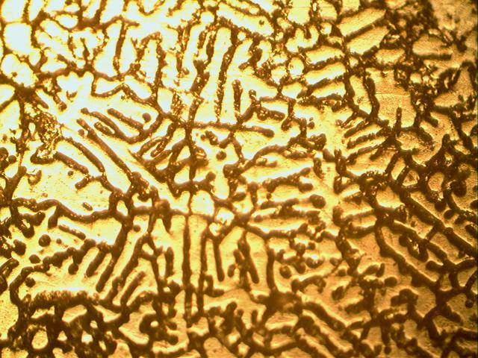 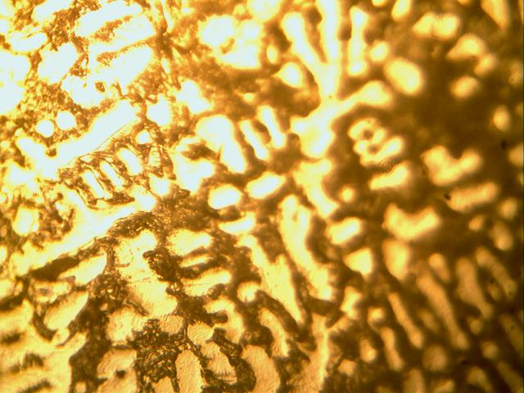 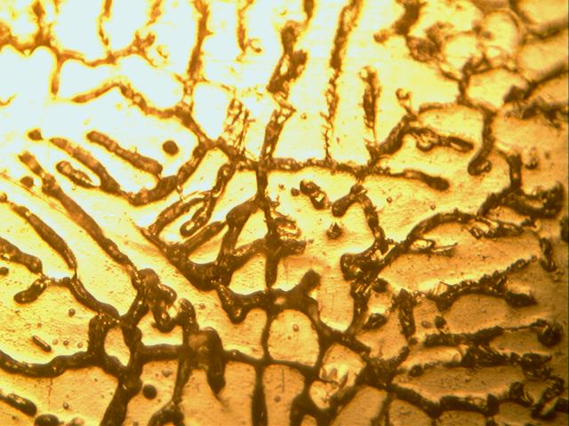

**(a) Sample Poured at 700OC (b) Sample Poured at 720OC (c) Sample Poured at 750OC**

**Plate 8: Micrographs of the Specimens from Skin Dried Mould**

Plate 9 show the micrographs of the specimens produced using green mould, which 9 (a) has acicular structures wide spread with some dark patches, 9 (b) has dendritic structures at the right top corner of the matrix of the specimen in mixture of some acicular structures mostly at the center of the micrograph with some dark patches, while the 9 (c) contain some intergranular widmanstatten plates and idiomorph structures mostly concentrated at the center, while the lower sides of the graph is darken compared to the upper part. The plate 9 (a) pouring temperature was 700OC, which resulted in the chilled grains, while 9 (b) pouring temperature was 720OC and that resulted in the moderately coarse grains and the 9 (c) pouring temperature was 750OC, which results in slower cooling that resulted in the coarse grains.

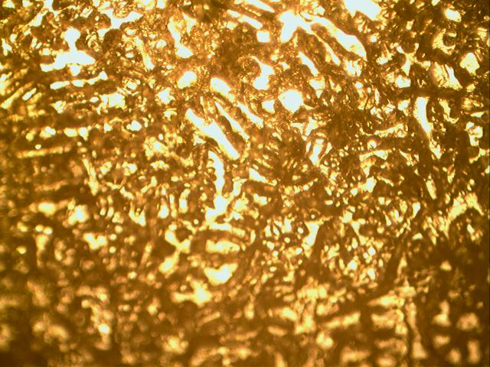 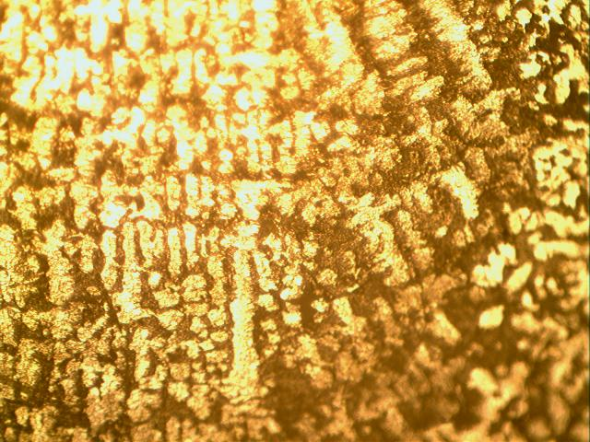 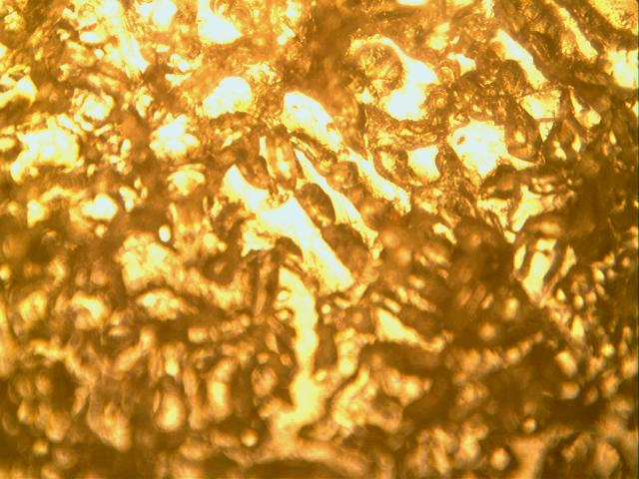

**(a) Sample Poured at 700OC (b) Sample Poured at 720OC (c) Sample Poured at 750OC**

**Plate 9: Micrographs of the Specimens from Green Mould**

**Conclusion**

From the results of the research, the following conclusion are made:

1. The dry mould specimen with pouring temperature of 700OC (D700) has the highest percentage elongation than any other specimen (9.80%), and 19.02% reduction in area, second only to D720 and it also has the highest UTS (77.44MPa). These are due strongly to the appearance of the micrograph where the grains are idiomorphs in mixture with intergranular Wadmanstatten plates, which induced strength into the specimen.
2. The dry mould specimen with pouring temperature of 720OC (D720) has 8.00% elongation, which the third after D700 and D750, the highest percentage reduction in area (20.30%) and the UTS of 75.56MPa. These are due to idiomorphs in mixture with intergranular Wadmanstatten plates in the micrograph, which induced strength into the specimen.
3. The sample D750, which was produced by using 750OC pouring temperature has the second highest elongation (9.62%), while the reduction in area is the third highest (17.64%). The UTS is the highest with the value of 84.40MPa. These are as a result of idiomorphs in mixture with intergranular Wadmanstatten plates as well as Wadmanstatten sawteeh structure, which induced high strength into the specimen.
4. The Skin dry mould specimen with pouring temperature of 700OC (S700) has 5.77% elongation, which is one of least and 14.55% reduction in area, moderate value. The UTS is 56.58MPa, the least of all. These are due to the thick dendritic structures wide spread throughout the matrix of the samples, which make the cast product less ductile.
5. Sample S720, with pouring temperature of 720OC has 7.56% elongation and 10.61% reduction in area and UTS value of 71.06MPa. These are due to the dendritic structures wide spread throughout the matrix of the samples, which are less thick compared to the S700 sample, which make it less brittle as compare to S700 sample.
6. The S750 has 6.59% elongation and 10.43% reduction in area. Its UTS value is 70.12MPa. These is due to the dendritic structures wide spread throughout the matrix in mixture of acicular structure in microstructure of the samples, which make it less ductile than the S720.
7. The green mould sample with pouring temperature of 700OC (G700) has 5.77% elongation and 17.34% reduction in area. The UTS is 69.64MPa. These are due to the acicular structures wide spread with some dark patches, which make it less ductile.
8. The G720 has percentage elongation of 7.84% and 7.39% reduction in area and ultimate tensile strength of 71.19MPa, which is due to the dendritic structures in the matrix of the specimen in mixture of some acicular structures with some dark patches, which results in moderately high ductility.
9. G750 has 5.88% elongation and 10.61% reduction in area and UTS value of 71.19MPa. These are owing to some intergranular widmanstatten plates and idiomorph structures, which results to the low ductility.

**REFERENCES**

Abolarin, M. S., Lawal, S. A. and AbdulRahman A. S. (2010). Effect of Moisture Content on the

Moulding Properties of River Niger Sand Using Tudun-Wada Clay as a Binder. AU J.T. 13(3): 170-174.

Astika, I. M., Negara, D. P., and Susantika, M. A. (2010). Pengaruh Jenis Pasir Cetak dengan Zat

Pengikat Bentonit terhadap Sifat Permeabilitas dan kekuatan Tekan Basah Cetakan Pasir (Sand Casting). Jurnal Energi Dan Manufaktur.

Desiana, S. (2012). Pengaruh Variasi Waterglass Terhadap Kadar Air Dan Kadar Lempung Pada Pasir

Cetak.

Errandonea, D.; Burakovsky, L.; Preston, D. L.; MacLeod, S. G.; Santamaría-Perez, D.; Chen, S.; Cynn,

H.; Simak, S. I.; McMahon, M. I.; Proctor, J. E.; et al. (2020). Experimental and theoretical confirmation of an orthorhombic phase transition in niobium at high pressure and temperature. Community of Materials, 1, 60.

Hendronursito, Y., and Prayanda, Y. (2016). Potensi Pasir Lokal Tanjung Bintang Pada Aluminium Sand

Casting Terhadap Porositas Produk Hasil Cor Aluminium. Jurnal Kajian Teknik Mesin, 1(2), 60-

68.

Ilya A. Zhukov, Alexander A. Kozulin, Anton P. Khrustalyov, Nikolay I. Kahidze, Marina G. Khmeleva,

Evgeny N. Moskvichev, Dmitry V. Lychagin and Alexander B. Vorozhtsov (2019). Pure Aluminium Structure and Mechanical Properties Modified by Al2O3 Nanoparticles and Ultrasonic Treatment. Metals. Received: 13 October 2019; Accepted: 6 November 2019; Published: 7 November 2019.

Jatimurti, W., Alexander, B., and Toto Wibisono, A. (2019). Effect of Degassing Time and Cooling Rate

on Microstructure and Porosity of Aluminium 6061 Alloy Using Sand Casting Method. Paper

presented at the Materials Science Forum.

John O. Oji, Buliamin, Kareem, and Nosa, Idusuyi (2011). Effects of Mould and Pouring Temperatures

on the Ultimate Tensile Strength of Aluminium Alloy Sand Castings: An ANOVA Approach. Leonardo Electronic Journal of Practices and Technologies. ISSN 1583-1078. Issue 19, July-December 2011. Pp. 97-108.

Kaushish, J. P. (2010). Manufacturing Processes.: PHI Learning.

Li, H.; Li, D.; Zhu, Z.; Chen, B.; Chen, X.; Yang, C.; Zhang, H. and Kang,W. (2016). Grain refinement

mechanism of as-cast aluminium by hafnium. Transaction of Nonferrous Metals Society of China, 26, 3059–3069.

Mohd Syukry, Z. and Ahmad Badri, I. (2015). Effect of Aging Time to the Commercial Aluminium

Alloy Modified with Zirconium Addition. Materials Science Forum, 819, 50–56.

Mostafa, A.; Adaileh,W.; Awad, A. and Kilani, A. (2021). Mechanical Properties of Commercial Purity

Aluminum Modified by Zirconium Micro-Additives. Crystals 2021, 11, 270.

<https://doi.org/10.3390/cryst11030270>.

Qosim, N., Mufarrih, A. M., Ali, S., Hanif, F. A., Fina A. F. A., Ratna, M. and Zakki F. E. (2020). Effect

of Moisture Content of Green Sand on the Casting Defects. Journal of Applied Engineering and Technological Science Vol 2(1): 1-6. Received: 18 May 2020, Revised: 5 August 2020, Accepted 6 August 2020.

Sama, S. R., and Manogharan, G. (2017). Sand casting design rules: Pennsylvania State Univesrity.

Siagian, S. J., Gede, I., Istri, C., and Dan Kusuma, T. M. (2017). Pengaruh Permeabilitas Cetakan Pasir

Dan Penambahan Silikon (Si) Pada Proses Pengecoran Terhadap Kekerasan, Porositas Dan Struktur Mikro Alumunium Silikon (Al-Si). 6(4), 305-310.

Smith, D.; Joris, O.P.J.; Sankaran, A.;Weekes, H.E.; Bull, D.J.; Prior, T.J.; Dye, D.; Errandonea, D.;

Proctor, J.E. (2017). On the high-pressure phase stability and elastic properties of Aluminium-titanium alloys. Journal of Physical Condensation Matter, 29, 155401.

Straumal, B.; Korneva, A.; Kilmametov, A.; Lity ´nska-Dobrzy´ nska, L.; Gornakova, A.; Chulist, R.;

Karpov, M.; Zi˛eba, P. (2019). Structural and Mechanical Properties of Ti–Co Alloys Treated by High Pressure Torsion Materials, 12, 426.

Surdia, T., and Chijiwa, K. (2006). Teknologi Pengecoran Logam Cetakan ke sembilan. Jakarta: Pradnya

Paramita.

Taryaman, T., Roslina, R., and Abdullah, H. (2018). Analisis Cacat Cor pada Produk Fly Wheel Hasil

Proses Pengecoran Menggunakan Cetakan Pasir. Metal Indonesia, 27(1), 44-55

Vaishnav, A., and Patel, V. (2016). Reduce Shrinkage-Porosity Defects in Sand Casting Using FEM.

Wasiu Ajibola Ayoola, Samson Oluropo Adeosun, Olujide Samuel Sanni and Akinlabi Oyetunji (2012).

Effect of Casting Mould on Mechanical Properties of 6063 Aluminum Alloy. Journal of Engineering Science and Technology. Vol. 7, No. 1 Pp. 89 – 96. School of Engineering, Taylor’s University.

Zhang, Y.; Ma, N.; Yi, H.; Li, S.;Wang, H. (2006). Effect of Fe on grain refinement of commercial purity

aluminium. Materials Desertation, 27, 794–798.