A plus type CC-based universal biquad configuration

Takao Tsukutani
Professor Emeritus, National Institute of Technology, Matsue College, Japan
E-mail t.tsukutani@sea.chukai.ne.jp

Abstract: This paper presents a universal biquad configuration using only plus type current conveyors (CCs) and grounded passive components. The circuit enables low-pass, band-pass, high-pass, band-stop and all-pass responses by the selection and addition of the circuit currents with no component matching constraints. Moreover the circuit parameters ω₀ and Q can be set orthogonally adjusting the circuit components. The biquad circuit enjoys very low sensitivity with respect to the circuit components. The achievement example is given together with simulation results by PSPICE.
Keywords: Analog circuit, Biquad responses, Current conveyors, CMOS technology

1. INTRODUCTION
At present high performance active circuits have received considerable attention. Circuit designs using active devices such as the CCs, operational trans-conductance amplifiers (OTAs) and others have been reported in the literature ^{[1-6]}. CCs are very useful active devices, and CC-based circuits are suitable for wide band operation. There are several kinds of CCs, e.g. second generation current conveyor (CCII) ^{[1]}, third generation current conveyor (CCIII) ^{[2]}, differential voltage current conveyor (DVCC) ^{[4]}, etc. The plus type CC is composed of a simpler circuit configuration than the minus type one. Hence it has a wide band operation and low power performance compared with the minus type CC.
The biquad circuit is a very useful second-order function block for realizing the high-order circuit transfer functions. Several biquad circuits using the CCs have been previously discussed ^{[1],[4-6]}. However only the plus type CC-based biquad circuit ^{[7,8]} has not been studied sufficiently.
This paper introduces a universal biquad configuration employing only the plus type CCs (i.e. DVCCs and CCIIs) and grounded passive components as mentioned above. First we propose a basic current-mode biquad circuit, and then we show a typical current-mode circuit using the basic current-mode one. The circuit enables low-pass (LP), band-pass (BP), high-pass (HP), band-stop (BS) and all-pass (AP) responses by the selection and addition of the circuit currents without any component matching constraints. Moreover the circuit has an orthogonal adjusting capability for the circuit parameters ω₀ and Q. It is made clear from sensitivity analysis that the biquad circuit has very low sensitivity to the circuit components. In addition voltage-mode biquad circuit is introduced employing the basic current-mode one.
The design example is given together by PSPICE simulation, and the circuit workability was confirmed.

2. CURRENT CONVEYORS
The symbols of the plus type CCs (DVCC and CCII) are given in Fig.1, and hereinto they show dual current output CCs.
The plus type DVCC and CCII are characterized by the following terminal equations:
$\begin{matrix}V_{x}=V_{y1}−V_{y2}, & I_{z}=I_{x}\end{matrix}$ (1)
$\begin{matrix}V_{x}=V_{y}, & I_{z}=I_{x}\end{matrix}$ (2)
Moreover the DVCC and CCII with MOS transistors are shown in Fig.2.
(a) DVCC
(b) CCII
Figure 1: Symbols of CCs
(a) DVCC
(b) CCII
Figure 2: Plus type CCs with MOS transistors

3. CC-BASED BIQUAD CIRCUIT
Figure 3 shows the basic current-mode biquad circuit configuration. This circuit is constructed with two DVCCs, two CCIIs and grounded passive components.
Figure 3: Basic current-mode biquad circuit
The current outputs I_{LP}(s), I_{BP}(s) and I_{HP}(s) are given by:
$I_{\text{LP}}(s)=−\frac{1}{s^{2}C_{1}C_{2}R_{1}R_{2}+{\text{sC}}_{2}R_{1}{R_{2}}/{R_{3}}+1}I_{i}(s)$ (3)
$I_{\text{BP}}(s)=−\frac{{\text{sC}}_{2}R_{1}{R_{2}}/{R_{3}}}{s^{2}C_{1}C_{2}R_{1}R_{2}+{\text{sC}}_{2}R_{1}{R_{2}}/{R_{3}}+1}I_{i}(s)$ (4)
$I_{\text{HP}}(s)=−\frac{s^{2}C_{1}C_{2}R_{1}R_{2}}{s^{2}C_{1}C_{2}R_{1}R_{2}+{\text{sC}}_{2}R_{1}{R_{2}}/{R_{3}}+1}I_{i}(s)$ (5)
The typical current-mode biquad circuit is consisted of using the basic current-mode one shown in Fig.4.
Figure 4: Typical current-mode biquad circuit
This circuit enables the LP, BP and HP responses by selection of the output currents I_{LP}(s), I_{BP}(s) and I_{HP}(s) as follows:
$T_{\text{LP}}(s)=\frac{I_{\text{LP}}(s)}{I_{\text{in}}(s)}=−\frac{R_{a}}{R_{b}}\frac{1}{s^{2}C_{1}C_{2}R_{1}R_{2}+{\text{sC}}_{2}R_{1}{R_{2}}/{R_{3}}+1}$ (6)
$T_{\text{BP}}(s)=\frac{I_{\text{BP}}(s)}{I_{\text{in}}(s)}=−\frac{R_{a}}{R_{b}}\frac{{\text{sC}}_{2}R_{1}{R_{2}}/{R_{3}}}{s^{2}C_{1}C_{2}R_{1}R_{2}+{\text{sC}}_{2}R_{1}{R_{2}}/{R_{3}}+1}$ (7)
$T_{\text{HP}}(s)=\frac{I_{\text{HP}}(s)}{I_{\text{in}}(s)}=−\frac{R_{a}}{R_{b}}\frac{s^{2}C_{1}C_{2}R_{1}R_{2}}{s^{2}C_{1}C_{2}R_{1}R_{2}+{\text{sC}}_{2}R_{1}{R_{2}}/{R_{3}}+1}$(8)
Moreover the BS and AP responses can be achieved by the current additions of I_{BS}(s)=I_{HP}(s)+I_{LP}(s) and I_{AP}(s)=I_{i}(s)+2I_{BP}(s), respectively. The circuit transfer functions are given as:
$T_{\text{BS}}(s)=\frac{I_{\text{BS}}(s)}{I_{\text{in}}(s)}=−\frac{R_{a}}{R_{b}}\frac{s^{2}C_{1}C_{2}R_{1}R_{2}+1}{s^{2}C_{1}C_{2}R_{1}R_{2}+{\text{sC}}_{2}R_{1}{R_{2}}/{R_{3}}+1}$ (9)
$T_{\text{AP}}(s)=\frac{I_{\text{AP}}(s)}{I_{\text{in}}(s)}=\frac{R_{a}}{R_{b}}\frac{s^{2}C_{1}C_{2}R_{1}R_{2}−{\text{sC}}_{2}R_{1}{R_{2}}/{R_{3}}+1}{s^{2}C_{1}C_{2}R_{1}R_{2}+{\text{sC}}_{2}R_{1}{R_{2}}/{R_{3}}+1}$ (10)
Thus standard circuit transfer functions can be obtained by the selection and addition of the circuit currents.
The circuit parameters ω₀, Q and H are represented as below:
$\begin{matrix}ω_{0}=\sqrt{\frac{1}{C_{1}C_{2}R_{1}R_{2}}}, & Q=R_{3}\sqrt{\frac{C_{1}}{C_{2}R_{1}R_{2}}}, & H=\frac{R_{a}}{R_{b}}\end{matrix}$ (11)
The circuit parameter ω₀ and Q can be set orthogonally according to the circuit components, while the parameter H is able to set independently.
Table 1 shows the sensitivities with respect to the circuit components. These values are rather small. We can find from them that the circuit enjoys very low sensitivity to the circuit components. It is noted that the sensitivities are not dependent on the circuit component values.
Table 1: Component sensitivity
(current-mode circuit)
x | ω₀ | Q | H
R₁ | -0.5 | -0.5 | 0.0
R₂ | -0.5 | -0.5 | 0.0
R₃ | 0.0 | 1.0 | 0.0
R_{a} | 0.0 | 0.0 | 1.0
R_{b} | 0.0 | 0.0 | -1.0
C₁ | -0.5 | 0.5 | 0.0
C₂ | -0.5 | -0.5 | 0.0
The voltage-mode biquad circuit is constructed with the basic current-mode one as shown in Fig.5. The current output I_{out}(s) presents any of the current outputs I_{LP}(s), I_{BP}(s), I_{HP}(s) and addition currents I_{BS}(s), I_{AP}(s) in the basic current-mode circuit. And the output voltage V_{out}(s) is obtained converting the current output I_{out}(s) to voltage.
Figure 5: Voltage-mode biquad circuit
The voltage-mode circuit can achieve the LP, BP, BS, HP and AP responses like as the current-mode one. The circuit parameters ω₀, Q and H are given as:
$\begin{matrix}ω_{0}=\sqrt{\frac{1}{C_{1}C_{2}R_{1}R_{2}}}, & Q=R_{3}\sqrt{\frac{C_{1}}{C_{2}R_{1}R_{2}}}, & H=\frac{R_{b}}{R_{a}}\end{matrix}$ (12)
Table 2 shows the sensitivities to the circuit components. It is found that the voltage-mode biquad circuit has very low sensitivity as well as the current-mode one.
Table 2: Component sensitivity
(voltage-mode circuit)
x | ω₀ | Q | H
R₁ | -0.5 | -0.5 | 0.0
R₂ | -0.5 | -0.5 | 0.0
R₃ | 0.0 | 1.0 | 0.0
R_{a} | 0.0 | 0.0 | -1.0
R_{b} | 0.0 | 0.0 | 1.0
C₁ | -0.5 | 0.5 | 0.0
C₂ | -0.5 | -0.5 | 0.0
In addition, biquad circuits on other operation modes (i.e. trans-admittance-mode, trans-impedance-mode) can easily be consisted of using the basic current-mode one.

4. DESIGN EXAMPLE AND SIMULATION RESULTS
We verify the circuit operation using PSPICE simulation program. As a design example, we tried to achieve a current-mode biquad circuit with f₀ (=ω₀/2π)=1MHz, Q=1.0 and H=1.0. In the simulation, we used the DVCC and CCII shown in Fig.2. In order to achieve the specification above, we set the circuit components listed in table 3.
Table 3: Circuit components
x | LP | BP | HP | BS | AP
R₁ (kΩ) | 9.8 | 10.4 | 11.4 | 10.5 | 10.2
R₂ (kΩ) | 9.8 | 10.4 | 11.4 | 10.5 | 10.2
R₃ (kΩ) | 9.8 | 10.4 | 11.4 | 10.5 | 10.2
R_{a} (kΩ) | 14.2 | 13.3 | 13.8 | 14.5 | 14.7
R_{b} (kΩ) | 10 | 10 | 10 | 10 | 10
C₁ (pF) | 12 | 12 | 12 | 12 | 12
C₂ (pF) | 12 | 12 | 12 | 12 | 12
Figure 6 shows the simulation responses. Figure 6 (a) shows the LP, BP, HP and BS responses, and the AP response is shown in Fig.6 (b). This can be viewed as an excellent result over a wide frequency range. Here we set the input current, bias currents and DC supply voltages as I_{in}=10μA, I_{b0}=I_{b1}=I_{b2}=I_{b3}=I_{ba}=5μA and V_{DD}= -V_{SS}=1.2V. The power dissipation was 0.472mW, while it was 0.485mW in the AP response.
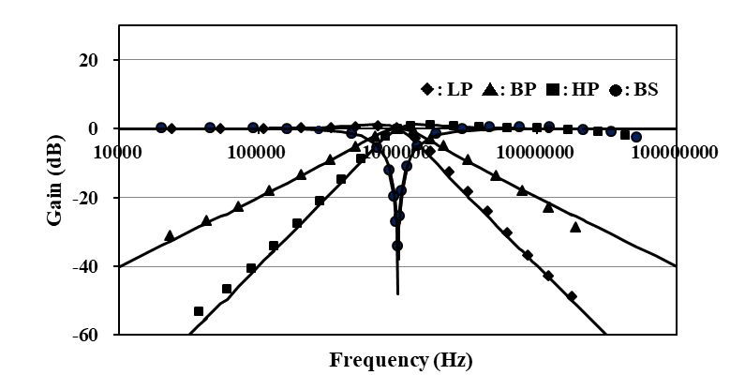 (a)
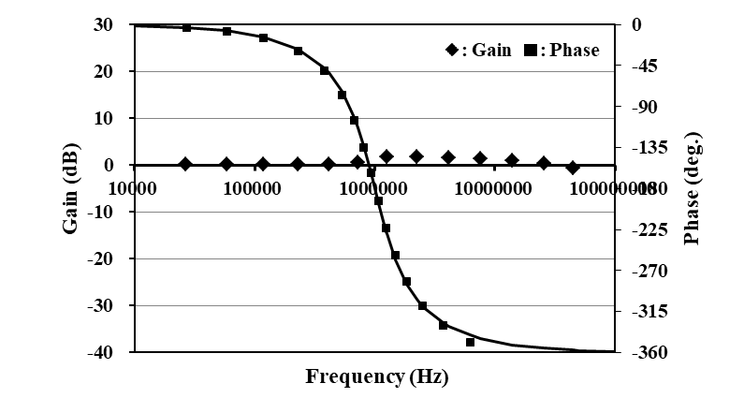 (b)
Figure 6: Simulation responses
In this simulation, we set the MOS transistor’s aspect ratios W/L=40μm/0.5μm (M1 to M4) and W/L=10μm/1μm (others) in the DVCC, while they were W/L=20μm/1μm (M1 to M4) and W/L=10μm/1μm (others) in the CCII. And we used device parameters of MOSIS 0.5μm for other parameters.

5. CONCLUSION
This paper has described a universal biquad configuration employing only plus type CCs and grounded passive components. The circuit can achieve five standard circuit responses (i.e. LP, BP, HP, BS and AP responses) choosing and adding the circuit currents with no component matching constraints. The circuit parameters ω₀ and Q can be set orthogonally by adjusting the circuit components. Moreover it has been made clear that the biquad circuit enjoys very low sensitivity to the circuit components. In addition voltage-mode biquad circuit has been presented utilizing the basic current-mode one. The achievement example has been given together with simulation results by PSPICE. The simulation responses have been appropriate enough over a wide frequency range.
The biquad circuit has several advantages concerning the wide band operation, low power dissipation and circuit parameter adjusting, etc. The circuit configuration is very suitable for implementation in CMOS technology.
The non-idealities (i.e. x-terminal resistance, voltage and current tracking errors, etc.) of the CCs affect the circuit performances. The solution for this will be discussed in the future.

REFERENCES
- A. Fabre, et al., “High frequency applications based on a new current controlled conveyor,” IEEE Trans. Cir. Syst., vol.43, no.2, pp.82-91, 1996.
- A. Fabre, “Third-generation current conveyor: a new helpful active element,” Electron. Lett., vol.31, no.9, pp.338-339, 1995.
- M.T. Abuelma’atti, et al., “A novel mixed-mode OTA-C universal filter,” Int. J. Electron., vol.92, no.7, pp.375-383, 2005.
- H.O. Elwan, A.M. Soliman, “Novel CMOS differential voltage current conveyor and its applications,” IEE Proc. Cir. Dev. Syst., vol.144, no.3, pp.195-200, 1997.
- S. Minaei, M.A. Ibrahim, “General configuration for realizing current-mode first-order all-pass filter using DVCC,” Int. J. Electron., vol.92, no.6, pp.347-356, 2005.
- M.A. Ibrahim, et al., “A 22.5MHz current-mode KHN-biquad using differential voltage current conveyor and grounded passive elements,” Int. J. Electron. Comm., vol.59, pp.311-318, 2005.
- T. Tsukutani, et al., “A plus type CC-based current-mode universal biquad,” J. Elec. Eng., vol.8, no.1, pp.17-20, 2020.
- T. Tsukutani, et al., “Nobel plus current output CC-based biquad circuit,” Proc. ITC-CSCC 2021, pp.43-46, 2021.

