**Evaluating Spur Dike Performance in Sharp Bends in Bahr Youssef Canal**

Basma S. Awad1, Hesham El-Badry3, Emam A. Osman1, Nader M. Shafik2, Abd Elhamid Khater 4, and Shaimaa Fathy3

*1 Channel Maintenance Research Institute (CMRI), National Water Research Center (NWRC), Egypt.*

1. *Nile Research Institute (NRI), National Water Research Center (NWRC), Qalubia, Egypt.*
2. *Irrigation and Hydraulics Department, Faculty of Engineering, Ain Shams University, Cairo, Egypt.*
3. *Assistant Professor, National Water Research Centre, Egypt.*

*Corresponding Author: Basma S. Awad*

*ABSTRACT: The optimization of flow conditions in river bends is an important issue in maintaining the stability and efficiency of waterways. Spur dikes play a significant role in this context by influencing flow patterns and controlling scour, particularly in meandering rivers. In recent years, spur dikes have emerged as a promising alternative for effective and efficient scour control, which can deflect or repel the flow to reduce erosion. This study aims to compare the effectiveness of different attractive spur dike designs in improving flow patterns in a sharp bend in the natural Bahr Yousef canal. The study will utilize 2D numerical modeling (Delft3D FM Model) to simulate the flow patterns under different heights (ratio from water depth), and orientation angles of attractive spur dikes at the maximum flow condition. The results of this comparative analysis will provide valuable insights into the optimal design of spur dikes for enhancing flow conditions inside the bend. The results revealed that velocity was influenced by changing the parameters of the design of spur dikes, by varying trends observed for different configurations. The results indicated that the height ratio of 0.75 water depth provided an optimal balance between flow deflection and sediment transport efficiency. Additionally, increasing the spur dike length further reduced the depth average velocity across the bend. Consequently, the best spur dike configuration was 35% length with a height ratio of 0.75 at the angle of 110° with flow direction. The findings highlighted the importance of considering length, height, and angle when designing spur dikes to optimize their efficiency in controlling velocity in meandering canals. This research is important for improving the understanding of flow patterns in a sharp bend and developing effective mitigation strategies to ensure the stability of the waterway.*

***KEY WARDS:*** *Delft 3D FM model, Meandering canal, Spur dike, Scour, Sedimentation*

---------------------------------------------------------------------------------------------------------------------------------------

Date of Submission: xx-xx-xxxx Date of acceptance: xx-xx-xxxx

---------------------------------------------------------------------------------------------------------------------------------------

# INTRODUCTION

The scour issue in meandering canals, especially along the outer curve, presents a challenge for effective and sustainable river bend management. The maximum effect of the meandering river is reached at the fully developed spiral and transverse flow components (helical flow currents) near the bend apex where the maximum local scour is achieved. In contrast, the inner curve experiences lower flow velocities, promoting the deposition of sediments. This sediment build-up can reduce the effective cross-sectional area of the canal, diminishing its flow capacity and potentially leading to flooding during high-flow events. Human interference is required at these locations to protect the riverbank. Maintaining the stability and efficiency of waterways, especially in river bends, is critical for ensuring effective water flow and minimizing erosion [1]. Traditional methods for controlling scour, such as riprap and gabions, are effective but typically expensive and require extensive time for construction. In contrast, the emerging application of spur dikes exhibits potential as a cost-effective and efficient alternative for mitigating erosion. In recent years, spur dikes have gained attention as a promising solution for effective and efficient scour control, capable of deflecting or repelling flow to reduce erosion.

Studies have shown that spur dikes can effectively manipulate flow patterns to reduce scour, making them an attractive option for river bend management. [2] employed the 2D Finite Element Surface Water Modeling System (FESWMS) to simulate flow conditions in two meandering stream reaches along the Raccoon River, Iowa, USA, and evaluated the performance of dike structures in controlling streambank erosion. The study demonstrated that the optimal design involves alternate bendway weirs and spurs with a spacing of about 50 m. [3] found that increasing the Froude number of the flow, relative distance between spur dikes, and their relative lengths could influence local scour around spur dikes in river bends. [4] found that by setting spur dikes on the outer bank, the maximum scour depth could be reduced by more than 40% with proper placement. The study also highlighted the importance of considering the ratio of spur spacing to spur length in the design. [5] demonstrated the effectiveness of spur dikes in reducing bed scour in meandering canal bends. The study emphasized the need for site-specific design considerations, such as the angle and length of the spur dikes, to optimize their performance. [6] presented a comprehensive study on the use of submerged spur dikes for river training and sustainability in incised steep bend streams. The authors employed a combination of one-dimensional (1D) and two-dimensional (2D) morphodynamic simulations to analyze the behavior of fixed sandbars near the spur dikes and the local scour around the water control system. [7] presented a comprehensive review of the effects of spurs on river channels. The authors discussed the design criteria for spurs, including the orientation, length, and spacing of spurs, and the impact of these factors on the flow pattern and bed topography of the river channel. focused on the scour around a spur dike at a 90° bend, highlighting the need for more research on scour in bends with spur dikes. [8] conducted experiments in a laboratory setting on a series of bendway weirs with different crest slopes (0, 5, and 10 percent) installed in a 90° bend with a relative curvature of 3.3. The results showed that the maximum scour depth occurred at the tip of the first and last weirs, and the eroded sediment volume increased by 53, 36, and 15 percent due to the installation of weirs with crest slopes of 0, 5, and 10 percent, respectively. [9] investigated the performance of slope-crested groynes in controlling erosion in erodible meandering channels with different sinuosities. They concluded that the performance of the slope-crested groynes was slightly better in the low sinuosity channel. Furthermore, spur dikes employed in groups inside the stream and channel exhibited more complex flow characteristics [10], [11], and [12]. Overall, case studies have demonstrated that spur dikes can be highly effective in managing erosion and improving channel sustainability, particularly when constructed in series with optimal shapes and dimensions tailored to the specific river conditions. However, effectiveness could vary depending on factors such as river curvature and flood conditions [13].

A research gap exists in understanding the optimal design and installation methods for spur dikes in complex channel geometries. Particularly regarding how different shapes and configurations influence sediment transport and erosion control in bends. Addressing this gap is essential for improving the effectiveness and sustainability of river management practices. Through a comprehensive literature review, this study aims to build upon existing knowledge and address the gap in understanding the optimal design parameters (height & length) for spur dikes in mitigating flow turbulence and improving flow patterns in a sharp bend in Bahr Yousef canal. The study employed numerical modeling using the Delft3D FM Model to simulate flow patterns around spur dikes of varying lengths, heights, and orientation angles.

# STUDY AREA DESCRIPTION

Bahr Youssef canal is a natural waterway with approximately 293 km, it diverts water from the Nile River to the Fayoum governorate, providing a reliable source of irrigation for agricultural lands in this arid region. This is essential for growing crops in an otherwise dry climate. It plays a role in water management within the Fayoum Oasis, helping to control flooding and managing water resources effectively. As a natural channel, its waterway has a lot of meanders, sedimentation, and erosion problems. The canal's morphology is actively changing due to natural and human-induced factors, such as the canal's operational scheme and the dredging or disposal of sediments into the canal. These impacts often reduce the cross-sectional conveyance capacity and disrupt the streamlined flow in the canal. Consequently, this can further exacerbate lateral migration or downcutting of bed material, causing bank failures and hindering the operation of hydraulic structures. The canal exhibits a highly sinuous course, with numerous sharp bends and severe meandering sections, totaling approximately 200 bends along its entire length. The bend at kilometer 132.000 is one of the most critical bends along the entire length of the second reach. Bend reach is about 1 km long located between km 131.500 and km 132.500 downstream of Dahab regulator. It follows an anticlockwise direction where the inner curve is situated on the west side and the outer curve is located along the east side of the canal, layout of the bend is shown in Fig. (1). Parameters of the meandering planform relevant to the bend reach were deduced as illustrated in Table (1). The bend is classified as a sharp bend with curvature ratio < 2 [14].

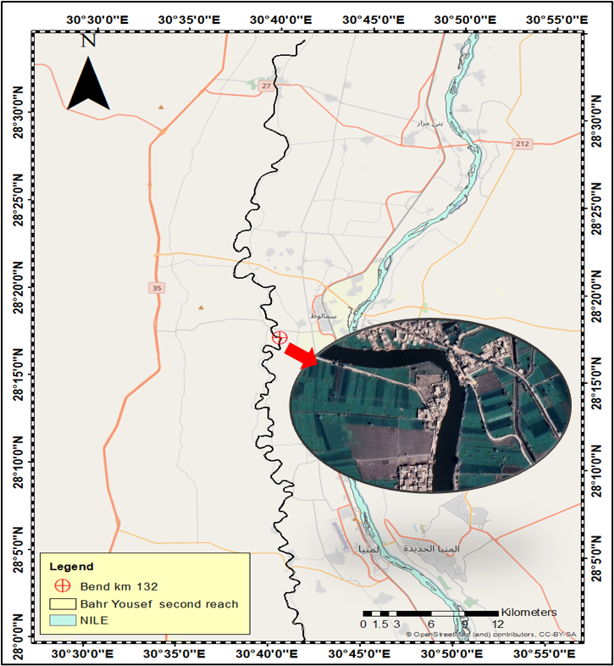

**Figure 1: Layout of the bend section**.

***Table I*. Characteristics of the bend reach**

|  |  |
| --- | --- |
| **Parameter** | **Value with unit** |
| Bend-wise wavelength (L) | 1000 (m) |
| Valley wavelength (λ) | 719.6 m |
| Ave. channel bank full width (B) | 65 m |
| Curvature radius (RC) | 168.44 (m) |
| Curvature angle (θ) | 120 ° |
| Sinuosity | 1.4 |
| Rc/B ratio | 1.85 |
| Slope | 6.5 cm/km |
| Side slope | 3:2 |

# Materials and methods

Fig. (2) illustrates the ﬂow chart of the study methodology. The study outline starts with fieldwork that was collected for the bend reach at km 132. Then the bend morphological condition was assessed. Finally, an evaluation of various configurations of attractive spur dikes was done to improve flow patterns and control erosion.

**Figure 2: Research methodology layout.**

# 3.1 Field Works

The hydrographic survey was implemented in the studied reach, where 197 cross-sections at approximately 50m intervals were surveyed. Spatially intensive Acoustic Doppler Current Profiler (ADCP) was used to measure velocity and discharge in 2019. According to the ADCP measurements, flow discharge was 108 m3/sec and the averaged measured velocity was 0.3 m/sec. It should be noted that the maximum discharge was approximately 150.7 m3/sec. Bed material samples were collected and analyzed at CMRI (Channel Maintenance Research Institute) soil laboratory. Soil analysis results showed that the bed material consists of 93.84 % fine sand and 6.16 % silt with a D50 value of 0.15 mm as shown in the grain size distributions **Fig. (3)**. The morphological changes in the target bend were quantified by comparing the bathymetric survey with the design cross-section and evaluated by comparing WorldView-2 (2023) with Quickbird (2004) satellite images. Quickbird image (2004) was acquired with a high resolution of 60 cm. WorldView-2 image of 2023 was free with a resolution of 2 m.

**Figure 3: The grain size distribution.**

# Numerical model approach

The study utilized numerical modeling 2D (Delft3D FM Model) to simulate flow patterns inside the reach at the measured cross-sections under the measured and maximum flow conditions. A series of straight-attracting spur dikes were proposed in various configurations to improve flow patterns and control erosion in the outer curve and sedimentation in the inner curve of the bend. Delft3D FM Model was used to examine hydraulics and simulate the flow field around spur dikes to evaluate the effect of spur dike's length and height ratio on the bend hydraulic characteristics. The effectiveness of different configurations in controlling velocities was assessed.

Delft 3D Flexible Mesh (Delft3D FM) model uses the shallow water equations to simulate flow in a river bend. These equations are a set of partial differential equations that describe the flow below a pressure surface in a fluid. It uses a flexible mesh approach, allowing for unstructured grids that can more accurately represent complex geometries like river bends. The governing equations include the continuity equation and the momentum equations. These equations form the basis of the hydrodynamic module in Delft3D FM. The model numerically solves these equations using finite difference to simulate the flow behavior in river bends, considering the complex interactions between flow, sediment transport, and morphological changes **[15]**.

1. **Continuity Equation**:

$$\frac{∂h}{∂t}+\frac{∂(hu)}{∂x}+\frac{∂(hv)}{∂y}=0$$

Where:

h = water depth

u = depth-averaged velocity component in the x-direction

υ = depth-averaged velocity component in the y-direction

t = time

x, y = horizontal coordinates

1. **Momentum Equations**:

**x-direction**:

$$\frac{∂(hu)}{∂t}+\frac{∂(hu^{2})}{∂x}+\frac{∂(huυ)}{∂y}+gh\frac{∂h}{∂x}=gh\left(\frac{∂z_{b}}{∂x}\right)+f_{υ}$$

**y-direction**:

$$\frac{∂\left(hυ\right)}{∂t}+\frac{∂\left(huυ\right)}{∂x}+\frac{∂\left(hυ^{2}\right)}{∂y}+gh\frac{∂h}{∂y}=gh\left(\frac{∂z_{b}}{∂y}\right)+f_{u}$$

Where:

* g = acceleration due to gravity
* zb = bed elevation
* fu, fυ= friction terms

The frictions (fu and fυ) are expressed using Manning’s formula:

$$f_{u}=-\frac{gn^{2}}{h^{1/3}}u\sqrt{u^{2}+υ^{2}} , f_{υ}=-\frac{gn^{2}}{h^{1/3}}υ\sqrt{u^{2}+υ^{2}}$$

Where: n = Manning’s roughness coefficient.

# 3.3 Model setup

At the beginning of the Delft3D FM model setup, a land boundary file was created in global mapper software. The significance of this land boundary file is to simplify the creation of unstructured grids within RGFGRID. A flexible mesh is used to simulate the bend reach in order to capture the curvature and the variations in width along the reach as shown in Fig. (4**).** Local refinement was carried out at the apex of the bend as this was the targeted area of the research. In order to simulate inclined spur dikes, the model utilizes a combination of grid rectangles at spur dike locations and grid triangles along the entire length of the bend that allows flow alignment. The connection between the grids is carried out using the merge nodes tool. Horizontal resolution ranges approximately from 2 at the apex of the bend to 18 m along the bend length. An estimated 6827 grid cells were generated along the reach. Boundary mesh for 2D Delft3D-FM model was generated based on the available surveyed bathymetric data. Interpolated bathymetric data were assigned to the developed numerical grid. The upstream boundary condition at km 131.500 was set as discharge. The downstream boundary condition at km 132.500 was set as water level.

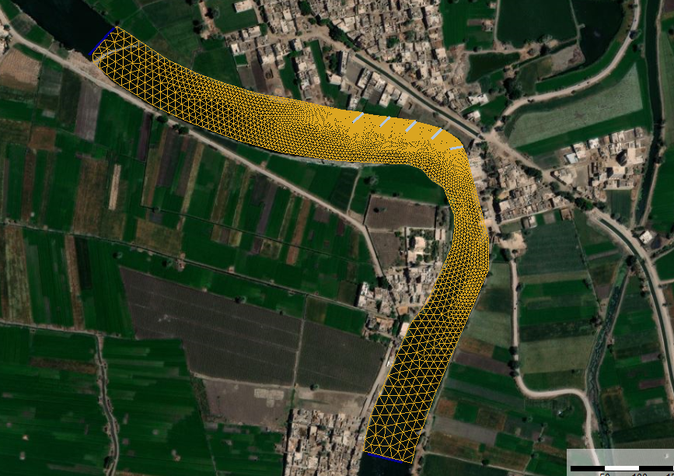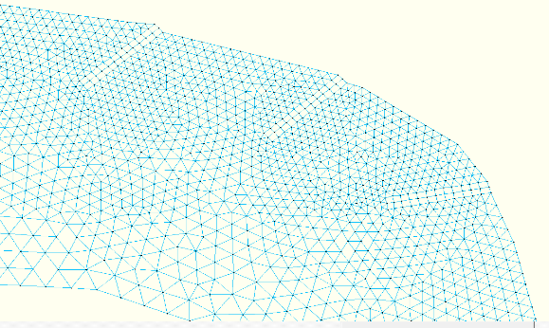

**Figure 4: Grid generation**

# 3.4 Model calibration

The values of the manning coefficient and horizontal eddy viscosity are used as calibration parameters. Calibration scenarios are carried out by trying different values for the main parameters that could affect water level and velocity. The recommended value for horizontal eddy viscosity for river models is 1 m2/s **[16]**. As a result of high velocities due to narrowing in width near the apex of the bend, horizontal eddy viscosity should be decreased to calibrate the model. The obtained calibration results are illustrated as shown in Fig. (5) which shows the comparison between the measured and computed water levels along the simulated study reach and velocity cross-section calibration at km 131.975. Consequently, the calibration tests revealed satisfactory results and good agreement with the Manning coefficient (0.02) and horizontal eddy viscosity 0.6 m2/s.

**a**

**b**

**Figure 5: Model calibration (a: water level calibration, b: velocity calibration)**

# 3.5 Evaluation Scenarios

The modeling scenarios for the series of spur dikes involved various configurations (9 scenarios) to analyze the performance of the spur dikes. Spur dikes were simulated as simple weirs. A series of spur dikes (5 dikes) will be implemented at angles of 110°, 120°, and 130 respectively along the outer curve of the bend after km 131.950. Angles decreased gradually downstream to align the flow towards the center of the channel and reduce the risk of flow stagnation zones. The last three spur dikes have the same angle of 130° because they were located in a less curved zone. The lengths of the spur dikes (Ls) were set as 25%, 30%, and 35% of the bend width (65 m), resulting in lengths of 16.25 m, 19.5 m, and 22.75 m respectively. The crest width was set as 3 m. The spacing (Ss) between adjacent spur dikes was established as twice their respective lengths. Three height ratios (the ratio between spur dike height to water depth) were tested. The tested values were 0.5, 0.75, and 1.2 of maximum water depth (Hw) as shown in Table (2).

***Table II*. Scenarios of different spur dike configurations.**

|  |  |  |  |  |  |
| --- | --- | --- | --- | --- | --- |
| **Case Name** | **Q**  **(m3/s)** | **Hw (water depth)**  **(m)** | **Ls**  **(m)** | **Ss**  **(m)** | **Hs (Spur dike height)**  **(m)** |
| **25% Width** | Q max = 157.4 | 7.2 | 16.25 | 32.5 | h0.5=3.6 |
| h0.75=5.4 |
| h1.2=8.6 |
| **30% Widtg** | Q max =157.4 | 7.2 | 19.5 | 39 | h0.5=3.6 |
| h0.75=5.4 |
| h1.2=8.6 |
| **35% Width** | Q max = 157.4 | 7.2 | 22.75 | 45.5 | h0.5=3.6 |
| h0.75=5.4 |
| h1.2=8.6 |

# RESULTS AND DISCUSSIONS

***4.1 Morphological condition***

The areas of sedimentation and Erosion on the stream banks were identified by comparing satellite images at the study area Fig. (6). The right bank is migrated by 4m at km 132 due to helical flow currents. Encroachments increased at the right bank by 100 m long and 13.5 m wide at the bend apex leading to the narrowing of the bend width. A reduction in bend width typically leads to an increase in flow velocity. This is due to the conservation of mass principle; as the cross-sectional area decreases, the velocity must increase to maintain the same discharge. For instance, in sharp bends, the high-velocity core (HVC) often shifts towards the outer bank, resulting in increased scouring effects on upstream point bars and changes in flow direction, [17]. This process can alter the channel's morphology over time, leading to changes in sinuosity and channel stability. It’s obvious that a dredged hole at km 132.000, with a depth of 4 meters, has been created to serve as a stilling basin Fig. (7). This dredged hole is created to reduce flow velocity and minimize disturbances and vibrations resulting from the water flow caused by the encroachments contraction, helping to protect the outer curve from erosion in this critical region Fig. (8).

**Figure 6: Comparison of satellite images 2004 & 2023.**

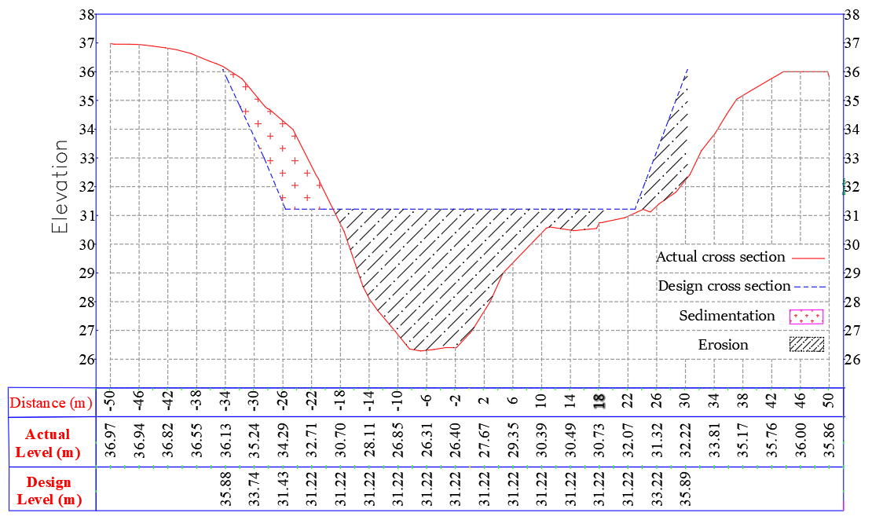

**Figure 7: Comparison between Actual and design cross-sections.**

**Figure 8: Bathymetric survey along the reach.**

***4.2 Spur Dike Performance Evaluation***

Evaluating spur dike performance in the modeled scenarios reveals significant insights into how different configurations impact flow dynamics in meandering canals. The effectiveness of various configurations was assessed according to the critical velocity required to initiate sediment transport. In fine sand bed streams, erosion happens more easily due to the lower critical velocity required to mobilize fine sand (typically around 0.2-0.5 m/s) [18] and [19]. The critical cross-section is located at km 132, so velocity cross-section profiles were taken at this location to show changes in depth average velocity profile. Figure (9) illustrates the velocity profiles for spur dikes at a 25 % width under different heights (0.5, 0.75, and 1.2 of water depth) compared to the base case. According to the submergence of spur dike, The results were indicated. The non-submerged condition (height ratio=1.2) showed a distinct decrease in velocity in the outer curve as it creates a physical barrier that redirects flow. As water approaches the dike, it is forced to change direction away from the outer curve, which can lead to increased velocities on the opposite side where the flow is concentrated. This occurs because the dike effectively narrows the channel width, causing water to accelerate as it passes around the spur dike. The submerged conditions (0.5 & 0.75 water depth) showed different behavior. As the spur dike submergence decreased, the maximum flow velocity at the outer curve increased. At a height ratio of 0.75 (submerged by 25% of water depth), the velocities peak around 0.9 m/s, while at 0.5 depth (submerged by 50% depth), the peak velocity drops to approximately 0.8 m/s. The velocity profiles for spur dikes at 30% width were presented under similar submergence conditions in Fig. (10). The trends observed are consistent with 25% width; however, the peak velocities are slightly lower due to the increased spur dike length. The non-submerged condition again results in lower velocities in the outer curve and an increase in the center line velocity. At a height ratio of 0.75, peak velocities reach about 0.8 m/s, while at 0.5 depth, they decrease to around 0.7 m/s. The spur dike velocity profiles at a width of 35% showed that increasing the spur dike length decreases velocities across the inner curve in submerged conditions Fig. (11). At a height ratio of 0.75, peak velocity at the outer curve is approximately 1 m/s but drop to about 0.8 m/s at a ratio of 0.5 depth. The non-submerged condition (1.2) continues to exhibit the highest velocities among all configurations, reinforcing the need for proper design and placement of spur dikes to optimize their effectiveness and emphasizing that maintaining appropriate water levels is crucial for effective scour control.

Spur dike

**Figure 9: Height Ratios Comparison at 25% Width at km 132.**

**Figure 10: Height Ratios Comparison at 30 % Width at km 132.**

**Figure 11: Height Ratios Comparison at 35% Width at km 132.**

Along the entire length of the bend, the velocity surface in the base case Fig. (12) was compared with the velocity surface of different scenarios as shown in Table 3. The results indicated that as the submergence of spur dikes increases (specifically at ratios 0.5 and 0.75 of water depth which represent fully submerged conditions), the maximum flow velocity generally decreases. This trend suggests that deeper water enhances energy dissipation around the spur dikes, leading to improved performance in redirecting flow and reducing stagnation zones. Conversely, at the not submerged condition of a height ratio of 1.2 water depth, the velocities are higher, indicating potential risks for increased erosion and sediment transport in the bed and opposite bank of spur dikes. The analysis showed that longer spur dikes (35% of the bend width) consistently exhibit better performance in controlling flow velocities compared to shorter dikes (25% and 30% bend width). This is particularly evident under fully submerged conditions (0.5 and 0.75 water depth), where longer dikes effectively mitigate erosion and enhance sediment transport management. The angle of the spur dikes significantly influences the direction and magnitude of flow velocities. As the angle increased from 110° to 130°, there was a noticeable change in how effectively the dikes redirect flow towards the center of the channel. The velocity profiles showed that spur dikes at a 110° angle produced lower peak velocities compared to those at 120° and 130°. This reduction in peak velocity is beneficial for minimizing erosion along the outer bend of the canal. For instance, under fully submerged conditions (0.75 depth), the maximum velocity observed with a 110° spur dike is approximately 0.4 m/s, while for a 130° dike, it reached up to 0.7 m/s. This indicates that sharper angles could lead to higher velocities and increased risk of scour.

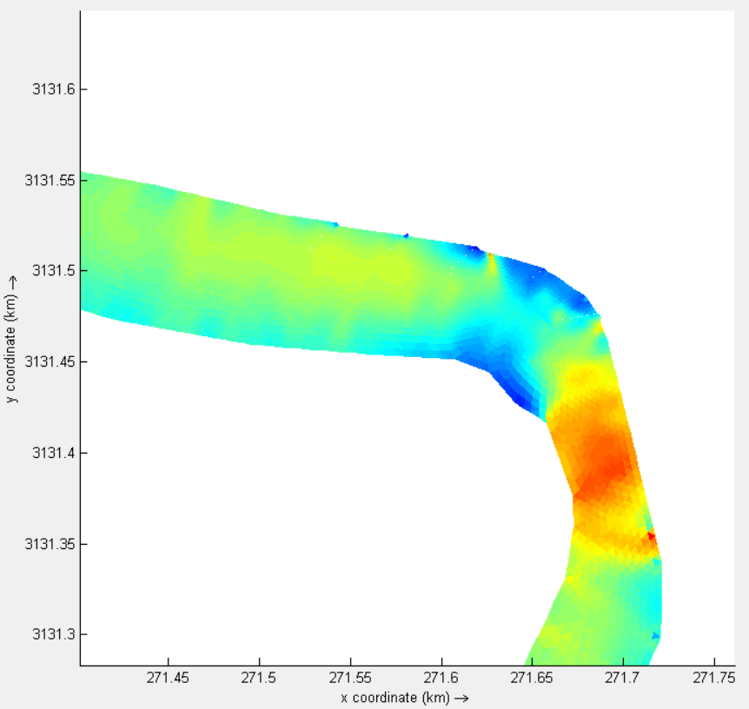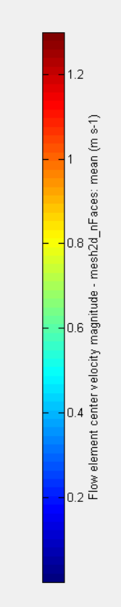

**Figure 12: Base case without dikes**

**Table III: Velocity surface at different scenarios.**

|  |  |  |  |
| --- | --- | --- | --- |
| **scenarios** | **0.5 depth** | **0.75 depth** | **1.2 depth** |
|  | | | |
| **25% Width** | **A colorful graph of a curve** |  |  |
| **30% Width** | **A graph of a graph showing a curve** | **A screen shot of a graph** |  |
| **35% Width** | **A graph showing a curved line** | **A graph of a curve** | **A graph showing a rainbow colored curve** |

# CONCLUSIONS AND RECOMMENDATIONS

The modeling scenarios for spur dike configurations demonstrate that effective management of flow dynamics in meandering canals is crucial for preventing erosion and ensuring sediment transport efficiency. The results indicate that submerged condition allows for better energy dissipation compared to non-submerged conditions.  Longer spur dikes (35% of the bend width) significantly reduce flow velocities, particularly under fully submerged conditions (height ratios of 0.5 and 0.75). This configuration not only mitigates the risk of excessive erosion but also maintains sediment transport within acceptable limits for fine sand (0.2-0.5 m/s). Therefore, it is recommended to implement the 35% spur dike length at a height ratio of 0.75 as the optimal solution for balancing velocity control across the entire canal bend. Even though this scenario effectively reduces downstream velocities, practical considerations regarding operational water levels should be considered to ensure effective implementation.

For scenarios requiring complete velocity control, the 35% spur dike at a 1.2 height ratio may be more effective in controlling outer bank scour but should be considered based on site-specific conditions. Dikes set at a 110° angle tend to create stronger lateral flow deflections, which can enhance sediment transport away from the outer bank, thereby reducing scour potential. The results indicated that careful consideration of the dike angles, along with submergence levels, can significantly enhance scour control measures and improve overall canal stability.

This integrated method optimizes flow conditions, reduces erosion risks, and enhances sediment transport efficiency in irrigation canals with fine sand beds. To ensure sustainability and functionality, spur designs should consider the hydrological and morphological features of the river channel in addition to the effects on the ecosystem. Understanding these interactions is crucial for effective river management and maintaining ecological balance.

**REFERENCES**

1. Pinasti, N. W., Wijayanti, E., Nurfaida, W., Sulaiman, M., & Kurniawan, A. (2024, March). Flow patterns at river bends and its response to surrounding infrastructures. In IOP Conference Series: Earth and Environmental Science (Vol. 1311, No. 1, p. 012002). IOP Publishing.
2. Elhakeem, M., Papanicolaou, A.N., & Wilson, C.G. (2017). Implementing Streambank Erosion Control Measures in Meandering Streams: Design Procedure Enhanced with Numerical Modeling. International Journal of River Basin Management, 15(2), 147-158.
3. Kiani, A., Masjedi, A., Pourmohammadi, M. H., Heidarnejad, M., & Bordbar, A. (2017). Experiment of local scour around a series of spur dikes in river bend. Fresenius Environmental Bulletin, 26(8), 5331-5339.
4. Shih, D. S., & Lai, T. Y. (2020). Reducing of bend scour by setting spurs in a curved channel. Water, 12(5), 1353.
5. Akbar, Z., Pasha, G. A., Tanaka, N., Ghani, U., & Hamidifar, H. (2024). Reducing bed scour in meandering channel bends using spur dikes. International Journal of Sediment Research.
6. Ohtsuki, K., Kono, T., Arikawa, T., Taniwaki, H., & Itsukushima, R. (2024). Spur Dike Applications for the Sustainability of Channels in Incised Steep Bend Streams. Water, 16(4), 575.
7. Alauddin, M., Hossain, M. M., Uddin, M. N., & Haque, M. E. (2017). A review on hydraulic and morphological characteristics in river channels due to spurs. International Journal of Geological and Environmental Engineering, 11(4), 397-404.
8. Hemmati, M., & Daraby, P. (2018). Erosion and sedimentation patterns associated with restoration structures of bendway weirs. Journal of Hydro-environment Research, 22, 19-28.
9. Karki, S., Nakagawa, H., Kawaike, K., & Hashimoto, M. (2018). Experimental Study on the Performance of Slope-crested Groynes in Erodible Meandering Channels of Different Sinuosity. Journal of Natural Disaster Science, 37(Special Issue), 93-105.
10. Han X, Lin P, Parker G (2019) 3D numerical study on local scour around spur dikes with different layout angles. IAHR World Congr - Water Connect World 38:1587–1594. https://doi.org/10.3850/38wc092019-0394
11. Han X, Lin P, Parker G (2022) Influence of layout angles on river flow and local scour in grouped spur dikes field. J Hydrol 614:128502. https://doi.org/10.1016/j.jhydrol.2022.128502.
12. Möws, R., & Koll, K. (2019). Roughness effect of submerged groyne fields with varying length, groyne distance, and groyne types. Water, 11(6), 1253.
13. Chakravarty, S., Patel, H. K., Mohanty, B., & Kumar, B. (2024). Review on different shapes of spurs and their effects on channel morphology. Water Practice & Technology, 19(1), 241-262.
14. Xia, J., Jiang, Q., Deng, S., Zhou, M., Cheng, Y., Li, Z., & Wang, Z. (2022). Morphological characteristics and evolution processes of sharp bends in the Lower Yellow River. Catena, 210, 105936.
15. Deltares. (2024). D-Flow Flexible Mesh User Manual. Deltares
16. Deltares, Delft3D-FLOW user’s manual. (2014). Simulation of multi-dimensional hydrodynamic flows and transport phenomena, including sediments
17. Wang, H., Yao, S., Lu, Y., Zuo, L., Liu, H., & Zhao, Z. (2022). Morphological changes of sharp bends in response to three gorges project operation at different discharges. Frontiers in Earth Science, 10, 876631.
18. Van Rijn, L. C. (1993). Principles of sediment transport in rivers, estuaries, and coastal seas.
19. Thandaveswara, B.S. (2010). Design of Canals. Available at Canal Design PDF.