**“Mechanisms for Effective Implementation of Town Planning Schemes: A Study of Bangalore Metropolitan Area and Bangalore Metropolitan Region”**

**Sannappaiah H.V.** (Research Scholar)¹, **Prof. Dr. H. N. Nagendra** (Professor)¹,

**Dr. Goutham Konikar S. M.** (Faculty)¹, and **Ar. Kavyashree U. A.** (Faculty)²

***¹*** *Department of Urban and Regional Planning, School of Planning & Architecture, University of Mysore, Mysuru, Karnataka, India.****²*** *Department of Architecture, School of Planning & Architecture, University of Mysore, Mysuru, Karnataka, India.*

**Corresponding Author:** Sannappaiah H.V.

**Email:** [gouthamsmkonikar@gmail.com](mailto:gouthamsmkonikar@gmail.com)

**ABSTRACT**

*Rapid urbanization poses significant challenges for urban governance, planning, and infrastructure provision, particularly in metropolitan regions. Bangalore Metropolitan Region (BMR), one of India's fastest-growing urban areas, exemplifies these challenges through unregulated urban expansion, fragmented governance structures, and infrastructural inadequacies. Town Planning Schemes (TPS) are recognized as critical tools that facilitate structured urban development by integrating land management, infrastructure provisioning, and equitable land distribution through participatory mechanisms. Despite their proven effectiveness in other contexts, TPS implementation in BMR has faced considerable obstacles, including fragmented institutional frameworks, regulatory ambiguities, delays in statutory processes, financial constraints, resistance from landowners, and gaps in stakeholder engagement.*

*This study systematically evaluates the existing implementation mechanisms of TPS within the Bangalore Metropolitan Area and the broader BMR, highlighting specific barriers and their implications. Employing primary data analysis, secondary data review, and GIS-based spatial analysis, the research proposes targeted strategies and actionable policy recommendations. These include strengthening institutional coordination, streamlining regulatory processes, enhancing financial mechanisms, promoting robust community participation, and clarifying legal frameworks. The findings aim to support policymakers, urban planners, and stakeholders in adopting structured approaches for sustainable metropolitan urbanization.*

**Keywords:** Town Planning Schemes (TPS), Bangalore Metropolitan Region (BMR), Urban Governance, Land Management, Sustainable Development, Spatial Planning.

**I. INTRODUCTION**

Urbanization is a defining characteristic of the contemporary global landscape, with profound implications for sustainability, governance, and infrastructure planning. Globally, urban populations are projected to constitute approximately 68% of the total by 2050, intensifying the need for effective urban management (United Nations, 2018). India is undergoing rapid urban transformation, expecting its urban population to reach nearly 40% by 2030, bringing about significant challenges related to governance, land management, infrastructure provision, and environmental sustainability (MoHUA, 2020).

The Bangalore Metropolitan Region (BMR), encompassing Bangalore Urban, Bangalore Rural, and Ramanagara districts, spans approximately 8005 sq. km and reflects severe impacts of uncontrolled urbanization (BMRDA, 2016). The region experiences environmental degradation, infrastructural deficits, congestion, and inequitable spatial development. These challenges necessitate robust planning instruments for effective urban growth management. Town Planning Schemes (TPS) have been acknowledged as critical instruments facilitating structured urban development through land pooling and participatory reconstitution, thus ensuring equitable land redistribution and comprehensive infrastructure provisioning (URDPFI Guidelines, 2014; NIUA, 2018).

Despite proven advantages, TPS implementation in BMR faces substantial challenges including fragmented governance, procedural delays, resistance from landowners, and financial constraints (URDPFI Guidelines, 2014). Therefore, the present study seeks to enhance understanding and improve the effectiveness of TPS mechanisms in BMR through the following specific objectives:

1. *To evaluate existing governance and institutional frameworks affecting TPS implementation in BMR.*
2. *To identify specific challenges and barriers hindering TPS execution within the region.*
3. *To propose targeted strategies and policy interventions for effective TPS implementation.*
4. *To recommend actionable measures ensuring sustainable and equitable urban development through TPS.*

The outcomes aim to inform policy-making and strengthen metropolitan governance structures, facilitating sustainable urban development in BMR.

**II. LITERATURE REVIEW**

Rapid urbanization globally poses significant governance, infrastructural, and environmental challenges, especially within metropolitan contexts. By 2050, 68% of the global population is projected to reside in urban areas, exacerbating the need for structured planning interventions (United Nations, 2018). India's urban population, which constituted approximately 31% in 2011, is expected to rise substantially, reaching about 40% by 2030, thereby increasing pressure on urban infrastructure and land resources (MoHUA, 2020).

These dynamics are particularly acute in metropolitan regions like Bangalore Metropolitan Region (BMR), which have experienced unprecedented demographic and spatial expansions, intensifying urban management complexities and necessitating structured planning solutions (BMRDA, 2016). Town Planning Schemes (TPS) have emerged as an effective mechanism for structured urban growth, particularly suited to complex urban settings. TPS is essentially a participatory method of land pooling and plot reconstitution, involving the redistribution of land parcels in a planned manner, coupled with infrastructure development (URDPFI Guidelines, 2014). Unlike traditional land acquisition processes that often result in resistance and protracted disputes, TPS offers an equitable land-sharing mechanism and enables infrastructure-driven urbanization (NIUA, 2018).

Several global experiences highlight the efficacy of TPS and similar mechanisms. For instance, in Japan and South Korea, Land Readjustment (LR)—conceptually similar to TPS—has successfully managed urban expansion, infrastructure financing, and community participation in rapidly urbanizing contexts (Sorensen, 2000; Archer, 1999). Similarly, TPS implementation in Ahmedabad and Surat (Gujarat, India) has demonstrated significant success by reducing land conflicts, ensuring equitable benefits to stakeholders, and accelerating infrastructure provision (Ballaney, 2008; Patel et al., 2019).

However, effective TPS implementation is critically dependent on clear policy frameworks, strong institutional capacities, and well-established governance mechanisms. India's governance framework for urban planning, shaped by the 74th Constitutional Amendment Act (CAA), emphasizes decentralized planning through Metropolitan Planning Committees (MPCs) to oversee integrated regional development (NITI Aayog, 2021). Despite these provisions, implementation gaps remain prominent in many Indian metropolitan regions due to overlapping jurisdictions, fragmented governance structures, and limited institutional coordination (Kundu, 2011; Sivaramakrishnan, 2013).

Specifically, within BMR, the Revised Structure Plan 2031 recognizes TPS as a crucial instrument to counteract unplanned sprawl and environmental degradation. However, the plan highlights substantial implementation barriers, including fragmented institutional frameworks, financial constraints, resistance from landowners, and unclear regulatory processes (BMRDA, 2016). Previous research by Konikar and Nagendra (2024) also emphasized that the lack of institutional coordination and community engagement represents fundamental barriers, necessitating enhanced governance and stakeholder engagement mechanisms.

In conclusion, existing literature underscores TPS's potential as a planning tool capable of addressing urban growth challenges through participatory mechanisms and equitable land redistribution. The literature also emphasizes that realizing this potential in metropolitan regions like BMR requires concerted efforts in governance reforms, institutional strengthening, regulatory streamlining, and stakeholder engagement. This study, therefore, contributes uniquely by evaluating TPS implementation specifically within the governance and institutional context of Bangalore Metropolitan Region, suggesting actionable pathways to enhance its effectiveness and sustainability.

**III. METHODOLOGY**

This study adopts a mixed-method approach, combining qualitative analysis and extensive review of secondary sources to understand and articulate the mechanism of Town Planning Schemes (TPS) for managing urban growth and development in Bangalore Metropolitan Region (BMR). The methodology primarily involves reviewing, synthesizing, and interpreting existing policy documents, official reports, government publications, scholarly articles, and guidelines related to TPS implementation.

The research process commenced with a detailed exploration of the existing governance framework and urban planning policies relevant to TPS, guided by national and regional planning directives, including the Urban and Regional Development Plans Formulation and Implementation (URDPFI) Guidelines (MoHUA, 2014). This step provided insights into the institutional arrangements, procedural frameworks, and regulatory context of TPS in India, specifically within Karnataka and the BMR.

Subsequently, a comprehensive analysis was conducted of existing urban policy documents, including the Revised Structure Plan 2031 prepared by Bangalore Metropolitan Region Development Authority (BMRDA, 2016), and statutory provisions mandated under the Karnataka Urban and Regional Planning and Development (KURPD) Act, 1998. Additionally, relevant policy and legislative frameworks such as the 74th Constitutional Amendment Act (CAA), 1992, guidelines by the Metropolitan Planning Committee (MPC), NITI Aayog policy papers, and documents from the Ministry of Housing and Urban Affairs (MoHUA) were critically reviewed. This facilitated understanding the policy-level challenges and gaps that impede effective TPS implementation.

To contextualize the findings within global and national urban planning practices, the research reviewed case studies of TPS implementation from international cities such as Tokyo and Singapore (Sorensen, 2000; Archer, 1999), as well as prominent Indian cases including Ahmedabad and Surat (NIUA, 2018; MoHUA, 2019). The case studies provided comparative insights, highlighting both successful mechanisms and challenges encountered in different regulatory and governance contexts.

Furthermore, the methodology incorporated detailed analysis of BMR-specific reports such as the Bangalore Metropolitan Region Revised Structure Plan-2031 (BMRDA, 2016), Census data (Government of India, 2011), and relevant state-level reports from the Karnataka Urban Infrastructure Development and Finance Corporation (KUIDFC). These documents offered comprehensive demographic, socio-economic, and land-use profiles essential for contextualizing urbanization dynamics, infrastructural deficits, and governance issues in the BMR.

The synthesis and triangulation of these secondary sources enabled the identification of critical challenges and strategies that are specific and pertinent to the BMR context. The approach involved thematic content analysis, categorizing data under identified themes such as governance, stakeholder participation, financial sustainability, and regulatory frameworks. Policy implications and recommendations were systematically derived from this thematic analysis, emphasizing regulatory clarity, institutional coordination, spatial integration, and participatory planning processes.

Finally, the methodological framework was structured around achieving clear study objectives: (1) evaluating the governance and institutional frameworks influencing TPS implementation; (2) identifying key challenges in TPS execution; (3) formulating strategies for improved implementation mechanisms; and (4) providing policy implications and recommendations tailored specifically to enhance urban growth management in the BMR through TPS.

This methodological design ensures robustness and applicability of the findings, providing actionable insights for policymakers, planners, and other urban stakeholders engaged in managing the rapid and complex urban expansion within metropolitan regions such as BMR.

**IV. PROFILE OF BANGALORE METROPOLITAN AREA (BMA) AND BANGALORE METROPOLITAN REGION (BMR)**

***A) Geographic and Locational Context***

Bangalore Metropolitan Region (BMR) is strategically located in the southeastern part of Karnataka State, India, extending between parallels of 12°39’ N and 13°19’ N latitudes and longitudinal meridians of 77°22’ E and 77°5’ E at an average elevation of around 900 meters (Bangalore Metropolitan Region Development Authority [BMRDA], 2016). Spanning an extensive area of 8,005.45 sq. km., it encompasses the administrative districts of Bangalore Urban (2,190 sq. km.), Bangalore Rural (2,260 sq. km.), and Ramanagara (3,855 sq. km.) districts. Bengaluru city, as its urban core, strategically connects major metropolitan and economic hubs across India, serving as a vital node in South India's transport network with strong connections via road, rail, and air. Fgure-1, Illustrates the Administrative and Planning Jurisdictions of BMR.

***B) Historical Context and Urban Evolution***

Historically, Bengaluru traces its urban origins back to at least 1000 B.C., though significant growth commenced in the 11th century A.D. with settlements such as Begur emerging as administrative and trading nodes (Government of Mysore, 1963). Bengaluru, as recognized today, was established by Kempe Gowda I in the late 16th century, originally shifting his capital from Yelahanka. The city's strategic location and defensive advantages made it central under successive rulers, including Hyder Ali and Tipu Sultan, who shaped Bengaluru as an industrial and commercial nucleus. After British conquest in 1791, Bengaluru gradually evolved into a significant administrative and military hub (Government of Mysore, 1963).

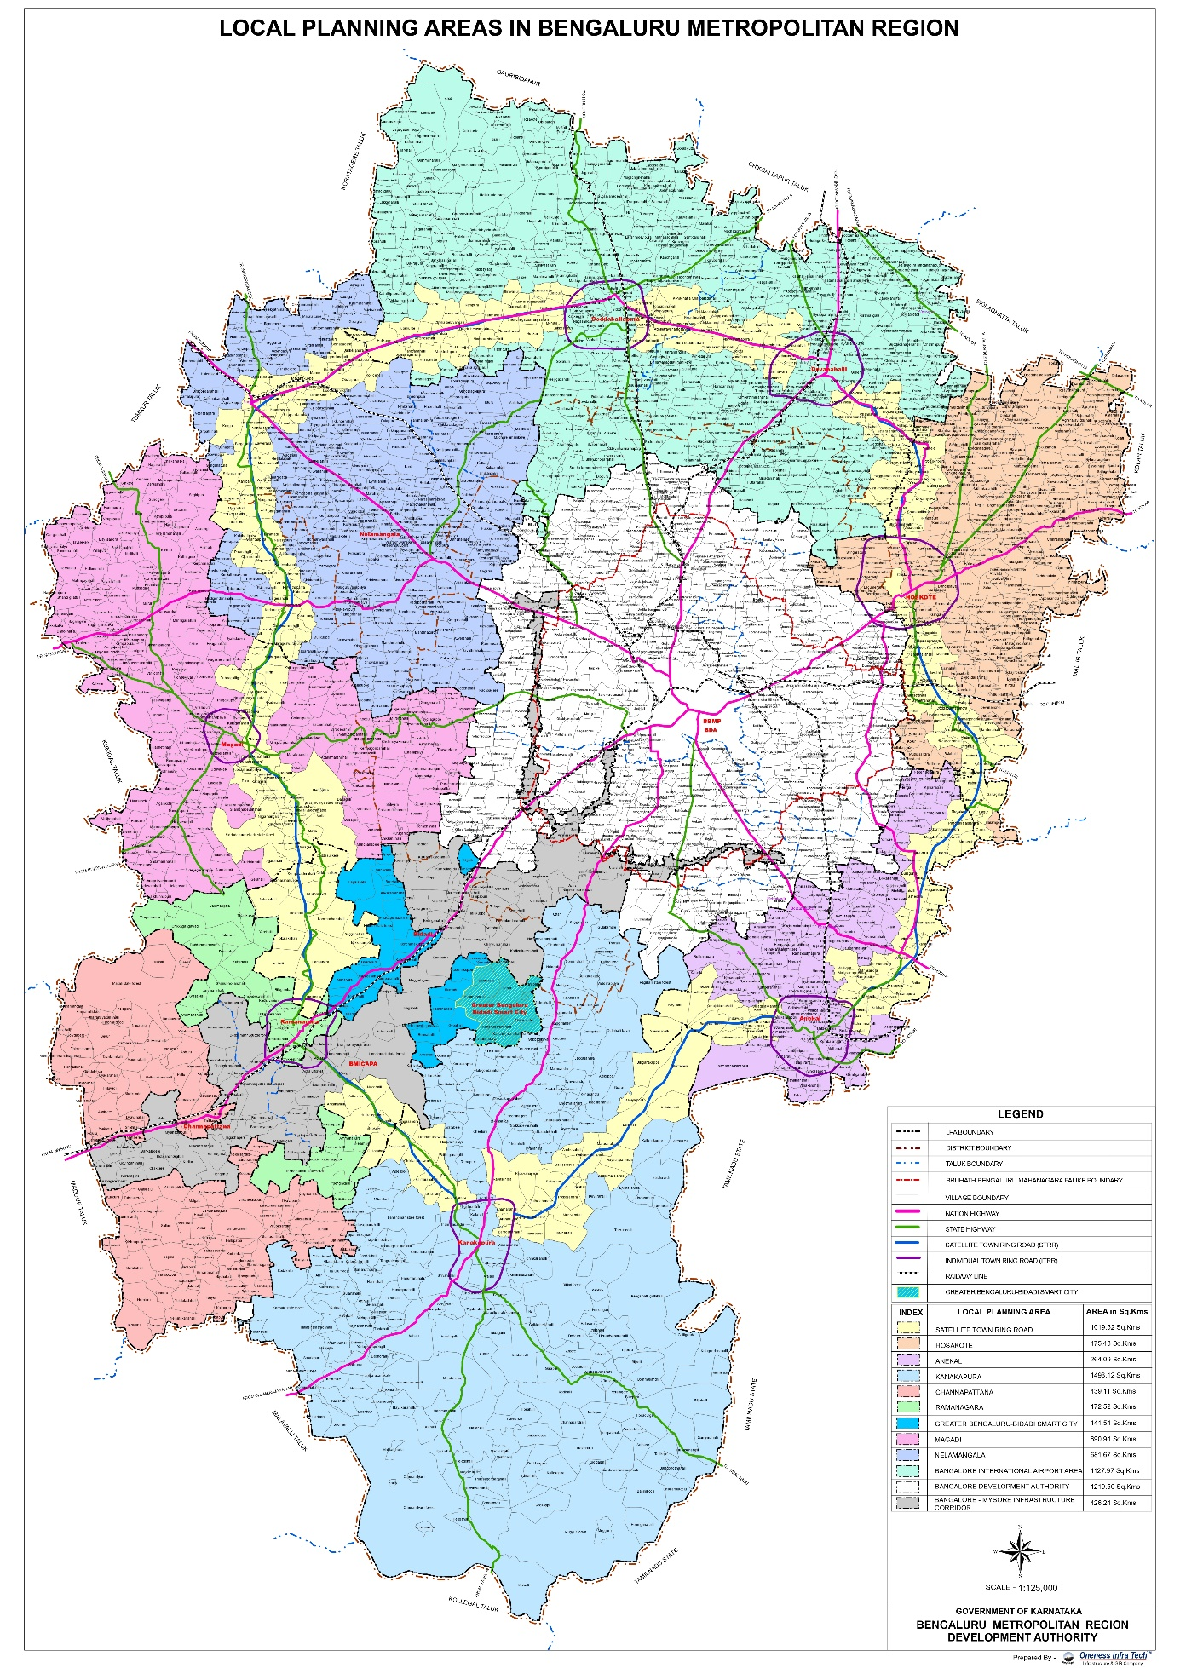

**Figure 1: Administrative and Planning Jurisdictions of BMR**

(Source: BMR Revised Structure Plan, 2016)

***C) Demographic Profile and Population Growth Trends***

Post-independence, Bengaluru experienced rapid demographic growth, driven by industrial development and migration. The city grew from about 5.10 lakh in 1941 to nearly 9.91 lakhs in 1951, prompting structured urban planning interventions (Government of Mysore, 1963). Subsequent decades saw rapid expansion and significant shifts in population distribution, resulting in the unprecedented spread of urban settlements into rural and agricultural areas. Table 1 and Figure-2 presents detailed statistics illustrating Bengaluru’s rapid physical expansion and increasing radial distances, a clear indicator of urban sprawl.

**Table 1: Physical Growth and Radial Expansion of Bengaluru (1901–2031)**

|  |  |  |  |  |  |  |  |  |  |  |  |  |  |  |  |  |  |  |  |  |  |  |  |  |  |  |  |  |  |  |  |
| --- | --- | --- | --- | --- | --- | --- | --- | --- | --- | --- | --- | --- | --- | --- | --- | --- | --- | --- | --- | --- | --- | --- | --- | --- | --- | --- | --- | --- | --- | --- | --- |
| |  |  |  |  | | --- | --- | --- | --- | | **Year** | **Conurbation Area**  **(sq. km.)** | **Decadal Growth Rate (%)** | **Avg. Radial Distance (km)** | | 1901 | 144.78 | – | 6.79 | | 1951 | 193.08 | 6.53 | 7.84 | | 1981 | 366.39 | 28.13 | 10.80 | | 2001 | 531.00 | 13.94 | 13.00 | | 2011 | 714.35 | 33.33 | 15.00 | | 2031 | 1,206.97 (projected) | 38.00 (projected) | 41.00 (Projected) | |  |  |  |

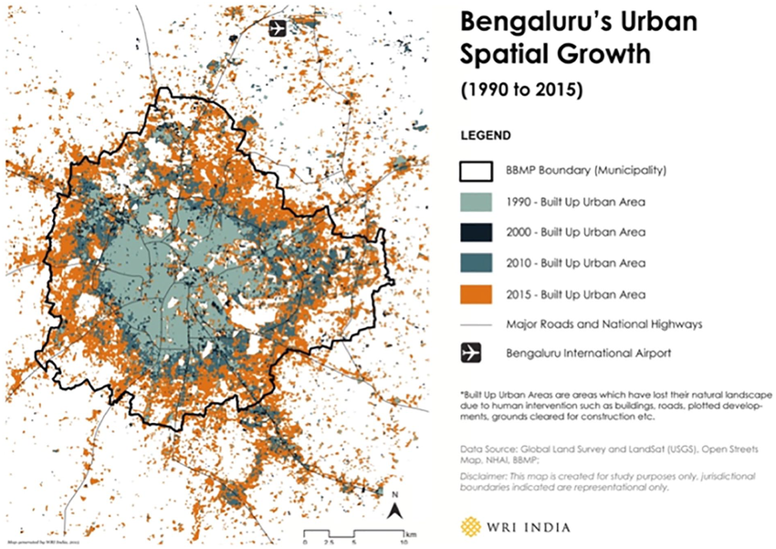(Source: Bangalore Development Authority, 2015; Revised Structure Plan, BMRDA, 2016)

**Figure 2: Historical Expansion of Bengaluru City showing urban sprawl from 1990 to 2015.**(Source: BMR Revised Structure Plan, 2016 and WRI Report, 2016)

***D) Administrative and Spatial Structure***

Administratively, BMR is subdivided into eleven taluks across its three districts, comprising Bengaluru Urban District, Bengaluru Rural District, and Ramanagara District. This region includes 11 urban local bodies (ULBs) and 284 Gram Panchayats covering 2,551 villages (BMRDA, 2016). The proximity of these urban settlements to Bengaluru city greatly influences their spatial development trajectories and interactions with the metropolitan core. Table 2 illustrates the administrative structure and relative distances of prominent towns from Bengaluru city within the BMR clearly.

**Table 2: Administrative Areas and Major Towns within BMR**

|  |  |  |  |
| --- | --- | --- | --- |
| **Districts/Taluks** | **Area (sq. km.)** | **% of Total BMR Area** | **Distance from Bengaluru City (km)** |
| Bengaluru (City+OG) | 299.37 | 3.72% | 0 |
| Bengaluru Urban | 2,190.00 | 27.20% | – |
| Bengaluru Rural | 5,860.45 | 72.80% | – |
| Devanahalli | 448.12 | 5.57% | 35 |
| Doddaballapur | 779.87 | 9.69% | 40 |
| Hoskote | 546.95 | 6.79% | 26 |
| Nelamangala | 509.93 | 6.33% | 28 |
| Ramanagaram | 632.68 | 7.86% | 49 |
| Channapatna | 542.87 | 6.74% | 59 |

(Source: Compiled by the author based on Census of India 1991, 2001)

***E) Land Use and Socio-economic Context***

BMR’s land-use dynamics clearly reflect pressures of urban expansion. Over recent decades, a significant portion of agricultural lands, natural water bodies, and open spaces have been rapidly converted to urban built-up areas. The encroachment of peripheral lands and ecological zones due to sprawling urbanization illustrates the failure of existing conventional planning methods, underscoring the urgency to adopt new and effective planning mechanisms such as Town Planning Schemes (TPS) (BMRDA, 2016).

Socio-economically, BMR serves as Karnataka’s economic engine, predominantly driven by information technology, manufacturing, and services sectors. However, infrastructural inadequacies and spatial management challenges persist, complicating urban governance and planned development (BMRDA, 2016). This scenario demands a mechanism like TPS, leveraging participatory land management and integrated infrastructure planning to ensure structured growth and equitable urban development.

Thus, Bengaluru's historical evolution, demographic dynamics, administrative complexity, and land-use transformation underscore the importance and necessity of adopting robust and efficient planning mechanisms, particularly TPS, tailored specifically to the unique challenges of metropolitan urban management in BMR. Figure 3, illustrates the Land Use/Land Cover (LULC) Map of BMR – highlighting built-up, agriculture, ecological zones, and peri-urban areas, sourced from Revised Structure Plan, BMRDA, 2016)

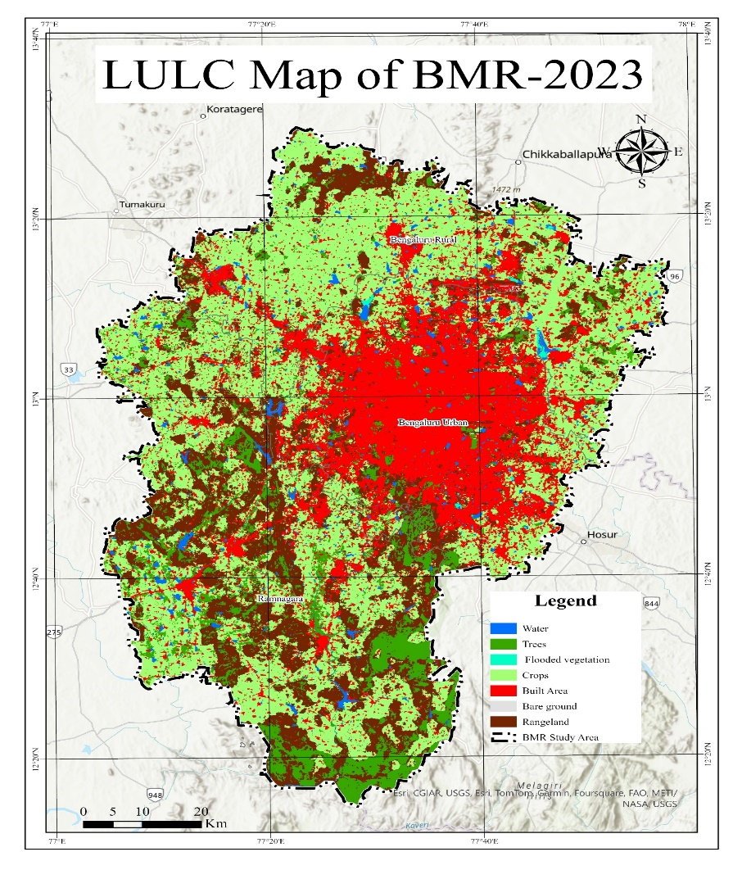**Figure 3: Land Use Land Cover of BMR-2023**

(Source: Author using GIS)

**V. THE TOWN PLANNING SCHEME MECHANISM**

***A) Concept and Evolution of Town Planning Schemes***

Town Planning Schemes (TPS) have emerged as a transformative urban planning tool in India, initially gaining recognition through their successful implementation in Ahmedabad, Gujarat (Ballaney, 2008; Patel, Patel, & Mishra, 2019). TPS offers a participatory and equitable approach to urban development, contrasting sharply with traditional land acquisition methods that have historically resulted in protracted legal disputes and social discontent (Archer, 1999; NIUA, 2018). The fundamental mechanism of TPS involves collaborative land pooling, equitable plot reconstitution, and land readjustment aimed at harmonizing land development with infrastructure provision (URDPFI Guidelines, 2014).

***B) Relevance of TPS in Bengaluru Context***

Rapid urbanization in Bengaluru Metropolitan Region (BMR) has triggered significant spatial challenges such as infrastructural inadequacies, haphazard urban sprawl, and socio-economic disparities (BMRDA, 2016). Traditional planning instruments such as master plans and comprehensive development plans (CDP) have proven inadequate due to their rigid implementation and limited participatory mechanisms (BDA, 2015). TPS, therefore, emerges as a critical mechanism that can facilitate sustainable urban growth by addressing planning challenges through decentralized and participatory frameworks.

***C) Operational Framework of TPS Mechanism***

The operational procedure of TPS typically encompasses distinct, sequential phases—Draft Scheme, Preliminary Scheme, and Final Scheme (Ballaney, 2008). Each phase necessitates government sanctioning and active stakeholder participation. Prompt execution and timely government approval are pivotal for effective TPS implementation, demanding transparent procedures and robust institutional coordination (NIUA, 2018).

***D) Land Pooling and Plot Reconstitution Process***

Central to TPS is the equitable land pooling and plot reconstitution process. In a typical scenario, approximately 35% to 40% of land within a scheme area is appropriated for developing essential urban infrastructure—roads (25-30%), parks, open spaces (10-15%), and civic amenities including schools and commercial establishments (15-20%) (Ballaney, 2008). Remaining land parcels, approximately 60-65%, remain with original landowners in reconstituted form. This rearrangement of plots ensures greater regularity, making plots more conducive for structured urban development and increasing their market viability post-development (Patel et al., 2019).

***E) Financial Aspects and Cost Recovery Mechanism***

TPS offers an innovative financial framework that significantly differentiates it from conventional land acquisition methods. Initial valuation of land is conducted based on standardized market metrics. Subsequently, anticipated valuation post-infrastructural development is calculated. The incremental increase in land value attributed exclusively to government investment (infrastructure provision) is partially recovered through "betterment charges," typically set at 50% of the incremental value (Ballaney, 2008; NIUA, 2018). This financial model ensures cost recovery and provides revenue sources for local authorities to sustainably manage urban growth without heavy fiscal burdens.

***F) Socio-economic Benefits of TPS: A "Win-Win" Proposition***

TPS mechanisms facilitate a balanced and equitable urban development approach. Unlike compulsory land acquisition—which often marginalizes small landowners through inadequate financial compensation—TPS allows original landowners to retain substantial proportions of their improved land parcels (Ballaney, 2008). Consequently, landowners, especially small and marginal farmers, gain significant economic benefits through increased land values after infrastructure improvements, thus fostering inclusive development and minimizing land acquisition resistance (Patel et al., 2019).

***G) Visual and Functional Urban Orderliness***

A critical advantage of TPS over conventional planning methodologies is its ability to impose visual coherence and orderly urban development. TPS achieves this by systematically realigning irregular agricultural plots into more organized, buildable urban plots, significantly reducing instances of unplanned, fragmented urban growth, particularly in urban fringes and peri-urban areas of BMR (BMRDA, 2016; Patel et al., 2019).

***H) Integration with Development Plans and Policy Guidelines***

TPS mechanisms function effectively as an integrated urban planning and development instrument, filling in infrastructural and spatial detailing often inadequately addressed by macro-level plans such as Master Plans or Comprehensive Development Plans. In Bengaluru, TPS can effectively complement the Revised Structure Plan (RSP 2031), addressing specific localized planning needs, including infrastructure deficits, housing shortages, and environmental protection through clearly mandated buffer zones (BMRDA, 2016; URDPFI, 2014).

***I) Urban Decentralization and Balanced Regional Development***

The unprecedented growth pressures experienced within Bangalore Metropolitan Area (BMA) necessitate decentralization of urban development to peripheral and peri-urban regions within BMR. TPS offers a structured pathway for controlled decentralization, facilitating urban infill within BMA and planned developments in the broader BMR (BMRDA, 2016). This spatial strategy effectively addresses Bengaluru’s burgeoning growth demands, infrastructural shortages, and housing needs, while simultaneously preserving critical ecological assets.

***J) Conservation and Sustainable Urban Practices***

TPS also inherently facilitates conservation-oriented urban growth practices. It explicitly incorporates environmental mandates such as the National Green Tribunal (NGT)-prescribed buffer zones for lakes, wetlands, and ecologically sensitive areas within Bengaluru (URDPFI, 2014). Financial mechanisms within TPS also generate surplus revenue for environmental conservation projects, social housing, and infrastructure improvements, thus promoting broader environmental sustainability objectives (Ballaney, 2008).

**K) Addressing Implementation Challenges: Reality versus Idealization**

Despite evident benefits, TPS implementation faces considerable practical challenges requiring cautious management.

* ***Transparency and Equity Challenges:*** *In reality, urban fringe areas often attract speculative land ownership practices, diminishing equitable distribution of benefits. Thus, stringent verification mechanisms—preferably digitally assisted—are essential for ensuring equitable inclusion of genuine beneficiaries (Deuskar, 2011).*
* ***Financial Assessment and Valuation Challenges:*** *Financial assessment procedures often differ significantly from idealized models due to difficulties in accurately valuing original and post-development land values, primarily attributed to non-transparent land markets. Standardized digital valuation models and Artificial Intelligence (AI)-assisted valuation could mitigate inaccuracies and streamline financial processes (Deuskar, 2011).*
* ***Procedural Delays and Institutional Capacity Constraints:*** *Government approval processes frequently delay TPS implementation. These delays predominantly stem from institutional weaknesses such as limited technical capacities, insufficient staffing, and absence of digital infrastructure. Enhancing institutional capacities and employing digital systems (including AI-based systems) can effectively alleviate procedural bottlenecks, enabling timely implementation of TPS stages (draft, preliminary, and final schemes) (Patel et al., 2019).*

***L) Addressing Social Equity and Community Participation***

Successful TPS implementation significantly depends upon ensuring social equity and stakeholder participation. The identification, inclusion, and compensation of Project-Affected Persons (PAPs)—particularly marginalized communities such as slum-dwellers, peripheral villagers, and informal settlements—are critical to ensuring sustainable and inclusive urban growth (Deuskar, 2011). A dedicated institutional mechanism to manage PAPs transparently, through preemptive stakeholder consultations, clearly defined compensation mechanisms, and participatory planning processes, ensures TPS effectively incorporates social justice and equitable urban development (Patel et al., 2019).

***M) Strategic Recommendations for Effective TPS Implementation in Bengaluru***

Considering Bengaluru’s unique urban management challenges, the TPS mechanism can be strategically leveraged through:

* *Comprehensive amendments in the Karnataka Town and Country Planning (KTCP) Act to clearly integrate TPS provisions.*
* *Robust institutional frameworks equipped with adequate technical capacity, skilled human resources, and digitized infrastructure.*
* *Transparent and digitally assisted land verification, valuation, and financial assessment processes.*
* *Active stakeholder engagement platforms, ensuring equitable participation of original landowners, marginalized groups, and private-sector participants.*
* *Environmental and ecological conservation explicitly integrated within the TPS framework.*

TPS emerges as a holistic urban development mechanism, effectively integrating planning, land management, infrastructural provisioning, cost recovery, and socio-economic equity within a singular, structured framework. If appropriately adapted to Bengaluru’s unique governance and spatial challenges, TPS can substantially enhance structured, equitable, and sustainable urban growth across the BMA and broader BMR, offering a replicable urban growth management model for other Indian metropolitan contexts.

**VIII. CONCLUSION**

The study systematically explored the mechanisms involved in the effective implementation of Town Planning Schemes (TPS) within the Bangalore Metropolitan Area (BMA) and broader Bangalore Metropolitan Region (BMR). Given the rapid urbanization pressures, infrastructural deficiencies, and fragmented governance frameworks characterizing the metropolitan region, TPS emerged as a robust mechanism capable of addressing these critical issues through integrated land management, participatory planning, and equitable land redistribution.

Findings clearly indicated that the existing governance structures and regulatory frameworks within the BMR are impeded by institutional fragmentation, delays in statutory approvals, financial constraints, and limited stakeholder participation, creating substantial barriers to successful TPS implementation. Despite these challenges, the research identified TPS as an advantageous, participatory, and financially sustainable alternative to conventional land acquisition methods, promoting orderly and environmentally sustainable urban growth, especially in peri-urban and fringe areas of the metropolitan region.

Strategic recommendations were articulated to enhance TPS implementation effectiveness, including institutional capacity-building, streamlined regulatory frameworks, digital and technological integration, robust community engagement, and clearly defined financial mechanisms, notably betterment charges and land pooling frameworks. If strategically integrated with regional planning initiatives such as the Revised Structure Plan 2031 and Comprehensive Development Plans, TPS has the potential to significantly transform urban governance, spatial management, and infrastructural provisioning across BMR.

Ultimately, this research underscores that the sustainable development of rapidly growing metropolitan regions like Bengaluru necessitates structured, transparent, and participatory urban governance mechanisms. TPS, with its comprehensive planning approach, financial sustainability, and socio-economic inclusivity, emerges as a replicable and viable model for metropolitan growth management, not just within Bengaluru but across other rapidly urbanizing regions in India and beyond.

**REFERENCES**

1. Archer, R. W. (1999). The potential of land pooling/readjustment to provide land for low-cost housing in developing countries. Habitat International, 23(4), 493-509. <https://doi.org/10.1016/S0197-3975(99)00019-7>
2. Ballaney, S. (2008). The Town Planning Mechanism in Gujarat, India. World Bank Institute.
3. Bangalore Development Authority (BDA). (1976). Comprehensive Development Plan (CDP). Bangalore Development Authority, Government of Karnataka.
4. Bangalore Development Authority (BDA). (2015). Bangalore Master Plan-2015. Bangalore Development Authority, Government of Karnataka.
5. Bangalore Metropolitan Region Development Authority (BMRDA). (2016). Revised Structure Plan–2031. Bangalore: Egis Geoplan Pvt. Ltd.
6. Census of India. (1991). District Census Handbook - Bengaluru. Government of India.
7. Census of India. (2001). District Census Handbook - Bengaluru. Government of India.
8. Census of India. (2011). District Census Handbook - Bengaluru. Government of India.
9. Deuskar, C. (2011). A betterment levy for India. Economic & Political Weekly, 46(12), 50-60.
10. Government of Mysore. (1963). A Report of the Outline Development Plan for the Bangalore Metropolitan Region. Department of Town Planning, Government of Mysore.
11. Konikar, S. M., & Nagendra, H. N. (2024). Enhancing the implementation of town planning schemes in Bangalore Metropolitan Region: Challenges, strategies, and policy implications. International Journal of Engineering Research & Technology (IJERT), 14(3), 236-243.
12. Kundu, A. (2011). Trends and processes of urbanisation in India. IIED and UNFPA, Human Settlements Group.
13. Ministry of Housing and Urban Affairs (MoHUA). (2014). Urban and Regional Development Plans Formulation and Implementation (URDPFI) Guidelines. Government of India, New Delhi.
14. Ministry of Housing and Urban Affairs (MoHUA). (2019). Town planning schemes for land management. Government of India, New Delhi.
15. Ministry of Housing and Urban Affairs (MoHUA). (2020). Report on Indian Urbanization. Government of India, New Delhi.
16. National Institute of Urban Affairs (NIUA). (2018). Town Planning Schemes for Land Management. Ministry of Urban Development, Government of India, New Delhi.
17. NITI Aayog. (2021). Reforms in Urban Planning Capacity in India. GoI, New Delhi.
18. Patel, S. B., Patel, A., & Mishra, A. (2019). Town planning schemes in Gujarat: Instruments for smart growth. Journal of Urban Planning and Development, 145(2), 05019001. <https://doi.org/10.1061/(ASCE)UP.1943-5444.0000501>
19. Sivaramakrishnan, K. C. (2013). Revisiting the 74th constitutional amendment for better metropolitan governance. Economic and Political Weekly, 48(13), 86-94.
20. Sorensen, A. (2000). Land readjustment and metropolitan growth: An examination of suburban land development and urban sprawl in the Tokyo metropolitan area. Progress in Planning, 53(4), 217-330. <https://doi.org/10.1016/S0305-9006(00)00002-7>
21. United Nations. (2018). World urbanization prospects: The 2018 revision. Department of Economic and Social Affairs, United Nations, New York.
22. World Resources Institute (WRI). (2016). Towards a more equitable city: Bangalore's growth story. WRI India Ross Center for Sustainable Cities.

**************