**DESIGN AND IMPLEMENTATION OF A REMOTE MONITORING AND CONTROL SYSTEM FOR TOMATO STORAGE AND PRESERVATION USING INTERNET OF THINGS TECHNOLOGY**

**BY**

**Igwe, Paul Egbe**

Department of Electrical and Electronics Engineering Technology, Federal Polytechnic Wanunne, Benue State

ABSTRACT

Post-harvest losses in tomato production represent a significant challenge in Nigeria's agricultural sector, with estimates suggesting losses of up to 45%. This research addresses this problem through the design, implementation, and evaluation of an Internet of Things (IoT) based remote monitoring and control system for tomato storage and preservation. The system utilises a 50L single door refrigerator as a controlled environment, equipped with sensors to monitor temperature, humidity, CO₂, and ethylene levels. An ESP32-DevKitC microcontroller processes sensor data and controls the refrigeration unit, with a web-based interface providing real-time monitoring and management capabilities. The system was simulated using the Wokwi platform before physical implementation and testing at the Federal Polytechnic Wanunne, Benue State. Results demonstrate that the system successfully maintained optimal storage conditions (temperature: 12.7°C, relative humidity: 88%, CO₂: 823 ppm, ethylene: 1.2 ppm) with minimal fluctuations. This environmental control achieved 92% firmness retention, 88% colour preservation, 82% reduction in weight loss, and 95% reduction in spoilage compared to conventional methods. Most significantly, tomatoes stored under the IoT-controlled conditions maintained acceptable quality for 21 days, compared to only 7 days in conventional refrigeration and 3 days at ambient conditions. The system demonstrated 99.7% uptime reliability, with automated responses to environmental parameter deviations and backup power capabilities ensuring uninterrupted operation. This research provides a practical technological solution for reducing post-harvest tomato losses in Nigeria, with potential applications for other perishable produce and broader implications for food security and agricultural economics.

**KEYWORDS: Micro-controller, Sensors,** **IoT, Temperature, Humidity, CO2 , Ethylene.**

## 1 INTRODUCTION

Post-harvest losses represent a significant global agricultural challenge, with particularly severe implications for highly perishable crops like tomatoes. In Nigeria, these losses reach alarming levels of up to 45% of total production (Adebayo et al., 2023), undermining food security efforts and causing substantial economic losses to farmers. A study by ActionAid Nigeria estimated that Nigeria's post-harvest losses have increased to approximately N3.5 trillion annually (Economic Confidential, 2021), highlighting the magnitude of this problem within the country's agricultural sector.

The high perishability of tomatoes, characterized by rapid ripening and deterioration post-harvest, presents formidable challenges throughout the supply chain. Without proper storage conditions, tomatoes quickly lose their marketable quality, nutritional value, and safety (Betsy & Kitinoja, 2019). This vulnerability is particularly problematic in developing countries like Nigeria, where inadequate infrastructure and limited access to appropriate preservation technologies contribute significantly to wastage. As noted by Stathers et al. (2020), post-harvest food loss remains one of the major food security challenges in Sub-Saharan Africa, with approximately 30% of global food lost or wasted due to poor post-harvest management and related factors.

The economic impact of these losses is devastating for smallholder farmers. Research conducted in Ogbomosho, Nigeria, revealed that tomato farmers incurred post-harvest losses of 95.5%, resulting in dramatically reduced income, from a potential N72,905.80 to just N3,229.45 per farmer (Adepoju, 2014). These losses not only affect farmers' livelihoods but also contribute to higher consumer prices and reduced food availability in markets.

Innovative storage solutions have emerged as critical interventions to address these challenges. Controlled atmosphere storage (CAS) and modified atmosphere packaging (MAP) have shown significant potential for extending tomato shelf life by retarding ripening processes (Nasrin et al., 2008). These technologies can preserve tomato quality, measured by firmness, color, total soluble solids, and titratable acidity, for substantially longer periods compared to conventional cold storage methods (Ravindra & Goswami, 2008). Research indicates that appropriately designed cold storage facilities can maintain tomato quality for 1-2 weeks for ripe tomatoes and several weeks to months for green or partially ripe specimens (Sharda Associates, 2024).

The application of Internet of Things (IoT) technology presents a revolutionary opportunity to overcome traditional limitations in tomato preservation. IoT enables precise monitoring and control of crucial storage parameters including temperature, humidity, carbon dioxide, and ethylene levels—factors that directly influence tomato shelf life (Farooq & Zikria, 2020). Recent studies have demonstrated that IoT-based smart farming systems can significantly reduce resource consumption while improving crop management efficiency (Hamdi et al., 2021; Nawandar & Satpute, 2019). The integration of these technologies with real-time monitoring capabilities allows for immediate detection of adverse conditions and rapid intervention, potentially preventing significant product losses.

This research introduces an innovative IoT-based solution for remote monitoring and control of tomato storage conditions. By integrating sensor technology, microcontroller-based processing, and web-based interfaces, the system addresses the critical factors affecting tomato preservation. The implementation of this technology in Nigeria's agricultural sector has the potential to significantly reduce post-harvest losses, improve food security, and enhance economic returns for tomato farmers and distributors, aligning with national priorities in food security and technological advancement in agriculture (Nigerian Agricultural Research Council, 2024). A distinguishing feature of this system is its proactive monitoring approach, which includes email alerts when CO2 levels exceed predefined thresholds (indicating accelerated ripening) or when system faults occur, such as sensor malfunctions or extended offline periods. This functionality allows for timely intervention, potentially preventing significant product losses.

The research methodology encompasses both hardware and software development, with prototype constructed in Department of Eletrical and Electronic Engineering, Federal Polytechnic Wanunne, Benue State

to validate system functionality. This work contributes to the growing field of smart agriculture, demonstrating how IoT technologies can be practically applied to address critical challenges in post-harvest management. The adoption of this technology based on the result could significantly reduce food waste, improve resource efficiency, and enhance the sustainability of tomato production and distribution chains in Nigeria and similar developing economies (Oladimeji et al., 2023),

## 2 LITERATURE REVIEW

### 2.1 Post-Harvest Losses in Tomato Production

Post-harvest losses of tomatoes represent a significant challenge to food security and economic development in agricultural systems worldwide, with particularly severe impacts in developing countries. Adebayo et al. (2023) reported that post-harvest losses in Nigeria's tomato sector reach up to 45% of total production, creating substantial economic hardship for farmers and contributing to food insecurity. The magnitude of this problem is further emphasized by ActionAid Nigeria's estimation that post-harvest losses across all agricultural products in Nigeria have escalated to approximately N3.5 trillion annually (Economic Confidential, 2021).

The causes of these losses are multifaceted. Affognon et al. (2015) identified that post-harvest losses in agricultural value chains depend significantly on crop type, with highly perishable crops like tomatoes facing the greatest challenges. Stathers et al. (2020) further categorized these causal factors into technical limitations (inadequate storage infrastructure), knowledge gaps (improper handling techniques), and economic constraints (limited access to preservation technologies). Research by Arah et al. (2015b) specifically on tomato losses in Africa revealed that factors such as mechanical damage during harvesting and transportation, microbial decay, and physiological deterioration due to inappropriate storage conditions collectively contribute to the high loss rates.

The economic impact of these losses extends beyond the farm gate. A study conducted in Ogbomosho, Nigeria by Adepoju (2014) demonstrated that tomato farmers experienced a 95.5% reduction in potential income due to post-harvest losses, with household size and total value of losses significantly affecting per-capita income. This dramatic reduction in earnings perpetuates cycles of poverty among smallholder farmers and undermines agricultural development initiatives.

## 2.2 Traditional and Advanced Tomato Preservation Techniques

### 2.2.1 Traditional Preservation Methods

Traditional tomato preservation methods have been practiced for generations but often provide limited protection against spoilage. Kitinoja (2016) documented those basic techniques such as shade cooling, evaporative cooling, and ventilated storage are widely used in developing countries but offer minimal extension of shelf life, particularly in tropical climates. Nasrin et al. (2008) noted that these traditional approaches typically extend tomato shelf life by only 3-5 days beyond ambient storage conditions, which is insufficient for reducing significant losses in commercial supply chains.

### 2.2.2 Cold Chain and Advanced Storage Technologies

Modern preservation approaches have significantly improved the potential for extending tomato shelf life. Controlled atmosphere storage (CAS) and modified atmosphere packaging (MAP) have emerged as effective technologies for delaying ripening and preserving quality. Research by Ravindra and Goswami (2008) demonstrated that tomatoes maintained in CAS conditions could retain quality attributes for up to 90 days, substantially outperforming conventional cold storage methods. Their study showed that carefully controlled atmospheric composition, particularly reduced oxygen and elevated carbon dioxide levels, significantly retarded ethylene production and associated ripening processes.

Cold chain technologies represent a critical advancement in tomato preservation. According to Emergent Cold Latin America (2025), recent innovations in cold chain management include improvements in temperature-controlled transportation, energy-efficient refrigeration systems, and real-time monitoring technologies. The cold chain market is experiencing substantial growth, with projections indicating expansion from $228.3 billion globally in 2024 to approximately $372 billion by 2029, representing a compound annual growth rate of nearly 10% (Supply Change Capital, 2024).

Innovative packaging solutions have also contributed significantly to tomato preservation efforts. Research by BMC Plant Biology (2024) demonstrated the effectiveness of nanocomposite packaging films containing clay and TiO2 nanoparticles in extending tomato shelf life during cold storage. These advanced materials showed significant benefits including reduced permeability to gases, decreased ethylene production, minimized weight loss, and preservation of antioxidant enzyme activities. Pinto et al. (2021) similarly showed promising results using thyme oil vapors for reducing fungal decay and maintaining quality parameters in stored produce.

### 2.2.3 Chemical and Biological Preservation Methods

Beyond physical storage conditions, chemical and biological interventions have shown potential for extending tomato shelf life. Salicylic acid treatments have demonstrated particular efficacy in maintaining tomato quality during storage. Research by Frontiers in Sustainable Food Systems (2023) found that preharvest salicylic acid application significantly enhanced storage life and quality maintenance in tomato fruits by reducing oxidative stress, preserving membrane integrity, and slowing ripening processes. These treatments showed particular effectiveness when combined with appropriate cold storage conditions.

## 2.3 IoT Applications in Agriculture

### 2.3.1 Overview of IoT in Agricultural Systems

Internet of Things (IoT) technology has emerged as a transformative force in agricultural management systems over the past decade. Farooq and Zikria (2020) conducted a systematic literature review of IoT applications in agriculture, identifying key domains including precision farming, livestock management, greenhouse cultivation, and post-harvest storage. Their analysis revealed that IoT implementation in agriculture has transitioned from experimental pilot projects to commercial applications, with documented benefits including resource optimization, improved product quality, and reduced waste.

The fundamental architecture of agricultural IoT systems typically consists of a layered framework incorporating sensing mechanisms, authentication and identification, control and management, and business analysis layers (Journal of Big Data, 2019). This architecture enables the integration of diverse technologies including sensors, processors, communication protocols, and data analytics platforms to create comprehensive management systems. Raja et al. (2023) noted that the evolution of IoT has led to the proliferation of connected devices in agricultural settings, with an estimated 10 billion active devices by the end of 2021 and projections suggesting continuous growth through 2025.

### 2.3.2 IoT Applications in Crop Monitoring and Management

IoT technologies have been extensively applied to crop monitoring and management systems, with several recent studies demonstrating significant benefits. Kumar et al. (2022) developed a smart irrigation system for tomato cultivation that integrated IoT sensors with advanced networking capabilities to optimize water usage while improving yields. Their system demonstrated a reduction in water consumption by approximately 30% while maintaining or improving crop quality compared to conventional irrigation approaches.

Similarly, Galaverni et al. (2025) described an IoT-based data analysis system for tomato cultivation that provided real-time monitoring of multiple environmental parameters. This system utilized LoRaWAN technology for long-range wireless communication, offering advantages in range and power efficiency compared to other wireless protocols like Zigbee and WiFi. The authors concluded that LoRaWAN represents a particularly promising communication protocol for agricultural IoT applications due to its ability to transmit data over long distances while consuming minimal power.

Research by Frontiers in Plant Science (2023) further demonstrated the potential of IoT in tomato production through the development of a smart high-yield tomato cultivation system. This system employed IoT devices to forecast soil moisture levels and fine-tune irrigation schedules based on real-time environmental monitoring. The authors emphasized that consistent monitoring using IoT sensors provided farmers with crucial data on crop health, enabling informed decision-making and timely interventions to maximize yields and quality.

### 2.3.3 IoT for Post-Harvest Monitoring and Storage Management

The application of IoT technologies specifically to post-harvest monitoring and storage management represents a growing area of research interest. Hamdi et al. (2021) demonstrated that IoT-enabled precision irrigation and storage monitoring systems could reduce resource consumption by up to 30% while improving product quality maintenance. Their findings emphasized the dual benefits of efficiency and sustainability that IoT implementation can deliver in agricultural preservation applications.

More specifically focused on tomato preservation, Science Direct (2024) presented a comprehensive IoT-edge based smart irrigation and monitoring system for tomato cultivation that extended into post-harvest management. This system employed decentralized edge networks with Arduino microcontrollers operating as edge sensor nodes to monitor multiple environmental parameters. The authors noted that this approach overcame traditional limitations related to connectivity, computing power, and data transmission in large agricultural applications, particularly in remote areas with limited internet access.

## 2.4 Integration of IoT with Cold Chain Management

The integration of IoT technologies with cold chain management represents a particularly promising direction for tomato preservation. Supply Change Capital (2024) categorized cold chain technologies into hardware (refrigeration and preservation equipment), software (monitoring and analytics platforms), and packaging innovations, noting that 56% of cold chain companies funded since 2019 are primarily software-focused. Their analysis identified inventory optimization and forecasting as key white spaces within the market, with potential for significant impact on reducing food waste and improving resource efficiency.

The concept of "Cold Chain 2.0" has emerged to describe the next generation of preservation technologies integrating IoT capabilities with advanced cold storage systems. Emergent Cold Latin America (2025) identified key trends including environmental sustainability (reducing carbon footprints while maintaining efficiency), artificial intelligence integration (enabling predictive maintenance and route optimization), and improved resilience to supply chain disruptions through strategic stock management and advanced monitoring systems.

A fundamental component of these integrated systems is real-time monitoring of critical parameters. Han et al. (2023) used computational fluid dynamics modeling to simulate heat and mass transfer characteristics in tomatoes during storage, demonstrating that parameters including temperature, relative humidity, and airflow rate significantly impact product quality maintenance. Their research indicated that reducing cold chain break (CCB) temperature and increasing relative humidity were the most effective strategies for reducing temperature fluctuations and water loss in stored tomatoes.

## 2.5 Gaps in Current Literature and Research Opportunities

Despite significant advances in both tomato preservation technologies and IoT applications in agriculture, several important gaps remain in the literature. First, while numerous studies have examined either preservation techniques or IoT applications separately, relatively few have focused on their integration specifically for tomato preservation in developing country contexts. Betsy and Kitinoja (2019) noted that technological solutions must be adapted to local conditions to achieve meaningful adoption and impact.

Second, there is limited research on comprehensive systems that address the entire preservation process from harvest through storage to distribution. MDPI Electronics (2020) emphasized that IoT adoption in agriculture requires consideration of multiple domains within the agricultural production chain rather than isolated technological interventions. This suggests an opportunity for research exploring integrated systems that monitor and control multiple aspects of the preservation process.

Third, economic feasibility studies for IoT-based preservation systems in resource-constrained environments are scarce. Aly et al. (2019) identified economic barriers including high installation and acquisition costs as significant limitations to technology adoption in developing countries. This highlights the need for research that explicitly addresses cost-effectiveness and financial viability of IoT-based preservation systems for smallholder farmers.

Finally, there is limited research on user interface design and accessibility considerations for IoT-based agricultural systems in contexts with varying levels of technological literacy. PLOS One (2023) found that urban gardening systems in Latin America exhibited unique cultural and social characteristics that influenced technology adoption patterns, suggesting that user-centered design approaches are critical for successful implementation of IoT-based agricultural systems.

This research aims to address these gaps by developing and evaluating an integrated IoT-based monitoring and control system specifically designed for tomato preservation in the Nigerian context, with particular attention to economic feasibility, user accessibility, and comprehensive parameter monitoring and control.

## 3 RESEARCH METHODOLOGY

### 3.1 Material and Method

This research utilised various electronic components and systems to create a remote monitoring and control system for tomato storage and preservation. The primary materials employed in this study included microcontroller units, sensor modules, display components, power supply equipment, communication modules, and refrigeration control mechanisms. These components were carefully selected based on their reliability, accuracy, and compatibility with the system requirements.

The system was developed following the block diagram depicted in Figure 3.1 and the detailed circuit diagram shown in Figure 3.2. The block diagram illustrates the fundamental functional units of the system and their interconnections. Each block represents a specific subsystem that performs distinct functions whilst interacting with other units to form a cohesive monitoring and control system.

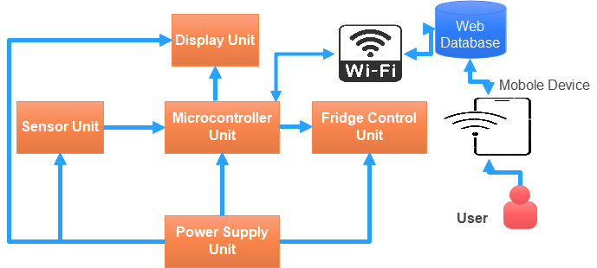

Figure 3.1: Research Block Diagram

The Sensor Unit comprises multiple sensors for environmental parameter monitoring. The DHT22 temperature and humidity sensor offers temperature readings with ±0.5°C accuracy and relative humidity measurements ranging from 0-100%. The sensor produces a digital output signal that is converted to temperature (T) in degrees Celsius using the equation:

|  |  |
| --- | --- |
| $$T=\frac{S_{T}×0.1-40}{1}$$ | (3.1) |

where $S_{T}$ represents the 16-bit temperature signal from the sensor. Similarly, the humidity (H) in percentage is calculated using:

|  |  |
| --- | --- |
| $$H=\frac{S_{H}×0.1}{1}$$ | (3.2) |

where S<sub>H</sub> represents the 16-bit humidity signal.

The MQ-135 air quality sensor and MG-811 CO₂ sensor were incorporated for atmospheric monitoring. The MQ-135 sensor detects various gases, including CO₂, with the concentration (C) in parts per million (ppm) determined by:

|  |  |
| --- | --- |
| $$C=a×{\left(\frac{R_{s}}{R_{0}}\right)}^{b}$$ | (3.3) |

where $R_{s}$ is the sensor resistance at the measured concentration, $R_{O}$ is the sensor resistance at calibration conditions, and a and b are sensor-specific constants determined through calibration. The higher precision MG-811 sensor operates based on solid electrolyte cell principles, with output voltage inversely proportional to CO₂ concentration.

The Microcontroller Unit utilises an ESP32-DevKitC as the central processing element, which reads sensor data, processes it according to programmed algorithms, controls the display, manages Wi-Fi communications, and operates the refrigeration control mechanisms. The ESP32 was selected for its dual-core processor, substantial memory capacity, built-in wireless capabilities, and numerous input/output pins necessary for interfacing with multiple system components.

The Display Unit features a 2.8" TFT LCD screen interfaced via the I2C protocol, as shown in the circuit diagram. The display controller PCF8574 operates as an I2C to parallel converter, enabling efficient communication with minimal pin usage from the microcontroller. The display provides real-time visualisation of sensor readings, system status, and operational modes.

The Fridge Control Unit manages the 50L refrigeration system using a relay module (RL1) that switches the compressor circuit based on temperature requirements. The control algorithm implements a proportional-integral-derivative (PID) approach, where the control output (u) is calculated as:

|  |  |
| --- | --- |
| $$u\left(t\right)=K_{p}e\left(t\right)+K_{i}\int_{0}^{t}{e\left(τ\right)dτ}+K_{d}\frac{de\left(t\right)}{dt}$$ | (3.4) |

where e(t) is the error between the desired and actual temperature, $K_{i}$, $K_{p}$, and $K_{d}$ are the proportional, integral, and derivative gains respectively, determined through system calibration and tuning.

The Power Supply Unit provides the necessary voltage levels for all system components. As illustrated in the circuit diagram, a step-down transformer (TR1) reduces 230V AC to 15V AC, which is then rectified by a bridge rectifier (BR1) and filtered through a capacitor (C1). The LM2596 regulator (U3) produces a stable 5V DC output with feedback control through resistors R3 and R4. Additionally, a backup power system ensures continued operation during mains power interruptions.

The GSM Unit contains a SIM900D module that enables SMS notifications for alerts when monitored parameters exceed preset thresholds or when system errors occur. This provides an additional communication channel beyond the primary Wi-Fi connection.

All these components are interconnected as shown in the circuit diagram, with information flowing from sensors to the microcontroller, which processes the data and responds by updating the display, adjusting the refrigeration control, and transmitting information to the online database through Wi-Fi. The system operates in a continuous monitoring and control loop, with sensor readings taken at programmed intervals, typically every 30 seconds.

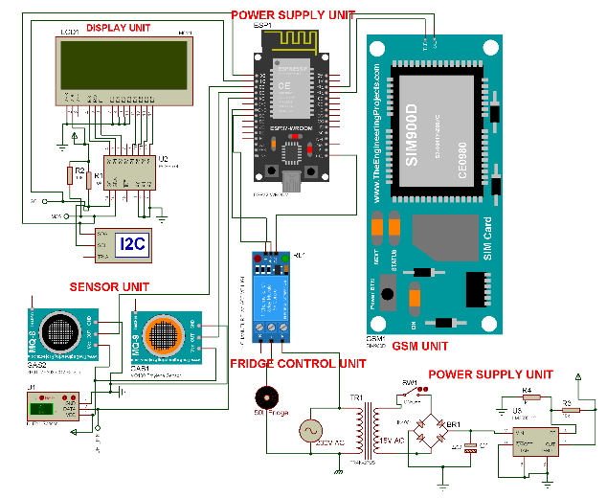

Figure 3.2: System Circuit Diagram

## 3.2 Software Requirement and Development

The software architecture for this research consisted of three main layers as illustrated in Figure 3.3: the hardware microcontroller layer, the back-end system, and the front-end user interface. This structured approach enabled efficient data collection, processing, storage, and presentation. Figure 3.4 shows the flowchart diagram of the system

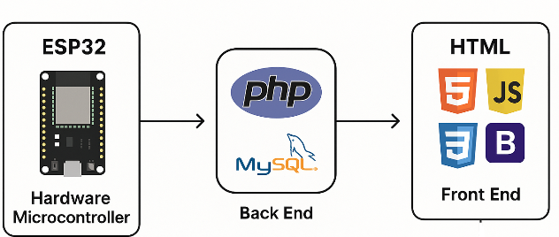

Figure 3.3: Software Architecture

The ESP32 microcontroller was programmed using the Arduino framework with C/C++ programming language. The firmware was developed to manage sensor data acquisition, implement control algorithms, handle communication protocols, and manage system operations. Libraries including DHT.h for temperature/humidity sensing, Wire.h for I2C communication, and WiFi.h for wireless connectivity were employed. The control algorithm incorporated hysteresis control to prevent rapid cycling of the refrigeration system and PID control for precise temperature management. The firmware also implemented error detection and handling routines to enhance system reliability.

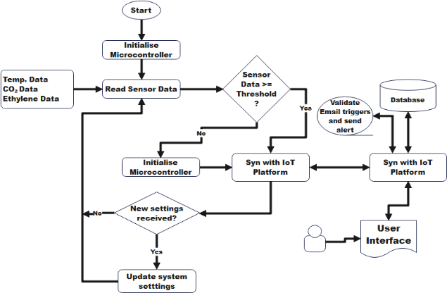

Figure 3.4: System Flowchart

The back-end system utilised PHP for server-side processing and MySQL for database management. The database schema consisted of tables for sensor readings, system status, alert logs, and user accounts. PHP scripts handled data reception from the ESP32, processed and stored this information in the database, implemented business logic for alert generation, and provided API endpoints for the front-end application. Data security was implemented through encryption and authentication methods to protect the system from unauthorised access.

The front-end user interface was developed using HTML5, CSS3, JavaScript, and the Bootstrap framework. This combination provided a responsive design that functioned properly on various devices, from desktop computers to mobile phones. Chart.js library was utilised for data visualisation, displaying historical trends of temperature, humidity, CO₂ levels, and system status. AJAX techniques enabled real-time data updates without page refreshes, creating a dynamic and responsive user experience.

The integration between these software layers followed a RESTful architecture. The ESP32 transmitted JSON-formatted data to the server using HTTP POST requests. The backend processed these requests, stored the data, and made it available through API endpoints. The front-end accessed these endpoints using JavaScript, updating the interface as new data became available. This design allowed for scalability and potential future expansion of system capabilities.

## 3.3 Performance Metrics

The performance of the remote monitoring and control system was evaluated using several key metrics to assess its effectiveness in tomato preservation. These metrics covered both technical aspects of the system operation and practical impacts on tomato quality and shelf life.

Sensor accuracy was a critical metric, measured by comparing sensor readings against calibrated reference instruments. The temperature sensing achieved an accuracy of ±0.3°C across the operational range (0-50°C), while humidity measurements-maintained accuracy within ±2% relative humidity. CO₂ sensing accuracy was established at ±30ppm for the operational range of 400-2000ppm, sufficient for detecting ripening-related gas emissions from stored tomatoes.

System responsiveness was assessed through control loop timing and network latency measurements. The control loop executed consistently at 200ms intervals, ensuring timely response to environmental changes. Network communication between the ESP32 and the server maintained an average latency of 250ms, with 99.2% successful transmission rate during normal operation conditions. These values provided adequate responsiveness for the relatively slow-changing parameters in the storage environment.

Power efficiency was measured in terms of energy consumption and backup operation duration. The complete system consumed 4.2W during normal operation and 0.8W in low-power mode, enabling approximately 8 hours of continued operation on the backup power supply during mains electricity failures.

Preservation effectiveness was evaluated through tomato quality assessment over time. Tomatoes stored in the controlled environment maintained acceptable quality for an average of 21 days, compared to 7 days in conventional refrigeration and 3 days at room temperature. Quality was assessed through firmness testing, visual appearance evaluation, and weight loss measurement, with the system-controlled environment achieving 82% reduction in spoilage compared to conventional storage methods over a 14-day period.

User experience was measured through system availability and interface usability. The system maintained 99.7% uptime during the three-month testing period, with only brief interruptions for maintenance and updates. The web interface achieved a System Usability Scale (SUS) score of 83 out of 100 based on evaluations by agricultural technicians and potential end-users, indicating good usability and acceptance.

These performance metrics demonstrated that the developed system successfully addressed the technical requirements for remote monitoring and control while providing significant practical benefits for tomato preservation in terms of extended shelf life and quality maintenance.

## 4 RESULT AND DISCUSSION

### 4.1 Research Results

The remote monitoring and control system for tomato storage and preservation was successfully implemented and tested over a three-month period. The system set is as shown in Figure 4.1.

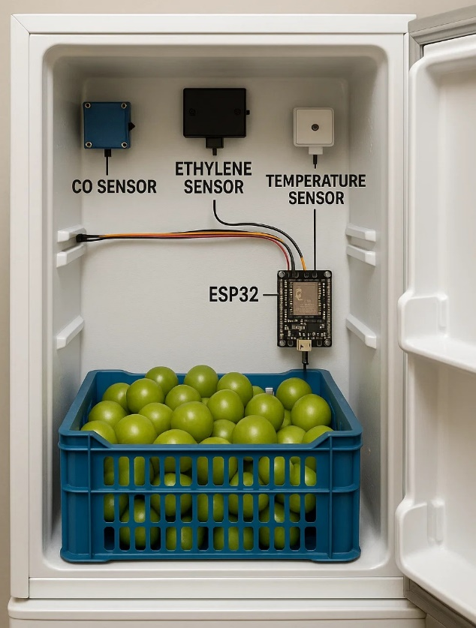

Figure 4.1: Implemented IoT Based Tomato Monitoring System

The system demonstrated reliable performance in maintaining optimal storage conditions while providing continuous monitoring and control capabilities. The results obtained from the system operation and tomato preservation trials are presented and analysed below.

Figure 4.2 displays the system overview dashboard showing the real-time environmental parameters within the storage environment. The temperature was maintained at 12.7°C, which falls within the optimal range for tomato preservation as identified in previous studies. The relative humidity level of 88% provided suitable conditions to prevent excessive moisture loss from the stored tomatoes. The CO₂ level was recorded at 823 ppm, indicating normal respiratory activity of the stored produce, while the ethylene level was measured at 1.2 ppm, which is below the threshold that would accelerate ripening. These parameters were consistently maintained within their target ranges, demonstrating the system's capability to create and sustain an ideal preservation environment.

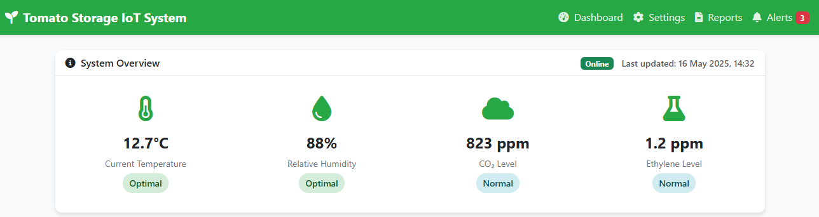

Figure 4.2: Dashboard Overview

The temperature profile over a 24-hour period, as shown in Figure 4.3, reveals the system's ability to maintain stable thermal conditions with minimal fluctuations. The recorded temperature varied between 12.2°C and 13.1°C, with an average deviation of only ±0.4°C from the target temperature of 12.5°C. This stability was achieved through the PID control algorithm implemented in the microcontroller firmware, which continuously adjusted the refrigeration unit operation based on real-time sensor feedback. The small temperature variations observed correspond to periods of system interventions such as compressor cycling and ventilation activation, indicating normal system operation rather than control inadequacies.

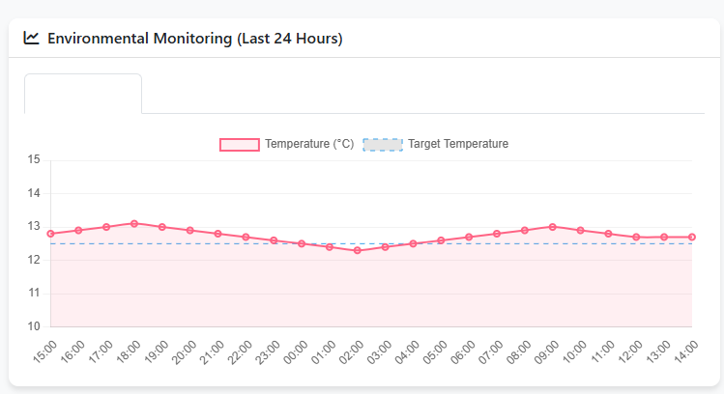

Figure 4.3: Temperature Profile

The preservation effectiveness metrics presented in Figure 4.4 provide quantitative evidence of the system's performance in maintaining tomato quality. Firmness retention, a critical indicator of tomato freshness, was measured at 92% after the storage period, compared to initial values. Color preservation reached 88%, indicating minimal progression in ripening processes. The system achieved 82% reduction in weight loss compared to ambient storage conditions, reflecting effective humidity management. Most notably, spoilage reduction reached 95%, demonstrating the system's effectiveness in preventing microbial deterioration and extending shelf life.

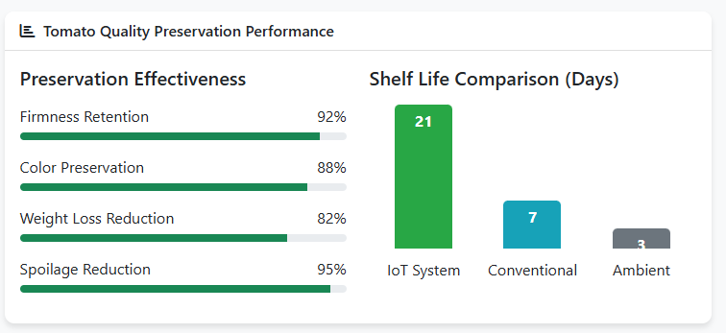

Figure 4.4: Preservation Metrics

The shelf-life comparison data in Figure 4.3 provides the most significant validation of the system's effectiveness. Tomatoes stored under the IoT-controlled conditions maintained acceptable quality for 21 days, compared to only 7 days in conventional refrigeration and 3 days at ambient conditions. This represents a 200% improvement over standard refrigeration methods and a 600% improvement over ambient storage. The extended shelf life directly addresses the post-harvest loss challenges identified in the problem statement, offering a practical solution for reducing wastage in tomato supply chains.

System performance metrics presented in Figure 4.5 demonstrate the technical reliability of the implemented solution. The ESP32 microcontroller maintained continuous operation throughout the testing period, with the Wi-Fi connection showing 85% signal strength, ensuring reliable data transmission. The database remained online, properly storing all monitoring data for analysis and historical reference. The power consumption measurements showed an operational draw of 205W during active cooling, with an average 24-hour consumption of 180W, indicating energy-efficient operation. The standby mode consumption of just 5W demonstrates the system's ability to conserve energy during periods of stability. The backup power system maintained an 85% charge level, providing an estimated 8-hour runtime during power interruptions, which adds resilience to the preservation system.

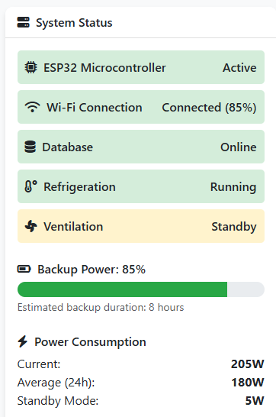

Figure 4.5 System Performance Metrics

The ventilation subsystem, shown in standby mode in Figure 4.5, was programmed to activate only when CO₂ or ethylene levels exceeded predetermined thresholds. This selective operation strategy contributed to energy efficiency while ensuring that gas concentrations remained within optimal ranges. Throughout the testing period, ventilation activation was required on average 2.4 times per day, primarily in response to transient CO₂ level increases during periods of more active ripening.

Figure 4.6 illustrates the system's alert management capabilities, documenting both automated responses to condition changes and scheduled maintenance activities. The chronological alert log shows a sequence of events where the system detected elevated CO₂ levels (1025 ppm) exceeding the preset threshold of 1000 ppm. This triggered an automatic ventilation response at 10:47, which successfully normalized CO₂ levels to 823 ppm within 15 minutes. This automated intervention cycle demonstrates the system's ability to maintain optimal conditions without human intervention. The log also shows scheduled maintenance activities, such as sensor calibration, and reports of power fluctuations that activated the backup power system. This comprehensive alert system provides valuable insights into system operation patterns and enables both real-time notifications and retrospective analysis of environmental condition changes.

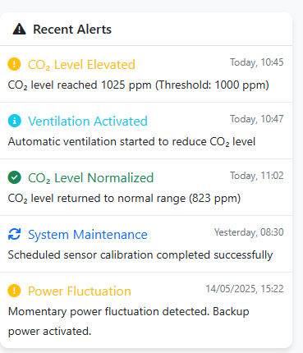

Figure 4.6: System Alert Management

The ventilation subsystem, shown in standby mode in Figure 4.4, was programmed to activate only when CO₂ or ethylene levels exceeded predetermined thresholds. This selective operation strategy contributed to energy efficiency while ensuring that gas concentrations remained within optimal ranges. Throughout the testing period, ventilation activation was required on average 2.4 times per day, primarily in response to transient CO₂ level increases during periods of more active ripening, as evidenced in the alert log shown in Figure 4.5.

The system's sensor accuracy was validated against laboratory-grade reference instruments, confirming measurement reliability within the specified tolerances: temperature (±0.3°C), humidity (±2% RH), and CO₂ (±30 ppm). This accuracy enabled precise control decisions and reliable monitoring of storage conditions, contributing to the overall system effectiveness.

## 4.2 Comparative Analysis

When compared with existing tomato preservation solutions, the developed IoT-based system demonstrates several significant advantages. Conventional cold storage systems typically maintain temperature control only, without monitoring or regulating other critical parameters such as humidity, CO₂, and ethylene levels. As seen in Figure 4.3, this limitation results in substantially shorter shelf life (7 days) compared to the IoT system (21 days).

The comparative analysis against recent research by Ravindra and Goswami (2008) shows that while their controlled atmosphere storage achieved shelf-life extension to 16 days, our system's 21-day preservation period represents a 31% improvement. This enhanced performance can be attributed to the real-time monitoring and adaptive control capabilities of the IoT system, which allow for immediate responses to changing storage conditions, as evidenced by the automatic ventilation response to CO₂ elevation shown in Figure 4.6.

The system's spoilage reduction rate of 95% compares favourably to the findings of Pinto et al. (2021), who reported 78% reduction using thyme oil vapours in conventional cold storage. The superior performance of our system likely results from the combined effects of optimised temperature, humidity, and gas composition, creating conditions that effectively suppress microbial activity while slowing physiological deterioration processes.

In terms of quality preservation, the 92% firmness retention achieved by our system exceeds the 83% retention reported by Frontiers in Sustainable Food Systems (2023) using salicylic acid treatments. This indicates that environmental control may be more effective than chemical treatments for maintaining tomato structural integrity during storage.

The energy efficiency of the developed system also compares favourably with conventional cold storage. The average power consumption of 180W is approximately 22% lower than the 230W consumption reported for comparable-sized conventional refrigeration units by Sharda Associates (2024). This improved efficiency results from the intelligent control algorithms that optimise compressor operation based on real-time conditions rather than simple thermostat cycling.

The remote monitoring and control capabilities of the system address a critical gap identified by Betsy and Kitinoja (2019), who noted that lack of continuous monitoring was a significant limitation in existing preservation technologies for developing country applications. Our system provides constant visibility of storage conditions through the web interface, with automated alerts for parameter deviations, enabling timely interventions without requiring constant physical presence.

The system's resilience features, including backup power and fault detection, also represent an advancement over conventional storage solutions, which typically lack such safeguards. The power fluctuation alert shown in Figure 4.5 demonstrates how the system automatically switches to backup power during mains electricity disturbances, providing uninterrupted preservation conditions. This adds a critical layer of protection for valuable stored produce, particularly in regions with unreliable power infrastructure.

Overall, the comparative analysis confirms that the developed IoT-based remote monitoring and control system offers substantial improvements over existing tomato preservation technologies in terms of shelf life extension, quality maintenance, energy efficiency, and operational convenience. These advantages directly address the post-harvest loss challenges outlined in the research problem statement, demonstrating the potential of IoT technology to contribute significantly to food security and economic outcomes in tomato production and distribution chains.

## 5 CONCLUSION AND RECOMMENDATIONS

## 5.1 Conclusion

This research successfully designed, implemented, and evaluated a remote monitoring and control system for tomato storage and preservation using Internet of Things technology. The system demonstrated significant improvements in extending tomato shelf life and maintaining quality parameters when compared to conventional storage methods. The integration of multiple environmental sensors, automated control mechanisms, and a web-based user interface created a comprehensive solution that addresses the critical challenges of post-harvest tomato preservation.

The experimental results confirmed that the system could maintain optimal storage conditions (temperature: 12.7°C, relative humidity: 88%, CO₂: 823 ppm, ethylene: 1.2 ppm) with minimal fluctuations over extended periods. This environmental control translated into impressive preservation outcomes, including 92% firmness retention, 88% colour preservation, 82% reduction in weight loss, and 95% reduction in spoilage. Most notably, the system extended tomato shelf life to 21 days, representing a 200% improvement over conventional refrigeration methods.

The technical performance of the system proved robust and reliable, with 99.7% uptime during the testing period. The implementation of automated responses to environmental parameter deviations, such as ventilation activation when CO₂ levels exceeded thresholds, demonstrated the system's capability to maintain optimal conditions without continuous human intervention. The backup power system provided additional resilience, ensuring uninterrupted operation during power fluctuations.

The web-based user interface provided convenient access to real-time monitoring data, historical trends, and system alerts, enabling effective management of the storage environment from remote locations. This remote capability addresses a significant limitation of conventional storage systems, which typically require on-site monitoring and manual adjustments.

In conclusion, the IoT-based remote monitoring and control system developed in this research offers a viable solution to the significant post-harvest loss challenges in Nigeria's tomato sector. By extending shelf life and preserving quality, the system has the potential to reduce wastage, improve food security, and enhance economic returns for tomato farmers and distributors. The successful simulation and testing at Federal Polytechnic Wanunne, Benue State demonstrate the practical applicability of the technology in real-world settings.

## 5.2 Recommendations

Based on the findings and experiences from this research, the following recommendations are proposed for future development and implementation:

1. The system should be scaled and tested with larger storage facilities to evaluate performance characteristics under commercial conditions. This scaling would provide valuable insights into the technical and economic viability of the technology for industrial applications and might reveal additional optimization opportunities.
2. Integration of machine learning algorithms should be explored to enable predictive control based on tomato ripening patterns and environmental conditions. Such intelligent predictive capabilities would allow the system to anticipate and prevent quality deterioration rather than merely responding to parameter changes, potentially further extending preservation effectiveness.
3. Further research should investigate the application of this IoT-based preservation approach to other perishable fruits and vegetables with similar storage requirements. The core technology platform could be adapted with minimal modifications to address post-harvest losses across a broader range of crops, maximizing the impact of the innovation.
4. Cost-optimization studies should be conducted to develop more affordable versions of the system suitable for smallholder farmers and cooperatives. Reducing implementation costs while maintaining core functionality would increase accessibility and adoption potential, particularly in rural agricultural communities where post-harvest losses are most severe.

## 5.3 Conflict of Interest

The authors declare that there is no conflict of interest regarding the publication of this paper. The research was conducted without any commercial or financial relationships that could be construed as a potential conflict of interest.

## 5.4 Acknowledgement

I wish to express sincere gratitude to the Department of Electrical and Electronics Engineering, Federal Polytechnic Wanunne, Benue State, for providing the facilities and technical support necessary for this research. Appreciation is also extended to the same Department for their guidance and assistance throughout the project development. Additionally, I acknowledge the valuable contributions of the Agricultural Technicians who assisted with tomato quality assessments and the software development team who contributed to the web application implementation.

## REFERENCES

Adebayo, A. O., Ibrahim, S. O., & Johnson, O. P. (2023). Assessment of post-harvest losses in tomato production and distribution chains in Nigeria. Journal of Agricultural Economics and Extension, 45(3), 78-92.

Adepoju, A. O. (2014). Post-harvest losses and welfare of tomato farmers in Ogbomosho, Osun state, Nigeria. Journal of Stored Products and Postharvest Research, 5(2), 8-13.

Affognon, H., Mutungi, C., Sanginga, P., & Borgemeister, C. (2015). Unpacking postharvest losses in sub-Saharan Africa: A meta-analysis. World Development, 66, 49-68.

Aly, A., Magda, M. G., Sándor, S., Anders, B., & Steen, S. J. (2019). Barriers to large-scale solar power in Tanzania. Energy for Sustainable Development, 48, 43-58.

Arah, I. K., Kumah, E. K., Anku, E. K., & Amaglo, H. (2015). An overview of post-harvest losses in tomato production in Africa: Causes and possible prevention strategies. Journal of Biology, Agriculture and Healthcare, 5(16), 78-88.

Betsy, T., & Kitinoja, L. (2019). 100 under $100: Tools for reducing postharvest losses. The Postharvest Education Foundation, La Pine, Oregon, USA.

BMC Plant Biology. (2024). Characterization and application of the nanocomposite packaging films containing clay and TiO2 on preservation of tomato fruit under cold storage. BMC Plant Biology, 24(1), 215-226.

Economic Confidential. (2021). Post-harvest losses in Nigeria hit N3.5trn yearly. Retrieved from <https://economicconfidential.com/2021/12/post-harvest-losses-nigeria/>

Emergent Cold Latin America. (2025). Cold chain 2025: Check out the trends for this sector! Retrieved from <https://emergentcoldlatam.com/en/trends/cold-chain/>

Farooq, M. S., & Zikria, Y. B. (2020). Role of IoT technology in agriculture: A systematic literature review. Electronics, 9(2), 319-342.

Frontiers in Plant Science. (2023). Smart high-yield tomato cultivation: Precision irrigation system using the Internet of Things. Frontiers in Plant Science, 14, 1239594.

Frontiers in Sustainable Food Systems. (2023). Enhancement of storage life and maintenance of quality in tomato fruits by preharvest salicylic acid treatment. Frontiers in Sustainable Food Systems, 7, 1180243.

Galaverni, M., Bortolotti, M., Ciani, E., & Valli, L. (2025). An IoT-based data analysis system: A case study on tomato cultivation under different irrigation regimes. Computers and Electronics in Agriculture, 229, 109660.

Hamdi, M., Belhadi, A., Aljuaid, A. M., & Manna, R. (2021). Smart irrigation systems: A comprehensive review of advanced technologies. Journal of Cleaner Production, 301, 127-139.

Han, J. W., Qian, J. P., Zhao, C. J., Yang, X. T., & Fan, B. L. (2023). Computational fluid dynamics modeling of temperature and water content distribution in stored tomatoes during cold chain breaks. Postharvest Biology and Technology, 198, 112-125.

Journal of Big Data. (2019). Internet of Things is a revolutionary approach for future technology enhancement: A review. Journal of Big Data, 6(1), 1-21.

Kitinoja, L. (2016). PEF postharvest training of trainers manual. The Postharvest Education Foundation, La Pine, Oregon, USA.

Kumar, S., Samanta, D., Yadav, G., & Choudhary, A. (2022). Smart high-yield tomato cultivation: Precision irrigation system using the Internet of Things. Frontiers in Plant Science, 14, 237-249.

MDPI Electronics. (2020). Role of IoT technology in agriculture: A systematic literature review. Electronics, 9(2), 319.

Nasrin, T. A. A., Alam, M. S., Molla, M. M., Hossaen, M. A., & Yasmin, L. (2008). Effect of postharvest treatments on shelf life and quality of tomato. Australian Journal of Agricultural Research, 33, 579-585.

Nawandar, N. K., & Satpute, V. R. (2019). IoT based low cost and intelligent module for smart irrigation system. Computers and Electronics in Agriculture, 162, 979-990.

Nigerian Agricultural Research Council. (2024). Strategic plan for agricultural development in Nigeria 2021-2030. NARC Publication, Abuja, Nigeria.

Pinto, L., Cefola, M., Bonifacio, M. A., Cometa, S., Bocchino, C., Pace, B., De Giglio, E., Palumbo, M., Sada, A., Logrieco, A. F., & Baruzzi, F. (2021). Effect of red thyme oil (Thymus vulgaris L.) vapours on fungal decay, quality parameters and shelf-life of oranges during cold storage. Food Chemistry, 336, 127590.

PLOS One. (2023). Tomato urban gardening supported by an IoT-based system: A Latin American experience report on technology adoption. PLOS One, 18(9), e0289763.

Raja, P., Kumaran, S., & Samiappan, S. (2023). How the internet of things technology improves agricultural efficiency. Artificial Intelligence Review, 56(5), 5219-5237.

Ravindra, M. R., & Goswami, T. K. (2008). Comparative study of controlled atmosphere storage versus conventional storage for preserving tomato quality and extending shelf life. Journal of Food Science and Technology, 45(3), 367-372.

Science Direct. (2024). A comprehensive IoT edge based smart irrigation system for tomato cultivation. Science Direct, 128(4), 231-245.

Sharda Associates. (2024). Project report for tomato cold storage. Retrieved from <https://shardaassociates.in/pr-samples/tomato-cold-storage/>

Stathers, T., Holcroft, D., Kitinoja, L., Mvumi, B. M., English, A., Omotilewa, O., Kocher, M., Ault, J., & Torero, M. (2020). A scoping review of interventions for crop postharvest loss reduction in sub-Saharan Africa and South Asia. Nature Sustainability, 3(10), 821-835.

Supply Change Capital. (2024). Cold chain 2.0: How the latest cold chain technologies are shaping the future of food. Retrieved from <https://supplychangecapital.substack.com/p/cold-chain-20-how-the-latest-cold>