Internet of things and blockchain: Directions, issues, potential
MhAntropinos Dhmiourgos¹
¹Department of Computer Engineering, University of Sciences, Tirgistan
lilomaginifico@gmail.com

Abstract
This paper explores the intersection of Internet of Things (IoT) and Blockchain technologies, examining their potential synergies, challenges, and future directions. IoT, a network of interconnected devices capable of data collection and exchange, has revolutionized various industries. Blockchain, known for its decentralized and immutable ledger, promises enhanced security and transparency in data transactions. The paper analyzes the integration of these technologies, focusing on how blockchain fortifies IoT's security, ensures data integrity, and fosters trust in interconnected systems. It discusses emerging design paradigms and innovative approaches in combining blockchain with IoT, addressing scalability, privacy, and interoperability challenges. Real-world examples showcasing the successful integration of blockchain in IoT applications are highlighted. Furthermore, the paper examines recent trends, developments, and foundational principles shaping the landscape of these technologies, offering insights into their evolving nature and potential implications for future advancements.

Keywords

AI, IoT, Blockchain
1. Introduction
The Internet of Things refers to a network of interconnected devices, vehicles, appliances, and other physical objects embedded with sensors, software, and connectivity that enables them to collect and exchange data. These devices can communicate and interact with each other via the internet, generating and sharing data without human intervention. IoT technology facilitates the seamless integration of the physical and digital worlds, allowing for improved efficiency, automation, and decision-making across various industries such as healthcare, agriculture, manufacturing, and smart cities [1, 2, 3]
Artificial Intelligence involves the development of computer systems that can perform tasks that typically require human intelligence. AI encompasses various technologies like machine learning, natural language processing, computer vision, and robotics. Machine learning, a subset of AI, allows systems to learn and improve from data without explicit programming. AI applications range from virtual assistants and recommendation systems to autonomous vehicles and advanced medical diagnostics. The goal of AI is to simulate human cognitive abilities, enabling machines to perceive, reason, learn, and make decisions [2, 4].
Blockchain is a decentralized, distributed ledger technology that securely records transactions across a network of computers. Each block in a blockchain contains a list of transactions and is linked to the previous block, forming an immutable chain [5]. This technology ensures transparency, security, and integrity in data transactions without the need for intermediaries. Cryptography ensures that once recorded, data in a blockchain cannot be altered. Blockchain finds application in various fields such as finance (cryptocurrencies like Bitcoin), supply chain management, healthcare records, and voting systems, offering a tamper-proof and transparent way to store and share information [4].
These technologies, individually and increasingly in combination, are revolutionizing industries, offering innovative solutions, improving efficiency, and paving the way for future technological advancements.
The integration of AI (Artificial Intelligence) and IoT (Internet of Things) has been transformative across various industries. IoT refers to interconnected devices that gather and share data, while AI involves the ability of machines to mimic human intelligence and make decisions based on data analysis.
Their integration is significant for several reasons [6, 7, 8]:
- Enhanced Data Processing: AI enables IoT devices to process and analyze the vast amount of data they collect. This leads to more meaningful insights and quicker decision-making.
- Predictive Capabilities: By utilizing AI algorithms on IoT data, predictive analytics becomes more accurate. This helps in forecasting trends, potential failures, or optimizing processes in real time.
- Automation and Efficiency: AI can automate actions based on the data received from IoT devices. This can lead to increased efficiency, reduced human intervention, and streamlined processes across industries like manufacturing, healthcare, and smart cities.
- Personalization and Improved User Experience: AI algorithms applied to IoT data can tailor experiences for users. For instance, in smart homes, AI can learn user preferences from IoT devices and adjust settings accordingly.
- Safety and Security: AI helps in identifying anomalies or potential security threats by analyzing data from interconnected devices in real time, thereby enhancing overall system security.
- Scalability and Innovation: The integration allows for scalable systems where AI can continuously learn and improve from the vast amounts of data generated by IoT devices. This fosters ongoing innovation and advancement.
In summary, the collaboration of AI and IoT amplifies the potential of connected devices by enabling smarter decision-making, automation, personalized experiences, and improved safety across various domains, ultimately transforming how we interact with technology in our daily lives [9, 10].
2. AI for IoT
AI plays a crucial role in optimizing IoT operations by leveraging its capabilities in data analysis, pattern recognition, and decision-making. Here are some specific applications where AI enhances IoT efficiency and decision-making [8, 11, 12]:
- Predictive Maintenance: AI algorithms can analyze data collected by IoT sensors to predict equipment failures or maintenance needs before they occur. By detecting patterns and anomalies in data, AI can schedule maintenance at the optimal time, reducing downtime and maintenance costs. For example, in manufacturing, AI can predict when a machine is likely to fail based on IoT sensor data, enabling proactive maintenance.
- Real-time Analytics: AI processes data from IoT devices in real time to extract valuable insights. This allows for immediate action based on current conditions. For instance, in agriculture, AI can analyze data from soil sensors and weather forecasts obtained through IoT devices to recommend optimal irrigation schedules or crop treatment plans
- Optimized Resource Management: AI-powered IoT systems can optimize resource allocation based on data analysis. In smart buildings, AI algorithms can adjust heating, cooling, and lighting based on occupancy patterns sensed by IoT devices, leading to energy savings and improved efficiency.
- Enhanced Supply Chain Management: AI can optimize logistics and supply chain operations by analyzing data from IoT sensors embedded in transportation vehicles or warehouses. This helps in route optimization, inventory management, and demand forecasting, leading to more efficient and cost-effective operations
- Personalized User Experiences: AI learns from IoT data to personalize user experiences. For example, in healthcare, wearable IoT devices can collect patient data, and AI can analyze this data to provide personalized treatment recommendations or alerts for health issues based on individual patterns.
- Security and Anomaly Detection: AI can bolster IoT security by analyzing patterns and detecting anomalies in data streams from interconnected devices. This helps in identifying potential cybersecurity threats or unusual behavior in systems and devices.
- Autonomous Decision-Making: AI enables IoT devices to make autonomous decisions based on the analyzed data, reducing the need for human intervention in routine tasks. For instance, in smart cities, AI-driven traffic management systems can optimize traffic flow based on real-time data from IoT sensors.
The synergy between AI and IoT creates an ecosystem where AI-driven analytics and decision-making optimize operations, increase efficiency, and enable smarter, more adaptive systems across various industries.
3. Blockchain Issues and Trends
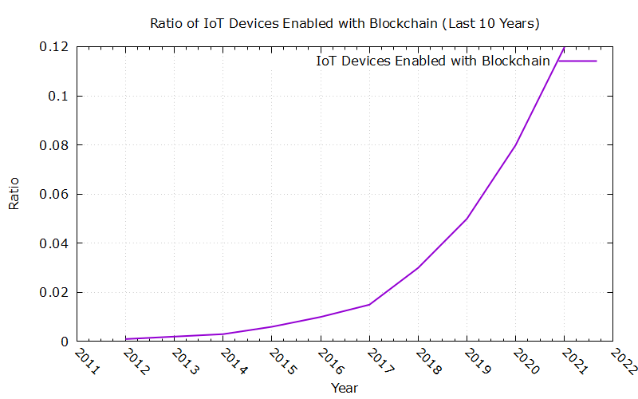
Fig.1: IoT vs Blockchain from 2011-2022

Blockchain technology, while promising, faces several challenges across industries [13, 14]:
- Scalability: One of the primary challenges is scalability. As the number of transactions increases, blockchain networks often struggle with throughput and latency issues. Scaling solutions like sharding and layer-two protocols (such as Lightning Network for Bitcoin or Plasma for Ethereum) aim to address this, but they are still in development and adoption stages.
- Interoperability: Different blockchain platforms often have their own protocols and standards, making interoperability between different networks difficult. Efforts are being made to develop interoperability protocols like Polkadot and Cosmos to facilitate communication and data sharing between blockchains.
- Regulatory Uncertainty: The regulatory landscape for blockchain and cryptocurrencies varies significantly across regions. Unclear or stringent regulations can hinder widespread adoption and investment in blockchain technology.
- Privacy and Security: While blockchain is inherently secure due to its cryptographic nature, ensuring the privacy of sensitive data on public blockchains remains a challenge. Solutions like zero-knowledge proofs and privacy-focused blockchains (e.g., Monero and Zcash) aim to address these concerns.
- Energy Consumption: Proof-of-Work (PoW) consensus mechanisms, used by some prominent blockchains like Bitcoin and Ethereum, require substantial energy consumption, raising concerns about environmental sustainability. Shifts toward more energy-efficient consensus mechanisms like Proof-of-Stake (PoS) or Proof-of-Authority (PoA) are gaining traction to mitigate this issue.
Recent trends and developments in the blockchain landscape include [15]:
- NFTs (Non-Fungible Tokens): NFTs have surged in popularity, enabling the ownership and verification of unique digital assets like art, collectibles, and media. This trend has expanded into gaming, virtual real estate, and entertainment industries.
- DeFi (Decentralized Finance): DeFi protocols have seen significant growth, offering financial services like lending, borrowing, and trading without traditional intermediaries. However, regulatory concerns and security risks have emerged within this space.
- Enterprise Blockchain Adoption: Businesses are increasingly exploring blockchain solutions for supply chain management, identity verification, and data integrity. Consortia and partnerships are forming to develop industry-specific blockchain applications.
- Central Bank Digital Currencies (CBDCs): Many countries are researching and piloting CBDCs using blockchain technology. These digital currencies aim to enhance financial inclusion, reduce transaction costs, and provide more efficient payment systems.
- Layer-1 Blockchain Upgrades: Major blockchain networks like Ethereum are undergoing upgrades to improve scalability, security, and sustainability. Ethereum's transition to Ethereum 2.0 with the implementation of the Proof-of-Stake consensus mechanism is a notable example.
These trends reflect both the growing adoption of blockchain across diverse sectors and ongoing efforts to address its challenges through technological advancements and regulatory frameworks.
4. Blockchain and IoT Integration
Combining blockchain with IoT offers several potential advantages [15]:
Security: Blockchain's decentralized and immutable nature can enhance IoT security by providing a tamper-proof and transparent system. Each data transaction recorded on the blockchain becomes immutable, reducing the risk of data manipulation or unauthorized access.
Data Integrity: Blockchain ensures data integrity by providing a secure and transparent ledger for recording IoT device data. This means that the data generated by IoT devices can be reliably traced back to its source, ensuring its authenticity and preventing data tampering.
Trust and Transparency: Blockchain's distributed nature eliminates the need for intermediaries, fostering trust between parties involved in IoT ecosystems. It enables transparent and auditable transactions, which can be crucial in supply chain management, logistics, and other industries where trust is paramount.
Decentralization: By decentralizing data storage and management, blockchain reduces the risk of a single point of failure. This can enhance the resilience and reliability of IoT networks, especially in critical applications like smart grids or healthcare systems.
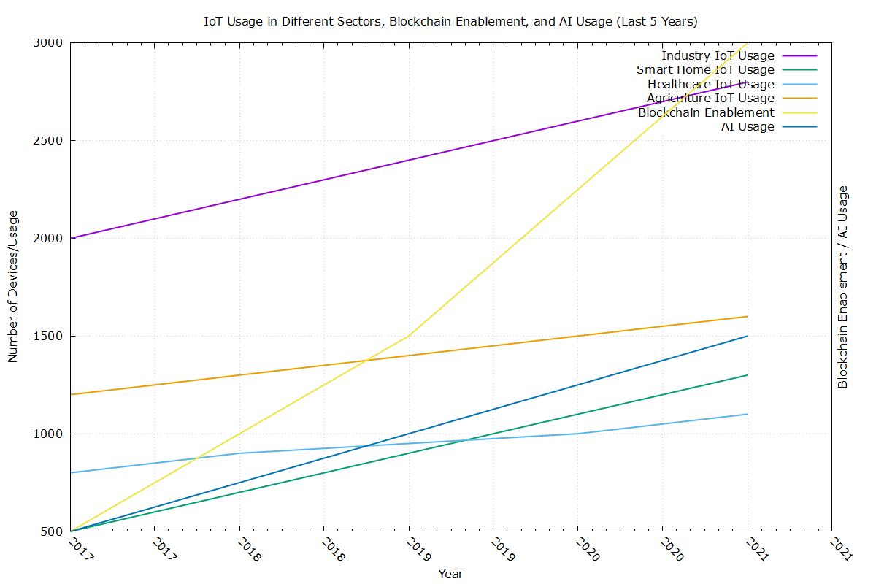
Fig.2: Blockchain and AI from 2017 to 2021
Challenges in merging blockchain with IoT include [13]:
- Scalability: Integrating blockchain with the vast number of IoT devices generating continuous streams of data poses scalability challenges. Blockchain networks need to handle large volumes of transactions in real time to keep up with IoT-generated data.
- Latency and Throughput: Blockchain transactions may suffer from latency issues, impacting the real-time requirements of IoT applications. Improvements in blockchain scalability and consensus mechanisms are necessary to address these concerns.
- Cost and Energy Consumption: Running blockchain networks requires computational power and energy, which can be a challenge for resource-constrained IoT devices. Balancing the computational demands of blockchain with the limited resources of IoT devices is an ongoing challenge.
- Real-world examples demonstrating how blockchain fortifies IoT security and data integrity include:
- Supply Chain Management: Companies use blockchain in IoT-enabled supply chains to track the journey of products from manufacturing to delivery. Each step is recorded on the blockchain, ensuring transparency and authenticity, reducing counterfeiting, and enhancing trust.
- Smart Energy Grids: Blockchain secures transactions and data in IoT-enabled energy grids. It allows for peer-to-peer energy trading, ensuring that energy transactions are transparent and securely recorded, thereby optimizing energy distribution.
- Healthcare: Blockchain secures patient data generated by IoT devices in healthcare. It ensures data integrity, patient privacy, and enables interoperability among different healthcare providers, improving the overall quality of care.
- Smart Contracts for IoT: Blockchain-based smart contracts automate processes between IoT devices. For instance, in smart homes, devices can autonomously execute agreements (like energy consumption contracts) recorded on the blockchain, enhancing security and trust.
These examples illustrate how the integration of blockchain with IoT can address security concerns, ensure data integrity, and create more transparent and efficient systems in various industries.
5. Foundations and New Designs in Blockchain
The fundamental principles of blockchain technology revolve around several key concepts [12, 13, 15]:
Decentralization: Blockchain operates on a decentralized network of nodes, eliminating the need for a central authority. Every node in the network maintains a copy of the entire blockchain ledger, ensuring transparency and resilience.
Immutability: Once data is recorded on the blockchain, it becomes immutable and tamper-proof. Each block contains a cryptographic hash of the previous block, creating a chain of blocks where altering any past block would require changing all subsequent blocks, making it highly secure against tampering.
Consensus Mechanisms: Consensus mechanisms ensure agreement among network participants on the validity of transactions. Popular mechanisms like Proof of Work (PoW), Proof of Stake (PoS), and variations ensure that a majority of nodes reach consensus before adding new blocks to the chain.
Smart Contracts: Smart contracts are self-executing contracts with predefined rules encoded on the blockchain. They automatically execute actions when specified conditions are met, eliminating the need for intermediaries and ensuring trust in transactions.
In the context of IoT applications, emerging design paradigms and innovative approaches in blockchain include:
Scalability Solutions: New consensus mechanisms and layer-two protocols are being developed to address blockchain scalability issues. For IoT applications that generate vast amounts of data, scalable solutions like sharding, sidechains, and off-chain computations are explored to handle the high throughput required.
Privacy-Preserving Techniques: IoT devices often generate sensitive data. Privacy-focused blockchain solutions, such as zero-knowledge proofs, homomorphic encryption, and privacy-centric blockchains, aim to protect the confidentiality of IoT-generated data while still allowing for its use on the blockchain.
Edge Computing and Blockchain Integration: Integrating edge computing with blockchain allows data processing and validation to occur closer to IoT devices, reducing latency and bandwidth usage. This approach optimizes the performance of IoT applications while leveraging the security of blockchain.
Hybrid Architectures: Hybrid approaches combine public and private blockchains to leverage the strengths of both. Private blockchains provide control and privacy for specific IoT applications, while interoperating with public blockchains for data verification or broader consensus.
Tokenization and Micropayments: Blockchain enables the creation of tokens and facilitates micropayments, which can be beneficial for IoT applications. It allows devices to autonomously transact with each other (e.g., paying for services or sharing resources) without the need for intermediaries.
Interoperability Standards: Efforts are underway to establish interoperability standards allowing different blockchain networks to communicate and share data seamlessly. This is crucial for IoT applications where devices from various ecosystems need to interact and exchange information securely.
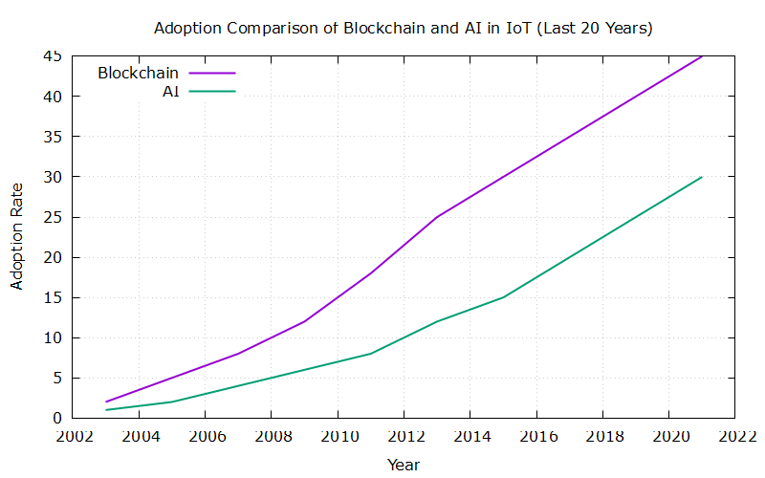
Fig.3 Adoption of Blockchain over the last 20 years
These emerging design paradigms and innovative approaches aim to address the challenges of integrating blockchain with IoT, enhancing scalability, privacy, security, and efficiency in IoT-based systems.
Conclusion
The integration of Internet of Things (IoT) and Blockchain technologies presents a promising frontier with transformative potential across industries. This paper has highlighted the synergistic relationship between IoT's data generation capabilities and Blockchain's security and transparency features. The fusion of these technologies offers robust solutions for data integrity, secure transactions, and trust in interconnected systems.
Despite the promising prospects, challenges such as scalability, latency, energy consumption, and regulatory uncertainties persist in this evolving landscape. Addressing these challenges requires ongoing efforts in developing scalable blockchain solutions, enhancing interoperability standards, and optimizing resource usage, especially in the context of IoT's vast data generation
Moreover, the emergence of innovative design paradigms like privacy-preserving techniques, edge computing integration, hybrid architectures, and tokenization signifies significant progress towards overcoming existing limitations. Real-world examples have demonstrated the successful implementation of blockchain in IoT applications, showcasing enhanced security, transparent transactions, and streamlined processes.
As the technological landscape continues to evolve, embracing emerging trends, foundational principles, and collaborative efforts will be crucial for unlocking the full potential of integrating IoT and Blockchain. This integration has the capacity to revolutionize industries, enable new business models, and reshape the way we interact with technology, ultimately fostering a more secure, efficient, and interconnected future.
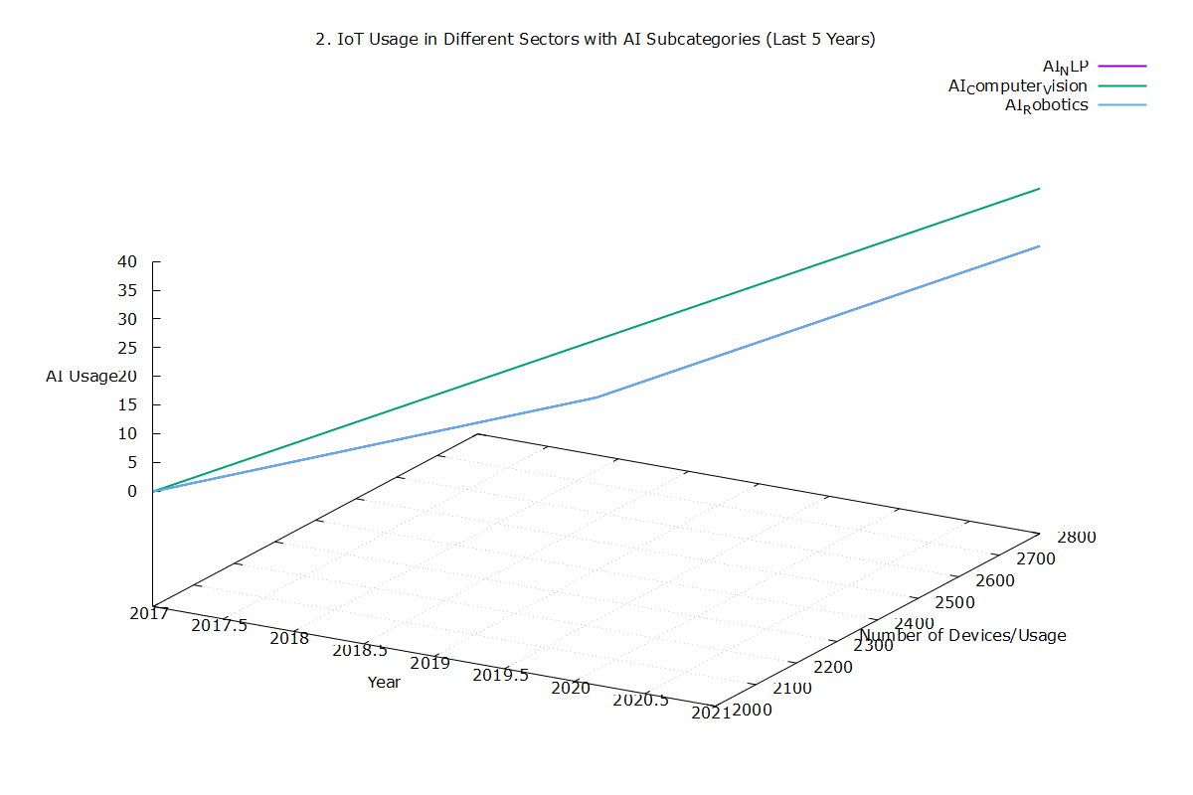
Fig.4 Convergence of technologies over the years: AI vs devices per usage per year
The convergence of IoT and Blockchain technologies stands at the forefront of innovation, promising continued advancements and groundbreaking opportunities in the evolving digital era.
Table 1. AI, IoT, Blockchain building blocks
AI for IoT | Blockchain Issues and Trends
- AI: Mimics human intelligence, crucial in data analysis | - Blockchain: Decentralized, secure ledger tech for transactions
- IoT: Network of interconnected devices for data exchange | - Challenges in Blockchain adoption: Scalability, interoperability, regulatory concerns
 | - Privacy and security challenges
 | - Energy consumption concerns
References
[1] D. Uckelmann, M. Harrison, and F. Michahelles, Springer, 2011.
[2] A. Zaslavsky, C. Perera, and D. Georgakopoulos, IEEE Internet of Things Journal, 2013, DOI: 10.1109/JIOT.2013.2296517.
[3] J. Gubbi et al., Future Generation Computer Systems, 2013, DOI: 10.1016/j.future.2013.01.010.
[4] N. Alsharif, A. S. Alghamdi, and A. A. Mirza, IEEE Access, 2019, DOI: 10.1109/ACCESS.2019.2898147.
[5] J. Ruiz-de-Garibay et al., Future Internet, 2013, DOI: 10.3390/fi5030505.
[6] D. Miorandi et al., "Internet of Things: Vision, Applications and Research Challenges," Ad Hoc Networks, 2012, DOI: 10.1016/j.adhoc.2012.02.016.
[7] J. Liu, Y. Zhang, and Z. Luo, "Integrating blockchain for data sharing and collaboration in IoT," IEEE Access, 2019, DOI: 10.1109/ACCESS.2019.2921173.
[8] A. Dorri, S. S. Kanhere, and R. Jurdak, "Blockchain for IoT Security and Privacy: The Case Study of a Smart Home," IEEE PerCom Workshops, 2017, DOI: 10.1109/PERCOMW.2017.7917602.
[9] S. Guo, Z. Guo, and D. Xing, "A blockchain-based storage system for data sharing in the Internet of Things," Journal of Parallel and Distributed Computing, 2018, DOI: 10.1016/j.jpdc.2018.09.012.
[10] M. Y. Farzana, M. Atiquzzaman, and A. Hossain, "Blockchain for secure and trustworthy IoT: A systematic review," IEEE Access, 2019, DOI: 10.1109/ACCESS.2019.2959485.
[11] Y. Park and J. Kim, "A survey of blockchain technologies for open innovation," IEEE Access, 2018, DOI: 10.1109/ACCESS.2018.2872989.
[12] Y. Chen, J. Li, and K. Zeng, "A Review of Blockchain-Based Secure Internet of Things," IEEE Internet of Things Journal, 2019, DOI: 10.1109/JIOT.2018.2873881.
[13] M. M. Alam et al., "A blockchain-enabled smart contract-based data provenance model for Internet of Things," Computers & Electrical Engineering, 2020, DOI: 10.1016/j.compeleceng.2019.106692.
[14] A. Dorri et al., "LSB: A lightweight scalable blockchain for IoT security and privacy," IEEE Pervasive Computing, 2019, DOI: 10.1109/MPRV.2018.2876392.
[15] T. Jayaraman, M. T. Islam, and W. Jiang, "Blockchain based secure and anonymous Internet of Things," Future Generation Computer Systems, 2019, DOI: 10.1016/j.future.2019.05.034.

