A universal biquadratic circuit employing plus current output devices

Takao Tsukutani
Professor Emeritus, National Institute of Technology, Matsue College, Japan
E-mail t.tsukutani@sea.chukai.ne.jp

Abstract: This paper presents a universal biquadratic circuit employing only plus current output devices (i.e. operational trans-conductance amplifiers (OTAs) and a current follower (CF)). The circuit enables low-pass (LP), band-pass (BP), high-pass (HP), band-stop (BS) and all-pass (AP) responses by the selection and addition of the circuit currents with no component matching constraints. Moreover the circuit parameters ω₀ and Q can be set orthogonally by adjusting the bias currents of the OTAs. The biquadratic circuit enjoys very low sensitivity with respect to the circuit components.
The achievement examples are given together with simulation results by PSPICE.
Keywords: Analog circuits, Biquadratic responses, OTA, CF, CMOS technology

1. Introduction
High performance active circuits have received considerable attention. Circuit designs using active devices such as second generation current conveyor (CCII), differential voltage current conveyor (DVCC), the OTA and others have been reported in the literature [1-9]. OTA is a very useful active device, and OTA-based circuit has electronic tuning capability for circuit responses by the bias currents. The plus current output devices are composed of a simpler circuit configuration than the minus current output ones. Hence they have a wide band operation and low power performance compared with the minus current output devices.
The biquadratic circuit is a very useful second-order function block for realizing the high-order circuit transfer functions. Several biquadratic circuits using the OTAs, DVCCs and CCIIs have been previously discussed [1-9]. However the biquadratic circuit based on the plus current output devices [10] hasn’t been studied sufficiently.
This paper introduces a universal biquadratic circuit employing only the plus current output devices (OTAs and CF) as mentioned above. First we propose a basic current-mode biquadratic circuit, and then we show typical current-mode circuit using the basic current-mode one. The circuit enables the LP, BP, HP, BS and AP responses by the selection and addition of the circuit currents without any component matching constraints. Moreover the circuit parameters ω₀, Q and H can be set electronically by the bias currents of the OTAs. Moreover it is made clear that the biquadratic circuit enjoys very low sensitivity to the circuit components. In addition voltage-mode circuit is introduced using the basic current-mode one.
The design examples are given with PSPICE simulation, and the circuit workability was confirmed.

2. Active devices
The symbols of the plus current output devices (OTA and CF) are given in Fig.1, and hereinto they show dual current output devices.
(a) OTA (b) CF
Figure 1: Symbols of active devices
The current output I_{o} of the OTA is given by:
$I_{o}=g_{m}(V_{+}−V_{−})$ (1)
where g_{m} denotes the trans-conductance gain.
The plus current output OTA with MOS transistors is shown in Fig.2 (a). The trans-conductance gain g_{m} is characterized as:
$g_{m}=\sqrt{μ_{n}C_{\text{ox}}\frac{W}{L}I_{b}}$ (2)
where μ_{n}, C_{ox}, W/L and I_{b} are the electron mobility of NMOS, gate oxide capacitance per unit area, transistor aspect ratio and bias current, respectively. The trans-conductance gain is adjustable by a supplied bias current I_{b}.
The terminal equation of the plus current output CF is given by:
$I_{z}=I_{x}$ (3)
The CF with MOS transistors is shown in Fig.2 (b).
(a) OTA
(b) CF
Figure 2: Plus current output OTA and CF
with MOS transistors

3. Biquadratic circuit configuration
Figure 3 shows the basic current-mode biquadratic circuit. This circuit is constructed with three plus current output OTAs, one CF and two grounded capacitors.
Figure 3: Basic current-mode biquadratic circuit
The current outputs I_{LP}(s), I_{BP}(s) and I_{HP}(s) are given by:
$I_{\text{LP}}(s)=−\frac{g_{m1}g_{m2}}{s^{2}C_{1}C_{2}+{\text{sC}}_{2}g_{m3}+g_{m1}g_{m2}}I_{i}(s)$ (4)
$I_{\text{BP}}(s)=−\frac{{\text{sC}}_{3}g_{m3}}{s^{2}C_{1}C_{2}+{\text{sC}}_{2}g_{m3}+g_{m1}g_{m2}}I_{i}(s)$ (5)
$I_{\text{HP}}(s)=−\frac{s^{2}C_{1}C_{2}}{s^{2}C_{1}C_{2}+{\text{sC}}_{2}g_{m3}+g_{m1}g_{m2}}I_{i}(s)$ (6)
Figure 4 presents the typical current-mode biquadratic circuit using the basic current-mode one.
Figure 4: Typical current-mode biquadratic circuit
The circuit enables the LP, BP and HP responses by the selection of the output currents as follows:
$T_{\text{LP}}(s)=\frac{I_{\text{LP}}(s)}{I_{\text{in}}(s)}=−\frac{g_{\text{mb}}}{g_{\text{ma}}}\frac{g_{m1}g_{m2}}{s^{2}C_{1}C_{2}+{\text{sC}}_{2}g_{m3}+g_{m1}g_{m2}}$ (7)
$T_{\text{BP}}(s)=\frac{I_{\text{BP}}(s)}{I_{\text{in}}(s)}=−\frac{g_{\text{mb}}}{g_{\text{ma}}}\frac{{\text{sC}}_{2}g_{m3}}{s^{2}C_{1}C_{2}+{\text{sC}}_{2}g_{m3}+g_{m1}g_{m2}}$ (8)
$T_{\text{HP}}(s)=\frac{I_{\text{HP}}(s)}{I_{\text{in}}(s)}=−\frac{g_{\text{mb}}}{g_{\text{ma}}}\frac{s^{2}C_{1}C_{2}}{s^{2}C_{1}C_{2}+{\text{sC}}_{2}g_{m3}+g_{m1}g_{m2}}$ (9)
Moreover the BS and AP responses can be achieved by the current addition of I_{BS}(s)=I_{LP}(s)+I_{HP}(s) and I_{AP}(s)=I_{i}(s)+2I_{BP}(s), respectively. The circuit transfer functions are given as:
$T_{\text{BS}}(s)=\frac{I_{\text{BS}}(s)}{I_{\text{in}}(s)}=−\frac{g_{\text{mb}}}{g_{\text{ma}}}\frac{s^{2}C_{1}C_{2}+g_{m1}g_{m2}}{s^{2}C_{1}C_{2}+{\text{sC}}_{2}g_{m3}+g_{m1}g_{m2}}$ (10)
$T_{\text{AP}}(s)=\frac{I_{\text{AP}}(s)}{I_{\text{in}}(s)}=\frac{g_{\text{mb}}}{g_{\text{ma}}}\frac{s^{2}C_{1}C_{2}−{\text{sC}}_{2}g_{m3}+g_{m1}g_{m2}}{s^{2}C_{1}C_{2}+{\text{sC}}_{2}g_{m3}+g_{m1}g_{m2}}$ (11)
The circuit parameters ω₀, Q and H are represented as below:
$\begin{matrix}ω_{0}=\sqrt{\frac{g_{m1}g_{m2}}{C_{1}C_{2}}}, & Q=\frac{1}{g_{m3}}\sqrt{\frac{C_{1}g_{m1}g_{m2}}{C_{2}}}, & H=\frac{g_{\text{mb}}}{g_{\text{ma}}}\end{matrix}$ (12)
The circuit parameter ω₀ and Q can be set orthogonally according to the bias currents, while the parameter H is able to set independently.
Table 1 shows the sensitivities with respect to the circuit components. These values are rather small. We can find from them that the circuit enjoys very low sensitivity to the circuit components. It is noted that the sensitivities are not dependent on the circuit component values.

Table 1: Component sensitivity
(current-mode circuit)
x | ω₀ | Q | H
g_{m1} | 0.5 | 0.5 | 0.0
g_{m2} | 0.5 | 0.5 | 0.0
g_{m3} | 0.0 | -1.0 | 0.0
g_{ma} | 0.0 | 0.0 | -1.0
g_{mb} | 0.0 | 0.0 | 1.0
C₁ | -0.5 | 0.5 | 0.0
C₂ | -0.5 | -0.5 | 0.0
The voltage-mode biquadratic circuit is constructed with the basic current-mode one as shown in Fig.5. The current output I_{out}(s) presents any of the current outputs in the basic current-mode circuit. And the output voltage V_{out}(s) is obtained converting the current output I_{out}(s) to voltage. The circuit can realize five circuit responses, and the circuit parameters ω₀ and Q are same as the current-mode circuit. The gain constant H is given by H=g_{ma}/g_{mb}.
Figure 5: Voltage-mode biquadratic circuit
Table 2 shows the sensitivities to the circuit components. It is found that the voltage-mode biquadratic circuit has very low sensitivity as well as the current-mode one.
Table 2: Component sensitivity
(voltage-mode circuit)
x | ω₀ | Q | H
g_{m1} | 0.5 | 0.5 | 0.0
g_{m2} | 0.5 | 0.5 | 0.0
g_{m3} | 0.0 | -1.0 | 0.0
g_{ma} | 0.0 | 0.0 | 1.0
g_{mb} | 0.0 | 0.0 | -1.0
C₁ | -0.5 | 0.5 | 0.0
C₂ | -0.5 | -0.5 | 0.0
In addition, biquadratic circuits on other operation modes (i.e. trans-admittance-mode, trans-impedance-mode) can easily be consisted of using the basic current-mode one.

4. Design examples and simulation results
We verify the circuit operation using PSPICE simulation program. First we tried to achieve a current-mode circuit with f₀ (=ω₀/2π)=1MHz, Q=1.0 and H=1.0. In the simulation, we used the OTA and CF shown in Fig.2.
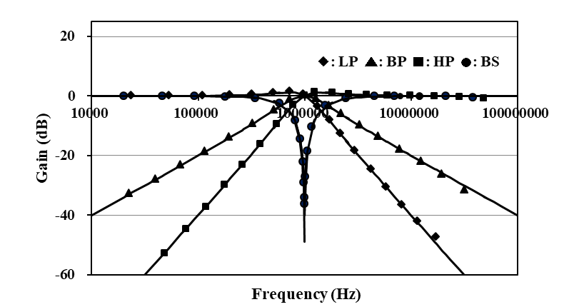
(a)
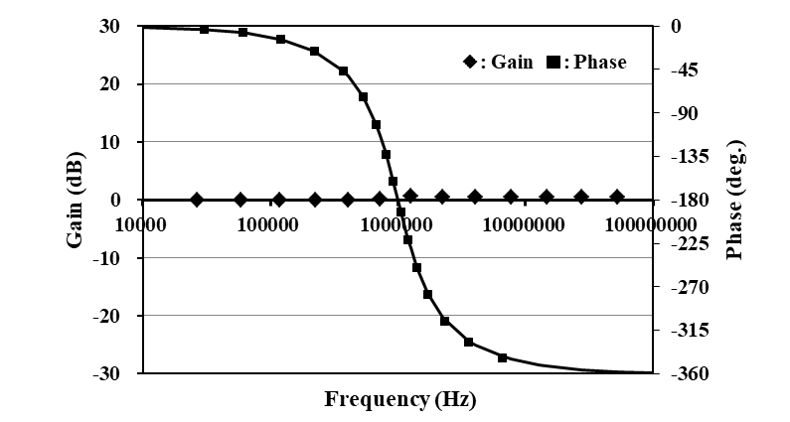 (b)
Figure 6: Simulation responses
(current-mode circuit)
In order to achieve the specification above, we set the bias currents of the OTAs I_{b1}=I_{b2}=I_{b3}=I_{ba}=I_{bb}=38μA and capacitors C₁=C₂=16pF, respectively.
Figure 6 shows the simulation responses. Figure 6 (a) shows the LP, BP, HP and BS responses, and the AP response is shown in Fig.6 (b). This can be viewed as an excellent result over a wide frequency range. Here we set the input current, DC supply voltages and the bias current of the CF as I_{in}=10μA, V_{DD}=-V_{SS}=1.2V and I_{b}=40μA. The power dissipation was 1.40mW, while it was 1.44mW in the AP response.
In the following, we considered to achieve a voltage-mode circuit with same specification as the current-mode one. We set the input voltage V_{in}=10mV, and the bias currents and the supply voltages were same as the current-mode circuit.
Figure 7 shows the simulation responses. We can see that the simulation responses are good enough over a wide range of frequencies. The power dissipation was same as the current-mode one.
In this simulation, we set the MOS transistor’s aspect ratios W/L=4μm/2μm in the OTAs, while it was W/L=20μm/0.5μm (M1 to M4) and W/L=4μm/2μm (others) in the CF. And we used device parameters of MOSIS 0.5μm for other parameters.
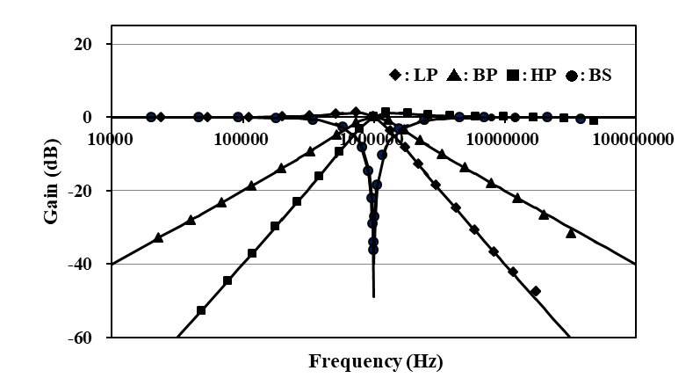
(a)
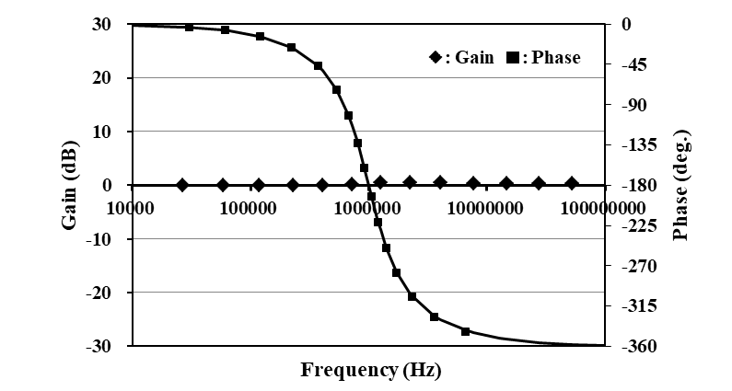
(b)
Figure 7: Simulation responses
(voltage-mode circuit)

5. Conclusion
This paper has described a universal biquadratic circuit employing only plus current output devices (OTAs and CF). The circuit can achieve five standard circuit responses (i.e. LP, BP, HP, BS and AP responses) by selecting and adding the circuit currents with no component matching constraints. The circuit parameters ω₀ and Q can be set orthogonally by the bias currents of the OTAs. Moreover it has been made clear that the biquadratic circuit enjoys very low sensitivity to the circuit components. In addition voltage-mode biquadratic circuit has been presented utilizing the basic current-mode one. The achievement examples have been given together with simulation results by PSPICE. The simulation responses have been appropriate enough over a wide frequency range.
The biquadratic circuit has several advantages concerning the wide band operation, low power dissipation and electronic adjusting of the circuit parameters, etc. The circuit configuration is very suitable for implementation in CMOS technology.
The non-idealities of the OTA and CF affect the circuit performances. The solution for this will be discussed in the future.

References
- A. Fabre, et al., “High frequency applications based on a new current controlled conveyor,” IEEE Trans. Cir. Syst., vol.43, no.2, pp.82-91, 1996.
- S.H. Tu, et al, “Novel versatile insensitive universal current-mode biquad employing two second-generation current-conveyors,” Int. J. Electron., vol.89, no.12, pp.897-pp.903, 2002.
- H.O. Elwan, A.M. Soliman, “Novel CMOS differential voltage current conveyor and its applications,” IEE Proc. Cir. Dev. Syst., vol.144, no.3, pp.195-200, 1997.
- T. Tsukutani, et al., “Novel current-mode biquadratic circuit using only plus type DO-DVCCs and grounded passive components,” Int. J. Electron., vol.94, no.12, pp.1137-1146, 2007.
- E. Sanchez-Sinencio, R.L. Geiger, “Generation of continuous-time two integrator loop OTA filter structures,” IEEE Trans. Cir. Syst., vol.35, no.8, pp.936-946, 1988.
- Y. Sun, “Note on two integrator loop OTA-C configurations,” Electron. Lett., vol.34, no.16, pp.1533-1534, 1998.
- Y. Tao, J.K. Fidler, “Electronically tunable dual-OTA second-order sinusoidal oscillators/filters with non-interacting controls: a systematic synthesis approach,” IEEE Trans. Cir. Syst., vol.47, no.2, pp.117-129, 2000.
- D.R. Bhaskar, et al., “New OTA-C universal current-mode/trans-admittance biquads,” IEICE Electron. Exp., vol.2, no.1, pp.8-13, 2005.
- M.T. Abuelma’atti, et al., “A novel mixed-mode OTA-C universal filter,” Int. J. Electron., vol.92, no.7, pp.375-383, 2005.
- T. Tsukutani, et al., “Current-mode biquad using OTAs and CF,” Electron. Lett., vol.39, no.3, pp.262-263, 2003.

