# SIGN LANGUAGE TRANSLATOR WITH THE USE OF CONVOLUTIONAL NEURAL NETWORK

**ABSTRACT:**

Communicating with people who have hearing and speaking disability is always a crucial task. Since people with hearing and speech loss used hand gestures to communicate, people have difficulty in understanding their language from the signals and gestures they make. As a result, a communication gap exists between normal people and the impaired community because understanding sign language is complex task for a normal person. Therefore, the impaired people have always faced difficulties in communicating with a normal person. Through this research, we have proposed a deep-learning approach Convolutional Neural Network (CNN) is used to detect sign- language, which can remove the barrier that has been built.

# INTRODUCTION:

The foremost requirement for social survival is communication. Deaf and dumb people use sign language to communicate with one another, but it is difficult for people to understand them. To address the issue, the Convolutional Neural Network(CNN) extended version of the Neural Network is used. It is transformed through a network of 5 layers one input layer, a series of interconnected convolution layers and a pooling layer for feature extraction, a fully connected layer, and an output layer for classification. The American Sign Language (ASI) dataset trains the model to identify the hand gesture. The dataset contains both right-hand and left-hand gestures to identify the input gesture. The Convolutional Neural Network train model is used to identify the gesture and translate the sign from the video frame using Open-CV. We have also used Media pipe, a Python library used to detect face and hand landmarks, and it also allows developers to build world-class MLsolutions.

The goal of this paper is to use the corresponding gesture to identify the sign language in American Sign Language. We have done this using gestures from photographs (which can be accessed through webcam) and not using high-end technology like gloves or Kinect and then we have used computer vision and machine learning techniques to extract features and classify them.

# METHODOLOGY:

Modern technology is very complex but capable of helping the deaf and hard of hearing. We have proposed a model that can grasp sign language and uses the Convolutional Neural Network. The predicted alphabet will be shown in real time when sign language is detected using a webcam. The model can also be used for other varieties of sign.

We have used the Keras and TensorFlow machine learning Framework to train the CNN Model. The dataset is taken from Kaggle, which includes all 26 alphabets (A- Z) hand gestures of both hands.

* 1. Data Collection and Preprocessing

Data Collection is the commencing stage of the proposed system, and in preprocessing, all the images that are present in the dataset are pre-processed. Then, we do image resizing and colouring, and now we detect the hand gesture using the Python Mediapipe and OpenCV library. Specifically, the MeidaPipe library is used for object detection and detecting hand gestures.

* 1. Model Building

In this paper, we used the CNN model to detect the static images, and we used CNN because it gave accurate results on the classification and detection tasks. While building neural network, the main objective was to define the input layer. We translate the data into a computer-readable format by converting the image into a series of numbers. The input layer captures the gesture, and then the neural

network hidden layers process it. The first hidden layer is made up of nodes which receive an input, and then that input is passed through an activation function known as a Rectified Linear unit or ReLU. The ReLU will produce 0 when the input is negative but will not change the input. The ReLU's outputs will be input for the next hidden layer

* 1. Model Training

For training the model, firstly need to compile the CNN model. To compile the model, we used compile functions, and after completion of the compile model, we train the model using a training dataset. For training, we used the fit method and train the model using 20 epochs and got a good accuracy after training the model with 20 epochs.

* 1. Real-time Prediction

After fully training the CNN model with the dataset then we save the model for real-time prediction. In real-time prediction, the webcam captures the hand position, analyses the hand position with the media pipe and opencv, and gives them into the train model. Then, the train model finds the best match with the given sign and the dataset sign. The model predicts the sign that best fits the given sign.

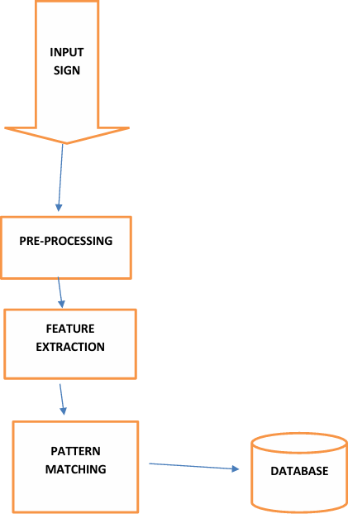

Fig 1 depicts the block diagram representation of workflow of Sign Language Translator

# CONCLUSION:

Sign Language Translation in Python helps in successfully recognizing and interpreting sign language through computer vision techniques and machine learning algorithms, and I have created a project that can understand and translate sign language into text. It opens the door for better communication accessibility for deaf and hard-of-hearing communities and bridges the communication gap in our society. This tool enables the deaf and dumb community to express their thoughts, feelings and wants so that they can participate in social activities.

# FUTURE SCOPE:

In future work, we will propose a system that can be developed and implemented using Raspberry Pi. Image Processing should be improved, and it will include basic human gestures like (hello, bye, thank you, and hi) and translate the signs with human emotions like (sad, happy, angry).

Wider implementation of sign language translation will become more widespread, integrating into everyday use and devices like platforms and smartphones.

# REFERENCES

1. Brownlee, J. (2017). Long Short-Term Memory Networks With Python. Machine Learning Mastery. Cheng, C. and Jackson, M. (2016). Python. Somerville, Mass.: Candlewick Press. Fabio Nelli (2015).
2. Python data analytics : data analysis and science using pandas, matplotlib and the Python programming language. Berkeley, Ca: Apress. Kaggle.com. https://[www.kaggle.com/datasets/ramisashararnidhi/emotion-dataset](http://www.kaggle.com/datasets/ramisashararnidhi/emotion-dataset) LavračN. (2002).
3. Machine learning : ECML 2002 : 14th European Conference on Machine Learning, Cavtat-Dubrovnik, Croatia, September 22-26, 2002 :

proceedings. Berlin ; New York: Springer. Strobel, G., Thorsten Schoormann, Banh, L. and Frederik Möller (2022).

1. Artificial Intelligence for Sign Language Translation – A Design Science Research Study. Communications of the Association for Information Systems, 52(1), pp.42–64.
2. Strobel, G., Thorsten Schoormann, Banh, L. and Frederik Möller (2022). Artificial Intelligence for Sign Language Translation – A Design Science Research Study. Communications of the Association for Information Systems, 52(1), pp.42–64. doi:https://doi.org/10.17705/1cais.05202.
3. abed sultan (2022). Sign Language Translation with ML (98% accuracy).