Analyzing of Vibration Characteristics in Timoshenko and Bernoulli Circular Beams Using Ansys Workbench

Mansoor Ali Ismail

*Department of Mechanical Engineering, University of Technology- Iraq, Baghdad, Iraq*

*ABSTRACT: Free and forced vibration analyses in Timoshenko and Bernoulli circular beams of fixed-free and simply supported* *ends have been presented in this work using Ansys workbench. Modal analysis has been used to evaluate the natural frequencies and mode shapes, while harmonic analysis has been used for forced vibration case. The forced excitations used in the analysis are vertical harmonic force of 750 N amplitude and harmonic torque of 500 N.mm amplitude. The forced excitations are applied at free end in fixed-free beam, and at mid-span in simply supported* *beam. Results of harmonic analysis show that maximum displacement, velocity, and acceleration of vibration are occur at the natural frequency that produce mode shape in the same direction of the excitation disturbance. Also the results show that to eliminate the effect of forced vibration at resonant frequency, the location of external excitation must be applied at the vibration nodes (zero vibration locations).*

***KEY WARDS:*** *Beam Vibration, vibration characteristics, circular Beam, Ansys workbench.*

---------------------------------------------------------------------------------------------------------------------------------------

Date of Submission: xx-xx-xxxx Date of acceptance: xx-xx-xxxx

---------------------------------------------------------------------------------------------------------------------------------------

# INTRODUCTION

Vibration is one of the important phenomena occurs in may mechanical applications and may cause a damage in mechanical components. Vibration of any system can be studied by mode analysis using modal expansion method for simple structures and FEM for complex structures. In beams, there are many studies presented to evaluate vibration results and dynamic behavior. Abrate [1] introduced simple formulas for prediction of fundamental natural frequency in non-uniform beams with a general shape and arbitrary boundary conditions by Rayleigh-Ritz method. Dynamic response analysis in circular Timoshenko beam had been presented by Lin and Lee [2] using closed form solutions with applying general elastic boundary conditions. Kang et al. [3] studied in-plane free vibration of curved circular beam using a symmetric approach. Chen [4] investigated free vibration in circular curved beam using the differential transform method. Rensburgand and Merweb [5] presented a systematic approach to solve the eigenvalue problems associated with the uniform Timoshenko beam model by finite element method FEM. Wang et al [6] utilized the principle of wave-train closure to evaluate natural frequencies and mode shapes in simply support and cantilever beams subjected to sinusoidal force, depending on the reflected wave nature at the beam boundaries. Yang et al. [7] investigated free vibration in uniform and non-uniform curved beams by FEM using the extended-Hamilton principle with taking into account the effects of shear deformation, rotary inertia, and axis extensibility. Kim et al [8] studied the out of plane vibration in thin curved beam using a finite thin circular beam element. The effects of torsional and transverse rotary inertia, as well as transverse shear deformation can be considered totally or partially in this method.

In 2011, Sedighi et al [9] presented a new analytical method for analyzing nonlinear vibration and obtain dynamic behavior in cantilever beam subjected to nonlinear boundary conditions. Ozturk [10] used finite element and reversion methods to analyze free vibration in cantilever curved beams using straight-beam element approach. Mahmoud et al. [11] applied the differential transformation method for the free vibration analysis of E-B (Euler Bernoulli) beams with uniform and non-uniform cross-sections. Abdelghany et al [12] studied free vibration in Euler-Bernoulli beam of variable cross section using differential transformation method. They proved the validity of their proposed method by compare the results with previous dependent results. Korabathina and Koppanat [13] developed the “coupled displacement field method” to calculate the fundamental frequency of Timoshenko beam which reduces the computational efforts compared with the other methods. Lv et al. [14] introduced an approach for free vibration analysis in multi-span curved Timoshenko beam by combining the Rayleigh-Ritz and improved Fourier series methods, with applying general elastic boundary conditions. Baxy and Sarkar [15] studied free vibration in curved beams of circular cross section using both FEM and analytical method for cantilever and simply supported beams. They proved that finite element and analytical solutions are close up to an opening angle (angle between beam ends measured from curve center) of 40˚. Liu and Zhu [16] presented an approach for formulation of wave propagation, vibration, and static problems in circular Timoshenko beam based on finite element models using Hamilton's principle. Hull and Perez [17] proposed an analytical method for frequency response in high frequency circular beams of T-shaped cross-section, utilizing exponential and Bessel functions to solve the resulting differential equations. Domagalski [18] presented a method to analyze free vibration in simply supported beams of variable mechanical properties and cross section along beam axis in periodic manner using classical Timoshenko and Euler beam theories. Lellep and Lenbaum [19] investigated free vibration in stepped nano-beam made of nano-materials with crack-like defects. Vibration results have been obtained using non-local theory of elasticity introduced by Eringen. Neamah et al [20] employed high shear deformation, Timoshenko, and Euler theories to study free vibration in functionally-graded beam of variable mechanical properties in thickness direction using Hamilton principle.

# MATERIAL AND METHODS

***2.1 Free and forced vibration:***

Free and forced vibration analysis in uniform beam can be covered by the following generalized equation [21]:

$EI\frac{∂^{4}y(x,t)}{{∂x}^{4}}+ρA\frac{∂^{2}y(x,t)}{{∂x}^{2}}=F(x,t)$………………………….............(1)

Where $E$ and $ρ$ are modulus of elasticity and density of beam material respectively, $I$ and $A$ are area moment of inertia and cross-sectional area of beam, $F$ is the external disturbance force applied at an axial distance (x) and time (t), and $y$ represents beam deflection in the same direction of force. To obtain eigen values and eigen vectors from Eq. 1, $F(x,t)$ must be substituted as zero (free vibration case).

To solve Eq. 1 in forced vibration case, $y(x,t)$ must be substituted as follows:

$y\left(x,t\right)=\sum_{n=1}^{∞}{y_{n}\left(x\right) q_{n}(t) }$…………………………...…………............. (2)

Where $y_{n}\left(x\right)$ is the nth normal mode and $q_{n}(t)$ is the generalized coordinate for nth mode.

For cantilever (fixed-free) beam, the boundary conditions at fixed end (x=0) and free end (x=L) are:

$deflection=y\left(0,t\right)=0$………………………………………….............(3)

$slope = \frac{∂y\left(0,t\right)}{∂x}=0$……………………………………………….............(4)

$Bending moment= EI\frac{∂^{2}y(L,t)}{{∂x}^{2}}=0$….………………………….............(5)

$Shear force= EI\frac{∂^{3}y(L,t)}{{∂x}^{3}}=0$………………………………….............(6)

While in simply supported beam, the boundary conditions are:

$y\left(0,t\right)=y\left(L,t\right)=0$……………………………………………….............(7)

$EI\frac{∂^{2}y(0,t)}{{∂x}^{2}}= EI\frac{∂^{2}y(L,t)}{{∂x}^{2}}=0$……………………………………….............(8)

Eq. 1 can be solved numerically using programmed FEM for both free and forced vibration cases under the applied boundary conditions.

***2.2 Finite Element method***

Finite element analysis (FEA) is one of the most effective methods used widely in last decades in various mechanical problems as a result of its flexibility, reliability and short executed time when programed. FEA based on the principle of discrete problem domain into a suitable number of sub-domains known as elements. The governing problem equations are applied at each element or node, and the final solution will be obtained by combine all elements or nodal equations in suitable manner depending on problem nature. FEM has an ability to solve linear, nonlinear and complex problems efficiently using many software applications in computer [22].

Ansys Workbench will be used in this paper as a programmed finite element utilizing modal analysis and harmonic analysis fields. From modal analysis, natural frequencies and mode shapes can be evaluated for any number of modes. While harmonic analysis gives the values of displacement, velocity, and acceleration of vibration under harmonic forced vibration. Knowing that there are infinity number of modes in beam since it is a rigid body.

***2.3*** ***Studied Cases***

Two cases are studied in the present analysis. The first is fixed-free circular beam subjected to two loading cases (vertical harmonic force and harmonic torque applied at free end). The second case is circular beam of simply supported ends subjected to the same loading conditions (vertical harmonic force and harmonic torque) but applied at beam mid-span. The diameter of beam specimens used in the analysis is 50 mm with 300 mm length (L). The amplitude of the applied force in all studied cases is 750 N, while the torque amplitude is 500 N.mm.

Fig. (1) shows the studied specimen that meshed in Ansys workbench. The total number of elements is 8241 with 37122 nodes. Beam material used in the analysis is structural steel of 250 MPa yield strength, 460 MPa ultimate tensile strength, 7850 Kg/m3 density, 200 GPa elasticity modulus, and 0.3 poison’s ratio.

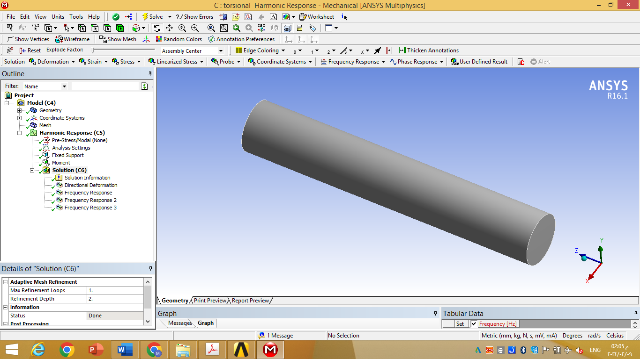

(a) Beam Specimen

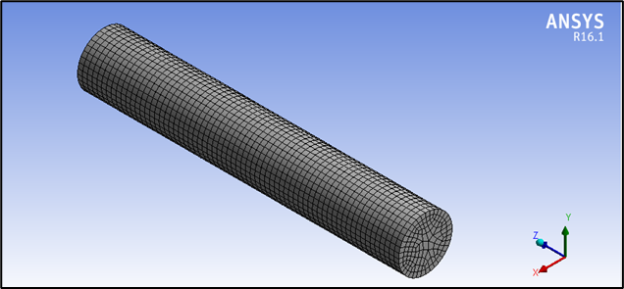

(b) Meshed Beam

**Figure 1: Circular beam modeled in Ansys workbench.**

# RESULTS AND DISCUSSIONS

***3.1*** ***Free Vibration Results***

Fig. (2) shows modal analysis results for the first six modes of fixed-free beam. The first mode shown in Fig. (2a) has only one wave of vibration in vertical direction. The second mode is similar to the first mode, has one wave only but in horizontal direction as illustrated in Fig. (2b). The natural frequencies of the first and second modes are of the same value (approximately) due to circular cross section of beam. Fig. (2c) and (2d) show the third and fourth modes. The third mode has two waves in vertical direction with one vibration node (zero vibration location) near the free end. The fourth mode also has two waves but in the horizontal direction with one vibration node near the free end. Fifth mode belong to torsional vibration, while the sixth mode related to axial vibration as shown in Fig. (2e) and (2f). Table (1) shows the resulting natural frequencies of the first sixth modes in fixed-free circular beam.

(a) 1st mode

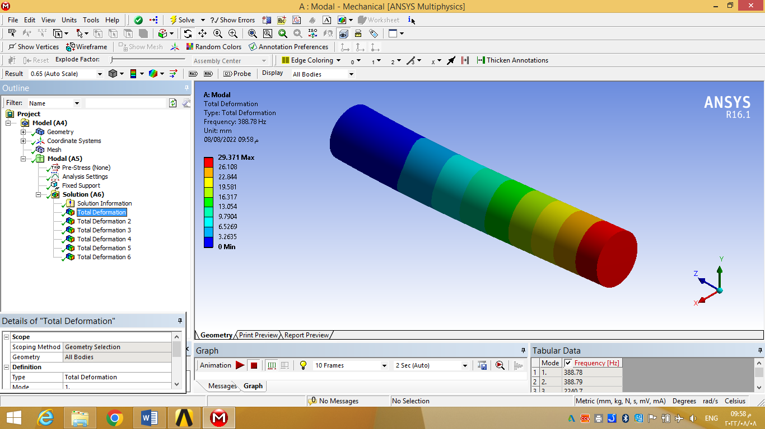

(b) 2nd mode

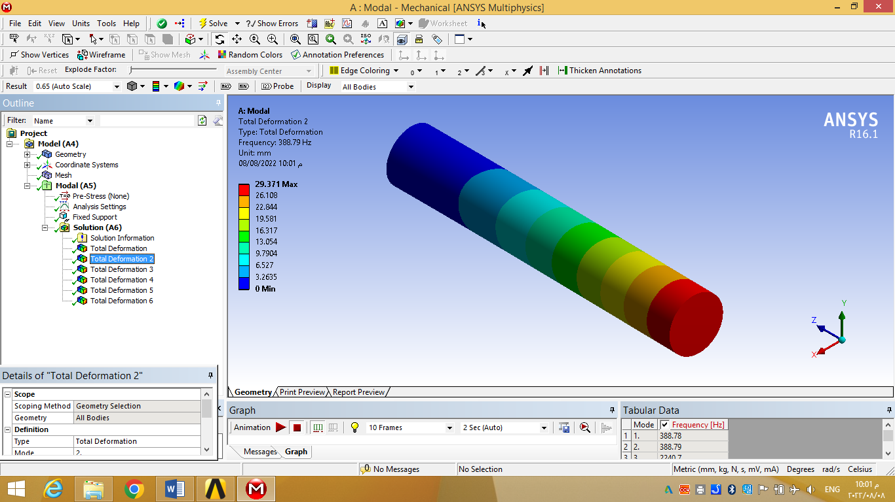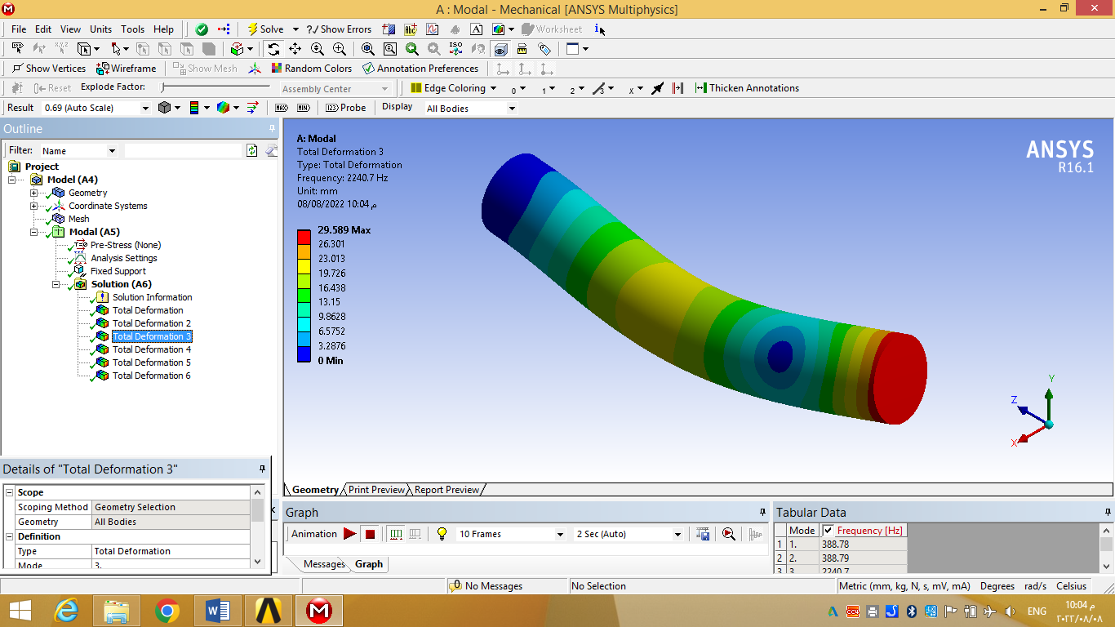

(c) 3rd mode

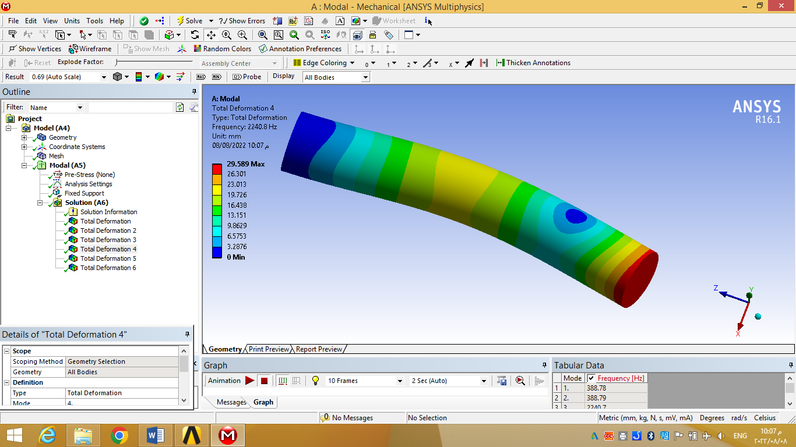

(d) 4th mode

(e) 5th mode

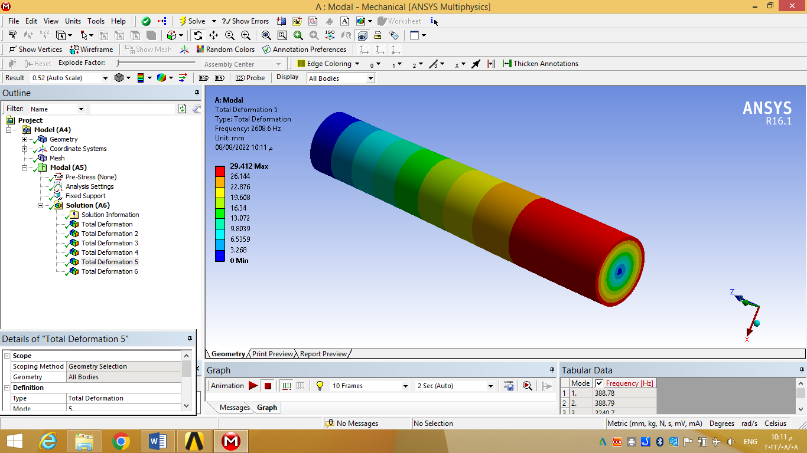

(f) 6th mode

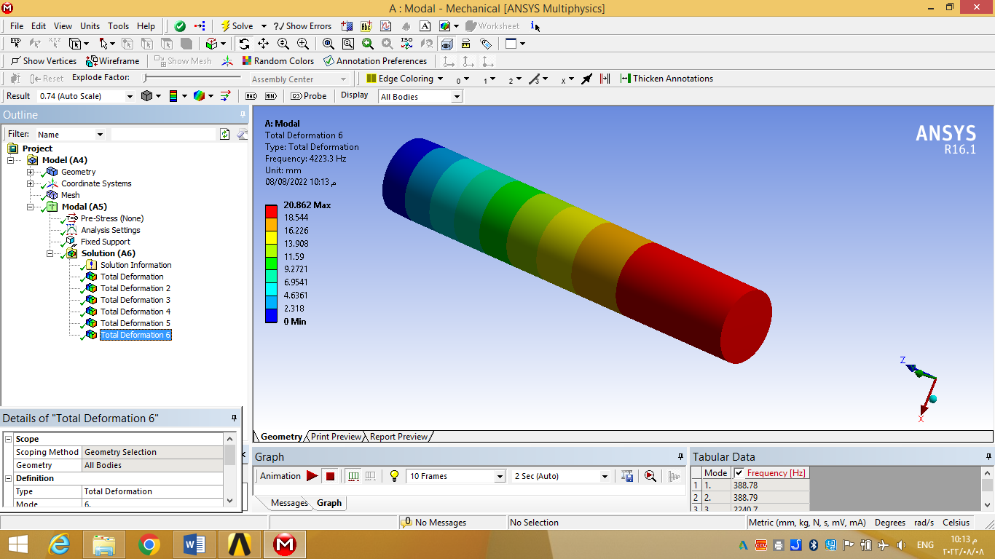

**Figure 2. Modal analysis of fixed-free circular beam (first sixth modes).**

**Table -1 Natural frequencies in fixed-free beam (first sixth modes).**

|  |  |
| --- | --- |
| **Mode Number** | **Natural Frequency, Hz** |
| **1** | **388.78** |
| **2** | **388.79** |
| **3** | **2240.7** |
| **4** | **2240.8** |
| **5** | **2608.6** |
| **6** | **4223.3** |

Results of modal analysis for the first sixth modes in the same beam when both ends are supported (simply supported ends) are shown in Fig. (3). The results can be summarized as follows: first and second modes are one wave vibration in vertical and horizontal (lateral) directions, respectively. Third mode related to torsional vibration, while the fourth and fifth modes have two waves of vibration in vertical and horizontal directions, respectively with one vibration node at beam mid-span. Finally, the sixth mode is related to axial vibration. Table (2) shows the resulting natural frequencies of the first sixth modes in simply supported circular beam.

(a) 1st mode

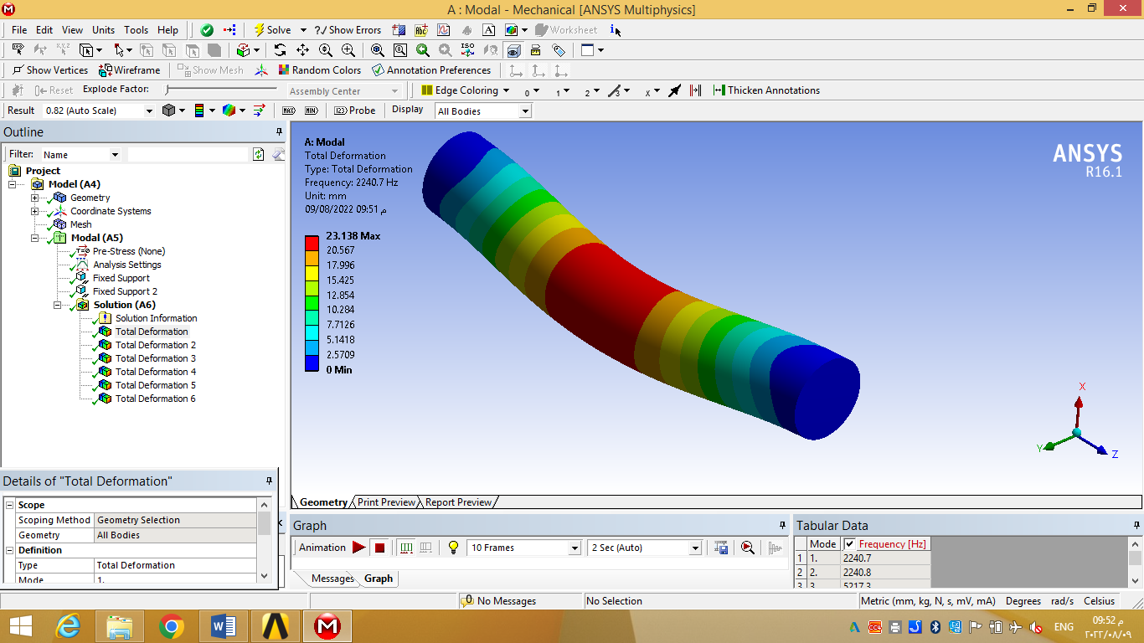

(b) 2nd mode

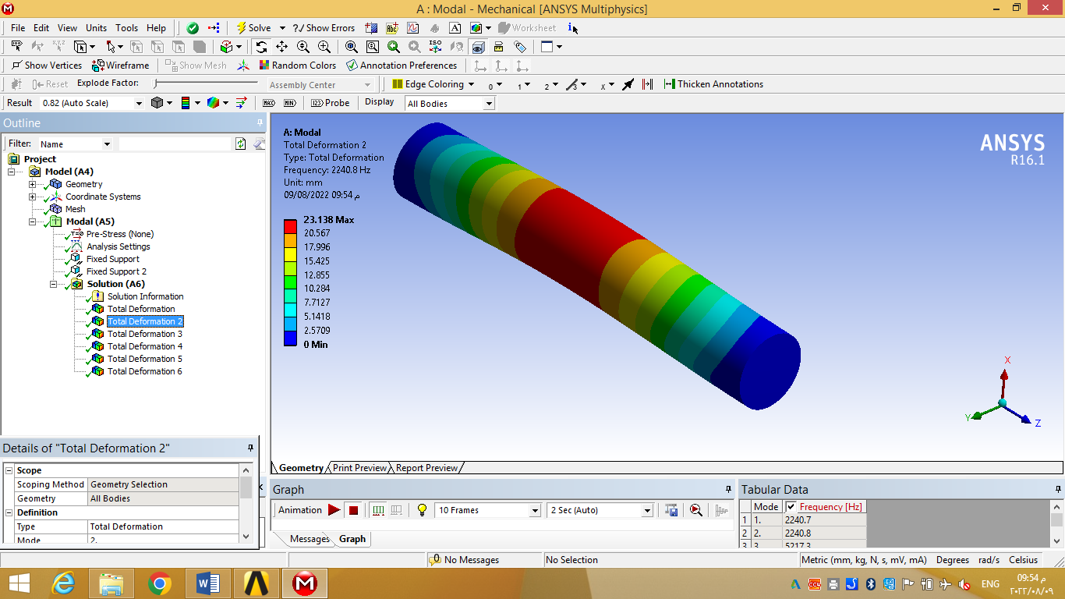

(c) 3rd mode

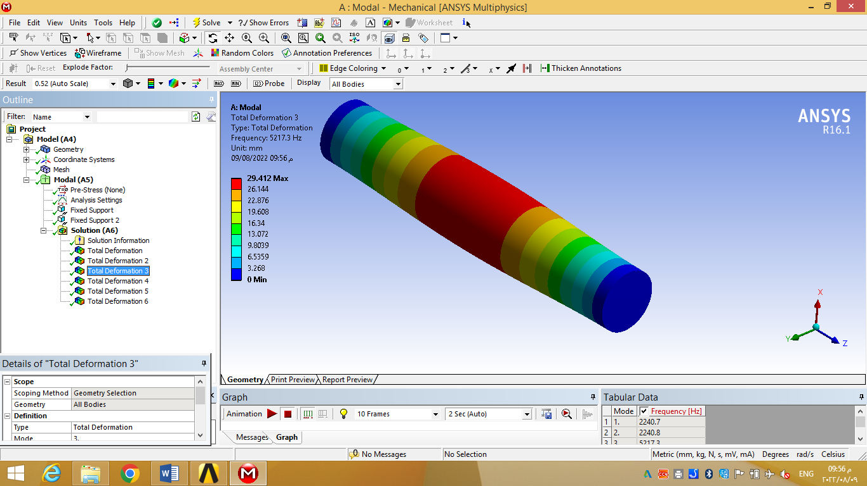

(d) 4th mode

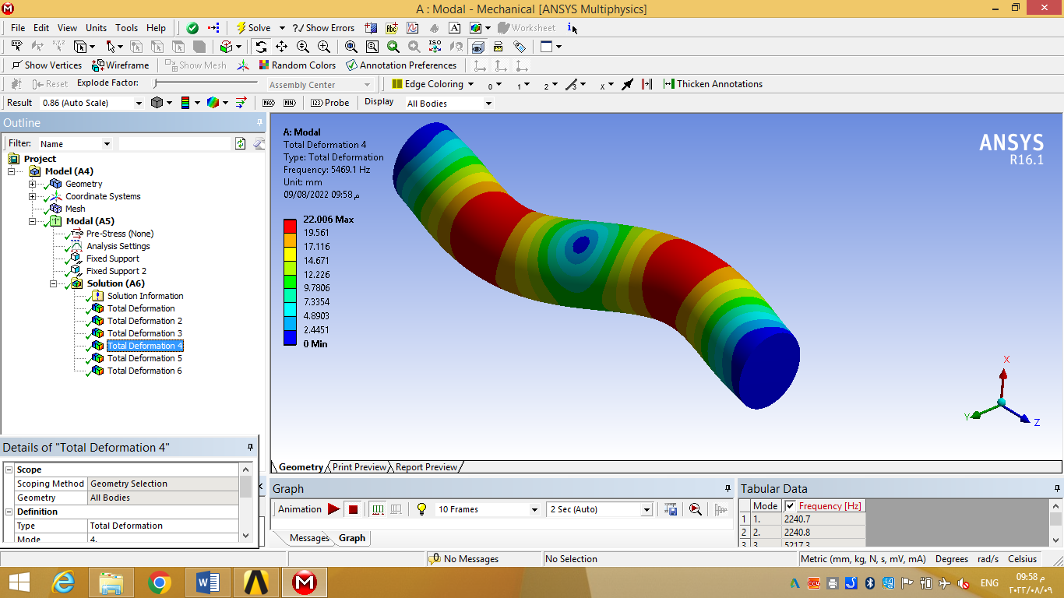

(e) 5th mode

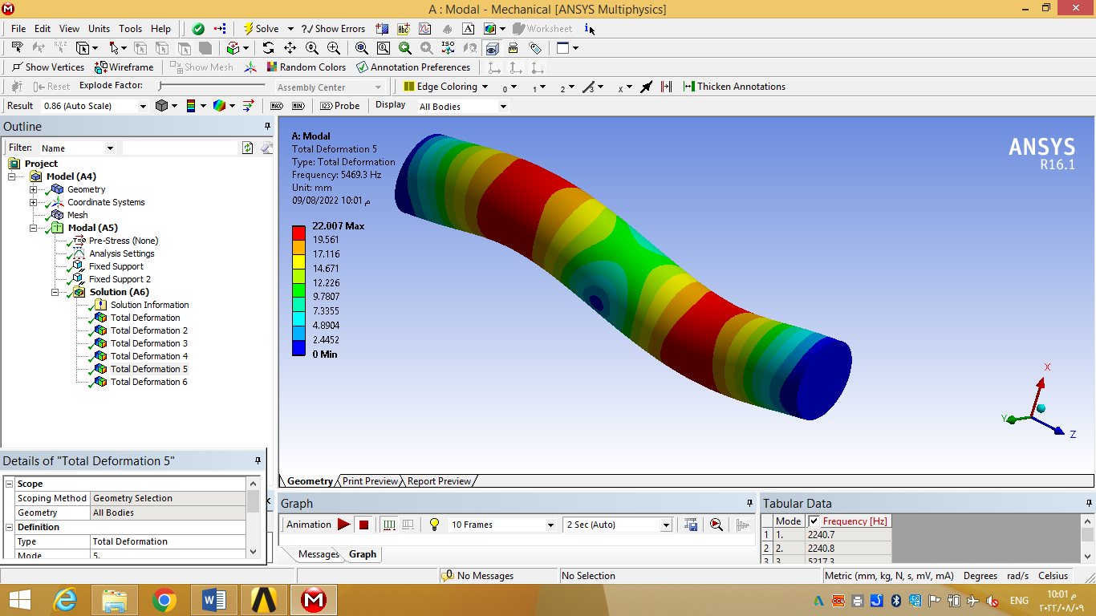

(f) 6th mode

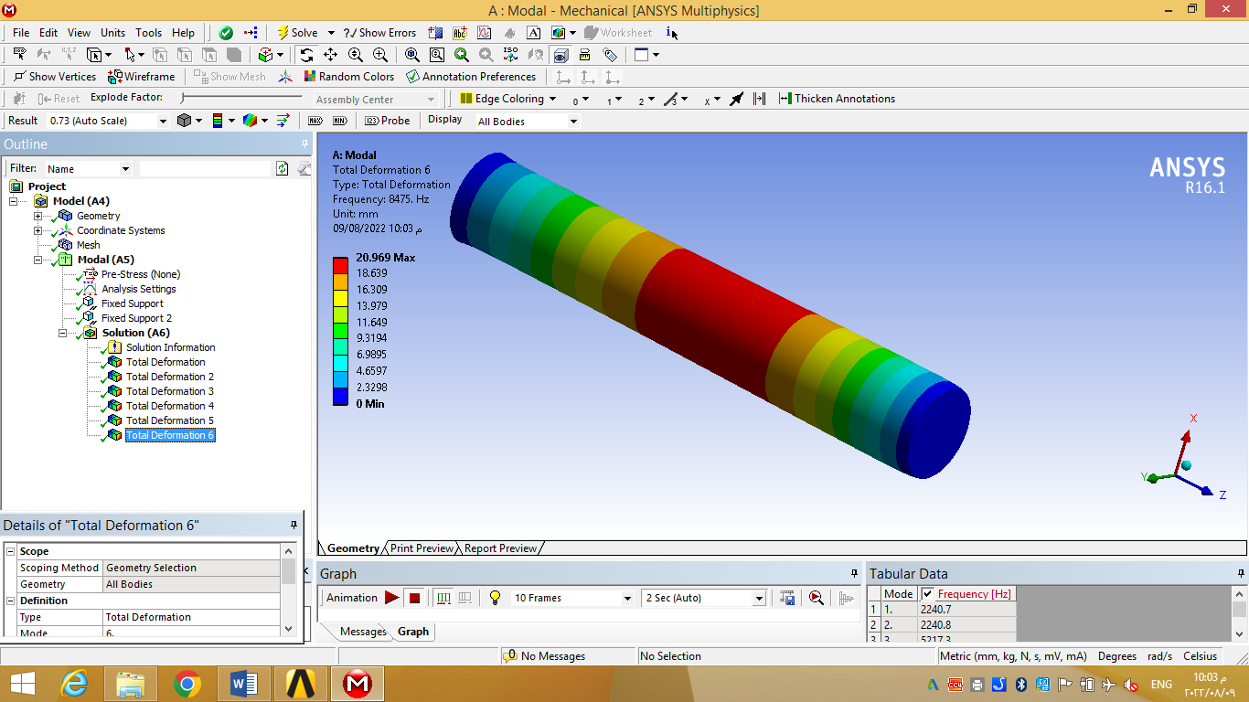

**Figure 3. Modal analysis in simply supported circular beam (first sixth modes).**

**Table -2 Natural frequencies in simply supported circular beam (first sixth modes).**

|  |  |
| --- | --- |
| **Mode** | **Natural Frequency, Hz** |
| **1** | **2240.7** |
| **2** | **2240.8** |
| **3** | **5217.3** |
| **4** | **5469.1** |
| **5** | **5469.3** |
| **6** | **8475** |

***3.2*** ***forced vibration Results***

Results of forced vibration in fixed-free circular beam under the action of harmonic force (750 sin(ωt) Newton) applied at free end under the frequency range from 0 to 4500 Hz are shown in Fig. (4). Fig. (4a) shows that maximum vibrational displacement in the beam occurs at first natural frequency (388.78 Hz) as a result of resonance case in vertical direction. While at the 3rd natural frequency (2240.7 Hz) the vertical vibrational displacement in the beam doesn’t reach to a maximum value although this mode is in vertical direction as a result of existence vibration node near the free end. Fig. (4b) shows the results of vibrational velocity which has a behavior similar to vibrational displacement for the same reasons. Results of vibration acceleration are shown in Fig. (4c), with a maximum value at third natural frequency. Fig. (5) shows the results of vibration in fixed-free beam under the action of harmonic torque of (500 sin(ωt) N.mm) applied at free end. From this figure it can be noted that maximum vibrational displacement, velocity, and acceleration are occurred at fifth natural frequency (2608.6 Hz) which belongs to torsional vibration as a result of resonance with torsion load excitation.

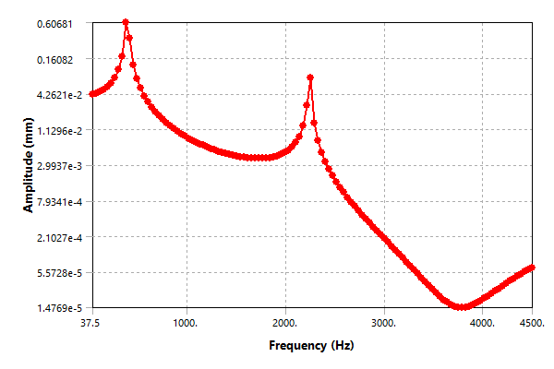

**Figure 4a. Vertical displacement of vibration versus forced frequency in fixed-free circular beam under vertical harmonic force.**

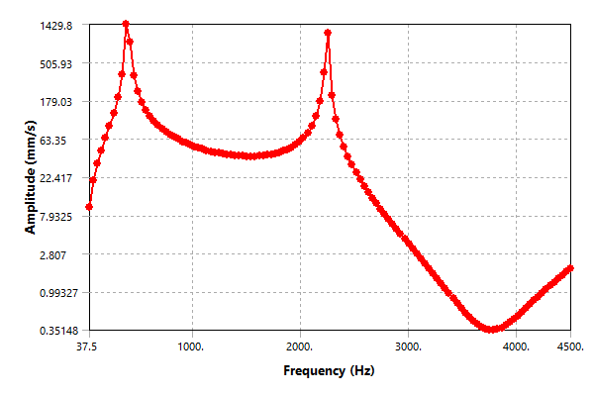

**Figure 4b. Vertical vibration velocity versus forced frequency in fixed-free circular beam under vertical harmonic force.**

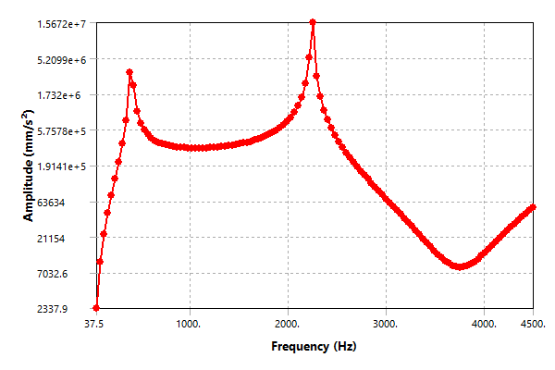

**Figure 4c. Vertical acceleration of vibration versus forced frequency in fixed-free circular beam under vertical harmonic force.**

**Figure 5a. Vertical displacement of vibration versus forced frequency in fixed-free circular beam under harmonic torsional load.**

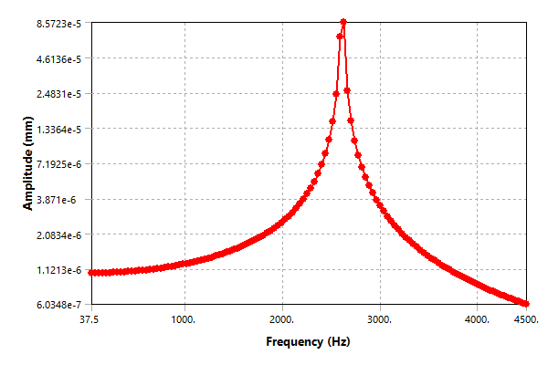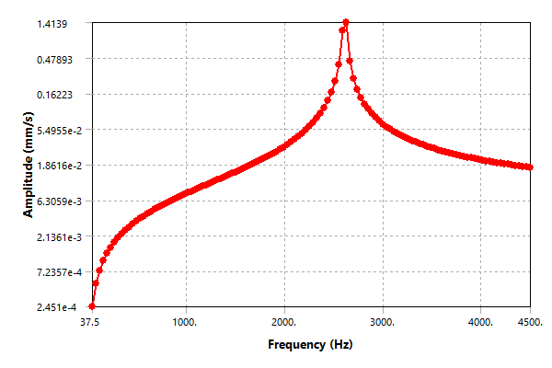

**Figure 5b. Vertical velocity of vibration versus forced frequency in fixed-free circular beam under harmonic torsional load.**

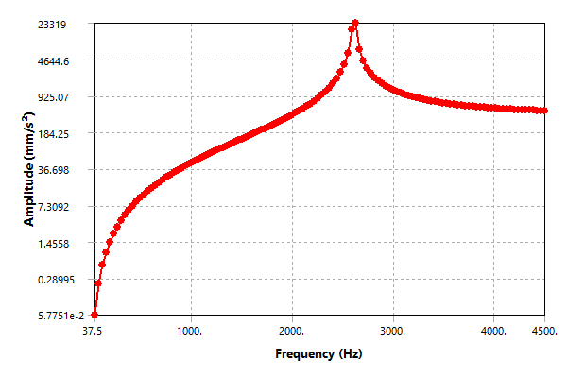

**Figure 5c. Vertical acceleration of vibration versus forced frequency in fixed-free circular beam under harmonic torsional load.**

Results of forced vibration in simply supported beam under the action of harmonic force (750 sin(ωt) Newton) applied at beam mid-span under the frequency range from 0 to 8500 Hz are shown in Fig. (6). Fig. (6a) shows that at first natural frequency (2240.7 Hz) the beam attains maximum vibrational displacement in vertical direction due to resonamce phenomena of external excitation force with first natural frequency which belongs to vibration in vertical direction. It is noted from this figure that the resonance phenomena doesn’t occurs at the natural frequency of fourth mode (mode of two vibration waves in vertical direction) because the excitation force applied exactlly at the vibration node (location of zero vibration) at this frequency.

Figs. (6b) and (6c) show the results of vibrational velosity and vibrational acceleration which have a behaviour similar to vibrational displacement for the same mentioned reasons. Finally, Fig. (7) shows the results of forced vibration in simply supported beam under the action of harmonic torque of (500 sin(ωt) N.mm) applied at beam mid-span. It is obvious from this figure that maximum vibrational displacement, velosity, and acceleration are occur at third natural frequency of 5217.3 Hz (frequency of torsional mode) due to resonance case with torsion load.

**Figure 6a. Vertical displacement of vibration versus forced frequency in simply supported circular beam under vertical harmonic force.**

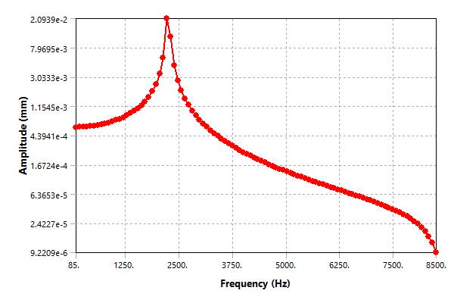

**Figure 6b. Vertical velocity of vibration versus forced frequency in simply supported circular beam under vertical harmonic force.**

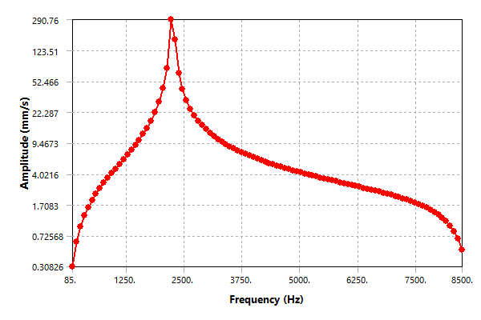

**Figure 6c. Vertical acceleration of vibration versus forced frequency in simply supported circular beam under vertical harmonic force.**

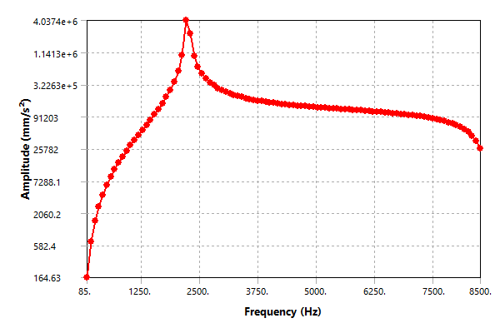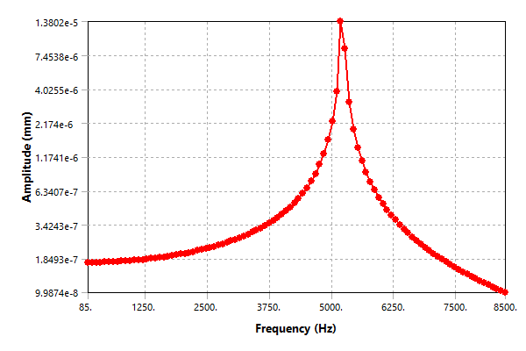

**Figure 7a. Vertical displacement of vibration versus forced frequency in simply supported circular beam under harmonic torsional load.**

**Figure 7b. Vertical velocity of vibration versus forced frequency in simply supported circular beam under harmonic torsional load.**

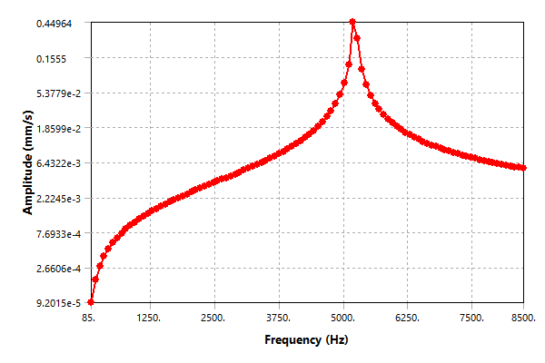

**Figure 7c. Vertical acceleration of vibration versus forced frequency in simply supported circular beam under harmonic torsional load.**

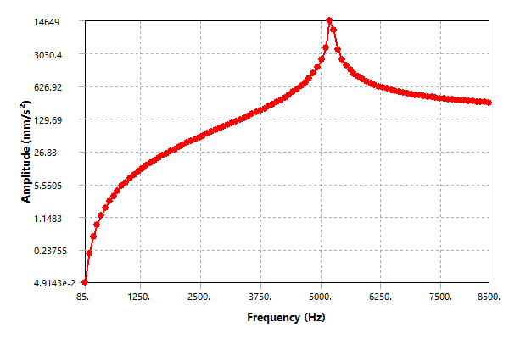

# CONCLUSIONS AND RECOMMENDATIONS

The conclusions that can be drawn from this work are summarized as follows:

1. To study forced vibration in any system, it is important to evaluate all natural frequencies and mode shapes up to the forced frequency of the external excitation.
2. The mode shapes and natural frequencies in vertical and lateral directions are of same values due to symmetry condition in circular beams.
3. In fixed-free circular beam the first fourth modes are related to vertical and lateral vibration, fifth mode is torsional vibration mode, and the sixth mode represents axial vibration mode. While in simply supported beam the first, second, fourth and fifth modes are related to vertical and lateral vibration, third mode represents torsional mode, and the sixth mode is related to axial vibration.
4. In forced vibration, location of the applied external excitation must be chosen at the locations of vibration nodes (locations of zero vibration) in order to eliminate the vibration effect at resonance frequency case.
5. Maximum displacement, velocity, and acceleration of vibration are occurred at the natural frequencies that produce mode shape in the same direction of external excitation.

It is recommended to use beams of factionally graded materials to ehnance vibration characteristics and dynamic response as well as use curved beams with different curve radii to obtain an optimum curved shape helps to ehnance vibration response.

**REFERENCES**

1. Abrate, S. (1995). "Vibration of non-uniform rods and beams. Journal of sound and vibration", 185(4), 703-716. <https://doi.org/10.1006/jsvi.1995.0410>
2. Lin, S. M., & Lee, S. Y. (2001). "Closed-form solutions for dynamic analysis of extensional circular Timoshenko beams with general elastic boundary conditions". *International Journal of Solids and Structures*, *38*(2), 227-240. <https://doi.org/10.1016/S0020-7683(00)00020-2>
3. Kang, B., Riedel, C. H., & Tan, C. A. (2003). "Free vibration analysis of planar curved beams by wave propagation". *Journal of sound and vibration*, *260*(1), 19-44. <https://doi.org/10.1016/S0022-460X(02)00898-2>
4. Chen, C. N. (2005). "DQEM analysis of in-plane vibration of curved beam structures". Advances in Engineering Software, 36(6), 412-424. <https://doi.org/10.1016/j.advengsoft.2004.12.006>
5. Van Rensburg, N. F. J., & Van der Merwe, A. (2006). "Natural frequencies and modes of a Timoshenko beam". Wave motion, 44(1), 58-69. <https://doi.org/10.1016/j.wavemoti.2006.06.008>
6. Wang, X. Q., So, R. M. C., & Chan, K. T. (2006). "Resonant beam vibration: A wave evolution analysis". Journal of sound and vibration, 291(3-5), 681-705. <https://doi.org/10.1016/j.jsv.2005.06.030>
7. Yang, F., Sedaghati, R., & Esmailzadeh, E. (2008). "Free in-plane vibration of general curved beams using finite element method". Journal of sound and vibration, 318(4-5), 850-867. <https://doi.org/10.1016/j.jsv.2008.04.041>
8. Kim, B. Y., Kim, C. B., Song, S. G., Beom, H. G., & Cho, C. (2009). "A finite thin circular beam element for out-of-plane vibration analysis of curved beams". Journal of mechanical science and technology, 23, 1396-1405. DOI: 10.1007/s12206-008-1213-2
9. Hamid, M. S., Arash, R., & Jamal, Z. (2011). "Study on the frequency-amplitude relation of beam vibration". International Journal of Physical Sciences, 6(36), 8051-8056. DOI: 10.5897/IJPS11.1556
10. Ozturk, H. (2011). "In-plane free vibration of a pre-stressed curved beam obtained from a large deflected cantilever beam". Finite Elements in Analysis and Design, 47(3), 229-236. <https://doi.org/10.1016/j.finel.2010.10.003>
11. Mahmoud, A. A., Abdelghany, S. M., & Ewis, K. M. (2013). "Free vibration of uniform and non-uniform Euler beams using the differential transformation method". Asian Journal of Mathematics and Applications, 2013, 1-16.
12. Abdelghany, S. M., Ewis, K. M., Mahmoud, A. A., & Nassar, M. M. (2015). "Vibration of a circular beam with variable cross sections using differential transformation method". Beni-Suef University journal of basic and applied sciences, 4(3), 185-191. <https://doi.org/10.1016/j.bjbas.2015.05.006>
13. Korabathina, R., & Koppanati, M. S. (2016). "Linear free vibration analysis of tapered Timoshenko beams using coupled displacement field method". Mathematical Models in Engineering, 2(1), 27-33.
14. Lv, X., Shi, D., Wang, Q., & Liang, Q. (2016). "A unified solution for the in-plane vibration analysis of multi-span curved Timoshenko beams with general elastic boundary and coupling conditions". Journal of Vibroengineering, 18(2), 1071-1087.
15. Baxy, A., & Sarkar, A. (2018). "Free vibrations of circular curved beams". In MATEC Web of Conferences (Vol. 211, p. 04006). EDP Sciences. <https://doi.org/10.1051/matecconf/201821104006>
16. Liu, M., & Zhu, W. D. (2019). "Modeling and analysis of in-plane and out-of-plane elastic wave propagation in a phononic-crystal circular beam". Journal of Sound and Vibration, 462, 114886. <https://doi.org/10.1016/j.jsv.2019.114886>
17. Hull, A. J., & Perez, D. (2019, March). "A high-frequency model of a circular beam with a T-shaped cross section". In Acoustics (Vol. 1, No. 1, pp. 295-336). MDPI. <https://doi.org/10.3390/acoustics1010017>
18. Domagalski, Ł. (2021). "Comparison of the Natural Vibration Frequencies of Timoshenko and Bernoulli Periodic Beams. Materials, 14(24), 7628. <https://doi.org/10.3390/ma14247628>
19. Lellep, J., & Lenbaum, A. (2022). Free vibrations of stepped nano-beams with cracks". Proceedings of the Estonian Academy of Sciences, 71(1), 103-116. <https://doi.org/10.3176/proc.2022.1.09>
20. Neamah, R. A., Nassar, A. A., & Alansari, L. S. (2022). "Modeling and Analyzing the Free Vibration of Simply Supported Functionally Graded Beam". Journal of Aerospace Technology and Management, 14. <https://doi.org/10.1590/jatm.v14.1257>
21. Rao, S. S. (2011). Mechanical vibrations fifth edition.
22. Geoffrey Modlen (2010). "Introduction to Finite Element Analysis", Department of Manufacturing, University of Manchester.