**Institutionalizing Industry Institute Interaction and Entrepreneurship at Higher Technical Education**

Sunil A. Bakhru

Research Scholar, G H Patel Post Graduate Institute of Business Management,

Sardar Patel University, Vallabh Vidyanagar, Gujarat, India, 388120

sabakhru97@gmail.com

Dr. Yogesh C. Joshi (Guide)

Professor and Director, Faculty of Management,

GH Patel PG Institute of Business Management,

Sardar Patel University, Vallabh Vidyanagar, Gujarat, India, 388120 [joshiyogesh_2000@yahoo.com](mailto:joshiyogesh_2000@yahoo.com)

**Abstract:**

India has more than 3000 engineering institutions under AICTE, producing more than eight lakh graduates and post graduate engineers every year. However, we have a situation in which as many as fifty percent of engineers are either not employed or are found not suitable for a job in an engineering industry. The huge number of unemployed engineers also point at the necessity of making the engineers self-reliant through the techno-entrepreneurship route. This paper describes a relatively simple framework which promises to develop an ecosystem nurturing Industry Institute Interaction and Entrepreneurship in a natural and an in-built manner, addressing the root of the problems. The initial pilot research on the proposed framework has shown very encouraging results. It is hoped that its large scale trial implementations-necessary to prove its effectiveness and sustainability will prove equally promising.

Keywords: Students’ Projects, Major Projects, Entrepreneurial Project, Engineering Academic Institutions, Marketable Product.

**1. Introduction**

India has more than 3300-degree engineering institutions producing more than 8 lakh engineers each year completing their UG or PG degree courses (2020, AICTE dashboard). The table-1 presents a summary of intake, pass-out and placed students’ data from the years 2014 to 2018, made available at the AICTE’s dashboard.

Based on the data from the table-1, following inference can be drawn:

1. A large number of the passing out engineering graduates – as many as 50% remain unemployed for a long time. This clearly suggests that the industry readiness of graduating engineers is an important issue and it needs to be addressed.  At PG level, the situation is even worse, where only about 30 percent of the students get placed at the campus interviews.

2. As a vast number of students are left unemployed, a question which is likely to arise is whether it can be possible for the industries to provide employment to all the passing out students if in case all the graduates were to be industry ready.  It is difficult to get an answer to this question as there is no study to predict the requirement of engineers at the national level. However this data clearly suggests that it is important to invoke entrepreneurial aspirations in students and to provide them basic entrepreneurial knowledge and mentoring to make them consider -seriously, entrepreneurship as an alternate career option.

Table-1: Engineering students’ data for four successive academic years 2014 – 2019

|  |  |  |  |  |  |  |
| --- | --- | --- | --- | --- | --- | --- |
| Sr.  No. | Parameter | 2014-15 | 2015-16 | 2016-17 | 2017-18 | 2018-19 |
| 1 | Total Institutions | 3488 (2328)* | 3461 (2306) | 3393 (2338) | 3326 (2138) | 3241  (2066) |
| 2 | Faculties | 4,43,924  (54,213) | 4,57,295  (54,213) | 4,54,406  (47,426) | 3,63,744  (47,426) | 3,63,744  (25,551) |
| 3 | Actual Intake -UG | 7,50,320 | 7,85,500 | 8,54,893 | 8,75,234 | 7,21,730 |
| 4 | Passed -UG | 7,38,600 | 7,98,072 | 7,87,595 | 7,60,420 | 7,48,252 |
| 5 | Placed-  UG | 3,43,291 | 3,63,796 | 3,61,888 | 3,35,418 | 3,95,735 |
| 6 | For UG (Placed / Passed) % | 46.47 | 45.58 | 45.94 | 46.47 | 52.88 |
| 7 | Actual Intake -PG | 1,22,662 | 90,299 | 69,399 | 68,696 | 66,928 |
| 8 | Passed -PG | 84,066 | 86,430 | 70,486 | 55,635 | 52,080 |
| 9 | Placed-  PG | 22,935 | 22,874 | 19,295 | 15,819 | 17,586 |
| 10 | For PG (Placed / Passed) % | 27.28 | 26.46 | 27.37 | 28.43 | 33.76 |

(* The data in brackets refers to the post-graduate cases only)

While the data above present a rather grim situation, the following discussion points at the ray of hope and also suggests a direction to address the issues just observed from the table.

Most engineering graduates and post graduates do major projects as a mandatory academic requirement for earning either a UG or the PG degree. As nearly 8 lakh students are passing out engineering studies each year, the number of such projects can actually be much larger than 100,000 even as a very conservative estimate. If it can be possible to create a mechanism through which students can conveniently take up academic projects which have the potential to be either industrially or entrepreneurially useful, and are even encouraged to work further on them for product development then such a mechanism can create a win-win partnership between industry and institutes and can also pave the way for building a promising ecosystem for nurturing entrepreneurship in young engineering graduates and post graduates.

**2. Literature Review**

In order to decide the objectives of the study, a brief literature survey is undertaken and presented below:

There have been various reports (NERE Annual Report 2019) (IUCEE ITF -2017) (Engineering Education in India – Short & Medium Term Perspectives 2018). These reports have tried to go to the root of the problems and have also suggested situations. The reports are quite unanimous in their observations and attribute the issues to insufficient discussions regarding the industry application of concepts covered in the course curriculum, nil or insufficient industry internship of students, insufficient seriousness towards searching and preparing for a truly useful major projects.

Alessandro Muscio, Giovanna Vallanti (2014). The authors have made an effort to study the factors which, to different extents, drive or hamper academics’ capabilities to engage in collaboration with the private sector. Based on their study of the original data from interviews with 197 university departments in Italy, their paper investigates the main obstacles to technology transfer activity as observed by the researchers, and its possible impact on university–industry collaborations. Parameswaran Ananthanarayanan, Basil Gnanappa, Muthamizhchelvan Chellamuthu. (2014, December), explain the engineering education system in India and need for Institute-Industry Collaboration, by identifying the different parameters to assess the effectiveness of Institute-Industry Collaboration. They have evaluated various types of Institute-Industry Collaborations, and have suggested an industrial experience resulting in research type projects. The authors describe how capstone projects satisfy the requirements for a major design experience methodology to improve the effectiveness. They also suggest a dedicated organization mechanism to coordinates amongst institutional sectors.

Robert Rybnicek, Roland Königsgruber. (2019, March). The authors present here the results of a well-organized review of the literature on the collaboration between industry and universities. An extensive analysis of research published on industry–university collaboration projects is carried out with the objective of finding factors that influence the success of such collaborations. Javier Izquierdo Reyes, Ricardo A. Ramirez-Mendoza, M. Rogelio Bustamante Bello. (2018, April 17-20), have proposed a work model to increase the interaction between undergraduate and postgraduate students in a project-management based industrial model applied to research. They demonstrate how the suggested structure helps to increase innovation, research and increase the students’ skills. The strengths of this model and the methodology to implement it have been presented.

 Chaturvedi Prateek, Dahiya Sanjeev, Agrawal Sachin. (2015), have presented a detailed work on Micro, Small and Medium Enterprises (MSMEs). MSME greatly contribute towards the national economy, employment generation, export promotion and removal of regional imbalance. The authors present their observations with evidences that these MSMEs are not operating at their fullest potential due to their technological obsolescence and suggest how the innovation at the MSMEs can be enhanced by the academic intervention to improve their performance. Bakhru, S. A., & Mehta, R. P. (2020) presents a case study of an innovative assignments based learning method where in students groups are continuously made to work on assignments based on the classroom activity of the previous week. This makes a tempting case for providing industry relevant assignments to students in collaboration with industries.

Dwivedi, A.K., Tiwari (2013) emphasize on the need for Entrepreneurship development programmes as an answer to the problem of unemployment. The author stresses that the entrepreneurs can be created and deals with the following issues of role of entrepreneurship development institutions in training the entrepreneurs in this reform era. Basu Rituparna. (2014) observes that the study of entrepreneurial aspects forms a prerequisite for management education particularly in developing economies. She advocates a compulsory initiation of entrepreneurship courses early in the curricula of contemporary business schools. She emphasizes to review the current entrepreneurship education in India to propose an effective ecosystem for integrating and promoting entrepreneurship education as fundamental to mainstream business management education in India. Panigrahi Ashok, Joshi Vijay. (2016, April-September) stress on the importance of entrepreneurship education for economic development of a country. Entrepreneurship education to reduce the increasing unemployment in developing countries pointing out that every year thousands of graduates passing out from various institutions of our country remain literate unemployed because of the lack of the required skill and ultimately become a burden for the society instead of economically contributing to the society and nation.

**3. Research Methodology Used**

To address and solve the problem under consideration- the “Impactful Research Design” has been considered appropriate. The basic building blocks of the impactful research design are as under and the justification of the research design used along with the description of each block is discussed further.





Figure 1: Building blocks for the Impactful Research Design approach

**3.1 Need for assessment of the existing teaching-learning pedagogy**

1. The present teaching learning mechanism- seems to be weak at addressing the issue of preparing industry ready engineers, as can be seen not only from the observation from AICTE website mentioned before but also as pointed out by various reports by important regulatory bodies closely monitoring higher technical education [1][2][3].

2. There is a huge potential lying untapped in the form of making good use of the intensive intellectual efforts of the students and also faculties on the major projects of the students which is also their mandatory academic requirement. If it can be possible to address this issue at the pedagogy or structural level, then a large number of these projects can be made industrially useful – which will not only make the students more confident and better prepared for the industries but will also prepare a win-win ground for the industries to get attracted to academic institutions for solving their research, innovations and development issues.

3. The present mechanism does not address the issue of preparing entrepreneurs. It is a sad sight to see so many engineers looking for jobs when they themselves could create jobs for many, with just a small additional mentoring. If students are motivated to aspire for entrepreneurial alternatives for their career and are also provided basic entrepreneurial mentoring then the problem of unemployment can actually become an opportunity – whereby a large number of students will consider entrepreneurship as a career option and creating many jobs in the process.

**3.2 Presenting a framework to provide the required intervention**

Based on the intensive study of the present teaching-learning process and literature survey, a pedagogy providing necessary interventions has been developed as follows to address and solve the issues mentioned so far. The pedagogy is presented in the form a modular framework.

Module-1: Subject Treatment with Actual Applications of Relevance (STAAR) Module: Through this module, faculties should share the syllabus of their subjects with the participating industries and invite subject relevant assignments. These assignments can then be used as a part of subject treatment and provide industry relevant assignments to students.

Module-2: Over - Lapped Industry Internships (OVL) Module: Through this module, all subject teachers can also request and invite micro, mini, medium and major project ideas from industries. The students can be made to work on such ideas and more so on the ideas of their choice at the subject lab level or at mini, medium or major project levels, even before their actual internship period, overlapping with the ongoing semester. This exercise can be greatly beneficial to the students to find and choose an industry relevant major project definition and prepare a win-win ground from which students, faculties and industries – all three can benefit.

Module-3: Continuous Assignment and Project Activity Based Learning: (CLASS-CAPABLE) Module: Under each subject, each student-group will make a PPT presentation of the weekly assignment topic allotted to them, during their tutorial or during last 20-25 minutes of the lab time slots to the instructor in presence of the other students of the lab batch. This method for evaluating students’ assignments provides a greatly productive and a full-proof method for evaluation of students’ assignments. This module has already been tried for more than four years (Bakhru, S. A., & Mehta, R. P. 2020), and has proved a hugely successful.

Module - 4: Mentoring Students to Maximize Gains from Industry Internships (MAXI-INTRIN) Module: The major activity in this module is students’ counselling. All the UG and PG students should be guided to undertake industry internships, in such a manner that they not only make a good project for the industry during internships, but also choose – under guidance from college faculties – an industry useful final year major project (dissertation in case of ME students).

Module-5: Technical Entrepreneurial Mentoring (Techno-Preneurship) Module: Only counselling required in this module. Students should be motivated to develop entrepreneurial aspirations. Students should be encouraged to take up and clear TWO subjects on “Entrepreneurship” through NPTEL MOOCs, at their own convenience, before entering final year (Basu Rituparna 2014). Students should be motivated to choose their major project definitions in such a manner that such definitions are in line with their “entrepreneurial aspirations” (Slinger Jansen, Tommy van de Zande ,SjaakBrinkkempe , Erik Stam, VasudevaVarma et al.).

Module- 6: Project Display, Exhibitions and Competitions: (Project - DEC) Module: Colleges should organize Project Expos, invite engineering personnel from neighbouring industries and should try to incentivise shortlisted projects for either industry useful or entrepreneurially useful product development. (Chaturvedi Prateek, Dahiya Sanjeev, Agarwal Sachin. 2015). This move can be greatly helpful in providing a very valuable visibility to students’ projects motivating them to find more and more industry useful projects.

Module- 7: Encouraging Entrepreneurship through useful schemes by Industry Ministry: (Nodal Centre) Module: (For the shortlisted students from Project Exhibitions). Each engineering college can start a nodal centre under the Government of Gujarat’s Start-Up and Innovation scheme (ic.gujarat.gov.in). This is a highly beneficial scheme, providing immense benefits to the start-up students’ group and colleges for innovative product development and entrepreneurship mentoring. This module can also be highly useful to the students to convert their successful major project carried out under BE/ME into market ready products.

Module- 8: A Post Graduate Diploma Course in Entrepreneurship Management: (PGDM) Module: Shortlisted project students can be given an option of clearing certain MOOCS on entrepreneurship management over and above successfully completing the project - which they would have already undertaken under the Module -7, to qualify to earn the proposed PGDM degree (Dwivedi, A.K., Tiwari 2013).

And finally Module- 9: Creation of an Interdisciplinary Centre for Innovations, Industry-Interactions and Entrepreneurship Development (In-CIIED Centre) Module: An engineering college should try to develop an Interdisciplinary Centre for Innovations, Industry-Interactions and Entrepreneurship Development to provide drive to interdisciplinary activities in the academic institution with an intention to enhance Innovativeness, Industry Interactions and Entrepreneurial mentoring of students (P Saurabh, S Kumar, D Biswas, 2011). An important advantage of such a centre can be that it can also serve as a Single Point of Contact (SPOC- Office) for the industries, greatly attracting them to come to colleges to seek R & D support for their new products-which would generally be interdisciplinary in nature.

**3.3 Performance measurement and Feedback:**

At least two of the modules presented in the modular framework have already been tried in the same format as discussed, namely Class Capable and Project Expo modules. Certain other activities such as Industry internship have been studied on the target group- which has already undertaken such internships, although not exactly as in the manner described. Results of the modules that have been tried and also of the modules on which opinion survey has been conducted as a part of my pilot research has been presented in annexures – A, B and C. As a part of the exploratory study, views of faculty members were sought on the possible success and probable difficulties in implementing Modules 1 and 2. Annexure-1 provides a summary of the results corresponding to the said modules. Feedback from the past students was sought for the CLASS-CAPABLE module which has already been implemented for more than four years. Annexure-2 provides a summary of these results. Views were sought from the final year students of various engineering colleges regarding possible advantages of modules 4,5,6,7 and 8. Annexure 3 summarizes these feedbacks. The results have been shown in the graphical manner covering the important message in a numerical manner, at all the annexures. It can be easily verified that the strategies proposed at the respective modules can indeed be a promising way to achieve the research goals stated in the beginning. The present strategy is to try this framework experimentally, at engineering colleges which would be willing to come forward to give it a try.

**4. Conclusion and Policy Implications:**

It is important to note that all of these modules combined together can achieve the following:

1. The treatment of every subject would be made as industry relevant as can be possible, through Module-1.

2. Students would be provided industry internships in the area of their interest, greatly helping the search for industry relevant projects through Module-2.

3. Through module 3, each subject a student will have to actually prepare and present industry relevant and innovative assignments, making him/her greatly confident and industry ready.

4. Through modules 4 and 5 the students would be encouraged and guided to choose academic projects in such a manner that their intellectual efforts through such projects would turn out to be a useful R & D work for the industries or a useful trial entrepreneurial exercise providing them a good initial thrust to consider entrepreneurship.

5. The contribution of modules 6 and 9 would be to make the industry know the good project work done by the engineering institutions and to provide them a SPOC-Office for administrative convenience.

6. The modules 7 and 8 would make it greatly convenient for a student to get entrepreneurial mentoring and a launchpad to develop a market ready product.

The full modular framework presented here would thus help institutes to carry out industry relevant subject treatment and will also form a win-win and a sustainable bond with the industries under which students, faculties and industries will greatly benefit. The framework would also help institutions to develop a sound ecosystem for entrepreneurship mentoring of students.

**5. Bibliography**

Alessandro Muscio & Giovanna Vallanti (2014). “Perceived Obstacles to University–Industry Collaboration: Results from a Qualitative Survey of Italian Academic Departments”. Industry and Innovation. Volume 21 - Issue 5. Pages 410-429

Aspiring_Minds_National Employability Report Engineers_2019.pdf. https://www.aspiringminds.com/research-reports/national-employability-report-for-engineers-2019/.

Bakhru, S. A., & Mehta, R. P. (2020). Assignment and Project Activity Based Learning Systems as an Alternative to Continuous Internal Assessment. Procedia Computer Science, 172, 397–405. doi:10.1016/j.procs.2020.05.073

Chaturvedi Prateek, Dahiya Sanjeev, Agrawal Sachin. (2015). “Technological Innovation: a necessity for sustainable MSME Sector in India”. International Conference on Futuristic Trends on Computational Analysis and Knowledge Management (ABLAZE). DOI:10.1109/ABLAZE.2015.7154993.

Dwivedi, A.K. and Tiwari, M. Int. J. (2013). “An analytical study on institutionalizing entrepreneurship in India” Business Continuity and Risk Management. Vol. 4, No. 2. pp. 108–127

Employability of Engineering Graduates In India - A View From IUCEE ITF Community:  IUCEE_ITF_Employability-White-Paper-Ver3.1.Pdf. https://iucee.org/iucee/wp-content/uploads/2017/10/ITF_Employability-White-Paper-Ver3.1.pdf

Engineering Education in India– Short & Medium Term Perspectives_Aicte_Report_2018 .Pdf.  https://www.aicte-india.org/sites/default/files

Javier Izquierdo Reyes, Ricardo A. Ramirez-Mendoza, M. Rogelio Bustamante Bello. (2018, April 17-20). “An industry-academia model for research”. IEEE Global Engineering Education Conference (EDUCON). Tenerife, Spain. DOI: 10.1109/EDUCON.2018.8363378.

P Saurabh, S Kumar, D Biswas (2011). From innovation to industry creation: chartering the role, impact and performance of government innovation programs at higher educational institutions in India. Proceeding papers of Triple Helix IX international conference. http://www. leydesdorff. net/th9

Panigrahi Ashok, JoshiVijay. (2016, April-September). “Entrepreneurship Education and Economic Development -An Indian Perspective”. Indian Journal of Rural And Urban Development, Vol. 5, Issue – 1. ISSN 2249-7285, SSRN: https://ssrn.com/abstract=2863818.

Parameswaran Ananthanarayanan, Basil Gnanappa, Muthamizhchelvan Chellamuthu. (2014, December). “Institute–Industry Collaboration in Higher Engineering Educational Institutions”, Proceedings of International Conference on Interactive Collaborative Learning (ICL), Dubai, pp197-202

Robert Rybnicek, Roland Königsgruber. (2019, March). This work of the authors present here the results of a well-organized review of the literature on the collaboration between industry and universities. An extensive analysis of research published on industry–university collaboration projects is carried out with the objective of distilling factors that influence the success of such collaborations.

**Annexure-1:**

Views and feedback from engineering faculties on the implementation aspects of Modules 1 and 2. This analysis is based on responses received from 34 respondents.

1. In your opinion to what extent it can be convenient to do the following: For each subject having lab or tutorial, the subject teacher makes a panel of about 5 industry experts and invites their industry based assignments relevant to his / her subject - by sharing syllabus and getting assignments by email without requiring physical meetings. (7+17) >> (5+4)

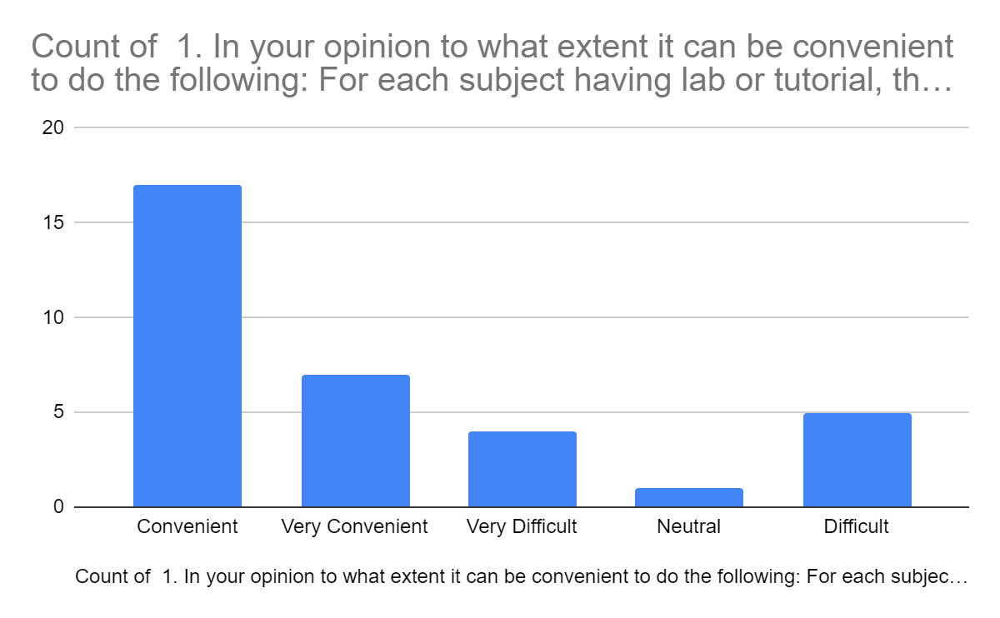

2. In your opinion to what extent it can be convenient to do: The subject teacher prepares a collective list of such assignments and makes it matching with the students’ level and the CO-PO requirements of the subject, by suitably modifying the same. (9+12) >> (7+4)

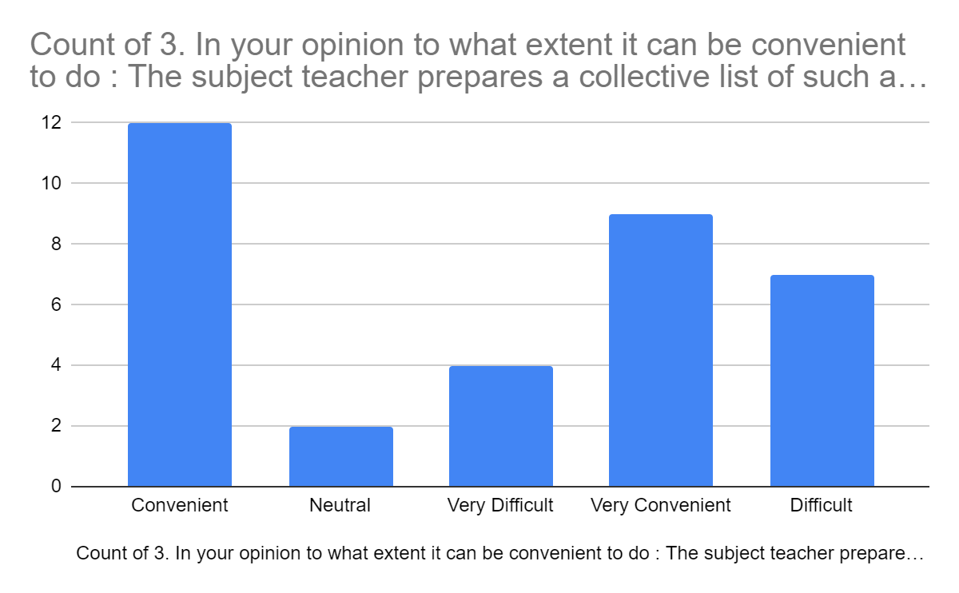

3. The subject teacher then makes the students work on these assignments prepared in the manner described earlier. The assignments are to be presented by students through PPT presentations, in the tutorial or in the last 25 minutes of the lab. (So that when one group is presenting, all other groups are learning from the corrective comments given to that group by the faculty.) (7+17) >> (10+1)

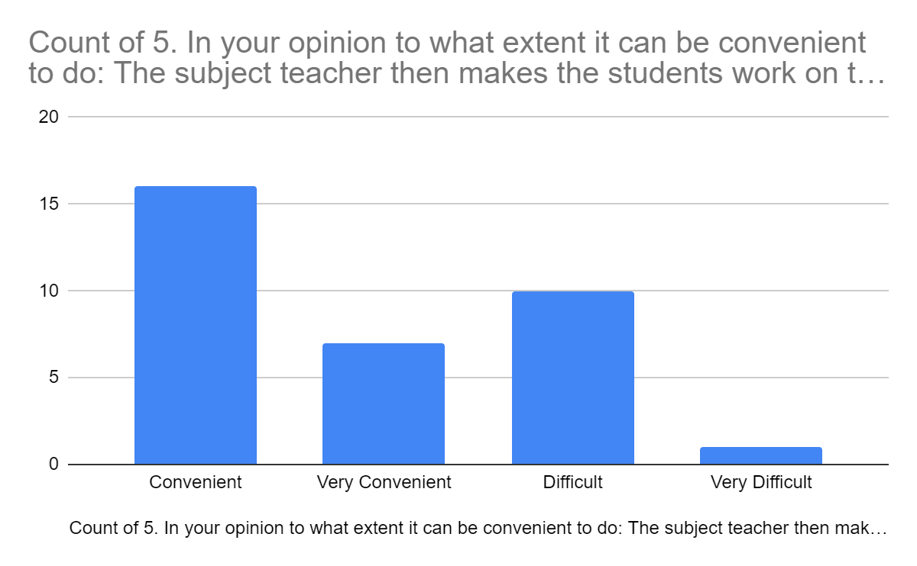

4. To what extent do you agree with this statement: By making students work on most such assignments suggested by industries, also supplemented by teachers own assignments -if required, to make up for the unattended topics, and present it through PPTs, it can be largely said, that the student is almost industry ready, as far as that particular subject is concerned. (15+6 >> 5+4+4)

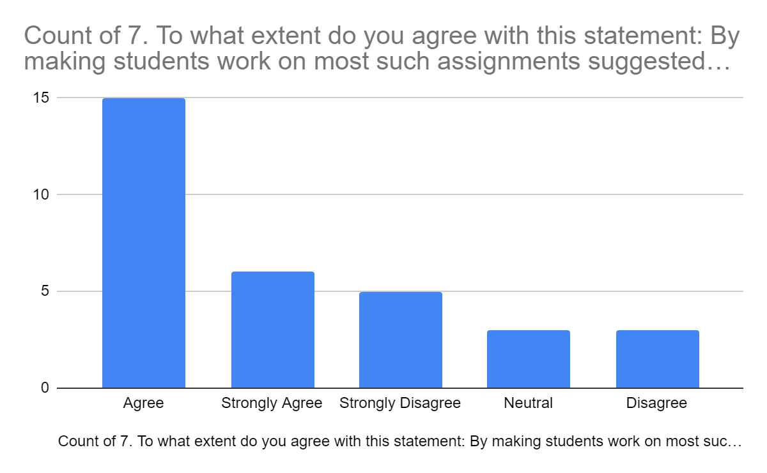

5. To what extent do you agree with this statement: As students will be doing such PPT presentations at all / most subjects, their subject confidence and professional communication skills will greatly improve. (18+9 >> 6+1)

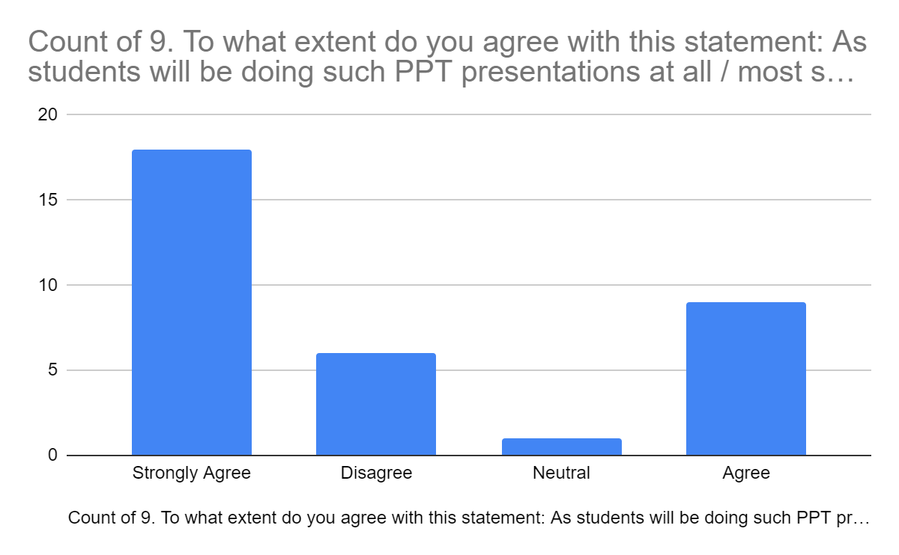

6. In your opinion to what extent it can be convenient to do the following: Each subject teacher also invites ideas from the industry expert panel members about the mini/major projects that they may wish to offer to students, if the students are to be sent for internships at their industries. (By email, and no physical meeting is required). (16+14>> 1+3)

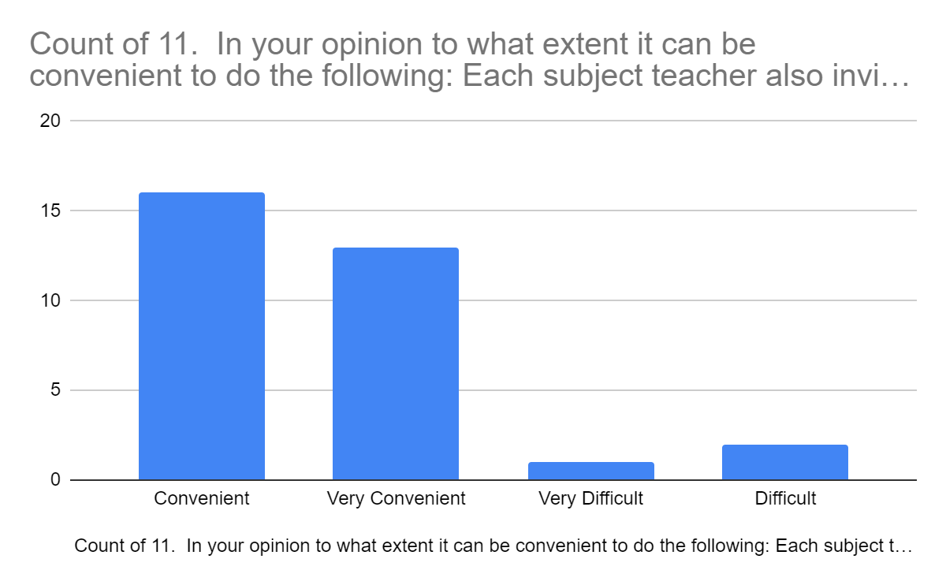

7. In your opinion to what extent it can be convenient to do the following: At the whole department level, all such assignments / mini /major project data are collected and with help of student coordinators, internship students are encouraged to choose the industries which offer problems which are more in line with the area of their interest. This can be more useful to students entering final year, so that they can choose industries which are likely to offer them major projects from their interest area. (12+13>> 3+6).

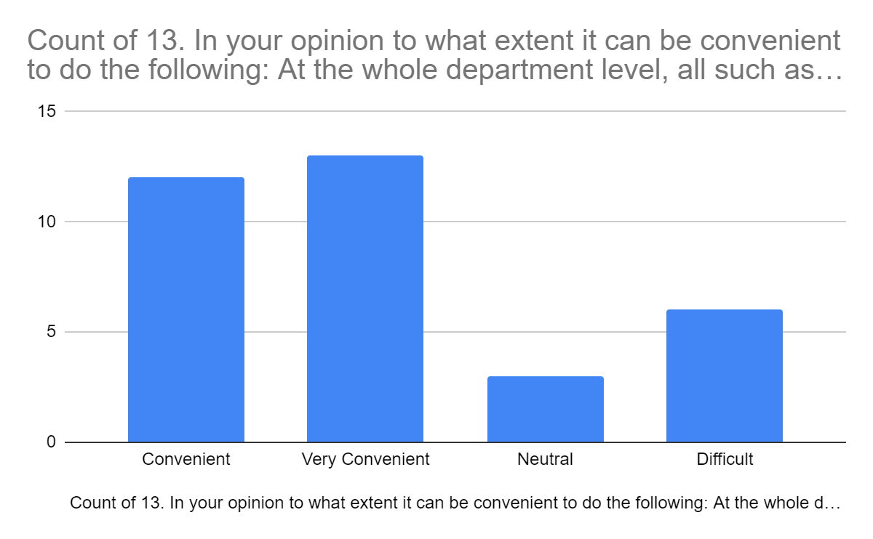

8. In your opinion to what extent it can be convenient to do the following: Coordinating faculties from each department, for 2nd year and for 3rd year levels, approach the industries on behalf of the students to ensure confirmation of their internship with a particular industry. (21+6 >> 1+5+1)

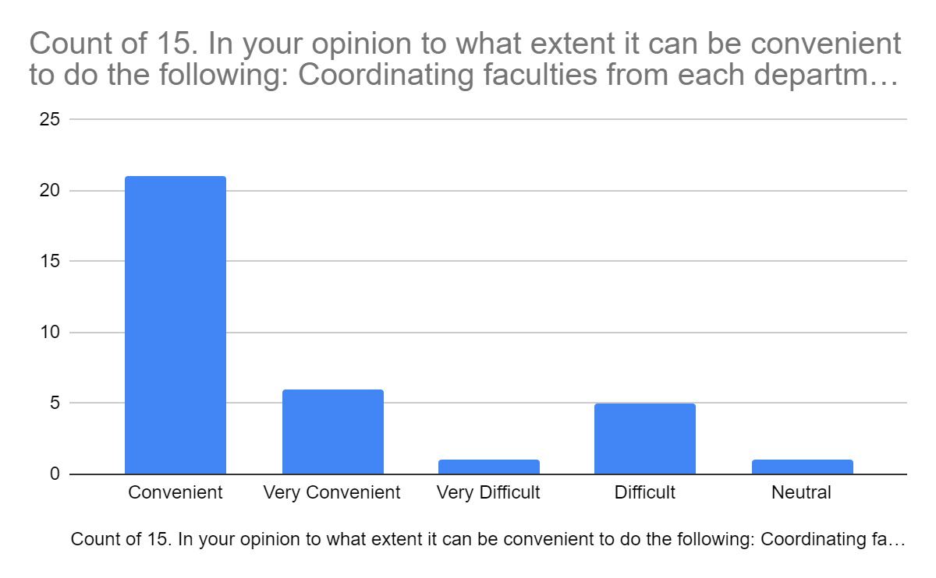

==========================================================================End of Annexure-1.

**Annexure-2:**

Feedback from the past students for the Module-3, CLASS-CAPABLE module which has been implemented for more than four years. This analysis is based on responses received from 59 past students, who have studied under the (Class-) CAPABLE system.

1. While working for the assignment-presentations, you had to work in the groups. Did this help you in understanding the topic or the subject in a better manner? (56>> 2+1)

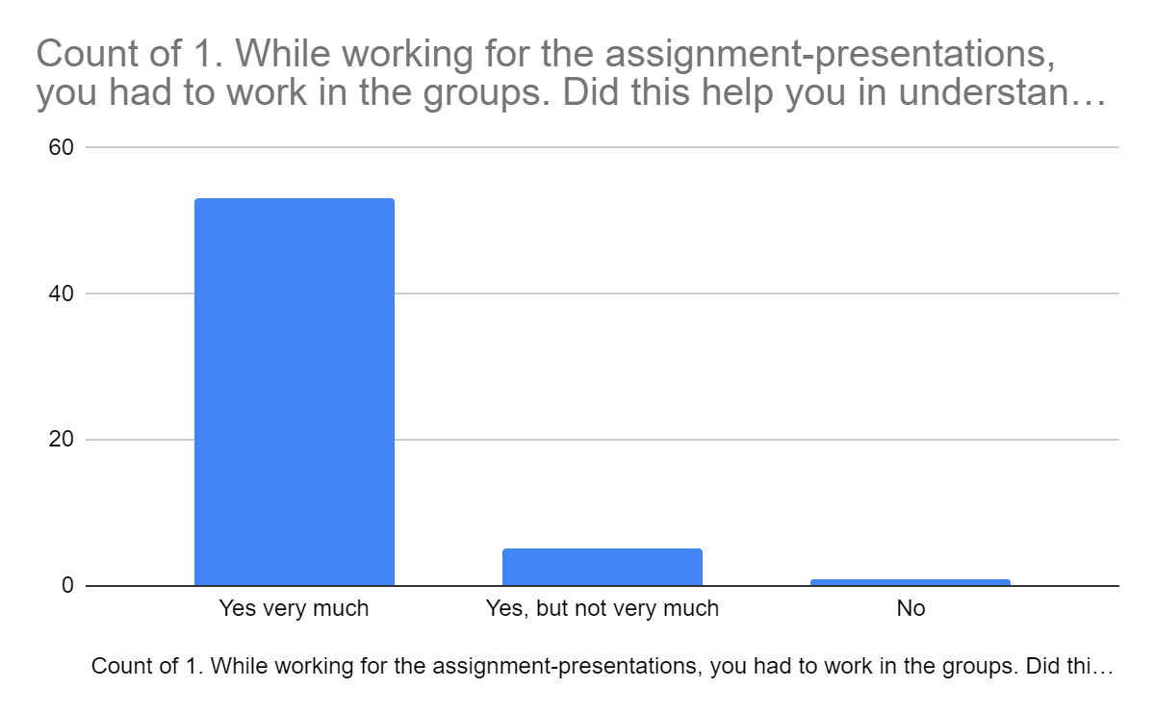

2. While presenting your assignments, did you get proper corrections and guidance, wherever the presentation was incorrect or weak? (37 >> 21+1) 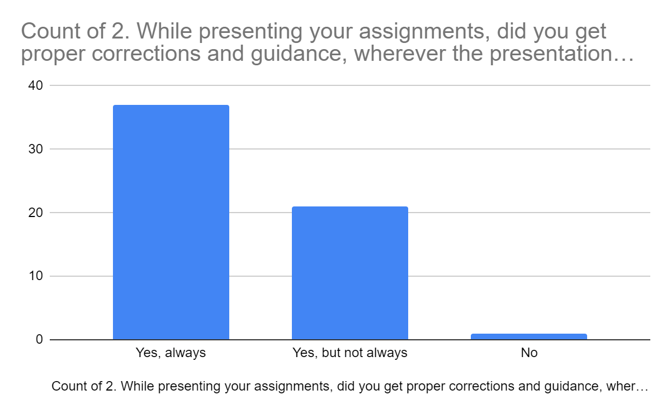

3. Did you get encouragement from your teacher to correct your weakness? (57>>2)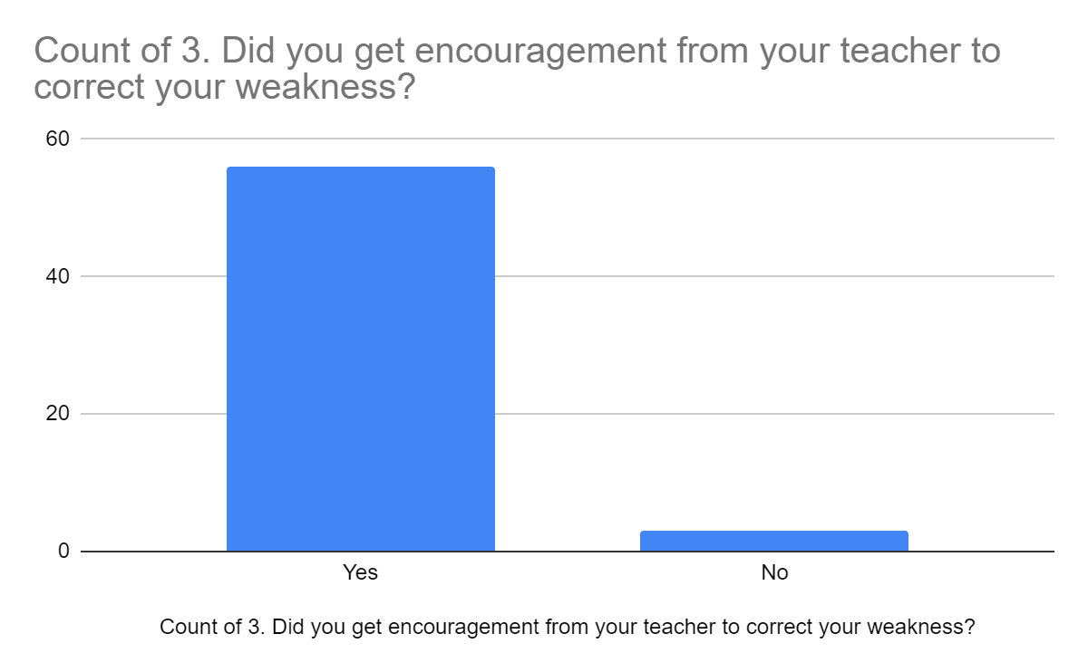

4. The assignments given to you each week were based on the class activity of the previous week. So, did these presentations clear your doubts if any, of the previous week’s study? (57>>2)

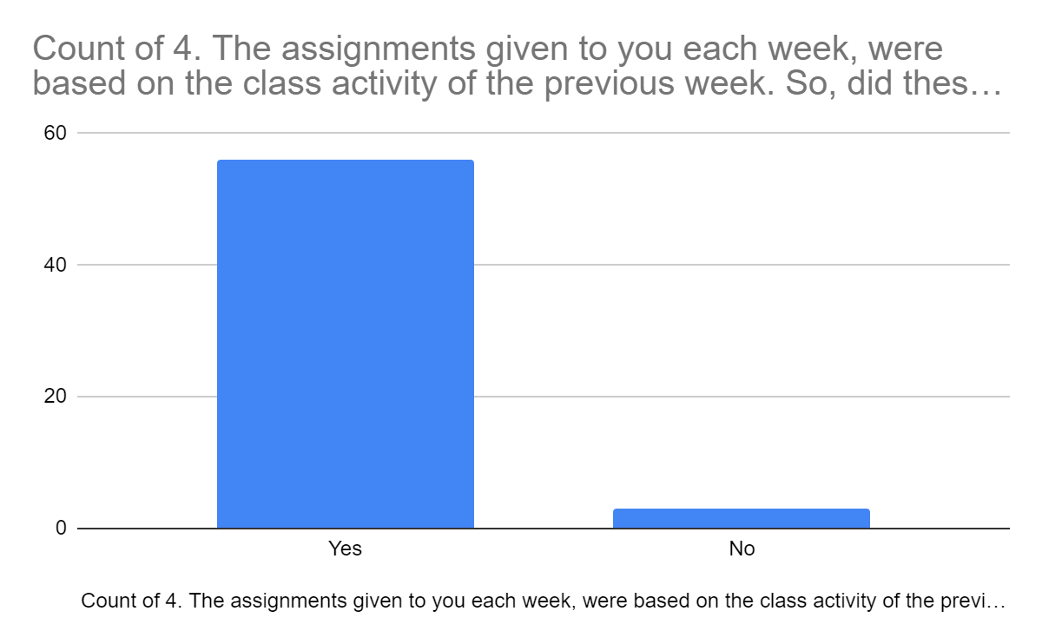

5. The assignments given to you each week were based on the class activity of the previous week. Did it provide you any further motivation to attend the classes, more regularly? (35+22 >> 2)

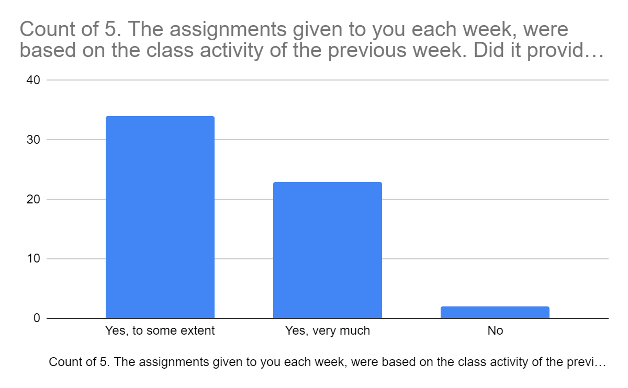

6. Did this scheme help you in any way, focus better during the classroom discussions?

(51 >> 8)

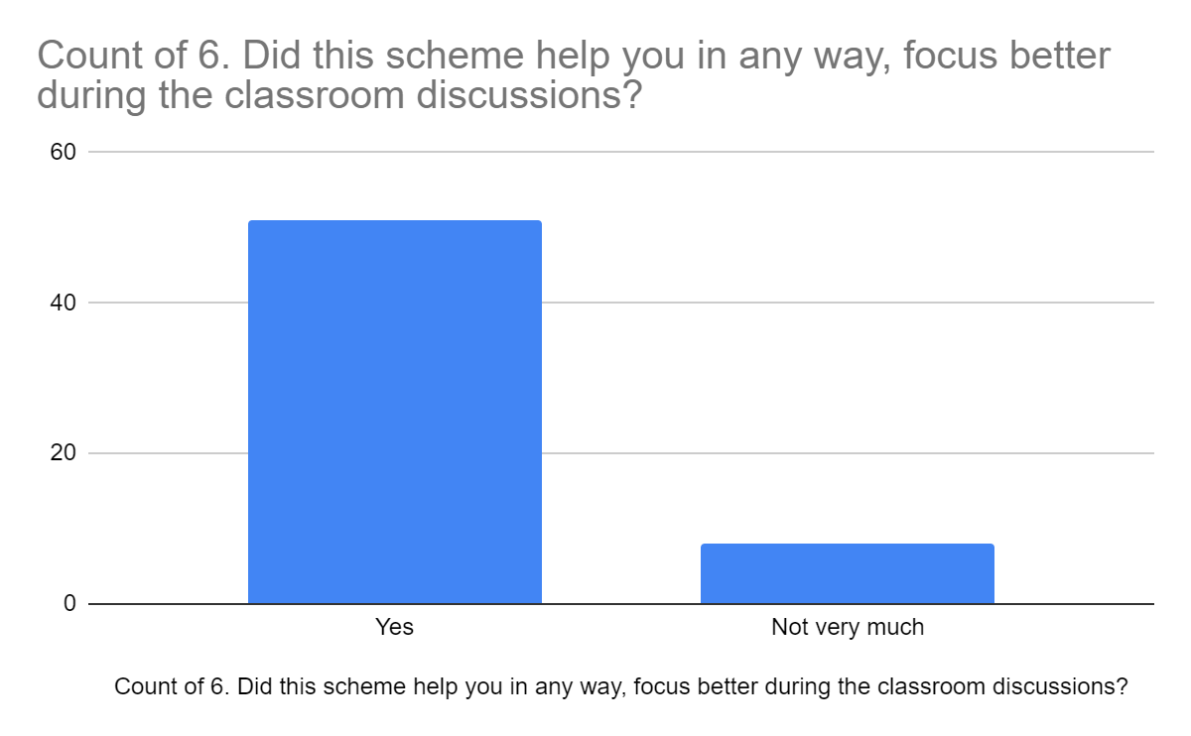

7. Did such theory assignments presentations improve your confidence? (41 >> 16+2)

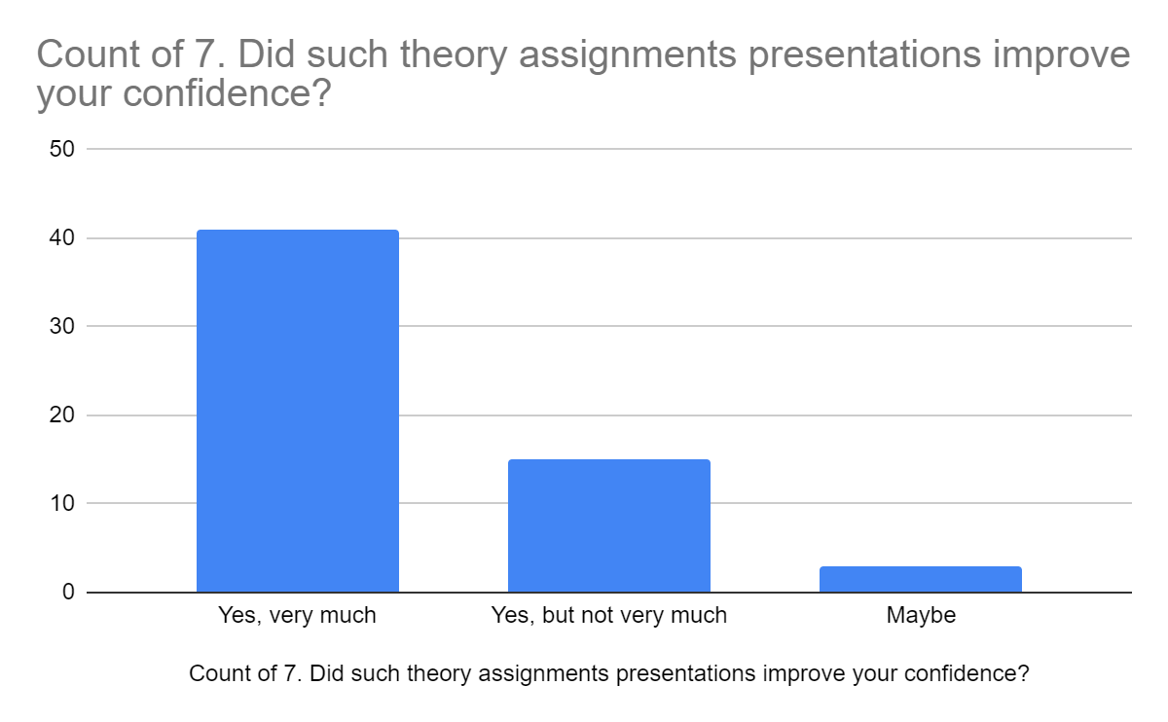

8. You were also given lab micro / mini projects as lab assignments. Did these assignments help improve your confidence? (41>> 17+1)

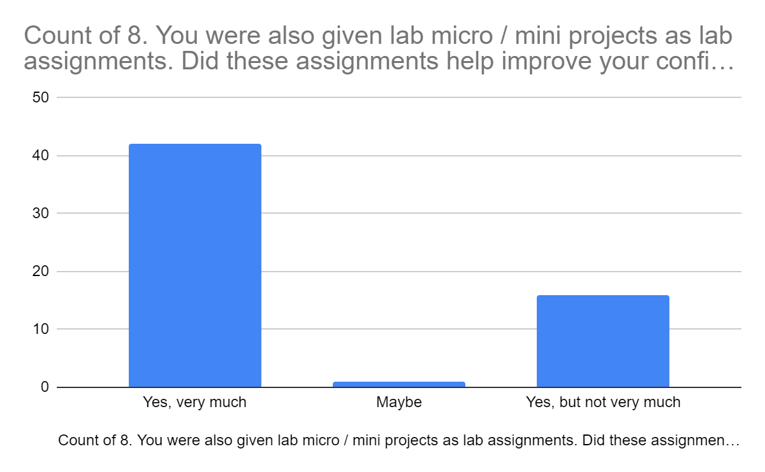

9. The subject teacher, as part of theory and lab assignments, can also assign you industry based small problems. Do you think this can better prepare the students to face industries?

(47>>12)

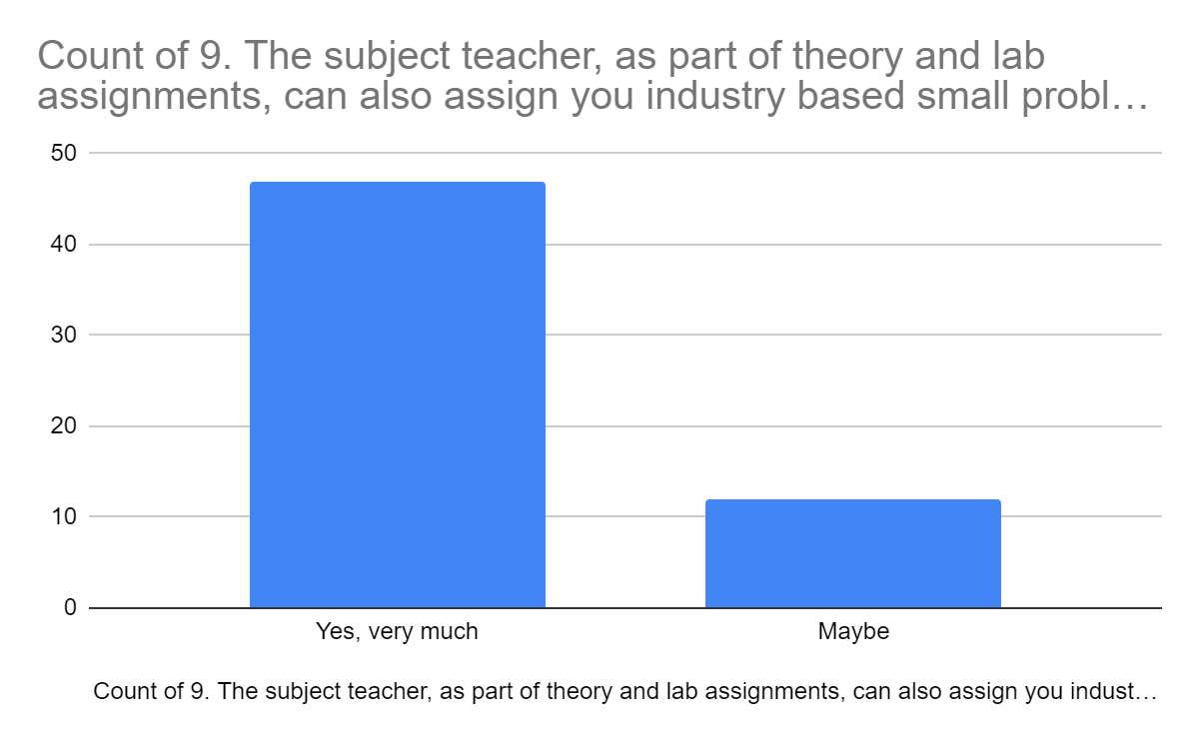

10. As per your observations can the Assignment - Presentations Based Learning method, be easier for judging your understanding of the topic and subject in a better manner when compared with traditional tests by your subject teacher? (49 >> 9+1)

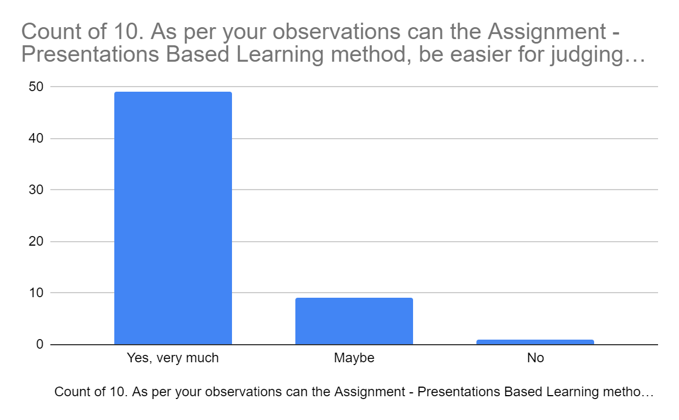

11. In your opinion, do you think that the Assignment - Presentations Based Learning method, can actually improve the learning abilities of the students in a better manner compared to traditional tests? (48 >> 8+2+1)

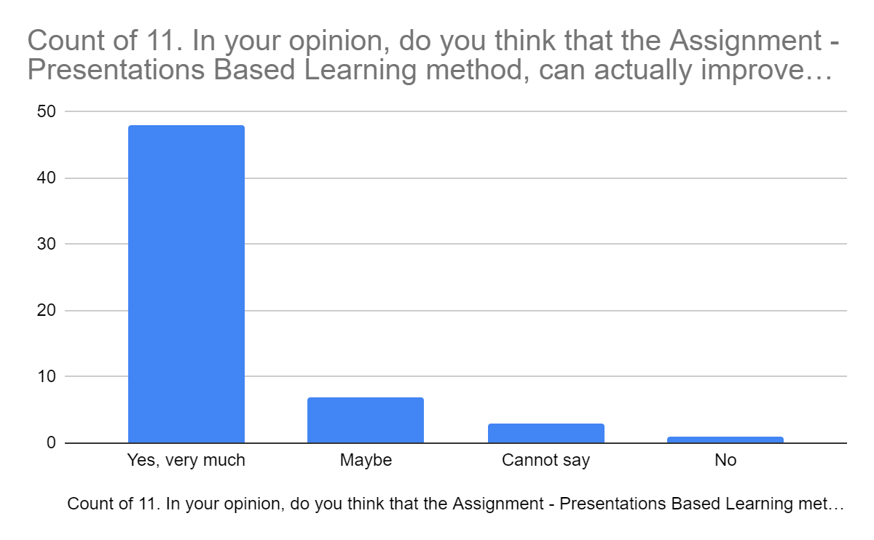

12. If the Assignment Based Learning Method is applied at all the courses, from first to final year, then each student group would present more than 60 presentations before graduating. Do you think this can greatly improve the knowledge, capabilities and confidence level of passing out engineering graduates? (56 >> 2+1)

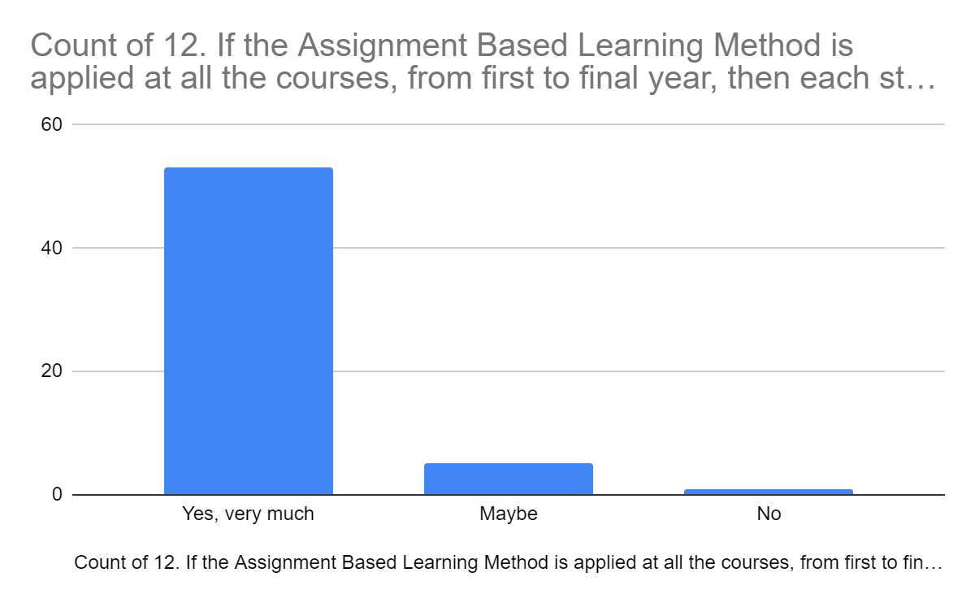

13. In your opinion, if the Assignment Presentation Method is clubbed with taking an online quiz in the last week, then can it be a good alternative to internal tests, for continuous internal evaluations? (46 >> 12+1)

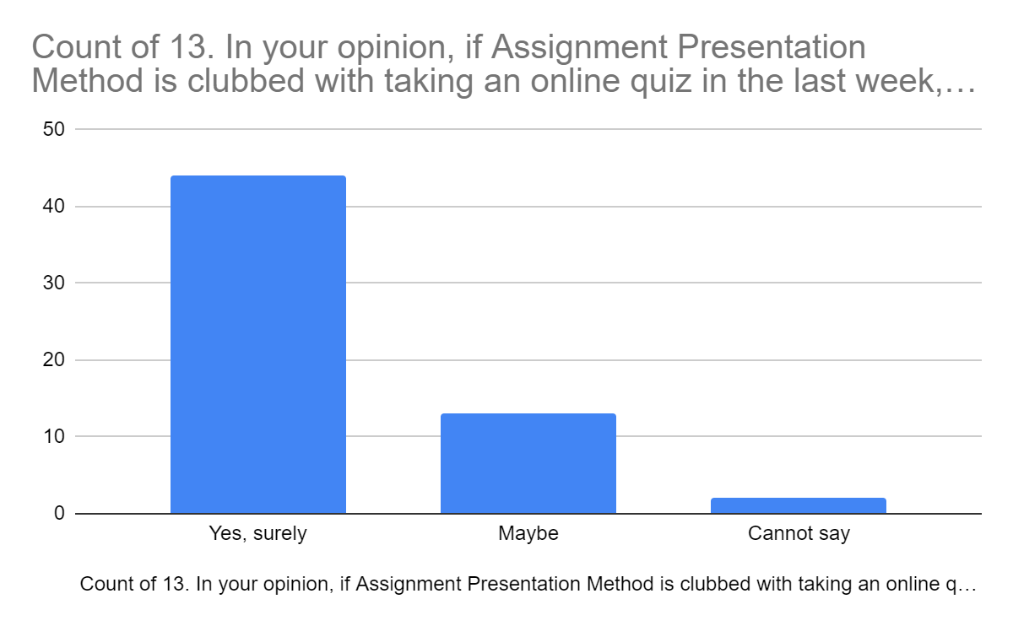

14. Do you think that if all the internal tests –at all the subjects, for all the disciplines are replaced by such a combination of ABLE System with computer based online tests in the last week, then it can develop a better learning environment at the colleges? (47 >> 1+10+1)

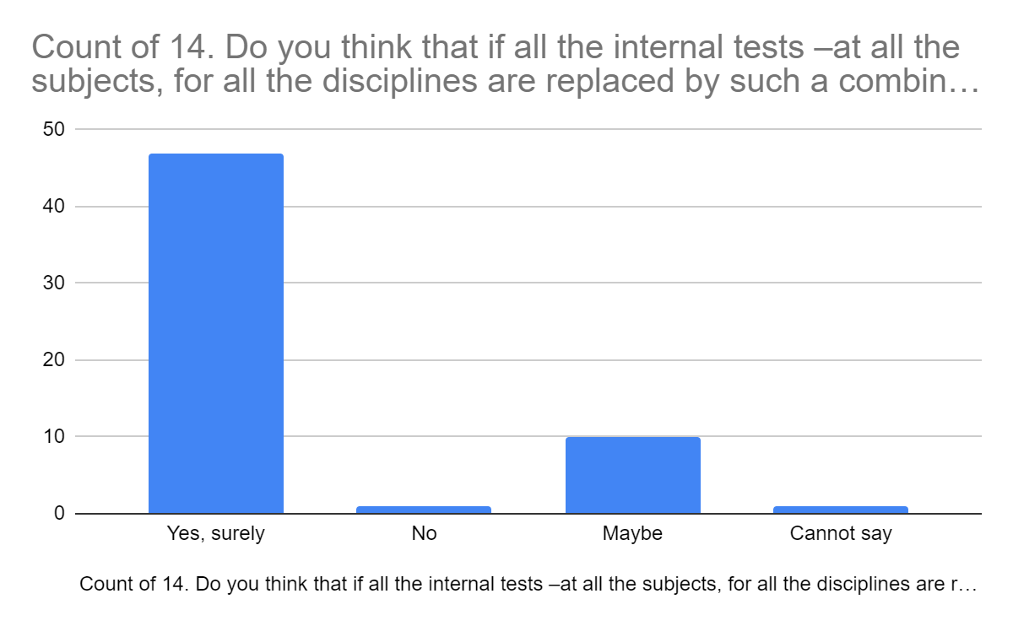==========================================================================

End of Annexure-2.

**Annexure-3:**

This annexure presents views sought from the final year students of various engineering colleges on possible advantages of the strategies presented in the modules 4,5,6,7 and 8. Presented herewith is the summary of these feedbacks received from (-up to-) 100 respondents.

1. If you have undertaken industry internship: In your opinion, to what extent industry internships (during summer vacations) are useful to students, for industry application of subjects, knowledge and confidence: 95 responses (55+30 >> 2+7+1)

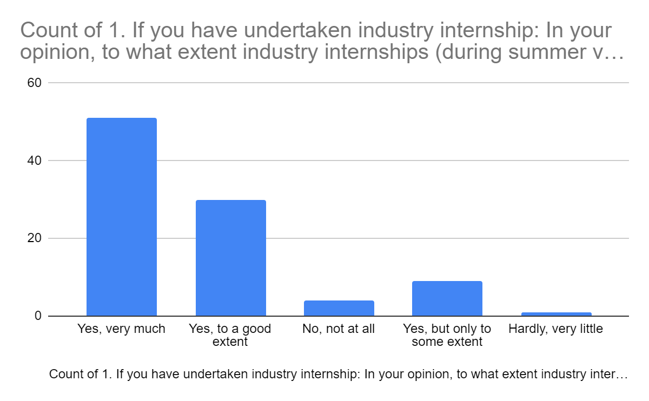

2. In your college, if an exhibition of final year projects (Project Expo) is arranged, then: Did Project Expo exercise in some way motivate you to take up industry useful projects? 97 responses (30+ 47 >> 18+1+1)

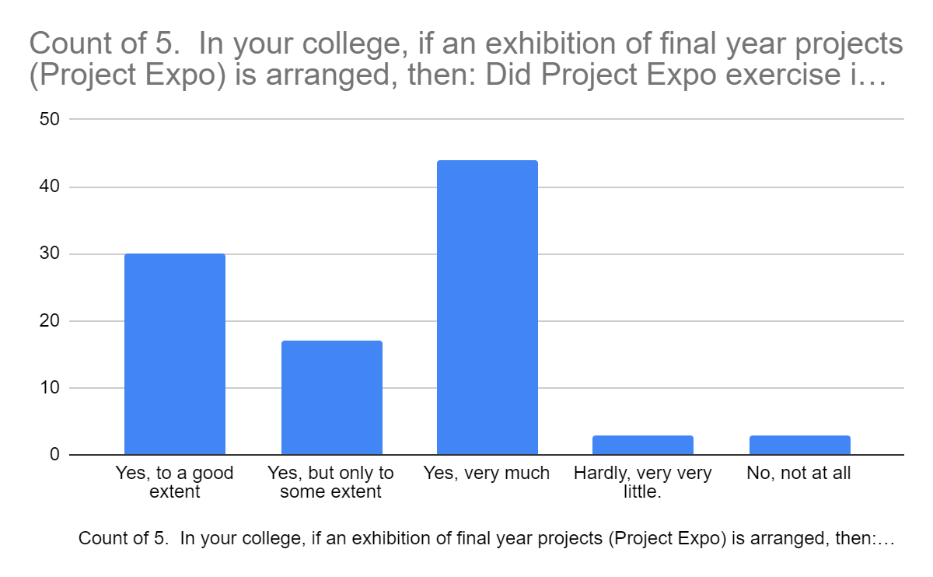

3. In your college, if an exhibition of final year projects (Project Expo) is arranged, then: Did you feel that due to Project Expo exercise, your project received good visibility? 98 responses. (47+36 +10 >> 2+1+2)

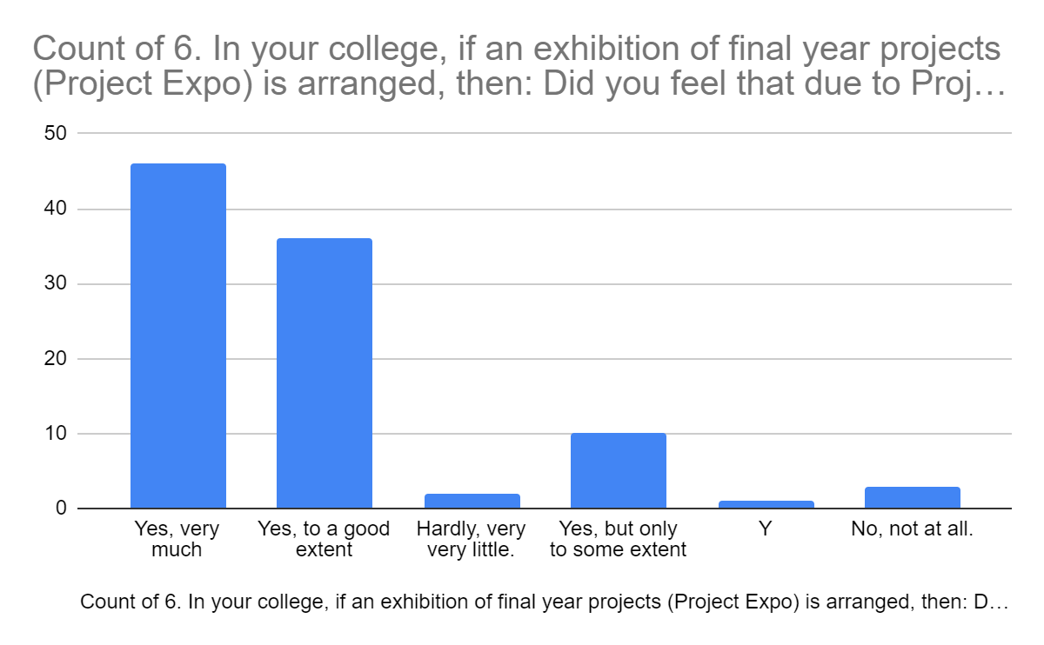

4. In your college, if an exhibition of final year projects (Project Expo) is arranged, then: Did Project Expo exercise, nurture any entrepreneurial aspiration in you? 94 responses. (35+25+30 >> 2+2)

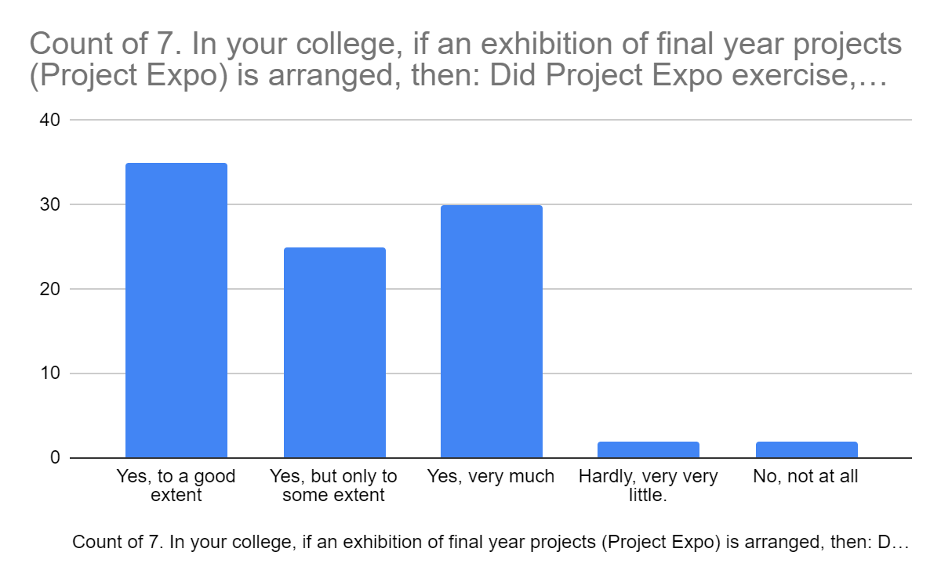

5. In your college, if an exhibition of final year projects (Project Expo) is arranged, then: In your opinion, did project expo type of exercises motivate you to do industry internship? 94 responses. (32+33+21 >> 4+4)

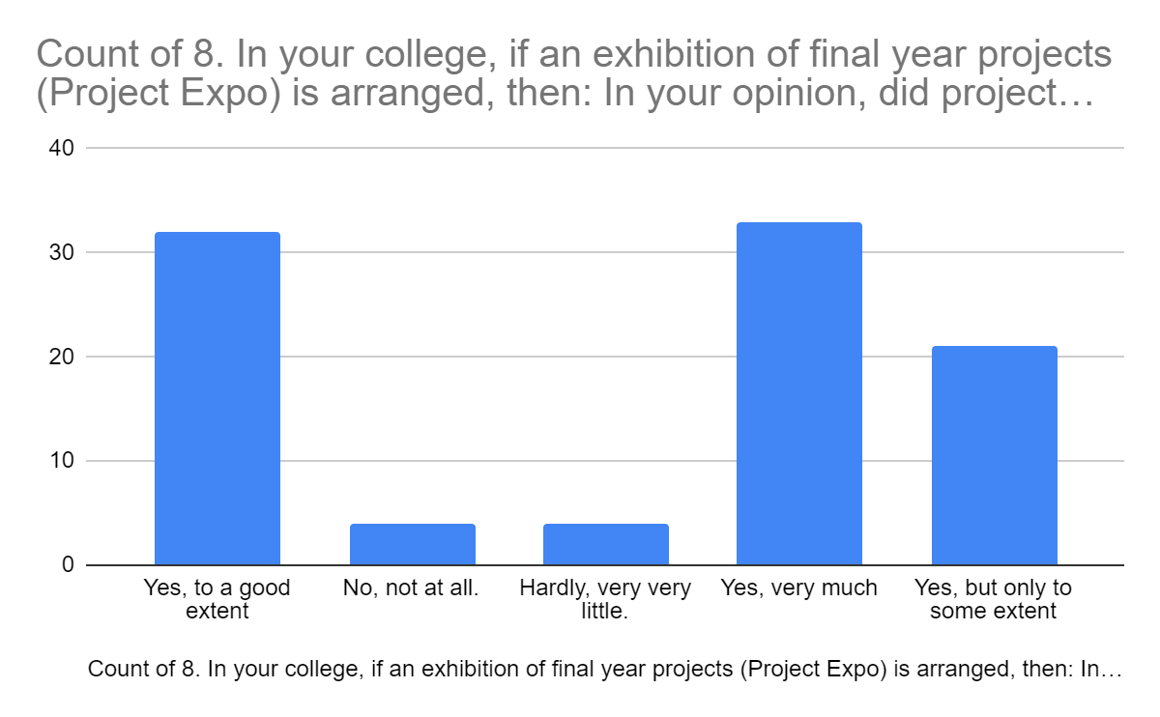

6. At any stage of doing your project did you ever think that if you had some basic understanding of entrepreneurship, you would have tried to give an entrepreneurial angle to your final year project? 95 responses. (39+29+19 >> 4+4)

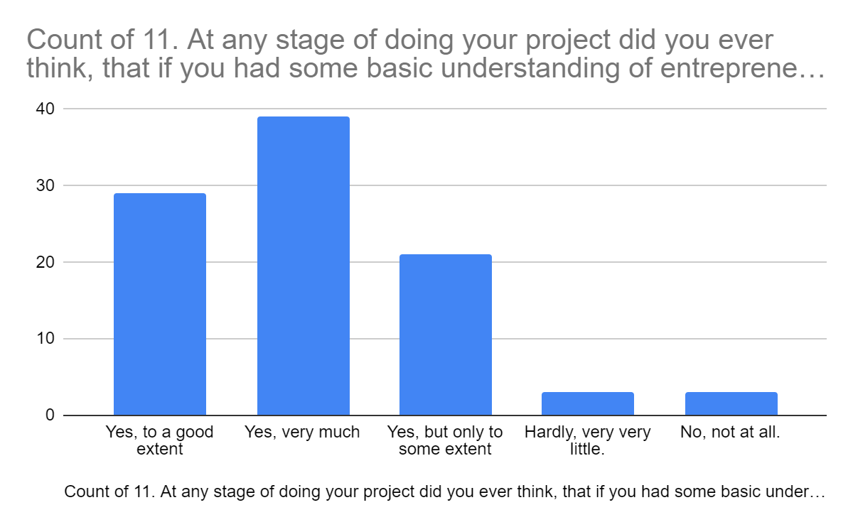

7. In your opinion, if a student is introduced to about two entrepreneurship subjects (say from NPTEL) during the first three years, then will he / she be keen to take up -as a trial- his final year project as a technology cum entrepreneurial project? 94 responses (36 + 31+ 22 >> 3+2)

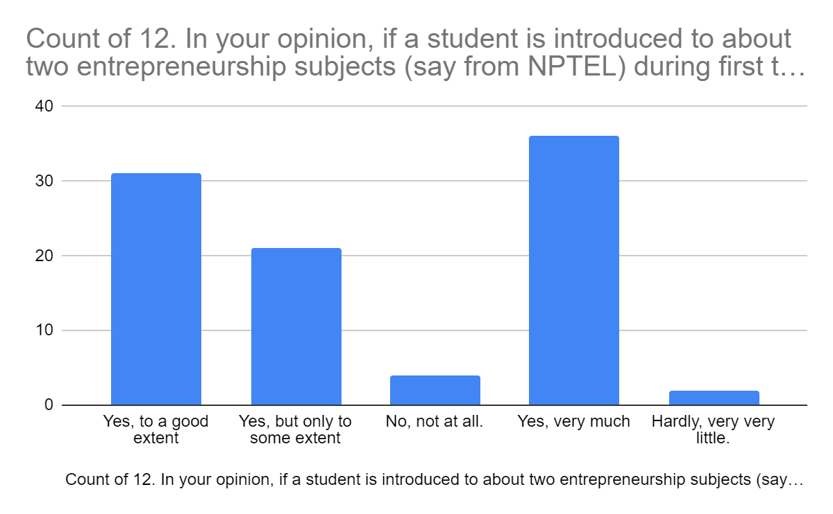

8. In your college, if an exhibition of final year projects (Project Expo) is arranged, then: At the time of Project Expo, if best projects are shortlisted based on their entrepreneurial promise, and are given some seed money (@ 1 lakh) and monthly stipend (@ Rs. 10K per month), to make the same project market ready, within one extra year of their graduation, then how many students in your opinion, will like to take that offer? 96 responses (36+ 32+ 14 >> 9+5)

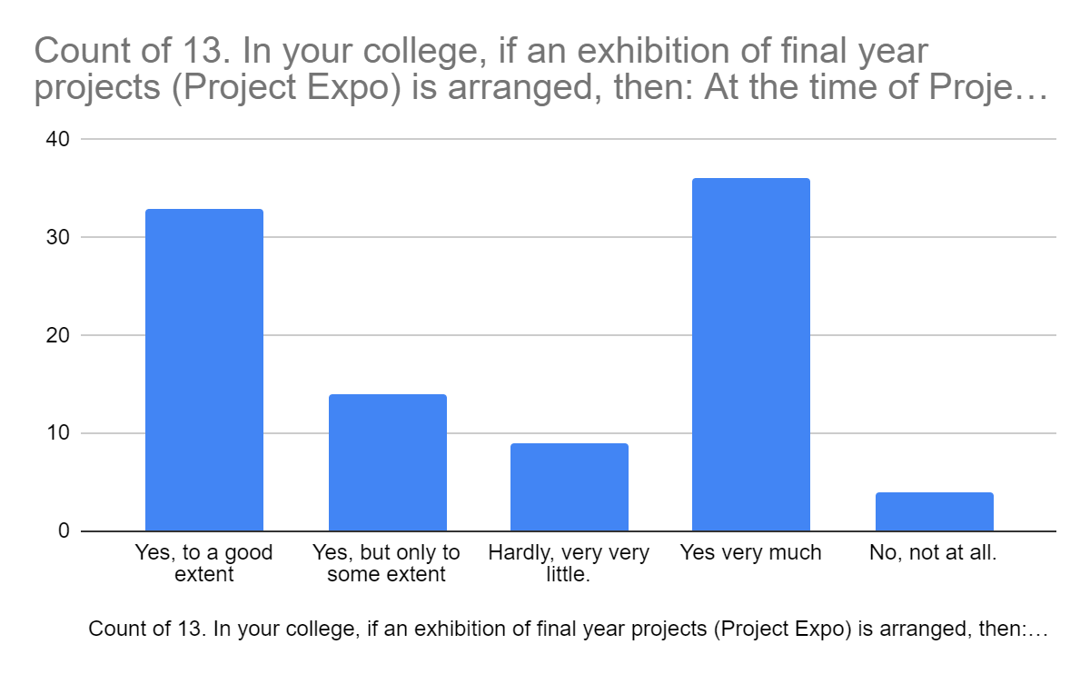

9. Do you think, that the chances of students taking up the above mentioned opportunity will increase, if they are given an option of doing a Diploma in Entrepreneurship Management, where, they are asked to make a complete market ready project, and also pass certain courses on entrepreneurship in one year (or two years- for those who request for more time), with seed money (@ 1 lakh ) and stipend for one year (@ Rs. 10K per month), and in the process also earn a Diploma in Entrepreneurship Management? 87 responses (41+ 20+ 22 >> 4)

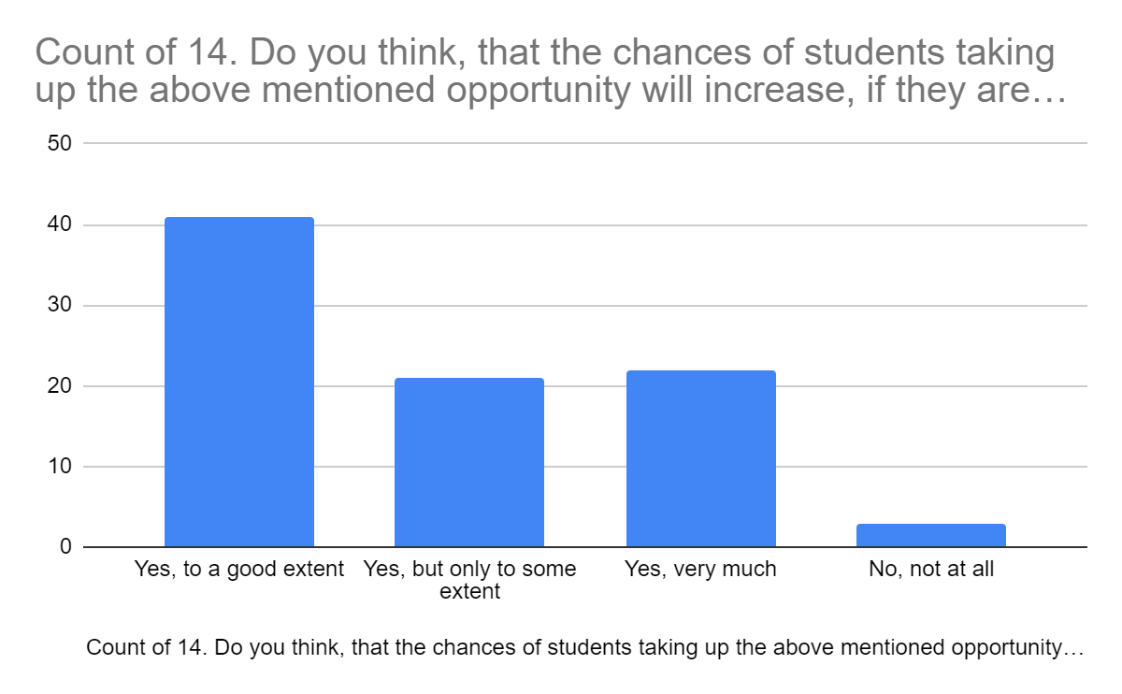

==========================================================================

End of Annexure-3.