**Wireless Electronic (Wi-E) System Considerations for Real Time Monitoring in Niger Delta Zones of Nigeria: A survey**

Collins Iyaminapu Iyoloma1, Shadrach Kukuchuku2 , Nkechinyere Eyidia3 Collins.iyoloma@ust.edu.ng; shadrach.kukuchuku@ust.edu.ng; eyidia.nkechinyere@ust.edu.ng

1 &3 Dept. of Electrical Engineering, Rivers State University, Port Harcourt, Nigeria.

2 Dept. of Computer Engineering, Rivers State University, Port Harcourt, Nigeria.

**Abstract**

In this paper, issues bordering on Wireless Electronic (Wi-E) system design for monitoring explorations in the Niger Delta regions of Nigeria are discussed considering the sensing modality or electronic sensor physical property and power conservation and bordering on three sub-themes – the electronic sensor type/cell capacity, the communication standards and node antenna selection. Considering electronic sensor type, primary sensing modality to be considered depends on the type of physical information and detection quality required. For the Niger Delta region, various environmental variables need to be monitored; hence, to improve scalability, various sensor types can be embedded in a single functional package while making a compromise between durable cells (battery) and long lasting ones. When choosing a communication standard or protocol, it is imperative to determine the impact on energy consumption and data throughput. In this regard, our findings showed that the ZigBee communication standard supports data rates between 20 Kbps and 250 Kbps and is suitable for pipeline monitoring achieving transmission ranges over 300m. For node antenna selection, our findings showed that relatively small micro-strip patch antennas can be designed to operate in the ISM band and are effective in Wi-E systems development. Indeed, the selection of a suitable e-system for monitoring explorations can be based on the sensing and communication device and it is recommended as critical areas for further examination and cross-examination when designing Wi-E systems for Niger Delta regions.

**Keywords:** Communication, Electronic, Niger Delta, Sensor, Wireless

**1. Introduction**

Electronic systems play a vital role in the development of more efficient and robust services in the modern society. Ranging from consumer products to industrial control and automation devices, the electronic system is at the heart of the development of such products or devices.

In recent times, the need for protecting the environment which includes human and material resources has instilled interest in the development of special types of electronic systems. This protection requirement has necessitated the need for monitoring electronic systems which can inform operators or the users of such systems in diverse environments.

Notwithstanding the many benefits of electronic monitoring systems (EMS), it is not without its own share of problems which have been mostly found to be environment-specific.

In this paper, we discuss issues bordering the EMS based on the aforementioned problem as it concerns the Niger Delta environment in the South-South region of Nigeria. We discuss the Niger Delta environment and the issue of gas flaring as a result of active exploration by major oil and gas multinational oil companies such as SNEPCO, Agip and Totalfina Elf. We shall also specifically discuss the issue of Electronic System (e-System) design and its effectiveness in the monitoring of explorations e.g. oil and gas explorations in the Niger Delta region of Nigeria.

**2. Niger Delta Region**

The Niger Delta is situated in the southern part of Nigeria and is bordered by the Gulf of Guinea on the South and located between 4.3 and 7.7 oN and 4.4 - 9.5 oE. All the oil exploration facilities in Nigeria are located in the Niger Delta. This region is in fact characterized by excessive gas flaring as a result of excessive oil exploration and production. It is important to emphasize here that more than 900 active oil wells (Osuji and Onojake, 2004) and over 300 active ﬂares are scattered around the region.

According to 2009 estimates, the region's 75,000 km2 landmass is occupied by about 31 million people (Raji et al., 2013; Ugor, 2013). Fig. 1 show the Niger Delta and the locations of active ﬂares scattered around the region (Elvidge et al., 2015); the red place marks indicate active flare zones . Of the 325 active ﬂare sites identiﬁed in the Nigeria oil ﬁeld in 2012, 97 (~30%) rank among the top 1000 largest ﬂares of the 7467 individual ﬂares identiﬁed globally (Fawole et al., 2016). From the inception of oil exploration over four decades ago, gas ﬂaring activities in the study area has been a persistent daily activity in the several ﬂow stations and rigs. In addition to gas flaring monitoring, other activities such as pipeline monitoring is also important to determine the situation at hand and proffer possible solutions to improve flow rate and protect facilities.

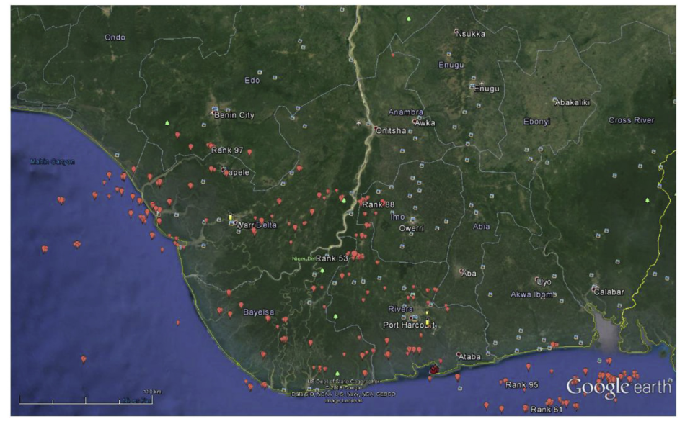

Fig.1. Niger Delta Gas Flaring; Map Source: Google Earth imagery showing Niger Delta.

**3. Electronic System (e-System) Design Issues**

Electronic system issues are discussed under the following sub-topics:

1) The Sensing modality

2) Power conservation issues

**3.1. The Sensing modality**

A sensor is typically an electronic systems device that is used for acquiring information from the environment; it is essentially a device that is tasked with the function of detecting variations in one type of physical energy or property then converting it into an electrical signal. Different sensors can detect various forms of physical information such as temperature, sound, lightning condition, vibration, magnetic and chemical fluctuations. The primary sensing modality to be considered depends on the type of physical information and detection quality required, and the platform needed to support the sensor. Platform in this context refers to power, size and integrability.

Since real time monitoring in environments such as the Niger Delta involves the detection of a mixture of several important environmental parameters (or variables), it is often important to combine different type of sensors in a single functional package in order to improve its scalability. Such technologies do exist as MEMS packages in single Integrated Circuits (IC’s) or microprocessors using wireless connectivity (Xiangyu & Chao, 2006), and are vital considerations in the design of e-System for monitoring of oil and gas explorations.

**3.2. Power conservation issues**

The optimization of power resource for electronic systems deployed in the Niger Delta presents an important consideration area; as most electronic systems are intended to operate on remote sites far away from the usual or conventional power supply, they run on batteries. Thus, the use of power usage has to be done optimally in order to sustain battery life and minimize power wastage. This sub-section will discuss the issues bordering on electronic sensor type/cell capacity, communication standard for monitoring information transfer and issues pertaining node antenna selection.

**3.2.1. Electronic Sensor type and cell capacity**

Different kinds of electronic sensors exhibit different power requirements. The amount of energy consumed by an electronic sensor depends on the material of the sensing element, and the working principle of the technology. Some electronic sensor technologies require a high sensing rate to operate, while the sensing rate of other electronic sensor technologies is low, this also corresponds to the type of monitoring task the sensor is designed to capture. For example, a combination of piezo-resistive sensors and ultrasonic electronic sensors investigated for pipeline monitoring in (Stoainov et al., 2007) show variations in the power requirements of the sensing modalities. While the piezo-resistive sensors require less than 10mW when operating incessantly, the ultrasonic sensors consume 550mW for the same operation. These ﬁndings limited the use of the ultrasonic sensors to only periodic and veriﬁcation monitoring.

Magneto-resistive sensors have also been shown in (Chinrungrueng et al. 2006) to exhibit good power performance. Thus when long network lifetime is the design objective, it is important to select a power efficient electronic sensor that is able to provide the required detection quality. Different battery types can be used to power electronic sensor nodes, these batteries differ in cell chemistry which directly corresponds to cell capacity. Some cell types are typically designed to meet short operating life requirements. Zinc–air cells for instance offer high power densities but their lifetime is very short (Roundy et al. 2004), they are thus unattractive for remote pipeline monitoring in regions such as the Niger Delta. In contrast, some commercially available cell types are potentially capable of long operating lifetimes. For instance, Plextek’s Lithium Thionyl-chloride cells used in remote gas measurement systems claim an operational lifetime of about 10 years (Methley & Forster, 2008). Other products using Lithium Thionyl-chloride cells claim up to 20 years lifetime. It is however important to note that certain other factors may affect the achievable operating lifetime of cells. Notably the operating environment, silicon geometry of cells, the state leakage current and other cell power management features like duty cycling. Generally, if low energy designs are implemented, a primary battery should be capable of long operating lifetimes of the order of 10 years or more for remotely deployed electronic sensor nodes.

**3.2.2. Communication standard**

It is well known fact that battery energy of electronic sensor nodes is mostly consumed by communication functions. In (Cheung & Varaiya, 2007; Cheung et al 2005) it was revealed that the electronic radio component is responsible for more than 90% of the energy consumed in the node. Therefore, a key design issue is to utilize energy efficient communication standards that will prolong the network lifetime. Most electronic sensor networks employ existing wireless network standards namely IEEE 802.11 or wireless LAN, IEEE 802.15 or ZigBee, or Bluetooth. Bluetooth and wireless LAN operate in the 2.4 GHz ISM band. Wireless LAN was initially developed for networks that constitute laptops and PDAs, and later they were subsequently extended to Wireless Sensor Networks (WSN). However, their high power consumption and excessively high data rate has discouraged their use in designs where long network lifetime is the objective. Bluetooth on the other hand utilizes a frequency hopping spread spectrum technique which provides additional security features and immunity to co-channel interference. WSN utilizing the Bluetooth communication standards can be legally operated at high data rates and are suitable for voice applications. Bluetooth is however unsuitable for most pipeline-monitoring scenarios because of the limited transmission range, typically 10 m. Also, the frequency hopping mode of operation means a significant amount of energy will be consumed during synchronization and in subsequent operation.

The use of Bluetooth standards is thus restricted to high data rate applications in small Adhoc network scenarios. In contrast, ZigBee is more suited for low data rate applications where long battery lifetime and non-intrusive operations are the objective. The ZigBee communication standard supports data rates between 20 Kbps and 250 Kbps suitable for pipeline monitoring and can achieve transmission ranges over 300 m. ZigBee

is based on direct sequence spread spectrum technologies which utilize low power modulation techniques like FSK or QAM. FSK modes of transmission have been shown in (Knaian, 2000; Owojaiye & Sun, 2013) to consume only 10–20mA in comparison to 500mA consumed by frequency hopping modes of transmission. ZigBee standards operate across three frequency bands namely 868 MHz, 915 MHz and 2.45 GHz at varying data rates.

**3.2.3. Node Antenna Selection**

Node antenna selection is also a key design issue. Electrical antennas designed for operation in the UHF band are commercially available. For pipeline monitoring WSN, transmission in the UHF band is favorable because UHF circuits are small in geometry and are low power devices. However, the difficulties of achieving the required wavelength of operation arise during antenna construction. For a more practical solution, the relatively small micro-strip patch antennas designed to operate in the ISM band can be utilized. These antennas are easily designed and fabricated and are characterized by small size and ruggedness.

**4. Conclusions**

We have discussed some important issues bordering on wireless electronic system (Wi-E System) design for monitoring explorations in the Niger Delta regions of Nigeria. We have presented the aspect of two very important issues: the sensing modality or electronic sensor physical property and power conservation issues bordering three sub-themes – the electronic sensor type/cell capacity, the communication standards and node antenna selection. Indeed, the selection of a suitable e-system for monitoring explorations will require knowledge of the kind of environmental parameters or process variables available at time of signal detection and nature of the field monitored (whether remote or nearby). In future, other possible design issues should be investigated to further improve the development of e-system devices deployed in such regions.

**References**

Cheung, S. Y., & Varaiya, P. (2007). *Traffic Surveillance by Wireless Sensor Networks* (No. qt4pn0m283). Institute of Transportation Studies, UC Berkeley.

Cheung, S. Y., Ergen, S. C., & Varaiya, P. (2005, November). Traffic surveillance with wireless magnetic sensors. In *Proceedings of the 12th ITS world congress* (Vol. 1917, p. 173181).

Chinrungrueng, J., Sununtachaikul, U., & Triamlumlerd, S. (2006, June). A vehicular monitoring system with power-efficient wireless sensor networks. In *2006 6th International Conference on ITS Telecommunications* (pp. 951-954). IEEE.

Elvidge, C. D., Zhizhin, M., Baugh, K., Hsu, F. C., & Ghosh, T. (2015). Methods for global survey of natural gas flaring from visible infrared imaging radiometer suite data. *Energies*, *9*(1), 14.

Fawole, O. G., Cai, X., Levine, J. G., Pinker, R. T., & MacKenzie, A. R. (2016). Detection of a gas flaring signature in the AERONET optical properties of aerosols at a tropical station in West Africa. *Journal of Geophysical Research: Atmospheres*, *121*(24), 14-513.

Knaian, A. N. (2000). *A wireless sensor network for smart roadbeds and intelligent transportation systems* (Doctoral dissertation, Massachusetts Institute of Technology).

Methley, S., Forster, C., Gratton, C., Bhatti, S., & Teh, N. J. (2008). Wireless Sensor Networks Final Report. *An Article of Plextek Limited, United Kingdom*.

Osuji, L. C., & Onojake, C. M. (2004). Trace heavy metals associated with crude oil: A case study of Ebocha‐8 Oil‐spill‐polluted site in Niger Delta, Nigeria. *Chemistry & biodiversity*, *1*(11), 1708-1715.

Owojaiye, G., & Sun, Y. (2013). Focal design issues affecting the deployment of wireless sensor networks for pipeline monitoring. *Ad Hoc Networks*, *11*(3), 1237-1253.

Raji, A. O., Grundlingh, L., & Abejide, T. S. (2013). The politics of resource control in Nigeria: Example of Niger Delta Region, 1990s-2010. *Arabian Journal of Business and Management Review (Kuwait Chapter)*, *3*(2), 1-18.

Roundy, S., Steingart, D., Frechette, L., Wright, P., & Rabaey, J. (2004). Power sources for wireless sensor networks. *Wireless Sensor Networks: First EuropeanWorkshop, EWSN 2004, Berlin, Germany, January 19-21, 2004. Proceedings 1*, 1-17.

Stoianov, I., Nachman, L., Madden, S., & Tokmouline, T. (2007, April). PIPENETa wireless sensor network for pipeline monitoring. In *Proceedings of the 6th international conference on Information processing in sensor networks* (pp. 264-273).

Ugor, P. U. (2013). The Niger Delta wetland, illegal oil bunkering and youth identity politics in Nigeria. *Postcolonial text*, *8*(3 & 4).

Xiangyu, J., & Chao, W. (2006, June). The security routing research for WSN in the application of intelligent transport system. In *2006 International Conference on Mechatronics and Automation* (pp. 2318-2323). IEEE.