Innovative Robotic Solutions for Fine Motor Skill Enhancement in Autism Therapy

Zulhisyam Salleh¹, Fizatul Aini PAtakor², Saiful Nizam Zakariah³
¹Electrical Engineering Department, Politeknik Melaka, Melaka, Malaysia .
²Electrical Engineering Department, Politeknik Merlimau, Melaka, Malaysia.
³Commerce Department, Politeknik Melaka, Melaka, Malaysia.
Corresponding Author: zulhisyamsalleh@gmail.com
ABSTRACT: This study addresses the persistent challenges faced by children with autism in developing fine motor abilities, which impairs their capacity to perform essential daily activities. The study suggests a new and innovative treatment option involving an exergame that utilises robotics technology to motivate and involve youngsters with autism in fine motor exercises. The study uncovers the common fine motor disabilities that young children often experience, emphasising the substantial influence on their everyday activities. The study introduces a new strategy that addresses the inherent constraints of traditional exercise methods by integrating robotics technology with therapeutic devices. The proposed intervention centres upon a robotic exoskeleton and hand that enables youngsters to do precise motor activities while receiving immediate feedback. This exergame not only tackles specific motor impairments, but it also focuses on the fine motor skills in the hands, which are associated with the visual attention of children with autism. The technology captures and analyses finger movements during workouts, allowing for real-time monitoring through a cloud-based server system. The technological approach utilises Arduino and Raspberry Pi devices that have been configured to regulate the entire operational circuit. This intelligent agent aims to revolutionise physical therapy by seamlessly integrating it with state-of-the-art robotics technology. If the mission operations are successful, the study predicts the creation of a highly advanced system that can significantly enhance the fine motor skills of youngsters with autism. This study contributes to the expanding field of assistive technologies, offering a possible solution for enhancing therapy techniques and producing favourable results in the autistic community.
KEYWORDS: exergame, therapy, robotic, autism

---------------------------------------------------------------------------------------------------------------------------------------
Date of Submission: xx-xx-xxxx Date of acceptance: xx-xx-xxxx
---------------------------------------------------------------------------------------------------------------------------------------

INTRODUCTION
Autism spectrum disorder (ASD) poses unique challenges to individuals, characterized by a lifelong developmental disability that significantly influences perceptual abilities and social interactions. A particularly noteworthy aspect of these challenges lies in the realm of fine motor skills, where children with autism often encounter difficulties that extend beyond the conventional realms of handwriting. Routine activities such as fastening buttons, zipping, wearing belts, and handling everyday appliances become intricate tasks, unveiling the profound impact of fine motor delays on their ability to navigate practical aspects of daily life.
While the significance of fine motor challenges is well-acknowledged, the motivational hurdles in engaging children with autism in therapeutic exercises further compound the complexities of intervention. The inactive lifestyles typical of many children with autism, coupled with the tendency for boredom during traditional fine motor exercises, create a substantial barrier to effective engagement in physical activities aimed at enhancing motor skills.
In response to these challenges, this paper introduces an innovative approach to therapeutic intervention through the integration of robotics technology—a proposal that seeks to revolutionize the landscape of fine motor skill development in children with autism. At the heart of this proposition is the concept of a robotic exergame, a dynamic therapeutic tool that utilizes a robotic exoskeleton and a robotic hand to engage children in purposeful and motivating fine motor exercises. The goal of this study is to address the specific motor issues presented by children with autism while bringing an element of enjoyment and prolonged involvement in the therapy process by seamlessly merging technology with therapeutic activities.
This article delves into the complexities of fine motor problems in autistic children, examining the measurable negative impact of delays on daily practical tasks. It navigates the motivational challenges associated with exercise in this demographic and introduces the concept of a robotic exergame as a novel means to overcome these barriers. Through a comprehensive exploration of the proposed intervention, we aim to contribute to the evolving landscape of assistive technologies, with a specific focus on enhancing fine motor skills and overall well-being in children with autism.

- Literature review
Autism is a spectrum disorder. Autism spectrum disorder encompasses a variety of conditions marked by difficulties in social skills, repetitive behaviours, speech, and nonverbal communication, as well as distinct strengths and variances. [1], [2]. With an increased interest in the early diagnosis and treatment of children with autism spectrum disorders (ASD), more attention has been called to the motor skills of very young children with ASD [2]. Motor skills, including locomotors (e.g. running, hopping, and jumping), object control (e.g., catching, throwing, and striking), gross motor (e.g., coordination, balance, and agility), and fine motor skills (e.g. precision, integration, and manual dexterity), are necessary for engaging in physical activities related to the development. Therefore, developing proficient motor skills maybe even more critical for children with ASD because it empowers them to engage in physically active activities with peers, enabling them to derive the developmental benefits of physical activities[3]. Fine motor skills are crucial for children at a school-aged level, and problems with these skills can affect children in various ways[4]. Fine-motor difficulties can affect a child's academic performance because the child may attend to the mechanical aspects of written work instead of concentrating on the work's content [5]. Fine motor skills challenges can make writing, drawing and get dressed very difficult. Fine motor skills involve using the smaller muscle of the hands, such as when doing up buttons, opening lunch boxes or using pencils or scissors. Fine-motor skill efficiency significantly influences the quality of the task outcome and the speed of task performance.
To improve the motor skill, focus, attention, cognitive development, sensory and social interaction of individuals with autism, researchers intended to develop and evaluate therapeutic aid tools mainly focused on the interfaces between end-user and therapy activities [6], [7], [8]. By integrating the concept of robotics and automation, it is observed how human interaction with the machine and design technologies let humans interact with computers in novel ways [9]. Research into applying robots as therapy tools has shown that robots improve engagement and elicit novel social behaviours from people (particularly children and teenagers) with autism [10]. Virtual reality electronic games that combine physical activity and play, known as exergames or active video games, are an effective intervention to increase cognitive capabilities and enhance body movement and energy expenditure in healthy individuals [11]. Exergames are appropriate for helping children practice motor skills because they ﬁnd them engaging [12], [13]. Therefore, this research attempts to combine robotics technology in therapeutic aid tools to help children with autism to improve their fine motor skills using exergame. In this research, exergame is a mixture of the game (using a robot hand as an interactive object) and exoskeleton hand as a finger exercise tool. Based on the therapeutic interface, children must attach their finger with a robotic exoskeleton and bend their finger, and the robot hand will provide feedback accordingly.

- Related Work
The substantial motor impairments observed in youngsters with Autism necessitate the development of initial motor skill therapies to mitigate these delays and enhance overall growth. [14], [15], [16]. A study revealed that both delicate and broad motor skills were a strong indicator of the level of autism severity between the ages of 14 and 33 months. Children with superior motor abilities had a reduced number of fundamental symptoms associated with autism. [16]. There are various exercises for intervention available to youngsters with autism spectrum disorder (ASD) who have difficulties with fine-motor skills. These activities encompass conventional play activities like as manipulating play dough, colouring, sketching, cutting paper, stringing beads, and participating in finger play songs and rhymes. However, these motor skills activities have a limitation in that they do not adequately evaluate the progress in authentic motor skills development. Furthermore, the market offers a variety of equipment that can effectively boost the development of fine motor abilities. These goods are not explicitly tailored for individuals with autism spectrum disorder (ASD), but rather intended for rehabilitative purposes.
According to a recent study, games are being more often utilised in various educational settings, including those involving children with autism spectrum disorder (ASD). [15], [17], [18]. This research shown that youngsters diagnosed with autism spectrum disorder (ASD) who engage in playing games are more inclined to display attention rather than actively engaging with the therapist alone. In [19], gestures-based games have proven to have a substantial beneficial impact as an intervention for individuals with autism spectrum disorder (ASD) to enhance their fine motor skills and object recognition abilities. A recent study has demonstrated that matching games utilising leap motion technology have enhanced fine-motor skills and cognitive abilities in youngsters diagnosed with autism. [20]. Similarly, [21] indicated a favourable outcome using a robotic kit to teach orientation, coordination between the hand and the eye, and the ability to grasp objects with the palm of the hand.
Hence, the objective of this project is to create a fitness apparatus combined with a game that encourages children with autism spectrum disorder (ASD) to engage in physical exercise. It involves the utilisation of fine motor skills in the hands, aligning with the visual focus of children and aiding in the development of finger muscles in autistic children. This exergame utilises a straightforward game that has the ability to engage with youngsters who have autism spectrum disorder (ASD). The incorporation of an interactive notion into this training tool is achieved by the utilisation of a Raspberry Pi Touch Screen, a 7" Display as an indicator, a voice system, and a robotic hand. This combination serves to captivate and engage autistic youngsters while also stimulating their cognitive abilities. The Arduino Mega and Raspberry PI serve as the major controllers for the exergame, overseeing the operation of the entire circuit system.

METHODOLOGY
The work undertaken in this research will be divided into three sections; design, implement and validation work. The exergame is designed using the interactive user-centered design process. The user-centered design technique prioritises the requirements of children with fine-motor difficulties and explores various treatment interventions that can be utilised. Then, an initial design is developed. These stages consist of designing a robotic exoskeleton that can communicate with a robotic hand in the wireless environment. Autism children will perform exercises using robotic exoskeleton hands, while the robot's hands will respond according to the set program. Figure 1 shows the general architecture and working principles of the proposed system.

Figure 1: General architecture and working principles of the proposed system

The exergame consists of three items: the robotic hand, the exoskeleton, and the screen, which is an interface between the robot hand and exoskeleton.

  - Design of exoskeleton
The design process commences by creating a model of an exoskeleton hand, which will serve as a therapeutic workout device for youngsters diagnosed with autism. The system integrates a 3D printed robotic exoskeleton hand, a flexible sensor, a transmitter module, and an auxiliary circuit. Subsequently, a robotic hand including many portions interconnected via linkage is devised. The system comprises a receiver module, servo motor, and pulley, which facilitate the corresponding motion. The design considerations encompass several factors such as weight, size, incentive factor, fun factor, aesthetics, technological appearance, and others. At this step, the process of designing and refining the system model is conducted in an appropriate environment to ensure accuracy and robustness. Several techniques have been experimented with to identify the correct and appropriate procedures for usage with autistic youngsters. Figure 2 shows hand exoskeleton.

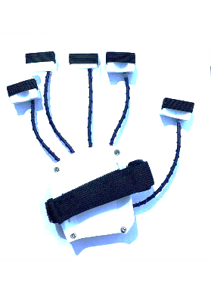
Figure 2: Hand exoskeleton using 3D printing
The exoskeleton is made from 3D printed as Figure 2. An accelerometer and gyro sensor are affixed to the periphery of each exoskeleton. This accelerometer and gyro sensor comprises three autonomous vibratory micro-electromechanical systems (MEMS) rate gyroscopes. which can detect rotational movement along the X, Y, and Z axes as Figure 3. When the autistic children wearing the exoskeleton, the gyros are rotated about any of the sense axes; the Coriolis Effect causes a vibration detected by a capacitive pickoff. The resulting signal is amplified, demodulated, and filtered to produce a proportional voltage proportional to the angular rate. This voltage is digitized using individual on-chip 16-bit Analog-to-Digital Converters (ADCs) to sample each axis. Then, the signal is transmitted through a wireless signal to the robotic hand.

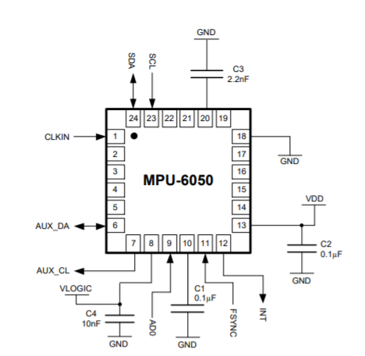 | 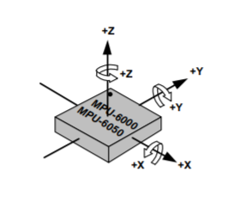
(a) | (b)
Figure 3: MPU 6050 accelerometer and gyro sensor (a) pin connection (b) Orientation of Axes of Sensitivity and Polarity of Rotation

The MPU6050 is equipped with a consolidated three-dimensional accelerometer and three-dimensional gyroscope on a single chip. A gyroscope is an instrument that quantifies the rotational velocity or the rate of change of the angular position over time, namely along the X, Y, and Z-axis. The device utilises Microelectromechanical Systems (MEMS) technology and exploits the Coriolis Effect to do measurements. The gyroscope outputs are expressed in units of degrees per second. Therefore, in order to determine the angular location, it is necessary to perform the mathematical operation of integrating the angular velocity. Figure 4 shows the initial testing of input and output of the MPU6050.

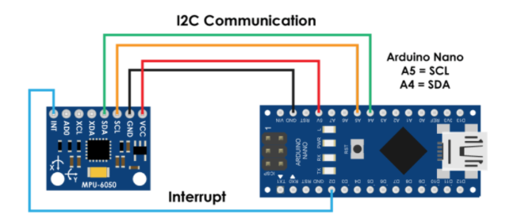
Figure 4: Initial testing input/output of the MPU6050

  - Design of Robot Hand
The design of the robot hand includes the forearm and the palm of the robot hand. It consists of six servo motor; an additional motor is used in thumb finger to move in 2 direction which is an abduction: Moving the bone below the thumb towards the palm and abduction: Moving the bone below the thumb towards the front of the wrist.
The hand's normal fingers permit the following movements at the metacarpophalangeal joint (MCP) or knuckle joint as Table 1. However, for the designed robot hand, the 4 fingers only allow movement the base fingers toward and away from the palm. The signal from the accelerometer, which consists of six angles, must be filtered to give the controller accurate input to move the robot hand. Figure 5 shows the design of a robot hand.

Table 1: Type of Bending of Normal Hand
Type of bending | Movement
Flexion: | Moving the base of the finger towards the palm.  Moving the last two segments of the finger towards the base of the fingers.
Extension | Moving the base of the fingers away from the palm.  Moving the last two segments of the finger away from the base of the fingers.
Adduction | Moving the fingers toward the middle finger.  Moving the fingers away from the middle finger.

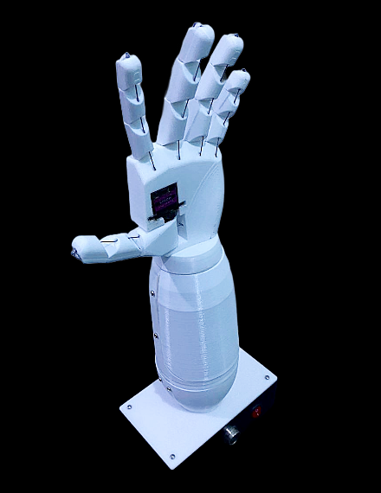
Figure 5: Design of the robot hand.

  - Design of the Display Controller

The overall design of the device proposed is shown in Figure 6. It consists of a robotic hand, the 7-inch Raspberry Pi touch screen display, and an exoskeleton. All three modules are consolidated into a single box that is conveniently portable. The 7-inch Raspberry Pi touch screen display facilitates the development of all-in-one, integrated projects such as tablets, infotainment systems, and embedded applications. The 800 x 480 display is connected via an adaptor board that manages power and signal conversion. Only two connections are necessary for the Pi: power from the GPIO port and a ribbon wire that connects to all Raspberry Pi devices on the DSI port. The new Raspbian OS can include touch screen drivers that allow 10-finger touch and include an on-screen keyboard, eliminating the need for a conventional keyboard or mouse and maximising functionality.

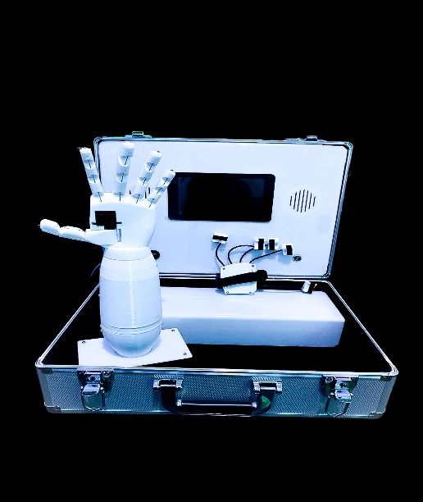
Figure 6: The overall system
The programming of the graphical user interface (GUI) in Raspberry Pi touch screen display enables users to register for first time login and sign every time the user uses this system. The design system has three selected modes which are Mirror Mode, Sequence Mode and Random Mode. Figure 7 displays the graphical user interface (GUI) for the login process. After logging in, the user can select the desired mode of FEFAC, as depicted in Figure 8. The directions for selecting the finger will be presented on the screen, as depicted in Figure 9.

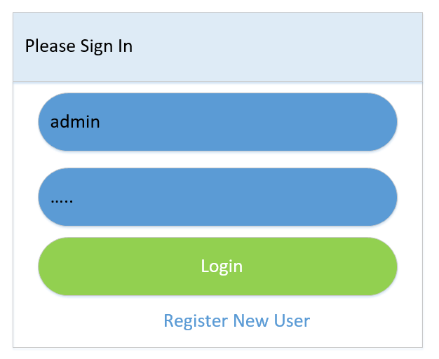 | 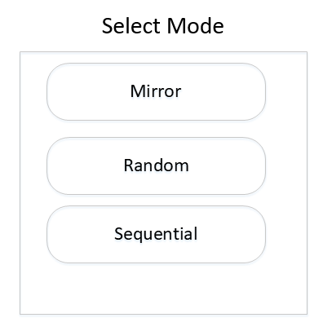
Figure 7: GUI for login | Figure 8: Selection mode

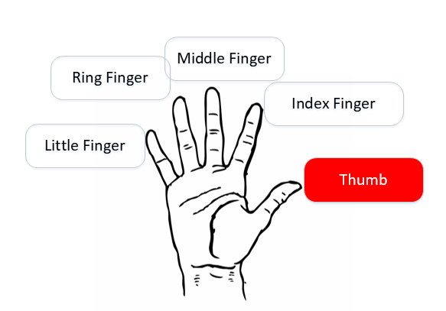 | 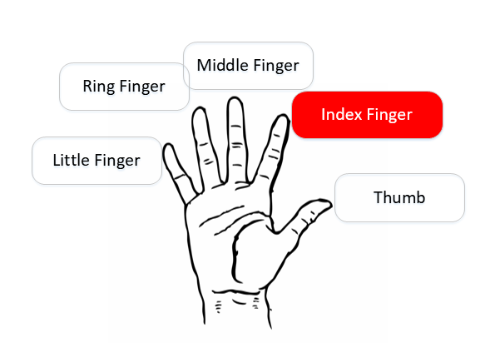
Figure 9: Instruction to display finger

Table 2: Operation of the FEFAC
Mode | Operation
Mirror | - User must bend one of their fingers, and the green indicator will highlight the same finger.  - At the same time, the robot hand will follow the bending finger of the user that wear exoskeleton.  - If the cycle is complete, the applause sounds will be heard.
Random | - The user bends their hand according to display instruction.  - According to the instruction, if the user is bending the correct finger, the green indicator will appear, and the sound of hand clap will produce.  - If the user is bending the incorrect finger specific strength, the green indicator will appear, and sound 'huh' will produce.  - User needs to bend the correct finger to complete the Random program.  - At the same time, the robot hand will follow the user's bending finger that wears exoskeleton.  - The time of user bending the correct finger will be captured and store in SD memory.  - If the cycle is complete, the applause sounds will be heard.
Sequence | - The user bends their hand according to instruction in sequence.  - If the user bending the incorrect finger specific strength, the green indicator will appear and sound 'huh' will produce.  - User needs to bend the correct finger to complete the Random program.  - If the cycle is complete, the applause sounds will be heard.
Table 2.2 shows the summarise operation of each mode of FEFAC, and the flow chart of the operating system is express in Figure 10 to Figure 12. Autism children as a user of this FEFAC will see a display that shows the finger they need to bend as instruct in sound and picture of the hand. The bending hand data is kept in data storage so that the therapist can monitor the development and pattern of movement of the autistic children.

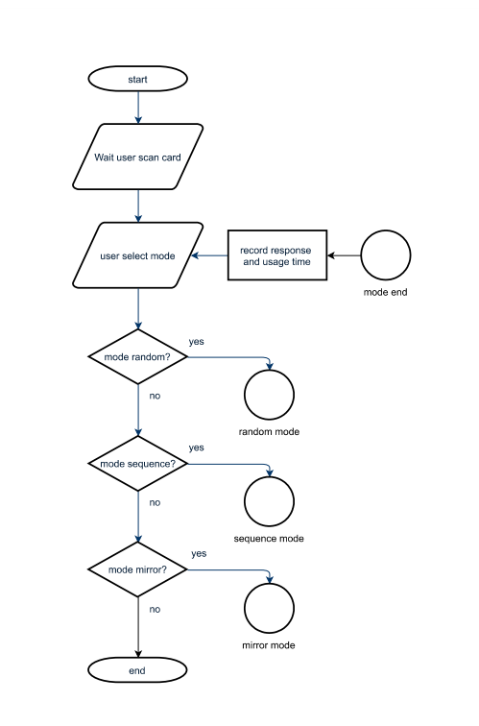 |  | 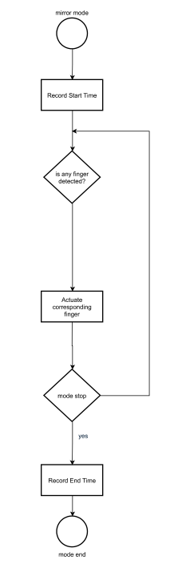
Figure 10: Flow chart for selection mode |  | Figure 11: Flow chart for Mirror Mode operation
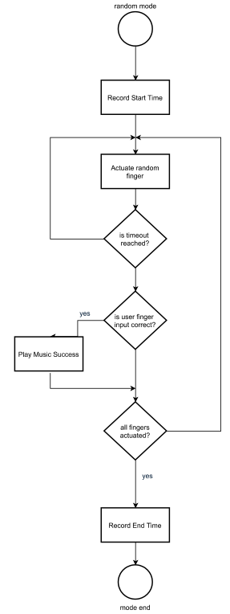 | 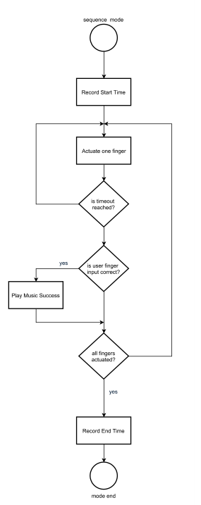
Figure 12: Flow chart for Random Mode operation | Figure 13: Flow chart for Sequence Mode operation

  - Experimental Instrument for The System

The experimental setup involves six children diagnosed with autism spectrum disorder (ASD) at one autism centre in the Southern Region of Malaysia. The objective of this experimental setup was to assess the tolerance of the target population towards the FEFAC and to record the performance of children to study the influence of the system on participants and evaluate the effectiveness of the suggested exercise and game in aiding fine-motor skill intervention. We believe that this experimental setup can demonstrate the practicality of using and the essential procedures for implementing new technology in clinical settings.

RESULTS AND DISCUSSIONS
Conducting a feasibility study is the initial prerequisite prior to collecting clinical data. The session was fully captured on camera, and the success rate of the participant's experimentation was measured. Prior to commencing the experiment, the therapist provided an introduction to the FEFAC system and elucidated the procedure for executing the job. Subsequently, the participant requested to modify the positioning of the finger exoskeleton on his hand and proceeded to rest his hand on a decorative pillow. Throughout the entire experiment, the subject was permitted to take a little respite following each activity. Additionally, individuals are notified of their freedom to terminate the experiment at any given moment. The session lasts for 10 minutes, during which participants have the flexibility to acquaint themselves with the system and ask any questions on the operation of the FEFAC. Upon completion of the experiment, under the supervision of the occupational therapist, the participant completed a concise user survey regarding their genuine sentiments towards the FEFAC. This input will assist us in enhancing the system.

- Acceptability of the FEFAC

All six respondents completed the experimental session. No one expresses the need to quit. Most of the participants are very interested in playing with FEFAC's robotic hand. Most of them have never experienced this kind of game before. The responses of participants to the short user survey reflect the participant's perception of FEFAC. The survey contained two simple questions, as in Table 3.1[22]

Table 3.1: Survey feedback of FEFAC (N=6)
No | Questions | Mean
1 | How much did you like playing these games?  Choices: Very much (5) A little, Neutral, Not much, Not at all (1) | 4.33
2 | How easy was to understand how to play this game?  Choices: Very easy (5), Easy, Neutral, Difficult, Very difficult (1) | 4.00

Based on observation and participant feedback, the participant did not face any difficulty using the system and did not resist using the FEFAC. The FEFAC method and related tasks were appropriate for the study participant.

- Analysis of Fine Motor Skill

All 6 volunteers are effectively conducting this experiment. However, one of them first experienced a sensory issue when wearing the exoskeleton hand and subsequently declined to wear it. However, despite the challenges, this participant successfully completes the experimental session with the therapist's clear and detailed explanation. In this experimental setup, participants have the opportunity to use FEFAC without adhering to any predefined programme prescribed by the therapist. The raw data collected from the participant is displayed in Figure 14. The finger's 25-second movement was recorded while wearing the exoskeleton, and participants were instructed to flex and extend their fingers. It displays the angular location of the finger over time. The objective is to assess the participant's capacity to flex and extend their finger simultaneously. The data indicates that Participant A, E, and F exhibit irregular movement patterns in their five fingers, whilst Participant D and E demonstrate a lack of coordination in their ring finger movements. To make it more understandable in this experimental rig, we capture the data of FEFAC in a neurotypical child as stipulated in Figure 15. The finger is shown to bend and straighten with the same pattern compared to the six participants.

- Participant A

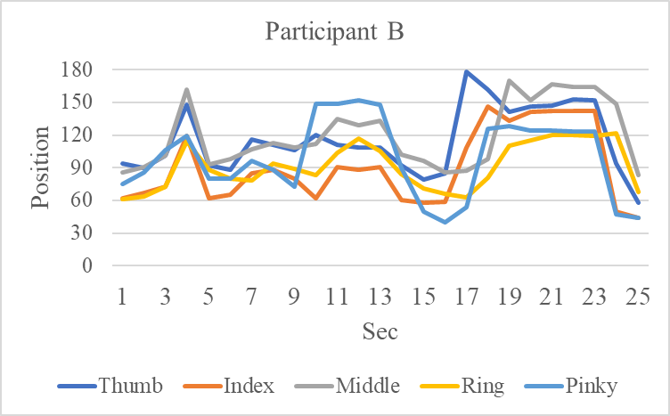
- Participant B
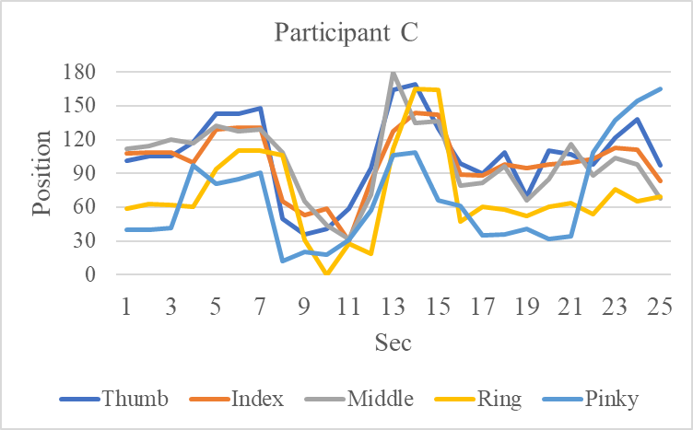
- Participant C

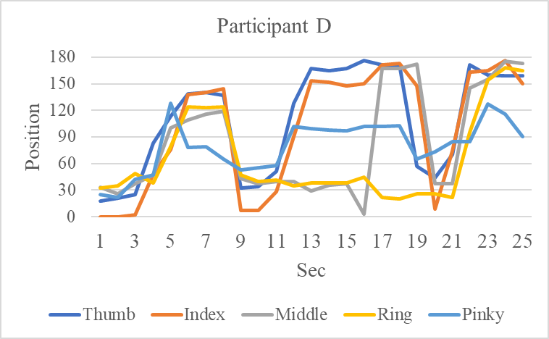
- Participant D

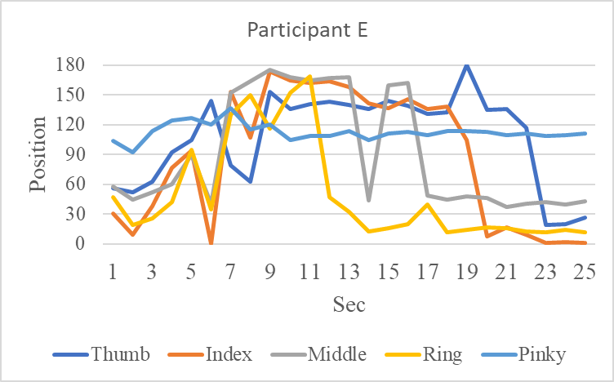
- Participant E
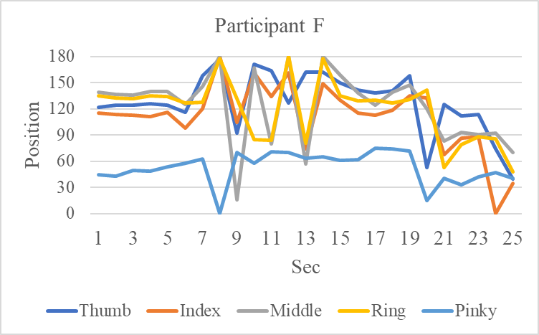
- Participant F
Figure 14: Data capture for a position in the finger's angle versus time for six participants.

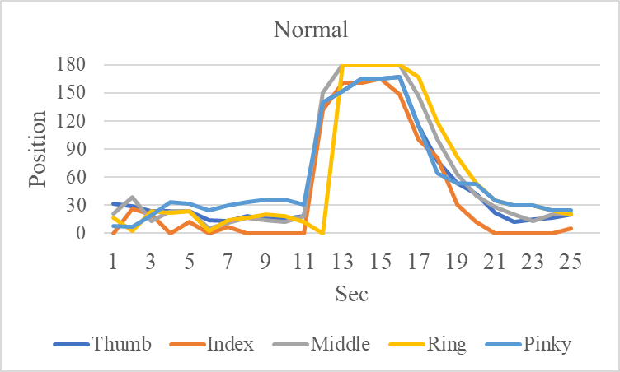
Figure 15: Data capture for a position in the finger's angle versus time for a neurotypical child
From these preliminary results, the feasibility usage indicates that the FEFAC system was acceptable to study participants. The experimental rig's initial data capture also shows that fine-motor skill performance can be captured and compare to the development at a suitable time.

CONCLUSIONS AND RECOMMENDATIONS

In contrast to typical kids, many autistic kids experience fine-motor function delays. In doing their fine-motor therapy, the exergame is intended to attract children with autism. Feasibility tests have been performed on six autistic children, and it has been found that children are involved in using them and could get used to it quickly. This study offers valuable recommendations for possible inquiries into the exergame capacity for autistic children to access and develop fine-motor skills.

This research project's results and findings can be useful to researchers, occupational therapists, the government, and all those who want to do further research for the autism community. For expansion and extensions in the areas of research, some of the following proposals are highlighted:
- It is suggested that the future researcher can enhance the data collection involving larger sample size, a matched group, the finer motor task of varying complexities and more session to meet the need of users with different fine-motor impairment.
- The experiment conducted shows that the robot hand design can be changed to make it more stable for frequently used. The suggestion is to use a robot hand design-driven continuously without any strings and pulleys using a linear motor.
- It is proposed that the product design of this research is a registered patent, as the contribution of novelty to children with autism, particularly in fine-motor skills, is truly promising.

REFERENCES

[1] C. Casellato, M. Gandolla, A. Crippa, and A. Pedrocchi, “Robotic set-up to quantify hand-eye behavior in motor execution and learning of children with autism spectrum disorder,” IEEE International Conference on Rehabilitation Robotics, pp. 953–958, 2017, doi: 10.1109/ICORR.2017.8009372.
[2] M. Lloyd, M. MacDonald, and C. Lord, “Motor skills of toddlers with autism spectrum disorders,” Autism, vol. 17, no. 2, pp. 133–146, 2013, doi: 10.1177/1362361311402230.
[3] G. Wulf, C. Shea, and R. Lewthwaite, “Motor skill learning and performance: A review of influential factors,” Med Educ, vol. 44, no. 1, pp. 75–84, 2010, doi: 10.1111/j.1365-2923.2009.03421.x.
[4] H. L. McGlashan, C. C. V. Blanchard, J. S. Nicole, R. Lee, B. French, and N. J. Sycamore, “Improvement in children’s fine motor skills following a computerized typing intervention,” Hum Mov Sci, vol. 56, no. December 2016, pp. 29–36, 2017, doi: 10.1016/j.humov.2017.10.013.
[5] H. L. McGlashan, C. C. V. Blanchard, J. S. Nicole, R. Lee, B. French, and N. J. Sycamore, “Improvement in children’s fine motor skills following a computerized typing intervention,” Hum Mov Sci, vol. 56, no. December 2016, pp. 29–36, 2017, doi: 10.1016/j.humov.2017.10.013.
[6] R. Ghazali, C. C. Soon, S. Najmuddin, and S. Hassan, “Design and Development of Therapeutic Aid Tools using Human-Machine Interaction Approach for Children with Autism Spectrum Disorder,” International Conference on Kansei Engineering & Emotion Research, pp. 530–537, 2018, doi: 10.1007/978-981-10-8612-0_55.
[7] S. Finkelstein, A. Nickel, T. Barnes, and E. A. Suma, “Astrojumper: motivating children with autism to exercise using a VR game,” Proceedings of the 28th of the international conference extended abstracts on Human factors in computing systems - CHI EA ’10, p. 4189, 2010, doi: 10.1145/1753846.1754124.
[8] S. O. Chicu, A. Ţicău, and L. Şoitu, “Training for New Technologies. Handwriting with New Technologies,” Procedia Soc Behav Sci, vol. 142, pp. 781–785, 2014, doi: 10.1016/j.sbspro.2014.07.616.
[9] M. Schickler et al., “An IT Platform Enabling Remote Therapeutic Interventions,” Proc IEEE Symp Comput Based Med Syst, vol. 2017-June, pp. 111–116, 2017, doi: 10.1109/CBMS.2017.78.
[10] B. Scassellati, Henny Admoni, and M. Matarić, “Robots for Use in Autism Research,” Annu Rev Biomed Eng, vol. 14, no. 1, pp. 275–294, 2012, doi: 10.1146/annurev-bioeng-071811-150036.
[11] D. Collins, A. Attal, and C. Hilton, “Use of Exergaming to Improve Physical and Mental Fitness for Children With Autism Spectrum Disorders,” American Journal of Occupational Therapy, vol. 69, no. Suppl. 1, p. 6911520176p1, 2015, doi: 10.5014/ajot.2015.69S1-PO3095.
[12] K. Caro, M. Tentori, A. I. Martinez-Garcia, and I. Zavala-Ibarra, “FroggyBobby: An exergame to support children with motor problems practicing motor coordination exercises during therapeutic interventions,” Comput Human Behav, vol. 71, pp. 479–498, 2017, doi: 10.1016/j.chb.2015.05.055.
[13] C. L. Hilton et al., “Effects of Exergaming on Executive Function and Motor Skills in Children With Autism Spectrum Disorder: A Pilot Study,” American Journal of Occupational Therapy, vol. 68, no. May, pp. 57–65, 2014, doi: DOI 10.5014/ajot.2014.008664.
[14] L. Ketcheson, J. Hauck, and D. Ulrich, “The effects of an early motor skill intervention on motor skills, levels of physical activity, and socialization in young children with autism spectrum disorder: A pilot study,” Autism, vol. 21, no. 4, pp. 481–492, 2017, doi: 10.1177/1362361316650611.
[15] H. L. McGlashan, C. C. V. Blanchard, J. S. Nicole, R. Lee, B. French, and N. J. Sycamore, “Improvement in children’s fine motor skills following a computerized typing intervention,” Hum Mov Sci, vol. 56, no. December 2016, pp. 29–36, 2017, doi: 10.1016/j.humov.2017.10.013.
[16] E. Bremer, R. Balogh, and M. Lloyd, “Effectiveness of a fundamental motor skill intervention for 4-year-old children with autism spectrum disorder: A pilot study,” Autism, vol. 19, no. 8, pp. 980–991, 2015, doi: 10.1177/1362361314557548.
[17] S. Finkelstein, A. Nickel, T. Barnes, and E. A. Suma, “Astrojumper: motivating children with autism to exercise using a VR game,” in Proceedings of the 28th of the international conference extended abstracts on Human factors in computing systems - CHI EA ’10, 2010, p. 4189. doi: 10.1145/1753846.1754124.
[18] K. Caro, M. Tentori, A. I. Martinez-Garcia, and I. Zavala-Ibarra, “FroggyBobby: An exergame to support children with motor problems practicing motor coordination exercises during therapeutic interventions,” Comput Human Behav, vol. 71, pp. 479–498, 2017, doi: 10.1016/j.chb.2015.05.055.
[19] S. Cai, G. Zhu, Y. T. Wu, E. Liu, and X. Hu, “A case study of gesture-based games in enhancing the fine motor skills and recognition of children with autism,” Interactive Learning Environments, vol. 26, no. 8, pp. 1039–1052, 2018, doi: 10.1080/10494820.2018.1437048.
[20] G. Zhu, S. Cai, Y. Ma, and E. Liu, “A Series of leap motion-based matching games for enhancing the fine motor skills of children with autism,” Proceedings - IEEE 15th International Conference on Advanced Learning Technologies: Advanced Technologies for Supporting Open Access to Formal and Informal Learning, ICALT 2015, pp. 430–431, 2015, doi: 10.1109/ICALT.2015.86.
[21] S. P. Ramya S. Moorthy, “Teaching Psychomotor Skills to Autistic Children by Employing a Robotic Training Kit: A Pilot Study,” Int J Soc Robot, vol. 9, no. 1, pp. 97–108, 2017.
[22] H. Zhao, Z. Zheng, A. Swanson, A. Weitlauf, Z. Warren, and N. Sarkar, “Design of a Haptic Virtual System for Improving Fine Motor Skills in Children with Autism,” Advances in Intelligent Systems and Computing, vol. 592, no. 4, pp. 204–216, 2018, doi: 10.1007/978-3-319-60366-7_20.

