**Synthesis, characterization, physicochemical kinetics and assay studies of novel *MOCEB* biofilm for bio-preservation of fresh tomato fruits**

Nonye Jennifer **Ohale1**, Matthew Chukwudi **Menkiti1\***, Chinenye Faith **Okey-Onyesolu1**\*, Paschal Enyinnaya **Ohale1**\*

***1****Department of Chemical Engineering, Nnamdi Azikiwe University, P.M.B. 5025, Awka, Nigeria.*

*\*Corresponding author’s contact *Corresponding author’s contact*

Phone +2348036431594 Phone +2348037441882

E-mail: [pe.ohale@unizik.edu.ng](mailto:pe.ohale@unizik.edu.ng) E-mail: [mc.menkiti@unizik.edu.ng](mailto:pe.ohale@unizik.edu.ng)

**ORCID**; P. E Ohale  **ORCID**; M.C Menkiti

[https://orcid.org](https://orcid.org/0000-0001-5332-7742)/0000-0001-5332-7742 [https://orcid.org](https://orcid.org/0000-0001-5332-7742)/0000-0002-2095-7294

*\*Corresponding author’s contact*

Phone +2348037856752

E-mail: [cf.okey-onyesolu@unizik.edu.ng](mailto:cf.okey-onyesolu@unizik.edu.ng)

**ORCID**; C. F. Okey-Onyesolu

[https://orcid.org](https://orcid.org/0000-0001-5332-7742)/0000-0002-4515-6960

**Abstract**

*The research was conducted to ascertain the efficacy of moringa leaf extracts (MOLE) and chitosan edible bio-preservative (MOCEB) in shelf-life extension of fresh tomato fruits. Functional group characterization revealed the presence of imines (C=N) at 1661.8 cm-1 which authenticated the cross-linking reaction between -NH2 of chitosan and carbonyl groups of MOLE. Hydrocarbon and phytochemical analysis with gas chromatography mass spectrometry (GC-MS) indicated that MOLE contained high amount of antimicrobial hydrocarbons (Pentadecane = 18.46%; Tridecane = 12.386%; Heptacosane = 12.013 %). Similarly, MOCEB was found to contain significant antioxidants including quercetin (10.265 %). After 20 days of non-refrigerated storage at 1% chitosan conc. and MOCEB ratio of 40:60, the tomato fruit maintained a titratable acidity (TA) of 2.1706 g/kg and reduction in weight loss of 20.01%. Zero-order (0.9797≤R2≤0.9815) and first order (0.8941≤R2≤0.9417) models were superior in describing the bio-preservation process at chitosan conc. and MOCEB mixing ratio, respectively. Assay studies showed the efficacy of MOCEB biofilm in antagonizing the growth of gram-positive (rA = 7.93 mm) and gram-negative (rA = 7.73 mm) bacteria, and authenticated the anti-oxidant activity (DPPH = 71% and FRAP = 0.62). The results from this study demonstrated that MOCEB biofilm can be employed to significantly reduce the post-harvest losses of tomato fruits through coating bio-preservation.*

**Key words**: Bio-preservation; Biofilm; Coating; Tomato fruit; *Moringa* leaf extract.

**Introduction**

The consumption of fresh and naturally grown fruits and vegetables is becoming increasingly common to consumers, but the preservation of these fruits and vegetables have become a major global problem to the food industry (Kayode and Afolayan, 2014). Tomato (*Solanum Cycopersium*) is one of the most widely grown vegetable crops in the world (Mahfoudhi et al., 2014). About 130 mega tonnes of tomatoes are produced annually in the globe; this is due to the availability throughout the year in most tropical regions of the world. Tomato is rich in vitamins (such as vitamin A, vitamin C), carbohydrate, protein, fibre and potassium (Ruelas-Chacon et al., 2017). It is also rich in lycopene which has many health benefits such as, the prevention of cancers, and improvement in the skin’s ability to protect itself against the sun’s harmful ultraviolet rays (Tarangini et al., 2022). Tomato is regarded as an ‘easy to damage’ kind of fruit, due to its climacteric characteristics of continuous ripening after harvest. The shelf life of untreated tomato fruit varies between 4 - 8 days at room temperature, depending on the mode of preservation (Pinheiro et al., 2015, Nasrin et al., 2008).

Nigeria is the 14th largest producer of tomato in the world and the 2nd largest Tomato producer in Africa (Olanrewaju et al., 2019). Nigeria produced more than 3.9 million tonnes of tomatoes in 2019, and recorded about 45 – 60 percent of this annual production to losses (Sibomana et al., 2019). This post harvest losses can be attributed to microbial decay and physiological activity during transportation and storage. In time past, different modes of food preservation, such as drying, freezing, curing and canning, were used to extend the shelf life of food crops (Islam et al., 2018); but were time consuming, required large amounts of energy, and altered the taste and nutritional value of the food. Also, the use of chemical preservative to extend the shelf life of food products has been associated with several health challenges, (Teshome et al., 2022). Hence, bio-preservatives are currently becoming an alternative option to chemical preservatives, because they maintain the hygienic quality, nutritional properties and extended shelf life of food products. Plants extract such as moringa oleifera leaf (Naik et al., 2023), green tea, clove extracts, and animal extracts (prawn, shrimps, crab shell) have been applied as bio-preservatives to inhibit the growth of pathogenic microorganism, slow down the oxidative reactions within the food system and extend the shelf-life fruits and vegetables (Islam et al., 2018).

Chitosan is non-toxic, bio-functional, biodegradable and bio-compatible edible coating. Chitosan has the ability to inhibit fruit decay through its antifungal and antimicrobial activities (Ruvubu and Roy, 2023). Chitosan based coatings have successfully reduced the respiration rate of fruits and vegetables by inhibiting the penetration of carbondioxide and oxgyen (Panda et al., 2023). Also, chitosan has demonstrated promising effectiveness when applied on food materials such as papaya, guava, strawberry, and banana (Hong et al., 2012, Islam et al., 2018). Previous studies (Islam et al., 2018, Butt et al., 2023) have demonstrated that the use of mixed formulation of chitosan coating & natural preservative improves the longevity of several perishable foods. Similarly, moringa oleifera leaves have been reported to possess various biological activities such as antidiabetic, hypertensive agent, and regulation of thyroid hormone (Alsamhary, 2023). The extracts from the leaves are known to be rich in β-carotene, and possess high amounts of phenolics, flavonoids, alkaloids, tannins, and anthraquinone which are responsible for the antimicrobial and antioxidant properties (Butt et al., 2023, da Silva et al., 2022).

One of the promising postharvest treatments used for extending the shelf-life of food is edible coating technology. Application of edible coating on fresh fruits reduces the alteration in quality and degradation index. The synthesis of Chitosan and Moringa Oleifera extract is envisaged to form a bio film which can be applied as an edible coating on the tomato fruit. To the best of our knowledge, there has not been any documented report on the application of chitosan and moringa oleifera leaf extract biomix in the coating of tomato fruit.

Optimization of bio-preservation storage conditions of tomato is necessary to consolidate the properties and shelf life of the fruit. Management of fresh tomato fruit entails regulating the physicochemical dynamics which occur during storage (Mai and Pathare, 2021). All of this will be accomplished by numerically analyzing the parameters of importance. Kinetic modeling is an important technique for predicting and controlling these dynamic changes in fresh product quality parameters (Liao et al., 2024). Kinetic based models have traditionally been employed to describe variations internal (titratable acidity), and external (weight loss) qualities of fruits and vegetables (Al-Dairi et al., 2023). To the best of our knowledge, the physicochemical kinetics of tomato fruit bio-preservation has not been effectively discussed.

Given Nigeria’s high tomato fruit production capacity, and associated significant amount of post-harvest losses, it is desirable to employ a benign approach to manage the shelf-life in order to reduce waste. This can be achieved by novelly harnessing the bio-preservation potentials of *MOLE* and chitosan complex in biofilm coating of fresh tomato fruit. Specifically, the current study will consider: (1) synthesis and characterization of *MOLE*, chitosan and *MOCEB* biofilm; (2) investigation of bio-preservation process variables; (3) physicochemical kinetic, and error appraisal studies; (4) exploration of antimicrobial and antioxidant activities.

**2.0 Materials and methods**

2.1 Materials

2.1.1 Sourcing of *Moringa Oleifera* leaves and Chitosan substrates

*Moringa Oleifera* leaves were sourced from local from farms grown in Anambra State. The fresh *Moringa Oleifera* leaves were washed to remove any dirt and other impurities and subsequently dried in open air to remove moisture on the surface of the leaves and were kept for further use. Medium molecular weight chitosan with ≥ 80% degree of deacetylation was purchased from Sigma-Aldrich, United States of America.

2.1.2 Collection and preparation of tomato fruits

Fresh tomatoes with uniform colour, and no obvious physical damage or bruising were carefully harvested from a local tomato farm in Kangimi, Igabi local government area, Kaduna state, Nigeria. The tomato fruits were well packaged and transported down to Awka, Anambra state, after 24 hr of harvest. The transported fruits were washed using distilled water and air-dried at room temperature prior to the treatment.

2.2 Methods

2.2.1 Synthesis of *MOCEB* biofilm

*Moringa Oleifera* leave extract was prepared by leaching *MOLE* from dried *Moringa Oleifera* leaves using pure ethanol. Five percent (5g weight of sample/100ml of solvent) dried moringa leaves were added to pure ethanol under constant stirring conditions. The solution was allowed to stir at 50 oC for 12 h. After which, it was filtered and oven dried at 70 oC onto constant weight to obtain *MOLE*.

Different concentration of chitosan solution encompassing 0.5 %, 1 %, 1.5 % , 2.0 %, and 2.5 % (weight of sample/100 ml) was prepared by dissolving measured amounts of chitosan powder in 1 % acetic acid solution under constant stirring at 60 oC, for 5 h. *MOCEB* was prepared by mixing the pure (chitosan 100 % or *MOLE* 100 %) and blended (*MOLE*:chitosan = 20%:chitosan 80% ; 40%:chitosan 60% ; 60%:chitosan 40% ; 80%:chitosan 20%) substrates of *MOLE* and Chitosan using glycerol plasticizer (25 % w/w). The mixture was allowed to stir at 40 oC and 500 rpm for 2 h using Axiom hotplate magnetic mixer (Model 85-2). After this process the sample as allowed to cool to room temperature. The cooled samples were immediately used for bio-coating of fresh tomatoes, while the remaining was labeled *MOCEB* and preserved with refrigeration until further use.

2.2.2 Coating and bio-preservation studies

Tomato samples were shared into two groups of equal number; one group served as the uncoated (negative control) while the other group was subjected to *MOCEB* coating. Subsequently, in each of the two batches, five sub-groups were selected to represent the process variable levels. Each level was made up of three tomato fruit samples, and the result obtained at the end of the experiment for each level of process variable was a mean value of the three tomato fruit samples. Coating was done by immersing each tomato fruit sample into the *MOCEB* biofilm for 60 sec., after which they were allowed to dry for 2 min. Prior to storage, the weight of all the samples and the initial titratable acidity (TA). All samples were placed in specially designed bio-respirators as depicted in Fig. S1 and S2 (supplementary material). Physicochemical properties in terms of Weight loss rate and titratable acidity were measured and recorded at different sampling days. The governing equations for estimating the weight loss, weight loss rate, and TA are given in Eqs. (1) - (3), respectively.

$Weight loss \left(\%\right)=\left(\frac{W_{1}−W_{2}}{W_{1}}\right)×100$ (1)

$Weight loss rate \left(\frac{g}{day}\right)=\left(\frac{W_{1}−W_{2}}{t_{ }}\right)$ (2)

Where W1 and W2 represent the initial and final weight (g) of tomato fruit at sampling time, while t denotes the sampling time (day).

$TA \left(\frac{g citric acid}{kg of tomato}\right) = \left(\frac{V×0.1×1000×0.064}{m}\right)$ (3)

Where 0.1 is the normality of NaOH (N), 0.064 is the conversion factor from sucrose acid to citric acid, V is the volume of NaOH required for the titration (ml), while m is the mass of tomato juice (g), (AOAC, 2000).

2.2.3 Characterization

The physicochemical characterization to determine the properties of MOLE, chitosan and MOCEB biofilm were carried out according to AOAC standard (Ohale et al., 2022, Feldsine et al., 2002).

The detailed procedures for ascertaining the phenolic compounds, flavonoids, alkaloids, tannins, styrene, and benzoic acid, were reported in section S1 of the supplementary material. The hydrocarbon and the phytochemical constituents of the substrates were carried with SHIMADZU GC-MS equipment (model QP2010), following AOAC guidelines (Feldsine et al., 2002). Furthermore, the chemical functional groups were determined with Buck scientific infrared spectrophotometer (Model 530).

2.2.5 Kinetic studies

To determine the physicochemical dynamics of the tomato fruits during storage at ambient temperature 25 oC, the kinetic data of the quality parameters were tested on established kinetic models outline in Eqs. (4) - (6).

Zero order model

$C=C_{o}−Kt$ (4)

Nonlinear first order

$C=C_{o}e^{±Kt}$ (5)

Linear first order

$Ln(C)={Ln(C}_{o})±Kt$ (6)

Where C is the measured quality parameter at sampling time (day), Co denoted the initial value of the quality parameter, while K and t represent the model rate constant and sampling time, respectively. A plot of C (or $Ln\left(C\right)$) vs time will produce K as the slope and Co as intercept (Al-Dairi et al., 2023).

The fitness of the kinetic data on each kinetic model was appraised using error function models outlined in Eqs (7) - (10), (Ohale et al., 2023, Abonyi et al., 2023).

 (7)

 (8)

${Adjusted R}^{2}= 1− \left[\left(R^{2}\right) x \frac{N−1}{N−P−1}\right]$ (9)

$SSE = \sum_{i=1}^{N}{{\left(y_{exp.}−\overline{y}\right)}^{2}}$ (10)

Where R is regression analysis, RMSE is the root mean square error, SSE represent the sum of square error, N denotes the number of data points, P is the number of variables, while y*pred.(i*) is the model prediction, y*exp.*(i) is the actual experimental response, y*exp.ave.* is the mean value of experimental data, and i is the data index.

2.2.6 Assay Studies

The assay studies was done to determine the antimicrobial inhibition of the biofilm on tomato juice.

2.2.6.1 Agar well diffusion

The antimicrobial activity of chitosan, *MOLE* and *MOCEB* were accessed using agar well diffusion method. The procedure adopted in the work has been previously reported by other researchers (Ahmadpour Kermani et al., 2021, Vijayakumar et al., 2020, Walia et al., 2020). The microbial cultures used were two gram positive species (*S. aureus and B. cereus*) and two gram negative (*E. coli and S. typhi*) species. A suspension containing 1.6×103 cells/m of each bacteria species was cultured on the tomato agar medium. Then, six millimetre walls were created in the agar medium using sterile cork borer. Equal volume (30µl) of varying concentration (25, 50, 75 100 mg/mL) of the inhibitors and positive control (gentimicin) were delivered into the wells. The medium was incubated for 24hr at 37 ± 0.5 oC to allow for full development bacteria growth and inhibition zone. Inhibitory efficiency was determined by measuring the annular diameter (inhibition zone) to get a reflection of the inhibition potency of each inhibitor (chitosan, *MOLE*, *MOCEB*) and the gentimicin positive control. The report of this antimicrobial assay was discussed in details (see section 3.41).

2.2.6.2 Antioxidant studies

Antioxidant activity by DPPH (2,2-diphenyl-1-picrylhydrazyl) radical scavenging assay. The free radical scavenging activity of the antioxidants was investigated using DPPH radical scavenging method, as reported by Karadag et al., (Karadag et al., 2009) with slight modification. One milliliter of each antioxidant (at 1.0 mg/ml conc.) was prepared in triplicate and mixed with 1 ml DPPH (0.135 mM). The mixture was further mixed with in 1 ml methanol. Afterwards, the sample mixture was carefully vortexed and kept to rest for 30 min at room temperature. The mixture absorbance was measured at 517 nm using UV/Vis spectrophotometer and the percentage of the DPPH radical scavenging was expressed using Eq. (11).

$\%Free radical scavenging activity=\frac{Ac−As}{Ac}×100$ (11)

Where Ac =Absorbance of control at 517 nm

As = Absorbance of sample.

2.2.6.2.2 Ferric ion Reducing Antioxidant Power (FRAP*)*

The methods described by Ghasemi et al., (Ghasemi et al., 2019) and Mohamed at al., (Mohamed et al., 2013) were used to study the ferric reducing power assay of the biofilms and positive control (garlic oil). Concisely, 1 ml of MOLE was mixed with 2.5 mL of 1% potassium ferricyanide [K3Fe(CN)6] and 2.5 mL of 200 mM phosphate buffer with pH 6.6. After the incubation of the mixture for 20 min at 50o C, 2.5 mL of 10% trichloroacetic acid was added to the mixture and centrifuged at 10,000 rpm for 10 min. Five milliliters of distilled water and 1 mL of 0.1% ferric chloride were mixed with 5ml of the top layer of mixture, and the final solution absorbance was recorded at 700 nm. Results were expressed by plotting absorbance against concentration, using ascorbic acid as standard.

**3.0 Results and discussion**

3.1 Characterization

3.1.1 Phytochemical properties

The phytochemical compositions of *MOLE* and *MOCEB* are illustrated in **Table 1**. The results show that both *MOLE* and *MOCEB* contain significant amounts (+++) of flavonoids, and phenolic compounds, and also moderate amounts (++) of tannins and alkaloids. Trace amounts of benzoic acid were detected in *MOLE* and *MOCEB*, while the aromatic compounds were undetected after *MOCEB* synthesis. These results satisfactorily authenticate the viability of *MOCEB* to promote antioxidant activities during tomato fruit storage.

|  |  |  |
| --- | --- | --- |
| Table 1: Phytochemical result of MOLE and MOCEB | | |
| Constituent | Qualitative mount | |
| MOLE | MOCEB |
| Alkaloids | **++** | **++** |
| Tannins | **++** | **++** |
| Flavonoids | **+++** | **+++** |
| Polyphenols and phenolic acids | **+++** | **+++** |
| Hydroxycinnamic acid and styrene | **+** | **-** |
| Benzoic acid | **+** | **+** |

3.1.2 FTIR

3.1.2.1 FTIR of *MOLE* and chitosan

The Fourier transform infra-red spectra (FTIR) of *Moringa Oleifera* leaf extract (*MOLE*) and chitosan film were depicted in **Figs**. 1 and 2, respectively. The infrared spectrum of MOLE produced nine prominent peaks at 3482.97, 2947.17, 2004.61, 1688.03, 1641.42, 1557.34, 1081.72, 1026.22 and 528.86 cm-1. The broad wavelength at 3482.97 cm-1 is attributed to O–H group, which highlights the presence of phenol functional group in *MOLE* (Khalid et al., 2023). This is not out of place given that *MOLE* substrate is laden with flavonoids which possess O–H functional group. Symmetric and asymmetric stretching of aliphatic C-H group of alkanes was detected by 2947.17 cm-1 vibration while the peak at 2004.61 cm-1 translates to a potent C–C triple bond alkyne group (Naik et al., 2023). These observations corroborate the findings of other researchers (da Silva et al., 2022, Khalid et al., 2023, Marrufo et al., 2013) who reported significant presence of alkane compounds in leaf extracts of *Moringa Oleifera*. Also, the antimicrobial activities of these compounds have been established (Wei et al., 2023, Carev et al., 2023a). Infrared peaks existing withing 1700 - 1800 cm-1 denote the presence of antioxidants in *MOLE* (Johnson et al., 2020). Characteristic vibrations at 1688.03 and 1641.42 cm-1 authenticate the presence of C=O carbonyl groups (present in carboxylic acids and ketones) and NH stretching of amide groups, respectively (Cusioli et al., 2023). The peak at 1557.34 cm-1 corresponds to C–N elongation and bending vibrations found in primary and secondary amides of *MOLE* proteins. The sharp bands at 1081.72 and 1026.22 cm-1 are associated with C–H and C–O elongation vibrations of alcohols (Aisida et al., 2021). This is expected, since ethanol was used in the extraction of MOLE substrates. The presence of halo compounds is linked to the spectral peak at 528.86 cm-1.

Similarly, the infrared spectrum of chitosan depicted identical number of relevant peaks between 3324.8 to 659.15 cm-1 (see **Fig.** 2). The highest absorption band at 3324.4 cm-1 accounts for the presence of N–H bonds inherent in amino groups of chitosan molecules. This peak also highlights the existence of O-H stretching vibration resulting from intra-molecular hydrogen bonding (Ruvubu and Roy, 2023). The absorption band at 1649.8 cm-1 reveals the presence of N–H bending vibration associated with amine groups of chitosan (Tan et al., 2018). Also, the peak at 1593.11 cm-1 denotes the presence of **˗**NH2 vibration of primary amine, which is a very reactive functional group of chitosan biopolymer (Bhat et al., 2023). The wave bands at 1420.60 and 1350.60 cm-1 correspond to symmetric deformation of CH2 groups, and amide III group vibration which resulted from NH group deformation respectively (Smolarkiewicz-Wyczachowski et al., 2023). Infrared absorption bands that exist within the range 1250 to 800 cm-1 are typically associated with glycosidic ring. Specifically, characteristic vibrations at 1061.04 and 993.03 cm-1 shows the pressure of C–O stretching bonds of glucosamine ring in the chitosan sample (Hadidi et al., 2020). Furthermore, the peak at 659.14 cm-1 shows the O**–**C**‒**O vibration of acetic acid. This observation is connected to the fact that acetic acid was used as the dissolution solvent in forming the chitosan solution. A universal observation from the *MOLE* and chitosan surface chemistry reveals that the *MOLE* substrate possess desirable qualities to promote both antimicrobial and antioxidant properties during tomato fruit bio-preservation, while chitosan predominantly illustrate antimicrobial qualities.

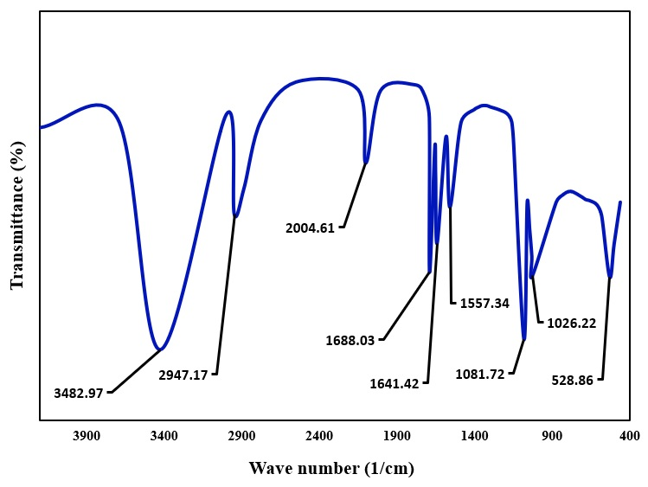

Fig. 1. FTIR Spectrum of *Moringa Oleifera* leaf extract (*MOLE*).

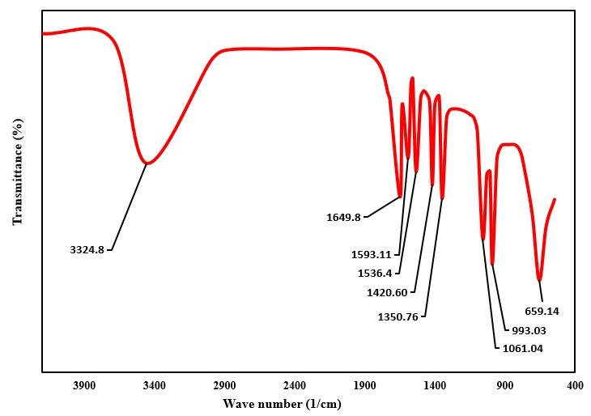

Fig. 2. FTIR Spectra of Chitosan

3.1.2.2 FTIR of *MOCEB*

FTIR spectroscopy was useful in exploring the chemical relationships between chitosan and *MOLE*, which contributed to the physicochemical characteristics of the *MOCEB* biofilms. The infrared spectra of pure substrates (*MOLE* and chitosan) and their variable composition derivatives were depicted in **Fig**. 3. The spectra results of *MOCEB* species illustrate the formation of new peaks which could be attributed to the interactions of *MOLE* and chitosan functional groups. The vibrational peak at 3454.61 cm-1 highlights a slight shift from the OH functional group of 3482.97 cm-1 found in *MOLE*. However, the formation of this band may be as a result of the interractions of NH amino group of chitosan (3324.8 cm-1) and OH functional group of *MOLE*. This reactive interaction could signal the cross-linking of chitosan and flavonoids contained in *MOLE* substrate.

Additionally, the alkane group was identified by the absorption peak at 2948.11 cm-1, while the alkyne group shifted from 2004.61cm-1 in *MOLE* to 1980.83 cm-1 in the *MOCEB* sample. The new sharp absorption peak at 1661.8 cm-1 highlights the formation of C=N stretching mode of imines, which could result from the interactions of amine groups (N–H, –NH2) of chitosan and carbonyl groups (C=O, Ketones, carboxylic acid) of *MOLE* in a Schiff-base reaction (Božič et al., 2012, Tan et al., 2018). The presence of amide II and III in the *MOCEB* biofilm was noted at 1560.25 and 1357 cm-1, respectively. It is important to note that these amide peaks shifted from their original bands in *MOLE* and chitosan, confirming efficient interactions in *MOCEB* synthesis. The wave band at 1071.7 cm-1 and 936.3 cm-1 which are slight deviations from 1081.72 cm-1 (*MOLE* substrate), and 993.3 cm-1 (chitosan substrate) indicates the presence of alcohol traces and glucosamine in the *MOCEB* biofilm. It is important to note that the presence of acetic acid at 659.84 cm-1 remained unaffected in all mixed species involving chitosan sample. This implies that there was no interaction between *MOLE* and acetic acid remnants contained in chitosan solution.

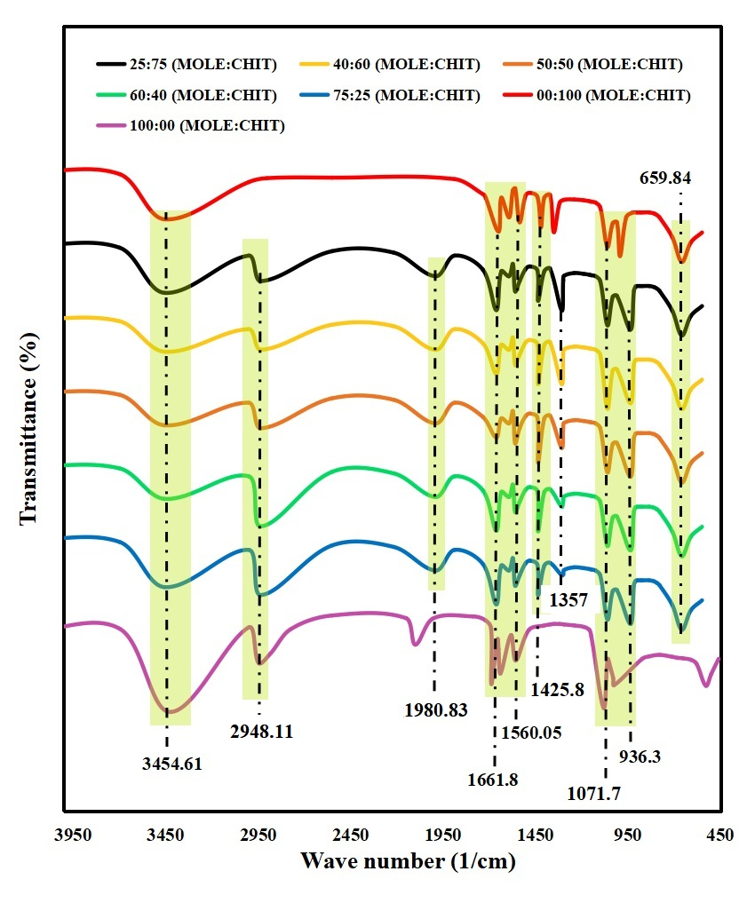

Fig. 3. FTIR Spectra for *MOCEB* at different mixing ratios

3.1.2 Gas chromatography–mass spectrometry

The hydrocarbon and phytochemical constituents of *MOLE* and *MOCEB* were given in **Figs**. 4 - 5, respectively. **Table 2** presents the hydrocarbons and phytocomponents of *MOLE* and their associated retention time (RT), Molecular weight (MW), peak area, and concentrations (%).

The hydrocarbon analysis indicated that the *MOLE* substrate contained four major hydrocarbon constituents having concentrations above 10 %. These hydrocarbons include Tetradecane (41.24 %), Pentadecane (18.46 %), Tridecane (12.386 %) and Heptacosane (12.013 %). Tetradecane has been identified as a major anti-microbial agent with vast applications in food preservation and packaging (Karim et al., 2022, Bains et al., 2023). Similarly, the antimicrobial and anti-oxidant activities of pentadecane (Faridha Begum et al., 2016, Girija et al., 2014) and tridecane (More et al., 2022) have been documented. These findings corroborate the observations of Marrufo et al., (2013), who reported that heptacosane was among the major constituents of *Moringa Oleifera* leaf extract. It is important to state that heptacosane is a very active anti-microbial ingredient found in the liquid extracts of plant leaves (Carev et al., 2023b). These observations validate the results obtained by FTIR analysis which highlighted the presence of alkanes in *Moringa Oleifera* leaf extract (*MOLE*). The phyto-components of *MOLE* were identified in **Fig**. 4. The result shows that *MOLE* contains significant amounts of Quercetin (>25 %), Kaempferol (>20 %) and Artemetin (>10 %) flavonoids. Other compounds within 5–10 % concentration range include Daidzin, Robinolic, and Ferrulic phenolic acid acid. Several reports have highlighted the anti-oxidant properties of quercetin (Marrufo et al., 2013) and kaempferol (Tian et al., 2021). Also, quercetin has been reported to exhibit natural cross-linking abilities, which is highly desirable in forming biochemical mixtures between plant extracts and other substrates (Wiggers et al., 2022, Hong et al., 2022). The concentration hierarchy of these flavonoids are comparable to the findings of Kashyap (Kashyap et al., 2022), and Lin (Lin et al., 2018) who reported the phytochemical constituents of *Moringa Oleifera* leaf extracts. These observations emphasize the suitability of *MOLE* to inhibit oxidation and microbial attack of fruits and vegetables coated with MOLE biofilm.

The phyto-components of *MOCEB* biofilm showed a decline in the concentrations of some major constituents found in *MOLE*. The concentration of quercetin declined significantly from 26.5035 % in *MOLE* to 10.2656 % in *MOCEB*, while the presence of Kaempferol was not detected. This reduction in concentration is attributed to the active participation of quercetin in cross linking with chitosan biopolymer. The disappearance of kaempferol in *MOCEB* biofilm implies that it was consumed in the formation of a new *MOCEB* bioconjugate. A general comparative overview of the phytochemical constituents of *MOLE* and *MOCEB* reveals that a significant amount of flavonoid and phenolic compounds were involved in the synthesis of *MOCEB* biofilm.

|  |  |  |  |  |
| --- | --- | --- | --- | --- |
| **Table 2**: GC-MS results of *MOLE* and *MOCEB* | | | | |
| Hydrocarbon constituents of *MOLE* | | | | |
| Hydrocarbon content | MW(g/mol) | RT (min) | Area | Conc (%) |
| Dodecane | 170.34 | 7.235 | 1.21769 | 4.682 |
| Tridecane | 184.4 | 8.0374 | 3.22123 | 12.386 |
| tetradecane | 198.39 | 9.396 | 10.72631 | 41.246 |
| Pentadecane | 212.42 | 9.296 | 4.8008 | 18.46 |
| Hexadecane | 226.45 | 10.341 | 1.25744 | 4.8351 |
| Hexacosane | 366.71 | 16.378 | 1.65823 | 6.376 |
| Heptacosane | 380.74 | 16.785 | 3.12467 | 12.013 |
| Phytochemical quantitative result of *MOLE* | | | | |
| Compound | MW(g/mol) | RT (min) | Area | Conc (%) |
| Apigenin | 270.0528 | 3.884 | 1.87208 | 2.23448 |
| Artemetin | 388.37 | 5.56 | 6.58526 | 10.46861 |
| Quercetin | 302.236 | 7.537 | 22.27661 | 26.50350 |
| Daidzin | 254.23 | 8.246 | 5.0254 | 6.11321 |
| Butein | 272.25 | 9.286 | 2.73057 | 3.28393 |
| Naringenin | 272.257 | 10.054 | 2.64946 | 3.18328 |
| Luteolin | 286.24 | 10.592 | 3.876688 | 4.69589 |
| Kaempferol | 286.23 | 11.124 | 16.41721 | 20.14230 |
| Epicatechin | 290.26 | 11.779 | 1.57236 | 1.74839 |
| Daidzein | 254.23 | 12.671 | 1.26927 | 1.47638 |
| Robinetin | 302.238 | 13.899 | 4.48533 | 5.43520 |
| Myricetin | 318.2351 | 14.865 | 3.59993 | 4.23879 |
| Cinnamic acid | 148.1586 | 17.981 | 1.30506 | 1.44220 |
| Ferrulicn acid | 194.18 | 20.037 | 7.4216 | 9.03383 |
| Phytochemical quantitative result of *MOCEB* | | | | |
| compound | MW (g/mol) | RT (min) | Area | Conc (%) |
| Catechin | 290.26 | 3.8884 | 1.87208 | 2.8536 |
| Quercetin | 302.236 | 5.56 | 6.58526 | 10.2656 |
| Artemetin | 388.37 | 7.537 | 22.27661 | 34.9662 |
| Retusin | 358.34 | 8.246 | 5.0254 | 7.807 |
| Ellagic acid | 302.197 | 9.286 | 2.73057 | 4.138 |
| Vanillic acid | 168.14 | 10.054 | 2.64946 | 4.0653 |
| Naringenin | 272.257 | 10.592 | 3.87668 | 5.997 |
| Apigenin | 270.0528 | 11.779 | 1.57236 | 2.2328 |
| Myricetin | 318.2351 | 12.671 | 1.26927 | 1.8854 |
| Daidzein | 254.23 | 13.899 | 4.48533 | 6.9412 |
| Genistein | 270.241 | 14.865 | 3.59993 | 5.4133 |
| Naringenin | 272.257 | 17.981 | 1.30506 | 1.8418 |
| Baicalein | 270.237 | 20.037 | 7.4216 | 11.5369 |

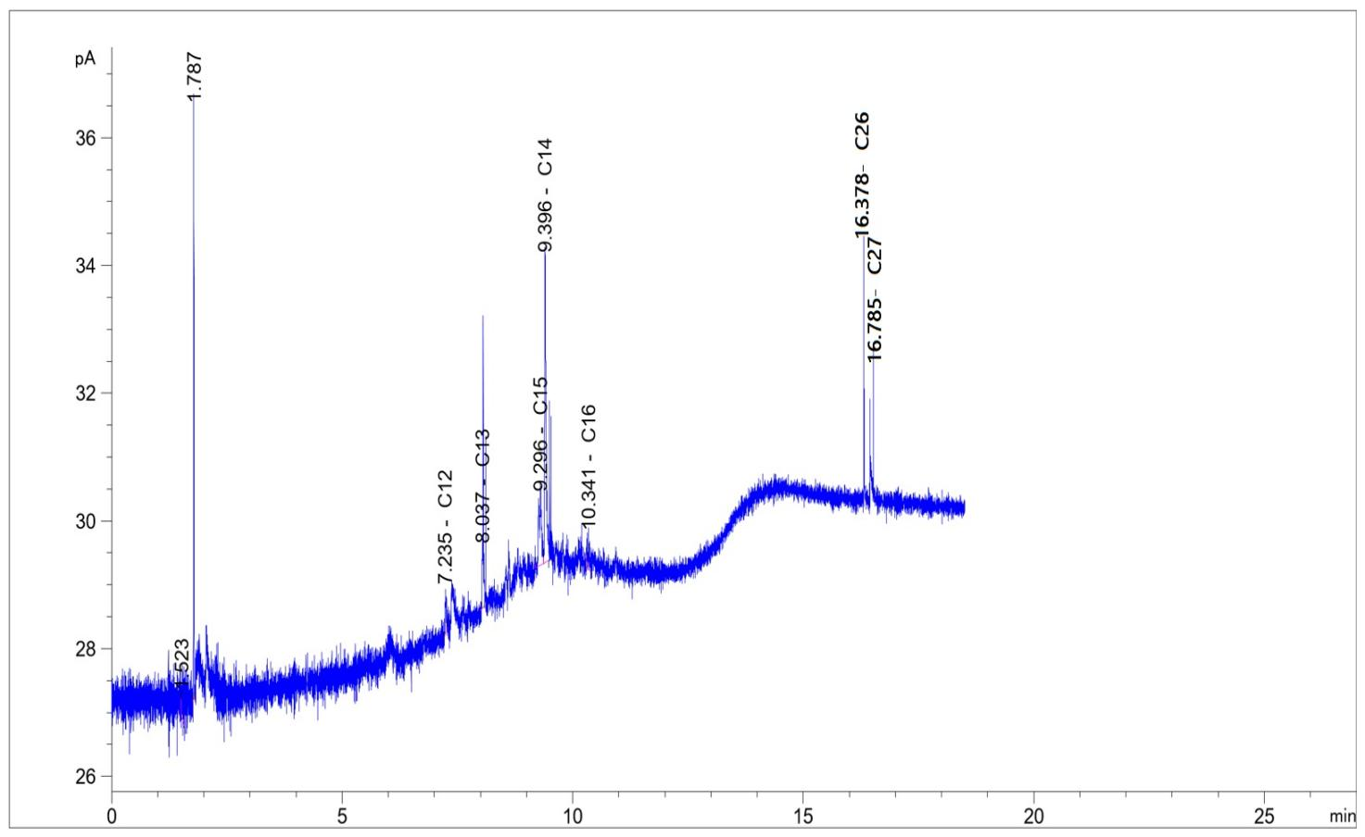

Fig. 4. GC-MS result of hydrocarbon constituents of *MOLE*

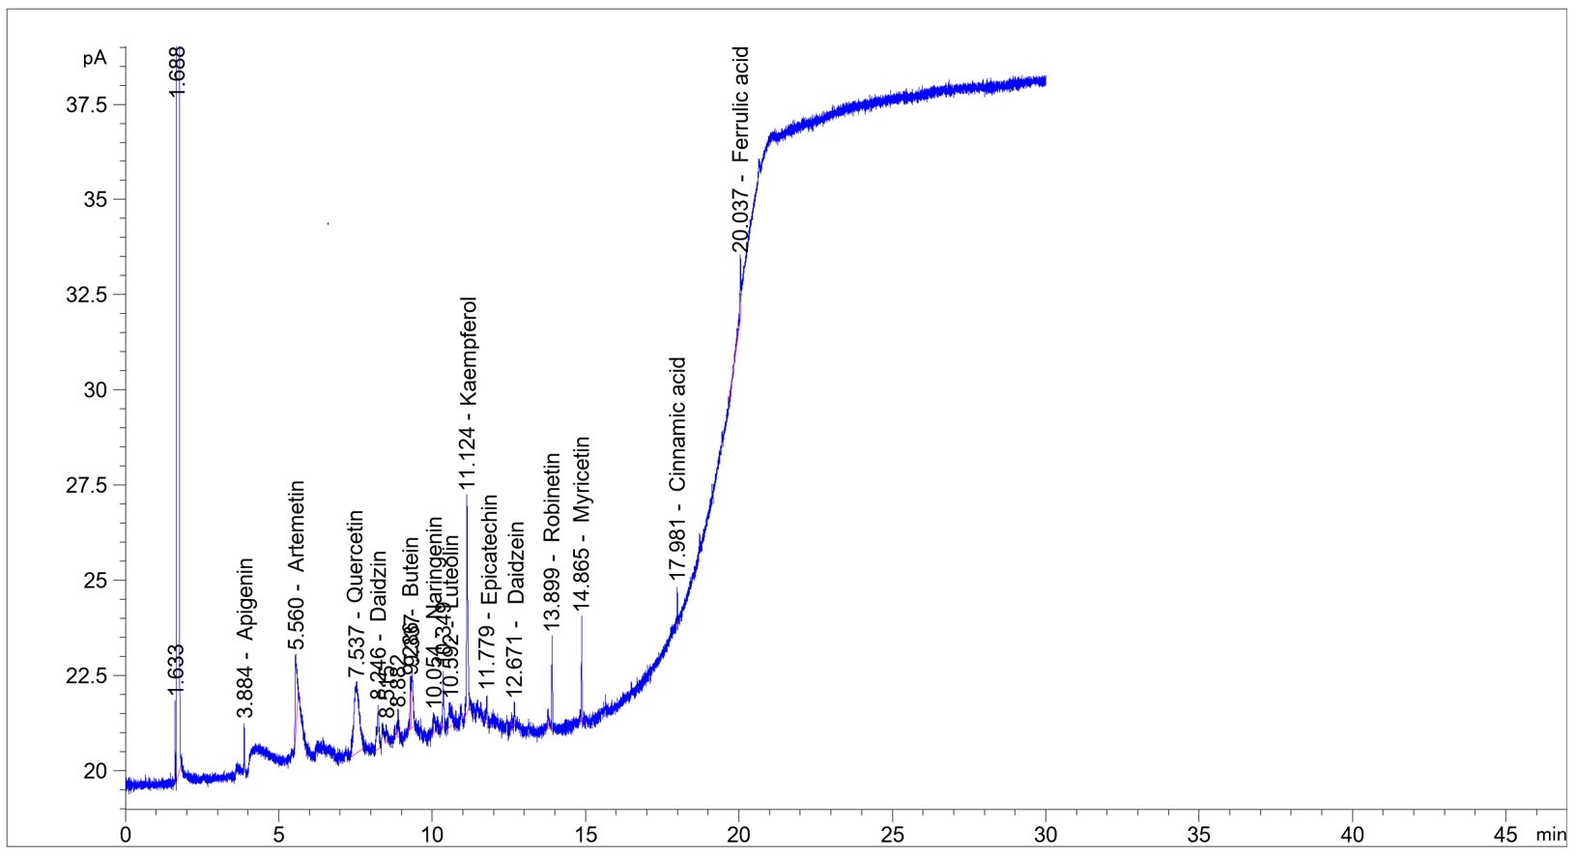

**(a)**

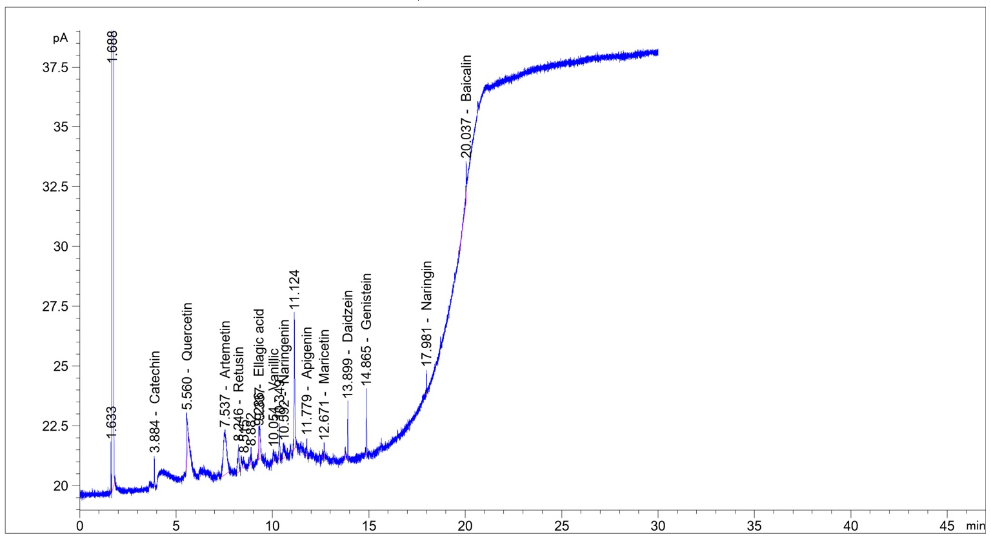

**(b)**

Fig 5. Phytochemical constituents of (a) *MOLE* and (b) *MOCEB*

3.2 Effect of bio-preservation variables

3.2.1 Effect of chitosan concentration

The effect of chitosan concentration on titratable acidity (TA) of fresh tomatoes fruits was investigated at five levels (0.5 %, 1.0 %, 1.5 %, 2.0 % and 2.5 %). The results were sampled at day 5, 10, 15, and 20, using a *MOCEB* mixing ratio of 50:50 (*MOLE*:chitosan, v/v). From the results presented in **Fig.** 6, on the 5th day of incubation, the value of TA increased from 3.607 g/kg to 3.738 g/kg at chitosan concentrations of 0.5 % and 1.0 %, respectively. Beyond 1.0 % conc., the measured TA value maintained a negligible difference until the peak at 2.5 % chitosan concentration. The increment in TA value at higher chitosan concentration is attributed to the complimentary sealing effect of chitosan in *MOCEB* biofilm for coating of tomato fruit. From the result in **Fig.** 6, this effect was significantly enhanced when chitosan concentration increased from 0.5 - 1.0 %, but was negligibly improved beyond this conc. range. Consequently, 1.0 % conc. of chitosan was taken to be the best for subsequent studies. Similar results have been reported by other researchers who investigated the effect of chitosan concentration on shelf extension of fruits and vegetables (Chien et al., 2007, Dong et al., 2004).

**Fig.** 6. Effect of chitosan concentration on TA

3.2.2 Effect of *MOCEB* mixing ratio

The effect of *MOCEB* biofilm ratio on weight loss rate and TA of coated tomato species at different sampling time were depicted in **Figs.** 7 (a) and (b), respectively, while a pictorial illustration was depicted in **Fig.** 8. Figure 7 (a) demonstrated that the weight loss rate in g/day remained approximately idem as the *MOLE* composition increased from 0 to 40 %. Beyond 40 % *MOLE* composition, the rate of weight loss continued to increase until the final *MOCEB* mixing ratio of 100:0 (*MOLE*:Chitosan, v/v). A similar observation was recorded for titratable acidity measurement where the highest value was noted at a *MOCEB* ratio of 40:60 (*MOLE*:Chitosan, v/v). According to Chen et al. (Chen et al., 2019), a reduced rate of weight loss is desirable for optimum shelf life preservation of fruits and vegetables. Reduced rate of weight loss signals controlled loss of organic acid content of tomato fruit. The increase in weight loss rate (Fig. 7 (a)) and reduction in titratable acidity (Fig. 7 (b)) were occasioned by the reducing composition of chitosan in the mixing ratio of *MOCEB* biofilm. The slight increment in titratable acidity which was stimulated by increase in *MOCEB* mixing ratio could be attributed to the complimentary nature of *MOLE* increment in bio activity of chitosan.

**(a)**

**(b)**

Fig. 7. Effect of mixing ratio on (a) TA, (b) weight loss rate

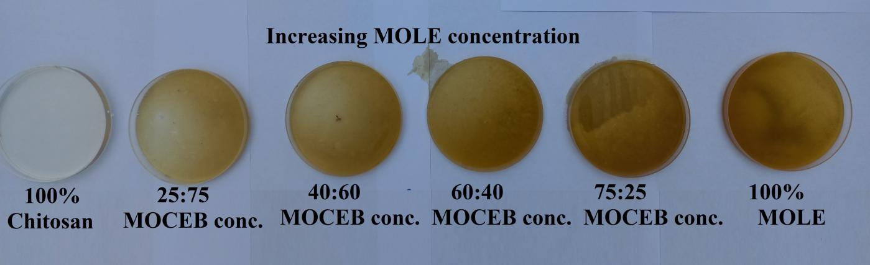

Fig. 8. Pictorial illustration of different concentrations of *MOCEB*

3.2.3 Effect of storage time

The influence of incubation time on titratable acidity of coated and uncoated tomato fruits at best chitosan conc. and best *MOCEB* mixing ratio were illustrated in **Figs.** 9 (a) and 9 (b), respectively. The weight loss rate measurement of both coated and uncoated species were depicted in **Fig.** 10 (a) (for best mixing ratio of 40:60), and 10 (b) (for best chitosan conc of 1%). From the graphical results, it is discernible that, for both coated and uncoated species, the values of TA reduced proportionally with increase in storage time. The decline in titratable acidity is attributed to the dynamic reduction of citric acid which takes place during the storage respiration process. According to Gol et al. (Gol et al., 2013) given that titratable acidity and organic acid content are strongly correlated, a decrease in acidity may be anticipated during incubation due to the respiration induced metabolic changes which consumes the organic acids. For all species, the titratable acidity of the uncoated samples were much lower than the *MOCEB* coated samples. This underscores the coating effectiveness of *MOCEB* biofilm in controlling the decomposition of citric acid during the respiration process of the tomato fruits. Furthermore, the coated tomato fruit maintained good quality throughout the incubation period, while the quality of the uncoated sample went below 0.30 g/kg threshold (TA = 0.30 g/kg) on the 15th day of sampling (Kayode and Afolayan, 2014). It is also important to note that during respiration, the tomato fruit losses its moisture content which culminated in cumulative weight loss (%) depicted in **Fig.** 11.

The weight loss rate (**Figs.** 10 (a) and 10 (a)) of the coated tomato fruit displayed a quadratic relationship with storage time. The first region of accelerated weight loss rate was observed between 2 - 9 days of storage (**Fig.** 10 (a)). During this period, the weight loss rate increased from 0.068 g/day - 0.6762 g/day. The rapid rate of weight loss could be attributed to the initial characteristics (soft and permeable) of the *MOCEB* coated tomato fruit surface, which did not significantly resist the permeability of water through the membrane. As the storage time increased, the *MOCEB* biofilm became increasingly hardened resulting in the equilibrium stage (Day 10: 0.7103 g/day - Day 14: 0.7146 g/day) and reduced rate of weight loss (Day 15: 0.6826 g/day - Day 20: 0.3246 g/day). A slightly extended period of accelerated weight loss rate was noted at best chitosan concentration depicted in **Fig.** 10 (b). Due to the unprotected surface of the uncoated tomato fruit, the weight loss rate was approximately 2.6 times higher than the *MOCEB* coated species during the storage period. This magnitude of protection further underscores the importance of *MOCEB* coating in enhancing the membrane resistance to moisture loss.

Another important graphical representation of the effect of storage time is the percentage weight loss (see **Fig.** 11 (a) and (b)). While the weight loss rate accurately captures how phase changes in *MOCEB* coating controls the weight loss during storage, the percentage weight loss depicts the progressive loss in moisture which affects the total weight during storage. The percentage weight loss is a natural process observed during post harvest incubation of fruit and vegetables. As demonstrated in **Figs.** 11 (a) and (b), all species showcased progressive weight loss throughout the incubation period. The progressive weight loss was a direct consequence of moisture loss which resulted in shriveling of the coated species (see **Fig**. 12), and rupturing of the uncoated species. At the end of 20 days incubation period, the uncoated samples lost 32.88 % of their initial weight, while the coated samples (at best *MOCEB* mixing ratio) lost 12.87 wt%. The weight loss obtained in this study for uncoated tomato species is slightly higher than the value obtained by other researchers who performed tomato incubation at ambient conditions (Mahfoudhi et al., 2014, Tarangini et al., 2022, Ruelas-Chacon et al., 2017). After 20 days of incubating tomato fruits, Mahfoudhi et al., (2012), recorded 23.65 wt% loss of initial weight, while Tarangini et al., (2022), obtained 27 wt% loss. The difference between these results and our findings could be attributed to variations in physicochemical environments such as fluctuations in temperature and humidity. However, it is important to note that the performance of *MOCEB* biofilm was superior to almond gum (Mahfoudhi et al., 2014) and sericin complex (Tarangini et al., 2022) in regulating weight loss of tomato fruit. Another visible consequence of uncoated exposure is the appearance of white rot on the surface of the fruit as depicted on the 10th, 15th and 20th days of sampling (**Fig.** 12). From the obtained pictorial result, there was an intensified increment in the rot size. The initial detection on the 10th day occupied a diameter of 6.5 mm, which increased to 13.6mm and 18.53mm on the 15th and 20th days, respectively. It is interesting to note that this rot was not detected in the coated species throughout the storage period.

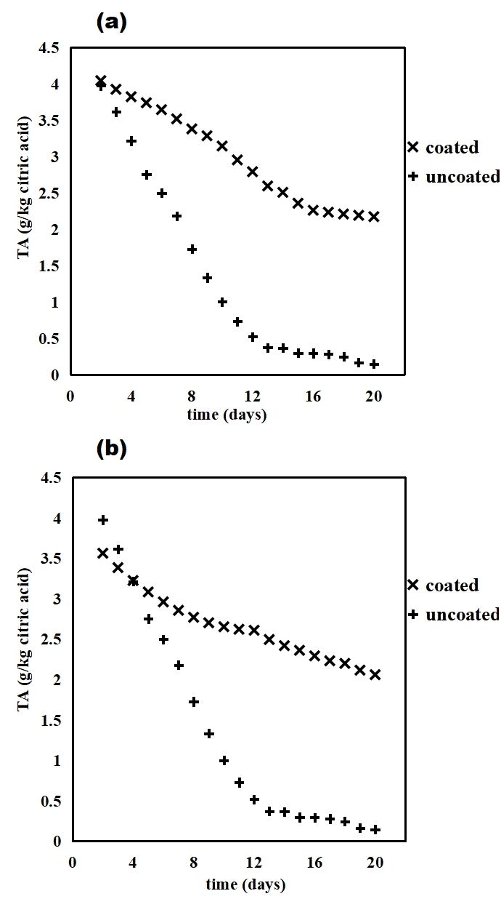

Fig. 9. Effect of storage time on TA at (a) best chitosan concentration, (b) best *MOCEB* mixing ratio.

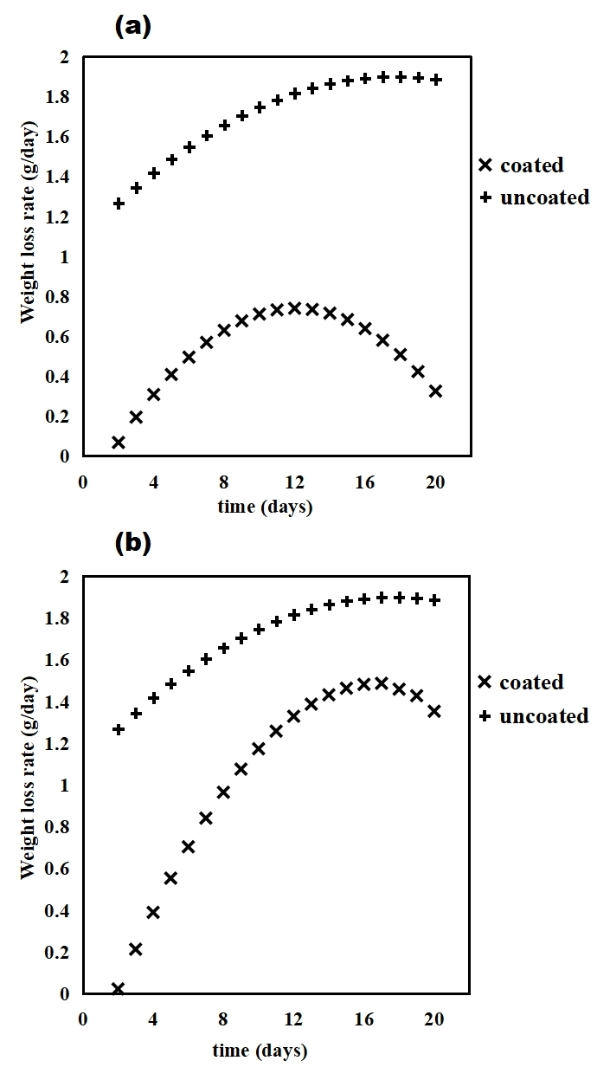

Fig. 10. Effect of storage time on weight loss rate at (a) best chitosan concentration, (b) best *MOCEB* mixing ratio.

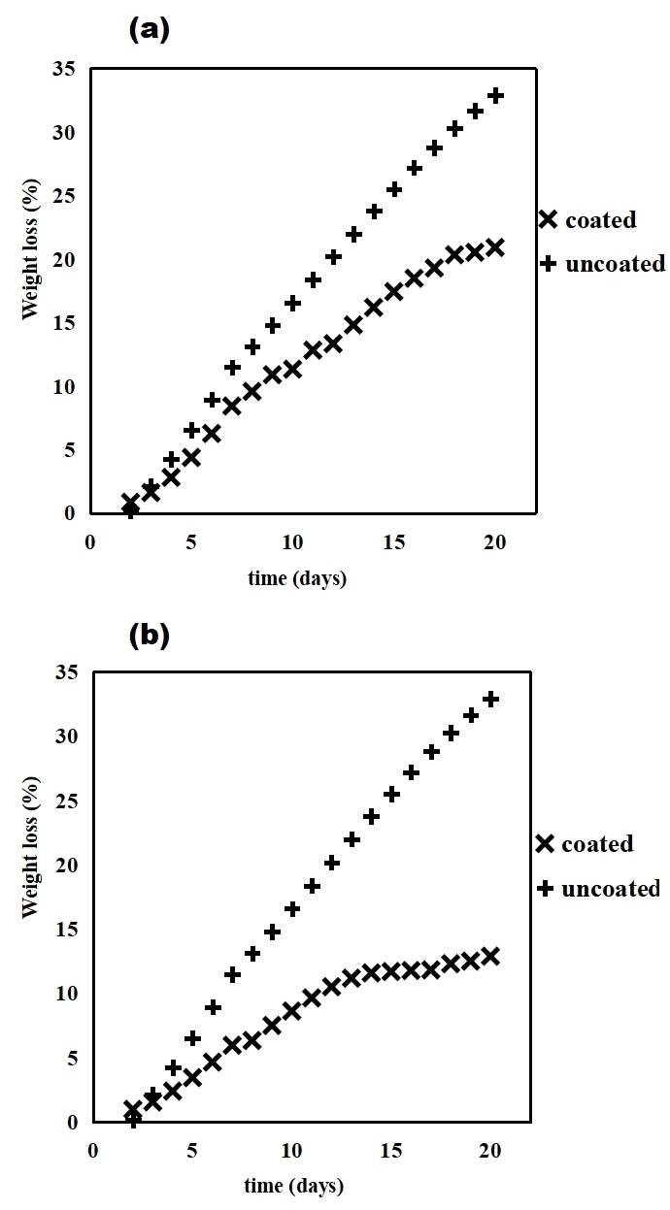

Fig. 11. Effect of storage time on weight loss at (a) best chitosan conc., (b) best *MOCEB* mixing ratio

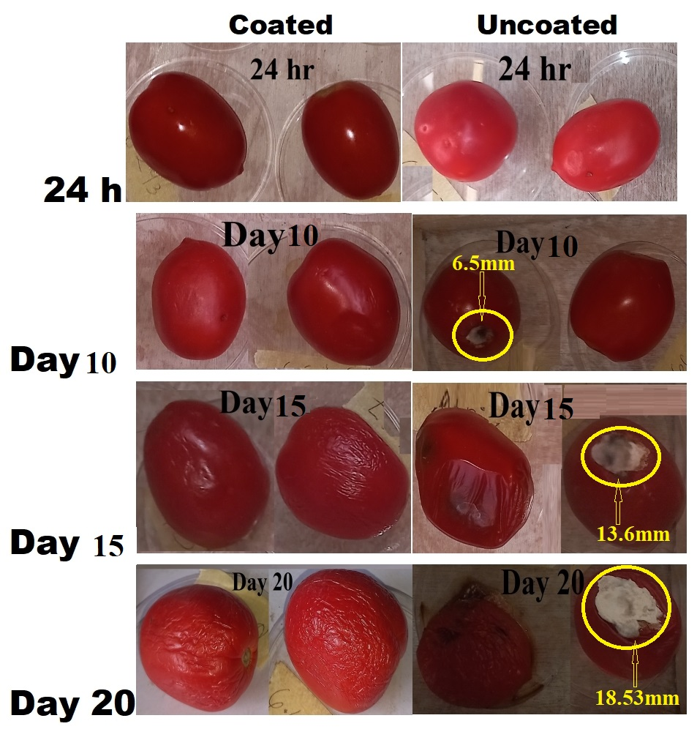

Fig. 12. Pictorial view of coated and uncoated tomato fruits at different incubation times.

3.3 Physicochemical kinetics

The kinetic studies of the physicochemical properties were explored using the two most suitable models (zero and first order models) applied in bio-preservation of fruits and vegetables (Hosseinifarahi et al., 2020, Maringgal et al., 2020, Mai and Pathare, 2021). The data extracted from plotting the physicochemical kinetic models (Eqs. (4) - (6)) for titratable acidity (Fig. 13 (a) and 14 (a)) and weight loss (**Fig.** 13 (b) and 14 (b)) were tabulated in **Tables** 3 - 4. For titratable acidity (TA) and weight loss parameters, the kinetic rate constants K (day-1) for zero order model were higher than the K values obtained for the first order model. An overview of the kinetic parameters revealed that the kinetic rate constant for the uncoated species obtained for zero order, nonlinear and linear first order models were 0.2237, 0.1439, and 0.1905 day-1, respectively. Many researchers have reported similar results of decreasing kinetic rate constant of fruits and vegetables preserved under ambient conditions (Devi and Das, 2017, Mai and Pathare, 2021, Al‐Juhaimi, 2014). The reason for the disparity in the values of rate constant was obviously due to the peculiar nature and assumptions associated with each model (Mai and Pathare, 2021, Al‐Juhaimi, 2014).

Although both kinetic models satisfactorily described the physicochemical dynamics of the bio-preservation process (R2 > 0.8800), it is important to note zero order model was superior in fitting the TA (**Fig.** 13 (a)) and weight loss (**Fig.** 13 (b)) data under best chitosan concentration. This implies that under optimum chitosan concentration, an independent relationship exists between each physicochemical quality parameters (TA and weight loss) and rate constant (K). However, the first order model was more suitable in describing the kinetics of titratable acidity and weight loss at optimum condition of *MOCEB* mixing ratio. This was illustrated by the low values of SSE (weight loss rate = 0.003602; TA= 0.03262) and RMSE (weight loss rate = 0.01415; TA= 0.04257) deviation parameters tabulated in **Table** 4, and comparable values between the predicted and observed process parameters (Co). This suggests that at best mixing ratio, the dynamic changes of the investigated quality parameters (TA and weight loss) is dependent on the reaction rate constant (K). Furthermore, these observations indicates that enzymatic degradation took place at the best chitosan concentration (Gallagher et al., 2011), while oxidation induced lycopene degradation was prevalent at best MOCEB concentration (SKREDE, 1985, Ibarz et al., 2000, Ling et al., 2021, Van Boekel, 2008).

|  |  |  |  |  |  |
| --- | --- | --- | --- | --- | --- |
| Table 3. Kinetic parameters at optimum chitosan concentration | | | | | |
| Model | Parameter | TA | | Weight loss | |
| Coated | Uncoated | Coated | Uncoated |
| Zero Order | Exp. Co | 4.2684 | 4.2684 | 76.507 | 76.507 |
| Model Co | 4.277 | 3.836 | 80.55 | 78.47 |
| K (day-1) | 0.1173 | 0.2237 | 1.654 | 1.996 |
| R2 | 0.9797 | 0.8956 | 0.9815 | 0.998 |
| Adj. R2 | 0.9785 | 0.8898 | 0.9805 | 0.9979 |
| SSE | 0.1958 | 3.996 | 35.25 | 5.335 |
| RMSE | 0.1043 | 0.4712 | 1.0547 | 0.5444 |
| Nonlinear first order | Exp. Co | 4.2684 | 4.2684 | 76.507 | 76.507 |
| Model Co. | 4.435 | 5.006 | 81.84 | 80.56 |
| K (day-1) | 0.03816 | 0.1439 | 0.025 | 0.03393 |
| R2 | 0.9795 | 0.9477 | 0.9693 | 0.9837 |
| Adj. R2 | 0.9783 | 0.9448 | 0.9676 | 0.9828 |
| SSE | 0.1975 | 2.002 | 58.03 | 44.63 |
| RMSE | 0.1047 | 0.3335 | 1.805 | 1.575 |
| Linear first order | Exp. Co | 4.2684 | 4.2684 | 76.507 | 76.507 |
| Model Co. | 4.413 | 6.298 | 82.33 | 81.61 |
| K (day-1) | 0.03665 | 0.1905 | 0.02642 | 0.03542 |
| R2 | 0.9738 | 0.9731 | 0.9727 | 0.9844 |
| Adj R2 | 0.9491 | 0.9717 | 0.9712 | 0.9832 |
| SSE | 0.03262 | 0.686 | 0.0134 | 0.01359 |
| RMSE | 0.04257 | 0.1952 | 0.02728 | 0.02784 |

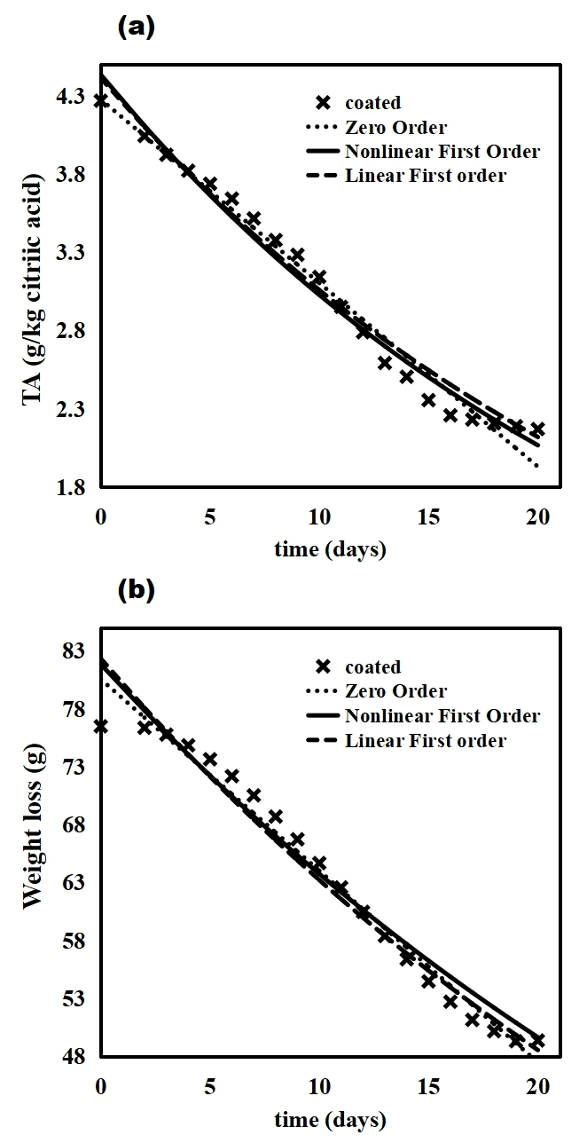

Fig. 13. Effect of storage time on (a) TA, and (b) weight loss of coated tomato fruit at best chitosan conc.

|  |  |  |  |  |  |
| --- | --- | --- | --- | --- | --- |
| Table 4. Kinetic parameters at optimum *MOCEB* concentration | | | | | |
| Model | Parameter | TA | | Weight loss | |
| Coated | Uncoated | Coated | Uncoated |
| Zero Order | Exp. Co | 4.2684 | 4.2684 | 76.507 | 76.507 |
| Model Co | 3.652 | 3.836 | 76.95 | 78.47 |
| K (day-1) | 0.08699 | 0.2237 | 0.6664 | 1.996 |
| R2 | 0.8941 | 0.8956 | 0.9417 | 0.9980 |
| Adj. R2 | 0.8883 | 0.8898 | 0.9385 | 0.9979 |
| SSE | 0.6137 | 3.996 | 18.82 | 5.335 |
| RMSE | 0.1847 | 0.4712 | 1.023 | 0.5444 |
| Nonlinear first order | Exp. Co | 4.2684 | 4.2684 | 76.507 | 76.507 |
| Model Co. | 3.797 | 5.006 | 77.24 | 80.56 |
| K (day-1) | 0.03297 | 0.1439 | 0.009592 | 0.03393 |
| R2 | 0.9334 | 0.9477 | 0.9500 | 0.9837 |
| Adj. R2 | 0.9297 | 0.9448 | 0.9472 | 0.9828 |
| SSE | 0.386 | 2.002 | 16.16 | 44.63 |
| RMSE | 0.1464 | 0.3335 | 0.9474 | 1.575 |
| Linear first order | Exp. Co | 4.2684 | 4.2684 | 76.507 | 76.507 |
| Model Co. | 3.713 | 6.298 | 76.98 | 81.61 |
| K (day-1) | 0.03065 | 0.1905 | 0.009313 | 0.03542 |
| R2 | 0.9518 | 0.9731 | 0.9428 | 0.9844 |
| Adj R2 | 0.9491 | 0.9717 | 0.9397 | 0.9832 |
| SSE | 0.03262 | 0.686 | 0.003602 | 0.01359 |
| RMSE | 0.04257 | 0.1952 | 0.01415 | 0.02784 |

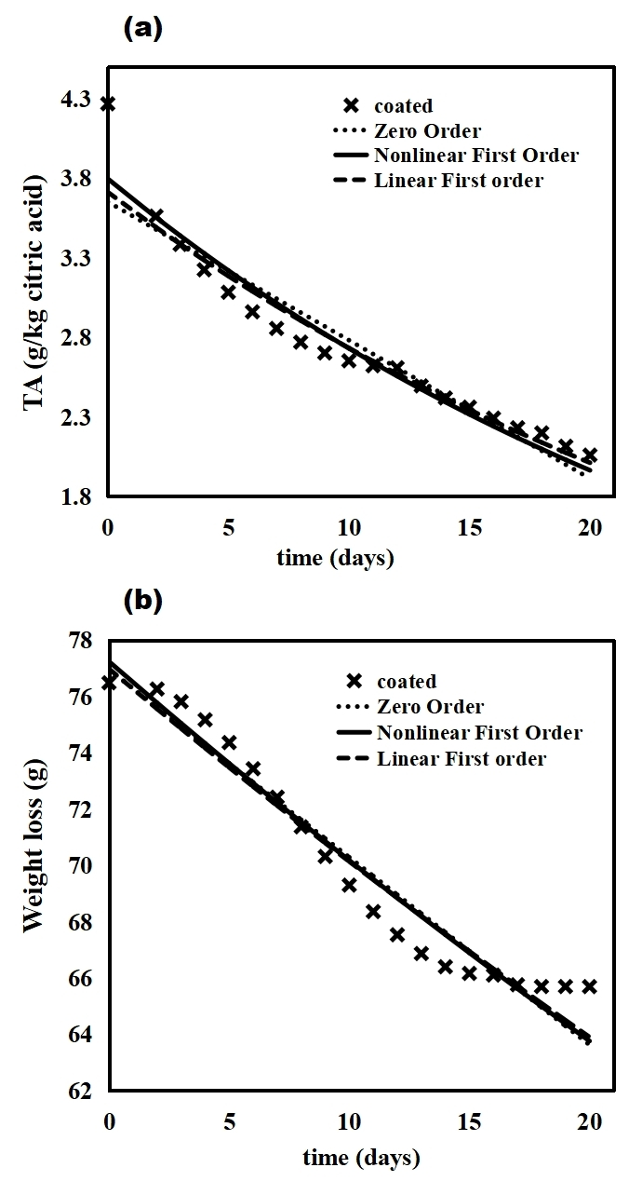

Fig. 14. Effect of storage time on (a) TA, and (b) weight loss of coated tomato fruit at best *MOCEB* mixing ratio.

3.4 Assay studies

3.4.1 Antimicrobial studies

The antimicrobial activities of *MOLE*, chitosan, and *MOCEB* against four microbial strains *(E. coli, S. typhi, S. aureus, and B. cereus*) were evaluated at different concentrations and compared to gentamicin antibiotics under identical conditions. The results of these antimicrobial investigation were presented in **Figs.** 15 and 16 The results illustrate that at 25 mg/mL uniform concentration of MOLE and chitosan (**Fig.** 15 (a)), *MOLE* performed better than chitosan in overall antimicrobial activity. However, the microbial inhibition potency of chitosan was enhanced at higher concentrations, culminating in a superior antagonistic performance against the bacteria compared to *MOLE* at 100 mg/mL. It is noteworthy to state that at 25 mg/mL chitosan inhibitor concentration, the free amino acid content was not sufficient to initiate a significant inhibitory diffusion against the bacteria in the tomato agar medium. Increasing the chitosan inhibitor concentration to 100 mg/mL resulted in sufficient activity of the free amino acid content to propagate significant inhibition through well diffusion of the tomato agar. This trend of enhanced microbial inhibition efficiency following increment in chitosan and *MOLE* inhibitor concentrations was also noted for other inhibitor substrates (see **Figs.** 15 and 16). This observation underscores the concentration dependence of their antimicrobial activity in tomato agar.

An overview of the antimicrobial activity of each inhibitor substrate reveals that *MOLE* was more active in resisting the growth of gram-positive bacteria (*S. aureus, and B. cereus*), than the gram-negative *E. coli and S. typhi*. It is important to note that although gram-positive bacteria possess a thicker *peptidoglycan* cell wall, these cell walls are easily susceptible to explosion and leakages following absorption of inhibitors. Given that the *MOLE* substrate is less viscous compared to chitosan, it has a higher physical attribute of accumulating on the microbial cell wall than chitosan. This phenomenon is responsible for the higher antimicrobial activity of *MOLE* on gram-positive bacteria than the gram-negative species. Notably, the synthesized *MOCEB* biofilm exhibited high antimicrobial activity (gram positive; $r_{A}=7.93 mm,$ gram negative; $r_{A}=7.73 mm$) comparable to the gentamicin positive control ($r_{A} =7.84 mm; r_{A}= 8.0 mm$), and also greater than each of the constituents acting alone. Studies have shown that polycationic compounds have higher antibacterial activity compared to purer polyatomic substances (Tan et al., 2013). Chitosan constitutes a macromolecule which cannot readily penetrate the outer protective layer of microorganisms, making a direct distribution of chitosan to internal portions of the cell unattainable (Wang et al., 2020). The introduction of *MOLE* into chitosan upgrades the antimicrobial activity of each component (*MOCEB*) by increasing the net cationic strength through addition of positive charges from *MOLE* substrate (Wu et al., 2023, Butt et al., 2023, Alsamhary, 2023). Consequently, the antimicrobial actions of *MOCEB* can be hypothesized thus: the positively cationic groups of *MOCEB* can interface with the lipopolysaccharides and proteins found primarily on the surface of the bacteria. The interactions between the cells causes an extreme distortion of the external layer framework, leading to proteinaceous cell leakage, and eventual inhibition (Panda et al., 2023).

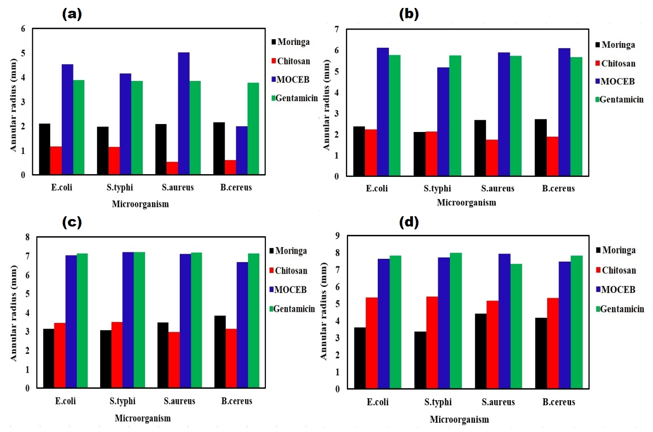

Fig. 15. Microbial resistance zone result of *MOLE*, Chitosan, *MOCEB* and control (Gentamicin) at (a) 25 mg/mL, (b) 50 mg/mL, (c) 75 mg/mL, (d) 100 mg/mL, against different microbial species in tomato agar.

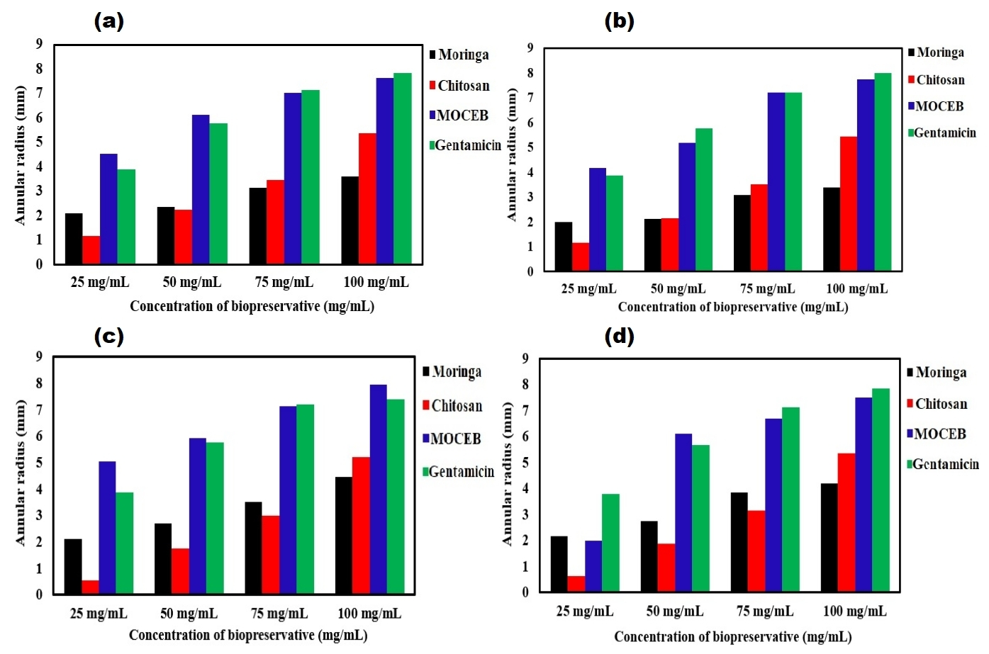

Fig. 16. Microbial resistance zone result of *MOLE*, Chitosan, *MOCEB* and control (Gentamicin) against (a) *E.Coli*, (b) *S. Typhi*, (c) *S. Aureus*, (d) *B. Cereus*, at different concentration of inhibitors.

3.4.2 Antioxidant activity

The ferric ion reducing antioxidant power (FRAP) and 2,2-diphenyl-1-picrylhydrazyl (DPPH) were used to assess the antioxidant activity of the biofilms (*MOLE*, chitosan, and *MOCEB*). The results were compared to the antioxidant activity of an established free radical scavenger (garlic oil) as depicted in **Figs.** 17 (a) - (b). DPPH is a free radical with stable structure that takes and an electron or hydrogen radical to generate a diamagnetic molecule that is commonly utilized in radical scavenging studies. The antioxidant scavenging activity described in section 2.2.6.2 was used to assess the DPPH and FRAP assays of the biofilms and positive control. The DPPH radical scavenging activities of chitosan, *MOLE* and *MOCEB* were 34, 41 and 71%, respectively. The *MOCEB* biofilm exhibited a potential antioxidant activity comparable to that of the garlic oil positive control under identical conditions. Furthermore, it is important to state that *MOLE* substrate exhibited DPPH antioxidant activity than chitosan, while *MOCEB* demonstrated significantly higher antioxidant activities than both constituents. Due to the existence of numerous antioxidant components, such as flavonoids and phenolics listed in **Table** 1, *MOLE* is a rich source of organic antioxidants. Also, the detection of two prominent flavonoids (Quercetin and kaempferol) with verified antioxidant capacities is of particular interest. The flavonoids, particularly Quercetin, contains phenolic hydroxyl groups which has potential therapeutic applications, and have also been used in various free radical scavenging studies (Azeem et al., 2023, Shahbaz et al., 2023, Visco et al., 2022). These flavonoids and phenolic constituents make up a significant amount of *MOLE* phytochemical composition (Sankhalkar and Vernekar, 2016). This is not the same case with chitosan, where the only strong hydrogen donating ability is a function of the concentration and class of molecular weight. According to Vinsova and Vavrikova (Vinsova and Vavrikova, 2011), increase in concentration of low molecular weight chitosan enhances the antioxidant activity. In the current study, 1% concentration of medium molecular weight chitosan was used to carryout the antioxidant investigation. This explanations justifies the superior performance of *MOLE* over chitosan throughout the free radical scavenging studies. The hydrogen donating ability of *MOLE* and chitosan was improved in *MOCEB* as depicted in DPPH and FRAP results. The incorporation of *MOLE* onto the chitosan network modified the antioxidant activities of both constituents compared to each of them acting alone. The resulting *MOCEB* specie showcased an improved free radical scavenging activity where the antioxidant in the parent constituents exerted a synergistic effect resulting in the significantly improved results.

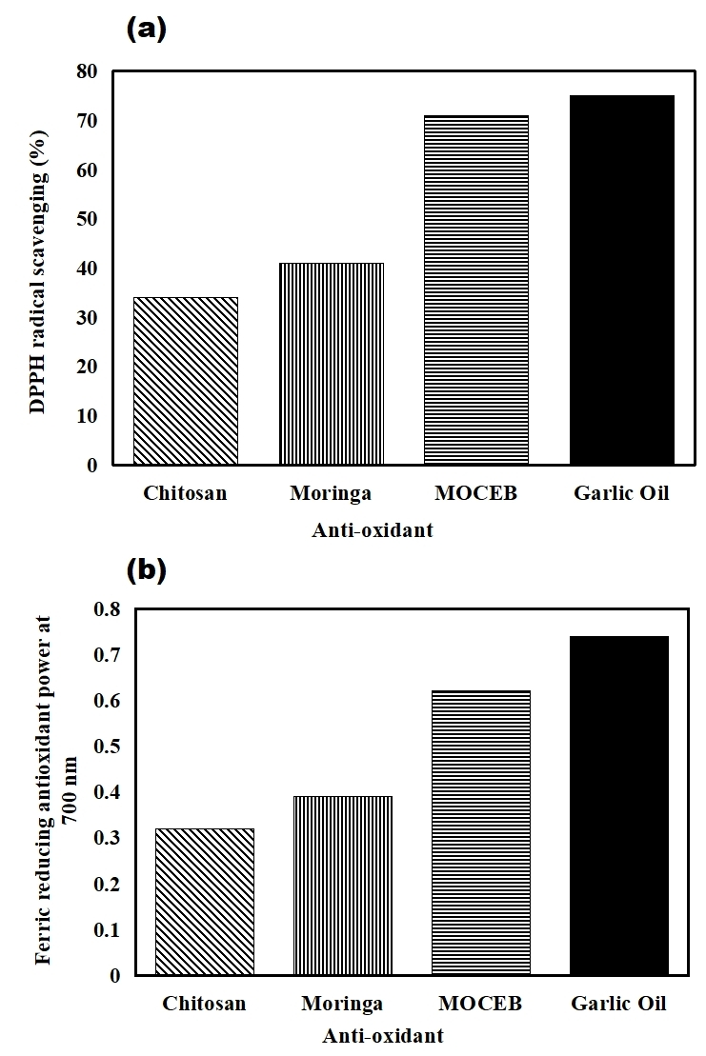

Fig. 17. Antioxidant activity of Chitosan, *MOLE*, *MOCEB* and control (Garlic oil) using (a) DPPH, and (b) FRAP

**4.0 Conclusion**

In this study, *MOCEB* biofilm was successfully synthesized by dynamic homogenization of *MOLE* and chitosan. The characterization of the biofilm was explored and found to contain significant antioxidant and antimicrobial ingredients suitable to propagate the bio-preservation of fruits and vegetables. The effect of bio-preservation variables revealed that increment in chitosan concentration significantly reduced the loss of weight and titratable acidity of coated tomato fruits. Furthermore, effect of *MOCEB* mixing ratio demonstrated that 40:60 *MOCEB* ratio was the optimum ratio, given the associated enhanced quality parameters at this value. Physicochemical kinetic analysis indicated that zero order equation was the most suitable model that described the bio-preservation process at best chitosan concentration, while kinetics at best *MOCEB* ratio was accurately captured by first order model. The established implication of the kinetic modeling was that enzymatic degradation took place at the best chitosan concentration, while oxidation induced lycopene degradation was prevalent at best *MOCEB* mixing ratio. Microbial assay studies revealed that *MOCEB* was resistant to both gram-positive and gram-negative bacteria species, while the antioxidant activity was slightly lower that garlic oil. Generally, the results from the present study has demonstrated that coating the tomato fruit with *MOCEB* biofilm can significantly regulate the quality deterioration rate. Also, coating application of fresh tomato fruit with *MOCEB* can guarantee the delivery of safe and edible tomatoes to the consumer even after 20 days of preservation.

**References**

ABONYI, M. N., NWABANNE, J. T., OHALE, P. E., NWADIKE, E. C., IGBONEKWU, L. I., CHUKWU, M. M. & MADIEBO, E. M. 2023. Application of RSM and ANFIS in the optimal parameter evaluation for crude oil degradation in contaminated water amended with PES. *Case Studies in Chemical and Environmental Engineering***,** 100483.

AHMADPOUR KERMANI, S., SALARI, S. & GHASEMI NEJAD ALMANI, P. 2021. Comparison of antifungal and cytotoxicity activities of titanium dioxide and zinc oxide nanoparticles with amphotericin B against different Candida species: In vitro evaluation. *Journal of Clinical Laboratory Analysis,* 35**,** e23577.

AISIDA, S. O., UGWU, K., AKPA, P. A., NWANYA, A. C., NWANKWO, U., BASHIR, A., MADIBA, I., AHMED, I. & EZEMA, F. I. 2021. Synthesis and characterization of iron oxide nanoparticles capped with Moringa Oleifera: the mechanisms of formation effects on the optical, structural, magnetic and morphological properties. *Materials Today: Proceedings,* 36**,** 214-218.

AL-DAIRI, M., PATHARE, P. B., AL-YAHYAI, R., JAYASURIYA, H. & AL-ATTABI, Z. 2023. Postharvest quality, technologies, and strategies to reduce losses along the supply chain of banana: A review. *Trends in Food Science & Technology*.

AL‐JUHAIMI, F. Y. 2014. Physicochemical and Sensory Characteristics of Arabic Gum‐Coated Tomato (S olanum Lycopersicum L.) Fruits during Storage. *Journal of Food Processing and Preservation,* 38**,** 971-979.

ALSAMHARY, K. E. 2023. Moringa oleifera seed based green synthesis of copper nanoparticles: Characterization, environmental remediation and antimicrobial activity. *Saudi Journal of Biological Sciences,* 30**,** 103820.

AZEEM, M., HANIF, M., MAHMOOD, K., AMEER, N., CHUGHTAI, F. R. S. & ABID, U. 2023. An insight into anticancer, antioxidant, antimicrobial, antidiabetic and anti-inflammatory effects of quercetin: A review. *Polymer Bulletin,* 80**,** 241-262.

BAINS, A., SHARMA, P., KAUR, S., YADAV, R., KUMAR, A., SRIDHAR, K., CHAWLA, P. & SHARMA, M. 2023. Gum arabic/guar gum stabilized Hydnocarpus wightiana oil nanohydrogel: Characterization, antimicrobial, anti-inflammatory, and anti-biofilm activities. *International Journal of Biological Macromolecules,* 239**,** 124341.

BHAT, M. I., SHAHI, N. C., LOHANI, U. C., PATHANIA, S., MALIK, S., SINGH, S. & AMIN, T. 2023. Cellulose nanocrystals reinforced chitosan/titanium dioxide bionanocomposite with enhanced interfacial compatibility: Fabrication, characterization, and application in fresh-cut apple slices. *International Journal of Biological Macromolecules***,** 127498.

BOŽIČ, M., GORGIEVA, S. & KOKOL, V. 2012. Homogeneous and heterogeneous methods for laccase-mediated functionalization of chitosan by tannic acid and quercetin. *Carbohydrate polymers,* 89**,** 854-864.

BUTT, M. S., MALIK, Z., GHAFFAR, R., BALUCH, A. H., SALEEM, M. & GHAFFAR, A. 2023. Moringa oleifera/chitosan-coated silk sutures for improved wound healing. *Materials Chemistry and Physics***,** 128737.

CAREV, I., GELEMANOVIĆ, A., GLUMAC, M., TUTEK, K., DŽELALIJA, M., PAIARDINI, A. & PROSSEDA, G. 2023a. Centaurea triumfetii essential oil chemical composition, comparative analysis, and antimicrobial activity of selected compounds. *Scientific Reports,* 13**,** 7475.

CAREV, I., RUŠČIĆ, M., GLUMAC, M., POLITEO, O. & SILJAK‐YAKOVLEV, S. 2023b. Phytochemical and cytogenetic study of two Centaurea species from Croatia: the particular case of diploid and tetraploid C. salonitana. *Chemistry & Biodiversity,* 20**,** e202300092.

CHEN, H., WANG, J., CHENG, Y., WANG, C., LIU, H., BIAN, H., PAN, Y., SUN, J. & HAN, W. 2019. Application of protein-based films and coatings for food packaging: A review. *Polymers,* 11**,** 2039.

CHIEN, P.-J., SHEU, F., HUANG, W.-T. & SU, M.-S. 2007. Effect of molecular weight of chitosans on their antioxidative activities in apple juice. *Food chemistry,* 102**,** 1192-1198.

CUSIOLI, L. F., MANTOVANI, D., BERGAMASCO, R., TUSSET, A. M. & LENZI, G. G. 2023. Preparation of a New Adsorbent Material from Agro-Industrial Waste and Comparison with Commercial Adsorbent for Emerging Contaminant Removal. *Processes,* 11**,** 2478.

DA SILVA, M., TRANCOSO, J., TORMEN, L., BOMBARDELLI, M. M., CORAZZA, M. L. & BAINY, E. M. 2022. Extraction of compounds from Moringa oleifera leaves using supercritical CO2 plus ethanol as a cosolvent. *Journal of Food Process Engineering,* 45**,** e13979.

DEVI, M. K. & DAS, S. K. 2017. Kinetics of color changes of popped rice during microwave popping: Effect of salt and moisture content. *Journal of food process engineering,* 40**,** e12560.

DONG, H., CHENG, L., TAN, J., ZHENG, K. & JIANG, Y. 2004. Effects of chitosan coating on quality and shelf life of peeled litchi fruit. *Journal of food engineering,* 64**,** 355-358.

FARIDHA BEGUM, I., MOHANKUMAR, R., JEEVAN, M. & RAMANI, K. 2016. GC–MS analysis of bio-active molecules derived from Paracoccus pantotrophus FMR19 and the antimicrobial activity against bacterial pathogens and MDROs. *Indian journal of microbiology,* 56**,** 426-432.

FELDSINE, P., ABEYTA, C. & ANDREWS, W. H. 2002. AOAC International methods committee guidelines for validation of qualitative and quantitative food microbiological official methods of analysis. *Journal of AOAC international,* 85**,** 1187-1200.

GALLAGHER, M. S., MAHAJAN, P. & YAN, Z. 2011. Modelling chemical and physical deterioration of foods and beverages. *Food and beverage stability and shelf life.* Elsevier.

GHASEMI, G., FATTAHI, M., ALIREZALU, A. & GHOSTA, Y. 2019. Antioxidant and antifungal activities of a new chemovar of cumin (Cuminum cyminum L.). *Food science and biotechnology,* 28**,** 669-677.

GIRIJA, S., DURAIPANDIYAN, V., KUPPUSAMY, P. S., GAJENDRAN, H. & RAJAGOPAL, R. 2014. Chromatographic characterization and GC-MS evaluation of the bioactive constituents with antimicrobial potential from the pigmented ink of Loligo duvauceli. *International Scholarly Research Notices,* 2014.

GOL, N. B., PATEL, P. R. & RAO, T. R. 2013. Improvement of quality and shelf-life of strawberries with edible coatings enriched with chitosan. *Postharvest Biology and Technology,* 85**,** 185-195.

HADIDI, M., POURAMIN, S., ADINEPOUR, F., HAGHANI, S. & JAFARI, S. M. 2020. Chitosan nanoparticles loaded with clove essential oil: Characterization, antioxidant and antibacterial activities. *Carbohydrate polymers,* 236**,** 116075.

HONG, D.-W., CHEN, L.-B., LIN, X.-J., ATTIN, T. & YU, H. 2022. Dual function of quercetin as an MMP inhibitor and crosslinker in preventing dentin erosion and abrasion: An in situ/in vivo study. *Dental Materials,* 38**,** e297-e307.

HONG, K., XIE, J., ZHANG, L., SUN, D. & GONG, D. 2012. Effects of chitosan coating on postharvest life and quality of guava (Psidium guajava L.) fruit during cold storage. *Scientia horticulturae,* 144**,** 172-178.

HOSSEINIFARAHI, M., JAMSHIDI, E., AMIRI, S., KAMYAB, F. & RADI, M. 2020. Quality, phenolic content, antioxidant activity, and the degradation kinetic of some quality parameters in strawberry fruit coated with salicylic acid and Aloe vera gel. *Journal of Food Processing and Preservation,* 44**,** e14647.

IBARZ, A., PAGAN, J. & GARZA, S. 2000. Kinetic models of non‐enzymatic browning in apple puree. *Journal of the Science of Food and Agriculture,* 80**,** 1162-1168.

ISLAM, T., AFRIN, N., PARVIN, S., DANA, N., RAHMAN, K., ZZAMAN, W. & ISLAM, M. 2018. The impact of chitosan and guava leaf extract as preservative to extend the shelf-life of fruits. *International Food Research Journal,* 25.

JOHNSON, J., MANI, J., ASHWATH, N. & NAIKER, M. 2020. Potential for Fourier transform infrared (FTIR) spectroscopy toward predicting antioxidant and phenolic contents in powdered plant matrices. *Spectrochimica Acta Part A: Molecular and Biomolecular Spectroscopy,* 233**,** 118228.

KARADAG, A., OZCELIK, B. & SANER, S. 2009. Review of methods to determine antioxidant capacities. *Food analytical methods,* 2**,** 41-60.

KARIM, M., FATHI, M., SOLEIMANIAN-ZAD, S. & SPIGNO, G. 2022. Development of sausage packaging with zein nanofibers containing tetradecane produced via needle-less electrospinning method. *Food Packaging and Shelf Life,* 33**,** 100911.

KASHYAP, P., KUMAR, S., RIAR, C. S., JINDAL, N., BANIWAL, P., GUINÉ, R. P., CORREIA, P. M., MEHRA, R. & KUMAR, H. 2022. Recent advances in Drumstick (Moringa oleifera) leaves bioactive compounds: Composition, health benefits, bioaccessibility, and dietary applications. *Antioxidants,* 11**,** 402.

KAYODE, R. M. & AFOLAYAN, A. J. 2014. Microbiological and chemical evaluation of decomposed open pollinated tomato (Lycopersicon esculentum) fruits in storage. *Journal of Pure and Applied Microbiology,* 8**,** 4441-4449.

KHALID, S., ARSHAD, M., MAHMOOD, S., SIDDIQUE, F., ROOBAB, U., RANJHA, M. M. A. N. & LORENZO, J. M. 2023. Extraction and Quantification of Moringa oleifera Leaf Powder Extracts by HPLC and FTIR. *Food Analytical Methods,* 16**,** 787-797.

LIAO, B.-K., GOH, A. P., LIO, C. I. & HSIAO, H.-I. 2024. Kinetic models applied to quality change and shelf-life prediction of fresh-cut pineapple in food cold chain. *Food Chemistry,* 437**,** 137803.

LIN, M., ZHANG, J. & CHEN, X. 2018. Bioactive flavonoids in Moringa oleifera and their health-promoting properties. *Journal of functional foods,* 47**,** 469-479.

LING, J. K. U., SAN CHAN, Y. & NANDONG, J. 2021. Degradation kinetics modeling of antioxidant compounds from the wastes of Mangifera pajang fruit in aqueous and choline chloride/ascorbic acid natural deep eutectic solvent. *Journal of Food Engineering,* 294**,** 110401.

MAHFOUDHI, N., CHOUAIBI, M. & HAMDI, S. 2014. Effectiveness of almond gum trees exudate as a novel edible coating for improving postharvest quality of tomato (Solanum lycopersicum L.) fruits. *Food Science and Technology International,* 20**,** 33-43.

MAI, A.-D. & PATHARE, P. B. 2021. Kinetic modeling of quality changes of tomato during storage. *Agricultural Engineering International: CIGR Journal,* 23**,** 183-193.

MARINGGAL, B., HASHIM, N., TAWAKKAL, I. S. M. A., MOHAMED, M. T. M., HAMZAH, M. H., ALI, M. M. & ABD RAZAK, M. F. H. 2020. Kinetics of quality changes in papayas (Carica papaya L.) coated with Malaysian stingless bee honey. *Scientia Horticulturae,* 267**,** 109321.

MARRUFO, T., NAZZARO, F., MANCINI, E., FRATIANNI, F., COPPOLA, R., DE MARTINO, L., AGOSTINHO, A. B. & DE FEO, V. 2013. Chemical composition and biological activity of the essential oil from leaves of Moringa oleifera Lam. cultivated in Mozambique. *Molecules,* 18**,** 10989-11000.

MOHAMED, A. A., ALI, S. I. & EL-BAZ, F. K. 2013. Antioxidant and antibacterial activities of crude extracts and essential oils of Syzygium cumini leaves. *Plos one,* 8**,** e60269.

MORE, K., TAYADE, S., GAWANDE, P., MANIK, S. & SHELKE, D. 2022. Antioxidant and antimicrobial potential of Canavalia gladiata (Jacq.) DC. leaves and seeds: GC-MS based metabolic profiling. *Indian Journal of Natural Products and Resources (IJNPR)[Formerly Natural Product Radiance (NPR)],* 13**,** 163-169.

NAIK, N. K., SINGH, R. K., SINGH, P., KUMAR, N., AHMED, G. & NARAYAN, S. 2023. Eco-friendly produced superfine Moringa oleifera nanometric food powder and its characteristic effect on its structural, morphological and toxicity for varied applications as new functional nanomaterials. *Materials Today: Proceedings,* 80**,** 1382-1391.

NASRIN, T., MOLLA, M., HOSSAEN, M. A., ALAM, M. & YASMIN, L. 2008. Effect of postharvest treatments on shelf life and quality of tomato. *Bangladesh Journal of Agricultural Research,* 33**,** 579-585.

OHALE, P. E., CHUKWUDI, K., NDIVE, J. N., MICHAEL, M. E., ABONYI, M. N., CHUKWU, M. M., OBI, C. C., ONU, C. E., IGWEGBE, C. A. & AZIE, C. O. 2023. Optimization of Fe2O3@ BC-KC composite preparation for adsorption of Alizarin red S dye: Characterization, kinetics, equilibrium, and thermodynamic studies. *Results in Surfaces and Interfaces***,** 100157.

OHALE, P. E., NWAJIOBI, O. J., ONU, C. E., MADIEBO, E. M. & OHALE, N. J. 2022. Solvent extraction of oil from three cultivars of Nigerian mango seed kernel: Process modeling, GA-optimization, nonlinear kinetics and comparative characterization. *Applied Food Research,* 2**,** 100227.

OLANREWAJU, T., JACOBS, I., SULEIMAN, R. & ABUBAKAR, M. 2019. Trend analysis of tomato production in Nigeria 2010 to 2014.

PANDA, P. K., SADEGHI, K., PARK, K. & SEO, J. 2023. Regeneration approach to enhance the antimicrobial and antioxidant activities of chitosan for biomedical applications. *Polymers,* 15**,** 132.

PINHEIRO, J., ALEGRIA, C., ABREU, M., GONÇALVES, E. M. & SILVA, C. L. 2015. Use of UV-C postharvest treatment for extending fresh whole tomato (Solanum lycopersicum, cv. Zinac) shelf-life. *Journal of food science and technology,* 52**,** 5066-5074.

RUELAS-CHACON, X., CONTRERAS-ESQUIVEL, J., MONTAÑEZ, J., AGUILERA-CARBO, A., REYES-VEGA, M., PERALTA-RODRIGUEZ, R. & SANCHÉZ-BRAMBILA, G. 2017. Guar gum as an edible coating for enhancing shelf-life and improving postharvest quality of roma tomato (Solanum lycopersicum L.). *Journal of Food Quality,* 2017.

RUVUBU, S. B. & ROY, I. 2023. Tandem Coating of Gly-Gly-Gly and 2–Mercaptoethylaminehydrochloride on Chitosan Magnetic Nanoparticles for Environmental Remediation of Dyes. *Journal of Polymers and the Environment***,** 1-28.

SANKHALKAR, S. & VERNEKAR, V. 2016. Quantitative and Qualitative analysis of Phenolic and Flavonoid content in Moringa oleifera Lam and Ocimum tenuiflorum L. *Pharmacognosy research,* 8**,** 16.

SHAHBAZ, M., IMRAN, M., ALSAGABY, S. A., NAEEM, H., AL ABDULMONEM, W., HUSSAIN, M., ABDELGAWAD, M. A., EL-GHORAB, A. H., GHONEIM, M. M. & EL-SHERBINY, M. 2023. Anticancer, antioxidant, ameliorative and therapeutic properties of kaempferol. *International Journal of Food Properties,* 26**,** 1140-1166.

SIBOMANA, M., QUADT, E. P., BLESSING, F., AKINWEKOMI, E., VAN DER WAAL, H. W. & CLERCX, L. 2019. Improving Inland Transport Modalities for Vegetables and Food Crops between Production Zones, Urban Conglomerations and Export Hubs.

SKREDE, G. 1985. Color quality of blackcurrant syrups during storage evaluated by hunter L', a', b'values. *Journal of Food Science,* 50**,** 514-517.

SMOLARKIEWICZ-WYCZACHOWSKI, A., KACZMAREK, H., PISKORZ, J. & ZIEGLER-BOROWSKA, M. 2023. Effect of heat and UV-irradiation on chitosan film doped with BODIPY dyes. *Polymer,* 285**,** 126324.

TAN, H., MA, R., LIN, C., LIU, Z. & TANG, T. 2013. Quaternized chitosan as an antimicrobial agent: antimicrobial activity, mechanism of action and biomedical applications in orthopedics. *International journal of molecular sciences,* 14**,** 1854-1869.

TAN, W., LI, Q., DONG, F., ZHANG, J., LUAN, F., WEI, L., CHEN, Y. & GUO, Z. 2018. Novel cationic chitosan derivative bearing 1, 2, 3-triazolium and pyridinium: Synthesis, characterization, and antifungal property. *Carbohydrate polymers,* 182**,** 180-187.

TARANGINI, K., KAVI, P. & JAGAJJANANI RAO, K. 2022. Application of sericin‐based edible coating material for postharvest shelf‐life extension and preservation of tomatoes. *eFood,* 3**,** e36.

TESHOME, E., FORSIDO, S. F., RUPASINGHE, H. & OLIKA KEYATA, E. 2022. Potentials of natural preservatives to enhance food safety and shelf life: A review. *The Scientific World Journal,* 2022.

TIAN, C., LIU, X., CHANG, Y., WANG, R., LV, T., CUI, C. & LIU, M. 2021. Investigation of the anti-inflammatory and antioxidant activities of luteolin, kaempferol, apigenin and quercetin. *South African Journal of Botany,* 137**,** 257-264.

VAN BOEKEL, M. A. 2008. Kinetic modeling of food quality: a critical review. *Comprehensive reviews in food science and food safety,* 7**,** 144-158.

VIJAYAKUMAR, S., ARULMOZHI, P., KUMAR, N., SAKTHIVEL, B., KUMAR, S. P. & PRASEETHA, P. 2020. Acalypha fruticosa L. leaf extract mediated synthesis of ZnO nanoparticles: Characterization and antimicrobial activities. *Materials Today: Proceedings,* 23**,** 73-80.

VINSOVA, J. & VAVRIKOVA, E. 2011. Chitosan derivatives with antimicrobial, antitumour and antioxidant activities-a review. *Current pharmaceutical design,* 17**,** 3596-3607.

VISCO, D. B., MANHÃES-DE-CASTRO, R., DA SILVA, M. M., COSTA-DE-SANTANA, B. J., PEREIRA DOS SANTOS JUNIOR, J., SAAVEDRA, L. M., DE LEMOS, M. D. T. B., VALDÉZ-ALARCÓN, J. J., LAGRANHA, C. J. & GUZMAN-QUEVEDO, O. 2022. Neonatal kaempferol exposure attenuates impact of cerebral palsy model on neuromotor development, cell proliferation, microglia activation, and antioxidant enzyme expression in the hippocampus of rats. *Nutritional Neuroscience***,** 1-22.

WALIA, S., MUKHIA, S., BHATT, V., KUMAR, R. & KUMAR, R. 2020. Variability in chemical composition and antimicrobial activity of Tagetes minuta L. essential oil collected from different locations of Himalaya. *Industrial crops and products,* 150**,** 112449.

WANG, W., XUE, C. & MAO, X. 2020. Chitosan: Structural modification, biological activity and application. *International Journal of Biological Macromolecules,* 164**,** 4532-4546.

WEI, L., WANG, W., HOU, Y., XIE, X., LI, X., CHEN, F., WANG, Z., ZHOU, Y., LI, F. & JING, B. 2023. Chemical Composition, Antibacterial Test, and Antioxidant Activity of Essential Oils from Fresh and Dried Stropharia rugosoannulata. *Journal of Chemistry,* 2023.

WIGGERS, H. J., CHEVALLIER, P., COPES, F., SIMCH, F. H., DA SILVA VELOSO, F., GENEVRO, G. M. & MANTOVANI, D. 2022. Quercetin-Crosslinked Chitosan Films for Controlled Release of Antimicrobial Drugs. *Frontiers in Bioengineering and Biotechnology,* 10**,** 814162.

WU, W., LI, Y., ZHU, X., WANG, L., WANG, J., QIN, Y., ZHANG, M., YU, C., GOU, C. & YAN, X. 2023. Antimicrobial activity enabled by chitosan-ε-polylysine-natamycin and its effect on microbial diversity of tomato scrambled egg paste. *Food Chemistry: X,* 19**,** 100872.