A Dual Degree of Freedom Model for Ferromagnetic Ring Overload Analysis

Yangwei Sun 1, Zixuan Huang *2, Houming Zhou 1

1. Hubei University of Technology, Wuhan 430068, China

2. Information Center of Health Commission of Hubei Province, Wuhan 435099, China

* Correspondence: 1053177013@qq.com

*Abstract*— This paper proposes a ferromagnetic ring overload simulation analysis method and system based on a dual degree of freedom model at Hubei University of Technology. Adopting a dual degree of freedom nonlinear dynamic equation, a dual degree of freedom overload theoretical model is established for the overload testing fixture during free fall impact on the experimental platform. Based on the dual degree of freedom overload theory model, a finite element modeling method is adopted to establish an equivalent simulation model of the vertical impact table through material constitutive analysis, setting boundary conditions, and contact conditions. Based on the equivalent simulation model of the vertical impact table, the entire impact process is calculated using explicit dynamics to obtain dynamic signals near the edge points on the impact table. Invert and filter the acceleration signal in the dynamic signal to obtain the simulated overload curve of the fixture. Proposed simulation model. The proposed general method for optimizing the vertical impact platform theory and simplifying simulation has improved simulation efficiency, and the overload analysis results have high accuracy, which can be widely applied in other long-term overload impact analyses.

*Index Terms*—Ferromagnetic ring, overload, dual degrees of freedom

# INTRODUCTION

A

s a key magnetic component, ferromagnetic rings are widely used in power electronics, motor drives, communication equipment, and industrial applications. The stable magnetic properties and good load-bearing capacity of its ferromagnetic ring are essential factors for ensuring the normal operation of the system [1-3]. However, in practical application scenarios, ferromagnetic rings often face complex and variable magnetic field environments and potential overload conditions. All of these may have adverse effects on its magnetic properties and even cause system failures. Therefore, conducting overload analysis on ferromagnetic rings and comprehensively evaluating their performance and stability under extreme conditions is of crucial importance for ensuring the reliable operation of the system [4-5].

After overloading, the performance of ferromagnetic rings not only deteriorates, such as a decrease in magnetic permeability and an increase in hysteresis loss, but may also pose a serious threat to the stability and reliability of the entire system [6]. For example, in power electronic devices, overload may cause saturation of the ferromagnetic ring, resulting in distortion of the current waveform and affecting the normal operation of the equipment. In the motor drive system, overload may cause the temperature rise of the ferromagnetic ring to be too high, and even cause demagnetization, reducing the output efficiency and service life of the motor. The overload analysis of ferromagnetic rings is a complex problem involving multiple disciplinary fields, which requires accurate simulation and calculation of the behavior of ferromagnetic rings in complex environments [7-9]. At the same time, it is necessary to understand the relevant knowledge of materials science in order to accurately describe the material property changes of ferromagnetic rings under overload conditions. Traditional overload analysis methods for ferromagnetic rings often focus on single directional forces or magnetic field changes. However, in practical applications, ferromagnetic rings often face multi-directional, complex magnetic field environments and overload conditions [10]. This single directional analysis method may not fully reflect the true behavior of ferromagnetic rings under overload conditions.

In order to comprehensively and accurately evaluate the performance of ferromagnetic rings under overload conditions, a dual degree of freedom overload analysis method can be used [11]. This method comprehensively considers the dynamic response and load-bearing capacity of ferromagnetic rings, which can simulate complex situations in actual working environments more realistically, analyze their possible failure modes, and provide a basis for the design optimization, material selection, and reliability evaluation of ferromagnetic rings [12-13]. In addition, the dual degree of freedom overload analysis method can provide useful reference and guidance for the research and development of new magnetic materials, promoting the continuous innovation and progress of ferromagnetic ring technology. However, the research and application of dual degree of freedom overload analysis methods also face some challenges and difficulties. Firstly, this method requires comprehensive consideration of knowledge and technology from multiple disciplinary fields. Secondly, this method requires a large amount of computation and analysis work, and also has high requirements for computing resources and time. Finally, this method still needs to be experimentally validated and revised to ensure its accuracy and reliability [14-15].

This paper studies the basic principles and implementation steps of the dual degree of freedom overload analysis method. By simplifying the experimental platform, a comparative analysis between simulation and testing is achieved. Taking into account the dynamic response and load-bearing capacity of ferromagnetic rings during free fall and impact processes, it can more realistically simulate complex situations in actual working environments. This method provides a scientific basis for the design optimization and reliability evaluation of ferromagnetic rings by analyzing the force changes of ferromagnetic rings.

# finite element simulation

Similar to the study of car collisions, the strict requirements for impact testing are generally multiple non repetitive tests. During the theoretical research and performance testing phase, overload simulation tests based on vertical impact tables are an indispensable, simple, and efficient analysis method. The shock absorption device of the vertical impact platform usually consists of a base, airbags, and dampers, etc., used to reduce the impact force of the experimental platform on the foundation during impact. The test piece is installed on the workbench of the experimental platform, which is guided by sliding rails and can move up and down. The cylinder is connected to the worktable through a pull rod installed on the piston rod. When the cylinder is charged, the piston rod extends and the pull rod drives the worktable to lift. During impact, the cylinder is inflated and the workbench is lifted. When it reaches the set height, the cylinder quickly deflates and the bottom of the workbench collides with the waveform generator, completing one impact process. Adjusting the drop height of the workbench can obtain different initial impact velocities, thereby obtaining different impact overload values. By changing the stiffness of the waveform generator, different pulse width values can be obtained. By coordinating the two, various impact test waveforms that meet the design specifications can be obtained. Due to the complex structure and functional composition of the vertical impact table, there is an urgent need for a simple and effective theoretical analysis model and a simplified simulation analysis model.



Fig. 1 Simplified simulation model of of impact table

## Dynamic solution under impact load

In practice, the process of the hammer hitting the fixture is generally simplified as a spring mass block model. The impact force and displacement changes of the fixture can be simplified using a single degree of freedom or double degree of freedom spring mass model. The single free vacation fixed hammer *G*1 (impactor) impacts the spring-loaded mass block G (fixture) at a speed *V*, and after the impact, the two move together (speed *V*1) until the speed decreases to 0. The final deformation of the fixture is x, and it is believed that the spring does not function during the impact process due to the extremely short time. Satisfy the following momentum conservation relationship:

 (1)

The single degree of freedom model considers the impact process as the overall response of the fixture, but it is not applicable to situations with high speeds. When the speed is high, the deformation of the workpiece is mainly concentrated in the local formation of plastic hinges, and the overall structure does not fully respond. The dual degree of freedom spring mass block model uses a spring to replace the local deformation stiffness (*k*1) of the impact fixture. Another spring replaces the linear stiffness of the structure (*k*2). Mass block *G*1 represents the drop hammer, and *G*2 represents the equivalent mass of the workpiece. The impact process satisfies the following formula:

 (2)

where, *x*1and *x2* are the relative displacements of the falling body and fixture respectively, and their motion equations can be modeled using the corresponding single degree of freedom system:

 (3)

*kb* is the bending fracture stiffness corresponding to the structure, *km* is the structural stiffness considering the influence of thin films. It can be seen that this equation requires iterative solution and cannot be directly used to calculate the maximum deflection and stress peak of elastic-plastic structures such as fixtures in experiments.

 

(a) Single degree of freedom (b) Dual degree of freedom

Fig. 2 Spring mass block model.

## Finite element model

When using Ansys ldyna software for structural analysis, the simulation steps are mainly divided into three main parts: pre-processing, loading and solving, and post-processing. Defining material models and parameters, partitioning mesh models, loading boundary constraints, and load loading methods are all key steps in the simulation process that have a significant impact on simulation results. Fig. 1 is a simulated equivalent model. Using hypermesh finite element modeling software, the equivalent models of tooling samples, tooling fixtures, test bench, buffer foam and impact bench are established respectively. By meshing the model, the average size of the tooling grid can be set to 3mm, and the solid grid can be divided by sweep. The average size of the test bench, impact bench and buffer foam grid is 25mm. The finite element mesh model is shown in Table 1. The tooling is made of aluminum alloy, the screw sleeve is made of nylon, and the material of the ferrite ferromagnetic ring is replaced by soft magnets. All materials in the tooling are modeled using the MAT024 isotropic constitutive model, which reflects the elastic-plastic mechanical properties of the materials. The impact table and fixture fixing parts are modeled using rigid materials (MAT020) without considering their deformation. The experimental table controls its mass to 150kg by changing the material density. Consistent with the experiment, the material has a simple elastoplastic constitutive equation (MAT01). Large elastic modulus is set to prevent deformation, and MAT057 low-density foam material is used as buffer foam. Table II shows the mechanical parameters of the experimental fixture materials.

Table 1. Finite element mesh model

|  |  |  |  |  |  |  |
| --- | --- | --- | --- | --- | --- | --- |
| Component Name | btest-bed | Tooling components | screw | sleeve | Supporting base | ferromagnetic ring |
| Component |  |  |  |  |  |  |
| Grid Type | hexahedron | tetrahedron | tetrahedron | hexahedron | hexahedron | hexahedron |
| Element | 39 | 17224 | 996 | 30400 | 840 | 570 |
| Node | 5130 | 4584 | 303 | 9260 | 1328 | 310 |

Table II Basic material parameters

|  |  |  |  |  |
| --- | --- | --- | --- | --- |
| material | Density  (kg/m3) | Elastic modulus（*GPa*） | Poisson's ratio | yield strength（*MPa*） |
| Aluminium | 2700 | 71 | 0.3 | 230/284 |
| Nylon | 1140 | 1.11 | 0.35 | 24/59.4 |
| Ferromagnetic ring | 5260 | 1.5 | 0.25 | 7 |
| test-bed | 2890 | 2100 | 0.3 | - |
| Foam | 0.043 | 0.6 | - | - |



(a) acceleration



(b) Velocity

Fig. 3 Impact waveform.

The fixture and test bench are fixed to the surface of the test bench through fixture fixing devices, retaining only translational degrees of freedom along the vertical direction. Considering the drop height of the test-bed during the experiment is 480mm, it is calculated that the instant velocity of the test-bed contacting the buffer foam is 3.07m/s. Set the initial velocity of the whole drop test-bed, and the base is replaced by a rigid wall, so that no deformation and displacement will occur during the impact process. The impact table emits a half sine acceleration impact pulse as shown in Fig. 3 (a) 0.5ms after the experimental table comes into contact with the buffer device. Finally, the speed of the waveform transmitter was quickly reduced to 0 by using hydraulic brake calipers on the impact table. To accurately simulate the entire process, integrate the curve in Fig. 3 (a) to obtain the equivalent velocity impact signal curve. And set it to decelerate to 0 within 1ms, as shown in Fig. 3(b). Apply acceleration shock waveform to the impact table and apply overall gravity acceleration.

## Simulation results

Self contact is established for the whole tooling, surface contact is established between the buffer foam and the impact table, and equivalent "force sensor" is set to output the contact force between the upper and lower surfaces of the buffer foam. This time, Ls dyna explicit dynamics was used to calculate the entire impact process. The overload impact time was set to 5ms, and the dynamic signal near the edge point on the impact table was output, as shown in Fig. 4. The position of this point was consistent with the experiment.

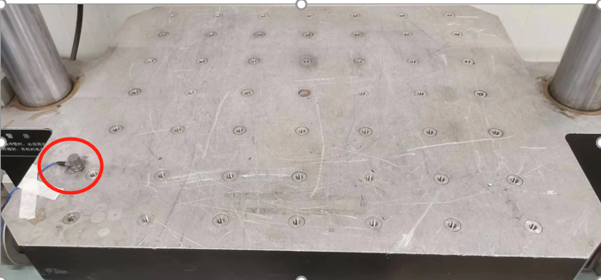

(a) actual installment



(b) Simulation settings

Fig. 4 Sensor settings of shock machine.

Fig. 5 shows the equivalent plastic strain evolution cloud map of the ferromagnetic ring during the impact process. It can be seen that after 2.5 ms, the maximum strain point of the ferromagnetic ring shifts from the upper end of the ferromagnetic ring to the contact point between the two ferromagnetic ring edges. After the simulation is completed, the maximum residual strain of the ferromagnetic ring is 0.3.

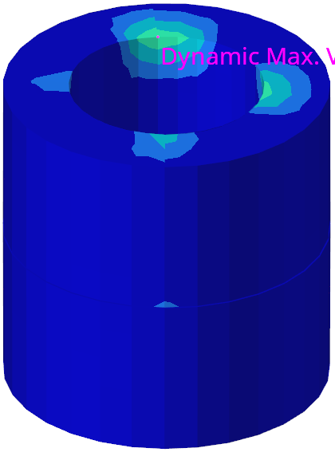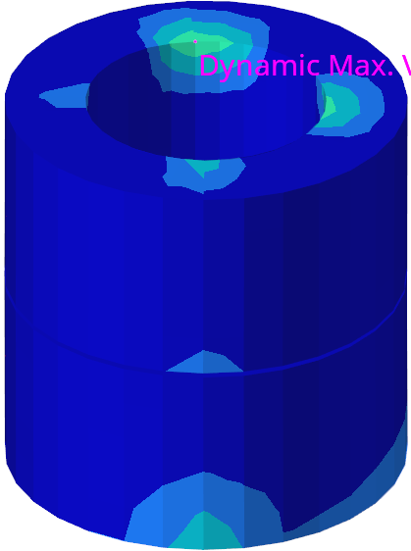 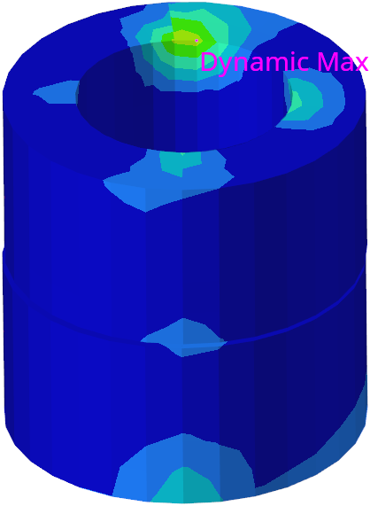

0.5ms 1ms 1.5ms

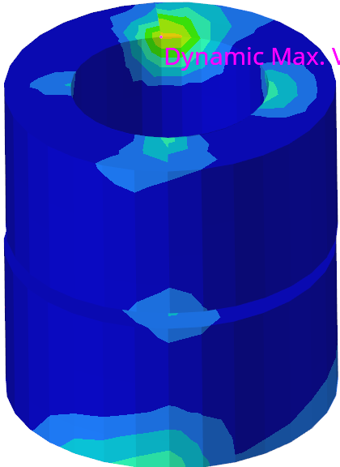 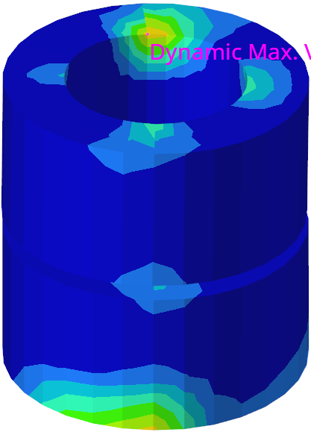 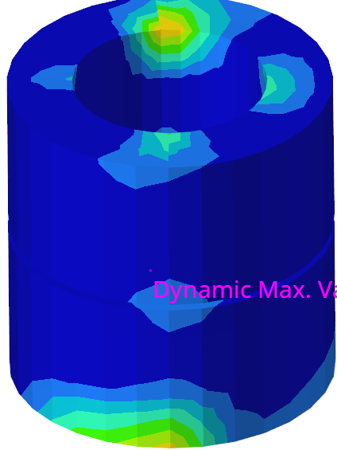

2ms 2.5ms 3ms

Fig. 5 Cloud diagram of strain evolution of ferromagnetic ring.

# Measured results

Fig. 6 shows the experimental CL-200 vertical impact table. Among them, the peak acceleration of the impact is 10-500g, the pulse width of the impact is 1~18ms, and the test load is 0~300kg. The size of the experimental platform is 800mm × 650mm × 86mm, the size of the convex platform is 350mm × 350mm × 60mm, and the total mass of the experimental platform is 150kg. The impact table can perform conventional half sine wave, back peak sawtooth wave, square wave and other waveform impact tests to simulate the ability of ferromagnetic rings to withstand impact damage in practical use. Fix the fixture to the test bench with bolts, as shown in Fig. 6, and lift the test bench to a free fall motion 480mm away from the impact table. At the moment of contact, a half sine impact signal is emitted. The maximum impact acceleration in this experiment is 500g, and the pulse width is 1.2ms.

The acceleration signal of the impact overload experiment contains high-frequency noise and requires inverse filtering processing. To ensure consistent analysis accuracy, the following steps are adopted for processing: select three typical acceleration raw signals, perform frequency spectrum analysis, and perform Fourier transform to obtain frequency domain distribution; Due to the attenuation of the acceleration amplitude of the impact load with increasing frequency, the cut-off frequency is determined based on spectral analysis; Low pass filtering is also required for the acceleration raw signal.

This filtering adopts the CFC-1000 digital filtering algorithm, which uses a 4-channel Butterworth low-pass filter. It is a common digital filtering algorithm in vehicle motion measurement, especially suitable for calculating dynamic acceleration based on high-speed data. This algorithm is used in standards such as ISO6487 and SAEJ211. By calculating the cutoff frequency of CFC 1000 as 1666Hz, any frequency greater than this will be filtered out, meaning that the sampling frequency of the original signal must be greater than 1666Hz. Fig. 7(a) shows the acceleration raw signal curve and the filtered curve at the output point. Fig. 7(b) shows the contact force signal curve of buffered foam. The maximum contact force of buffered foam is 35kN, and the time of maximum contact force is 1.8ms.

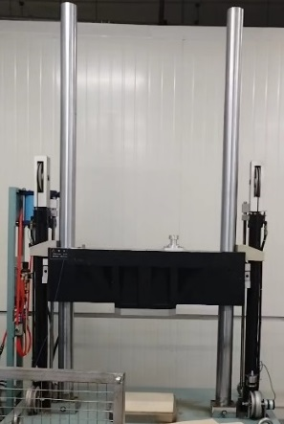

Fig. 6 Vertical impact table experimental scene.

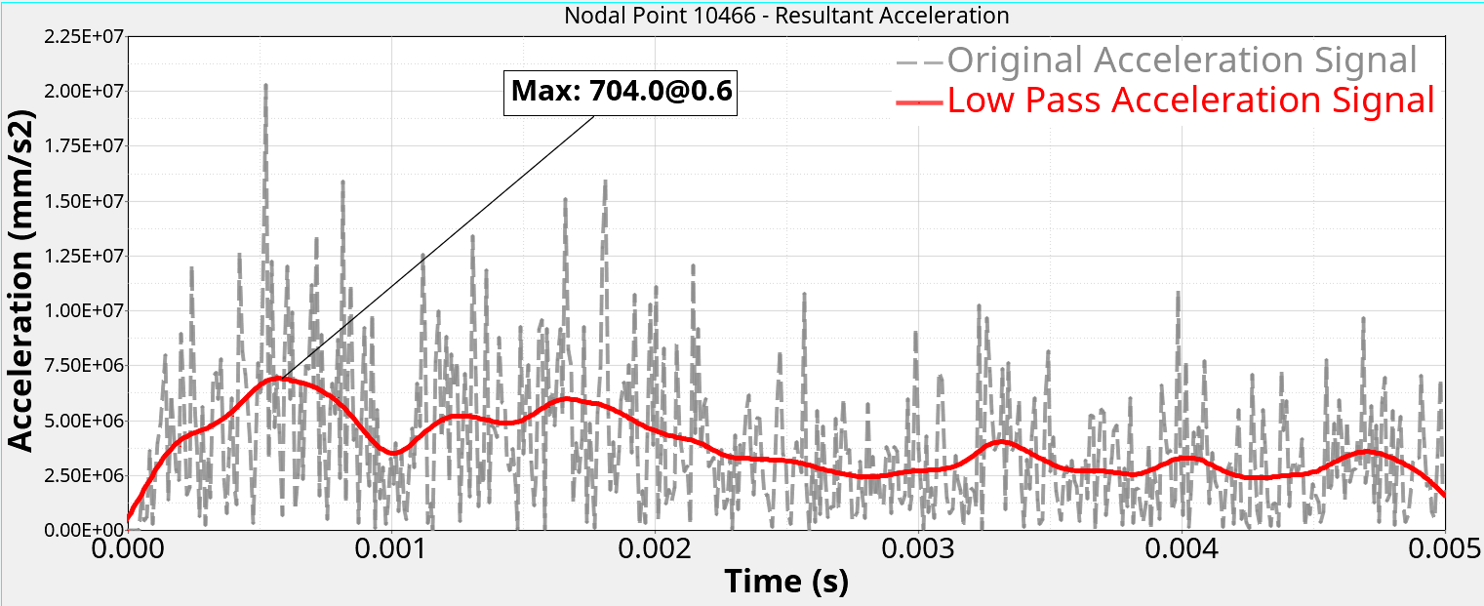

(a) Acceleration signal curve of the output point of the test bed



(b) Contact force between the upper and lower surfaces of the buffer foam

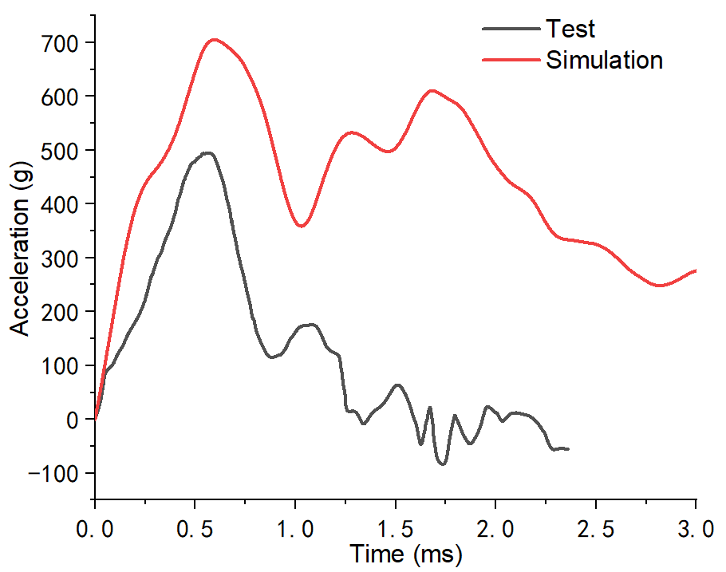

(c) Acceleration time curve of the output point of the test bed

Fig. 7 Comparison of Overload Curve between Simulation and Testing.

Fig. 7(c) shows the acceleration time curve of the output point of the experimental platform, and the trend of the simulation and experiment curves is basically consistent. The main reasons for the error are as follows: there are errors between the simulated input acceleration signal curve and the experimental input, and there are errors in the peak value and pulse duration of the acceleration shock waveform; The experimental sampling points and filtering methods are inconsistent with the simulation; The error of the material itself (with minimal impact).

Fig. 8 shows a comparison between the final failure mode of the ferromagnetic ring in the impact completion experiment and the simulated plastic strain cloud map. It can be seen from the Fig. that the damaged area of the ferromagnetic ring after the experiment is basically consistent with the maximum strain position in the simulation. However, due to three overload impacts on the same sample in the experiment, the strain accumulates and the damage extends from the inside out to the outer surface of the ferromagnetic ring, resulting in damage.

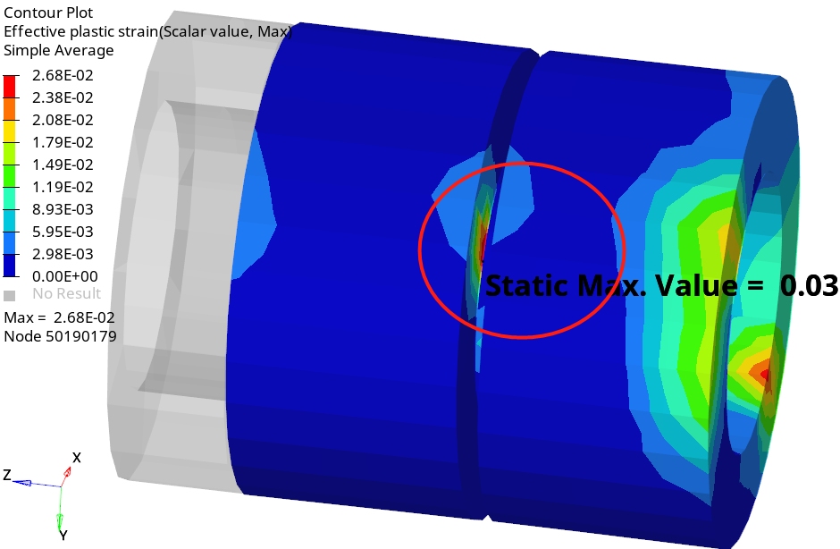

(a) Simulation

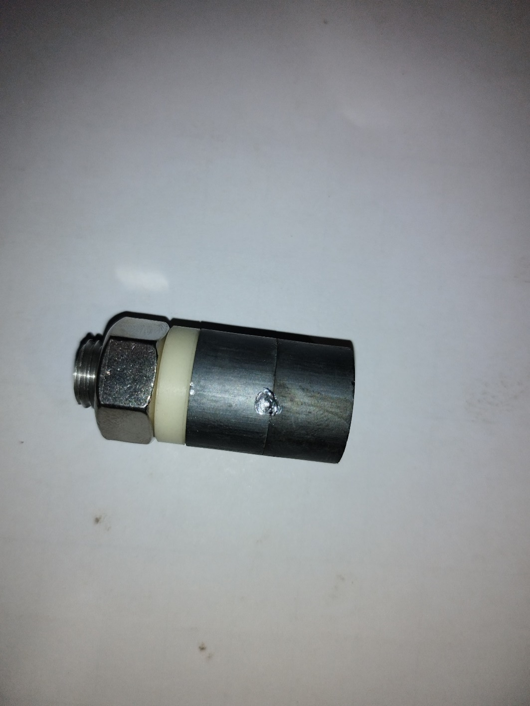

1. Measurement

Fig. 8 Comparison of simulation and testing failure modes

# CONCLUSION

This paper investigates the overload of ferromagnetic rings based on a dual degree of freedom model. The ferromagnetic ring is installed in the tooling to make free fall movement. When the test bench contacts with the buffer foam, the impact bench emits acceleration pulse signal, and the impact bench has the acceleration of upward movement to generate upward velocity; Use buffered foam to quickly reduce the speed of the shock table and the speed of the test table to 0 (corresponding to the actual hardware operation: quickly reduce the speed of the waveform transmitter to 0 through the hydraulic brake caliper of the shock table); Ensured that the experimental platform only withstands the acceleration pulse signal emitted by the impact platform during the duration of the pulse signal, effectively reproducing the loading process; By analyzing the acceleration of the workpiece under the action of the impact pulse signal, the simulated overload curve of the workpiece can be obtained. The ferromagnetic ring of the object for overload analysis is placed in the tooling for free fall movement. When the test bench contacts with the buffer foam, the impact bench emits acceleration pulse signal, and the impact bench has an upward acceleration, which then generates an upward velocity; Use buffered foam to quickly reduce the speed of the shock table and the speed of the test table to 0 (corresponding to the actual hardware operation: quickly reduce the speed of the waveform transmitter to 0 through the hydraulic brake caliper of the shock table); Ensured that the experimental platform only withstands the acceleration pulse signal emitted by the impact platform during the duration of the pulse signal, effectively reproducing the loading process; By analyzing the acceleration of the workpiece under the action of the impact pulse signal, the simulated overload curve of the workpiece can be obtained. The simulation and test results are in good agreement, verifying the correctness of the analysis method proposed in this paper.

# References

1. Wang Z Y, Jie Q, Wang Y J, et al. Realization of the unidirectional amplification in a cavity magnonic system. *Applied physics letters*, vol. 123, no. 15, pp: 153904.1-153904.7, 2023.
2. Zeng S, Li H, Zhao C. Magneto-mechanical coupling effect of ferromagnetic materials: Test characteristics and theoretical model. *Journal of Magnetism and Magnetic Materials*, vol. 583, 2023.
3. Zhang Y N, Yang G, Niu C, et al. Structural stability and electronic properties of Er nanowire on Si(001). *Physica, E. Low-dimensional systems & nanostructures*, vol. 142, 2022.
4. Palabindela P, Sinha J, Behera B C. Effect of void geometry and magnetic anisotropy in controlling the vortex in sub-micron annular Permalloy disc. *IOP Publishing Ltd*, DOI:10.1088/1402-4896/ad695c. 2024.
5. Savelev D V, Fedulov F A, Musatov V I,et al. Nonlinear resonant magnetoelectric effect in a circumferentially magnetized ferromagnetic–piezoelectric ring heterostructure. *Applied Physics Letters*, vol. 122, no. 19, 2023.
6. Wu Z, Paredes M, Seguy S. Targeted energy transfer in a vibro-impact cubic NES: Description of regimes and optimal design. *Journal of Sound and Vibration*, 2023.
7. Liu M, Zhao X, Xie C K. First-principles investigation of the impact of stress and lattice vibration on the hyperfine interactions of the nitrogen-vacancy center in diamond. *Physical review, B. Covering condensed matter and materials physics*, vol. 108, no. 15, 2023.
8. Son L, Farid M, Bur M,et al. Impact response analysis of vibration system with inerter. *Noise & Vibration Worldwide*, vol. 54, no. 3, 2023.
9. Zhang Y, Zhang X, Chen Y,et al. A frequency-domain hydroelastic analysis of a membrane-based offshore floating photovoltaic platform in regular waves. *Journal of Fluids and Structures*,vol. 127, 2024.
10. Lizunov P, Pogorelova O, Postnikova T. Prediction and diagnostics of crises and critical states in an unusual vibro-impact system with soft impact. *Nonlinear Dynamics*, vol. 111, no. 3, pp: 2379-2394, 2023.
11. Li W, Wang Z, Brennan M J,et al. Design and optimization of a two-degrees-of-freedom single-sided vibro-impact nonlinear energy sink for transient vibration suppression of a thin plate. *Journal of Sound and Vibration*, 587. 2024.
12. Xie C, Wang X, Vasdravellis G. Steady-state dynamic response analysis of single-degree-of-freedom dual frame-wall resilient system. *Soil dynamics and earthquake engineering*, vol. 172, no. 9, pp: 108043.1-108043.15, 2023
13. Wang T, Post M A. A Symmetric Three degree of Freedom tensegrity Mechanism with Dual Operation modes for robot actuation. *Biomimetics*, vol. 6, no. 2: 30, 2021.
14. Zhao M, Anzai T, Shi F,et al. Design, modeling, and control of an aerial robot DRAGON: A dual-rotor-embedded multilink robot with the ability of multi-degree-of-freedom aerial transformation. *IEEE Robotics and Automation Letters*, vol. 3, no. 2 pp: 1176-1183, 2018.
15. Dolev A, Bucher I. Dual frequency parametric excitation of a nonlinear, multi degree of freedom mechanical amplifier with electronically modified topology science direct. *Journal of Sound & Vibration*, vol. 419, pp: 420-435, 2018.