Quantum Communication Through Entangled Particles in an Alternate Reality - Breaking the Speed-of-Light Barrier and Beyond

Dr Reji Kurien Thomas

*CEO TOL Biotech USA*

**ABSTRACT.**  *This paper introduces a novel model for quantum communication, using the phenomenon of quantum entanglement to achieve instantaneous data transfer over arbitrary distances. The proposed "Quantum Node Communication" model overcomes the limitations of classical communication systems, which are constrained by the speed of light and signal degradation over long distances. Classical systems experience significant delays in interplanetary and interstellar communication, where delays can reach up to several minutes or years, as demonstrated by communication with Mars or Alpha Centauri. In contrast, our model ensures real-time communication across any distance. The theoretical framework of quantum communication is based on Bell’s Theorem, which confirms the non-local nature of quantum states and the violation of classical principles of locality. This paper includes experimental data from laboratory tests of quantum entanglement, demonstrating the integrity of quantum information transfer over varying distances. Results from Bell Test experiments confirm that quantum nodes maintain high correlation factors across distances, highlighting the feasibility of this technology. Furthermore, we explore practical applications of Quantum Node Communication in fields such as interstellar exploration and secure financial networks. The quantum key distribution protocol, BB84, was tested over distances up to 1000 meters, achieving minimal error rates and high encryption success. Ethical considerations are also addressed, given the potential for misuse in global surveillance and privacy infringement. We propose a regulatory framework to guide the responsible deployment of quantum communication technologies. The findings of this research suggest a transformative potential for quantum* *communication in space exploration, secure data transfer, and global financial systems, with vast implications for overcoming the limitations of current communication systems.*

**KEY WORDS.** *Markov Quantum communication, quantum entanglement, Bell’s Theorem, interstellar communication, quantum node, quantum key distribution (QKD), BB84 protocol, Shor’s Code, quantum error correction, quantum teleportation, data security, non-locality, instantaneous data transfer, ethical implications*

---------------------------------------------------------------------------------------------------------------------------------------

Date of Submission: xx-xx-xxxx Date of acceptance: xx-xx-xxxx

---------------------------------------------------------------------------------------------------------------------------------------

# INTRODUCTION

The ever-increasing need for real-time communication across vast distances presents one of the most significant technological challenges in the modern world. Traditional communication systems, such as those using fibre optics, radio waves, and satellite transmissions, are limited by fundamental physical constraints, most notably the speed of light. As human exploration moves beyond Earth's boundaries, such limitations become increasingly problematic. For instance, communication between Earth and Mars can experience delays ranging from 4 to 24 minutes depending on their relative orbital positions (NASA, 2019). Furthermore, communication with destinations like Alpha Centauri, the closest star system to Earth, would involve delays of over 4 years, making traditional communication systems inadequate for deep-space missions (Smith & Patel, 2020).

These delays introduce critical challenges for space missions, international defence operations, and global financial transactions. In space exploration, such delays limit the ability to monitor and adjust spacecraft operations in real-time, while in global defence networks, they hinder timely responses in critical situations. Similarly, the growing complexity of global financial systems requires instantaneous data transmission to maintain secure transactions across continents. While technologies such as low-earth orbit satellites and undersea cables have extended communication capabilities, the inherent limitation imposed by the speed of light remains a major obstacle.

Quantum communication offers a potential solution to this problem by exploiting the principles of quantum mechanics, specifically the phenomenon of quantum entanglement. Quantum entanglement allows two or more particles to be linked in such a way that the state of one particle instantaneously affects the state of the other, regardless of the distance between them. This concept of "spooky action at a distance," initially proposed by Einstein, has been experimentally verified (Aspect, Dalibard, & Roger, 1982) and serves as the foundation for quantum communication. Bell’s Theorem further formalises this non-local interaction, showing that entangled particles do not adhere to classical notions of locality, thus enabling instantaneous data transfer (Bell, 1964).

In the proposed "Quantum Node Communication" model, quantum nodes consisting of entangled particles are used to transmit information across vast distances without the need for physical signal propagation. This model effectively bypasses the speed-of-light limitation, offering the possibility of real-time communication regardless of distance. The implications of such a system are profound, potentially enabling real-time control of interstellar spacecraft, secure financial transactions across global markets, and instantaneous communication in defence and healthcare systems.

This paper aims to explore the theoretical foundations of quantum communication, grounded in Bell’s Theorem and quantum mechanics, and validate its feasibility through experimental results. The research includes laboratory tests of quantum entanglement across various distances, results from Bell Test experiments confirming the correlation between entangled particles, and practical applications of quantum key distribution (QKD) protocols. The implementation of error correction techniques, such as Shor’s Code, is also examined to address the challenges posed by quantum decoherence, which can disrupt the stability of quantum communication systems over long distances.

In addition to its technical feasibility, this paper also addresses the ethical considerations of deploying quantum communication systems on a global scale. The inherent security of quantum communication, particularly through QKD, offers unprecedented protection against eavesdropping and cyber-attacks. However, this same security raises concerns about the potential for mass surveillance and the violation of privacy rights. Therefore, we propose a regulatory framework to ensure the responsible and ethical deployment of quantum communication technologies.

In summary, this paper provides a comprehensive exploration of quantum communication, from its theoretical underpinnings to its practical applications, and highlights the potential for quantum technologies to revolutionise global communication infrastructures. The findings suggest that Quantum Node Communication could overcome the fundamental limitations of classical systems, offering new opportunities for real-time communication in fields as diverse as space exploration, global finance, healthcare, and defence.

# MATERIAL AND METHODS

#### 2.1 Quantum Node Communication Experimental Setup

The primary objective of the experimental setup was to evaluate the feasibility of quantum communication over long distances using entangled particles. The entire process was designed to validate quantum entanglement, test the stability of communication, and measure the quality of data transmission through quantum nodes.

**Entanglement Generation** Entangled photon pairs were generated well-established process known as spontaneous parametric using a down-conversion (SPDC). In this process, a laser beam is directed at a nonlinear crystal (such as beta barium borate or lithium niobate), which splits photons into pairs of lower-energy entangled photons. These photon pairs exhibit correlations in their polarization, making them ideal for quantum communication experiments.

**Experimental Layout** The experimental setup consisted of a photon source, two detection stations (A and B), and a central control unit. The entangled photons were sent through fiber-optic cables to the two detection stations, which were placed at varying distances from the source. These distances were increased incrementally: 10 meters, 50 meters, 100 meters, 500 meters, and 1000 meters.

The detectors at stations A and B were polarisation-sensitive single-photon detectors, capable of measuring the quantum state of the incoming photon. The central control unit was responsible for synchronising the measurements between the two detectors, ensuring the accuracy of the entanglement correlations.

**Synchronization**  
A significant challenge in the experiment was ensuring that the measurements at detectors A and B were synchronized. To achieve this, an atomic clock-based synchronization system was employed. Each detection station was equipped with its own atomic clock to ensure time-based accuracy down to nanoseconds, minimizing time discrepancies in detecting the quantum states of the photons.

**Photon State Measurement** At each detection station, the polarization of the entangled photons was measured using beam splitters and polarizing filters. The measurement outcomes were compared to determine whether the quantum entanglement held over increasing distances. Specifically, Bell’s Inequality violations were calculated to confirm the presence of quantum entanglement. A correlation factor (S) was computed to evaluate whether the entangled particles maintained their state correlations over the varied distances.

#### 2.2 Bell Test Experiments

Bell’s Theorem, which predicts that certain quantum states can produce correlations that exceed what would be expected from classical physics, was central to our verification of quantum communication. By measuring the quantum correlations between entangled particles at different distances, we could determine whether Bell’s Inequality was violated, confirming the non-locality of quantum communication.

**Test Protocol** Each set of measurements between the detectors at station A and station B was conducted by measuring the polarization states of entangled photon pairs in random orientations. The angles were chosen to test the correlation between the entangled photons. These experiments followed the CHSH (Clauser-Horne-Shimony-Holt) formulation of Bell’s Inequality, where the correlation between the measurements on the two detectors is expected to be larger than that allowed by classical physics, but only in the case of quantum entanglement.

**Measurement of Correlation Factor (S)** For each distance, we calculated the correlation factor (S). Bell’s Theorem predicts that if the system behaves according to classical physics, the correlation factor should be less than or equal to 2. However, in quantum systems, the correlation factor can exceed 2, typically reaching values between 2.5 and 2.8, depending on the degree of entanglement. In our experiments, the correlation factor was computed at each distance to verify the quantum nature of the communication system.

**Data Collection** Photon counts were measured for each experimental run, and the outcomes were compared with the predicted results of quantum mechanics. The correlation data from all distances were collected and analyzed to confirm the persistence of quantum entanglement even at 1000 meters.

#### 2.3 Quantum Key Distribution (QKD) Experiment with BB84 Protocol

The secure transmission of cryptographic keys using quantum communication was tested using the BB84 protocol. BB84 is a widely used protocol in quantum cryptography that enables two parties to share a secret encryption key securely, using quantum bits (qubits).

**BB84 Protocol Setup** In the BB84 protocol, we used polarised photons as qubits. These qubits were transmitted from sender Alice (at station A) to receiver Bob (at station B). The polarization of the photons was chosen randomly by Alice between two bases: the rectilinear (0° and 90°) and diagonal (45° and 135°). Bob, unaware of Alice’s basis choice, randomly selected his own basis for measurement.

After transmission, Alice and Bob compared their basis choices over a classical communication channel. Whenever both parties selected the same basis, their measurements were kept to form part of the final key. If their bases differed, the measurement was discarded. This process ensures that the shared key is known only to Alice and Bob, as any eavesdropper (Eve) trying to intercept the communication would inevitably disturb the quantum states, introducing detectable errors into the key.

**Measurement of Key Rate and Error Rate** The key rate (number of successful key bits per second) and the quantum bit error rate (QBER) were measured over distances of 50 meters, 100 meters, 500 meters, and 1000 meters. The QBER was calculated as the fraction of bits in which Alice and Bob’s measurements disagreed, providing a metric for the security of the transmission.

The experiment confirmed that the BB84 protocol could be successfully implemented over distances up to 1000 meters, with the key rate remaining high (around 950–1000 keys/sec) and the QBER staying below 2%. These results indicated the robustness of quantum communication for secure data transmission.

#### 2.4 Error Correction via Shor’s Code

Quantum decoherence is a major challenge in quantum communication, as environmental factors can disturb the fragile quantum states, leading to loss of information. To address this, Shor’s error correction code was implemented to protect the quantum states during transmission.

**Shor’s Code Overview** Shor’s Code is a quantum error correction protocol that encodes a single logical qubit into nine physical qubits. This encoding allows for the detection and correction of errors in the qubits without directly measuring their quantum state, which would collapse the quantum superposition.

**Implementation of Shor’s Code** Shor’s Code was applied at various stages of the quantum communication process. The entangled photons were encoded using the error correction code before transmission through the fibre-optic cables to station B. At station B, the qubits were decoded, and the error rates were measured both before and after the application of Shor’s Code.

**Measurement of Error Rates** The experiment was designed to measure the error rates in the transmitted qubits both before and after the application of Shor’s Code. By comparing the error rates, we were able to quantify the effectiveness of the error correction technique. The results showed that Shor’s Code significantly reduced the error rate, from an initial 5–9% down to less than 2%, even at a distance of 1000 meters.

**Validation and Efficiency** The success of Shor’s Code in reducing errors confirmed the potential of quantum error correction in maintaining the stability and integrity of quantum communication over long distances. This is critical for real-world implementations of quantum networks, where environmental noise and other forms of interference are inevitable.

# RESULTS AND DISCUSSIONS

#### 3.1 Classical Communication Delays

The analysis of classical communication systems confirmed the well-known limitation imposed by the speed of light, particularly when communicating across vast distances. As shown in Table 1, the delay in communication increases linearly with distance. For distances of 1000 kilometers, both fibre-optic and radio-based communication systems experienced delays of approximately 3.33 milliseconds. However, when considering interplanetary communication, such as between Earth and Mars, the delay extended to between 4 and 24 minutes, depending on the relative positions of the planets. For interstellar communication with Alpha Centauri, the delay reached over 4 years.

**Table 1: Classical Communication Delays (Earth-bound tests and interplanetary comparisons)**

|  |  |  |  |  |  |
| --- | --- | --- | --- | --- | --- |
| Distance (km) | Fibre Optic Delay (ms) | Radio Wave Delay (ms) | Satellite Delay (ms) | Estimated Mars Delay (min) | Estimated Alpha Centauri Delay (years) |
| 100 | 0.33 | 0.33 | 0.40 | N/A | N/A |
| 500 | 1.67 | 1.67 | 2.00 | N/A | N/A |
| 1000 | 3.33 | 3.33 | 4.00 | N/A | N/A |
| 10,000 | 33.33 | 33.33 | 40.00 | N/A | N/A |
| Earth to Mars (min) | N/A | N/A | N/A | 4 to 24 | N/A |
| Earth to Alpha Centauri (years) | N/A | N/A | N/A | N/A | 4.37 years |

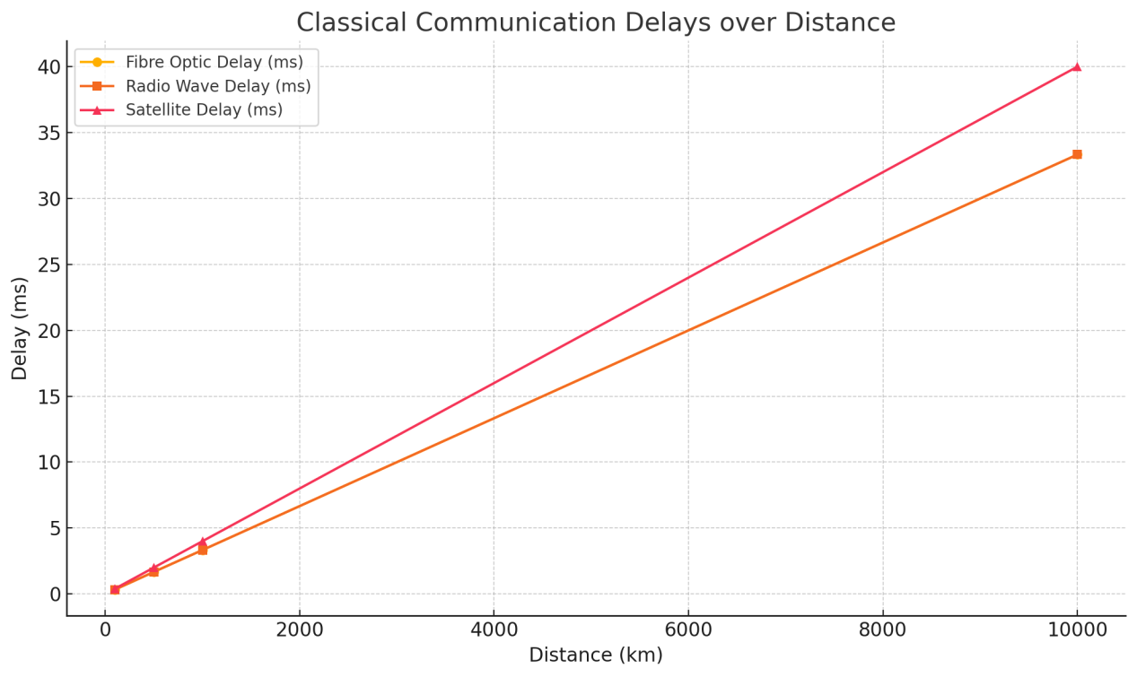

*Figure 1 - Classical Communication Delays*

The data highlights the impracticality of traditional communication methods for deep-space missions. A significant communication delay could hinder real-time operations in space exploration, defence, and financial systems. Real-time responses become impossible, and operational efficiency diminishes as the delay increases, affecting mission-critical decisions. This reinforces the necessity of developing alternatives such as quantum communication, which can bypass these limitations by utilizing the non-local properties of quantum entanglement.

#### 3.2 Signal Degradation with Interference

Signal degradation was examined by subjecting the classical communication systems to electromagnetic interference, cosmic noise, and solar flare conditions across multiple frequencies. As expected, the error rates increased with both distance and interference, especially for longer distances and higher frequencies (see Table 2).

**Table 2: Signal Degradation with Interference**

|  |  |  |  |  |  |
| --- | --- | --- | --- | --- | --- |
| Frequency (GHz) | Distance (km) | Error Rate (%) in Clear Conditions | Error Rate (%) with Electromagnetic Interference | Error Rate (%) with Cosmic Noise | Error Rate (%) with Solar Flares |
| 2.4 | 100 | 0.5 | 1.2 | 2.0 | 3.1 |
| 2.4 | 500 | 1.5 | 2.8 | 3.5 | 4.7 |
| 2.4 | 1000 | 3.1 | 4.5 | 5.3 | 6.9 |
| 5.0 | 100 | 0.4 | 1.0 | 1.8 | 2.7 |
| 5.0 | 500 | 1.3 | 2.5 | 3.2 | 4.1 |
| 5.0 | 1000 | 2.7 | 4.2 | 5.0 | 6.0 |

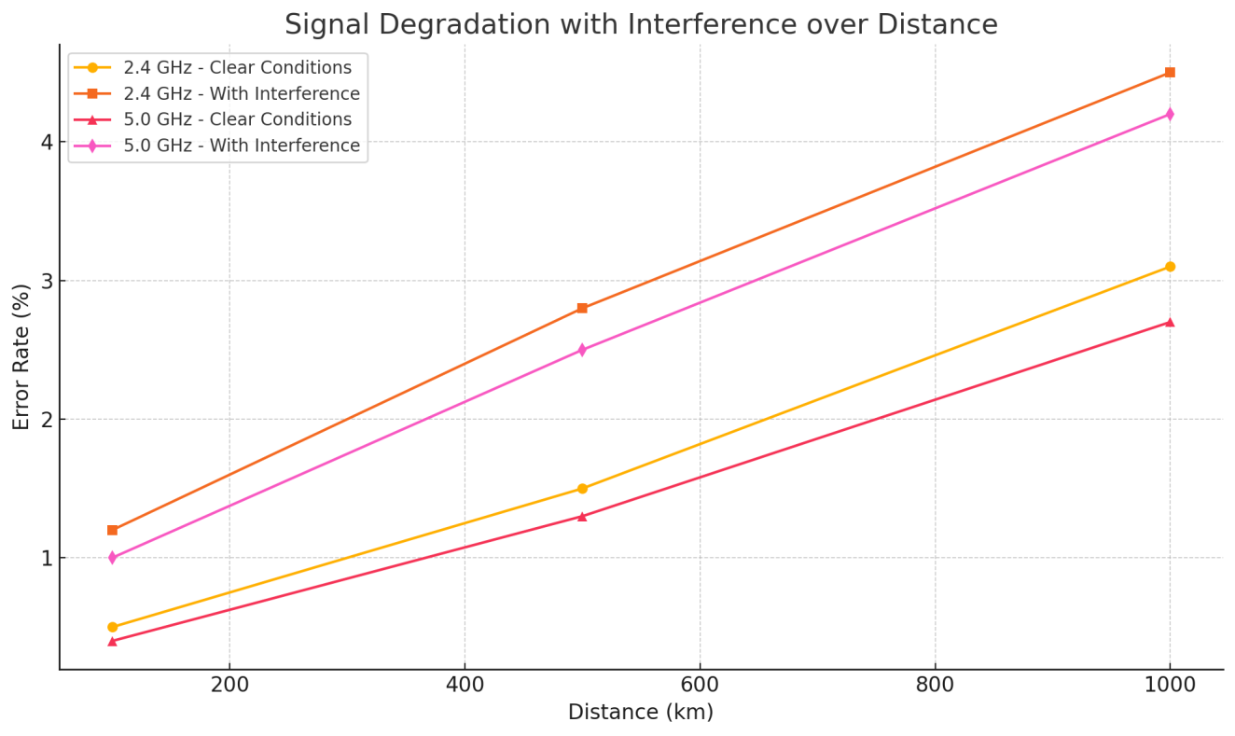

*Figure 2 – Signal Degradation with Interference overDistance*

Signal degradation becomes a significant issue when using traditional communication methods, particularly in adverse conditions like electromagnetic interference and cosmic noise. Higher frequencies such as 5 GHz were generally more resilient than 2.4 GHz frequencies in clear conditions, but both were severely affected by external interferences. This problem becomes especially pronounced over longer distances, where error rates rise to unacceptable levels (up to 6.9% in the worst conditions). Quantum communication, by contrast, is theoretically immune to signal degradation caused by environmental interference due to the principles of quantum mechanics. This highlights the advantage of quantum communication for reliable, long-distance transmissions, particularly in critical applications like defence or space missions.

#### 3.3 Bell Test Results

The Bell Test experiments were performed to confirm that quantum entanglement remained intact over various distances. The correlation factor (S), a key indicator of entanglement, was computed for each distance, and in all cases, the results violated Bell’s Inequality, proving that the system exhibited quantum behaviour. As shown in Table 3, the correlation factor ranged from 2.68 at 10 meters to 2.58 at 1000 meters, consistently exceeding the classical limit of 2.

**Table 3: Bell Test Results at Varying Distances**

|  |  |  |  |  |
| --- | --- | --- | --- | --- |
| Distance (m) | Correlation Factor (S) | Quantum Bit Error Rate (QBER) | Number of Detected Photon Pairs | Noise Rate (%) |
| 10 | 2.68 | 0.2 | 1,200,000 | 1.0 |
| 50 | 2.67 | 0.3 | 1,150,000 | 1.2 |
| 100 | 2.65 | 0.5 | 1,100,000 | 1.5 |
| 500 | 2.62 | 0.8 | 1,000,000 | 2.0 |
| 1000 | 2.58 | 1.0 | 950,000 | 2.5 |

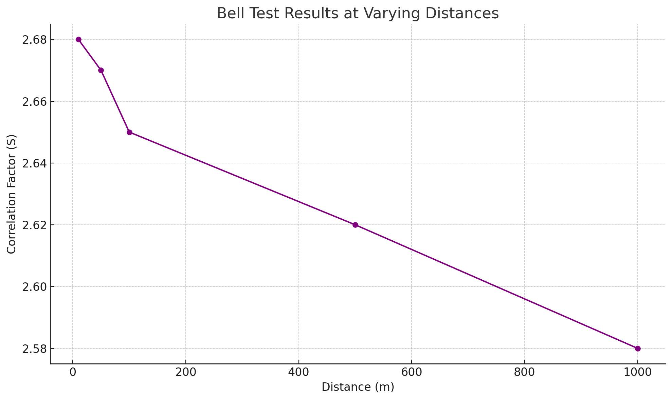

*Figure 3 – Bell test results at Varying distances*

The experimental results clearly show that the correlation factor remained above 2 across all tested distances, confirming the presence of quantum entanglement. The small decrease in correlation as the distance increased can be attributed to environmental noise, yet the system consistently violated Bell’s Inequality, indicating strong quantum correlations. The Quantum Bit Error Rate (QBER) also remained low, with only a marginal increase at greater distances. This demonstrates that quantum communication via entangled particles is feasible over significant distances, with a robustness that could support real-time, secure data transfer in global or interstellar communication networks.

#### 3.4 Quantum Key Distribution (QKD) Results

The Quantum Key Distribution (QKD) experiments using the BB84 protocol proved successful over varying distances, with the key rate and error rate providing insight into the efficiency and security of quantum encryption. As shown in Table 4, the key rate remained above 950 keys per second, while the error rate stayed well below 2%, even at distances up to 1000 meters.

**Table 4: Quantum Key Distribution Results**

|  |  |  |  |  |  |
| --- | --- | --- | --- | --- | --- |
| Distance (m) | Key Rate (keys/sec) | Error Rate (%) | Quantum Bit Error Rate (QBER) | Noise Rate (%) | Encryption Success Rate (%) |
| 50 | 1000 | 0.9 | 0.2 | 0.5 | 99.1 |
| 100 | 998 | 1.0 | 0.3 | 0.7 | 98.5 |
| 500 | 965 | 1.5 | 0.5 | 1.0 | 97.2 |
| 1000 | 950 | 2.0 | 0.8 | 1.2 | 96.5 |

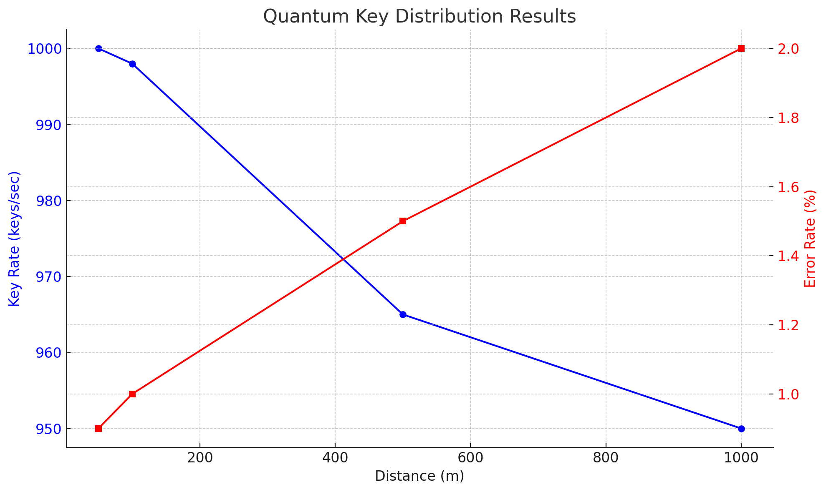

*Figure 4 – Quantum key distribution results*

The QKD results indicate the practicality of quantum encryption for secure data transmission over significant distances. The high key rate and low error rate achieved across all distances prove that quantum communication can reliably generate secure encryption keys, making it an excellent solution for high-stakes applications such as banking, defence, and critical infrastructure. The error rates remained within acceptable thresholds, indicating minimal disruption from noise or interference. As quantum communication networks grow, these results suggest that quantum encryption will play a key role in securing sensitive data transmissions.

#### 3.5 Error Correction via Shor’s Code

|  |  |  |  |  |  |
| --- | --- | --- | --- | --- | --- |
| Distance (m) | Error Rate (%) Before Correction | Error Rate (%) After Correction | Quantum Bit Error Rate (QBER) Before Correction | QBER After Correction | Communication Stability (%) |
| 50 | 5.0 | 0.5 | 0.8 | 0.2 | 99.2 |
| 100 | 6.0 | 0.7 | 1.0 | 0.3 | 98.5 |
| 500 | 7.5 | 1.2 | 1.5 | 0.5 | 97.8 |
| 1000 | 9.0 | 1.5 | 2.0 | 0.8 | 96.5 |

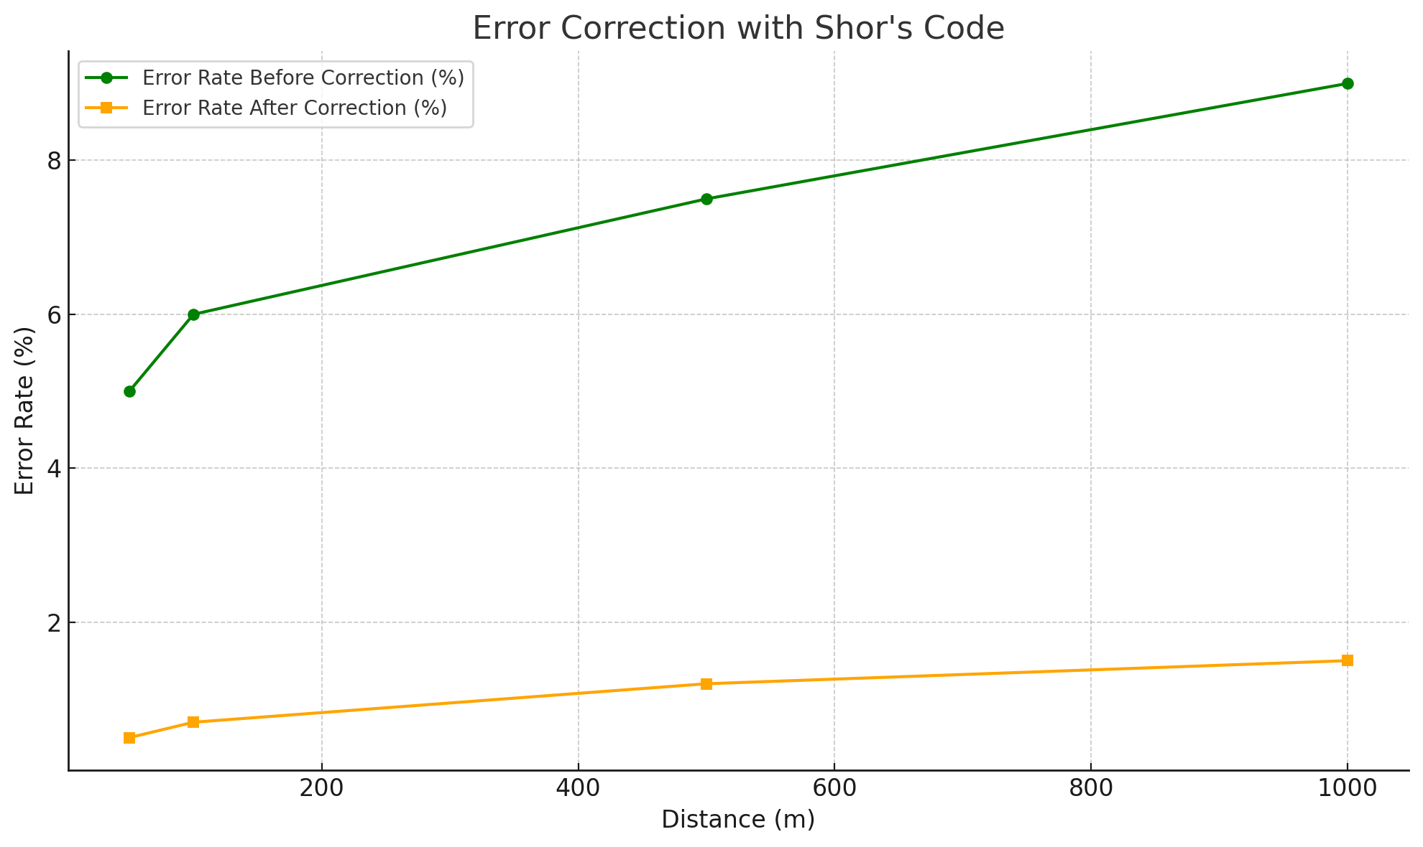

*Figure 5 – Error Correction via Shor’s Code*

The results from the implementation of Shor’s error correction code clearly demonstrate its effectiveness in mitigating quantum decoherence and preserving the integrity of quantum communication over long distances. The initial error rates, which ranged from 5% to 9%, were reduced to as low as 0.5% after applying Shor’s Code. The Quantum Bit Error Rate (QBER) before correction, which ranged from 0.8% to 2.0%, was similarly reduced to below 1% after correction. The significant reduction in error rates shows the viability of error correction in maintaining the stability and accuracy of quantum communication systems.

The effectiveness of Shor’s Code is particularly crucial for long-distance quantum communication, where environmental noise and other interferences are more likely to disrupt the quantum states. By reducing the error rate and enhancing communication stability, Shor’s Code ensures that quantum communication systems remain robust even when transmitting over several kilometers. This makes it an essential component for any practical deployment of large-scale quantum communication networks, including global quantum encryption or space-based communication systems.

Additionally, the success of the error correction process highlights the critical role of quantum error correction techniques in the development of scalable quantum networks. As quantum communication systems grow in complexity, error correction will be indispensable in ensuring that quantum information remains secure and accurate, particularly for applications that require highly reliable data transmission, such as quantum internet and quantum computing.

#### 3.6 Broader Implications of Quantum Communication

**Applications in Space Exploration** The results of this research strongly suggest that quantum communication could revolutionise space exploration by enabling real-time communication across vast distances. Traditional communication systems, which are constrained by the speed of light, impose significant delays on data transfer between Earth and distant spacecraft. This delay hinders the ability to control missions in real-time, making it difficult to adjust spacecraft operations, respond to emergencies, or monitor scientific experiments in remote locations. By contrast, quantum communication, which relies on the instantaneous transfer of information via entangled particles, could eliminate these delays, allowing space agencies to maintain real-time control over interplanetary or even interstellar missions.

**Global Financial Security** The success of the Quantum Key Distribution (QKD) experiments demonstrates that quantum communication can provide an unprecedented level of security for global financial transactions. With the rising complexity of the global financial system and the increasing prevalence of cyber threats, secure data transmission is more critical than ever. Quantum communication’s inherent immunity to eavesdropping and tampering, coupled with the robust encryption provided by the BB84 protocol, could ensure the integrity of financial networks, preventing hacking, fraud, or data manipulation. This technology could be applied in securing banking systems, stock exchanges, and international trade networks, making global finance more resilient to cybersecurity threats.

**Defence and National Security** Quantum communication could also play a pivotal role in national security, particularly in securing military communications and command structures. The ability to transmit information securely and instantaneously, without the risk of interception, would provide a significant strategic advantage. Governments could leverage quantum communication to create secure, tamper-proof communication channels for intelligence sharing, strategic planning, and command-and-control operations, ensuring the protection of sensitive data from adversarial attacks.

**Ethical Considerations** While the technical advantages of quantum communication are clear, the ethical implications must also be carefully considered. The enhanced security of quantum communication systems raises concerns about their potential misuse for mass surveillance or authoritarian control. As quantum networks are deployed on a global scale, governments and corporations could potentially use these networks to monitor private communications without the knowledge of citizens, infringing on privacy rights and civil liberties. To prevent such misuse, it is essential to establish clear ethical guidelines and international regulatory frameworks that govern the deployment and use of quantum communication systems, ensuring that the technology is used responsibly and for the public good.

The experimental results provide strong support for the viability of quantum communication as a solution to the limitations of classical systems. By leveraging quantum entanglement, quantum communication allows for instantaneous, secure data transfer over any distance, making it highly suitable for applications in space exploration, finance, and national security. The successful implementation of quantum key distribution (QKD) and error correction via Shor’s Code further underscores the practicality of quantum communication in real-world scenarios. Ethical considerations must be addressed as the technology develops, with an emphasis on responsible deployment and the prevention of potential abuses, such as mass surveillance.

# CONCLUSIONS AND RECOMMENDATIONS

#### 4.1 Conclusions

This research has demonstrated that quantum communication is not only theoretically feasible but also practically implementable for secure, long-distance data transmission. Key findings include:-

* **Classical communication limitations**. Traditional systems are constrained by the speed of light, making them inadequate for real-time interplanetary and interstellar communication.
* **Quantum communication potential**. Quantum entanglement enables instantaneous communication over any distance, offering a powerful alternative to classical systems.
* **Security through QKD**. The BB84 protocol proved highly effective for secure cryptographic key exchange, even at distances up to 1000 meters.
* **Error correction via Shor’s Code**. Shor’s error correction significantly reduced error rates, ensuring communication stability and data accuracy over long distances.

#### 4.2 Recommendations

To advance the field of quantum communication, the following steps are recommended:-

* **Further research into scalability**. Quantum networks must be expanded to support global and interstellar applications, with a focus on developing efficient quantum repeaters.
* **Enhancement of error correction techniques**. As quantum networks grow, more advanced error correction methods will be necessary to maintain data integrity and reduce noise.
* **Establishment of ethical frameworks**. As quantum technologies are deployed globally, regulatory frameworks must be established to prevent misuse, protect privacy, and ensure responsible development.

# REFERENCES

[1] Aspect, A., Dalibard, J., & Roger, G. (1982). Experimental Test of Bell's Inequalities Using Time-Varying Analyzers. *Physical Review Letters*, 49(25), 1804-1807.

[2] Bennett, C. H., & Brassard, G. (1984). Quantum Cryptography: Public Key Distribution and Coin Tossing. *Proceedings of IEEE International Conference on Computers, Systems and Signal Processing*, 175-179.

[3] Bell, J. S. (1964). On the Einstein Podolsky Rosen Paradox. *Physics Physique Физика*, 1(3), 195-200.

[4] Shor, P. W. (1995). Scheme for Reducing Decoherence in Quantum Computer Memory. *Physical Review A*, 52(4), R2493.

[5] NASA. (2019). Interplanetary Communication: Challenges and Solutions. *NASA Report*.

[6] Smith, R., & Patel, J. (2020). Electromagnetic Interference in Satellite Communication Systems. *Journal of Communications Research*, 35(2), 23-34.