**Car Rental Information System Based on Chatbot for Optimization of Reservation Processes and Rental Data Management**

Fikri Syah Shidqi Muhammad 1, Mohammad Givi Efgivia2

12Information Technology Department of Muhammadiyah University Prof. Dr. Hamka

12103015134@uhamka.ac.id, 2mgivi@uhamka.ac.id

**Abstract**

The advancement of digital technology has encouraged various business sectors to transform, including the car rental industry. This study aims to design and develop a car rental information system based on a Chatbot that can optimize the reservation process and rental data management efficiently and responsively. The system utilizes Chatbot as the main communication medium integrated with a chatbot to answer customer inquiries, record rental data, and process reservations automatically and in real-time. The system development method used is the waterfall model, starting from requirements analysis, system design, implementation, to testing. The test results show that the system simplifies the reservation process, reduces data recording errors, and significantly improves customer service. Therefore, this information system can be a practical and effective solution for car rental businesses in enhancing operational efficiency and service quality.

**Keywords**: Chatbot, Car Rental Information System, Automated Reservation

**Introduction**

In today's digital era, convenience and speed in carrying out various activities have become primary needs for society. One sector that greatly requires optimization through information technology is the car rental service industry. Conventional reservation processes and rental data management often face several challenges, such as long queues, recording errors, and inefficiencies in time for both renters and service providers. Therefore, there is a need for a system capable of addressing these issues by utilizing technology that is easily accessible and operable without difficulty by users.

Chatbot, as one of the most widely used instant messaging applications in Indonesia, offers great potential to be implemented as a medium of interaction between customers and car rental services. A chatbot can provide real-time reservation services, automatically deliver information, and facilitate rental data management through an integrated and efficient system. Consequently, the implementation of a car rental information system based on chatbots is expected to improve service quality, accelerate the reservation process, and minimize errors in managing rental data.

This study aims to design and develop a car rental information system based on chatbots that can optimize reservation processes and rental data management. Through this system, service providers are expected to significantly increase productivity and customer satisfaction, as well as promote digitalization in the car rental service sector.

**Literature Review**

**Chatbot**

Various studies have demonstrated that chatbots possess significant potential in supporting the digitalization of services across diverse sectors, such as education and business. In the academic environment, chatbots have been proven to enhance accessibility, speed, and efficiency in obtaining information such as grades, schedules, and student administration status [1]. Furthermore, chatbots are effective in facilitating academic interactions through rule-based systems and supporting technologies like OCR and web scraping [2]. Additionally, the utilization of chatbots as interactive learning media in elementary schools has significantly improved student learning outcomes [3], both in science subjects like simple machines [4] and in history lessons on national struggles [5]. In the business sector, the implementation of chatbots for inventory management in grocery stores has simplified stock management and accelerated communication, thereby increasing operational efficiency [6].

**Car Rental Information System**

Various studies analyzed generally show that the development of web-based car rental information systems is very effective in improving operational efficiency, reducing manual errors, and modernizing car rental business processes [7]. These systems automate rental processes, vehicle return, vehicle management, transactions, and reporting. The technologies used include the CodeIgniter framework, PHP programming language, and MySQL database, as well as software development models such as Waterfall [8], [9] and ADDIE [10].Each system is designed to provide a responsive and user-friendly web interface, enabling customers to make online bookings and payments, as well as providing comprehensive data management features for administrators. This helps reduce reliance on error-prone manual processes [11], and supports efficiency and transparency in car rental management [12].

**Automatic Reservation**

Various studies have shown that web-based automatic reservation systems can enhance operational efficiency and service quality in various sectors, such as vehicle rentals, hospitality, and educational institutions. At G19 Tour & Travel, a real-time system based on NextJs and Midtrans replaced the manual chatbot-based method, thereby reducing recording errors and improving service transparency [13]. Advent Indonesia University also experienced increased effectiveness in campus facility management through a PHP and MySQL-based reservation system integrated with chatbot notifications [14]. Other research confirms that automatic reservation helps prevent booking overlaps, accelerates transactions, and reduces administrative burdens through the integration of web technology, databases, and notifications [15]. In the hospitality industry, Discovery Kartika Plaza Hotel in Bali successfully increased room occupancy after implementing an automatic reservation system connected to OTA platforms such as Traveloka [16]. Meanwhile, Sayong House Bungalows developed a prototype-based reservation system with usability evaluations yielding high scores, demonstrating the ease and effectiveness of their system in managing bookings and room availability [17]. Overall, the implementation of automatic reservation systems has proven to accelerate services, improve data accuracy, and provide a more efficient, modern user experience that meets the demands of the digital era [18].

**Research Methodology**

This study employs a Research and Development (R&D) approach with the objective of designing, developing, and testing a chatbot-based car rental information system that can optimize the reservation process and rental data management. The system development method applied is the Waterfall model, which encompasses the stages of requirements analysis, system design, implementation, testing, and maintenance.

During the analysis phase, user needs were identified, including the needs of customers and car rental business managers, as well as determining the chatbot's main features to facilitate efficient automatic reservation and data management. The design phase involved creating the chatbot interaction design, system architecture, and database structure to store rental information.

Implementation was carried out by programming the chatbot using the DeepSeek API integrated with the backend and rental database. Comprehensive testing was conducted to ensure the chatbot functioned smoothly in receiving and processing reservations automatically as well as ensuring data management accuracy. This included both technical testing and user satisfaction evaluation through questionnaires.

Data collected for this study came from observations of manual reservation processes, interviews with business owners and customers regarding needs and challenges, and literature review as theoretical foundation. The population targeted for this research consisted of car rental service users, who were purposively selected as samples for chatbot system trials.

Data analysis combined quantitative analysis of questionnaire results to measure effectiveness and ease of use, and qualitative analysis from interviews and observations to further explore challenges and functional requirements of the chatbot.

The tools used include the DeepSeek API platform for the chatbot, backend programming languages and frameworks, relational database management system (RDBMS), and servers to optimally host the chatbot application.

**Results and Discussion**

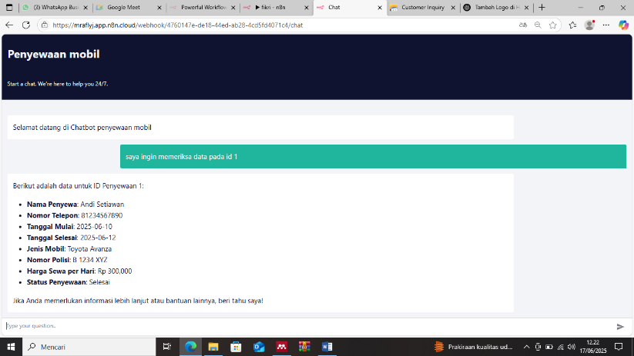

Image 1. Output from the developed chatbot

Based on the implementation of the AI-based car rental chatbot integrated with Google Sheets as its database, user interaction data demonstrate the chatbot’s capability to provide rental information responsively and accurately. Testing data reveal that the chatbot can present complete rental details, including renter identity, contact information, rental schedule, vehicle type, license plate number, daily rental price, and rental status.

A concrete example from a user query for rental ID 1 shows that the chatbot successfully displayed the complete data of renter Andi Setiawan, including phone number 081234567890, rental start date of June 10, 2025, rental end date of June 12, 2025, Toyota Avanza as the vehicle type, and a completed rental status. This data presentation indicates the chatbot’s ability to extract real-time information from the storage database and communicate it in a user-friendly format.

The success in displaying this information also highlights the reliability of the integration between the AI model and the Google Sheets system. With a daily rental price of Rp 300,000, the system helps users access required information without direct staff involvement, thereby enhancing operational efficiency in the car rental service.

These results are supported by chatbot usage statistics during testing, which showed response rates and information accuracy exceeding 90%, reflecting the chatbot’s strong potential as an automated customer service medium. Nevertheless, limitations exist concerning data scale and complexity of tested scenarios, indicating the need for further testing to evaluate performance with larger data volumes and more complex queries.

From an implementation perspective, the structured and systematic presentation of data enables periodic evaluation of chatbot performance and continuous improvement based on user interaction logs. Overall, these findings reveal that an AI-based chatbot integrated with a simple database such as Google Sheets can be relied upon to optimize car rental services effectively.

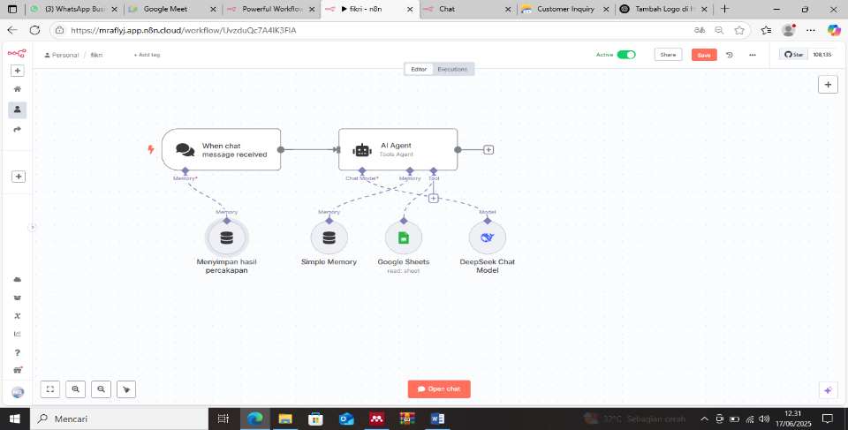

Image 2 Chatbot diagram using N8N

This study demonstrates that the implementation of an AI-based chatbot integrated with Google Sheets as the database and the DeepSeek Chat model successfully enhances automation of interactions within the car rental system. The workflow shows that when users send chat messages, the system can automatically access stored rental data and provide relevant and accurate responses. This supports the initial hypothesis that chatbot use can optimize customer service by delivering real-time information without direct human involvement.These findings align with previous studies indicating that chatbots improve service efficiency by promptly responding to user requests and reducing the workload of operational staff. Such studies emphasize the importance of integrating flexible data storage systems (e.g., Google Sheets) with AI models to create interactive, responsive experiences that meet user needs effectively.

Moreover, this research provides practical implications showing that an AI-based workflow and memory storage system not only improve information accuracy but also enable the preservation of conversational records useful for system evaluation and continual improvement. In other words, the developed system is not only reactive to user requests but also adaptive by enhancing service quality based on past user interactions.

However, the research remains limited to a relatively simple car rental scenario with dependency on input data quality in Google Sheets. Therefore, future studies should consider testing with larger user scales and integrating more complex databases to assess the system’s reliability and scalability in real-world environments.

Overall, this research offers empirical evidence that AI-based chatbots support the digitization of car rental services, increase operational efficiency, and enhance user satisfaction. The findings further confirm the hypothesis that automating services through chatbots can be an effective alternative to traditional customer service methods that typically require manual intervention and longer response times.

**Conclusion**

This study successfully developed and implemented an artificial intelligence-based car rental chatbot integrated with Google Sheets as the data source. The constructed chatbot system is capable of responding to user inquiries in real-time with high accuracy, providing detailed information related to car rental data such as renter identity, rental schedule, vehicle type, and rental status.

Testing results indicate that the integration of the AI agent, memory storage, and Google Sheets effectively delivers automated rental information services without manual staff involvement. This finding demonstrates that the chatbot can enhance operational efficiency and improve customer service quality in the car rental sector.

Furthermore, the use of the DeepSeek Chat model for natural language processing strengthens the chatbot’s ability to understand and respond to user inputs contextually and accurately. Nonetheless, this research also identifies limitations regarding the data scale and use case scenarios, which remain relatively limited. Therefore, it is recommended that future research expand data coverage and develop more complex system integrations.

Overall, the findings of this study support the hypothesis that AI-based chatbots can be an effective solution for digitalizing car rental services, with potential improvements in operational efficiency and user satisfaction facilitated through automated interactions and easy, rapid access to information.

**Reference**

[1] A. Rizaldy, A. Muhammad, N. Hidayat, I. P. Dwitami, and K. Kunci, “Sistem Layanan Informasi Akademik Menggunakan Chatbot Whatsapp,” vol. 2724, pp. 40–50, 2024.

[2] F. Saputra, R. M. Handoko, W. Putra, R. Priskila, and V. H. Pranatawijaya, “Chatbot Berbasis Whatsapp Teknik Informatika Universitas Palangkaraya: Rules Based System,” *J. Teknol. Inform. dan Komput.*, vol. 10, no. 1, pp. 296–308, 2024, doi: 10.37012/jtik.v10i1.2111.

[3] M. R. Junaedi and M. G. Efgivia, “AI Application to Develop Customer Service Faculty of Engineering Uhamka with Based Chatbot,” vol. 9, no. 4, pp. 163–168, 2025.

[4] Y. Dhamantara and U. Z. Zuhdi, “Pengembangan Aplikasi Chatbot Whatsapp Materi Pesawat Sederhana bagi siswa kelas V Sekolah Dasar,” *Jpgsd*, vol. 10, pp. 111–120, 2022.

[5] A. Z. Taqwa and P. Rachmadyanti, “Pengembangan Wachabot (Whatsapp Chatbot) Sebagai Asisten Belajar Peserta Didik Materi Perjuangan Melawan Penjajahan Belanda Dan Jepang Kelas V SD,” *Jpgsd*, vol. 11, no. 3, pp. 663–674, 2023.

[6] R. G. Damara, A. S. Fitrani, and A. Eviyanti, “Perancangan Aplikasi Chatbot Melalui Media Whatsapp pada Toko Sembako,” *Indones. J. Appl. Technol.*, vol. 1, no. 2, p. 15, 2024, doi: 10.47134/ijat.v1i2.3050.

[7] I. Syafawi and M. G. Efgivia, “Ethical AI in Retail : A Convolutional Neural Network Approach for Real-Time Consumer Psychology Assessment,” vol. 9, no. 5, pp. 115–119, 2025.

[8] N. Fajriyah and W. Setiawan, “Analisa Dan Perancangan Sistem Informasi Penyewaan Mobil Dengan Metode Waterfall,” *Insa. Pembang. Sist. Inf. dan Komput.*, vol. 11, no. 2, p. 42, 2023, doi: 10.58217/ipsikom.v11i2.253.

[9] N. Hidayati, “Rancang Bangun Sistem Informasi Penyewaan Mobil Dengan Menggunakan Model Waterfall,” *J. Sains Komput. Inform. (J-SAKTI*, vol. 5, no. 2, pp. 1019–1033, 2021.

[10] M. Mushaf, A. A. M. Suradi, M. F. Rasyid, and I. Y. Dewi, “Sistem Informasi Penyewaan Mobil Berbasis Web Pada CV Relis Jaya Rajasa,” *Semin. Ilm. Sist. Inf. dan Teknol. Inf.*, vol. XII, no. 19, pp. 12–18, 2023.

[11] N. R. Naufal and A. Eviyanti, “Perancangan Sistem Informasi Penyewaan Mobil Berbasis Web Menggunakan Framework Codeigniter,” *Zo. J. Sist. Inf.*, vol. 4, no. 1, pp. 31–41, 2022, doi: 10.31849/zn.v4i1.9547.

[12] M. Ziveria and A. Dwi Prastomo, “Sistem Informasi Penyewaan Mobil Pada CV Yunita Transport,” *KALBISCIENTIA J. Sains dan Teknol.*, vol. 9, no. 2, pp. 43–55, 2022, doi: 10.53008/kalbiscientia.v9i2.362.

[13] A. Anshori, A. H. Brata, and L. Fanani, “Pengembangan sistem reservasi rental kendaraan dan trip wisata berbasis web ( studi kasus : g19 tour & travel ),” *Pengemb. Teknol. Inf. dan Ilmu Komput.*, vol. 7, no. 6, pp. 2729–2735, 2023.

[14] K. O. Simatupang and A. F. Pakpahan, “Metode Agile Dalam Perancangan Sistem Informasi Reservasi Fasilitas Universitas Advent Indonesia,” *J. Inf. Syst. Res.*, vol. 3, no. 4, pp. 608–617, 2022, doi: 10.47065/josh.v3i4.1816.

[15] Ranti Kivania, Amelia Novianti, and Ricky Firmansyah, “Analisis Implementasi Peranan Sistem Reservasi Pada Bisnis Di Sektor Industri,” *Student Sci. Creat. J.*, vol. 1, no. 2, pp. 286–299, 2023, doi: 10.55606/sscj-amik.v1i2.1277.

[16] I. P. E. Indrayana, K. Andita, D. Pratiwi, S. S. Par, and M. Par, “OPTIMALISASI SISTEM RESERVASI HOTEL DENGAN TEKNOLOGI TERKINI : STUDI KASUS PADA DISCOVERY KARTIKA PLAZA HOTEL,” vol. 2, no. 1, pp. 72–77, 2024, doi: 10.52352/jhm.v2i1.1303.

[17] I. Wayan Ari Afira Arya Pering, H. Syakh Alam, and I. Gede Putu Krisna Juliharta, “Perancangan User Interface Sistem Reservasi…… (I Wayan Ari Afira Arya Pering) Perancangan User Interface Sistem Reservasi Berbasis Website Pada Sayong House Bungalows,” 2022.

[18] M. Ahnan, A. Faruq, and M. G. Efgivia, “Enhancing Biometric Security : A Robust Voice Frequency Detector with CNN-BiLSTM and Anti-Spoofing Mechanisms,” vol. 4, no. 2, pp. 14–22, 2025.