# **FIRE AND SMOKE DETECTION USING YOLO ALGORITHM**

**R. Ponneela Vignesh*1, P. Darshan Kumar2, S. Rajasekar3, K. Prakash4** 1Assistant Professor 2, 3, 4UG Students

1,2,3,4Electronics and Communication Engineering,

1,2,3,4 Tamilnadu College of Engineering, Coimbatore, India.

**ABSTRACT** – **This research focuses on the implementation of the YOLOv8 (You Only Look Once version 8) algorithm for real-time detection of fire and smoke in diverse environments. YOLOv8 is renowned for its speed and accuracy in object detection, making it a suitable candidate for fire and smoke detection applications. The proposed system involves training the YOLOv8 algorithm on a curated dataset containing annotated images of fire and smoke scenarios. The training process aims to optimize the model's ability to accurately identify and localize these critical elements in various environmental conditions. The integration of the YOLOv8 algorithm into a real-time fire and smoke detection system will be demonstrated, showcasing its potential for early detection and prompt response in emergency situations.**

**Keywords: Fire and smoke detection, YOLO algorithm, YOLOv8, Ultralytics, Python.**

**I.INTRODUCTION**

Fire and smoke incidents pose significant threats to human life, property, and the environment. Timely detection and response are crucial for minimizing the impact of such events. Traditional fire detection systems often rely on sensors and rule-based algorithms, which may have limitations in terms of accuracy and speed, particularly in complex environments or with obscured views.In recent years, the emergence of deep learning techniques has revolutionized the field of computer vision, offering unprecedented capabilities in object detection and recognition. Among these techniques, the You Only Look Once (YOLO) algorithm has gained prominence for its real-time processing speed and accuracy in object detection tasks.This paper presents a novel application of the YOLO algorithm for fire and smoke detection. The use of YOLO facilitates efficient processing of video data, enabling prompt detection and response to potential fire incidents.

**II.LITERATURE REVIEW**

**1**.An Improvement of the Fire Detection and Classification Method using Yolov3 for Surveillance Systems - Akmalbek Abdusalomov, Nodirbek Baratov, AlpamisKultimuratov, Taeg Keun Whangbo - 2021 **Description** - They selected Yolov3 network to improve by modifying algorithm for high-precision detection of fire, during both day and night.

**2**.Fire Detection Method in Smart city Environments using a Deep-Learning (Yolov4) Based approach - Kuldoshbay Avazov, Mukhriddin Mukhiddinov, Fazliddin Makhmudov, Young Im Cho – 2021 Description - In this, deep learning algorithms, CNN and fastRNN were considered for quick and reliable fire detection. Implemented the method on a BPI M3 board which allows to reduce processing time of CPU and GPU tools.

**3**.An Efficient Forest Fire Detection Algorithm Using Improved Yolov5 - Pei Shi, Jun Lu, Quan Wang, Yonghong Zhang, Xi Kan – 2023**Description** - This advanced algorithm aims to achieve more effective fire detection. In this they use SAC, PSA and Soft-NMS.

**4**.A Yolov6 based improved Fire Detection approach for smart city environments - Akmalbek Abdusalomov, RashidNasimov, Dinara KozhamZharova, Young-Im Cho - 2023 **Description** - Yolov6 for object identification running on an NVIDIA GPU platform, to identify fire-related items.

**5.**RepVGG- Yolov7: A modified Yolov7 for Fire smoke Detection - Xin Chen, Yipeng Xue, Qingshan Hou, Yan Fu, Yaolin Zhu – 2023**Description** - RepVGG is added to Yolov7 to enhance the ability to achieve lossless compression of model. Firstly, the introduction of RepVGG makes it possible for the network to achieve simple interference with complex training. The proposed fire smoke detection algorithm requires intensive computations.

**III.PROPOSED SYSTEM**

The proposed fire and smoke detection system adopts the YOLOv8 algorithm as its core component. YOLOv8 follows a one-stage object detection paradigm, where it divides the input image into a grid and predicts bounding boxes and class probabilities for each grid cell simultaneously. This enables efficient detection of multiple objects in real-time. The training data for the YOLOv8 model consists of annotated images and videos containing instances of fire and smoke. Data augmentation techniques such as random scaling, translation, and rotation are employed to enhance the robustness of the model and improve its generalization capabilities.

**IV.OBJECTIVE**

Training a YOLOv8 model on a dataset containing images or videos with labelled fire and smoke instances.

Fine-tuning the model to improve detection accuracy and reduce false positives. Implementing the trained model into a real-time detection system capable of running on various devices.

Evaluating the performance of the system on different datasets to assess its robustness and effectiveness.

The system's effectiveness will be evaluated through rigorous testing using both synthetic and real-world datasets.

**V.BLOCK DIAGRAM**

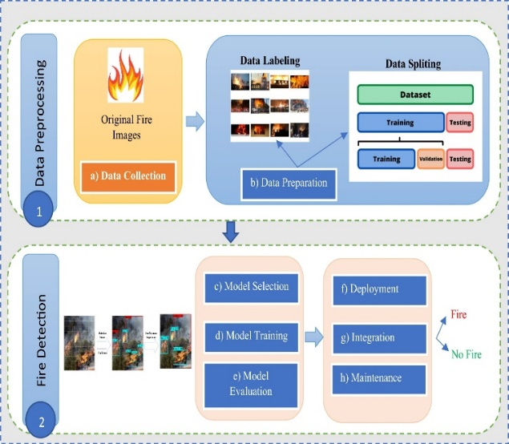

This block diagram explains two main processes involved in detection of fire and smoke using YOLOv8 algorithm. They are

1.Data preprocessing – In this, input is a dataset of real-time images and videos of fire and smoke. Once data is collected, dataset is split into three stages training, test and valid.

2.Fire and Smoke Detection – The model is trained by the help of three stages mentioned earlier and the results will be stored in the path/folder valid.

**VI.SOFTWARE AND HARDWARE REQUIREMENTS**

1.Software Requirements: YOLOv8 Implementation, Training data, Training pipeline, Model evaluation and Deployment.

2.Hardware Requirements: GPU (Graphics Processing Unit), CPU (Central Processing Unit), Sufficient RAM for storage during training datasets and model.

**VII.RESULTS**

The development of the fire and smoke detection system using YOLOv8 builds upon a rich foundation of previous YOLO versions. To improve the detection performance of YOLOv8 model, we used pre-trained model weights. These pre-training weights were trained on training datasets. By leveraging the capabilities of deep neural networks, our proposed system aims to accurately identify instances of fire and smoke in video streams in real-time.The below chart a) shows the loss, mAP (mean Average Precision) score for the train, test, validation set.

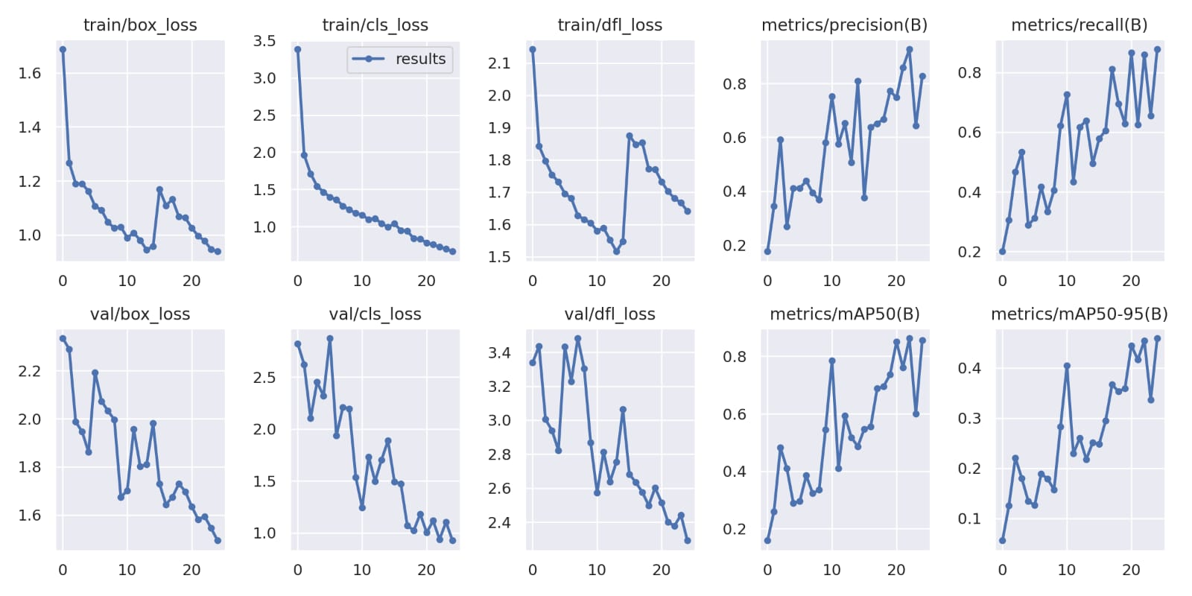

**a) Evaluation**

The below figure b) shows the confusion matrix for the trained model for fire and smoke detection.

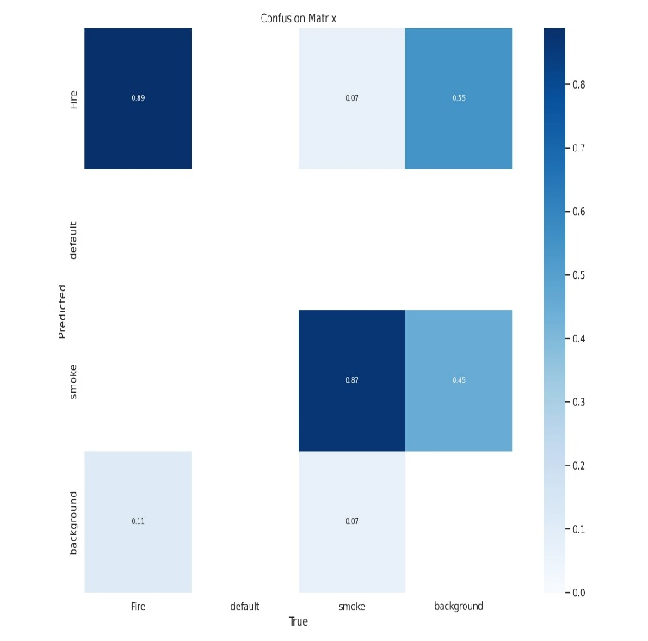

**b) Confusion Matrix**

The following figure c) shows the output of our trained YOLOv8 model for fire and smoke detection. 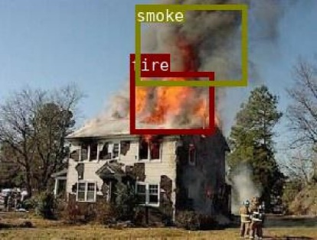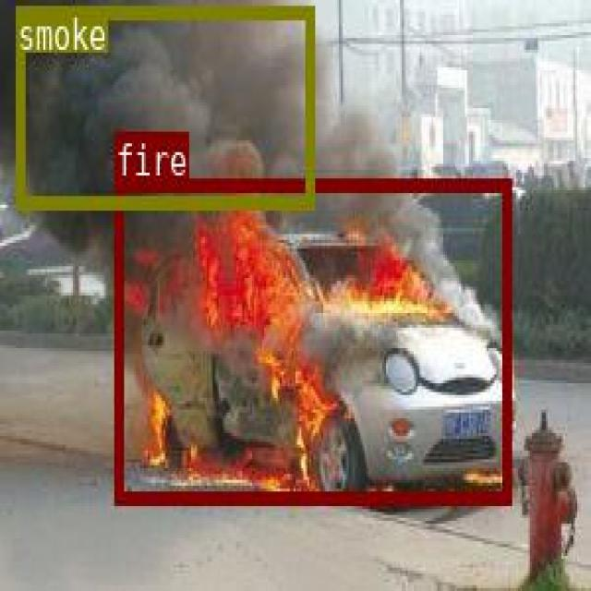

**VIII.CONCLUSION**

In conclusion, the application of YOLOv8 for fire and smoke detection presents a promising avenue for enhancing safety and security measures in various environments. Through the utilization of advanced object detection techniques, YOLOv8 offers significant advantages in terms of real-time detection, accuracy, flexibility, and scalability.By leveraging YOLOv8, researchers and practitioners can develop robust fire and smoke detection systems capable of promptly identifying potential hazards in diverse settings such as industrial facilities, urban areas, and forests. The algorithm's ability to detect objects in real-time, coupled with its high accuracy, ensures timely responses to fire incidents, thereby minimizing potential damage and saving lives.Moreover, the adaptability of YOLOv8 allows for customization and optimization to suit specific deployment scenarios and environmental conditions. Whether deployed on embedded devices, edge computing platforms, or cloud servers, YOLOv8 can efficiently process large volumes of data and deliver actionable insights for fire and smoke detection.However, successful implementation of YOLOv8 for fire and smoke detection requires careful consideration of both software and hardware requirements. Adequate training data, training pipeline setup, model evaluation, and deployment strategies are essential elements in achieving optimal performance and reliability.As advancements in deep learning algorithms and hardware technologies continue to evolve, the integration of YOLOv8 into fire and smoke detection systems holds great potential for enhancing safety standards and mitigating the impact of fire-related incidents in various sectors, including industrial, residential, and environmental management.In summary, the adoption of YOLOv8 represents a significant step forward in fire and smoke detection capabilities, offering unparalleled speed, accuracy, and scalability for safeguarding lives and properties against the devastating effects of fire.The development of the fire and smoke detection system using YOLOv8 builds upon a rich foundation of previous YOLO versions, including YOLOv4Fire Detection Method in smart city environments using deep learning (Yolov4) based approach – Kuldoshbay Avazov, Mukhriddin Mukhiddinov, Young Im Cho V11(1), pp73 (Dec 2021)., YOLOv3An Improvement of the Fire Detection and Classification Method using Yolov3 for Surveillance Systems - Akmalbek Abdusalomov, Nodirbek Baratov, AlpamisKultimuratov, Taeg Keun Whangbo pp V21, pp6519 (Sep 2021)., YOLOv5 An Efficient Forest Fire Detection Algorithm Using Improved YOLOv5 – Pei Shi, Jun Lu, Quan Wang, Yonghong Zhang, V-14, pp1999-4907 (Dec 2023).

**IX.REFERENCES**

1. An Improvement of the Fire Detection and Classification Method using Yolov3 for Surveillance Systems - AkmalbekAbdusalomov, Nodirbek Baratov, AlpamisKultimuratov, Taeg Keun Whangbo pp V21, pp6519 (Sep 2021).
2. Fire Detection Method in smart city environments using deep learning (Yolov4) based approach – Kuldoshbay Avazov, Mukhriddin Mukhiddinov, Young Im Cho V11(1), pp73 (Dec 2021).
3. An Efficient Forest Fire Detection Algorithm Using Improved YOLOv5 – Pei Shi, Jun Lu, Quan Wang, Yonghong Zhang, V-14, pp1999-4907 (Dec 2023).
4. A Yolov6 based improved Fire Detection for smart city environments - AkmalbekAbdusalomov,Rashid Nasimov, Dinara KozhamZharova, Young-Im Cho V23(6), pp3161 (Mar 2023).
5. RepVGG- Yolov7: A modified Yolov7 for Fire smoke Detection - Xin Chen, Yipeng Xue, Qingshan Hou, Yan Fu, Yaolin Zhu V V6(10), pp (383) (Oct 2023).
6. An Efficient Deep Learning Algorithm for Fire and Smoke Detection with Limited Data – A. Namozov, Y.I. Cho V18(4), pp (121-128) (Nov 2018).
7. Fire and Smoke Detection using YOLO Through Kafka – Kai-Yu Lien, Jung-chun Liu, Yu-Wei Chan, Chao-Tung Yang V4, pp (269-275) (Jan 2024).
8. A Real-Time Smoke Detection model based on YOLO-SMOKE Algorithm – Welbin Cai, Cuiyu Wang, Hongan Huang, Tongzhen Wang V52,pp (1-3) (Jun 2020).
9. Real-time detection of flame and smoke using an improved YOLOv4 network– Yifan Wang, Changchun Hua, Weili Ding &Ruinan Wu V16, pp (1109-1116) (Jan 2022).
10. An Improved Fire and Smoke detection Method based on YOLO v7 – Jie Lian, Xinyu Pan, Jin Guo pp (1-7) (Jan 2023).