Three-Phase **Oil-type** Transformer Modeling and Magnectic Flux Density Analysis Using ANSYS Maxwell

Cuong Nguyen Cong1*, Vu Nguyen The2

*1,2School of Electrical & Electronic Engineering, Hanoi University of Industry, Hanoi, VietNam*

*\*Corresponding Author: Cuong Nguyen Cong*

*ABSTRACT:* **Oil-type transformers have several disadvantages, including issues related to insulation, weight, size, losses, heating, and torsional forces. The design and modeling of transformers play a crucial role in addressing these challenges. This paper proposes the modeling and** *magnectic field* density **analysis of a three-phase oil-type distribution transformer with a power capacity of 1250 kVA using the ANSYS Maxwell simulation program. The simulation results present the transformer model along with its losses, voltages, currents, and** *magnectic flux* **distribution. The finite element method (FEM) is employed in the simulations. The input voltage results are consistent with the applied excitation values. Magnetic flux distribution reveals critical points on the transformer core. The results for magnetic flux are validated through comparison with similar studies in the literature.**

**This study serves as a useful guide for researchers and engineers involved in transformer modeling and analysis using simulation software like ANSYS. Future work will focus on optimization studies for thermal analysis and partial discharge localization.**

*KEY WARDS: T*****ransformers*****, Modeling, Design, Analisis, Ansys Maxwell, Oil type*

---------------------------------------------------------------------------------------------------------------------------------------

Date of Submission: xx-xx-xxxx Date of acceptance: xx-xx-xxxx

---------------------------------------------------------------------------------------------------------------------------------------

# INTRODUCTION

Transformers are special type electrical machines used toincrease / decrease the voltage level in order to reduce the losses that occur during the transmission of electricity. Transformers are classified as power transformers and distribution transformers in terms of power capacity, and they are classified as oil and dry type transformers in terms of insulation material. Oil-type transformers are often used due to low production costs. However, there are many problems in oil type transformers such as insulation, excess weight and size, losses, losses due to design, heating problems caused by losses, and torsional forces.

In the literature, several studies have been conducted using simulation programs to address issues such as losses, modeling, and analysis in oil-type transformers [1-3]. These studies include the calculation of core clamp losses in a 40 MVA distribution transformer [1], the reduction of stray losses in the flange-bolt regions of large-capacity power transformer tanks [2], and the mitigation of leakage losses through the use of horizontal magnetic shunts in power transformers [3]. Additionally, research has been carried out on the design of a 1 MVA three-phase oil-immersed distribution transformer with a focus on short-circuit testing and its effects on the windings [4], the analysis of power transformer geometries through electromagnetic and thermodynamic simulations [5], and 2D electromagnetic transient and thermal modeling of three-phase power transformers [6]. The finite element method (FEM) is used in simulation to analyze the electromagnetic transients of the Ansys three-phaseoil type distribution transformer simulation program. Results are presented in terms of losses, voltages, currents and magnetic flux of the transformer [7][8]. The distributions of the scattered magnetic fields, dissipative reactance and EMF affecting the high voltage and low voltage windings (HLVWs)of the transformer in case of SC are analyzed and calculated using FEM [9-11].

In this paper, modeling and magnectic flux density analysis of a 3-phase oil type distribution transformer with a 1250kVA power capacity using ANSYS Maxwell is proposed.

# STRUCTURAL MODELING OF THE TRANSFORMER

# 3D Transformer model design

In related studies, simulation programs are used in transformer modelling and analysis. In this study, 1250 kVA distribution transformer was modelled using ANSYS Maxwell simulation program and magnectic flux density analysis was simulated. ANSYS Maxwell simulation program uses the finite element method as the calculation method. Technical specifications are presented of the designed three-phase distribution transformer in Table I.

**Table I. Technical specifications of designed transformer**

|  |  |
| --- | --- |
| **Element** | **Value/Feature** |
| Power Rating | 1250 kVA |
| Primary Voltage | 22±2x2.5% kV |
| Secondary Voltage | 0,4 kV |
| # of Core Stage | 4 stage |
| Core material | Silic 3404 |
| Winding material | Copper |

**2.2 Design of core**

The core design process follows the sequence outlined below. First, the desired core is selected, after which its geometric properties are defined in the pop-up window. The following path is used: **Draw > User Define Primitive > RmExpert > Transcore**. The modeling steps and examples of the created models are shown in Figure 1.

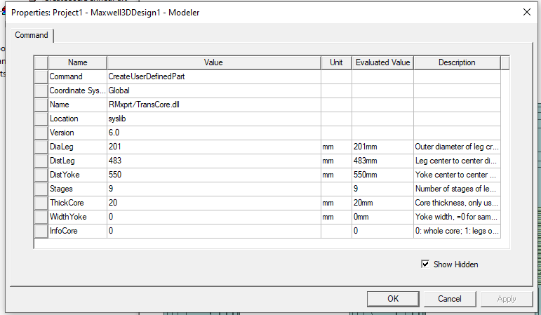

**Figure 1**: **The window with the geometric features of the core**

3D transformer model of designed oil type transformer is presented with trimetric view Figure 2). Set initial parameters of steel core:

* Select the diameter of the column: Dialeg = 201mm;
* Distance C of the pillar DistYoke = 550mm

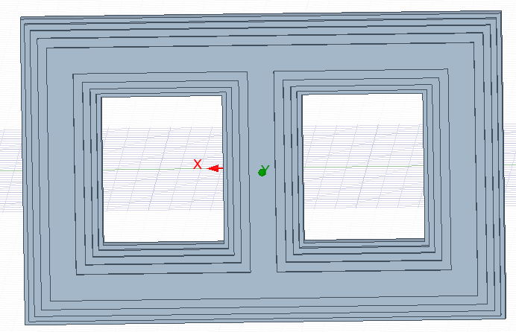

**Figure 2**: **Transformer steel core**

**2.2 Design of winding**

Transformers use a concentrated winding type, resulting in a winding factor of *kw=1*. Each limb of the core is required to carry three coils and, consequently, three terminals. Therefore, the coils and terminals are designed accordingly for all three legs. Similar to the core, the windings are designed following the sequence outlined below. First, the windings are selected from the menu, and then their geometric properties are defined in the window that appears. The selection path is: **Draw > User Define Primitive > RmExpert > Transcoils**. The screen for defining winding properties is shown in Figure 3, 4. The windings designed are given in Figure 5

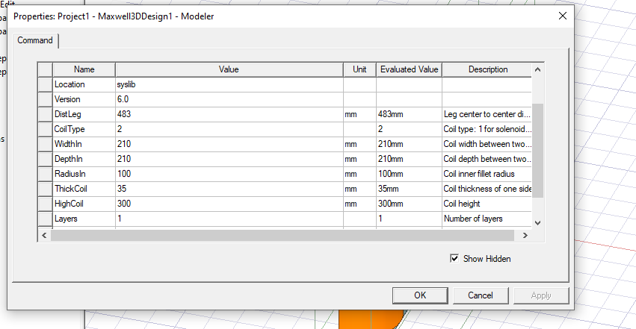

**Figure 3**: **The window with the geometric features of the primary coil**

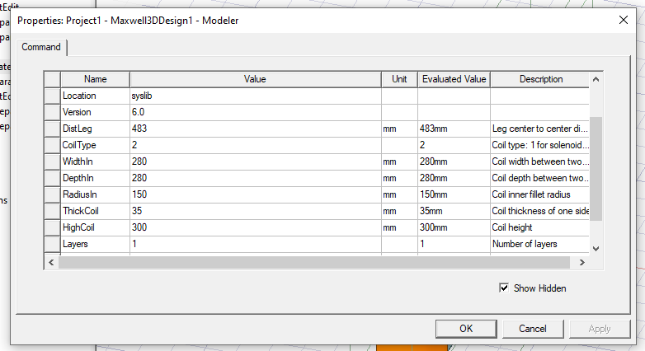

**Figure 4**: **The window with the geometric features of the secondary coil**

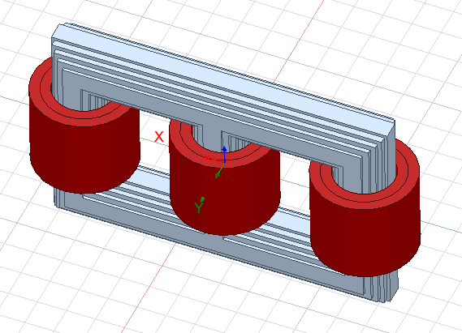

**Figure 5**: **Transformer winding**

# RESULTS AND DISCUSSIONS

Designed model is analyzed during 60 ms time interval with 0.5 ms time step. The results of load analysis are presented below. The currents results on primary and secondary windings of three phase are shown in Figure 3. The input voltages results on primary and secondary windings of three phases are shown in Figure 4. The induced voltage results on primary and secondary windings of three phases are shown in Figure 5.

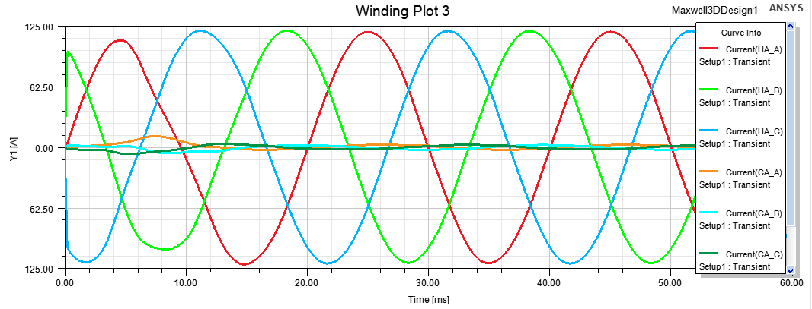

**Figure 3**: **Currents on primary and secondary windings of three phases**

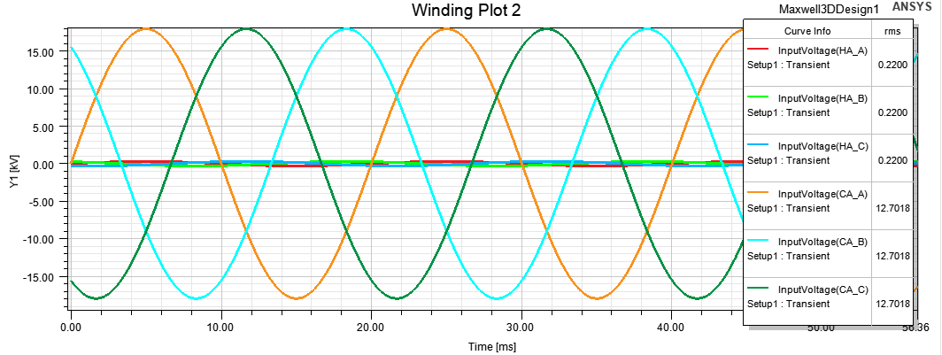

**Figure 4**: **Input voltages on primary and secondary windings of three phases**

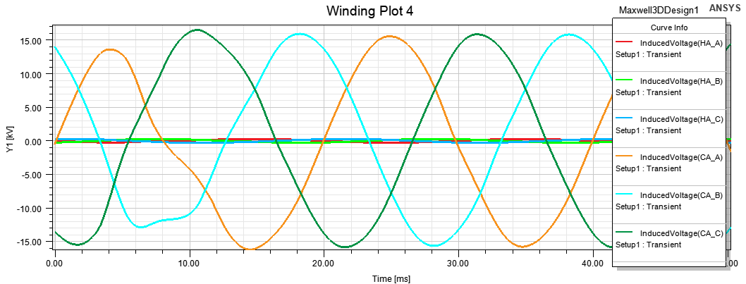

**Figure 5: Induced Voltage on primary and secondary windings of three phases**

Flux Linkage **t**ransient on transformer core center is shown in Figure 6. Magnetic flux on transformer core is shown with vectors in Figure 7. Magnetic flux distribution on transformer core is shown with colors at t=0.0932s in Figure 8. The magnetic flux mainly closes the circuit in the cylinder and yoke. The part of the magnetic flux that is released into the air is negligibly small compared to that in the magnetic circuit.

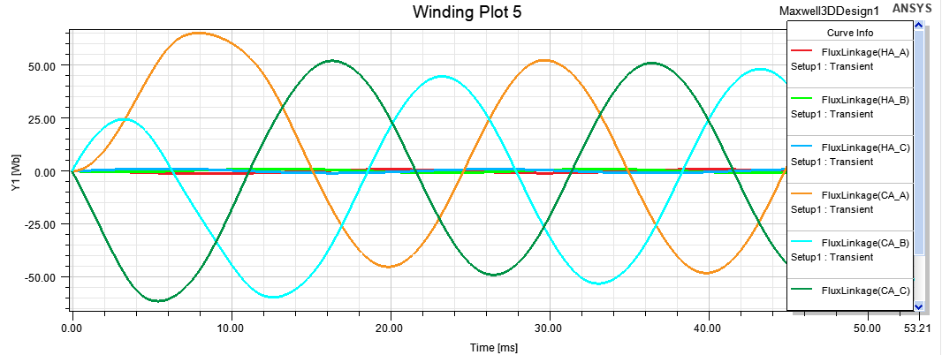

**Figure 6: Flux Linkage transient on primary and secondary windings of three phases**

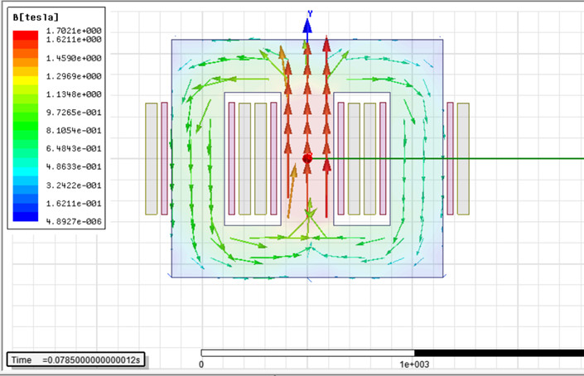

**Figure 7. Magnetic flux on transformer core with vectors**

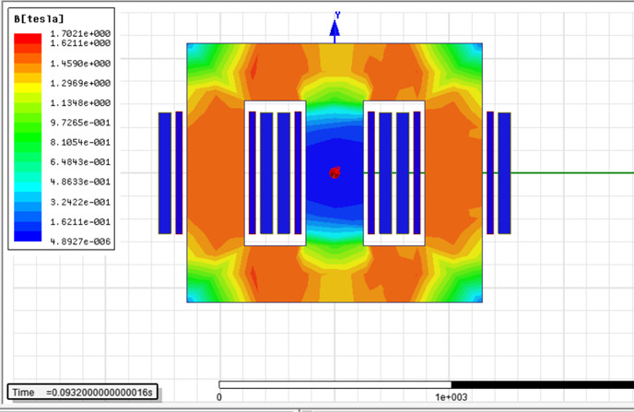

**Figure 8**. **Magnetic flux distribution on transformer core with colors**

Results of input voltages are consistent with applied excitation values. Critical points on inner corners of designed transformer core are also similar to critical points in [6] regarding to magnetic flux on the core. The result of magnetic flux of this study is validated by comparison of similar studies in literature.

# CONCLUSIONS AND RECOMMENDATIONS

Oil-type transformers present several disadvantages, including issues related to insulation, weight, size, energy losses, heat generation, and torsional forces. Therefore, the design and modeling of transformers play a crucial role in addressing these challenges.

This paper presents the modeling and magnetic flux analysis of a 3-phase, oil-type distribution transformer with a power capacity of 1250 kVA, using the ANSYS Maxwell simulation software. The simulation results include the transformer model, voltages, currents, and magnetic flux distribution. The finite element method (FEM) is employed in the simulations. The input voltage results align well with the applied excitation values. Additionally, the critical points at the inner corners of the transformer core show similarities in magnetic flux behavior to those reported in [6]. The magnetic flux results obtained in this study are validated through comparison with similar findings in the existing literature.

This paper serves as a valuable guide for researchers and engineers involved in transformer modeling and analysis using simulation software such as ANSYS. In the future, further studies will focus on optimization for thermal analysis and partial discharge localization

**REFERENCES**

1. D. Žarko, Z. Maljković and S. Štefan, "Calculation of losses in the core clamps of a transformer using 3-D finite-element method", in Proc. of Macedonian-Polish Symposium On Applied Electromagnetics (SAEM'2006), Ohrid, Macedonia, 2006.
2. J. C. Olivares-Galvan, S. Magdaleno-Adame, R. Escarela-Perez, R. Ocon-Valdez, P. S. Georgilakis and G. Loizos, "Reduction of stray losses in flange-bolt regions of large power transformer tanks," IEEE Transactions on Industrial Electronics, vol. 61, no. 8, pp. 4455-4463, Aug. 2014.
3. M. Moghaddami, A. I. Sarwat and F. de Leon, "Reduction of stray loss in power transformers using horizontal magnetic wall shunts," IEEE Transactions on Magnetics, vol. 53, no. 2, pp. 1-7, Feb. 2017, Art no. 8100607.
4. M. F. Hsieh, C. H. Hsu, C. M. Fu, and Y. M. Huang, “Design of transformer with high-permeability ferromagnetic core and strengthened windings for short-circuit condition,” IEEE Trans. Magn., vol. 51, no. 11, pp. 3-6, 2015.
5. J. R. da Silva and J. P. A. Bastos, "Analysis of power transformer geometry simplifications on electromagnetic and thermodynamic simulations," IEEE Transactions on Magnetics, vol. 51, no. 3, pp. 1-4, March 2015, Art no. 8400404.
6. P. M. Nicolae, D. Constantin and M. C. Nitu, "2D electromagnetic transient and thermal modeling of a three phase power transformer," in Proc. of 4th International Youth Conference on Energy (IYCE), Siófok, Hungary, 2013, pp. 1-5.
7. Zhai, Y., Zhu, R., Li, Q., Wang, X., Gu, Y., & Li, S. (2022, September). Simulation research on electrodynamic force and deformation of transformer windings under short-circuit condition. In 2022 IEEE International Conference on High Voltage Engineering and Applications (ICHVE) (pp. 1-4). IEEE. <https://doi.org/10.1109/ICHVE53725.2022.9961358>.
8. Bal, S., Demirdelen, T., & Tümay, M. (2019). ThreePhase Distribution Transformer Modeling and Electromagnetic Transient Analysis Using ANSYS Maxwell. In 2019 3rd International Symposium on Multidisciplinary Studies and Innovative Technologies (ISMSIT), (pp. 1-4). IEEE. <https://doi.org/10.1109/ISMSIT.2019.8932953>.
9. Bao, D.T., Tung, D. D., & Ho T. Le. (2023), Computation of Electromagnetic Forces in the Windings of Amorphous Core Transformers, Archives of Electrical Engineering, 72(2), 521 –539. <https://doi.org/10.24425/aee.2023.145423>.
10. Yahiou, A., Mellah, H., & Bayadi, A. (2022). Inrush current reduction by a point-on-wave energization strategy and sequential phase shifting in three-phase transformer. International Journal of Engineering, 35(12), 2321-2328. <https://doi.org/10.5829/IJE.2022.35.12C.07>.
11. Jin, M., Wen, T., Chen, W., Zhao, Y., Wu, J., Wu, X., & Zhang, Q. (2022). Influence of frequency components of short-circuit electromagnetic force on vibration characteristics of power transformer windings. In 2022 IEEE International Conference on High Voltage Engineering and Applications (ICHVE) (pp. 01-04). IEEE. https://doi.org/doi: 10.1109/ICHVE53725.2022.9961671