# Why AI will not be replacing Public Art: The legacy and irreplicable impact of pioneering artists who transformed urban landscapes

1**Susan Mya Çaksın***\****,** 2**Nevbahar Atalay**

*1PhD Candidate, Department of Architecture, Istanbul Okan University, Türkiye*

*2Asst. Professor, Department of Architecture, Istanbul Okan University, Türkiye*

*\*Corresponding Author email: myasusan@gmail.com*

***ABSTRACT:*** *This study attempts to answer why the motive and the soul of the art will not be replaced by AI. This article examines the diverse realm of public art through the lens of four remarkable individuals who have made an indelible impact on the sphere of Public Art and Urban Spaces. Each artist's unique approach is explored, from timeless contributions of Pablo Picasso, Roberto Burle Marx’s tasteful fusion of nature and design, reflective memorials by Maya Lin to the social and political commentary of Ai Weiwei. These four significant figures demonstrated how public art is a broad and dynamic field that includes a variety of artistic expressions, from street art to landscape architecture, and how it can be a powerful medium for social commentary, cultural enrichment, and the transformation of public spaces. Methodology of these case studies relied on an extensive literature review along with in-depth content analysis about the transformative power of public art and impact of it on* *urban spaces. This approach makes it possible to comprehend each artist's contributions to the evolution of public art as well as how their creations continue to impact the way people experience and perceive urban public spaces.*

***Keywords:*** *Urban Narratives in Public Art, Influential Public Artists, Contemporary and Historical Public Art, Cultural Significance of Public Art, Transformation of Urban Landscapes, AI and Public Art*

---------------------------------------------------------------------------------------------------------------------------------------

Date of Submission: 07-01-2024 Date of acceptance: xx-xx-2024

---------------------------------------------------------------------------------------------------------------------------------------

# Introduction

Public art stands as a vital catalyst in the evolution of urban landscapes, not only enhancing the aesthetic appeal of a city but also reflecting society's narratives and values. Its presence in public places promotes engagement and reflection of our society, fostering a sense of community while provoking critical discourse on our cultural, social, and political issues. This paper examines the diverse settings of public art through the distinct perspectives of four influential figures each bringing a unique viewpoint and transformation to urban environments. Their creations demonstrate the wide range of possibilities in the field of public art, from lavish installations to subtle urban interventions. This paper unveils the multifaceted impact of public art and how it may enhance, reflect, and question urban life and its narratives. AI will not be replacing art. Because art is not something of mere visual effect product. It is a representation of the artist’s heart and soul, their philosophy and their vision towards appreciation of the beauty and how they see the world.

# Methodology

A comprehensive review of the literature and in-depth content analysis are the base of this study on the transformative power of public art. Delving into a wide range of articles, biographies and art critiques, this paper unravels each artist's contributions to public art and urban spaces. Initially, a thorough literature review was conducted, exploring into the historical context, artistic philosophy, and societal contributions of each artist. In addition, various artworks were analyzed to understand the aesthetic and thematic aspects of each artist. We studied not only the artists' works and philosophies but also the broader cultural, political, and social contexts in which these artworks were created and received. Case studies of each artist's style, background, method and their unique influence on public discourse and urban environments enable for a holistic understanding of the ways in which each artist has influenced the development of public art and how their works continue to shape the perception and experience of urban public places.

# Pablo Picasso: Shaping Modernity in Public Art

Picasso's contributions to public art go beyond traditional boundaries, integrating modernist ideas into the urban spaces. His sculptures and artworks challenge the public to see the world through an abstract lens. Abstract art has been misinterpreted by many in contemporary world as if anyone who can dab paint in interesting splashes knows what modern abstract art is and has the ability to appreciate the depth and beauty in it. It has been reduced into mere madness. He asked to learn the rules like a pro, so you can break them like an artist. It takes mastery and genius to make new rules. He said it took him four years to paint like Raphael, but a lifetime to paint like a child. He was someone who was constantly learning and wondering about the world and his medium was art. He said ‘Others have seen what is and asked why. I have seen what could be and asked why not.’

Picasso viewed objects and figures from several perspectives at once, dissecting the down into geometric shapes and piecing them back together in fragmented ways. Cubism makes this clear by showing a face simultaneously from the front, side, and top. This method challenged the conventional one-point view. It reflected his belief that we could experience the world through multiple perspectives. John Richardson noted on his ability to see fragmentations and multiple perspectives as "He saw everything simultaneously, from all sides and in all its contradictory aspects." [1] His art always is as an outlet for deep, strong emotions. His work wasn't just about visual representation; it was also a conduit for deep emotions. The Blue Period's (his monochromatic artworks between 1901 and 1904) somber blues portrayed melancholy and poverty, while the Rose Period's gentler tones expressed newfound optimism. Carlton Lake and Françoise Gilot described his expression as a cry. "His paintings were always a cry – a cry of pain, of joy, of anger, of tenderness, of love, of hate – but always a cry. [2]

Picasso was never afraid of distortion. Arianna Huffington stated "He stretched faces, elongated limbs, and contorted bodies to express the inner turmoil of his subjects." [3] John Richardson and Marilyn McCully described the Bull in ‘Guernica’ as arguably one of the most moving piece of him and powerful anti-war painting. It was "both a symbol of Spanish fascism and a Minotaur, the mythical beast half-man, half-bull that haunted Picasso's imagination." [4] He was constantly experimenting, learning, implementing and playing but never repeating himself nor imitating anyone. "He treated painting like a playground, a place where anything was possible and the only rule was to break the rules".[5].He was in constant contact with other contemporary artists and their styles. He was continuously learning like a sponge and absorbing inspiration from classical sculpture and surrealism to African masks. His relentless search for new forms of expression pushed him to the forefront of the art world.

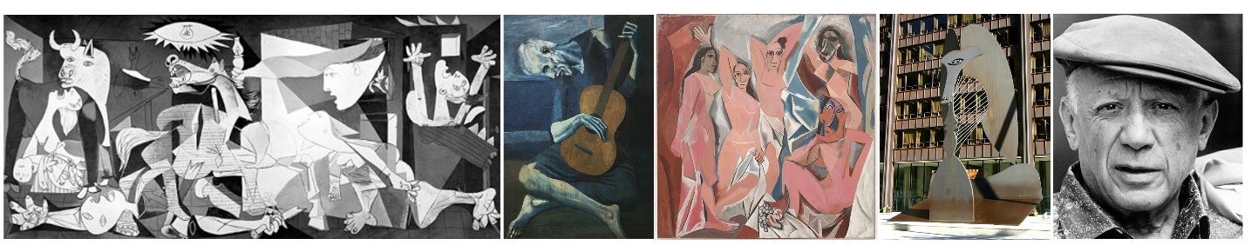

**Figure 1 Left to Right: Guernica, 1937**

**Blue Period, The Old Guitarist, 1903**

**African influenced period, Les Demoiselles d'Avignon, 1907,**

**The Chicago Picasso, a 50-foot-high public Cubist sculpture, 1967**

**Picasso in 1962**

# Roberto Burle Marx: The Art of Landscape Architecture

Brazilian landscape architect Roberto Burle Marx revolutionized landscape design in the 20th century. He has a unique and significant view on the relationship between the natural world and art. He viewed landscapes and gardens as living paintings, where the forms, colors, and textures of the plants might be arranged similarly to the manner in which brushstrokes are on a canvas. He moved away from the rigid formality of traditional European gardens, implementing the powerful organic forms, expressive, abstract motifs and bold colors of the Brazilian landscape. He was a global legacy, champion of sustainability and a much-cherished individual for being able to blur the lines between Art, Architecture and Nature.

His fusion with modernism and nature was one of a kind. He wasn't particularly imitating nature, he was collaborating with it.[6] He saw art as a living experience and claimed at the Stanford University lecture as "The garden is not just a stage set, it is a living theater." He appreciated rhythm and harmony and often used vivid texture and colors to play. More importantly, he rejected the European model and celebrated the local.[7] He was known to be the artist who painted with plants. He was pioneering advocate for sustainability, water efficiency and demonstrated deep respect for the natural world through his works. His landscapes were not just beautiful, they were also ecologically responsible, demonstrating a deep respect for the natural world.[8]

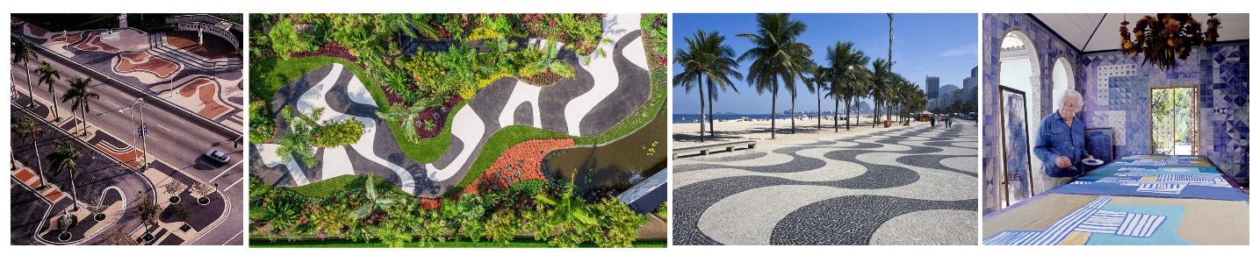

**Figure 2 Left to Right: Biscayne Boulevard, Miami,**

**New York, Botanical Garden,**

**Copacabana beach promenade,**

**Roberto Burle Marx working with different mediums (1909-1994)**

# Maya Lin: Memorial, Environmental and Minimalistic Dimensions of Artistry

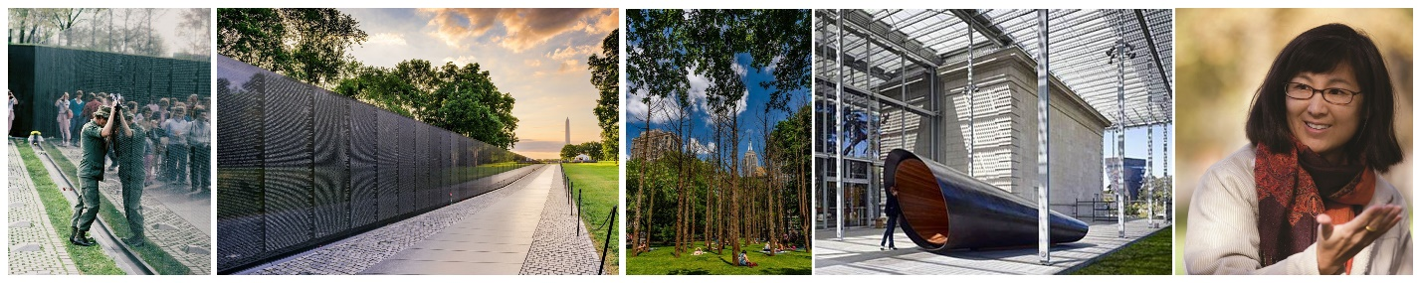Her artworks often blend perfectly with their surroundings, allowing visitors to participate in the experience rather than just witnessing it. Her materials either reflect nature or frequently echoes the organic textures and colors of nature. Most of Lin's significant works, such as the Vietnam Veterans Memorial, are memorials honoring memory and significant events of history. Her works usually evoke emotions and encourage reflections on sacrifice, loss, and the passing of time through the use of nuanced forms and symbols. But they are always simple, elegant and avoid grandiosity.

**Figure 3 Left to right: Vietnam Veterans Memorial, 1981,**

**Vietnam Veterans Memorial, 1981,**

**Ghost Forest, 2021,**

**What is missing, 2009,**

**Maya Lin**

Maya Lin often uses cartography, geometry, and even mathematical formulae to inform the structure and placement of her pieces. The fusion of environmental awareness, art and science give depth to her work. Installation of Ghost Forest in Madison Square Park called for the attention in deforestation and global warming. Her last memorial, the web-based “What is Missing?” raised awareness of biodiversity loss to climate change. [9][10][11]

# Ai Weiwei: Art as a Medium for Social Commentary

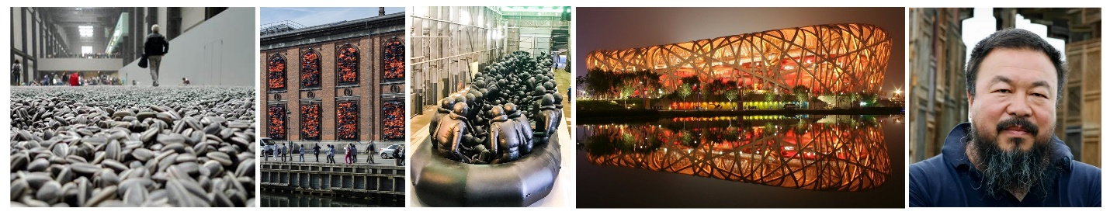Ai Weiwei is considered most influential contemporary Chinese artist and activist. He is known for his bold political statements. His art is at the forefront of political activism voicing provocative opinions on current social issues and justice. His artworks always act as catalysts for public conversation. Famous statements of him include "The function of art is not to decorate the world, but to critique it." "Art should disturb the comfortable and comfort the disturbed." "If a nation cannot face its past, it has no future." [12] Beijing Olympics’ Bird's Nest stadium in 2008 where he participated as Artistic Consultant expressed an unsettling symbol of the forced labor and relocation that fueled China's economic boom. [13] "Remembering" was an art installation by Ai Weiwei that consists of 9000 children’s school backpacks in varying colors of green, blue, red and yellow. Each backpack honored and represented the life of a child who was tragically killed in an earthquake in Sichuan, China. He questioned the authorities for censoring and covering up news about the event through his artwork.[14]Another iconic piece of him, "Sunflower Seeds" installation featured millions of hand-painted porcelain sunflower seeds. It intended to highlight the dehumanization of individuals throughout mass movements while alluding to Mao Zedong's ambition for an agricultural revolution.[15] "Soleil Levant" was the art installation that took place at Berlin’s Konzerthaus concert hall on UN International Refugee Day June 20th 2017. The installation barricaded the windows of Kunsthal Charlottenborg with more than 14,000 rescued life jackets collected from refugees arriving the shores at the Greek Island of Lesbos.[16]

**Figure 4 Left to Right: Sunflower seeds, 2010**

**Soleil Levant, Art installation of 3500 rescued life jackets, 2017**

**Law of the Journey, a 230-foot inflatable boat containing 258 faceless life-size figures, 2017**

**Bird's Nest, 2008 Beijing Olympic**

# Conclusion

To sum up, this article highlights the importance of human creativity, values and visions in the realm of public art. The human experience, culture, meaning and authenticity are the things AI won’t be able to produce.

Picasso's avant-garde abstract method of creating art pushed the boundaries of expression and gave us fresh perspectives on urban spaces. Roberto Burle Marx’ creations of innovative landscape design and promotion of localizing the design elements and principles shifted landscape architecture. Deeply ingrained in the history and human experience, Maya Lin's minimalistic and contemplative memorials give spaces for thought and remembering while capturing profound emotional and historical narratives. Finally, Ai Weiwei’s bold and politically charged pieces represented the artist’s voice and conscience.

Every artist demonstrates how profoundly personal and contextually rich public art can be in their own special way. Their works are embodied with unique ideologies, cultural contexts, and a deep comprehension of the human condition—aspects that are uniquely human and impossible for artificial intelligence to imitate. In addition to their creative accomplishments, these artists' legacies come from their capacity to evoke emotion, provoke the thoughts, and connect people across time and space. As our civilization advances into an increasingly digital and AI-integrated future, the irreplaceable impact of human artists in shaping, reflecting, and enhancing our public spaces and societal narratives stands more relevant than ever.

# Matrix

| **Aspect** | **Pablo Picasso** | **Roberto Burle Marx** | **Maya Lin** | **Ai Weiwei** |
| --- | --- | --- | --- | --- |
| **Field of Expertise** | Painting, Sculpture | Landscape Architecture | Sculpture, Architecture,  Minimalism | Contemporary Art |
| **Notable Works** | Guernica, Les Demoiselles d'Avignon | Brazilian landscape design, Copacabana Promenade,  Biscayne Boulevard | Vietnam Veterans Memorial, Ghost Forest | Soleil Levant, Sunflower Seeds, Bird's Nest,  Sichuan Earthquake |
| **Approach to Public Space** | Contributions to public murals and art | Designed urban parks and green spaces | Integrated art into architectural design | Addresses social and political issues through art |
| **Social and Political Commentary** | Addressed political and social themes | Advocated for environmental conservation | Reflects social and historical narratives | Strong political activism and advocacy |
| **Medium and Style** | Painting, sculpture, ceramics | Landscape design with artistic aesthetics | Sculpture, architecture, memorials | Multi-media, including sculptures |
| **Legacy and Impact** | A seminal figure in modern and contemporary art | Influential in landscape architecture | Commemorates historical events and veterans | Addresses global issues through art |
| **Influence on Urban Spaces** | Influences urban aesthetics and design | Transformed urban spaces through park design | Creates iconic urban memorials and landmarks | Challenges traditional urban notions |
| **Inclusivity, Motivation and Accessibility** | Embraced non-western art forms, depicted marginalized people, poor, disables, working class and women, anti-war | Celebrated local biodiversity, promoted sustainability, Advocated for inclusivity in park design, | Provide emotional bondage with history and provoke dialogues about war and destructions through artworks, environmentally conscious | Advocates for inclusivity through art, challenges authority, raises awareness, and advocates for freedom of speech and democratic reform |
| **Environmental Consciousness** | Not primary focus but often used recycled materials | Emphasized ecological considerations and celebrated native flora | Climate change activist, Incorporate sustainability in designs | Addresses environmental issues and critiques environmental destruction through art |

**References**

1. Andrews, Richard, ‘Maya Lin: Systematic Landscapes’, The Corcoran Gallery of Art, March.6 (2009), 120 <https://doi.org/10.2307/20636793>
2. Gilot, Françoise, and Carlton Lake, Life with Picasso (Nabu Press, 2011)
3. Huffington, Arianna, Picasso (HarperCollins, 1996)
4. MoMA, ‘Roberto Burle Marx: Landscape as Art’, May, 1991
5. Richardson, John, A Life of Picasso (Random House, 1991)
6. Richardson, John, and Marillyn McCully, A Life of Picasso; Vol. I: The Early Years, 1881-1906 (Random House, 1996)
7. Ritter, Joachim, The Gardens of Roberto Burle Marx (Harry N Abrams Inc, 1991)
8. Rubin, Susan Goldman, Thinking with Her Hands: Maya Lin, Artist-Architect of Light and Lines (Chronicle Books, 2010)
9. Saxon, Jamie, ‘Maya Lin: Connecting Art and the Environment’, Princeton University, 2020 <https://www.princeton.edu/news/2020/01/06/maya-lin-connecting-art-and-environment>
10. Silva, Roberto, New Brazilian Gardens: The Legacy of Burle Marx (Thames & Hudson, 2014)
11. Warsh, Larry, ‘Weiwei-Isms’, Princeton University Press, p. 152
12. Weiwei, Ai, 1000 Years of Joys and Sorrows: A Memoir (Crown, 2021)
13. Weiwei, Ai, Ai Weiwei: Sunflower Seeds (Tate Publishing, 2013)
14. Weiwei, Ai, ‘Art 2030’, 2030 <https://www.art2030.org/projects/ai-weiwei-soleil-levant>
15. Weiwei, Ai, ‘The Artwork That Made Me the Most Dangerous Person in China’, The Guardian,2018

1. John Richardson, *A Life of Picasso* (Random House, 1991).
2. Françoise Gilot and Carlton Lake, *Life with Picasso* (Nabu Press, 2011).
3. Arianna Huffington, *Picasso* (HarperCollins, 1996).
4. John Richardson and Marillyn McCully, *A Life of Picasso; Vol. I: The Early Years, 1881-1906* (Random House, 1996).
5. Huffington.
6. Joachim Ritter, *The Gardens of Roberto Burle Marx* (Harry N Abrams Inc, 1991).
7. Roberto Silva, *New Brazilian Gardens: The Legacy of Burle Marx* (Thames & Hudson, 2014).
8. MoMA, ‘Roberto Burle Marx: Landscape as Art’, *May*, 1991.
9. Jamie Saxon, ‘Maya Lin: Connecting Art and the Environment’, *Princeton University*, 2020 <https://www.princeton.edu/news/2020/01/06/maya-lin-connecting-art-and-environment>.
10. Richard Andrews, ‘Maya Lin: Systematic Landscapes’, *The Corcoran Gallery of Art*, March.6 (2009), 120 <https://doi.org/10.2307/20636793>.
11. Susan Goldman Rubin, *Thinking with Her Hands: Maya Lin, Artist-Architect of Light and Lines* (Chronicle Books, 2010).
12. Larry Warsh, ‘Weiwei-Isms’, *Princeton University Press*, p. 152.
13. Ai Weiwei, *1000 Years of Joys and Sorrows: A Memoir* (Crown, 2021).
14. Ai Weiwei, ‘The Artwork That Made Me the Most Dangerous Person in China’, *The Guardian*, 2018.
15. Ai Weiwei, *Ai Weiwei: Sunflower Seeds* (Tate Publishing, 2013).
16. Ai Weiwei, ‘Art 2030’, 2030 <https://www.art2030.org/projects/ai-weiwei-soleil-levant>.