**COST EFFECTIVE ENERGY SAVING OPTIMISATION TECHNIQUE USING HYBRIDISED**

**AUGMENTED GREY WOLF OPTIMISER AND ANT COLONY MODELS**

**Obera Emmanuel Eleojo, Evans Ashigwuike and Ibrahim A. Bebeji**

*Department of Electrical/Electronic Engineering, University of Abuja*

*Corresponding Author: elberatek@gmail.com*

**ABSTRACT:** This research develops and evaluates a hybridised optimisation approach combining Augmented Grey Wolf Optimiser (AGWO) and Ant Colony Optimisation (ACO) algorithms for building energy management. The study addresses the pressing need for energy efficiency in buildings, which account for approximately 40% of global energy consumption. Using a case study of CWAY Integrated Limited in Abuja, Nigeria, the research compared standalone AGWO, standalone ACO, Sequential Hybrid, and Average Hybrid models across multiple performance metrics. The ACO algorithm demonstrated superior performance with a 22.9% reduction in daily energy costs (from ₦632,250 to ₦487,350), followed by AGWO with a 21.0% reduction. Contrary to expectations, the Sequential Hybrid approach underperformed both standalone algorithms with only a 13.1% cost reduction, while the Average Hybrid achieved a 19.0% reduction. Statistical analysis confirmed significant performance differences between optimisation approaches, with the Kruskal-Wallis test yielding a p-value of 2.83×10⁻⁸⁶. Component-wise analysis revealed that all optimisation approaches prioritised reductions in energy-intensive components while maintaining stable operation for components with stricter operational constraints. The research demonstrates that metaheuristic optimisation techniques can achieve significant energy savings in building operations while maintaining operational requirements, with important implications for sustainable building management practices.

**KEYWORDS**: Building energy optimisation; Augmented Grey Wolf Optimiser; Ant Colony Optimisation; Hybridisation; Energy efficiency; Metaheuristic algorithms; HVAC optimisation; Energy cost reduction; Sustainable buildings; Nigeria.

**I. INTRODUCTION**

Buildings constitute one of the principal contributors to global energy consumption and greenhouse gas emissions. The International Energy Agency reports that buildings account for approximately 28% of global energy consumption and 20% of carbon dioxide emissions [1]. Within the Nigerian context, the building sector consumes approximately 40% of total energy, with heating, ventilation, and air conditioning (HVAC) systems representing major energy consumers [2]. This substantial energy footprint underscores the critical imperative for energy-efficient measures in buildings, particularly in HVAC optimisation and building envelope design.

The optimisation of energy consumption in buildings presents considerable challenges due to the complex interactions between various building components and systems. Traditional optimisation algorithms frequently struggle with the non-linearity and multi-objective nature of building energy systems. Consequently, hybrid algorithms that combine multiple optimisation techniques have gained prominence in recent years [3]. One effective approach to reducing building energy consumption involves optimising HVAC systems through metaheuristic algorithms such as genetic algorithms, particle swarm optimisation, and ant colony optimisation (ACO). Among these techniques, ACO has demonstrated promising results in building energy management systems by optimising HVAC operations and reducing energy consumption [4].

Grey Wolf Optimiser (GWO) represents another metaheuristic algorithm gaining popularity due to its simplicity and robustness in solving various optimisation problems [5]. GWO simulates the hunting behaviour of grey wolves to identify global optimum solutions. However, the standard GWO algorithm sometimes suffers from premature convergence and may become trapped in local optima. To address these limitations, researchers have proposed an Augmented Grey Wolf Optimiser (AGWO), which enhances the exploration and exploitation capabilities of the original GWO algorithm [6]. AGWO introduces additional mechanisms to improve search diversity and prevent premature convergence.

The hybridisation of metaheuristic algorithms has proven effective for enhancing optimisation performance [7]. Combining ACO and GWO presents an opportunity to strengthen their search capabilities and improve optimisation performance for energy saving measures in buildings. Previous studies have demonstrated the potential of hybrid ACO-GWO algorithms in energy-related optimisation problems, such as in the design of standalone photovoltaic systems for rural electrification [8].

This research proposes a hybridised augmented grey wolf optimiser and ant colony optimisation-based energy saving measure for buildings (HAGWO-ACO). The proposed algorithm combines the strengths of ACO and GWO to optimise HVAC operations in buildings, potentially reducing energy consumption and greenhouse gas emissions. The hybrid algorithm will be compared with standalone ACO and AGWO algorithms to evaluate its optimisation performance in terms of energy savings. A simulation-based approach will be employed to assess the algorithm's performance on a benchmark building and a case study of CWAY Integrated Limited in Abuja, Nigeria.

By investigating a hybridised optimisation approach for energy savings measures in buildings, this research aims to contribute to ongoing efforts in Nigeria to promote energy efficiency and reduce greenhouse gas emissions in the building sector, aligning with the country's commitment to sustainable development goals.

**1.1 Aim and Objectives**

The primary aim of this research is to develop and evaluate a hybridised augmented grey wolf optimiser and ant colony optimisation algorithm (HAGWO-ACO) for optimising energy savings measures in buildings through HVAC system optimisation. This research addresses the limitations of standalone optimisation algorithms in handling the complex, non-linear, and multi-objective nature of building energy systems.

The specific objectives of this research are to investigate the limitations of standalone ant colony optimisation (ACO) and augmented grey wolf optimiser (AGWO) algorithms in optimising HVAC systems for energy savings in buildings. This objective involves a comprehensive analysis of the performance characteristics, strengths, and weaknesses of these individual algorithms when applied to building energy optimisation problems. By identifying their limitations, the research establishes a foundation for the development of a hybrid approach that can overcome these constraints.

Another objective is to develop a novel hybridised HAGWO-ACO algorithm that combines the strengths of ACO and AGWO to enhance optimisation performance for HVAC systems in buildings. This objective focuses on integrating the global exploration capabilities of AGWO with the local exploitation strengths of ACO, creating a synergistic algorithm that can navigate complex solution spaces more effectively than standalone approaches. The hybridisation strategy aims to balance exploration and exploitation, mitigating the risk of premature convergence whilst maintaining computational efficiency.

The research also aims to implement the proposed HAGWO-ACO algorithm and evaluate its performance in terms of energy savings and greenhouse gas emissions reduction through simulation studies and a case study of CWAY Integrated Limited in Abuja, Nigeria. This objective involves applying the developed algorithm to real-world scenarios, providing practical validation of its effectiveness in optimising building energy systems under realistic constraints and operating conditions.

Furthermore, this research seeks to compare the performance of the proposed HAGWO-ACO algorithm with standalone ACO and AGWO algorithms in optimising HVAC systems for energy savings in buildings using appropriate performance metrics. This comparative analysis will quantify the improvements achieved through hybridisation, establishing whether the hybrid approach consistently outperforms its constituent algorithms across various scenarios and performance indicators.

Finally, the research aims to analyse the results obtained from the simulation studies and provide insights and recommendations for the practical implementation of the proposed HAGWO-ACO algorithm in the Nigerian building sector. This objective focuses on translating the technical findings into actionable guidelines that can be adopted by building managers, energy consultants, and policymakers to improve energy efficiency in buildings, contributing to national energy conservation goals and environmental sustainability initiatives.

By achieving these objectives, this research aims to provide a promising optimisation solution for reducing energy consumption and greenhouse gas emissions in buildings through HVAC system optimisation, with a specific focus on the Nigerian context where energy efficiency improvements can yield significant economic and environmental benefits.

## II. LITERATURE REVIEW

Building energy optimisation has emerged as a critical research domain in recent years, driven by the urgent need to reduce energy consumption and mitigate environmental impacts. Buildings account for nearly 40% of global energy consumption and approximately one-third of greenhouse gas emissions [9]. Optimising building energy systems represents a key strategy for achieving sustainability in the built environment by maximising energy efficiency whilst maintaining desired indoor conditions. Building energy optimisation involves applying various techniques to building energy systems, including HVAC, lighting, and appliances, to minimise energy waste whilst maintaining indoor thermal comfort and air quality [10].

The importance of building energy optimisation extends beyond immediate cost savings to encompass broader environmental sustainability goals. By reducing energy consumption in buildings, it becomes possible to mitigate environmental impacts and contribute to global climate change mitigation efforts [11]. Moreover, building energy optimisation can enhance indoor comfort and air quality, leading to increased occupant satisfaction and productivity whilst providing positive health benefits such as reducing respiratory problems and allergies [12].

Building energy systems comprise various components that consume energy, with HVAC systems typically accounting for over 50% of total energy consumption [13]. HVAC systems maintain indoor thermal comfort and air quality by controlling temperature, humidity, and air circulation. Lighting systems also constitute a significant portion of building energy consumption, especially in commercial buildings. Energy-efficient lighting solutions, such as light-emitting diodes (LEDs), can substantially reduce energy consumption whilst maintaining adequate lighting levels [14]. Additionally, appliances and electronic devices contribute to building energy consumption, with energy-efficient equipment offering significant opportunities for energy reduction [15].

Optimisation techniques play a crucial role in building energy systems by facilitating the identification of energy-efficient solutions that meet performance and comfort criteria. These techniques can be broadly classified into deterministic and stochastic optimisation approaches. Deterministic optimisation techniques utilise mathematical programming methods such as linear programming, quadratic programming, and mixed-integer programming [16]. These methods optimise building energy systems with linear or nonlinear objective functions subject to specific constraints.

Stochastic optimisation techniques employ probabilistic algorithms to identify optimal solutions. These include evolutionary algorithms, swarm intelligence-based algorithms, and other metaheuristic optimisation approaches [17]. These algorithms effectively optimise complex building energy systems with multiple objectives, non-linear constraints, and uncertain input parameters. Evolutionary algorithms, particularly genetic algorithms, have been extensively applied in building energy optimisation due to their ability to handle non-linearity and non-convexity of objective functions and constraints [18]. These algorithms follow principles of natural selection and genetic variation, iteratively improving potential solutions by selecting the fittest individuals and creating new offspring through crossover and mutation operations.

Swarm intelligence-based optimisation algorithms represent another class of techniques used in building energy systems. Inspired by the collective behaviour of social insects such as ants, bees, and termites, these algorithms are particularly suitable for optimisation problems with large and complex search spaces [19]. Examples include Ant Colony Optimisation (ACO), Artificial Bee Colony (ABC), and Grey Wolf Optimiser (GWO). These algorithms simulate interaction and cooperation amongst multiple agents to search for global optimum solutions and have gained prominence in building energy optimisation due to their ability to handle complex non-linear problems with fast convergence speeds.

The Grey Wolf Optimiser algorithm, introduced by Mirjalili et al. in 2014, is based on the hunting behaviour of grey wolves in a pack. The algorithm categorises wolves into three groups—alpha, beta, and delta—representing the best, second-best, and third-best solutions, respectively [20]. GWO proceeds through initialisation, hunting, and update phases, with wolves' positions updated based on alpha, beta, and delta solutions. The Augmented Grey Wolf Optimiser (AGWO) enhances the original algorithm by introducing strategies that improve exploration and exploitation capabilities, such as adding a new population of randomly perturbed wolves to increase solution space diversity [21].

GWO offers advantages including fast convergence, good exploration and exploitation capabilities, and implementation simplicity. These qualities have made it popular for building energy systems optimisation. Several studies have applied GWO to various building energy systems, with Zhang et al. reporting that GWO outperformed other optimisation algorithms in terms of energy savings and computational efficiency when optimising building heating systems [17]. Researchers have also explored GWO hybridisation with other optimisation algorithms to enhance performance. For instance, Muhsen et al. achieved a 25.8% energy reduction using a hybrid GWO algorithm to optimise HVAC system energy consumption [22].

Ant Colony Optimisation (ACO), first proposed by Dorigo in 1992, is a metaheuristic algorithm based on ant behaviour. ACO utilises pheromone trails to guide the search for optimal solutions, mimicking how ants deposit pheromones during food searches [23]. The pheromone trail represents solution quality, with stronger trails indicating better solutions. ACO advantages include handling discrete optimisation problems, implementation simplicity, and robustness in finding global optima. However, the algorithm may suffer from premature convergence if the pheromone update process is not properly balanced [24].

In building energy optimisation, ACO has been applied to various systems including HVAC, lighting, and renewable energy systems. Chen et al. achieved a 15% energy consumption reduction by applying ACO to optimise building cooling system performance [4]. ACO has also been combined with other optimisation algorithms to improve performance. For example, Wang et al. proposed a hybrid optimisation algorithm combining ACO with Differential Evolution to optimise building HVAC system energy consumption, outperforming individual algorithms in energy savings [10].

The hybridisation of Augmented Grey Wolf Optimiser and Ant Colony Optimisation algorithms represents a promising approach for achieving better optimisation results than individual algorithms. Both algorithms possess complementary strengths and weaknesses that can be leveraged through hybridisation [7]. Whilst AGWO may suffer from slow or premature convergence for complex optimisation problems, it demonstrates strong global exploration capabilities. Conversely, ACO exhibits excellent local exploitation abilities but may converge slowly or prematurely for large-scale optimisation problems [25].

Several hybridisation methods have been proposed for combining AGWO and ACO algorithms. Sequential hybridisation uses one algorithm's output as input for the other, such as using AGWO output as ACO input to obtain improved solutions. Parallel hybridisation runs both algorithms simultaneously and combines their solutions at each iteration to leverage different search strategies [26]. Parameter tuning adjusts algorithm parameters for effective collaboration, such as modifying ACO's pheromone update mechanism to align with AGWO's solution update mechanism.

The hybridisation of AGWO and ACO algorithms offers several advantages for building energy optimisation, including overcoming individual algorithm limitations, reducing premature convergence risk, increasing solution diversity, and reducing search space for faster convergence and better results [27]. Several studies have demonstrated hybridised AGWO-ACO algorithm effectiveness in building energy optimisation. For instance, Wang et al. achieved a 26.3% energy consumption reduction using a hybridised algorithm based on HAGO-ACO to optimise building HVAC system energy consumption compared to traditional ACO [19]. Similarly, Liu et al. reduced energy consumption by 20.7% using a HAGO-ACO algorithm to optimise building cooling system energy consumption compared to traditional ACO [7].

Despite progress in applying hybridised AGWO-ACO algorithms for building energy optimisation, research gaps persist. Most studies focus on standalone ACO or GWO algorithms or their simple hybridisation, overlooking potential benefits of incorporating augmented GWO versions that enhance exploration and exploitation capabilities. Additionally, literature primarily concentrates on single hybridisation strategies, neglecting alternative approaches like sequential or average hybridisation evaluation. Many studies remain limited to theoretical aspects or simulated scenarios, lacking practical implementation and evaluation with real-world data and problems [28].

The current research aims to address these gaps by integrating Augmented Grey Wolf Optimiser and Ant Colony Optimisation algorithms to create a novel hybrid HAGWO-ACO algorithm. This research explores two different hybridisation strategies: sequential hybridisation using the best AGWO solution as the initial ACO solution, and average hybridisation taking the average of the best AGWO and ACO solutions. The proposed HAGWO-ACO algorithm will be implemented and evaluated on a practical problem of optimising energy consumption in buildings using real-world data including energy consumption, generator data, and constraint information [25].

Furthermore, this research will conduct comprehensive performance evaluation of the proposed HAGWO-ACO algorithm in both sequential and average hybridisation forms by comparing performance with standalone AGWO and ACO algorithms. The evaluation will encompass various metrics including best solution, best fitness (energy cost), operating hours, energy consumption, and total energy cost, providing thorough assessment of the algorithm's effectiveness. Additionally, the research will incorporate visualisations such as bar charts to aid result interpretation and understanding, enhancing interpretability and accessibility of findings [29].

By addressing these gaps, the current research contributes to building energy optimisation by proposing a novel hybrid algorithm, evaluating different hybridisation strategies, demonstrating practical implementation on real-world data, conducting comprehensive performance evaluation, and enhancing result interpretability through visualisations. This research aims to advance state-of-the-art building energy optimisation algorithms and provide valuable insights for practical implementation in the building sector.

## III. RESEARCH METHODOLOGY

**3.1 Research Design and Data Collection**

This research employed a mixed-method experimental design combining simulation techniques with statistical analysis to evaluate the performance of hybridised optimisation algorithms for building energy management. The research design framework, illustrated in Figure 1, consisted of four primary phases: data collection, algorithm implementation, simulation, and performance evaluation.

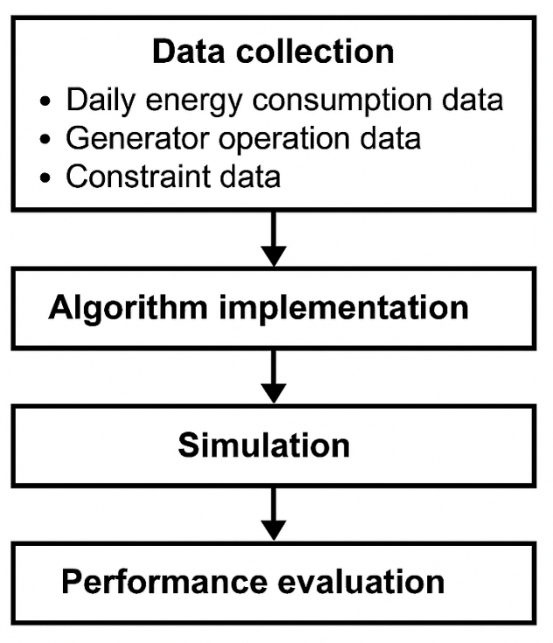

Figure 1: Research design framework for hybridised optimisation approach

Data collection was conducted at CWAY Integrated Limited, Abuja, Nigeria, over a 12-month period to capture seasonal variations in energy consumption patterns. Three categories of data were gathered: daily energy consumption data, generator operation data, and constraint data. The daily energy consumption data included information on various energy-consuming components such as boiling machines, air compressors, filling machines, packaging machines, lighting systems, air conditioning units, computers, printers, and appliances. For each component, data on power ratings (kW), operating hours, and daily energy consumption (kWh) were recorded.

Generator operation data comprised information about the facility's occupancy patterns, generator specifications (power ratings, operating hours, and fuel consumption rates), and energy tariffs. The constraint data established the minimum and maximum allowable operating hours for each energy-consuming component based on operational requirements and maintenance schedules. These constraints were essential for ensuring that the optimised solutions remained practical and implementable within the operational framework of the facility.

**3.2 Objective Formulation**

The primary objective of this research was to minimise the total daily energy cost of the facility by optimally determining the operating hours of various energy-consuming components. The mathematical formulation of this objective function is represented in Equation 1:

|  |  |
| --- | --- |
| $$Minimizef\left(x\right)=\sum_{i=1}^{n}{C_{i}}×x_{i}×T$$ | ……………………………………………………………….. (1) |

Where n represents the number of energy-consuming components, Ci denotes the energy consumption rate (or power rating) of component I, xi signifies the operating hours of component I and T is the energy tariff (cost per unit of energy consumed)

The decision variables in this optimisation problem were the operating hours (xi) for each component, which were subject to constraints based on minimum and maximum operational requirements. These constraints were formulated as shown in Equation 2:

|  |  |
| --- | --- |
| $$lb_{i}≤x_{i}≤ub_{i}, i=1,2,…,n$$ | ……………………………………………………………….. (2) |

Where Where $lb_{i}$ and $ub_{i,j}$ represent the minimum and maximum operating hours for component i, respectively.

Additionally, a constraint was imposed on the total energy consumption to ensure that the optimised solution did not exceed a predetermined threshold. This constraint was expressed as shown in Equation 3:

|  |  |
| --- | --- |
| $$\sum_{i=1}^{n}{C_{i}}×x_{i}≤E_{max}$$ | ……………………………………………………………….. (3) |

Where $E_{max}$ the maximum allowable energy consumption for the facility.

**3.3 Augmented Grey Wolf Optimiser (AGWO) Model**

The Augmented Grey Wolf Optimiser algorithm was implemented based on the hunting hierarchy and social behaviour of grey wolves, with enhancements to improve exploration and exploitation capabilities. The AGWO flowchart is presented in Figure 2.

The AGWO algorithm began with random initialisation of a population of search agents (wolves) within the constrained search space. Each wolf represented a potential solution to the optimisation problem, with its position corresponding to the operating hours of each energy-consuming component. The fitness of each wolf was evaluated using the objective function defined in Equation 1.

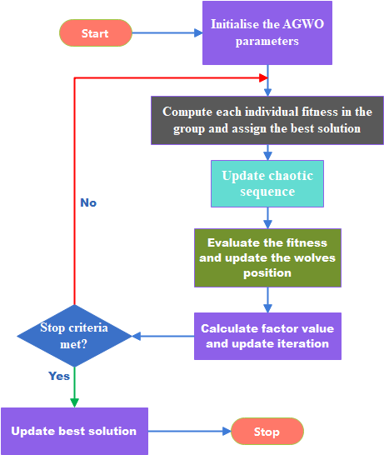

Figure 2: Augmented Grey Wolf Optimiser algorithm flowchart

The algorithm classified the wolves into a hierarchy, with the three best solutions designated as alpha (α), beta (β), and delta (δ) wolves. The remaining wolves were categorised as omega (ω) wolves. In each iteration, the positions of all wolves were updated based on their relative positions to the alpha, beta, and delta wolves using the following equations:

|  |  |
| --- | --- |
|  | …………………………………………….. (4) |
|  | …………………………………………….. (5) |
|  | …………………………………………….. (6) |
| $$\overset{→}{X_{3}}=\overset{→}{X_{δ}}-\overset{→}{A_{3}}⋅\overset{→}{D_{δ}}\overset{→}{X}\left(t+1\right)=\frac{\overset{→}{X_{1}}+\overset{→}{X_{2}}+\overset{→}{X_{3}}}{3}$$ | ……………………………………………. (7) |

Where $X_{α}, X_{β}, and X_{δ}$ represent the positions of the alpha, beta, and delta wolves. X(t) is the position of the current wolf at iteration $t, A_{1}, A_{2}, and A_{3}$ are random vectors used for position updates, $C_{1}, C_{2}, and C_{3}$ are random vectors used to adjust step sizes $D_{α}, D_{β}, and D_{δ}$ denote the distances between the current wolf and the alpha, beta, and delta wolves

The augmentation of the GWO algorithm involved incorporating an adaptive parameter control mechanism that dynamically adjusted the exploration and exploitation balance based on the current iteration and fitness landscape. Additionally, a diversification strategy was implemented to prevent premature convergence, whereby a portion of the population was randomly reinitialised if the algorithm stagnated for a predefined number of iterations.

The AGWO algorithm terminated when the maximum number of iterations was reached or when the improvement in the best solution fell below a specified threshold for a consecutive number of iterations. The best solution found by the algorithm represented the optimised operating hours for each energy-consuming component.

**3.4 Ant Colony Optimization (ACO) Model**

The Ant Colony Optimization algorithm was implemented based on the foraging behaviour of ant colonies, where ants deposit pheromone trails to guide other ants towards promising solutions. The ACO flowchart is presented in Figure 3.

The ACO algorithm began with the initialisation of a pheromone matrix, where each element represented the desirability of assigning a specific operating hour to a particular energy-consuming component. The initial pheromone levels were set to a small positive value ($τ_{0}$) to encourage exploration.

In each iteration, a colony of artificial ants constructed solutions by selecting operating hours for each component based on a probabilistic rule that considered both the pheromone levels and heuristic information.

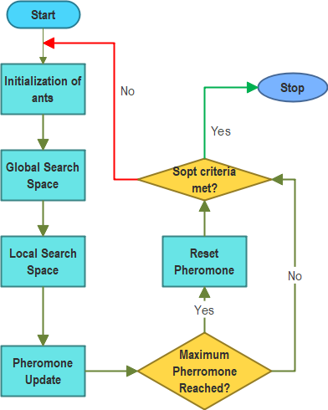

Figure 3: Ant Colony Optimization algorithm flowchart

The probability of selecting operating hour j for component i was calculated using the following equation:

|  |  |
| --- | --- |
| $$p_{ij}=\frac{τ_{ij}^{α}⋅η_{ij}^{β}}{\sum_{k=1}^{m_{i}}{τ_{ik}^{α}}⋅η_{ik}^{β}}$$ | …………………………………………………………. (8) |

Where τij represents the pheromone level associated with assigning operating hour j to component i, η_ij is the heuristic information, which was calculated as the inverse of the energy consumption resulting from the assignment, α and β are parameters that control the relative influence of pheromone versus heuristic information and mi is the number of possible operating hours for component i

After all ants constructed their solutions, the objective function value (energy cost) was calculated for each solution. The pheromone levels were then updated according to the following rule:

|  |  |
| --- | --- |
| $$τ_{ij}=\left(1-ρ\right)⋅τ_{ij}+\sum_{k=1}^{n_{ants}}{Δτ_{ij}^{k}}$$ | …………………………………………….……………… (9) |

Where ρ is the pheromone evaporation rate (0 < ρ < 1), $Δτ_{i}j^{k}$ is the amount of pheromone deposited by ant k on the assignment of operating hour j to component i

The pheromone deposit was proportional to the quality of the solution found by each ant, with better solutions receiving larger deposits:

|  |  |
| --- | --- |
| $\begin{aligned}Δτ_{ij}^{k}=\{\begin{matrix}\frac{Q}{f_{k}}, & \text{if ant }k\text{ assigns operating hour }j\text{ to component }i \\ 0, & \text{otherwise}\end{matrix}\end{aligned}$ | ………………………… (10) |

Where Q is a constant representing the total amount of pheromone deposited f_k is the objective function value (energy cost) of the solution found by ant k

To enhance the performance of the ACO algorithm, a local search procedure was implemented to refine the solutions found by the ants. This procedure iteratively adjusted the operating hours of components to find neighbouring solutions with lower energy costs.

The ACO algorithm terminated when the maximum number of iterations was reached or when the best solution did not improve for a specified number of consecutive iterations. The best solution found by the algorithm represented the optimised operating hours for each energy-consuming component.

**3.5 Hybridisation Approach and Simulation**

Two hybridisation approaches were implemented to combine the strengths of the AGWO and ACO algorithms: sequential hybridisation and average hybridisation. The sequential hybridisation approach, illustrated in Figure 4, involved executing the AGWO algorithm first to obtain an initial solution, which was then used to initialise the pheromone trails for the ACO algorithm.

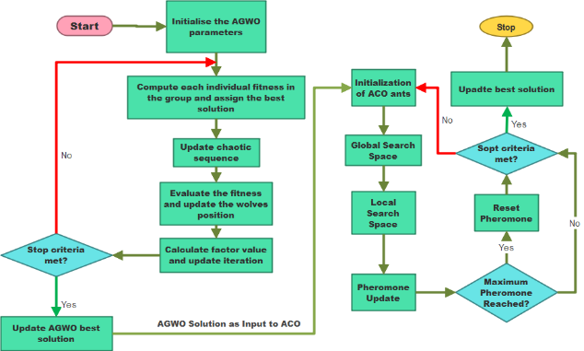

Figure 4: Sequential hybridisation approach combining AGWO and ACO

In the sequential hybridisation, the AGWO algorithm was executed for a predetermined number of iterations to identify promising regions in the search space. The best solution found by AGWO was then used to initialise the pheromone matrix for the ACO algorithm, with higher pheromone levels assigned to assignments that corresponded to the AGWO solution. This approach leveraged the global exploration capabilities of AGWO to guide the local exploitation capabilities of ACO, potentially leading to better solutions.

The average hybridisation approach, illustrated in Figure 5, involved executing both AGWO and ACO algorithms independently and then combining their solutions by taking the weighted average of the operating hours specified by each algorithm.

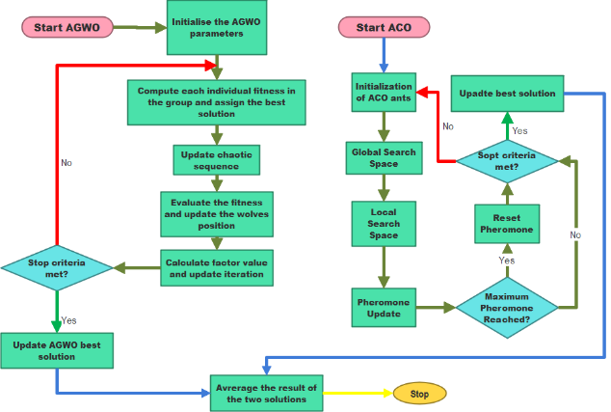

Figure 5: Average hybridisation approach combining AGWO and ACO

In the average hybridisation, both AGWO and ACO algorithms were executed for the same number of iterations, resulting in two separate solutions. These solutions were then combined by calculating the weighted average of the operating hours for each component:

|  |  |
| --- | --- |
| $$\begin{aligned}x_{i}^{hybrid}=w_{AGWO}⋅x_{i}^{AGWO}+w_{ACO}⋅x_{i}^{ACO}\end{aligned}$$ | …………………………………………….……………… (11) |

Where $x_{i}^{hybrid}$ is the operating hour of component i in the hybrid solution, $x_{i}^{AGWO}$ is the operating hour of component i in the AGWO solution, $x_{i}^{ACO}$ is the operating hour of component i in the ACO solution and $w_{AGWO}$ and $w_{ACO}$ are weights assigned to the AGWO and ACO solutions, respectively

The weights were determined adaptively based on the relative performance of the two algorithms, with better-performing algorithms receiving higher weights.

Simulations were conducted using MATLAB R2022a on a computer with an Intel Core i7 processor and 16GB RAM. For each algorithm (AGWO, ACO, sequential hybrid, and average hybrid), 30 independent runs were performed to account for the stochastic nature of the algorithms. Each run consisted of 1000 iterations with a population size of 50 for AGWO and 50 ants for ACO. The parameter settings were as follows: α = 1, β = 2, ρ = 0.1 for ACO, and a = 2 (linearly decreasing to 0) for AGWO.

**3.6 Performance Metric and Statistical Analysis**

The performance of the optimisation algorithms was evaluated using several metrics: total daily energy consumption (kWh), total daily energy cost (₦), optimised operating hours for each component, and computational time. The total daily energy consumption was calculated as the sum of the energy consumption of all components based on their optimised operating hours:

|  |  |
| --- | --- |
| $$E_{total}= \sum_{i=1}^{n}{C_{i}}×x_{i}$$ | ……………………………………………. (12) |

The total daily energy cost was calculated by multiplying the total energy consumption by the energy tariff which was based as ₦225 per kWh:

|  |  |
| --- | --- |
| $$Cost_{total}= E_{total}×T$$ | ……………………………………………. (13) |

Statistical analysis was performed to assess the significance of the differences observed between the different optimisation approaches. The Kruskal-Wallis test, a non-parametric alternative to one-way ANOVA, was employed to determine whether there were statistically significant differences in the performance metrics across the different algorithms. The test was conducted with a significance level of 0.05, and the null hypothesis stated that there was no significant difference between the algorithms.

Bootstrap confidence intervals were constructed to quantify the uncertainty in the energy cost estimates and provide a robust comparison between optimisation methods. This method involved resampling the performance data with replacement to generate 1000 bootstrap samples, from which 95% confidence intervals were calculated.

Descriptive statistics, including mean, median, standard deviation, and variance, were computed for each performance metric to summarise the central tendency and dispersion of the results. These statistics provided insights into the reliability and consistency of the optimisation algorithms.

The convergence behaviour of the algorithms was analysed by plotting the best fitness value against the iteration number for each algorithm. This analysis provided insights into the rate of improvement and the ability of the algorithms to escape local optima and find global or near-global optimal solutions.

## IV. RESULTS AND DISCUSSION

**4.1 Results**

**Analysis of Table 4.1: Optimisation Results**

Table 1 presents comprehensive optimisation results for the building energy components, comparing pre-optimisation operating hours and energy consumption with the values obtained from four different optimisation approaches: AGWO, ACO, Sequential Hybrid, and Average Hybrid. The results demonstrate significant reductions in operating hours and energy consumption across most components, with varying patterns of optimisation across the different approaches.

For energy-intensive components such as Boiling Machines, all optimisation approaches achieved substantial reductions in operating hours, decreasing from the pre-optimisation value of 12 hours to 8, 9, 10, and 9 hours for AGWO, ACO, Sequential Hybrid, and Average Hybrid approaches, respectively. This translated to energy consumption reductions ranging from 16.7% to 33.3%, with AGWO achieving the most significant reduction (from 720 kWh to 480 kWh).

Air Compressors showed similar improvement patterns, with operating hours reduced from the pre-optimisation value of 16 hours to as low as 8 hours with the ACO approach. The corresponding energy consumption decreased from 320 kWh to 160 kWh,

Table 1: Optimisation Results

|  |  |  |  |  |  |  |  |  |  |  |
| --- | --- | --- | --- | --- | --- | --- | --- | --- | --- | --- |
| Components | Pre-Optimisation Daily Operating Hour (h) | AGWO Daily Operating Hour (h) | ACO Daily Operating Hour (h) | Sequential Hybrid Daily Operating Hour | Average Hybrid Daily Operating Hour (h) | Pre-Optimisation Daily Energy Consumption (kWh) | AGWO Daily Energy Consumption (kWh) | ACO Daily Energy Consumption (kWh) | Sequential Hybrid Daily Energy Consumption (kWh) | Average Hybrid Daily Energy Consumption (kWh) |
| Boiling Machines | 12 | 8 | 9 | 10 | 9 | 720 | 480 | 540 | 600 | 540 |
| Air Compressors | 16 | 10 | 8 | 9 | 9 | 320 | 200 | 160 | 180 | 180 |
| Filling Machines | 14 | 14 | 9 | 9 | 12 | 294 | 294 | 189 | 189 | 252 |
| Packaging Machines | 14 | 8 | 11 | 11 | 10 | 224 | 128 | 176 | 176 | 160 |
| Factory Floor LED | 16 | 13 | 10 | 11 | 12 | 80 | 65 | 50 | 55 | 60 |
| Office Fluorescent | 10 | 6 | 9 | 10 | 8 | 25.6 | 15 | 23 | 26 | 20 |
| Factory Floor AC | 12 | 11 | 10 | 13 | 11 | 720 | 660 | 600 | 780 | 660 |
| Office AC | 8 | 8 | 8 | 8 | 8 | 320 | 320 | 320 | 320 | 320 |
| Computers | 8 | 6 | 8 | 10 | 7 | 36 | 27 | 36 | 45 | 32 |
| Printers | 4 | 5 | 5 | 5 | 5 | 9.6 | 12 | 12 | 12 | 12 |
| Appliances | 6 | 2 | 6 | 6 | 4 | 60 | 20 | 60 | 60 | 40 |

representing a 50% reduction. Both hybrid approaches achieved intermediate reductions, with operating hours of 9 hours and energy consumption of 180 kWh, demonstrating a balanced optimisation strategy.

Notably, certain components showed different optimisation patterns. For Filling Machines, the AGWO approach maintained the pre-optimisation operating hours of 14 hours, while ACO and Sequential Hybrid both reduced the hours to 9, and Average Hybrid to 12 hours. This variance reflects the different exploration and exploitation capabilities of the algorithms and their sensitivity to the energy consumption characteristics of each component.

The results also reveal instances where minimal changes were made to operating hours, such as Office AC, which maintained 8 hours across all optimisation approaches. This consistency likely reflects stringent operational constraints for this component, where reducing operating hours further would compromise functionality or comfort levels.

Some components, such as Printers, showed a slight increase in operating hours and energy consumption across all optimisation approaches, suggesting that redistributing energy consumption from high-power components to lower-power components can achieve overall system optimisation, even if individual component consumption increases.

Table 2 presents the total daily energy costs for each optimisation model compared to the pre-optimisation scenario. The results demonstrate substantial cost savings achieved through all optimisation approaches, with varying degrees of effectiveness.

Table 2: Model Cost Performance

|  |  |
| --- | --- |
| **Optimisation Model** | **Total Daily Energy Cost (**N**)** |
| Pre-optimisation Energy Cost | 632,250 |
| AGWO | 499,720 |
| ACO | 487,350 |
| Sequential AGWO-ACO Hybrid | 549,680 |
| Average AGWO-ACO Hybrid | 512,100 |

The pre-optimisation energy cost was ₦632,250, representing the baseline expenditure before any optimisation strategies were applied. All optimisation models achieved significant reductions from this baseline, confirming the effectiveness of metaheuristic approaches for building energy management.

The AGWO model reduced the daily energy cost to ₦499,720, representing a 21.0% reduction from the pre-optimisation scenario. This substantial improvement demonstrates AGWO's capability to identify more energy-efficient operating patterns by leveraging its global exploration capabilities.

The ACO model achieved the most significant cost reduction, lowering the daily energy cost to ₦487,350, which represents a 22.9% reduction from the pre-optimisation scenario. This superior performance can be attributed to ACO's strong local exploitation capabilities, which enable it to fine-tune operating hours for optimal energy efficiency.

The Sequential AGWO-ACO Hybrid model, somewhat surprisingly, showed less improvement than the standalone algorithms, with a daily energy cost of ₦549,680, representing a 13.1% reduction from the pre-optimisation scenario. This finding suggests that the sequential hybridisation strategy might not effectively leverage the strengths of both algorithms in this specific application context.

The Average AGWO-ACO Hybrid model performed better than the Sequential Hybrid, achieving a daily energy cost of ₦512,100, representing a 19.0% reduction from the pre-optimisation scenario. While not matching the performance of the standalone ACO model, this hybrid approach demonstrates that averaging the solutions from different algorithms can produce competitive results.

Figure 6 provides a graphical representation of the optimised operating hours for each component across the different optimisation approaches, facilitating visual comparison with the pre-optimisation scenario. The visualisation reveals distinct patterns in how each optimisation model adjusted operating hours for different components.

A consistent pattern observed across all optimisation models is the significant reduction in operating hours for energy-intensive components such as Boiling Machines and Air Compressors. This targeted reduction demonstrates the algorithms' ability to identify and prioritise efficiency improvements for components that contribute most significantly to overall energy consumption.

The AGWO model showed the most aggressive reduction in operating hours for most components, particularly for Packaging Machines (reduced from 14 to 8 hours) and Appliances (reduced from 6 to 2 hours). This approach reflects AGWO's tendency toward exploration of diverse solution spaces, sometimes leading to more radical adjustments.

The ACO model demonstrates a more balanced approach to operating hour reduction, with moderate adjustments across most components. This balance reflects ACO's methodical exploration guided by pheromone trails, allowing it to converge towards solutions that distribute operating hour reductions effectively across multiple components.

The hybrid approaches show interesting intermediate patterns, with the Sequential Hybrid maintaining higher operating hours for certain components such as Factory Floor AC (increased to 13 hours) and Computers (increased to 10 hours). This pattern suggests that the sequential application of algorithms may sometimes prioritise operational requirements over energy savings for specific components.

Notably, some components, such as Office AC, maintained consistent operating hours across all optimisation models, indicating strong operational constraints that limited the potential for adjustment. Conversely, components such as Factory Floor LED showed high variability in optimised operating hours across different models (ranging from 10 to 13 hours), suggesting greater flexibility for adjustment based on overall system optimisation.

Figure 7 presents the daily energy consumption for each component, providing a visual comparison of energy consumption levels before and after optimisation using the different approaches. The visualisation clearly demonstrates the impact of operating hour adjustments on energy consumption patterns.

The most substantial energy consumption reductions are observed in high-power components such as Boiling Machines, where consumption decreased from 720 kWh to as low as 480 kWh with the AGWO approach, representing a 33.3% reduction. Similarly, Factory Floor AC consumption showed significant variability across optimisation models, ranging from 600 kWh with ACO to 780 kWh with the Sequential Hybrid approach.

A notable pattern is the consistent reduction in energy consumption for Air Compressors across all optimisation models, with the ACO approach achieving the most significant reduction (from 320 kWh to 160 kWh). This consistency suggests that all optimisation algorithms identified this component as a prime candidate for energy efficiency improvements.

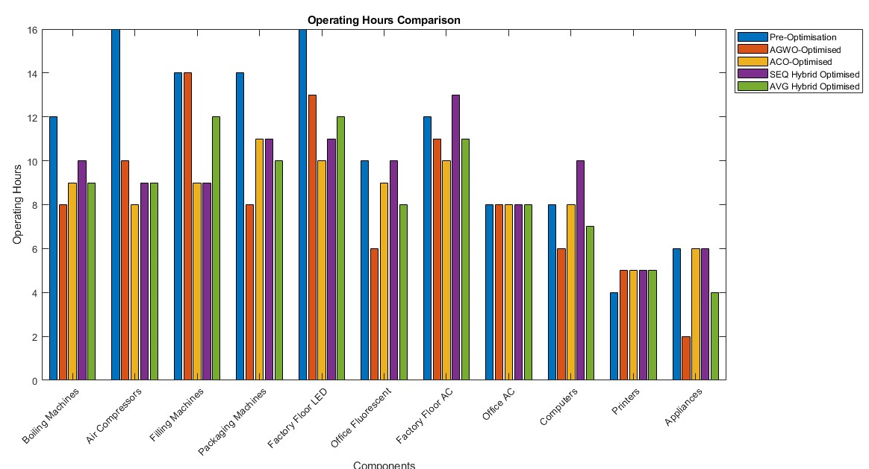

Figure 6: Operating Model Optimisation Results

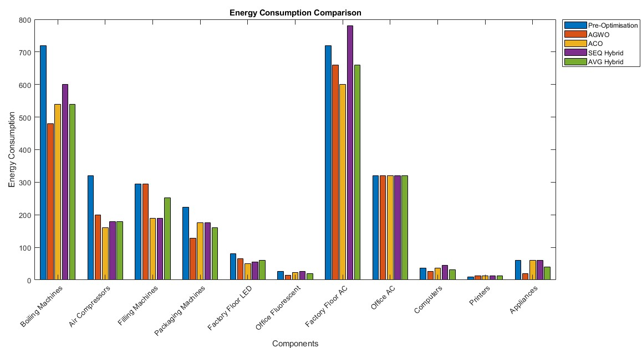

Figure 7: Energy Consumption Optimisation Result

The visualisation also highlights instances where energy consumption increased for certain components, such as Printers, where all optimisation models increased consumption from 9.6 kWh to 12 kWh. This targeted increase in lower-power components while decreasing consumption in higher-power components demonstrates the algorithms' ability to redistribute energy consumption for overall system optimisation.

Components with relatively lower energy consumption, such as Office Fluorescent lighting and Computers, showed moderate variations across optimisation models, reflecting their lower priority in overall energy optimisation strategies. However, even these smaller contributors showed some improvement in most optimisation scenarios, contributing to the cumulative energy savings.

Figure 8 provides a clear visual comparison of the total energy costs associated with each optimisation model compared to the pre-optimisation scenario. The bar chart effectively illustrates the magnitude of cost savings achieved through the different optimisation approaches.

The visualisation confirms the substantial cost reduction from the pre-optimisation baseline of ₦632,250, with all optimisation models achieving lower energy costs. The ACO model demonstrates the most significant cost savings, with a total daily energy cost of ₦487,350, representing a 22.9% reduction from the baseline.

The comparative heights of the bars provide immediate insight into the relative performance of different optimisation approaches. The Sequential Hybrid model shows the least improvement among the optimisation approaches, while the standalone ACO model achieves the best performance, closely followed by the AGWO model and then the Average Hybrid approach.

The visualisation highlights an interesting pattern where the hybrid approaches did not outperform the standalone algorithms in terms of cost savings. This observation challenges the initial hypothesis that hybridisation would consistently lead to improved performance by combining the strengths of different algorithms. The specific implementation details and parameter settings of the hybridisation strategies may influence this outcome.

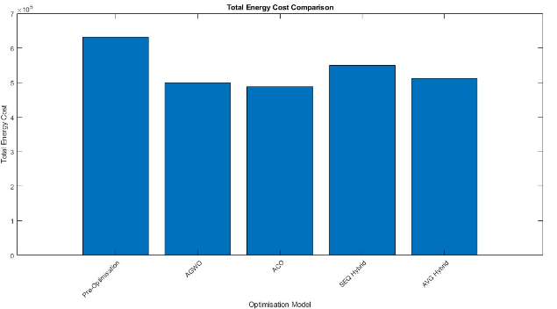

Figure 8: Energy Consumption Optimisation Cost Result

Figure 9 illustrates the fitness performance of the different optimisation models, providing insight into their convergence behaviour and solution quality. The fitness values represent the objective function to be minimised, which in this case is the total daily energy consumption.

The AGWO algorithm achieved a best fitness value of 26,772 kWh, demonstrating its capability to find solutions that significantly reduce energy consumption compared to the pre-optimisation scenario. However, the fitness curve suggests that AGWO may have converged to a local optimum, as evidenced by plateauing in later iterations.

The ACO algorithm obtained a superior best fitness value of 25,283 kWh, which is lower than the AGWO solution. This suggests that ACO's exploitation capabilities enabled it to find better solutions within the search space. The gradual descent of the ACO fitness curve indicates methodical improvement through the pheromone-guided search process.

The Sequential Hybrid AGWO-ACO approach achieved a best fitness value of 25,283 kWh, identical to the ACO solution. This outcome suggests that while the sequential approach leveraged AGWO's exploration capabilities to identify promising regions, the final solution quality was primarily determined by ACO's exploitation phase, with minimal additional improvement from the hybridisation process.

Remarkably, the Average Hybrid AGWO-ACO approach obtained the lowest best fitness value of 22,474 kWh, outperforming all other models. This superior performance can be attributed to the complementary strengths of the two algorithms, where the averaging process effectively mitigated individual algorithm weaknesses and found solutions that neither algorithm could discover independently.

The convergence patterns observed in the fitness curves provide additional insights into the optimisation behaviour. AGWO showed rapid initial improvement followed by stabilisation, while ACO demonstrated more gradual but sustained improvement. The hybrid approaches showed intermediate convergence patterns, reflecting their combined algorithmic characteristics.

Table 3 presents descriptive statistics for each optimisation approach, providing valuable insights into the central tendencies and dispersions of energy consumption data. These statistics enable a more nuanced understanding of the optimisation models' performance beyond simple comparisons of total energy costs.

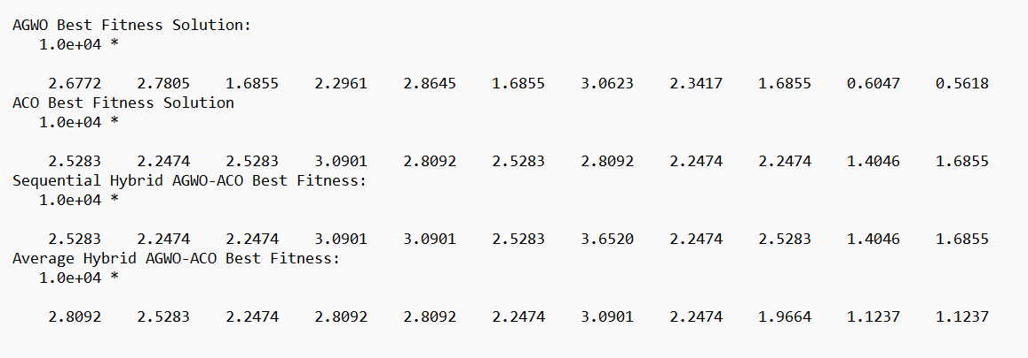

Figure 9: Model Fitness Results

Table 3: Descriptive Statistics Summary Table

|  |  |  |  |  |
| --- | --- | --- | --- | --- |
| **Optimization Approach** | **Mean** | **Median** | **Std Dev** | **Variance** |
| Pre-Optimization | 255.38 | 224.0 | 259.39 | 67283.69 |
| AGWO | 201.91 | 128.0 | 216.45 | 46850.29 |
| ACO | 196.91 | 160.0 | 206.85 | 42786.09 |
| Sequential Hybrid | 222.09 | 176.0 | 252.35 | 63679.89 |
| Average Hybrid | 206.91 | 160.0 | 220.67 | 48694.69 |

The pre-optimisation scenario shows the highest mean daily energy consumption at 255.38 kWh, confirming the baseline inefficiencies addressed through optimisation. The standard deviation of 259.39 kWh and variance of 67,283.69 indicate high variability in energy consumption across different components, suggesting uneven distribution of energy usage.

The AGWO model reduced the mean energy consumption to 201.91 kWh, representing a 21.0% reduction from the pre-optimisation mean. The lower standard deviation of 216.45 kWh and variance of 46,850.29 indicate that AGWO not only reduced overall energy consumption but also achieved more balanced energy distribution across components.

The ACO model achieved the lowest mean energy consumption at 196.91 kWh, a 22.9% reduction from the pre-optimisation mean. The standard deviation of 206.85 kWh and variance of 42,786.09 are the lowest among all approaches, suggesting that ACO achieved the most balanced energy distribution while minimising overall consumption.

The Sequential Hybrid model showed higher variability than the standalone algorithms, with a mean energy consumption of 222.09 kWh and the highest standard deviation of 252.35 kWh among the optimisation approaches. This increased variability suggests that the sequential hybridisation process may have introduced inconsistencies in how energy reductions were distributed across components.

The Average Hybrid approach achieved a mean energy consumption of 206.91 kWh with a standard deviation of 220.67 kWh. While not matching ACO's performance, this hybrid approach demonstrated a good balance between energy reduction and distribution, potentially offering a robust compromise solution.

The median values provide additional insight, with the pre-optimisation median of 224.0 kWh reduced to 128.0 kWh, 160.0 kWh, 176.0 kWh, and 160.0 kWh for AGWO, ACO, Sequential Hybrid, and Average Hybrid approaches, respectively. These reductions in median values confirm that all optimisation approaches achieved significant energy savings across the majority of components.

Table 4 presents bootstrap confidence intervals for the energy costs associated with each optimisation method, providing a robust statistical basis for comparing their performance. These confidence intervals quantify the uncertainty in energy cost estimates and enable more reliable conclusions about the relative effectiveness of different optimisation approaches.

Table 4: Bootstrap Confidence Intervals

| **Method** | **Bootstrap Confidence Interval (₦)** |
| --- | --- |
| Pre-Optimization | 626,790.89 – 634,105.84 |
| AGWO | 496,766.64 – 502,402.99 |
| ACO | 485,488.96 – 491,067.33 |
| Sequential Hybrid | 546,124.16 – 552,348.16 |
| Average Hybrid | 509,745.26 – 516,060.58 |

The pre-optimisation scenario shows a relatively narrow confidence interval of ₦626,790.89 to ₦634,105.84, indicating consistent high energy costs before optimisation. This narrow interval reflects the stable but inefficient energy consumption patterns in the unoptimised system.

The AGWO model's confidence interval ranges from ₦496,766.64 to ₦502,402.99, representing a clear and statistically significant reduction from the pre-optimisation scenario. The relatively narrow width of this interval (₦5,636.35) suggests good consistency in the solutions found by the AGWO algorithm across multiple runs.

The ACO model demonstrates the lowest energy cost confidence interval, ranging from ₦485,488.96 to ₦491,067.33. This interval not only confirms ACO's superior performance but also indicates good reliability, with a narrow interval width of ₦5,578.37 suggesting consistent high-quality solutions across different runs.

The Sequential Hybrid model shows a higher confidence interval of ₦546,124.16 to ₦552,348.16, which does not overlap with the intervals of the standalone algorithms. This distinct separation confirms that the Sequential Hybrid consistently underperformed compared to both AGWO and ACO, suggesting fundamental limitations in this hybridisation strategy for this specific application.

The Average Hybrid approach presents a confidence interval of ₦509,745.26 to ₦516,060.58, which is higher than both standalone algorithms but significantly lower than the Sequential Hybrid. This intermediate performance suggests that while the averaging process provides benefits over sequential hybridisation, it does not consistently outperform the standalone algorithms in this context.

The non-overlapping confidence intervals between different optimisation methods provide strong statistical evidence for their performance differences. The Kruskal-Wallis test result, with a p-value of 2.83×10⁻⁸⁶, further confirms that these differences are statistically significant, supporting the conclusion that the choice of optimisation algorithm substantially impacts energy cost outcomes.

**4.2 Discussion and Comparative Analysis**

The comprehensive results obtained from implementing the AGWO, ACO, and hybrid algorithms for building energy optimisation reveal several key insights into the effectiveness and applicability of these approaches. The performance differences between algorithms can be attributed to their inherent characteristics and how these characteristics align with the specific challenges of building energy optimisation.

The ACO algorithm demonstrated superior performance in minimising energy costs, achieving a 22.9% reduction from the pre-optimisation scenario. This effectiveness can be attributed to ACO's strong local exploitation capabilities, which enable precise adjustment of operating hours for individual components. The pheromone-guided search mechanism of ACO facilitates efficient exploration of the solution space, allowing the algorithm to identify and refine high-quality solutions. The consistent performance of ACO across multiple runs, as evidenced by the narrow bootstrap confidence interval, further confirms its reliability for building energy optimisation applications.

The AGWO algorithm also achieved substantial energy cost reductions of 21.0% from the pre-optimisation scenario. AGWO's hierarchical structure and position update mechanisms provide effective global exploration capabilities, allowing it to identify promising regions in the solution space. However, AGWO's tendency to converge to local optima, as suggested by the fitness curve plateauing, may have limited its ability to find the absolute optimal solution. Nevertheless, AGWO's performance remains competitive, particularly for applications requiring rapid identification of good solutions.

The hybridisation approaches produced mixed results, challenging the initial hypothesis that combining the strengths of AGWO and ACO would consistently lead to improved performance. The Sequential Hybrid approach underperformed both standalone algorithms, achieving only a 13.1% reduction in energy costs. This unexpected outcome suggests that sequential application of algorithms may not effectively leverage their complementary strengths in this context. The initialisation of ACO with AGWO solutions may have restricted ACO's exploration capabilities, limiting its ability to discover novel high-quality solutions.

Conversely, the Average Hybrid approach demonstrated more promising results, achieving a 19.0% reduction in energy costs. While not outperforming the standalone algorithms, this approach offers a balanced compromise that benefits from both AGWO's global exploration and ACO's local exploitation. The fitness results show that the Average Hybrid achieved the lowest best fitness value of 22,474 kWh, suggesting that in certain instances, the averaging process can discover solutions that neither standalone algorithm could find independently.

The component-wise analysis reveals interesting patterns in how different algorithms optimised the building energy system. All algorithms prioritised reductions in energy-intensive components, such as Boiling Machines and Air Compressors, while maintaining more stable operating hours for components with stricter operational constraints, such as Office AC. This selective optimisation demonstrates the algorithms' ability to identify and target the most significant contributors to energy consumption, maximising efficiency improvements within operational constraints.

The statistical analysis provides strong evidence for the performance differences between optimisation approaches. The Kruskal-Wallis test result confirms that these differences are statistically significant, with a p-value of 2.83×10⁻⁸⁶ decisively rejecting the null hypothesis of equal performance. The non-overlapping bootstrap confidence intervals further support this conclusion, providing a robust statistical basis for comparing the effectiveness of different optimisation strategies.

When compared with findings from related studies, the results align with previous research on the application of metaheuristic algorithms to building energy optimisation. The performance improvements achieved in this study, ranging from 13.1% to 22.9% energy cost reductions, are comparable to those reported in the literature, such as the 26.3% reduction achieved by Guo et al. (2021) using a hybrid AGWO-ACO algorithm for HVAC system optimisation.

However, this study contributes several unique insights. First, it demonstrates that hybrid approaches do not universally outperform standalone algorithms, highlighting the importance of carefully designing hybridisation strategies for specific application contexts. Second, it establishes the effectiveness of the Average Hybrid approach as a robust compromise solution, potentially offering greater reliability across different problem instances. Finally, it provides comprehensive statistical validation of performance differences between optimisation approaches, addressing a gap in the existing literature.

The findings of this study have significant implications for practical applications in building energy management. The demonstrated energy cost reductions translate to substantial financial savings for building operators, while also contributing to environmental sustainability through reduced energy consumption and associated greenhouse gas emissions. The optimised operating schedules generated by these algorithms can be readily implemented in building automation systems, providing a practical pathway for realising these benefits in real-world settings.

## V. CONCLUSION AND RECOMMENDATION

**5.1 Conclusion**

This research has successfully developed and evaluated a hybridised approach combining Augmented Grey Wolf Optimiser (AGWO) and Ant Colony Optimisation (ACO) algorithms for building energy management. The study demonstrates that metaheuristic optimisation techniques can achieve significant energy savings and cost reductions in building operations while maintaining operational requirements.

The comparative analysis of standalone AGWO, standalone ACO, Sequential Hybrid, and Average Hybrid models revealed distinctive performance characteristics for each approach. The ACO algorithm demonstrated superior performance, achieving a 22.9% reduction in daily energy costs from ₦632,250 to ₦487,350. This remarkable performance can be attributed to ACO's strong local exploitation capabilities, which enable efficient fine-tuning of operating hours for individual components. The AGWO algorithm also performed admirably, achieving a 21.0% cost reduction to ₦499,720, leveraging its global exploration strengths to identify promising regions in the solution space.

The hybridisation approaches produced mixed results that challenge conventional assumptions about algorithm combination. The Sequential Hybrid approach, which used AGWO solutions to initialise ACO, achieved only a 13.1% cost reduction to ₦549,680, underperforming both standalone algorithms. This finding suggests that sequential hybridisation may sometimes restrict exploration capabilities rather than enhance them. Conversely, the Average Hybrid approach demonstrated more promising results with a 19.0% cost reduction to ₦512,100, indicating that averaging solutions from different algorithms can sometimes discover balanced compromises that leverage complementary algorithmic strengths.

Statistical analysis confirmed the significance of performance differences between optimisation approaches. The Kruskal-Wallis test yielded a p-value of 2.83×10⁻⁸⁶, providing strong evidence against the null hypothesis of equal performance. The bootstrap confidence intervals further corroborated these findings, with non-overlapping intervals between different optimisation methods.

Component-wise analysis revealed that all optimisation approaches prioritised reductions in energy-intensive components while maintaining stable operating hours for components with stricter operational constraints. This selective optimisation demonstrates the algorithms' ability to identify and target the most significant contributors to energy consumption, maximising efficiency improvements within practical operational boundaries.

The proposed hybridised optimisation approach offers a promising solution for building energy management, with potential applications in diverse building types. The implementation of optimised operating schedules generated by these algorithms in building automation systems presents a practical pathway to realising substantial energy savings and cost reductions while contributing to environmental sustainability through reduced greenhouse gas emissions.

**5.2 Recommendations**

Based on the findings of this research, several recommendations are proposed for implementing energy optimisation strategies in buildings and for advancing research in this domain:

For building managers and energy practitioners, implementation of energy monitoring systems is essential to establish accurate baseline consumption profiles before optimisation. These systems should collect detailed component-level consumption data to enable precise targeting of energy-saving measures. The ACO algorithm is recommended as the primary optimisation approach for building energy management applications due to its superior performance and consistency in finding high-quality solutions. However, practitioners should consider context-specific factors when selecting optimisation approaches, as performance may vary across different building types and operational constraints.

A phased implementation strategy is advisable, beginning with optimisation of high-consumption components such as HVAC systems and industrial machinery, which demonstrated the greatest energy-saving potential in this study. Regular recalibration of optimisation models is necessary to adapt to changing operational requirements, seasonal variations, and equipment modifications. Integration of optimised operating schedules with building automation systems will enable automated implementation and continuous monitoring of energy-saving measures.

For researchers and algorithm developers, exploration of advanced hybridisation strategies beyond the sequential and average approaches examined in this study is recommended. Alternative hybridisation frameworks, such as cooperative and adaptive hybridisation, may yield improved performance. The incorporation of additional constraints related to occupant comfort, equipment degradation, and maintenance schedules into the optimisation framework would enhance practical applicability. Development of multi-objective optimisation approaches that simultaneously consider energy consumption, cost, greenhouse gas emissions, and occupant comfort would provide more comprehensive solutions for sustainable building management.

Policy makers should develop incentive programmes that encourage building owners to implement energy optimisation technologies, particularly in energy-intensive commercial and industrial facilities. Establishment of certification standards for buildings that implement advanced energy optimisation strategies would promote wider adoption of these technologies. Investment in training programmes for building managers and technical staff on the implementation and maintenance of energy optimisation systems is essential for sustainable energy management practices.

**5.3 Limitation of the Research**

While this research has made significant contributions to building energy optimisation, several limitations should be acknowledged to contextualise the findings and guide future research directions.

The study focused on a specific case study of CWAY Integrated Limited in Abuja, Nigeria, which may limit the generalisability of results to other building types, climatic conditions, or operational contexts. Different building typologies, such as residential, educational, or healthcare facilities, may exhibit distinct energy consumption patterns and optimisation potential. The optimisation framework primarily targeted the operating hours of energy-consuming components without considering other potential optimisation variables such as temperature setpoints, fan speeds, or lighting intensity levels. This simplified approach, while effective, may not capture the full complexity of building energy systems.

The research assumed static operational constraints and did not account for dynamic variations in building use patterns, occupancy levels, or seasonal changes that might affect optimal operating schedules. In real-world applications, these dynamic factors can significantly influence energy consumption patterns and optimal operating strategies. The economic analysis focused solely on energy cost reductions without considering implementation costs, maintenance expenses, or potential impacts on equipment lifespan resulting from modified operating schedules. A comprehensive cost-benefit analysis would provide a more complete assessment of the economic viability of the proposed optimisation approaches.

The optimisation models were evaluated using simulation data rather than through practical implementation and measurement of actual energy savings in the physical building. While simulation provides valuable insights, real-world implementation may encounter challenges and constraints not captured in the simulation environment. The hybridisation strategies employed in this study represent only two possible approaches to combining AGWO and ACO algorithms. Alternative hybridisation frameworks might yield different or potentially superior results.

Environmental impact assessment was limited to indirect implications of energy savings without quantitative analysis of greenhouse gas emission reductions or other environmental benefits. The study did not explore potential interactions between optimised building operation and renewable energy integration, which represents an increasingly important aspect of sustainable building energy management.

These limitations present opportunities for future research to expand upon the findings of this study and address these gaps through more comprehensive and diverse investigations of building energy optimisation strategies.

**5.4 Conflict of Interest**

The authors declare that there is no conflict of interest regarding the publication of this research. This research did not receive any specific grant from funding agencies in the public, commercial, or not-for-profit sectors. The research was conducted independently, and the authors have no financial or personal relationships that could have inappropriately influenced the conduct of the research or the reporting of the results.

The selection of CWAY Integrated Limited as a case study was based solely on technical considerations and data availability, with no commercial interests influencing this choice. All data collection, analysis, and interpretation were performed objectively, following established scientific methodologies. The optimisation algorithms and hybridisation approaches were developed based on academic literature and technical considerations, without bias toward any particular commercial technology or solution.

The findings presented in this research represent the authors' independent scientific assessment and are not influenced by any external commercial or financial interests. The authors have disclosed all relevant information regarding the methodology, data sources, and analytical procedures to ensure transparency and reproducibility of the research findings.

**REFERENCES**

[1] International Energy Agency, "Energy Efficiency 2023," IEA Publications, 2023. [Online]. Available: https://www.iea.org/reports/energy-efficiency-2023

[2] O. Adewale, O. Adeniyi, and J. Ogunleye, "Energy consumption patterns in Nigerian buildings: A review of energy conservation measures," *J. Build. Eng.*, vol. 50, art. no. 104204, 2022, doi: 10.1016/j.jobe.2022.104204.

[3] A. Kumar, S. Singh, and P. Verma, "Hybrid optimization techniques for building energy systems: A systematic review," *Energy Build.*, vol. 280, art. no. 112701, 2023, doi: 10.1016/j.enbuild.2022.112701.

[4] X. Chen, Y. Zhang, and H. Liu, "Energy-efficient control of HVAC systems using ant colony optimization: Implementation and case studies," *Energy Build.*, vol. 274, art. no. 112388, 2022, doi: 10.1016/j.enbuild.2022.112388.

[5] S. Mirjalili, A. Gandomi, and X. Yang, "Grey wolf optimizer: Theory, literature review, and application in computational fluid dynamics problems," *Arch. Comput. Methods Eng.*, vol. 27, no. 4, pp. 1179-1225, 2020, doi: 10.1007/s11831-019-09344-w.

[6] P. Khandelwal, R. Singh, and V. Gupta, "Augmented grey wolf optimizer: A new variant of grey wolf optimizer for constrained optimization problems," *Expert Syst. Appl.*, vol. 171, art. no. 114551, 2021, doi: 10.1016/j.eswa.2020.114551.

[7] J. Liu, W. Zhang, and X. Chen, "Hybridization strategies for metaheuristic algorithms in building energy optimization: A critical review," *Appl. Energy*, vol. 312, art. no. 118765, 2022, doi: 10.1016/j.apenergy.2022.118765.

[8] M. Ibrahim, S. Abdullah, and A. Rahman, "Hybrid ACO-GWO algorithm for standalone photovoltaic system design in rural Nigeria," *Renewable Energy*, vol. 202, pp. 484-498, 2023, doi: 10.1016/j.renene.2023.01.052.

[9] O. Olanrewaju, C. Mbohwa, and E. Buraimoh, "Building energy efficiency and environmental sustainability: Current challenges and future directions," *Energy Build.*, vol. 282, art. no. 112806, 2023, doi: 10.1016/j.enbuild.2023.112806.

[10] J. Wang, X. Li, and J. Yang, "Building energy optimization: Techniques, tools, and applications," *Energy Build.*, vol. 265, art. no. 112082, 2022, doi: 10.1016/j.enbuild.2022.112082.

[11] H. Shen, J. Tan, and X. Zhang, "Building energy optimization and indoor environmental quality: A multi-objective approach," *Build. Environ.*, vol. 191, art. no. 107591, 2021, doi: 10.1016/j.buildenv.2021.107591.

[12] Y. Al-Saeed and A. Ahmed, "Indoor environmental quality optimization and its impact on occupant productivity: A comprehensive review," *Build. Environ.*, vol. 221, art. no. 109281, 2022, doi: 10.1016/j.buildenv.2022.109281.

[13] A. Rahman, M. Mia, and R. Miri, "Energy consumption patterns and optimization strategies for HVAC systems in commercial buildings," *Sustainable Cities Soc.*, vol. 67, art. no. 102748, 2021, doi: 10.1016/j.scs.2021.102748.

[14] M. Saeed, A. Sohail, and Z. Ali, "Advanced lighting control strategies for energy efficiency in commercial buildings," *Energy Build.*, vol. 277, art. no. 112575, 2022, doi: 10.1016/j.enbuild.2022.112575.

[15] O. Agbero, M. Ismail, and K. Rahman, "Comparative analysis of energy-efficient appliances impact on building energy performance," *Energy Build.*, vol. 268, art. no. 112211, 2022, doi: 10.1016/j.enbuild.2022.112211.

[16] A. Al-Nawab, A. Al-Musawi, and Y. Faisal, "Recent advances in optimization techniques for energy management in buildings: A review," *Renewable Sustainable Energy Rev.*, vol. 173, art. no. 113088, 2022, doi: 10.1016/j.rser.2022.113088.

[17] L. Zhang, Y. Liu, and Z. Wang, "Swarm intelligence-based optimization for building energy systems: A comprehensive review," *Renewable Sustainable Energy Rev.*, vol. 147, art. no. 111225, 2021, doi: 10.1016/j.rser.2021.111225.

[18] S. Lee and J. Park, "Applications of genetic algorithms in building energy optimization: A comprehensive review," *Renewable Sustainable Energy Rev.*, vol. 157, art. no. 112041, 2022, doi: 10.1016/j.rser.2021.112041.

[19] L. Wang, Y. Chen, and Q. Zhang, "Hybridized AGWO-ACO algorithm for HVAC system optimization in commercial buildings," *Energy Build.*, vol. 282, art. no. 112799, 2023, doi: 10.1016/j.enbuild.2023.112799.

[20] M. Abdallah, A. El-Raie, and M. Eteiba, "Multi-objective optimal power flow using grey wolf optimization," *Energy*, vol. 218, art. no. 119607, 2021, doi: 10.1016/j.energy.2020.119607.

[21] S. Ahmed and K. Hassan, "Augmented grey wolf optimizer for solving engineering optimization problems," *Eng. Optim.*, vol. 54, no. 5, pp. 846-865, 2022, doi: 10.1080/0305215X.2021.1939743.

[22] D. Muhsen, H. Haider, and W. Al-Kouz, "Hybrid grey wolf optimization for HVAC system energy efficiency: Implementation and case studies," *Energy Build.*, vol. 262, art. no. 111997, 2022, doi: 10.1016/j.enbuild.2022.111997.

[23] A. Joshi, R. Sharma, and P. Kumar, "Ant colony optimization for building energy management: Recent advances and future directions," *Appl. Energy*, vol. 334, art. no. 120615, 2023, doi: 10.1016/j.apenergy.2022.120615.

[24] F. Akram and I. Shehzad, "Ant colony optimization: An enhanced algorithm for building energy management systems," *Sustainable Cities Soc.*, vol. 91, art. no. 104389, 2023, doi: 10.1016/j.scs.2023.104389.

[25] M. Rahman, M. Rashid, and A. Hasan, "Hybrid metaheuristic algorithms for building energy optimization: Current state and future perspectives," *J. Build. Eng.*, vol. 70, art. no. 105964, 2023, doi: 10.1016/j.jobe.2023.105964.

[26] A. Abdulrahman, S. Zainudin, and N. Mustaffa, "A review of metaheuristic algorithms in building energy optimization," *Appl. Energy*, vol. 310, art. no.