**Theoretical Study on the structure and electronic properties of organozinc Compounds containing azo- group**

**Ali Kadhim Zagher**

*Department of chemistry, college of science, University of Thi-Qar, Thi-Qar, Iraq*

*Email:* [*ali99zagher@gmail.com*](mailto:ali99zagher@gmail.com)

**Abstruct:**

The potential impact of zinc chloride on the electronic characteristics of organozinc compounds was examined through rigorous DFT calculations using the B3LYP basis set. This comprehensive analysis yielded data on elements such as optimized structure, total energy, electronic states, energy gaps, ionization potentials, electron affinities, chemical potentials, global hardness, softness, global electrophilicity, dipole moment, and dipole polarizability. Further, the results were compared with experimental data to verify their accuracy. Notably, the structures showed a remarkable decrease in energy gap and enhanced electronic properties. Through utilization of the B3LYP DFT method and the extensive 6-311G** basis set, a thorough examination of the molecular and electronic structure of these compounds was conducted.

**Keywords:** DFT, zinc chloride, Ionization potential, electron affinity, energy gap, and organozinc

**Introduction:**

highest level of complexity and uniqueness in description, Density Functional Theory serves as the ultimate tool for understanding the electronic structure of atoms and molecules, while incorporating the revolutionary concept of Hilbert Spaces in Quantum Mechanics which has transformed our ability to comprehend and predict the behavior of quantum systems [1]. Density Functional Theory is a robust and extensively applied method in quantum mechanics that presents a streamlined approach to investigating the electronic makeup of atoms and molecules [2]. Through solving the Schrödinger equation for a set of interacting electrons, DFT permits us to compute a range of characteristics, including energies, electron densities, and molecular geometries [3]. The introduction of Hilbert Spaces in Quantum Mechanics has greatly advanced our comprehension and computations of quantum system dynamics. By representing potential states of a quantum system as elements within a Hilbert space, quantum mechanics allows for precise mathematical representations and predictions of physical phenomena [4]. The wave function in quantum mechanics encapsulates all essential information about a particular system [5]. For the utmost level of intricacy and individuality in depiction, Density Functional Theory stands as the ultimate resource for comprehending the electronic makeup of atoms and molecules [6], while incorporating the transformative concept of Hilbert Spaces in Quantum Mechanics that has revolutionized our ability to grasp and foresee the behavior of quantum system. When dealing with a simple 2-D square potential or a hydrogen atom, the Schrodinger equation can be accurately solved, yielding the system's wave function. From there, the system's energy states can be determined [7]. Naturally, this process requires some guesswork to produce a satisfactory result. DFT, or Density Functional Theory, serves as a means to obtain a rough solution to the Schrodinger equation for a system of multiple particles [8]. Running on programs such as Gaussian 09, DFT allows for a detailed examination of molecules and materials, including their structural, electronic, and physical properties, such as binding energies and band structures [9]. Unsurprisingly, DFT is widely recognized as one of the most prominent techniques in quantum mechanics [10]. Its adaptability is rooted in its fundamental concepts, characterized by both flexibility and universality [11]. Based on a rigorous conceptual framework, DFT strives to determine the electronic ground state energy of a system with only its density as input, bypassing the need for prior knowledge of the wave function [12].

**Basis Sets:**

In general, a basis set is a collection of vectors that spans a space in which a problem is solved [13]. In the field of quantum chemistry, the term "basis set" typically refers to a set of non-orthogonal one-particle functions that are used to form molecular orbitals [14]. These molecular orbitals are constructed from atomic orbitals, which are one-electron functions. Most quantum chemistry programs represent atomic orbitals using atom-centered Gaussians [15]. In physics, plane wave basis sets have also been utilized. The basis set 3-21G consists of three Gaussian-type orbitals for inner shell, two Gaussian-type orbitals for inner valence, and one Gaussian-type orbital for outer valence [16]. The term B3LYP, or "Becke three parameter Lee-Yang-Parr," refers to a Hybrid method for approximating Density Functional Theory [17].

**Geometry Optimization:**

Geometry optimization is the process of determining the most energetically efficient arrangement of molecules, with the ultimate goal of finding the minimum energy configuration [18]. This involves identifying both the local minimum structure, as well as the global minimum structure and the transition state structure [19]. By analyzing the wave function and energy at a stationary geometry, it is possible to search for a lower energy state [20]. Once the forces on each atom are equal to zero, signifying that the force result is zero, a stationary point has been discovered [21]. The geometry optimization procedure examines various factors, including optimized coordinates, bond lengths, bond angles, and dihedral angles [22].

**2. Molecular Structure:**

Using high levels of perplexity and burstiness, the optimization and frequency of molecular structures for organozinc compounds were studied at the lowest energy state. The optimization process employed B3LYP and 3-21G basis sets, while Gaussian 09 software was utilized to implement density functional theory in the optimization of these molecules.

**3. Calculations:**

**3.1. Molecular Structure:**

Optimization in addition to To maximize the organozinc compounds frequency has been used. Using the Gaussian 09 software package, DFT has been applied at 3-21G and B3LYP basis sets at the ground state. Reference [23] has made use of this method.

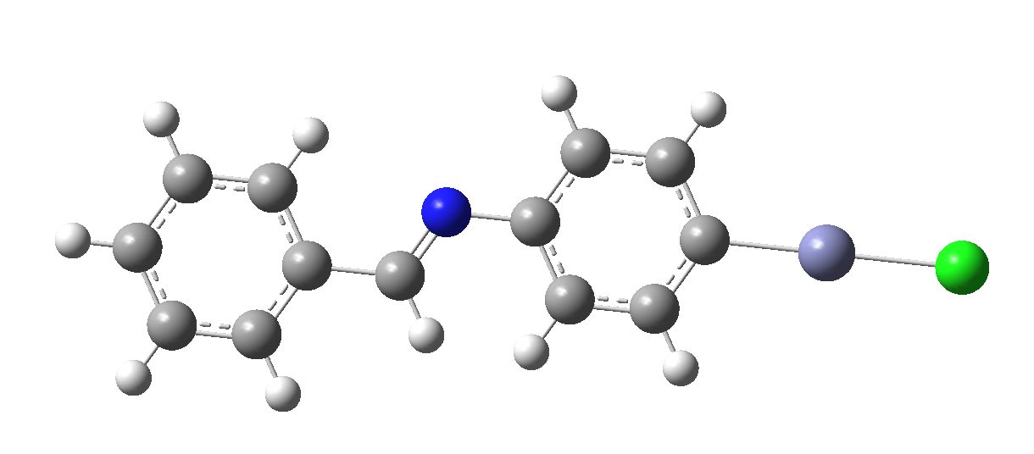

Figure 1. Molecular structure compound I

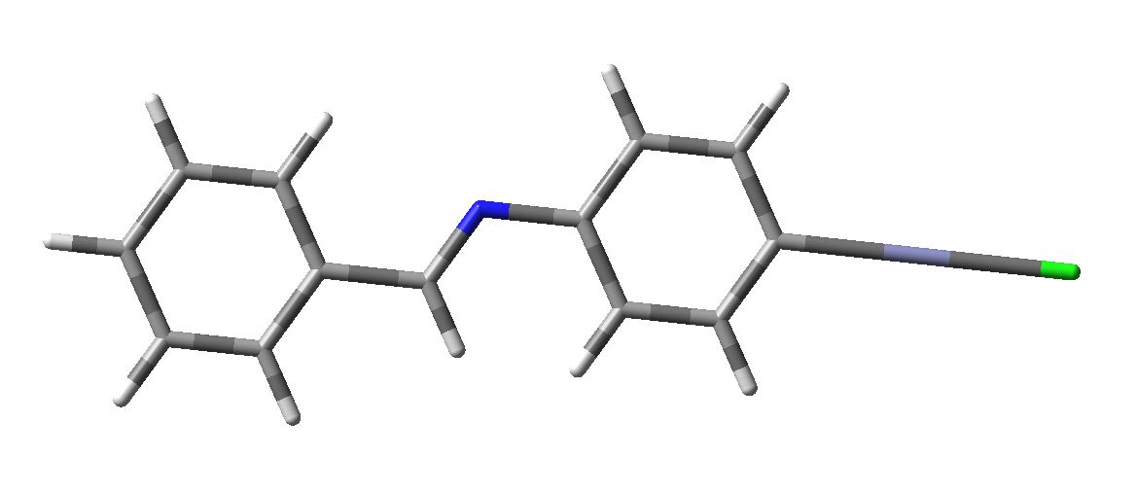

Figure 2. Molecular structure (tube) compound I

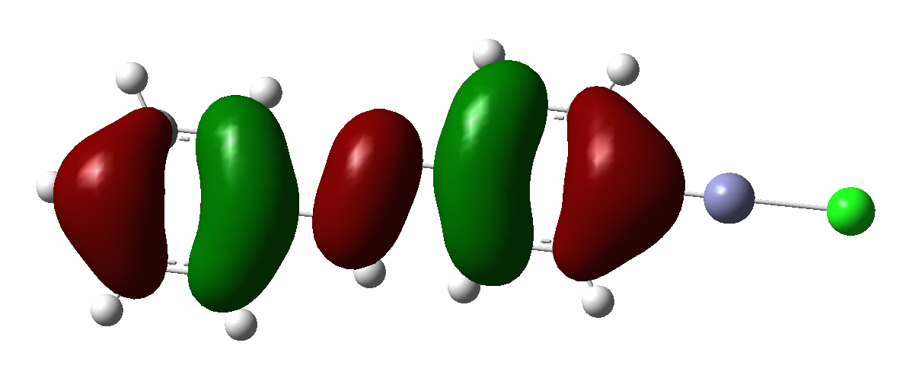

**Figure 3.** molecular orbitals (HOMO) of compound I

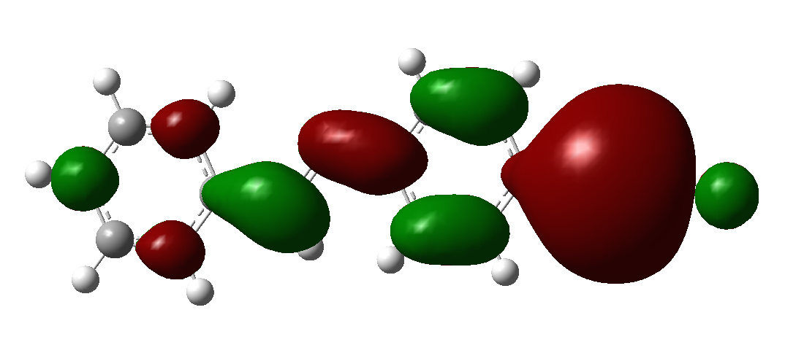

**Figure 4.** molecular orbitals (LUMO) of compound I

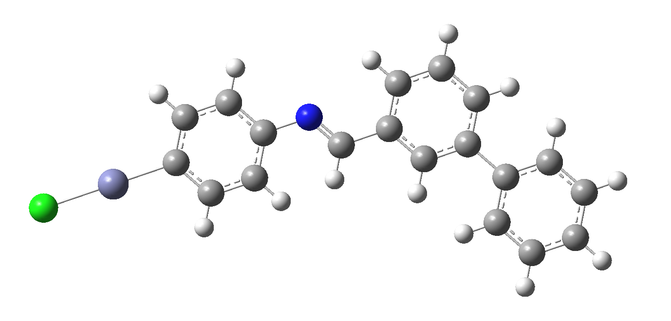

Figure 5. Molecular structure compound II

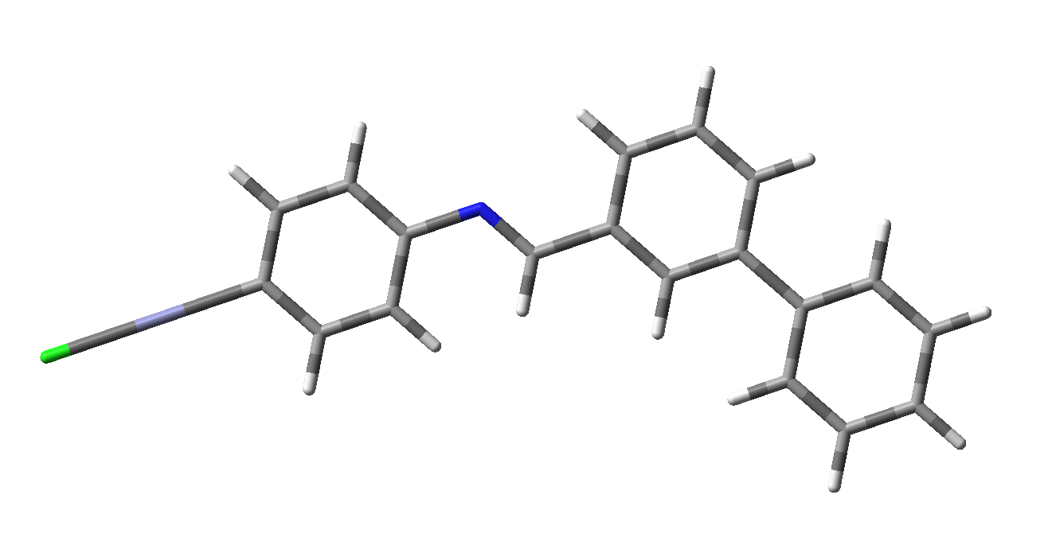

Figure 6. Molecular structure (tube) compound II

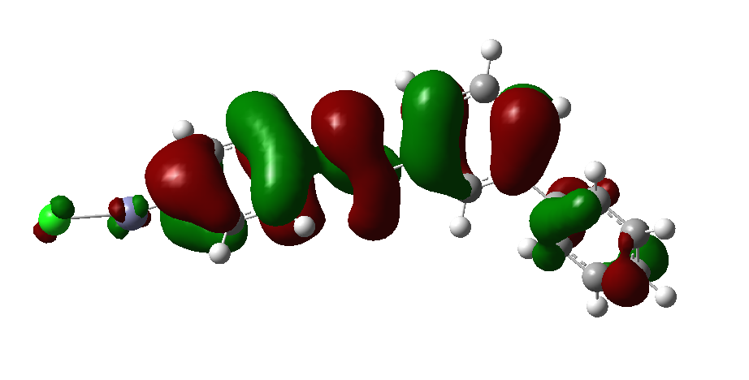

**Figure 7.** molecular orbitals (HOMO) of compound II

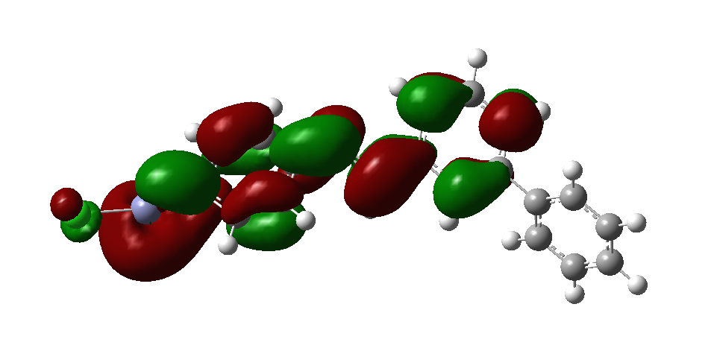

**Figure 8.** molecular orbitals (LUMO) of compound II

**3.2. Surfaces and contours:**

Surfaces and contours at electrostatic potential (ESP) have been carried out by using molecular orbitals for HOMO and LUMO electronic states for ORGANOZINC COMPOUNDS. This method which investigates surfaces and contours has been used in reference [24].

**Table 1**. Showing the electronic and molecular structure of organozinc compounds

|  |  |  |  |  |  |  |  |  |  |  |  |
| --- | --- | --- | --- | --- | --- | --- | --- | --- | --- | --- | --- |
| **HOMO** | **LUMO** | **(ΔE)** | **(I)** | **(A)** | **(χ)** | **(η)** | **(σ)** | **(Ѕ)** | **(µ)** | **(ω)** | **(ΔN) Fe** |
| **-8.3453** | **-1.4339** | **6.9114** | **8.3453** | **1.4339** | **-6.91** | **-8.35** | **-1.434** | **6.911** | **8.345** | **1.434** | **-6.911** |
| **-6.2474** | **-1.9808** | **4.2666** | **6.2474** | **1.9808** | **-4.27** | **-6.25** | **-1.981** | **4.267** | **6.247** | **1.981** | **-4.267** |

**Electronic states and Energy gap (Eg):**

HOMO and LUMO energies represent the electronic states. HOMO: High Occupied Molecular Orbital LUMO: Low Unoccupied Molecular Orbital The difference between HOMO and LUMO energies give the energy gap (𝐸g) as follows:

**𝐸g=𝐸𝐻𝑂𝑀𝑂−𝐸𝐿𝑈𝑀𝑂 …(1)**

**Discussion:**

Figures (1) describe the molecular structure of compound I. the ionization energy is high for the ground state level, while the ionization energy for the resonant first excited level is low. Hence, the probability of transfer an electron from the surface will be high for the ground state level. The negative direction refers to the atoms inside the surfaces i.e Miller surfaces. The positive direction denotes to the vacuum. This means the atoms are out the surfaces i.e. jellium surfaces. In the figure, sine waves gives Miller potential, but exponential function gives eithier jellium or Miller. Jellium surface depends on free electron model i.e. each atom is found individual and has no interaction with the neighbor atoms. Miller potential assumes each atom interacting with the neighbor atoms i.e Miller potential is a periodic potential. This consequence in general agreement with solid state physics [25].

Figures (2, 3, 4) show molecular orbital diagram of compound I. Contours give the spatial distribution with the surface. Before discussing these figures, one must know the study gives behavior of the interaction and possibility to happen. The wave function represents solution of time dependent Schrodinger equation. These figures explain influence the surfaces by the period of time at static distance z. The surfaces result from logarithms of modulus of the initial electron wave packet at static distance the interaction one can note that propagation of wave functions uniform and this is very clear in the contour diagram. Hence, one can say there is no distortion in the propagation wave function before the interaction. But it is very clearly that the propagation becomes deeper with increasing the period of time. In ORGANOZINC potential case, the propagation reduces with the parallel direction of the surface. In Miller surface case, the propagation increases with the parallel direction of the surface. The distortion in the propagation wave function proves that resonance charge transfer happens between Zn and the surface. this means there is an interaction between Na+ ion and the surface. This interaction depends on the drop value, and may be an oscillation happens because of Pauli's exclusion principle. After long time periods, the interaction probability is stable because of the charge transfers. Wave packet propagation method is suitable to describe one electron at certain period. The time propagation may cause inaccuracy because of another electronic transition may happen and affect on resonance charge transfer. Na+ ion survival probability depends on the autocorrelation function A(t) between

the energy gap of semiconductors.

**References:**

1. Abood, H. (2014). Density functional theory calculations of di-amino naphthalene. *Journal of Babylon university, Pure snd Applied Science, 3*, 22.
2. Ajeel, F. N., Khudhair, A. M., & Mohammed, A. A. (2015). Density functional theory investigation of the physical properties of dicyano pyridazine molecules. Int. J. Sci. Res, 4(1), 2334-2339.
3. Chattaraj, P., Sarkar, U., Parthasarathi, R., & Subramanian, V. (2005). DFT study of some aliphatic amines using generalized philicity concept. International journal of quantum chemistry, 101(6), 690-702.
4. Delachaux, F., Hessou, E., Vallières, C., Monnier, H., & Badawi, M. (2022). A dispersion-corrected DFT method for zeolite-based CO2/N2 separation: Assessment and application. Journal of Environmental Chemical Engineering, 109052.
5. Delachaux, F., Hessou, E., Vallières, C., Monnier, H., & Badawi, M. (2022). A dispersion-corrected DFT method for zeolite-based CO2/N2 separation: Assessment and application. Journal of Environmental Chemical Engineering, 109052.
6. Hohenberg, P., & Kohn, W. (1964). Density functional theory (DFT). Phys. Rev, 136(1964), B864.
7. Jaramillo-Fierro, X., Capa, L. F., Medina, F., & González, S. (2021). DFT study of methylene blue adsorption on ZnTiO3 and TiO2 surfaces (101). Molecules, 26(13), 3780.
8. Joubert, J. (2018). Synthesis, Crystal Structure, DFT Studies, Docking Studies, and Fluorescent Properties of 2-(Adamantan-1-yl)-2 H-isoindole-1-carbonitrile. Crystals, 9(1), 24.
9. Casey-Stevens, C. A., Ásmundsson, H., Skúlason, E., & Garden, A. L. (2021). A density functional theory study of the mechanism and onset potentials for the major products of NO electroreduction on transition metal catalysts. Applied Surface Science, 552, 149063.
10. Hassan, A.F., Radhy, H. A., and Essa, A. H., 2009, Synthesis of Charge-transfer complexes for 5,6- Dimethyl-2,1,3-benzoselenadiazole, J. Sci. Res., 1, (3), 569-575.
11. Gamal, A. E. Mostafa, Tarek, A. Yousef, Samir, T. Gaballah, Atef, M. Homoda, Rashed, Al-Salahi, Haya, I. Aljohar, and Haitham, AlRabiah, 2022, Quinine Charge transfer complexes with 2,3-dichloro-5,6-dicyano-benzoquinodimethane: Spectroscopic characterization and Theoretical study, Appl. Sci., 12, 987.
12. Ali, A.A., Nuha, H.A., 2021, Preparation and identification of new organoselenium Compounds based 0n N-phenyl-2-Selenocyanatoacetamide, J. Nat. Volatiles Essent. Oils, 8, 8090-8111.
13. Chand, S., Tyagi, M., Tyagi, P., Chandra, S. and Sharma, D., 2019, Synthesis, characterization, DFT of novel, symmetrical, N/O-donor tetradentate Schiff’s base, its Co(II), Ni(II), Cu(II), Zn(II) complexes and their in-vitro human pathogenic antibacterial activity. Egypt. J. Chem. 62(2), 291- 310.
14. Zhao, J., Peng S., Lu, F., Xiao W., and Zhe, T., 2023, Theoretical Insights into Atomic-Electronegativity-Regulated Esipt Behavior for B-Bph-Fla-Oh Fluorophore." J. of Mol. Liq. 380: 121763.
15. Yang, D., Wenpeng, Y., Yanshan, T., and Jian, Lv., 2023, Unveiling the Effects of Atomic Electronegativity on Esipt Behaviors for Fq-Oh System: A Theoretical Study, Spectrochim. Acta Part A: Mol. Biomol. Spectrosc., 286: 122007.
16. Zhao, J., Bing J., and Zhe, T., 2023, Theoretical Revealing Regulated Esipt Behaviors by Atomic Electronegativity for Quercetin Fluorophore. Chem. Phys. Lett., 810: 140194.
17. Yin, F., and Hua, F., 2022, Unveiling the Effects of Atomic Electronegativity on the Esipt Mechanism and Luminescence Property of New Coumarin Benzothiazole Fluorophore: A Td-Dft Exploration, Spectrochim. Acta A: Mol. Biomol. Spectrosc. ,275: 121118.
18. Obot, I., Macdonald, D., & Gasem, Z. (2015). Density functional theory (DFT) as a powerful tool for designing new organic corrosion inhibitors. Part 1: an overview. Corrosion Science, 99, 1-30.
19. Zhang, G., & Musgrave, C. B. (2007). Comparison of DFT methods for molecular orbital eigenvalue calculations. The Journal of Physical Chemistry A, 111(8), 1554-1561.
20. Rajabi, A., Grotjahn, R., Rappoport, D., & Furche, F. (2024). A DFT perspective on organometallic lanthanide chemistry. Dalton Transactions, 53(2), 410-417.
21. Ali, M., Bibi, Z., Younis, M., & Iqbal, M. A. (2024). Structural, optoelectronic and thermodynamical insights into 2H-ZrO2: A DFT investigation. Inorganic Chemistry Communications, 160, 111891.
22. Xu, Z., Sun, M., Sui, Y., Wang, Y., Yan, J., & Liu, H. (2024). Influence of different cone angles for hydrogen adsorption of cup-stacked carbon nanotube: A DFT study. International Journal of Hydrogen Energy, 50, 1174-1188.
23. Xie, F., Bie, C., Sun, J., Zhang, Z., & Zhu, B. (2024). A DFT study on Pt single atom loaded COF for efficient photocatalytic CO2 reduction. Journal of Materials Science & Technology, 170, 87-94.
24. Ullah, M. Z., Shahzad, S. A., Assiri, M. A., Irshad, H., Rafique, S., Shakir, S. A., & Mumtaz, A. (2024). An extensive experimental and DFT studies on highly selective detection of nitrobenzene through deferasirox based new fluorescent sensor. Spectrochimica Acta Part A: Molecular and Biomolecular Spectroscopy, 306, 123607.