Optimization of Ethanol-Assisted Ultrasonic Extraction for Cordycepin from Cordyceps militaris
Rongshuai Jiang, Tao Zheng, Youcong Yang, Wenhao Sun, Nankun Ao, Qian Li
School of Life and Health, Dalian University, China
Corresponding Author: Qian Li, liqian@dlu.edu.cn
ABSTRACT: Cordycepin, an adenosine analog, demonstrates a range of biological activities, including anti-tumor, anti-inflammatory, antiviral, immune-regulating, and anti-diabetic effects. This study investigates the extraction of cordycepin from Cordyceps militaris using an ethanol-ultrasonic extraction method. The raw material, dried fruiting bodies of Cordyceps militaris, was subjected to ethanol ultrasonic extraction. Various parameters, including ethanol concentration, extraction time, and extraction cycles, were optimized. The findings indicate that the optimal conditions for cordycepin extraction were: 50% ethanol concentration, an extraction time of 50 minutes, and a single extraction cycle.
KEY WARDS: Cordycepin, Ethanol-ultrasonic extraction, Cordyceps militaris, Cordycepin isolation

---------------------------------------------------------------------------------------------------------------------------------------
Date of Submission: xx-xx-xxxx Date of acceptance: xx-xx-xxxx
---------------------------------------------------------------------------------------------------------------------------------------

INTRODUCTION
Cordycepin (Cordycepin, COR), with the chemical structure shown in Figure 1, is chemically named 3'-deoxyadenosine and has the molecular formula C₁₀H₁₃N₅O₃, functioning as an adenosine analog. It was first discovered in 1950 by Cunningham et al. in the fermentation broth of the medicinal fungus Cordyceps militaris [1].As an exceedingly precious natural compound, cordycepin exhibits a wide range of bioactive functions but is not limited to the following aspects [2]:
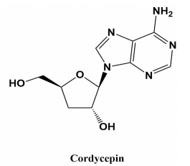
Figure 1: The structural formula of cordycepin

Antitumor effects: Cordycepin significantly inhibits metastasis in colon cancer, cholangiocarcinoma, lung cancer, and other malignancies by disrupting RNA synthesis, remodeling the tumor immune microenvironment [3], reprogramming lipid metabolism [4], and modulating the brain microenvironment [5].
Anti-inflammatory effects: Cordycepin alleviates nonalcoholic steatohepatitis (NASH) by activating the AMPK signaling pathway [6]. It also reduces neuroinflammation by suppressing neutrophil infiltration post-traumatic brain injury [7], and improves colitis by regulating gut microbiota composition [8].
Antiviral activity: Cordycepin suppresses viral replication by inhibiting viral particle formation, viral protein synthesis, and reducing pro-inflammatory cytokine/chemokine production [9].
Immunomodulatory effects: Cordycepin plays a critical role in immune regulation by modulating the activation and proliferation of various immune cells, demonstrating adjuvant therapeutic potential for immune-related diseases[10].
Amelioration of diabetes and hyperlipidemia: Cordycepin suppresses diabetes-related gene expression by inhibiting lipopolysaccharide (LPS)-induced macrophage inflammation [11]. For hyperlipidemia, cordycepin activates AMPK to prevent its onset and effectively enhances insulin sensitivity [12].
Cordycepin holds significant application potential across various fields, including pharmaceuticals, nutraceuticals, cosmetics, and agriculture. Notably, a modified cordycepin derivative, NUC-7738, which incorporates a protective phosphoramidate cap (preventing rapid deamination in vivo), has been successfully developed and completed Phase I clinical trials, demonstrating promising prospects as a novel cancer therapy [13].
Currently, cordycepin is primarily obtained through two methods: chemical synthesis and biosynthesis [14]. In chemical synthesis, adenosine is used as the precursor to produce cordycepin via multiple reaction steps [15]. However, this approach suffers from several drawbacks, including low production efficiency, high costs, poor precursor accessibility, numerous byproducts, challenging purification processes, and significant environmental pollution, making it unfeasible for industrial-scale applications. At present, the primary source of cordycepin remains its extraction from fruiting bodies of Cordyceps militaris or fermentation broths.
Research on extraction methods of cordycepin primarily includes traditional water decoction, ultrasonic extraction, microwave-assisted extraction, and enzymatic hydrolysis [16].
Traditional Water Decoction. This conventional method involves heating a mixture of C. militaris and water to dissolve cordycepin, followed by filtration and concentration. While simple to operate, this approach suffers from low extraction efficiency.
Ultrasonic Extraction. By leveraging the cavitation effect of ultrasound, this method accelerates the release of bioactive compounds into the solvent, significantly improving extraction yield. Advantages include high efficiency, simple operation, and time savings. However, drawbacks include potential damage to active components due to ultrasonic waves, difficulty in controlling ultrasound intensity, and possible noise pollution [17, 18].
Microwave-Assisted Extraction. This technique uses microwave heating to rupture cell walls and release target compounds. It offers rapid heating, high efficiency, and low energy consumption.
Enzymatic Hydrolysis. Employing specific enzymes to selectively degrade cell walls, this method enables gentle and eco-friendly extraction with high specificity [19].
However, current cordycepin extraction methods still face certain issues, such as low extraction efficiency and challenging operational condition control. Therefore, research on optimizing extraction conditions remains of significant importance [20,21]. In this study, dried C. militaris fruiting bodies were used as the raw material, employing an ethanol ultrasonic extraction method. Initially, samples were dried, ground, and sieved to ensure sample uniformity and stability. Through single-factor experiments, the effects of ethanol concentration, ultrasonic extraction duration, and number of extractions on cordycepin extraction efficiency were investigated respectively. The results indicated that by adjusting these parameters (ethanol concentration, ultrasonic extraction time, and number of extractions), the cordycepin extraction method from C. militaris could be optimized to improve extraction efficiency and reduce costs. This study provides a reference for further optimization of cordycepin extraction from Cordyceps militaris.

MATERIAL AND METHODS
  - Strain and Sample Preparation
Cordyceps militaris L5111, cultivated in our laboratory. After drying to a constant weight, strains were ground and sieved through an 80-mesh sieve to ensure uniform particle size of the powder.
  - Methods
2.2.1 Optimal Ethanol Concentration for Extraction
Weigh 2.0 g of C. militaris powder into a glass bottle, add 40 mL of ethanol of different concentrations (0%, 15%, 35%, 50%, 75%, 95%), followed by ultrasonic extraction for 50 min. Then collect the extract, centrifuge at 8000 rpm at room temperature for 10 min, collect the supernatant, and detect the cordycepin concentration by HPLC.
2.2.2 Optimal Extraction Time
Weigh 2.0 g of C. militaris powder into a glass bottle, add 40 mL of the optimal ethanol concentration, and perform ultrasonic extraction for 10, 30, 50, 70, 90, and 120 min. Collect the extract, centrifuge at 8000 rpm for 10 min at room temperature, collect the supernatant, and determine the cordycepin concentration by HPLC.
2.2.3 Optimal Extraction Times
Weigh 2.0 g of C. militaris into a glass bottle, add 40 mL of the optimal ethanol concentration, and perform ultrasonic extraction for the optimal extraction time. Collect the extract and record it as the first extraction. Then, add another 40 mL of ethanol to the residue and repeat the extraction process for a total of 1, 2, and 3 extractions. After each ultrasonic extraction, centrifuge the extract at 8000 rpm and room temperature for 10 min, collect the supernatant, and determine the cordycepin concentration by HPLC.
2.2.4 Cordycepin Detection
Cordycepin was quantified using high-performance liquid chromatography (HPLC). The HPLC system was an LC-20AD with an SPD-M20A UV/Vis detector (Shimadzu, Japan), equipped with a C18 reversed-phase column (200 mm × 4.6 mm, 5 μm; HuapuTech, China). The detection wavelength was set at 260 nm, and the mobile phase consisted of methanol:water (20:80, v/v) under isocratic elution at a flow rate of 0.8 mL/min. The column temperature was maintained at 25°C.
2.2.5 Establishment of the Cordycepin Standard Curve
The cordycepin standard (Solarbio, China) was serially diluted, and the cordycepin content was determined following the method described in Section 2.2.4. A standard curve was plotted with the peak area as the X-axis and the mass concentration (g/L) of the cordycepin standard solution as the Y-axis. Figure 2 shows the cordycepin standard curve (a) and the HPLC chromatogram of the cordycepin standard under these conditions (b) .
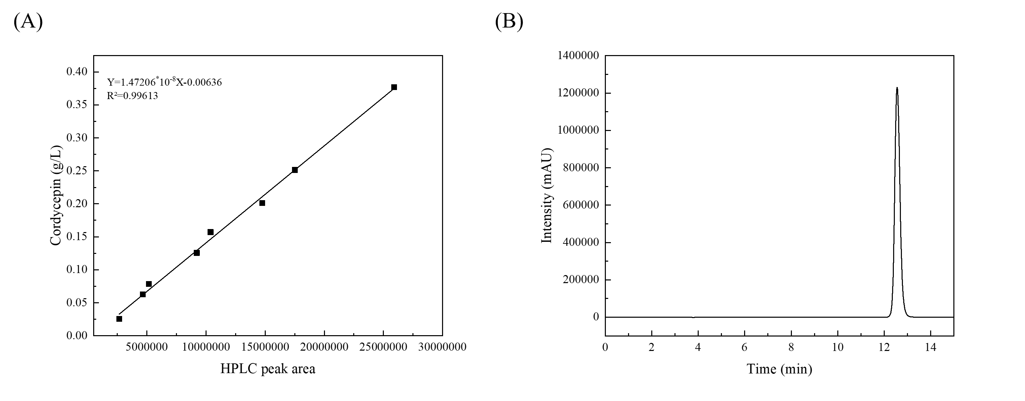
(a) (b)
Figure 2: The standard curve of the peak area versus the cordycepin concentration and the chromatogram in HPLC detection for cordycepin

RESULTS AND DISCUSSIONS

  - Effect of Ethanol Concentration on the Ultrasonic Extraction of Cordycepin
To determine the optimal ethanol concentration in the extraction process, we tested gradients of 0%, 15%, 35%, 50%, 75%, and 95% ethanol. The results are shown in Figure 3. The extraction efficiency of cordycepin varied with ethanol concentration. Specifically, under 0%–50% ethanol, the extraction efficiency increased progressively. However, when the ethanol concentration exceeded 50%–95%, the extraction efficiency declined. The highest yield was achieved at 50% ethanol, with a cordycepin concentration of 0.50 ± 0.01 g/L.
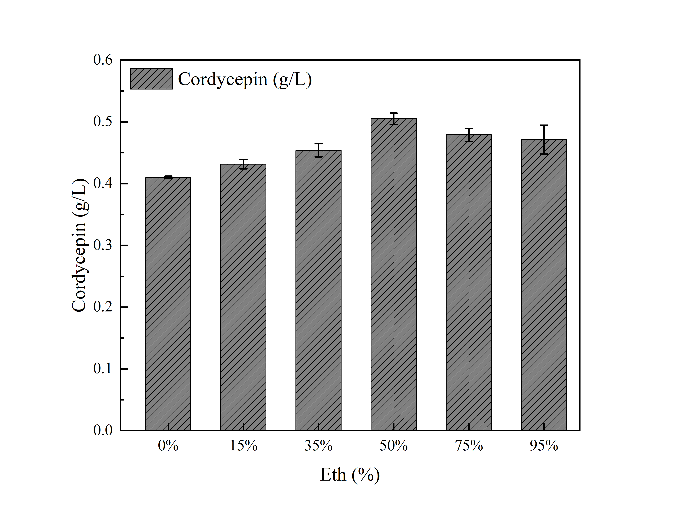
Cordycepin (3'-deoxyadenosine), containing hydroxyl (-OH), amino (-NH₂), and heterocyclic structures, is a polar molecule with high solubility in polar solvents (e.g., water and low-concentration ethanol). The extract consisted of a water-ethanol biphasic mixture, where higher ethanol concentrations reduced the overall polarity. We hypothesize that 50% ethanol exhibits a polarity closer to cordycepin, enhancing its dissolution. Additionally, the ethanol-water mixture effectively penetrates the chitin- and protein-based cell wall of C. militaris, disrupting lipid membranes and facilitating cordycepin release. However, at high ethanol concentrations (>50%), lipids or proteins may denature, encapsulating cordycepin and hindering its diffusion. 50% ethanol optimally disrupts cell walls without causing precipitation. Furthermore, ultrasound-induced cavitation enhances cell breakdown, but high ethanol reduces surface tension, potentially weakening ultrasonic mechanical effects and indirectly lowering extraction efficiency.
In conclusion, ethanol concentration critically influences cordycepin extraction in ultrasound-assisted ethanol extraction. The 50% ethanol condition demonstrated the highest extraction efficiency in this study
Figure 3: Effects of ethanol concentrations on cordycepin concentration
  - Effect of Ultrasonic Extraction Time on Cordycepin Yield
As shown in Figure 4, cordycepin concentration increased rapidly within the first 50 min of ultrasonication, reaching 0.50 ± 0.002 g/L at this time point. Beyond 50 min, the concentration plateaued with no significant further increase.
These findings indicate that ultrasonic duration plays a key role in cordycepin extraction. The mechanism relies on ultrasonic cavitation and mechanical vibration, which rapidly disrupts the chitin- and lipid-based cell walls of C. militaris, releasing intracellular cordycepin. We propose that the surge in concentration within 50 min results from efficient cell wall breakdown and concentration gradient-driven diffusion. After 50 min, most extractable cordycepin has been released, diminishing the mass transfer driving force (concentration gradient). Residual cordycepin may remain trapped in partially disrupted cellular debris or bound to cell wall components (e.g., chitin or lipids), limiting further dissolution.
In summary, 50 min represents the optimal balance between extraction efficiency and time cost, ensuring maximal yield without unnecessary prolongation. This outcome holds significant implications for the scalable production of cordycepin.
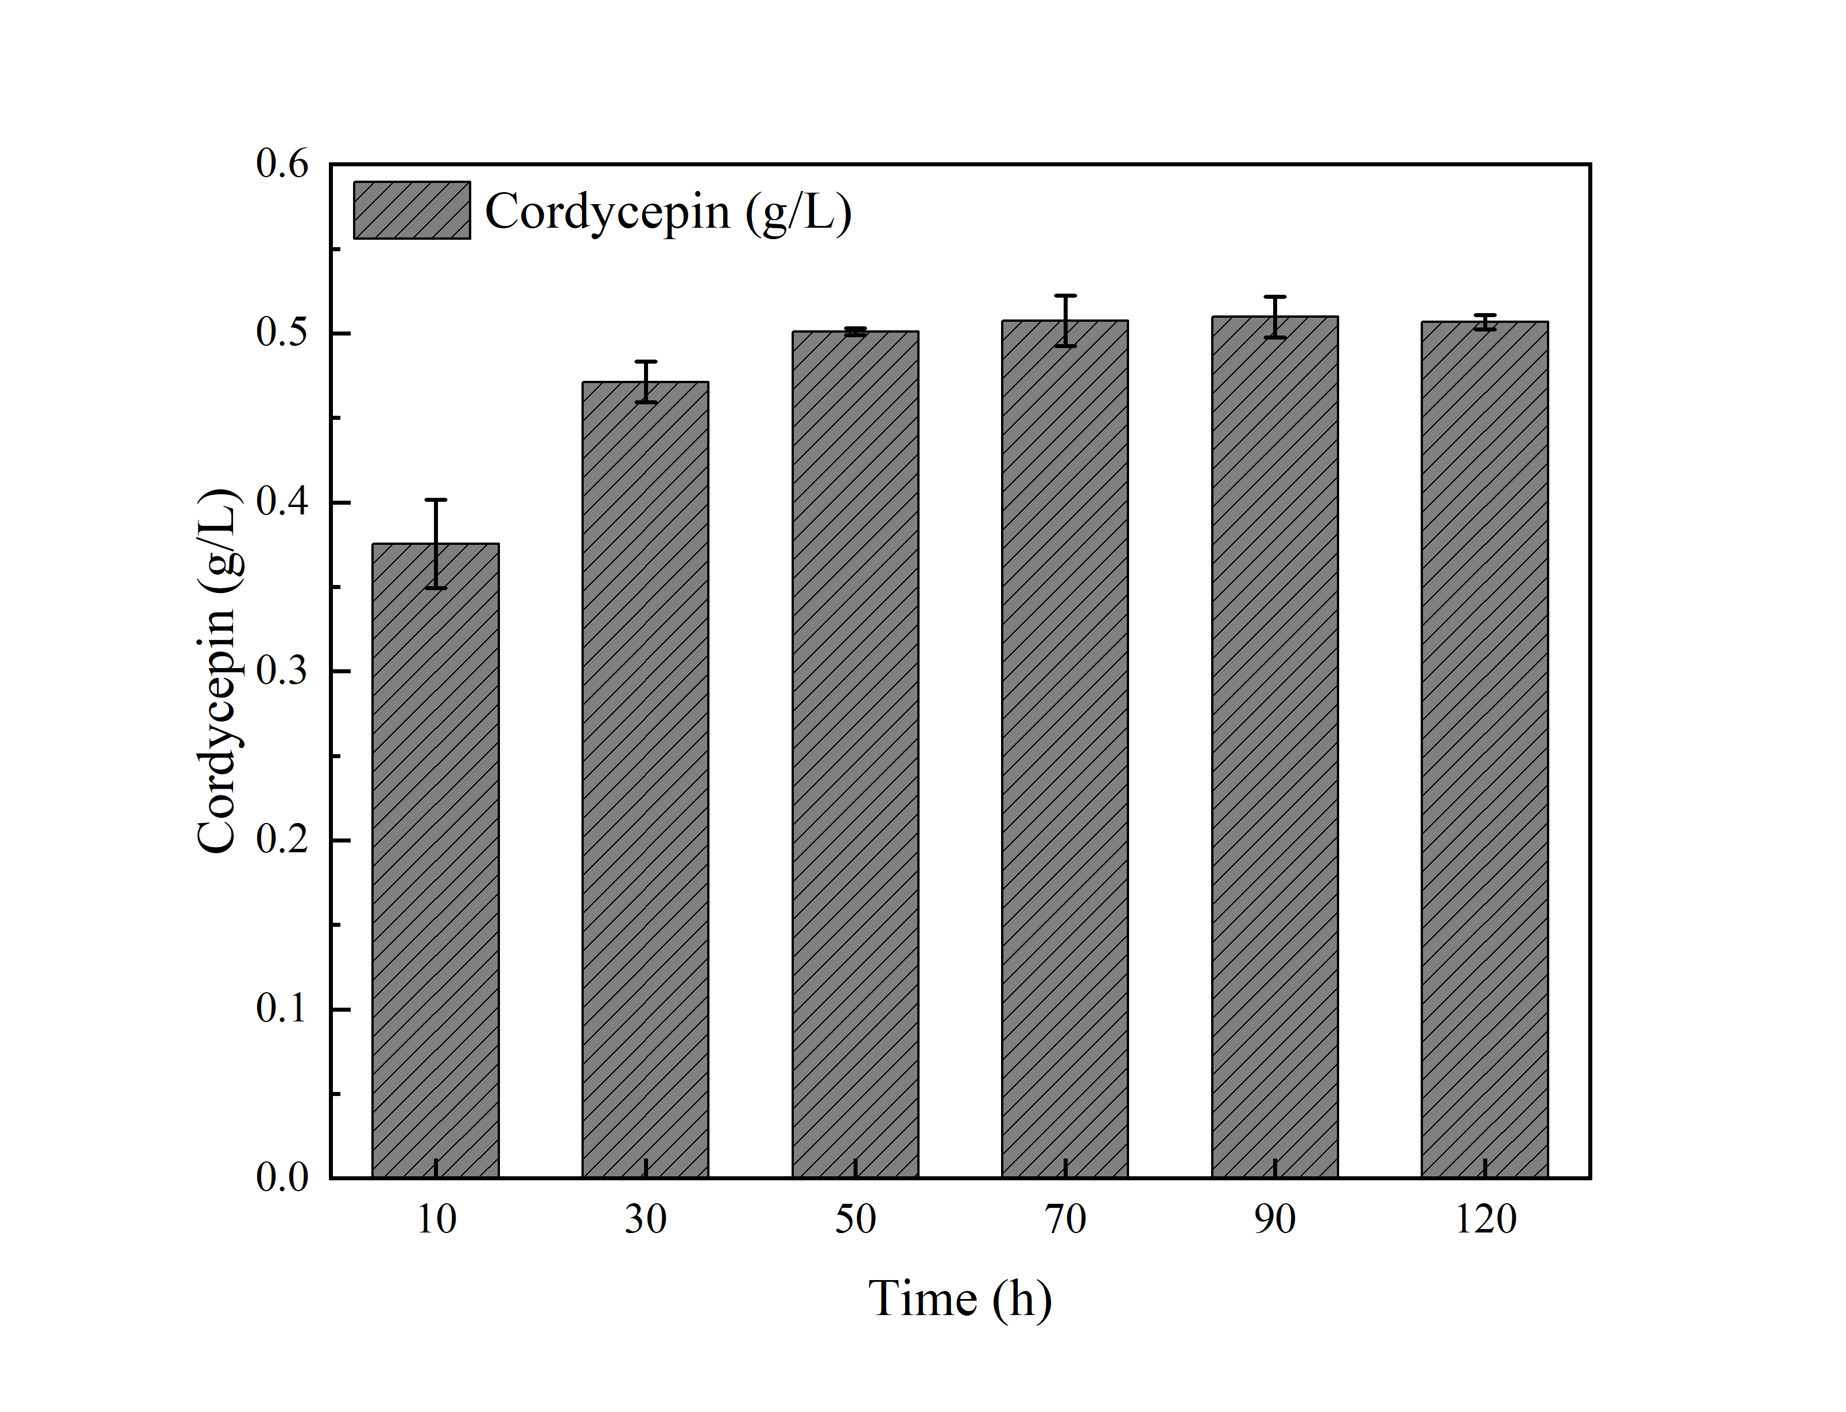
Figure 3: Effects of extraction time on cordycepin concentration
  - Effect of Extraction Cycles on Cordycepin Yield
As shown in Figure 5, the first ultrasonic extraction recovered the majority of cordycepin, yielding a concentration of 0.49 ± 0.002 g/L in the extract. However, with subsequent extractions, the cordycepin concentration dropped sharply-reaching 0.10 ± 0.01 g/L in the second cycle and 0.02 ± 0.0007 g/L in the third.
Cordycepin content in C. militaris powder has an inherent limit (approx. ~1% of dry weight). Assuming a total cordycepin content of 0.02 g (1%) in a 2.0-g sample, the first extraction recovered 0.0196 g (0.49 g/L × 0.04 L), accounting for ~98% of the theoretical maximum. This suggests that a single extraction is sufficient to release nearly all freely soluble cordycepin from the biomass. The residual cordycepin (≤2%) is likely tightly bound within resistant cellular structures or restricted by adsorption effects, making further extraction inefficient under standard ethanol conditions. Therefore, one extraction cycle is optimal for maximizing efficiency while minimizing solvent and energy consumption.
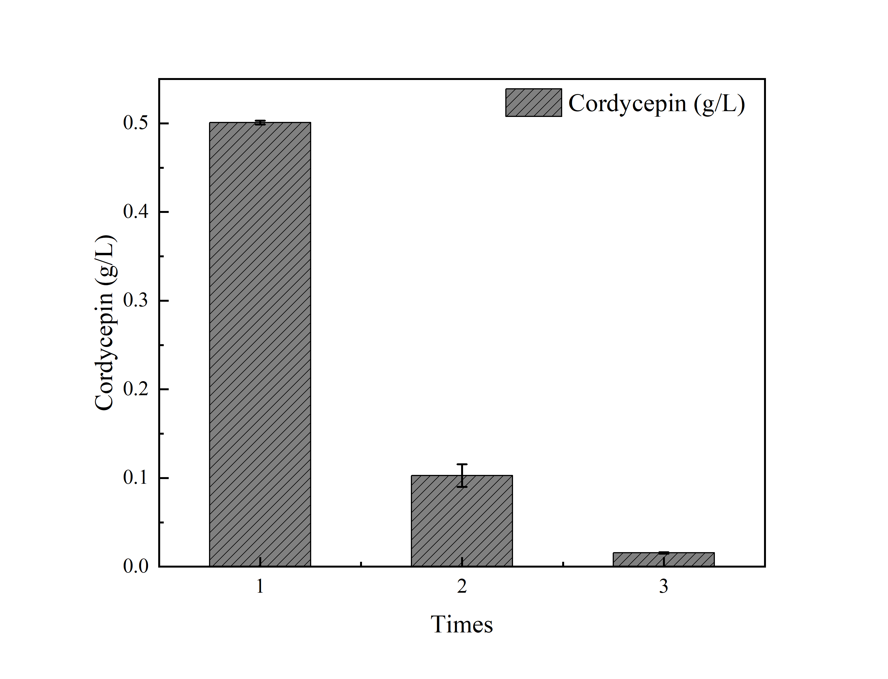
Figure 3: Effects of extraction times on cordycepin concentration

CONCLUSIONS AND RECOMMENDATIONS
As a highly valuable natural compound, cordycepin holds significant potential for diverse applications. In this study, ethanol-assisted ultrasonic extraction was employed to isolate cordycepin from C. militaris. Experimental results demonstrated that cordycepin yield was notably influenced by three critical parameters: ethanol concentration, ultrasonic extraction duration, and extraction cycles. Considering both extraction efficiency and time cost, the optimal extraction protocol was established as follows: 50% ethanol concentration, 50-minute ultrasonic processing, and a single extraction cycle. This optimized method offers distinct advantages of low operational cost and simplified procedures.

REFERENCES
- Cunningham K G, Manson W, Spring F S, (1950)."Cordycepin, a metabolic product isolated from cultures of Cordyceps militaris (Linn.) Link", Nature, 166(4231): 949.
- Tuli H S, Sandhu S S, Sharma A K, (2014)."Pharmacological and therapeutic potential of Cordyceps with special reference to Cordycepin", 3 Biotech, 4(1): 1-12.
- Chen R, Feng C, Chen L, (2024)."Single-cell RNA sequencing indicates cordycepin remodels the tumor immune microenvironment to enhance TIGIT blockade’s anti-tumor effect in colon cancer. International Immunopharmacology, 126: 111268.
- Zhou X, Li Y, Yang C, (2023)."Cordycepin reprogramming lipid metabolism to block metastasis and EMT via ERO1A/mTOR/SREBP1 axis in cholangiocarcinoma", Life Sciences, 327: 121698.
- Zhang S R, Pan M, Gao Y B, (2023)."Efficacy and mechanism study of cordycepin against brain metastases of small cell lung cancer based on zebrafish", Phytomedicine: International Journal of Phytotherapy and Phytopharmacology, 109: 154613.
- Lan T, Yu Y, Zhang J, (2021)."Cordycepin Ameliorates Nonalcoholic Steatohepatitis by Activation of the AMP-Activated Protein Kinase Signaling Pathway", Hepatology (Baltimore, Md.), 74(2): 686-703.
- Wei P, Wang K, Luo C,(2012)."Cordycepin confers long-term neuroprotection via inhibiting neutrophil infiltration and neuroinflammation after traumatic brain injury", Journal of Neuroinflammation, 18(1): 137.
- Liu Z, Wu S, Zhang W, (2024)."Cordycepin mitigates dextran sulfate sodium-induced colitis through improving gut microbiota composition and modulating Th1/Th2 and Th17/Treg balance", Biomedicine & Pharmacotherapy = Biomedecine & Pharmacotherapie, 180: 117394.
- Songprakhon P, Panya A, Choomee K, (2024)."Cordycepin exhibits both antiviral and anti-inflammatory effects against dengue virus infection" ,iScience,27(9): 110711.
- Zhou X, Meyer C U, Schmidtke P, (2002)."Effect of cordycepin on interleukin-10 production of human peripheral blood mononuclear cells", European Journal of Pharmacology, 453(2-3): 309-317.
- ]Shin S, Lee S, Kwon J, (2009)."Cordycepin Suppresses Expression of Diabetes Regulating Genes by Inhibition of Lipopolysaccharide-induced Inflammation in Macrophages", Immune Network, 9(3): 98-105.
- Guo P, Kai Q, Gao J, (2010)."Cordycepin prevents hyperlipidemia in hamsters fed a high-fat diet via activation of AMP-activated protein kinase", Journal of Pharmacological Sciences,113(4): 395-403.
- Schwenzer H, De Zan E, Elshani M, (2021)."The Novel Nucleoside Analogue ProTide NUC-7738 Overcomes Cancer Resistance Mechanisms In Vitro and in a First-In-Human Phase I Clinical Trial", Clinical Cancer Research: An Official Journal of the American Association for Cancer Research, 27(23): 6500-6513.
- Wang L, Yan H, Zeng B, (2022)."Research Progress on Cordycepin Synthesis and Methods for Enhancement of Cordycepin Production in Cordyceps militaris", Bioengineering (Basel, Switzerland), 9(2): 69.
- Li Xiaofeng, Hu Xiyao, Zhang Tao, (2023)."Research on the Synthesis Process of Cordycepin", Chinese Journal of Medicinal Chemistry, 33(9):656-659.
- Seldin D, Urbano S, Mccaffrey R, (1997)."Phase I trial of cordycepin and deoxy coformycin in TdT-positive acute leukemia", Blood,90(1):246.
- Li Ruixue, Wang Taichu, Hu Fei, (2013)."Research on the Extraction process of Cordycepin from Penicillium cicada", Food Science and Technology, 38(2):218-221.
- Ben Songbin, Huang Ziqi, Wang Ying, (2009)."Optimization of selenium-enriched conditions in Cordyceps militaris and the influence of selenium on the main active components Therein", Food Science, 30(17):266-269.
- Hennig, A., Bakirci, H.,Nau, W.M, (2007)."Label-free continuous enzyme assays with macrocycle-fluorescent dyecomplexes", Nat. Methods 4,629–632.
- Norouzy, A., Azizi, Z., Nau, W.M, (2015)."Indicator displacement assays inside live cells", Angew. Chem. Int. Ed.54, 792–795.
- Shaikh, M., Mohanty, J., Singh, P.K., (2008)."Complexation of acridine orange by cucurbit uriland β-cyclodextrin: Photophysical effects and pK a shifts", Photochem. Photobiol. Sci,7, 408–414.

