**ANALYSIS OF ECOLOGICAL HAZARDS UNDER EFFECT OF SEISMIC FORCES IN SKOPJE VALLEY – OHIS JOINT STOCK COMPANY**

**Tomislav Petrovski**[1]

“Ss.Cyril and Methodius “ University, Institut of Earthquake Engineering and Engineering Seizmology, Skopje, Republik of Macedonia Phone: +389-2-3107-708

[tomijp@iziis.ukim.edu.mk](mailto:tomijp@iziis.ukim.edu.mk)

**ABSTRACT**

During the Skopje earthquake of 26th July 1963, the greatest level of damage to engineering structures was recorded in the central Skopje city area. To explain this, the effects of structural geological characteristics of this area upon the devastating effects of the earthquake were analyzed. The effects of the lithological composition and thickness of the Quaternary deposits upon changes of the amplitude-frequency content of the seismic waves and the effects of the local tectonics upon the changes of the characteristics of the Quaternary deposits and changes of the seismic forces acting upon the dynamic stability of structures were analyzed. In 2016, a series of earthquakes with magnitude 3,6, 4,1 to 4,6 according to Richter took place in Skopje, whereat the Chair settlement was the epicentral area with 4.6 magnitude according to Richter.

Due to the increased seismic activity, the Kraishachki fault in the immediate vicinity of OHIS factory facilities was activated. Although OHIS factory is closed, its dumps containing lindane, lead, mercury, hydrogen chloride, arsenic and other toxins were exposed to the earthquake impacts.

Presented in this paper are the decennial polluters of the city of Skopje originating from OHIS factory and its production in the past as well as contamination of the Skopje valley whose alluvial – deluvial part and hydrological specificities cover larger areas that extend even beyond this valley. The unregulated storage of chemical resources and the seismic activity in the Skopje valley led to their emission into soil, water, underground waters and Vardar river.

**Key words:** seismic activity, active faults, pollution fields in Vardar river basin.

1. **INTRODUCTION**

The effect of earthquakes upon engineering structures depends, in a complex way, upon the regional and local seismogeological characteristics of the terrain and the characteristics of engineering structures.

The regional seismogeological characteristics are presented by maximum acceleration amplitudes and the amplitude frequency spectrum of the expected earthquakes.

The local seismogeological characteristics are presented by the geological, geomechanical and geophysical characteristics of the surface layers that affect changes in the regional amplitude-frequency content of the earthquakes. The characteristics of engineering structures are represented by the dynamic properties of the structures (natural periods and mode shapes) on which depends their seismic response to earthquake effects.

These characteristics of the Skopje region have been explored to details within the frames of a number of studies and projects in the field of engineering seismology and earthquake engineering since 1963. The first seismic microzoning was done in 1963-1964 by the Institute for Geological and Geophysical Surveys – Belgrade and the Geological Institute – Skopje /2,3), while the most recent one was elaborated by IZIIS – Skopje in 2011 /5/. During this period, a number of studies and seismic microzoning of individual settlements and important industrial and public buildings in Skopje were elaborated by IZIIS /1, 4, 5, 6/. In this paper, only the results of the investigations performed for the central city area of Skopje and its surrounding with industrial facilities among which OHIS are presented.

1. **REGIONAL SEISMOGEOLOGICAL CHARACTERISTICS**

The seismic activity of the Skopje region is related to the tectonic motions in the Neogene-Quaternary period. Fig. 1 shows the main neotectonic fault structures in the Skopje region (according to M. Arsovski) along which earthquakes are generated. For Skopje, the most important is the Skopje – Kustendil fault (26) with horizontal displacement along which earthquakes with M = 6.0-6.5 are expected particularly in the area of intersection with the longitudinal gravity faults – Lepenachki fault (3) and Brazdinski fault (31).

Earthquakes with M = 4.0 – 5.5 are expected along the remaining gravity faults (27 to 33) that intersect or touch the region. According to data from investigations that have been performed so far, the slope of the Skopje – Kustendil fault is about 70o toward north and northeast, i.e., toward Skopska Crna Gora. Due to such slope of the fault, the hypocenters of the occurred earthquakes (Scupi 518 and Skopje 1963) are north and northwest of the city area where the seismic waves of earthquakes come to the surface in the central city area under a skew angle causing increased horizontal seismic motions that are unfavourable for engineering structures.

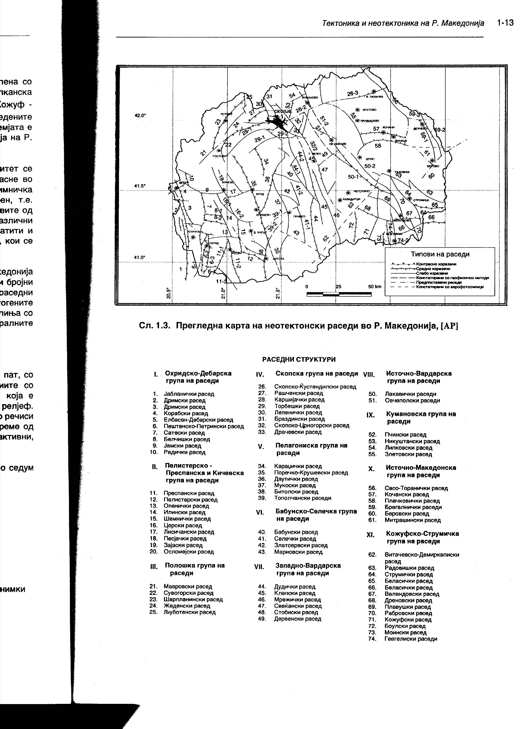

Fig. 1. Neotectonic seismogene faults in the Skopje region

According to these statements and possible unfavourable effects of faults in the urban media upon the seismic stability of structures, the position of this fault in the urban area of Skopje should be defined more precisely. Table 1 shows the expected average maximum accelerations at bedrock (ao) – seismic subsoil of the terrain due to the effect of earthquakes from the local foci, for return periods of seismic effect of 50, 100, 200, 500 and 1000 years used for seismic design of engineering structures in Skopje.

Table 1, Expected average maximum accelerations (ao)

|  |  |  |  |  |  |
| --- | --- | --- | --- | --- | --- |
| Seismic effects | Return periods in years | | | | |
| 50 | 100 | 200 | 500 | 1000 |
| From local foci | 0.12 | 0.19 | 0.25 | 0.27 | 0.36 |

The accelerations at bedrock are given in percentage of ground acceleration (g), with a probability for occurrence of earthquakes of 63%. These represent input parameters in the analyses of the effects of the local geological media upon the change of the amplitude-frequency content of earthquakes and were used for definition of the seismic effect of the Skopje earthquake in 1963.

1. **LOCAL SEISMOGEOLOGICAL CHARACTERISTICS**

The local seismogeological characteristics depend on the geological structure and the physical-mechanical characteristics of the surface Quaternary layers of the terrain and have dominant effect upon the amplitude-frequency modification of earthquake waves and their seismic effect upon structures. According to data from the geological investigations of the terrain of the wider uban area of Skopje performed after the Skopje earthquake of 1963, the terrain of the central city area, on the right side of Vardar river, is composed of:

* Alluvial gravel and sand (Q2t1) with thickness of 15-25 m;
* Pliocene sediments (Pl): dusty and clayey sand and gravel, marlstone, sandstone and conglomerates with a thickness of 30-50 m that extend in continuity or are in tectonic relation with the Miopliocene sediments;
* Miopliocene sediments (MP1): marlstone, marly clays and sandastone, marlstone, claystone and alike that are found in alternating layers, with thickness of about 2000 m/4/.

The spatial distribution of these sediments down to the depth of about 100 m is shown on engineering-geological profiles G18-18’ and G19-19’ (Fig. 3) defined by the geological investigations done in the period 1963-1964. In tectonic sense, with these investigations, 9 neotectonic faults (Fig. 2) were recorded in the closer city area. Fault R1 runs in NE-SW direction and represents, in fact, part of the regional Skopje-Kustendil seismogene fault (26) running through the central city area. The remaining faults R2 to R9 run in NW-SE direction (characteristic for the Vardar seismogene zone), parallel to the Brazdenski seismogene fault (31). Along their length, the seismic energy of the earthquake of 1963 propagated without any greater attenuation. The faults were defined based on geological and geophysical investigations in the period immediately after the earthquake. Tectonic displacements (faults 10 and 11) also in NE-SW direction /1/ were found with the more recent geophysical and reflection surveys.

1. **SEISMIC EFFECTS OF THE SKOPJE EARTHQUAKE**

The maximum seismic intensity of the Skopje earthquake of 26 July 1963 was recorded in the central city area, namely an intensity of Io = IXo according to MKS. Situated in this area is also the zone of the largest damages and failure of engineering structures marked as the zone of the first degree I. The zone is in the form of an ellipsoid and is bounded by the presented faults running in NW-SE and NE-SW direction. In addition to the location of zone I with the greatest damage, Fig. 2 shows the position of the faults, the geological profiles G18-18’ and G-19-19’ (Fig. 3) and the zone of predominant periods of microtremors of the terrain with T = 0.23sec/5/, overlapping the zone of maximum damage I.

1. **RESULTS FROM ANALYSES OF LOCAL EFFECTS**

To explain the occurrence of the heaviest damages in the central city area, the results from the recent investigations of the effect of the local soil characteristics upon earthquake effects on engineering structures were used. These investigations were done at IZIIS-Skopje by use of the SHAKE computer programme /4/. Included in these investigations were the parameters of the local and regional characteristics of the terrain with dominant effects upon the variation of the amplitude-frequency content of the earthquakes and their effect upon structures like:

* Thickness (H) and lithological content of the Quaternary deposit;
* Values of seismic Vp and Vs velocities and bulk densities ( ) of the materials in the deposits and the geological rocks at their base (Pliocene and Miopliocene sediments);
* Values of material attenuation of seismic energy (λ) in the Quaternary deposit;
* Evaluated time histories of occurred earthquakes for excitation of the Quaternary deposit;
* Expected levels of excitation according to the design criteria for engineering structures.

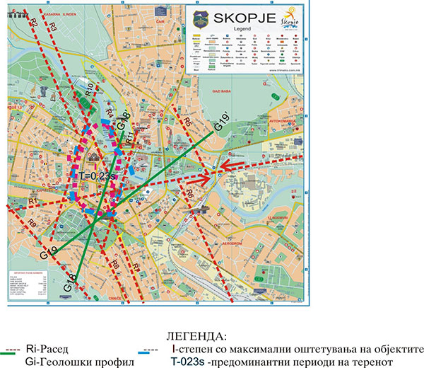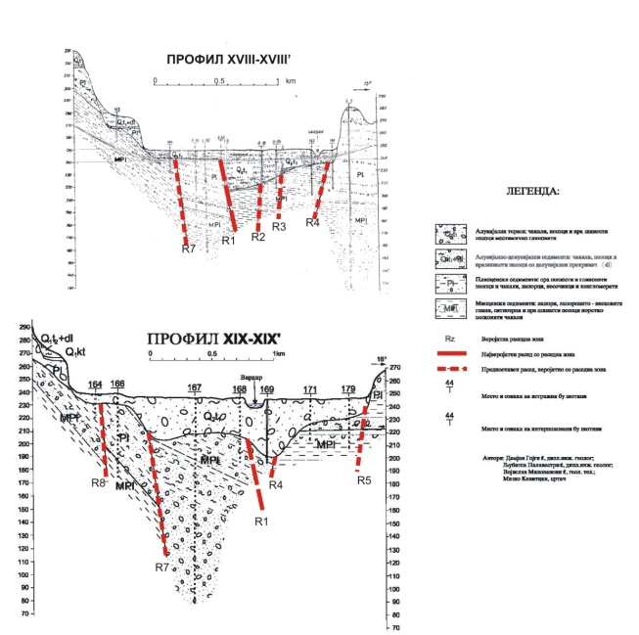

Fig. 2. Seismogeological characteristics Fig. 3. Geological profiles that intersect of the central Skopje area and OHIS the Skopje area with the height of the alluvium, diluvium.

To get an insight into the effect of the surface Quaternary sediments, 12 representative models of the alluvial deposit with thickness of 5 to 250 m present in the wider city area from Gjorche Petrov to Gorno Lisiche /4/ were analyzed. To define the models, data from the performed geological drilling of boreholes, geophysical measurements of Vp and Vs velocities, measurements of predominant periods of the terrain T(s) and seismic reflection investigations for definition of the boundaries between the Quaternary and Neogene sediments and recording of tectonic dislocations, were used.

Based on data from these investigations and for the purpose of evaluating the resonance characteristics of the Quaternary deposit, the following correlation relationships among thickness H(m) of the water saturated alluvial sands and gravels, values of seismic velocities Vs (m/s) and predominant periods T(s) of the terrain due to vibration of alluvial deposits /4/ were established.

-For the elastic range: T≈0.022H0.75, H≈161T1.333,Vs≈182H0.25,Vs≈644T0.333

-For the accelerations (ao) of expected earthquakes: T(ao)/T=Vs/Vs(ao)=kao0.25

where k represents a coefficient that depends on the lithological content and the nonlinear properties of materials in earthquake conditions. Depending on the lithological composition, it is defined by the following correlation expressions: for clay, it is k≈3.3+log0.25, while for sand, it is k≈2.8 log 0.25. The mean value of the coefficient is k≈2.42. Damping of materials depends on the excitation level and is defined in the process of analyses. The time histories and the acceleration levels (ao) of the selected earthquakes were defined based on the existing rulebooks on construction of engineering structures in seismically active areas, depending on the category and the serviceability life of the structures as well as the return period of earthquakes (Table 1). From the presented correlation relationships, it is seen that the values of the predominant periods of Quaternary deposits depend on the thickness of the deposits and the level of earthquake excitation and may cause different seismic effects of different earthquakes in different parts of the city. So for example, in parts of the city with Hal=10-30 m, the most critical are the local ones, in parts with Hal=30-100 m, the most critical are those at medium distance, while in the deepest deposits with Hal>100 m, the most critical are the distant earthquakes. The seismic effect of earthquakes upon structures mostly depends on the amplitude-frequency content of the earthquakes, the predominant period of the excited deposit in earthquake conditions and the periods of vibration of the structures. To get an insight into the thickness of the Quaternary deposit, Fig. 4 shows the values of the dynamic amplification factor (DAF) of the local soil materials depending on thickness (H) and the level of earthquake excitation for return periods of 50 years (ao=0.12g), 200 years (ao=0,185g) and 500-1000 years (ao=0,33g). Selected as critical earthquake for the analyses was the time history of acceleration of the Montenegro earthquake of 1979 recorded on location with similar geological conditions in Ulcinj, Olimpik hotel, with maximum amplitudes in the domain of periods of 0.25-0.45s. (Fig. 4) shows that the maximum increase due to local effects during the Skopje earthquake occurred in terrains with thickness of alluvial deposits of 15 to 25 m that, in earthquake conditions (ao=0,185-0.33g), are characterized by predominant periods of vibration of Ta0=0.25-0.45 sec.

|  |  |
| --- | --- |
| 3 |  |
| Fig.4.Effect of thickness of the alluvial deposit upon dynamic amplification of the effect of Skopje earthquake of 1963 | Fig. 5. Average amplitude frequency spectrum of the earthquake used in analyses of dynamic amplification. |

The Skopje earthquake of 1963 was not recorded and its amplitude-frequency spectrum is unknown. Fig. 5 shows the computed average spectrum that can be similar to that of the Skopje earthquake. Due to the small thickness of the Quaternary deposit in the central area, the presence of faults could have caused additional unfavourable effects: increased seismic energy release at the fault zones,

uneven settlements, different seismic acceleration forces at the foundations of engineering structures, weakening of the strength parameters of materials and causing of dynamic instability of the terrain contributing to maximum damage and failure of engineering structures. In the case of deep deposits, these effects are negligible since the soil materials are more compact and the seismic energy attenuation is greater.

This paper further shows the decennial polluters of the city of Skopje due to OHIS and its production in the past as well as contamination of the Skopje valley whose alluvial-deluvial part and hydrological specificities are spread over its large areas and beyond.

The unregulated storage of chemical substances and the seismic activity in the Skopje valley have led to their emission into soil, water, underground waters as well as Vardar river.

**5. OHIS – ORGANIC CHEMICAL INDUSTRY IN SKOPJE AND METHODOLOGY OF DISPOSAL OF WASTE**

Organic Chemical Industry from Skopje (OHIS joint stock company) was established in 1964. Ohis produced different types of chemical products including plastics, detergents, polyacrylic fibres, protective substances for plants, cosmetic products, basic chemicals (for example chlorine, hydrogen chloride acid), pharmaceutical products and processing equipment. About 10.000 chlorine chemicals (technical isomer mixture HCH) were stored at the very place, in several concrete pools, in a period of 20 years. Detailed inspection or monitoring of the place has not been done yet.

* 1. **Methodology of waste disposal**

The management assumrs that the waste has been stored in steel barrels covered with earth. One of the pools tested by the team is about 100 metres long, 50 metres wide and several metres high. It was built for collection of drained water, but it does not have a drainage system or any cover. If the barrels were used for storage, they are most probably corroded. The surrounding smells of chlorine compounds.

* 1. **Repercussions for the surrounding environment**

In the middle of the OHIS facilities and around them, there are reservoirs of toxic residuals. These compounds probably contain stable bioaccumulative substances. In addition, the waste probably pollutes the earth that is used for covering of the barrels and the contents probably flow into the underground waters under and around the pool. Therefore, they represent a serious threat and may extensively pollute the underground waters.

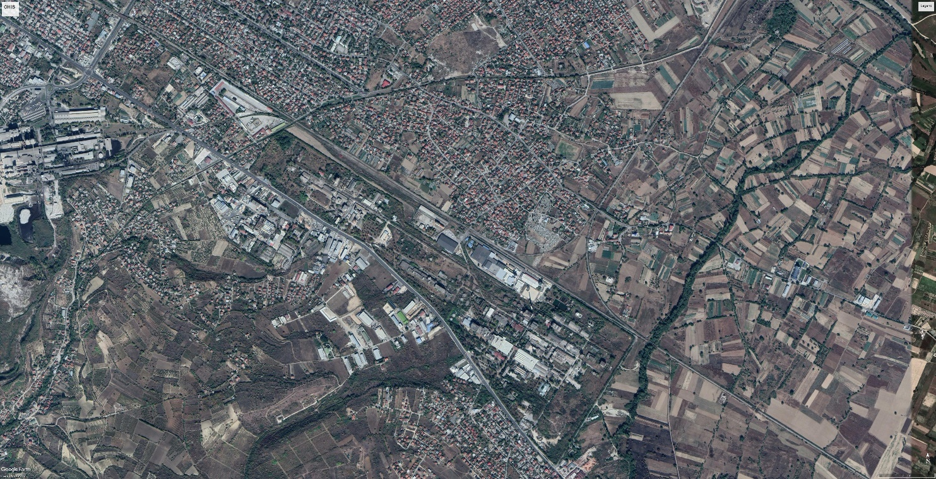

Fig. 5. OHIS location, dumps and storages of toxic material

The compound that covers a million of square metres is situated over an area that was formerly flooded by Vardar river so that there is probably a hydrological contact between the shalllow underground waters and the river, (Figure 6). If so, the contaminated underground water from the OHIS A.D. compound pollutes Vardar river.

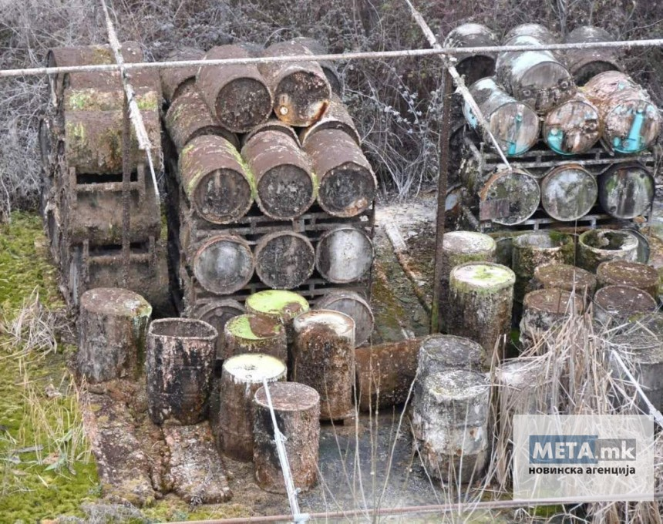

Figure 6. Steel barn with toxic waste in decomposition phase

The geological profile of OHIS location clearly shows the easy propagation of chemicals into the alluvial-deluvial layer supported by the hydrological conditions of the Skopje valley, the underground waters that flow into the Vardar river as well as the extensive segregation due to the seismic activity of the seismogene Kraishachki fault, (Fig. 2).

1. **ECOLOGICAL ASPECTS RELATED TO EFFECTS FROM INAPPROPRIATELY DEPOSITED CHEMICALS IN** **OHIS**
   1. **Pollution of river and underground waters in skopje valley**

In absence of corresponding facilities for treatment of industrial and hazardous waste in Macedonia, OHIS was forced to store the waste on its own location. The storages are old and in bad conditions as a result of their inappropriate construction and lack of maintenance. The management was not in condition to state precizely the types and quantities of such waste, but the total scope was over 160.000 m3 per annum. Undoubtedly, considerable pollution of envronment is caused by inappropriate collection, processing and unsafe storage of this waste. Waste waters partially pass through concrete channels that are cracked so that the waste flows into the soil and the underground waters.

* 1. **Ecological aspects of stored residual waste related to environment**

In the HCH plant, technical hexa-chlorine-cyclo-hexane with gamma isomer of 12-14% was produced with photosynthesis of chlorine and benzyl. This technical HCH further represented a material for obtaining a pure gamma isomer 99.9%, i.e., lindane, while the non-active isomers such as alpha, beta and delta which were extracted in the Lindane Plant represented a material for obtaining three-chlorine benzyl and hydrochloric acid in the TCB Plant.

The process of extraction of the gamma isomer from HCH was performed with methanol as a solvent and had a circle flow in the process, but didn’t take part in the process itself, (Figure 9). The process of obtaining three-chlorine benzyl and hydrochloric acid from non-active isomers was performed with thermal dissolution in the presence of active coal as a catalyst.



Fig. 9. Presentation of a series of diseases caused by lindane

The lindane complex was gradually put into function starting from 1964, but was functional until 1977 when it twas abandoned and stopped for ecological reasons and change of the market conditions. The license issuer was the German firm C.H.BOEHRINGER SOHN from INGECHEIM A.G.I. The newest part of the factory is connected to a station for purification of waste waters prior to their release into Vardar river.

At present, the purification station is not functioning. The other parts of the factory as is the recently closed electrolisis plant were not at all connected to the purification station. This factory used to uilize two tons of mercury per annum by which it used to produce waste full of mercury that was released into Vardar river. The management made clear that there were still eight tons of mercury in the factory storehouse. The samples of underground waters taken by UNEP, (Figure 10), do not show a high level of pollution. Several phthalates to the level of 0,5 mg/l were detected in the specimens. The analysis for mercury done for a single specimen showed a concentration of 65 mg/l which is ten times the allowed limit for potable water, but below the allowed limit for natural waters. The concentration of lead (500 mg/kg) in one soil specimen was over the allowed limit for normal soil in many countries, but not above the limit applied for soil around industrial places. (Table 2.)

In the analyses done in 2010, 40% of soil specimens taken at distance of 30 km from OHIS contained asenic, out of which 20 contained up to 100 ppm, which exceeds the maximum allowable level of about 20 ppm.

Eight specimens showed extremely high quantities of arsenic from 100 to 200 ppm in the vicinity of the facilities and the immediate asurrounding, OHIS compound also caused air pollution by mainly operating with fuel oil.

Table 2. Soil, water specimens

|  |  |  |  |  |
| --- | --- | --- | --- | --- |
| Location | Environment | Polluting quantity | Effect and Risk | Time duration and dimensions |
| Lindane | Polluted soil | Lindane and HCH isomers | Effect : | Long term |
| Dump- 1 : Concrete pool (50 x 100 x 5 m) | Polluted water | 35.000-40.000 t  3.000 t | -Upon surface waters of Vardar river and potable water | Local |
| Covered with soil 5  Dump-2  Individual dumps | Air | 20.000m3  Lindane and HCH isomers and other chlorine organic compounds - unknown | Local pollution of air with bad odour.  Danger HIGH  Risk – LOW |  |

The data obtained from the management show that the factory annually emits around 2.240 tons of sulfuric dioxide, 315 tons of nitric oxides and 15 tons of dust.

The concentration of sulfuric dioxide in exhaust gases amounts to 2.220 mg/m3, while the standard limit is 1.700 mg/m3. The factory for acrylic fibres which is a constituent part of the compound causes concerns with its emissions.

In OHIS, there are a lot of poisonous substances like mercury (Table 3), monochloroacetic acid, pesticides, herbicides, fungicides, polyacrylates, esters, PVC in dust and many other substances. There is a whole list of chemicals at OHIS for which former employees do not know whether these were properly stored. The photos taken in the factory courtyard show that some of these substances have probably been not kept appropriately, while some of them are scattered over the floor of the abandoned buildings of this big chemical factory, (Figure 6).

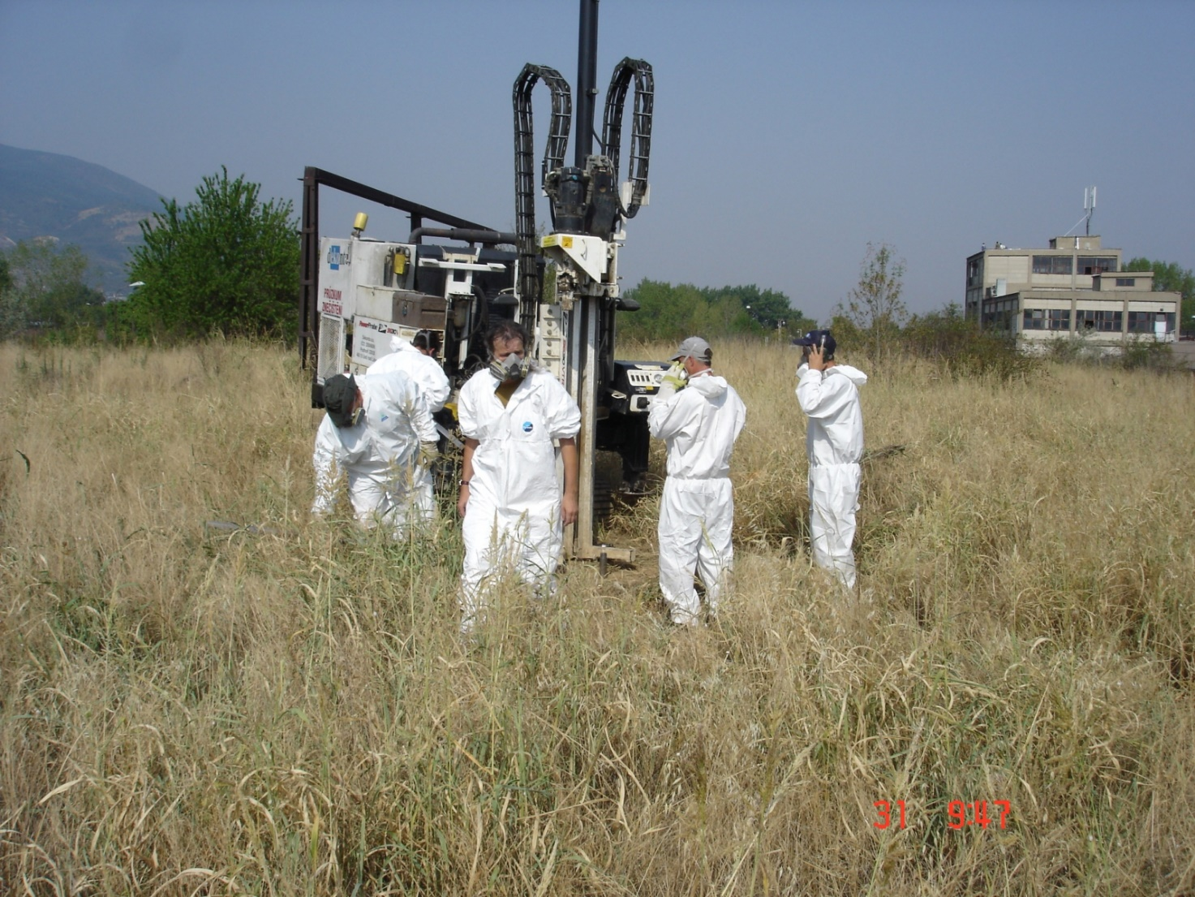

Fig. 10. A team is testing polluters in underground waters, soil and air in the terrain immediately close to the petrochemical factory OHIS.

In addition to the well known washing powder «Biljana» and other detergents, in the department for base chemicals, hexachlorocyclohexane (HCH) that has five isomers was also produced in the seventies of the last century. The gamma isomer of this organic compound is, in fact, the lindane that was then competitive for production because it was largely used as an insecticide. In 2009, as a pesticide, it was included in the Stockholm Convention that was signed by Macedonia in 2005 and was banned from use in more than 50 countries. Lindane has been classified in group 1 cancerogenic substances with sufficient evidence that it causes non-Hodkin’s lymphoma. Long term exposure to lindane by inhaling is connected with diseases related to liver, blood as well as disturbances of nervous, cardiovascular, immunological and reproductive system in people.

Table 3. OHIS, poisonous substances

|  |  |  |  |  |
| --- | --- | --- | --- | --- |
| Origin | Polluter | Danger | Risk | Rank |
| OHIS | Mercury | High (first 10) | Low – Moderate | 2 |
| OHIS | HCH isomers | High (first 8) | Moderate – High | 2 |

Corroded barrels for keeping chemicals are also seen in the courtyard. These have dilapidated in the course of time so that the chemicals flow all over the place or have penetrated the soil. The factory also has stored mercury which is neuro-toxic in the part which was formerly the electrolysis plant. Mercury will also be subject to future cleaning and it would be good if the technology selected for cleaning the lindane is used. There haven’t been any exact investigations of the quantity of mercury present, but there are photos showing puddles of mercury, meaning that it evaporates in the open.

1. **CONCLUSION, ECOLOGICAL PRIORITIES, BENEFITS OF ELABORATION OF A METHODOLOGY FOR REMEDIATION OF THE POLLUTED ENVIRONMENT.**

* The regional seismogeological characteristics of the terrain have conditioned strong horizontal seismic forces of seismic waves with unfavourable effect upon engineering structures. The regional faults passing through the city area have additionally increased the unfavourable effect of earthquakes.
* Local seismogeological characteristics have conditioned the occurrence of a resonance between the periods of the Quaternary deposit, the periods of the earthquake waves and the periods of 3 and 4 storey structures. Therefore, the Skopje earthquake showed maximum devastating effects in the terrains composed of alluvial deposits with thickness of 15-25 m as is the case with the central city area, the Zlokukani area, etc.
* For more successful protection of engineering structures in the central city area, it is necessary to avoid resonance conditions and building structures upon fault dislocations. If these are nevertheless built, it is necessary to take corresponding measures of protection.
* Among experts in the field of environment, it is not a new fact that such a horror is hidden, burried and forgotten in the chemical factory OHIS in Skopje. There are large quantities of poison left by the authorities to spread and reach all elements of the environment, namely, water, soil and air, causing permanent consequences related to the health of the citizens in the capital city.
* Despite the fact that OHIS location is found in the detailed urban plan of Kisela Voda municipality and Skopje city, without remediation of the location, structures for light industry and trade cannot be built.
* In the new Detailed Urban Plan, construction of kindergartens, schools and particularly structures of residential character in Kisela Voda settlement is forbidden despite the regulations for remediation of soil and waters.

**Notes on the author:** TOMISLAV PETROVSKI Assistant , MSi. at the Department of Special Engineering Structures, Institute of EarthquakeEngineering and Engineering Seismology (IZIIS), “Ss. Cyril and Methodius” University, P.O. Box 101, 1000 Skopje,Republic of Macedonia, Tel: +389-76 491 411, E-mail: [tomijp@pluto.iziis.ukim.edu.mk](mailto:tomijp@pluto.iziis.ukim.edu.mk)

* **2001, Assistant. M.Sc.** Department of Natural and Technological Hazards, Institute of EarthquakeEngineering and Engineering Seismology (IZIIS), “Ss. Cyril and Methodius” University, Skopje, Republic of Macedonia.
* **1997, Researcher, grad. civil eng.,** Faculty of Civil Engineering, “Ss. Cyril and Methodius" University, Graduated Civil Engineer, Skopje, Republic of Macedonia.

**Specialization** (specify), Bergamo ISMES and ENEL, Italy, 1988.

(specify), Kinematics, Los Angeles California 1991-1993.

**Main field:** Protection of human environment; analysis of ecological hazards including industrial risks; air pollution due to emission of harmful matter. Water pollution and management, Solid waste management, Investigation of methods for definition of seismic hazard and risk, Seismic Risk and Disaster Prevention, Strong Motion digital telemetric network, Special Structures.

1. **REFERENCES**
2. Aleksovski, D., Gjorgjeska, I., *Pedestrian Bridge « OKO » over Vardar river, Geophysical Surveys, (in Macedonian),* IZIIS 2010-1, Skopje.
3. Arsovski, M., Grujic N., Gojgic, D., *Seismogeological and Engineering Geological Investigation of Skopje Valley and Skopje City Area (in Serbian)*, Skopje – Belgrade, 1964.
4. Mirakovski, G., Stamatovska, S., Micajkov, S., Mircevska, V. et al., *Geological and Seismological Basis for General Urban Plan of Skopje City and the Wider City Urban Area, (in Macedonian)*, IZIIS 2011-31, Skopje.
5. Haygart, P.T. et al., *Atmospheric Deposition of Metals on Agricultural Surfaces.* CRC Press Inc., Florida, 1992.
6. Le Maitre, R.W., *Numerical Petrology: Statistical Interpretation of Geological Data,* Els. Sci. Publ Company, Amsterdam, 1982.
7. Andjelov, M., *Rezultati radiometricnih in geokem. Meritev za karto naravne radioakt,* Slovenia.
8. Bowen, H.J. *Environmental Chemistry of Elements. Acad*. Press, London, 1979.
9. <http://www.moepp.gov.mk/wp-content/uploads/2014/11/Volume%20I> OHIS feasibility final 22 08 07.pdf.

1. Msi Tomislav Petrovski Assistant