**Post-Event Evaluation and Assessment of Flash Flood Dam Efficiency**

Author (14)

: Sally Esmail 1*, Hossam Eldin Ali2, Eehab Khalil11, Sayed M. Ahmed2, AbdelWahab Mohamed3

*1 Construction Research Institute, National Water Research center, Egypt.*

*2 Faculty of Engineering, Ain Shams University, Egypt.*

*3 National research Center, Egypt.*

*ABSTRACT: Flash flood dams are critical for mitigating downstream hazards, but their effectiveness depends heavily on robust design and construction. This study presents a post-event assessment of the Matrouh Dam in Egypt, a 6-meter-high embankment structure that failed to retain impounded water, releasing ~80% of its 200,000 m³ storage within 72 hours after its first flood event. Through integrated field investigations (including borehole sampling, land surveys, and visual inspections), laboratory permeability testing (ASTM D5084), and 2D finite element modeling (DIANA software), we identify the causes of premature water release. Three numerical scenarios were evaluated: (1) baseline design conditions, (2) an inefficient upstream riprap layer (simulating construction defects), and (3) a compromised core with doubled permeability. Results demonstrate that construction flaws—particularly mortar failure in the upstream riprap layer and elevated permeability in core materials—enabled rapid seepage through the dam body and foundation. Scenario 2 closely mirrored the dam’s actual failure mode, underscoring the upstream layer’s critical role in hydraulic head reduction and stability. The study highlights the necessity of stringent construction quality control for zoned embankment dams and provides a methodology for post-flood forensic analysis to inform future remediation and design practices in arid regions..*

***KEY WARDS:*** *Flash flood dam, Post-event assessment, Seepage analysis, Numerical modeling*

---------------------------------------------------------------------------------------------------------------------------------------

Date of Submission: xx-xx-xxxx Date of acceptance: xx-xx-xxxx

---------------------------------------------------------------------------------------------------------------------------------------

# INTRODUCTION (10 Bold)

Flash floods are high-energy hydrological events characterized by rapid onset and short duration, often resulting from intense rainfall over a small catchment area, steep topography, or the sudden failure of hydraulic structures such as dams. Flash floods represent one of the most dangerous forms of flooding due to their sudden occurrence, high velocities, and destructive force. The United States Geological Survey (USGS) defines a flash flood as a flood that develops within six hours of the causative event, typically intense rainfall or a dam breach. [1]. Their unpredictability and the limited time available for early warning make flash floods a significant threat to both human life and infrastructure, especially in arid and semi-arid regions where such events can occur with minimal historical precedent. [2].

Despite their episodic nature, flash floods have far-reaching socio-economic and environmental consequences. [3]. The direct impacts include the destruction of infrastructure such as roads, bridges, and buildings, as well as the displacement of communities and the loss of human lives. Indirect effects often persist long after the event, including economic disruption, increased vulnerability to future floods, and long-term ecological degradation. Flash flood control dams can buffer downstream communities from extreme hydrological events, recharge groundwater reservoirs, and regulate sediment loads. However, the effectiveness of these structures is contingent upon robust design, reliable monitoring systems, and timely post-event assessments.

Inadequate monitoring of flash flood events and the hydraulic structures designed to manage them introduces serious risks, particularly in regions prone to compound or cascading failures[4]. When dams are not closely monitored, especially during or after extreme rainfall, the likelihood of structural failure increases due to undetected seepage, overtopping, or internal erosion. The consequences of such failures can be catastrophic. For example, during the 2022 monsoon season in Pakistan, a combination of unprecedented rainfall and insufficient monitoring of embankments and reservoirs contributed to widespread flooding that affected over 33 million people, destroyed more than 2 million homes, and caused billions of dollars in damage [5] This disaster illustrates the dire consequences of underestimating the complex interplay between flash floods and aging or poorly maintained flood infrastructure. Additionally, failures can propagate beyond the initial impact site, leading to cascading events such as the breaching of downstream dams, increased sedimentation, and further loss of hydraulic control.

Traditional dam monitoring techniques include the use of piezometers, settlement gauges, and visual inspections. While these methods provide valuable localized information, they often fall short in terms of spatial coverage and real-time capability, critical limitations during rapidly evolving flash flood events.[6]. The performance of flash flood dams must be evaluated not only in terms of their storage capacity or structural stability but also based on their ability to retain water over a necessary duration to prevent downstream hazards. One of the key factors influencing this retention capability is the permeability of the dam’s structural layers, including the core, shell, and foundation. Permeability defects, whether due to material selection, construction flaws, or long-term degradation, can lead to rapid seepage and uncontrolled release of impounded water [7], [8].

The failure of the Teton Dam (USA) in 1976 serves as a seminal case study in embankment dam engineering. The collapse was attributed to internal erosion resulting from unfiltered seepage through a jointed volcanic foundation and poorly compacted embankment soils (Morris et al., 2008). This incident highlighted the critical role of permeability control and drainage design in dam safety.

Numerical modeling and laboratory experiments have been widely employed to investigate the behavior of embankment dams under seepage and hydraulic loading. The Finite Element Method allows for detailed simulation of saturated and unsaturated flow within embankment materials. These models incorporate complex soil-water interactions, permeability anisotropy, and transient boundary conditions, offering valuable insight into potential failure mechanisms.

Moreover, a key gap in the existing literature is the limited emphasis on post-event assessment. Most studies focus on predictive analysis or pre-construction design optimization, with relatively few investigations dedicated to evaluating dam performance after a flash flood has occurred. This represents a critical shortfall, as real-world flood events offer unique opportunities to validate models, identify design shortcomings, and inform future rehabilitation efforts. Addressing this gap is crucial for enhancing dam safety in regions experiencing heightened hydrological variability resulting from climate change.

This study investigates a case where a flash flood dam released the majority of its stored water within three days following a flood event. Such behaviour raises critical concerns regarding the dam’s internal structure, particularly its ability to withstand the hydrostatic pressures generated by sudden water impoundment. Through site investigation data and numerical modeling, this paper aims to assess the root causes of the premature release and evaluate the efficiency of the dam’s design and material composition.

# Matrouh Dam (Wadi Abo Skook)

In 2023, a six-meter-high dam was constructed in Matrouh, Egypt. The dam's reservoir has a storage capacity of approximately 200,000 m³. The dam is located in a wide valley with a 500 m wide area surrounded by mountains 20 m higher. The slope of the mountains is steep, around 1:6.5 for the left bank and 1:15 for the right bank, as shown in Figure 1.

By August 2023, following the first impoundment, the reservoir had reached its total capacity and successfully protected the downstream village from potential flooding. However, the dam released the stored water, and daily measurements of the upstream water levels were recorded to monitor the reservoir's performance.

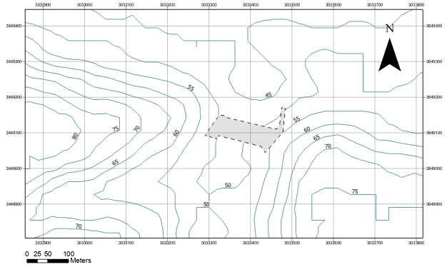  
(a) Contour Map

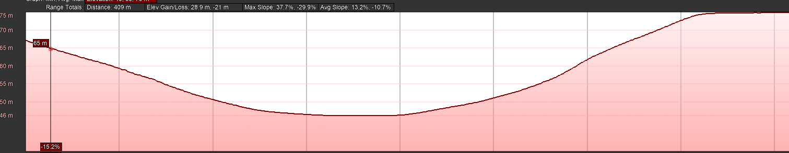  
(b) Cross Section

Figure 1: Dam location, Contour, and section

After the first significant flood event, the dam exhibited higher-than-expected seepage levels. Over two days, approximately three meters of the stored water leaked out. Within a week, the entire reservoir had emptied due to excessive seepage through the dam body and underneath its foundation. These issues with seepage and leakage compromised the dam’s ability to retain water, raising concerns about the dam's structural integrity and long-term performance. Figure 2 illustrates the seepage issues and their impact on the water levels within the dam's reservoir.

## Methodology

A comprehensive multi-method approach was adopted to assess the post-event performance of a flash flood embankment dam that exhibited abnormal permeability behavior, evidenced by the complete release of stored upstream water within three days. This methodology integrates site investigation, material characterization, and numerical modeling to evaluate dam integrity and simulate rehabilitation scenarios under extreme hydrological conditions.

The rapid depletion of the reservoir not only highlights potential flaws in the dam's design or construction but also underscores the need for urgent remediation measures to prevent further structural deterioration and ensure that the dam can effectively perform its intended flood control function. This incident is a critical learning point for future dam projects in regions with similar geological and hydrological conditions.

Additionally, after the storm and the reservoir were empty, a land survey was implemented to check for deformations at 16 points distributed, Figure 3. The survey was periodically executed twice a month for three months during field tests to check the dam safety. Parallel to the land survey, SAR interferometry was studied as discussed in the previous sections and compared with the land survey results.

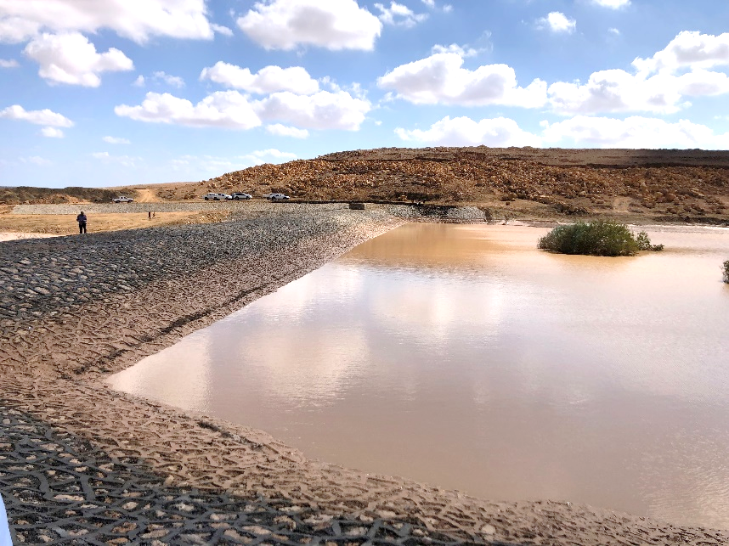

Figure 2: Post-Storm Condition of Matrouh Dam.

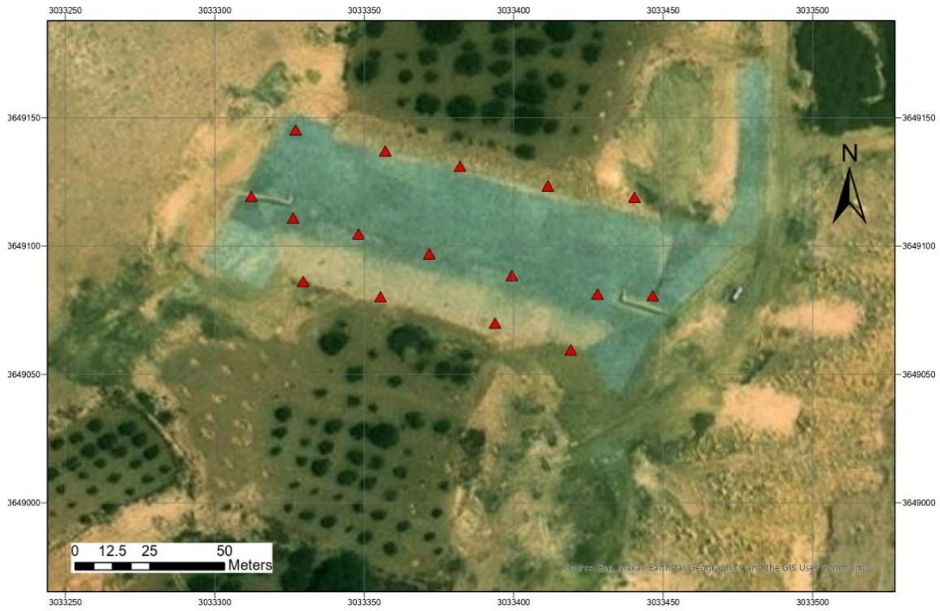

Figure 3: Matrouh Dam land survey points

The visual inspection showed some defects in the upstream face, such as a water vortex at the upstream apron and some failure in the mortar between ripraps, which is supposed to be the reason for the water flow inside the dam. Active seepage locations on the upstream slope were documented and monitored. So, Accurate data collection is fundamental to maintaining the validity and reliability of the analysis. A soil investigation was implemented at the dam, and two boreholes were drilled within the dam body, which extended 5 m underneath the dam. In addition, open excavations were conducted within the dam to check the condition of the inner layer and the rock material. In addition, there were no differential settlements, and any visible cracks were recorded, however, there were different locations of mortar loss between the ripraps. The layer of mortar underneath the riprap of the dam was not constructed well.

## Material Investigation

To evaluate the in-situ conditions of the dam’s structural materials, a set of laboratory tests was performed on soil samples collected from various dam zones (boreholes and foundation). These included:

* Permeability Testing: Falling-head permeability tests were conducted by ASTM D5084 to quantify the hydraulic conductivity of compacted samples. .
* Grain Size Distribution: Sieve and hydrometer analyses were carried out to classify soils and assess their suitability as filter or barrier materials. Uniformity coefficients and fines content were calculated to evaluate piping susceptibility.

The combination of these tests allowed for a detailed understanding of material performance and provided key input parameters for numerical modeling. Material properties were defined for the analysis using the General Mohr-Coulomb model, a widely accepted first approximation of soil behavior, as summarized in Table 1. The model incorporates key parameters, including Young’s modulus (E), Poisson’s ratio (ʋ), and permeability. Additionally, the analysis covered seepage analysis to assess the dam core and its stability.

***Table 1: Material properties***

|  |  |  |  |
| --- | --- | --- | --- |
| Material Type | E (Young’s Modulus MPa) | Designed Permeability (m/Sec) | Low Permeability (m/Sec) |
| A, B | 50 | 0.0046 | 0.025 |
| C, D | 30 | 0.025 | 0.025 |
| H, E | 30 | 0.05 | 0.05 |
| Base_1 | 15 | 1e-6 | 1e-6 |
| Base_2 | 24 | 1e-7 | 1e-7 |

## Numerical Modeling

The 2D numerical model simulates an embankment dam with scaled geometry to minimize boundary effects. The domain extends vertically to 5 times the height below the dam as a foundation to cover the bulb of stress and 20H upstream/downstream to approximate semi-infinite lateral conditions. Boundary conditions are defined to reflect realistic geotechnical constraints; the base is fully fixed to simulate rigid bedrock, while lateral boundaries employ roller supports to allow vertical settlement while restricting horizontal displacement.

A structured mesh uses refined quadrilateral elements near the dam and coarser elements toward the boundaries, ensuring computational efficiency and accuracy, with total number of 2110 elements. Self-weight and hydrostatic loads are applied incrementally to mimic staged construction and reservoir filling, with initial geostatic stresses (K₀) assumed in the foundation. .

Material heterogeneity is incorporated to reflect the dam’s zoned construction. Parameters such as young’s modulus, Poisson’s ratio, and permeability are calibrated to field data (Table 1 . Transient seepage analysis captures pore pressure evolution under reservoir loading. The model is validated with in-situ measurements and deformations, Figure 4

To identify the reasons for the high seepage and its effect on dam safety, numerical analysis using Diana software was used to study the impact of the upstream riprap layer on the dam stability (Figure 4. The model extended 3 times the dam width upstream and downstream, and five times the height of the dam [9]. The mesh sizes were determined according to the sensitivity of the hydraulic gradient and seepage discharge and varied from 0.5 to 2m for different zones of the dam.

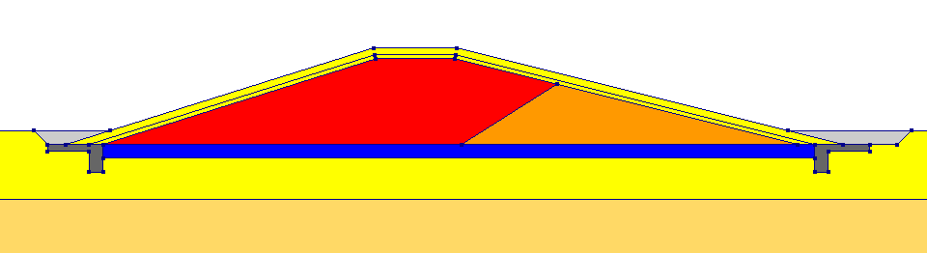

(A) Dam discretization

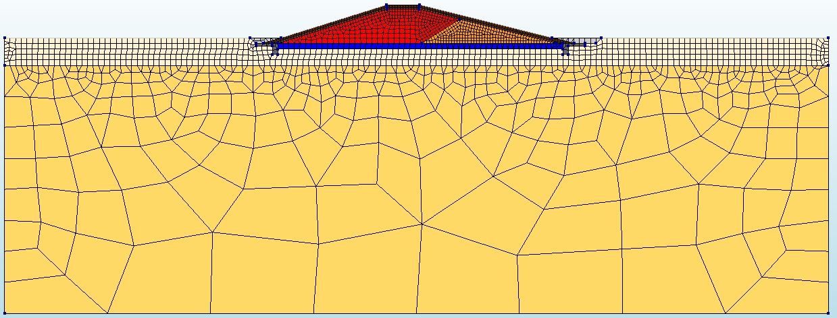

(A) Mesh

Figure 4: Dam Numerical Model

## ****Results and discussion****

To evaluate the embankment dam's hydraulic performance and structural integrity, three distinct modeling scenarios were developed using DIANA software. These scenarios were based on observed field conditions, laboratory test results, and historical design data. Each scenario represents a different configuration of material properties and construction quality, enabling comparative analysis of dam behavior under varying permeability profiles.

### ****Baseline Scenario – Ideal Design Conditions****

The baseline scenario assumes that all dam components were constructed as per the original design specifications, with well-compacted materials and permeability values within the expected range. This model serves as the theoretical optimal condition for evaluating deviations in other scenarios.

Simulation results indicated that under these ideal conditions, the upstream face is mainly responsible for restricting water, and around 10 % of the head is dropped within the upstream layer, with minimal seepage reaching the downstream face. Water retention was stable, and the drawdown curve remained gradual. However, this scenario does not reflect the post-event reality observed during site inspections, indicating that actual dam conditions deviate significantly from the design.Figure 5

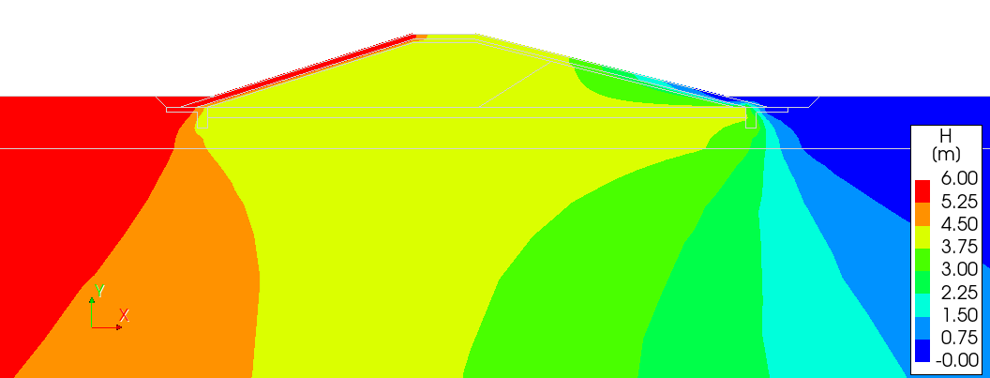

Figure 5: Pressure head within the dam and foundation (Baseline Scenario)

### ****Scenario 2 – Inefficient Upstream Layer****

In this scenario, the upstream shell material was modeled with permeability values equivalent to the core, simulating construction flaws such as the use of improper fill material or inadequate compaction. This change resulted in a significant alteration in seepage pathways.

The simulation revealed that high permeability in the upstream layer allowed rapid infiltration into the dam body, accelerating saturation of the core. This scenario reflects the dam’s ***actual condition during the flash flood event***, highlighting the consequences of inefficient upstream zoning and the failure to isolate seepage within low-permeability materials, Figure 6

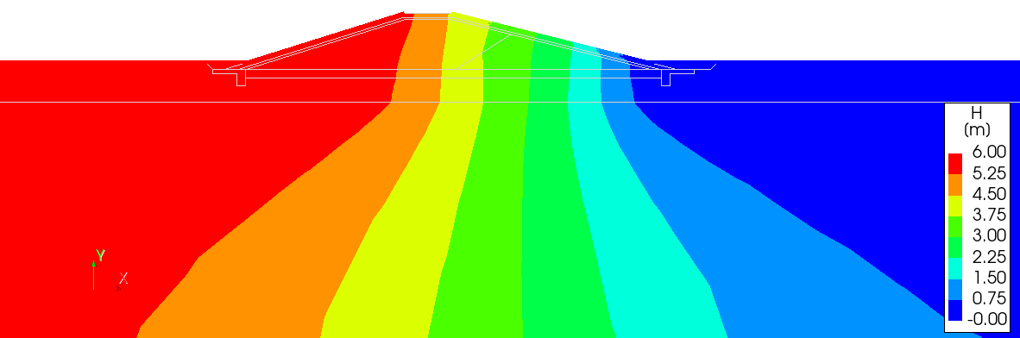

Figure 6: Pressure head within the dam and foundation (Scenario 2)

### ****Scenario 3 – Compromised Core (Inner Layer Permeability Doubled)****

This model simulated a condition where the core (inner layers) permeability was twice as high as the design value, representing internal degradation, differential settlement, or construction deficiencies such as incomplete compaction. While the upstream and downstream shells maintained standard permeability, the compromised core significantly altered internal water flow dynamics, describing the dam behavior after retrofitting the upstream face and the critical case of weak material within the core.Results showed that seepage quickly propagated through the core and increased pore water pressures along the downstream slope, Figure 7

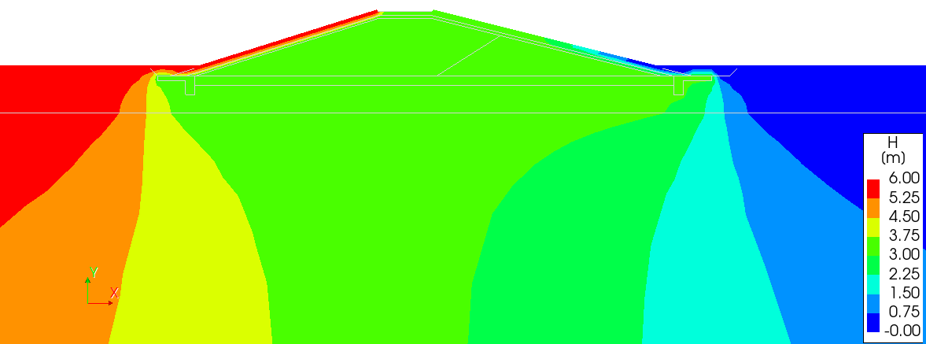

Figure 7: Pressure head within the dam and foundation (Scenario 3)

# Conclusion

This study provided a detailed post-event assessment of a flash flood embankment dam that failed to retain upstream water, discharging nearly 80% of its storage within 72 hours. The investigation identified critical issues in the material properties of construction layers, particularly concerning permeability defects. Three numerical scenarios were evaluated to diagnose the failure:

* Scenario 1 (Design Review) assessed baseline design safety, revealing no inherent defects.
* Scenario 2 (Upstream Layer Deficits) simulated construction flaws in the upstream zone.
* Scenario 3 (Core Permeability Doubled + Restored Upstream Layer) tested the impact of inner material degradation while assuming upstream repairs.

Results demonstrated the upstream layer’s vital role in reducing hydraulic head within the dam core and ensuring structural stability. Critically, retrofitting the upstream layer to restore impermeability significantly enhanced dam safety in Scenario 3. These structural inefficiencies, driven by permeability mismatches, compromised the dam’s core flood attenuation function.

# References

[1] N. Coleman, A. Clarke, M. Esparza, and A. Mostafavi, “Analyzing common social and physical features of flash-flood vulnerability in urban areas,” International Journal of Disaster Risk Reduction, vol. 122, p. 105437, May 2025, doi: 10.1016/J.IJDRR.2025.105437.

[2] E. M. Ramadan, H. A. Shahin, H. F. Abd-Elhamid, M. Zelenakova, and H. M. Eldeeb, “Evaluation and Mitigation of Flash Flood Risks in Arid Regions: A Case Study of Wadi Sudr in Egypt,” Water (Switzerland), vol. 14, no. 19, Oct. 2022, doi: 10.3390/w14192945.

[3] M. S. Petersen, “IMPACTS OF FLASH FLOODS,” 2001.

[4] “Risk Management Series Design Guide for Improving Critical Facility Safety from Flooding and High Winds FEMA 543,” 2007.

[5] “OCHA UNITED NATIONS OFFICE FOR THE COORDINATION OF HUMANITARIAN AFFAIRS A N N U A L R E P O RT 2 0 2 2.”

[6] B. Li, J. Yang, and D. Hu, “Dam monitoring data analysis methods: A literature review,” Mar. 01, 2020, John Wiley and Sons Ltd. doi: 10.1002/stc.2501.

[7] “Filters for Embankment Dams Best Practices for Design and Construction,” 2011.

[8] Materials for embankments dams. [U.S. Society on Dams], 2009.

[9] G. Kheiri, H. Javdanian, and G. Shams, “A numerical modeling study on the seepage under embankment dams,” Model Earth Syst Environ, vol. 6, no. 2, pp. 1075–1087, Jun. 2020, doi: 10.1007/s40808-020-00742-9.