**Analysis of an unsteady MHD convective heat and mass transfer flow over a semi-infinite vertical porous plate with a chemical reaction.**

**Dr. Kumud Borgohain**

**Assistant Professor, Department of Mathematics**

**Dhemaji College, Dhemaji**

**Email:** [**kumudborgohain01@gmail.com**](mailto:kumudborgohain01@gmail.com)

**Abstract:** This work investigates the effects of a magnetic field and a chemical reaction on unsteady MHD convective heat and mass transfer flowing past a semi-infinite vertical porous plate. The plate moves at a steady speed in the direction of the fluid flow. To investigate the problem, the continuity equation, momentum equation, energy equation, and species concentration equation are used. First, the dimensional terms in the aforementioned governing equations are converted to non-dimensional form. The problem is then addressed using skin friction, Nusselt number, and Sherwood number, and the aforementioned finding is visually presented by assigning different values to the parameters involved in the problem, such as magnetic field parameter m, Grashof number Gr, and porosity number Kr. Various graphs have been used to derive conclusions.

**Keywords:** MHD**,** porous plate, skin friction, Magnetic parameter

Introduction: Magnetic hydrodynamics is a subdivision of fluid dynamics that studies the motion of electrically accompanying fluids in the existence of a magnetic field. The fundamental principle of MHD is based on the correlative interactions amongst the electromagnetic field and a field of flow velocity. This movement affects the magnetic field by partly carrying the magnetic field lines, liable to the electrical conductivity of the fluid, and the magnetic pitch produces a mechanical force called Lorentz force. Magnetohydrodynamics, which in numerous disciplines of science have significant applications, has become one of the most imperative parts of fluid dynamics. Geophysics, liquid metallic fluids, astronomy, space science are examples where MHD theory has been used. When the fluid is electrically conductive, it can be perceived that MHD plays a role.

There are various applications of MHD principal i. e MHD generator, MHD pumps, Solar flares, Earth's magnetosphere, Astrophysical magnetic fields, Plasma stability, etc. Convection problems of electrically conducting fluid in a transverse magnetic field are of great importance because of their wide applications in Geophysics, Astronomy, Plasma Physics, etc. Flow through a porous medium has numerous engineering and geographical applications. Many researchers have studied MHD-free convection heat and mass transfer flow in a porous medium because of various applications of many branches of science and technology.

**MATHEMATICAL FORMULATION**

Considered MHD viscous, electrically conducted incompressible fluid flowing through a vertical plate with porosity getting influence by a uniform transverse magnetic field.

In the three-dimensional coordinate system, the X-axis is aligned upward, the Y-axis is vertical, and the Z-axis is aligned with the plate thickness as shown in Figure 1.

g





X

Y

Z





O

Figure 1: Physical Model of the Problem

Working on the above-mentioned assumptions, the equations of the problem are:

1. Equation of Continuity:

 (1)

2. Equation of Momentum:

 (2)

3. Energy Equation:

 (3)

4. Concentration Equation:

 (4)

Limiting circumstances relate to the present problem:

 (5)

From equation (1),

 (6)

Considered the equation that describes the boundary layer from the exterior:

 (7)

The following are a few non-dimensional parameters that are taken into account in this

 (8)

From equations (6) -(8), the equations (2) -(4) imply

 (9)

Applying non-dimensional variables given in equation (8), equation (5) minimizes to

 (10)

SOLUTION OF THE PROBLEM

Now for solving partial differential equations (9)-(10), it is needed to construct following equations

 (11)

Substituting the equations (1) to (3) into the equation (9) neglecting the coefficient of, equating ε term and non-ε terms, it is obtained by following equations as follows:

 (12)

Applying the equations above the boundary conditions can be written as

 (13)

Solving and applying the above boundary conditions and obtained the following equations:









 

From the equations (1) to (3), found the following equations:







Viscous Drag





Nusselt Number





Sherwood number





To better understand the physical situation of this issue, various mathematical calculations of non-dimensional flow characteristics with coefficients of viscous drag, rate of mass, and heat transport must be performed using a variety of physical variable values.

Figure 2 shows that fluid motion eventually decreases as M increases, indicating that fluid flow slows due to magnetic induction.

Figure 3 shows that increasing the number of Kr reduces the fluid velocity.

Figure 4 depicts the impact of Gr, illustrating that fluid motion intensifies as Gr values rise.

Figures 5 and 6 depict the fluid temperature change against y as a function of Pr and exponential index n. This shows that increasing Pr values causes the fluid temperature to decrease, and increasing the amount of exponential index n reduces fluid temperature.

Figures 7 and 8 describe the change of concentration against y due to Kr and Sc. The fluid concentration is reduced on account of Kr, and the fluid concentration steadily goes down with the higher values of Sc. It has been seen that if the numerical value of Schmidt number Sc increases, the fluid concentration is found to get retarded.

Figures 9-12 resemble the Skin-friction coefficient τ against t under the induced of M, Kr, Gr, and Gm.

In Figure 9, it can be seen that an increase in the quantity of M is associated with a rise in the coefficient of skin friction. Conversely, Figure 10 illustrates a different trend where τ decreases in response to Kr. Figures 11 and 12 demonstrate that the coefficients of skin friction increase due to the influence of Gr and Gm.

The impact of variations in Pr and the exponential index n on the Nusselt number Nu is depicted in Figures 13 and 14. Both figures indicate that the Nusselt number rises with greater values of Pr and the exponential index n.

Figures 14-15 point out the Sherwood number Sh against t with the action of Kr and Sc. It has been seen in both of the Figures that Sh gets wheezing awake due to the influence of Kr and Sc.

**GRAPHS**

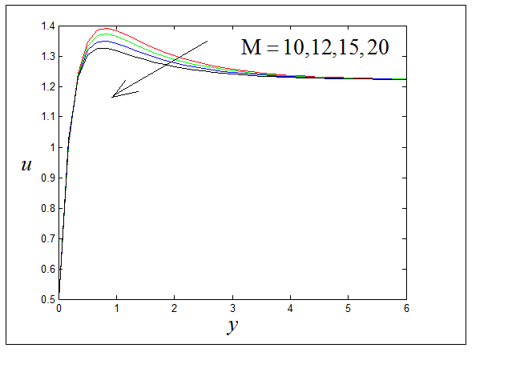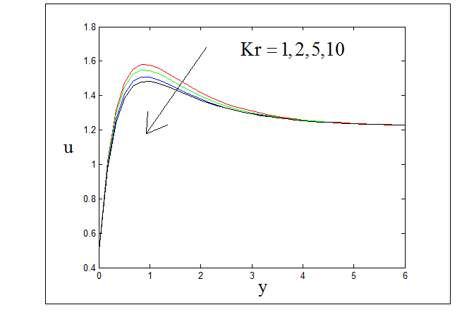

 

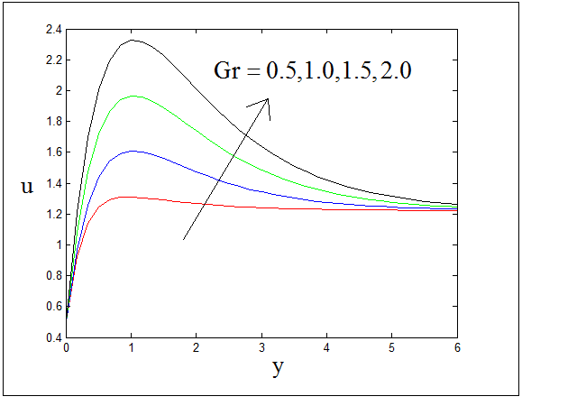 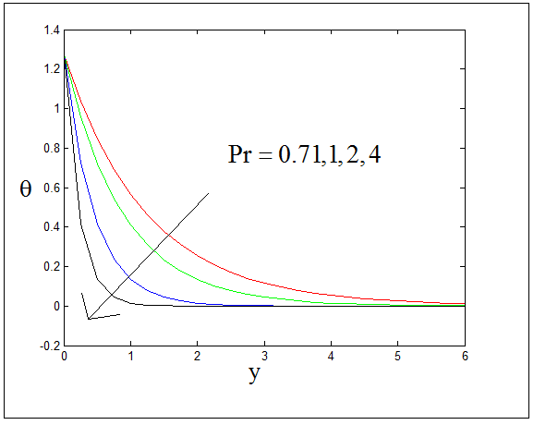

 

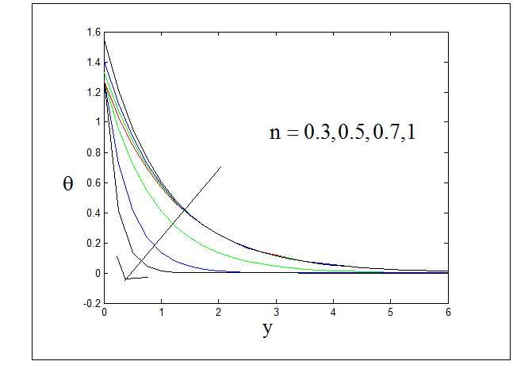 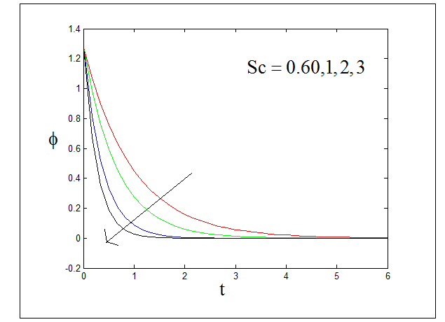

 

**Figure 4.1.5 :** Temperature against y with n=0.3, A=0.5, =0.2, t=1

**Figure 4.1.5 :** Temperature against y with n=0.3, A=0.5, =0.2, t=1

 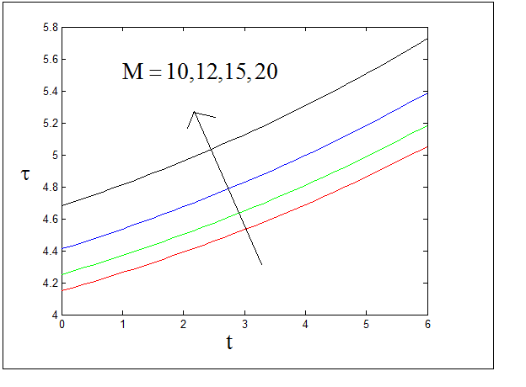

 

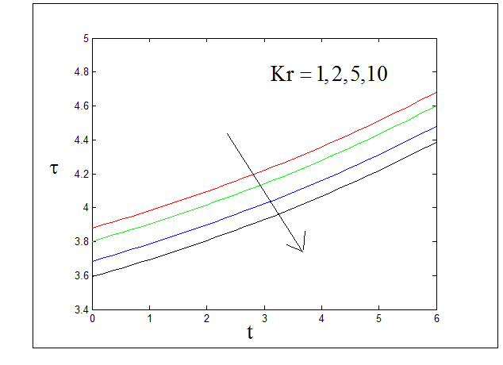 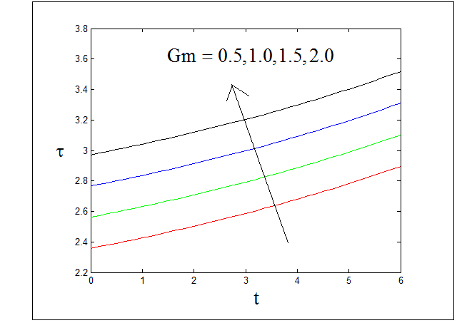

 

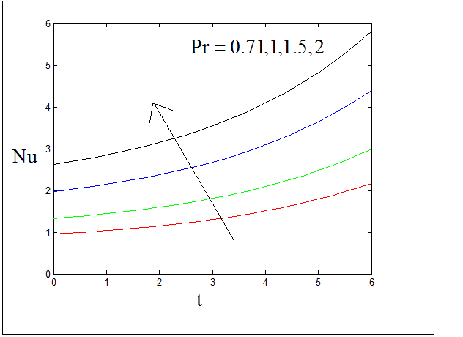 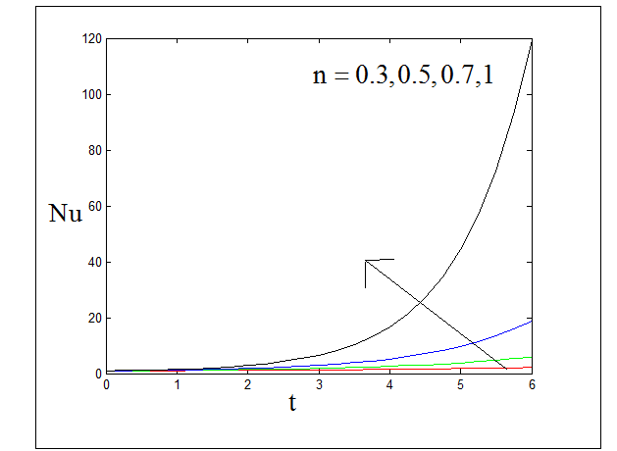

 

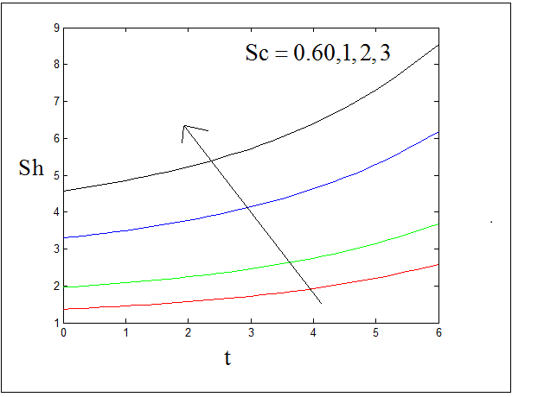 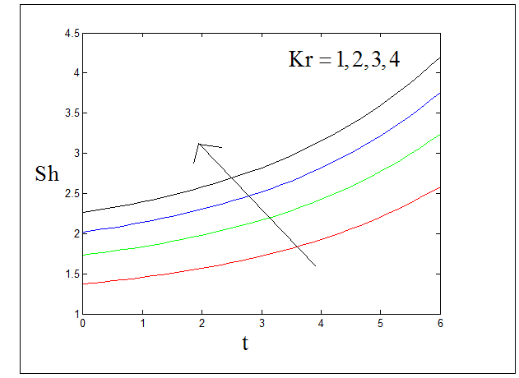

 

Conclusion:

The fluid motion decreases due to M's impact, whereas Gr and Gm increase. Pr and exponential index n both have a cooling effect on fluid temperature.

**References**

[1] Anwar T, Kumam P, Shah Z, Watthayu W, Thounthong P.Molecules. (2020), Unsteady Radiative Natural Convective MHD Nanofluid Flow Past a Porous Moving Vertical Plate with Heat Source/Sink, 14;25(4):854. doi: 10.3390/molecules25040854.

[2] A. Mythreye , J.P. Pramod , K.S. Balamurugan,(2015).Chemical Reaction on Unsteady MHD Convective Heat and Mass Transfer Past a Semi-Infinite Vertical Permeable Moving Plate with Heat Absorption, [Procedia Engieering](https://www.sciencedirect.com/journal/procedia-engineering) [Volume 127](https://www.sciencedirect.com/journal/procedia-engineering/vol/127/suppl/C), Pp 613-620

[3] Cheng, Ping, Minkowycz (1977) W.J. FREE CONVECTION ABOUT A VERTICAL FLAT PLATE EMBEDDED IN A POROUS MEDIUM WITH APPLICATION TO HEAT TRANSFER FROM A DIKE.Volume 82, Issue 14, May 10, Pp. 2040-2044 **DOI:**10.1029/JB082i014p02040

[4] Chamkha Ali J. (2004) Unsteady MHD convective heat and mass transfer past a semi-infinite vertical permeable moving plate with heat absorption. Int J Eng Sci; 42:217-30.

[5] G.V. Ramana Reddy, Ch.V. Ramana Murthy and N. Bhaskar Reddy. (2009). Mixed Convective MHD Flow and Mass Transfer Past an Accelerated Infinite Vertical Porous Plate, Mathematics Applied in Science and Technology, Volume 1, Number 1, pp. 27-37

[6] Georgantopoulos, G.A., Koullias, J., Goudas, C.L. *et al.* (1981).Free convection and mass transfer effects on the hydro-magnetic oscillatory flow past an infinite vertical porous plate. *Astrophys Space Sci* 74,pp. 357–389. <https://doi.org/10.1007/BF00656444>

[7] Hossain M., Khanafer K. and Vafai K. (2001), The eﬀect of radiation on free convection ﬂow of ﬂuid with variable viscosity from porous vertical plate, Int. J. Therm. Sci., Vol.40, pp.115-124

[8]O.D. Makinde (2005) Free convection flow with thermal radiation and mass transfer past a moving vertical porous plate, [International Communications in Heat and Mass Transfer](https://www.sciencedirect.com/journal/international-communications-in-heat-and-mass-transfer) [Vol.32, Issue 10](https://www.sciencedirect.com/journal/international-communications-in-heat-and-mass-transfer/vol/32/issue/10), Pp. 1411-1419

[9] R. Deka, U.N. Das, V.M. Soundalgekar (1994). Effects of mass transfer on flow past an impulsively started infinite vertical plate with constant heat flux and chemical reaction, Forschung im Ingenieurwesen, 60 , pp. 284-287

[10] R. Muthucumaraswamy, P. Ganesan, (2001). Effect of the chemical reaction and injection on flow characteristics in an unsteady upward motion of an isothermal plate. J Appl Mech Tech Phys, 42 , pp. 665-671

[11] S. Ibrihem, I.A. Hassanien, A.A. Bakr(2005).Nonclassical thermal effects in stokes’ second problem for micro polar fluids, ASME J Appl Mech, 72, pp. 468-474

[12] S.S. Das , A. Satapathy , J.K. Das , J.P. Panda(2009) .Mass transfer effects on MHD flow and heat transfer past a vertical porous plate through a porous medium under oscillatory suction and heat source, [International Journal of Heat and Mass Transfer](https://www.sciencedirect.com/journal/international-journal-of-heat-and-mass-transfer) [Vol. 52, Issues 25–26](https://www.sciencedirect.com/journal/international-journal-of-heat-and-mass-transfer/vol/52/issue/25), pp. 5962-5969

[13]Youn J Kim,(2000). Unsteady MHD convective heat transfer past a semi-infinite vertical porous moving plate with variable suction, [International Journal of Engineering Science](https://www.sciencedirect.com/journal/international-journal-of-engineering-science), [Vol. 38, Issue 8](https://www.sciencedirect.com/journal/international-journal-of-engineering-science/vol/38/issue/8), pp.833-845

[14] Zubi, M. (2018) MHD Heat and Mass Transfer of an Oscillatory Flow over a Vertical Permeable Plate in a Porous Medium with Chemical Reaction. *Modern Mechanical Engineering*, 8,pp.179-191. doi: [10.4236/mme.2018.83012](https://doi.org/10.4236/mme.2018.83012)