RETINAL IMAGE ANALYSIS FOR DISEASE SCREENING USING LOCAL BINARY PATTERN

B.Chitra Devi   
*Associate Professor- Dept.of Electronics and Communication*  
*Tamilnadu College of Engineering*Coimbatore, India  
bchitrdevi2421@gmail.com

J.Gnana Arul Raj  
*Student - Dept.of Electronics and Communication*  
*Tamilnadu College of Engineering*Coimbatore, India  
arunjerald.2003@gmail.com

G.Ganeshamoorthy  
*Student - Dept.of Electronics and Communication*  
*Tamilnadu College of Engineering*Coimbatore, India  
moortyganesha53@gamil.com

V.Dharshini  
*Student - Dept.of Electronics and Communication*  
*Tamilnadu College of Engineering*Coimbatore, India  
dharshinidharshu1929@gmail.com

*Abstract*—Strict control of blood glucose and blood pressure is critical for reduction of the incidence and progression of diabetic retinopathy (DR). Follow-up of patients with diabetes mellitus is protocol based and not based solely on the presence of symptoms. Staging of the level of DR (mild, moderate, or severe non proliferative DR vs. proliferative DR, PDR) drives the follow-up interval. The most common cause of visual loss in diabetic patients is diabetic macular edema (DME). Detection of Eye Disorders Through Retinal Image Analysis Blood Vessel Segmentation, Optic Disc Segmentation and Fuzzy Logic Image Processing. Common Retinal Eye Disorders that has been solved in this project. The results of multicenter, randomized studies suggest that the best visual results for DME currently are achieved with intravitreal ranibizumab injections ± focal laser photocoagulation. Results using bevacizumab seem quite comparable to those with ranibizumab. In addition to treating DME, this approach also seems to reduce the likelihood of progression of DR. Selected patients also may benefit from intravitreal steroid treatment and focal laser therapy, but there is a relatively higher rate of glaucoma and cataract formation. Glaucoma is a neuro-degenerative eye disease developed due to an increase in the Intra-ocular Pressure inside the retina. Being the second largest cause of blindness worldwide, it can lead the person towards complete blindness if an early diagnosis does not take place. The architecture of CNN is cognate to that of the linking form of neurons in the brain of humans and was inspired by the suggestion of the visual cortex. The CNN algorithm has a faster

Keywords—MATLAB, ARDUINO Uno, LCD Display, Image pre-processing, LBP.

# **I Introduction**

Diabetic retinopathy, a complication of diabetes, damages the retina and can lead to blindness. It often shows no early signs, but macular edema can cause blurred vision. Non-proliferative diabetic retinopathy (NPDR) has no symptoms initially and requires fundus photography for detection. Macular edema symptoms include blurred vision and distorted images. Proliferative diabetic retinopathy (PDR) involves abnormal blood vessels that can burst, causing vitreous hemorrhage and vision loss. Diabetes type and duration increase the risk; 40-45% of Americans with diabetes have some retinopathy. Microvascular changes due to hyperglycemia damage retinal blood vessels, leading to retinopathy. Digital image processing aids in early detection through fundus photograph analysis.

Glaucoma, another leading cause of vision loss, requires optic nerve examination via fundus imaging for early detection. Cataracts and glaucoma, often age-related, may coexist and exacerbate each other. Cataracts can trigger healthcare seeking due to noticeable vision changes, while glaucoma's gradual vision loss often goes unnoticed until advanced stages.

Efforts toward early detection of diabetic retinopathy and glaucoma are crucial for timely intervention to prevent irreversible vision loss. Automated screening programs with robust image processing algorithms play a key role. Early intervention for both conditions can significantly reduce visual impairment and improve quality of life.

In summary, diabetic retinopathy and glaucoma pose significant threats to vision, with early detection being paramount for effective treatment and prevention of blindness. Automated screening programs and advancements in digital image processing offer promising avenues for enhancing early detection and intervention efforts.

# **II LITERATURE SURVEY**

## **A Survey on Diabetic Retinopathy Disease Detection and Classification using Deep Learning Techniques (2021)**

Diabetes, when left untreated, can lead to the development of several diseases across the body. Diabetic Retinopathy (DR) is an asymptomatic eye disease induced by diabetes that results in damaged retinal vessels. Many automatic diagnostic systems have been developed in the literature in which conventional handcrafted features were used. With the development of Deep Learning (DL), particularly in medical imaging, more accurate and potential results are produced,as it performs automatic feature extraction. Convolutional Neural Networks (CNNs) are the most widely used deep learning method in medical image analysis. In this paper, several Deep Learning-based diabetic retinopathy 5 disease detection and classification techniques are analyzed and reviewed for better understanding.

## **Automatic Glaucoma Diagnosis Based on Photo Segmentation with Fundus Images (2021)**

Medical imaging is a process of creating images of internal parts of the human body for medical diagnosis. These images are used to help the doctors to quickly detect the most varieties of eye diseases which occur on the retina. The fundus camera is employed to capture the retinal images, and these images are called fundus images. Glaucoma is a leading disease in which eye vision is lost due to the destruction of the optic nerves. Early detection of glaucoma is noteworthy as recovering the damaged optic nerves is an especially complex task. Hence, it becomes vital to detect automated detection glaucoma is very challenging. Conventionally, the glaucoma disease detection using different machine learning techniques is very popular. The proposed photo segmentation approach is carried out the usage of a fundus picture database for qualitative quantitative analysis. Experimental assessment is finished using a fundus photograph dataset with exceptional parameters along with peak sign to noise ratio, sickness detection accuracy, false-wonderful rate, and disorder detection time with recognize to the variety of photographs.

## **Glaucoma detection in retinal fundus images using U-Net and supervised machine learning algorithms (2021)**

This work proposes an offline Computer-Aided Diagnosis (CAD) system for glaucoma diagnosis using retinal fundus images. This application is developed using image processing, deep learning and machine learning approaches. Le-Net architecture is used for input image validation and Region of Interest (ROI) detection is done using brightest spot algorithm. Further, the optic disc and optic cup segmentation is performed with the help of U-Net architecture and classification is done using SVM, Neural Network and Adaboost classifiers.

## **Glaucoma Uncertainty-Aware Deep Learning Methods for Robust Diabetic Retinopathy Classification (2022)**

We present novel results for 9 BNNs by systematically investigating a clinical dataset and 5-class classification scheme, together with benchmark datasets and binary classification scheme. Moreover, we derive a connection between entropy- based uncertainty measure and classifier risk, from which we develop a novel uncertainty measure. We observe that the previously proposed entropy-based uncertainty measure improves performance on the clinical dataset for the binary classification scheme, but not to such an extent as on the benchmark datasets. It improves performance in the clinical 5-class classification scheme for the benchmark datasets, but not for the clinical dataset. Our novel uncertainty measure generalizes to the clinical dataset and to one benchmark dataset. Our findings suggest that BNNs can be utilized for uncertainty estimation in classifying diabetic retinopathy on clinical data, though proper uncertainty measures are needed to optimize the desired performance measure. In addition, methods developed for benchmark datasets might not generalize to clinical datasets.

**III EXISTING SYSTEM**

* The method consists of two stages: coarse level and fine level. In coarse level, we extract HEs candidate regions by combining histogram segmentation with morphological reconstruction.
* While in fine level, we define 44 representative features for each candidate region, and train a support vector machine (SVM) model to classify retinopathy.
* We evaluate the proposed method on the public diaretdb1 database Experiment results show that our method can detect HEs efficiently.
* The algorithm is based on Fisher’s linear discriminant analysis and makes use of color information to perform the classification of retinal exudates.
* We prospectively assessed the algorithm performance using a database containing 58 retinal images with variable color, brightness, and quality.

**Disadvantages:**

* + - * The prediction of Retinopathy is quite difficult and the segmentation method may produce unwanted noise.
      * It only detects only normal and defect, whereas detection of various parameters is required.
      * Performance, evaluation, efficiency and accuracy are moderate.

**IV PROPOSED SYSTEM**

* Retinopathy cause changes in eye damage the blood vessel. Image will undergo a standard method of applying image processing which include image acquisition, pre-processing, feature extraction followed by exact identification of disease.
* In existing, the system can detect only one disease. We have proposed an algorithm which is capable of detecting all eye diseases in a single system.
* Considering the fact that retinal image is one of the most important medical references that help to diagnose the cataract, DR, glaucoma this project proposes to use LBP algorithm for automatic eye disease detection based on the classification of retinal images.
* There are many algorithms used for classification but LBP is better than most of the other algorithms used as it has a better accuracy in results**,** and classification.
* Algorithm has a fast and prediction along with better accuracy in results, and classified to execute the system.
* Some of the eye issues are minor and simple to cure at home which will go away on their own, other major eye issues need assistance from the expert doctors.
* When these eye diseases are accurately diagnosed at an early stage, only then the progression of these eye diseases can be stopped.
* In this project, our proposed model analyses and classifies eye diseases namely cataracts, glaucoma, diabetic retinopathy and normal eye.
* In this project, a new method based on Linear Binary Pattern (LBP) along with segmentation of retinal blood vessels is presented.
* Also the proposed system helps to give classification to patients. This can be done with the help of an microcontroller.

# **III PROPOSED BLOCK DIAGRAM**

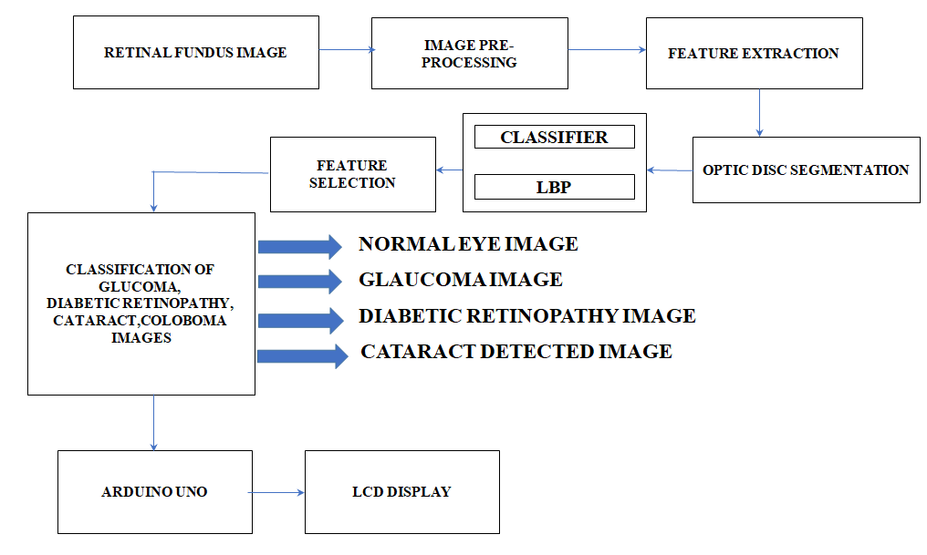

Fig 1: Block Diagram

**Advantages:**

* Retinopathy Prediction is performed by using blood vessel segmentation and it gives better efficiency compared to existing method.
* Accuracy, performance and evaluation of output is comparatively higher while using LBP algorithm.

# **COMPONENTS SPECIFICATION**

**ARDUINO UNO:**

* The operating voltage is 5V
* The recommended input voltage will range from 7v to 12V
* The input voltage ranges from 6v to 20V
* Digital input/output pins are 14
* Analog i/p pins are 6
* DC Current for each input/output pin is 40 mA
* DC Current for 3.3V Pin is 50 mA
* Flash Memory is 32 KB
* SRAM is 2 KB
* EEPROM is 1 KB
* CLK Speed is 16 MHz

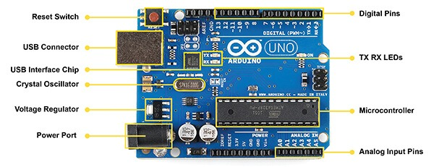

Fig 2: ARDUINO UNO

**LCD Display:**

* The operating voltage of this display ranges from 4.7V to 5.3V
* The display bezel is 72 x 25mm
* The operating current is 1mA without a backlight
* PCB size of the module is 80L x 36W x 10H mm
* HD47780 controller
* LED color for backlight is green or blue
* Number of columns – 16
* Number of rows – 2
* Number of LCD pins – 16
* Characters – 32
* It works in 4-bit and 8-bit modes
* Pixel box of each character is 5×8 pixel
* Font size of character is 0.125Width x 0.200height.

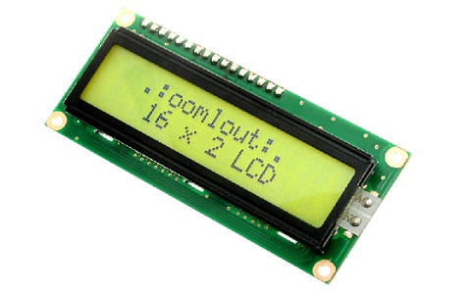

Fig 3: LCD Display

# **Experimental Setup**

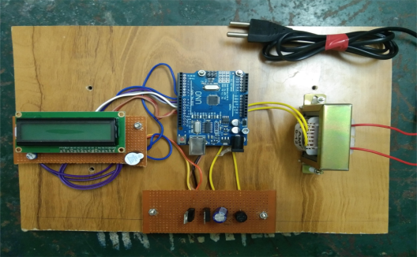

Fig 4: Experimental Setup

# **Results**

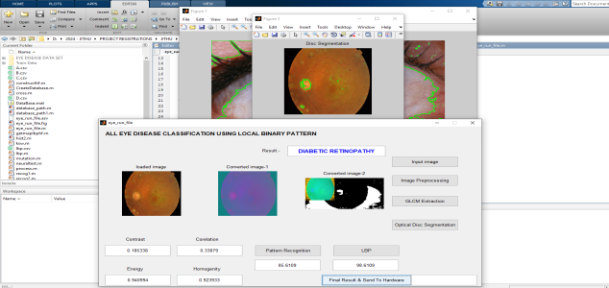

Fig 5: Diabetic Retinopathy

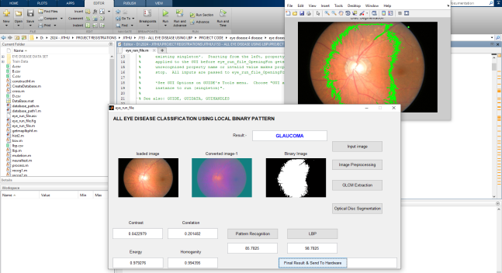

Fig 6: Glaucoma

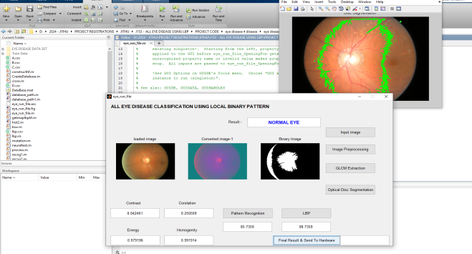

Fig 7: Normal Eye

# **Conclusion**

Retinal image processing plays a crucial role in the diagnosis and treatment of various diseases that affect the retina and the choroid. One such disease is diabetic retinopathy, which is a complication of diabetes mellitus that affects the retina and the choroid. The advent of retinal imaging technology has enabled optometrists to capture digital images of the retina, blood vessels, and optic nerve located at the back of the eyes. This has greatly aided in the early detection and management of diseases that can affect both eyes and overall health, such as diabetic retinopathy, cataract, and Glaucoma.

# **VI References**

1. U. R. Acharya, M. R. K. Mookiah, J. E. W. Koh, J. H. Tan, S. V. Bhandary, A. K. Rao, H. Fujita, Y. Hagiwara, C. K. Chua, and A. Laude, ‘‘Automated screening system for retinal health using bidimensional empirical mode decomposition and integrated index,’’ Comput. Biol. Med., vol. 75, pp. 54– 62, Aug.2016.
2. V. Gulshan, L. Peng, M. Coram, M. C. Stumpe, D. Wu, A. Narayanaswamy,S. Venugopalan, K. Widner, J. Cuadros, and R. Kim, ‘‘Development and validation of a deep learning algorithm for detection of diabetic retinopathy in retinal fundus photographs,’’ J. Amer. Med. Assoc., vol. 316, no. 22, pp. 2402–2410, Dec. 2016.
3. R. Williams, M. Airey, H. Baxter, J. Forrester, T. Kennedy-Martin, and A. Girach, ‘‘Epidemiology of diabetic retinopathy and macular oedema: A systematic review,’’ Eye, vol. 18, pp. 963–983, Jul. 2004.
4. R. Klein, B. E. K. Klein, S. E. Moss, M. D. Davis, and D. L. DeMets, ‘‘The Wisconsin epidemiologic study of diabetic retinopathy: III. Prevalence and risk of diabetic retinopathy when age at diagnosis is 30 or more years,’’ Arch. Ophthalmol., vol. 102, no. 4, pp. 527–532, Apr. 1984, doi: 10.1001/archopht.1984.01040030405011.
5. Z. L. Teo, Y.-C. Tham, M. Yu, M. L. Chee, T. H. Rim, N. Cheung, M. M. Bikbov, Y. X. Wang, Y. Tang, Y. Lu, I. Y. Wong, D. S. W. Ting, G. S. W. Tan, J. B. Jonas, C. Sabanayagam, T. Y. Wong, and C.-Y. Cheng, ‘‘Global prevalence of diabetic retinopathy and projection of burden through 2045: Systematic review and meta-analysis,’’ Ophthalmology, vol. 128, no. 11, pp. 1580–1591, 2021. [Online].
6. N. Kaur, S. Chatterjee, M. Acharyya, J. Kaur, N. Kapoor, and S. Gupta, ‘‘A supervised approach for automated detection of hemorrhages in retinal fundus images,’’ in Proc. 5th Int. Conf. Wireless Netw. Embedded Syst.