Development of a Simple and Reliable Soft Starter for 3 Phase Induction Motor

Muhammad A. Ridhwan¹, Izzeldin I. Mohamed^{1*}, Intisar Ibrahim Ridwan², Aisha H. Abdalla³
¹College of Engineering, Universiti Malaysia Pahang, 26300 Gambang, Kuantan, Pahang, Malaysia
^{1*}Faculty of Engineering, Sohar University, Sohar, Oman
^{2,3}College of Engineering, International Islamic University Malaysia, Kuala Lumpur, Malaysia
^{1*}iabdelaziz@su.edu.om, ²intisaribrahim27@gmail.com, ³aisha@iium.edu.my

Abstract—The three-phase induction motor draws a high initial starting current than its capacity, resulting in a mechanical jerk and high electrical stress on the windings of the motor. Several conventional methods have been proposed for starting the induction motor. However, these methods are costlier and have some loopholes as well. This paper, developed a thyristors based electronics soft starter abled to reduce the starting current of a three-phase induction motor and provides an efficient starting control. The proposed system which is consist of a unit of three groups of counter parallel thyristor and a unit of trigger angle control circuit is developed and simulated using MATLAB/SIMULINK. The system was evaluated experimentally where the results show that the system significantly reduced the starting current and the torque as well as effectually offer efficient and smooth acceleration current control and hence improve the induction motor starting current characteristics.
Keywords—Weather Prediction, Big Data, Hadoop, MapReduce
- INTRODUCTION
The induction motor has been used widely across the globe since its creation. The three phase induction motors are the main electrical component in industrial company or organization. This is because its design is simple and unique, high efficiency and highly independence to start by itself and doesn’t require much maintenance [1]. These criteria have set development and standardization of the manufacturing and infrastructure that has led these to vast installation of induction motors. It is estimated that most of the energy usage in the world are being used by these motors. This unit have no moving part except for the rotor, and there are no commutators, brushes or slip ring that gives its advantages compares other motors out there [2].
In these few years, the control of high-performance asynchronous motor for industrial application and area of production has received lots of research attention. Asynchronous motor modelling has received constant attraction and attention of power system engineers and researchers not only the motors are made and used in most of the companies nowadays but also due to their various mode of operation both under the steady state and the transient state.
The squirrel cage asynchronous motor is largely and used in many applications. Every time an induction motor is started, the current surges the electrical system and the mechanical system experiences a torque [3]. The line voltage connected to the motor, the current can be amplified to almost three to eight times the motor full load current depends on the systems design of installation or usage [4].
Currently, conventional starter that were commonly used is an old way to start electrical machine such as asynchronous motor. The problem with this conventional starter is that it produces high inrush current, torque and rotor speed. It also produces a low efficiency to the induction motor and waste of electricity. This may have endangered our electrical instrument in the machine we use thus shorten its lifespan. This situation also increases the cost maintenance of the machine at the same time and by overtime it would become a troublesome, problems and issues to the company that uses this induction motor as they need to spend money every time there’s problem such as electrical circuit in the motor burned up or maybe there is part in the motor is not functioning anymore. This paper proposed and developed a thyristors-based cost effective electronic soft starter for three phase induction motor. The designed regulator thyristors circuit controlled and reduced the inrush current and torque in the induction motor by adjusting of the thyristors trigger angles to ensure smooth starting of the motor [5, 6].

- SOFT STARTER SYSTEM DEVELOPMENT
This section describes general approach to modular design methodology of the developed soft starter system. The general development process is introduced and the system designed flow is explained as well as the software and tools used during the development process. Figure 1 illustrates the development of a system which follows an analysis-design-implementation approach. The developed system consists of main four units namely, three phase supply unit, synchronization unit, thyristors unit and trigger phase angle control unit. SIMULINK base and SimPowerSystems in MATLAB used to establish the soft starter simulation model.

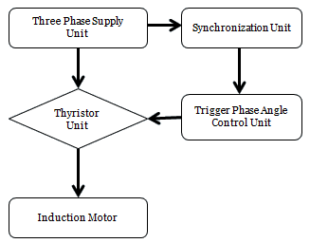

Figure 1: System development flow chart

Three Phase Source Supply Unit: Figure 2 shows the three phase AC voltage power unit. The peak amplitudes of each phase is 400V which a suitable voltage for industrial applications with 50Hz frequency and the phases are 0⁰, 120⁰ and 240⁰ respectively.

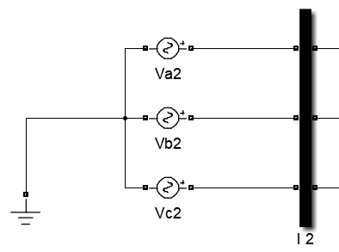

Figure 2: Power supply unit
Synchronization Unit: The Synchronization unit which is responsible for generating synchronized pulses to the thyristor unit is shown in Figure 3. The alpha degree which is the delay angle was set to 40 degrees.

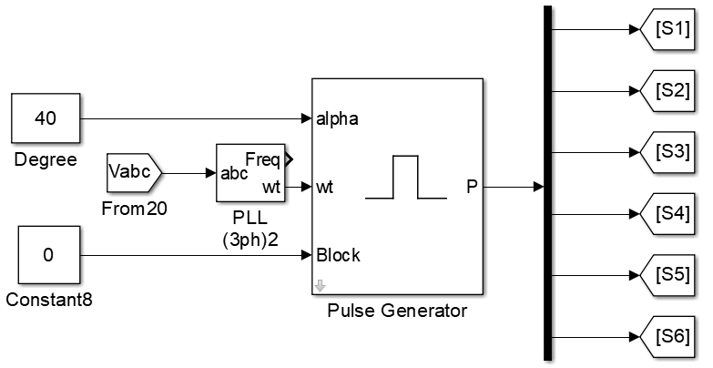

Figure 3: Synchronization Unit

The model produces synchronized six pulses from which it was originally only one output but was connected to demux (busbar) that abled to produces much more outputs. However, in this work is designed to produce six outputs to the thyristors.

Thyristor Unit: Figure 4 illustrates the thyristors unit which represent the main components in the soft starter system. In this work, three pairs of thyristors were created in which the input of the pair comes from the line-to-line three phase supply unit and the synchronization unit while the output of the thyristor was connected to the asynchronous motor. The type of the thyristor is a semiconductor component at which it can be only being turned on via the gate signal or the gate pulse comes from the synchronization unit

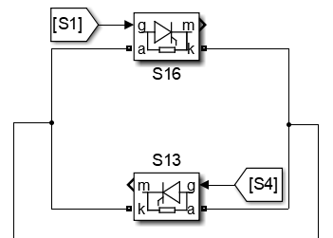

Figure 4: One of three pairs thyristor units

Load Torque Unit: This system is developed to provide the asynchronous motor with a required certain value of torque during the simulation process. A set of algorithm system model was designed as shown in Figure 5. The output of the system was connected to the input load of the asynchronous motor.
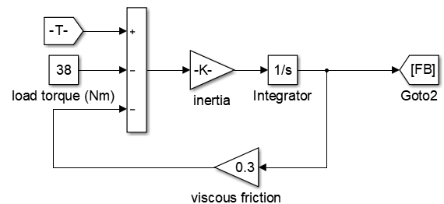

Figure 5: One of three pairs thyristor units

Asynchronous Motor: A squirrel-cage induction motor is used to which two input sources are connected which are a three phases source fired by the thyristor and the load generated by the load torque system unit. During the simulation, several outputs were generated from the motor. However, this study focused only on the measurement of the motor rotor speed and its electromagnetic torque which are connected to the measurement unit as shown in Figure 6 and Figure 7 shows the SIMULINK developed the soft starter of the motor

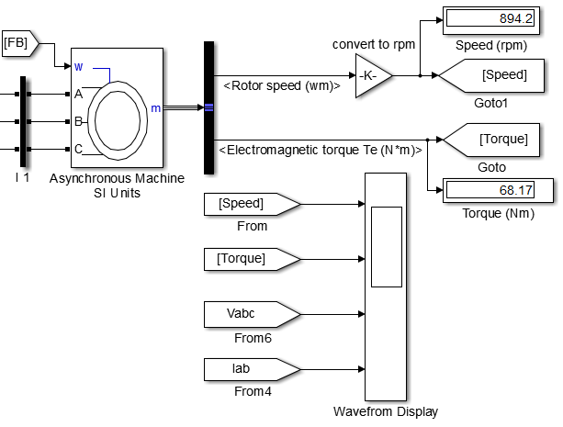

Figure 6: Asynchronous motor unit SIMULINK model

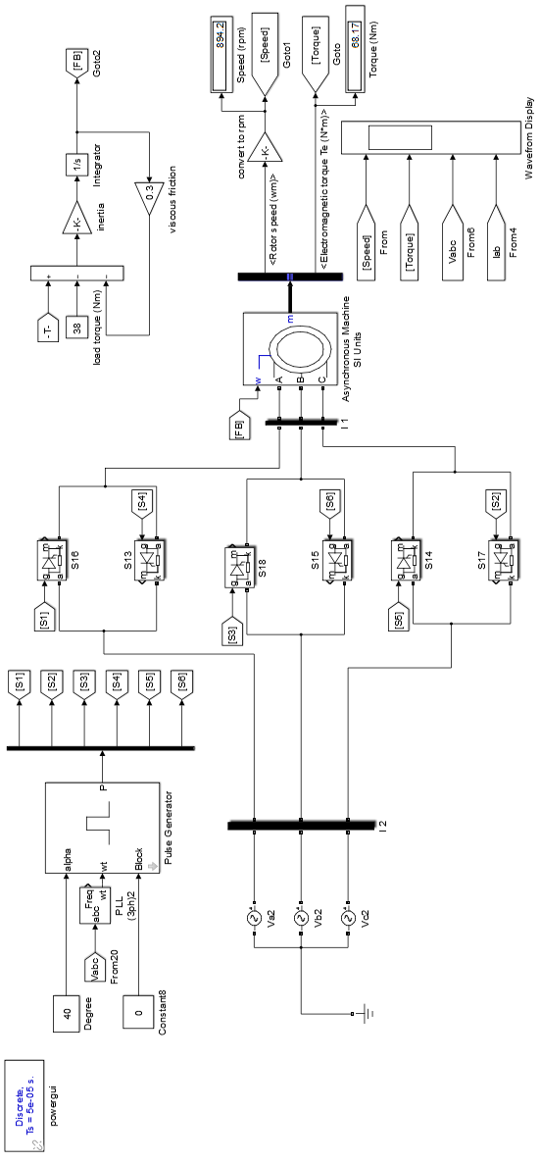

Figure 7: The developed soft Starter System SIMULINK model
- RESULTS AND DISCUSSION
This section presents the results from our simulation study. In order to evaluate the performance of the developed soft starter system we designed a simulation study focusing on the effects of four distinct simulation parameters, namely: (i) rotor speed; (ii) torque; and (iii) current.

Rotor Speed: Figure 8 and Figure 9 presents the motor under study rotor using the developed soft starter model and the direct on-line model (DOL) respectively. The results showed that the DOL is required only 0.5 second to reached the steady state which faster to the developed soft starter model which needs 1 second to reached the steady state. However, this result is not unexpected and the difference in the time is not significant and noticeable

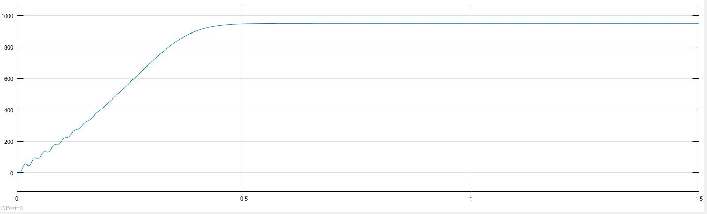
Figure 8: Direct-On-Line Rotor Speed Graph (RPM)

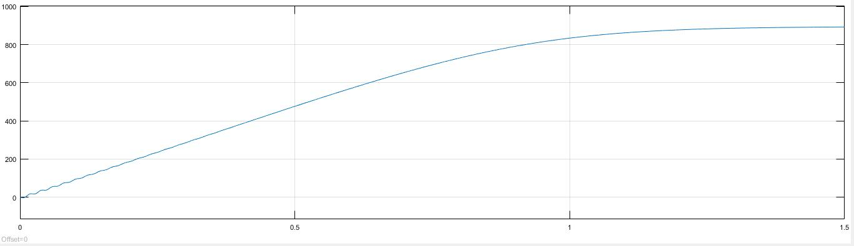
Figure 9: Soft-Starter Rotor Speed Graph (RPM)

Torque: The torque applied to the motor’s rotor has major impact toward the motor lifespan. A large force of torque suddenly applied on the torque would exert stress toward the motor and damaging the motor slowly throughout the years. Hence, the experimental results of the developed soft starter model and DOL model in Figure 10 and Figure 11 respectively revealed that the developed soft starter model reduced the motor starting torque by 50% compared to the DOL model indicating that its ability to significantly reduce the starting torque and hence increasing its life expectancy.
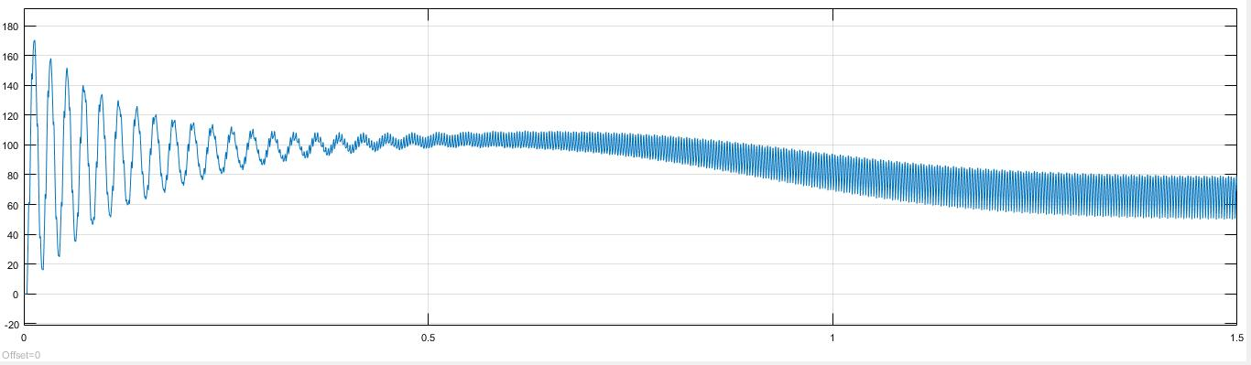
Figure 10: Soft-Starter model starting torque (Nm)

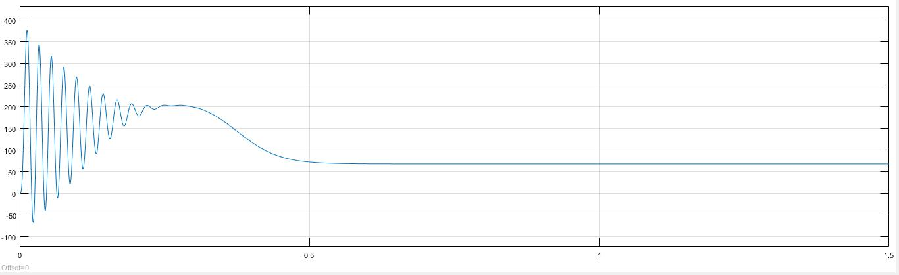
Figure 11: Direct-On-Line model starting torque (Nm)

Current: The starting currents which known as in surge current played a major role in extending the life expectancy of the induction motor. The results of the measured starting current using the soft starter model in Figure 12 and the DOL model in Figure 13 revealed that the developed model abled to reduce the starting current significantly resulting in a healthy motor starting and increasing of its lifetime.

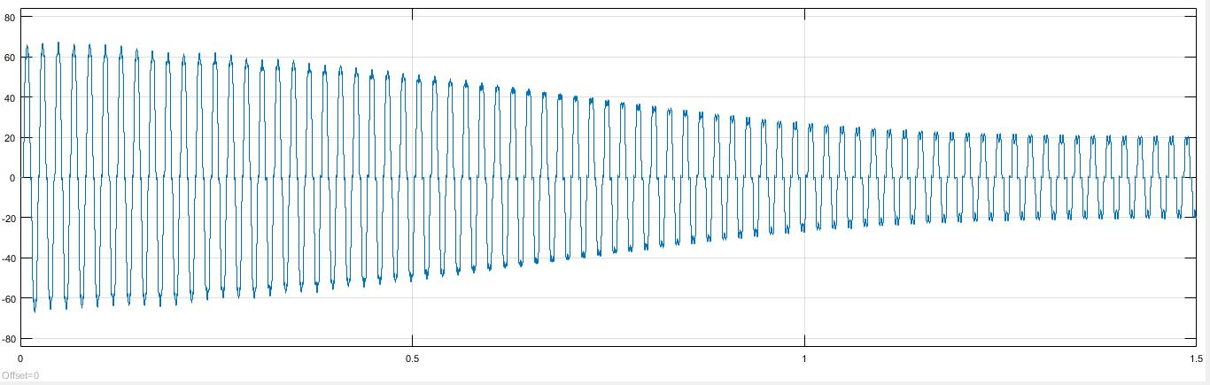
Figure 12: Soft Starter model starting current (Ampere)
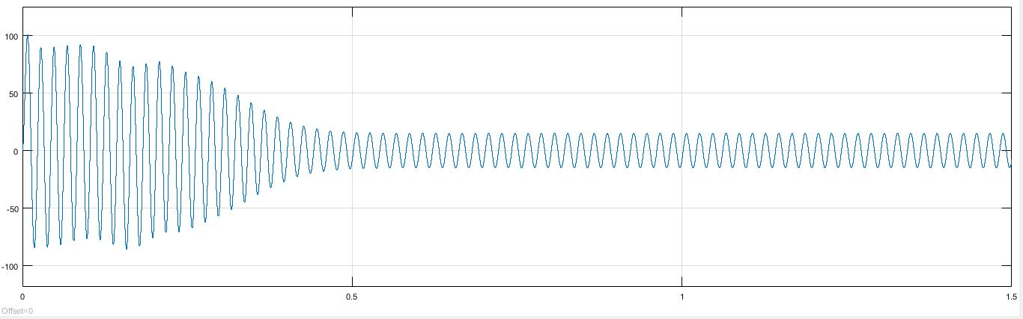
Figure 13: Direct on liner model starting current (Ampere)

- CONCLUSION
The motor starting current and torque played a major role in extending the life its expectancy. Therefore, this paper developed and evaluated a soft starter model that is capable to reduced them and their effect on the motor. From the simulation results, it is clear that the developed model is able to reduce the motor starting current and torque significantly to a large extent and perform excellently compare to the general direct on-line model indicating that it could better control of the motor starting process.

References

- M. M. Abboud, “Simulation of 3ph induction motor in Matlab with Direct and Soft starting methods.”
- W. Gu, J. Chu, and S. Gan, “Starting performance research of a high-power middle-voltage induction motor soft starter based on the on-off transformer,” IEEE Int. Symp. Ind. Electron., vol. 3, pp. 2063–2068, 2006.
- J. Zhijun, H. Xiaoling, and L. Na, “Simulation study of heavy motor soft starter based on discrete variable frequency,” Proc. 2009 4th Int. Conf. Comput. Sci. Educ. ICCSE 2009, pp. 560–563, 2009.
- L. Shue and F. Chao, “Design and simulation of three-phase ac motor soft-start,” Proc. 2013 3rd Int. Conf. Intell. Syst. Des. Eng. Appl. ISDEA 2013, pp. 554–557, 2013.
- C. O. Nwachukwu and M. I. Ajumuka, “Asynchronous Machine Response to Transients,” 2017 IEEE 3rd Int. Conf. Electro-Technology Natl. Dev., 2017.
- T. C. Mallick, S. Dhar, and J. Khan, “Artificial Neural Network based Soft-Starter for Induction Motor,” 2015 2nd Int. Conf. Electr. Inf. Commun. Technol., no. Eict, pp. 228–233, 2015.

