Mineralogical-petrographic and tomographic study of a pilot series of “yellow” paving stones

Luben Lakov1, Kamelia Marinova2, Rositza Dimitrova1, Danail Yovchev2,Mariya Georgieva1, Marieta Gacheva1, Krasimira Toncheva1

*1Bulgarian Academy of Sciences, Institute of Metal Science, Equipment and Technologies with Hydro- and Aerodynamics Centre “Acad. A. Balevski”, 67, “Shipchenski Prohod” Blvd, 1574 Sofia, Bulgaria;*

*2University of Mining and Geology “St. Ivan Rilski,” Prof. Boyan Kamenov St., 1700, Sofia, Bulgaria*

*Corresponding Author: Marieta Gacheva*

*ABSTRACT: This study presents the mineralogical, petrographic and tomographic characterization of a “yellow” paving stones pilot series. The aim of the study is to establish the colour characteristics, mineral composition and structural features of a new ceramics product and their similarities with those of the original “yellow” paving stones laid in the central part of Sofia. The great importance of this research lies in the need to design, introduce to manufacturers and start the production of a new material and new paving stones as similar as possible to the original ones, so that missing or broken ones can be successfully replaced. The study carried out is complex and has yielded results showing that the yellow pavers from the pilot series are as similar as possible to the original ones produced in Hungary more than 100 years ago.*

***KEY WARDS:*** *Sedimentary rocks, high-temperature, petrographic material (products – “yellow” paving stones), methods for the study of artificial stones*

---------------------------------------------------------------------------------------------------------------------------------------

Date of Submission: xx-xx-xxxx Date of acceptance: xx-xx-xxxx

---------------------------------------------------------------------------------------------------------------------------------------

# INTRODUCTION

Subject of the study is a pilot series of yellow paving stones manufactured at the Institute of Metal Science, Equipment and Technologies with Hydro- and Aerodynamics Centre “Acad. A. Balevski”, Bulgarian Academy of Sciences, Sofia, Bulgaria [1].

The original yellow paving stones are an established symbol of the newly built European capital of Bulgaria at the end of the 19th and the beginning of the 20th century. They were laid in the administrative, historical and cultural centre of the capital and are an indispensable part of the capital’s appearance to this day. They have been officially listed as Sofia’s cultural and historical heritage [2], which requires that any new ceramics produced for their replacement must be equivalent in colour and should possess analogous physical-mechanical and tribological indicators. A number of scientists focus their research on the raw materials [3], the method of production [4], firing methods and characteristics of the final products [5,6,7,8,9].

Firstly, the pilot series of yellow paving stones were characterized according to their macroscopic characteristics; representative samples were then selected for optical studies in transmitted light; next, powder samples were prepared for the detection of mineral phases by X-ray diffraction (XRD), metallographic specimens were made for microprobe analyses (SEM-EDX), and X-ray tomographic studies were carried out to identify the specifics of their internal structure.

# RESEARCH METHODS

***2.1. Macroscopic color characterization***

The determination of the color of the samples was carried out using the Munsells 2000 system [10]. The nomenclature used is a three-component system combining hue, value and chroma. Determination of color was made using the Munsells Soil color catalogue.

***2.2. Optical examinations in transmitted light***

The ceramic samples were studied by means of petrographic analysis, for which purpose thin sections were made from representative samples to determine their composition and structure. A NIKON microscope and an OLIMPUS 5060 digital camera were used to examine the microphotographs of the samples.

***2.3. X-ray diffraction method******(XRD)***

X-ray diffraction of powder samples was used to identify the different mineral phases in the composition of the samples. The diffractograms were taken with a TUR M62 powder X-ray diffractometer with step scanning using So radiation, 0.04 2Q step and 1.5s step exposure time.

***2.4. Scanning electron microscopy (SEM-EDS)***

The method is used to characterize the structure and types of mineral phases. To analyze the ceramics with a scanning electron microscope, metallographic specimens were made. The apparatus used to perform the analyses is a (CEM) JEOL JSM-6010 PLUS/LA with an EDS (energy-dispersive-spectrometer) type analyzer. The analyses are semi-quantitative (non-standard), with factory-set standards.

***2.5. Computed tomography scan***

To obtain information on the presence or absence of pores and defects in the volume of the material, as well as to calculate the porosity, the computed tomography method was used. The selected scan settings were as follows: source voltage 100 kV, source current 100 µA, pixel size 16.1999 µm, Cu filter 0.11mm, resolution 1632 x1092 pxl, full rotation of the specimen with 0.4º rotation step. After scanning with a 3D X-ray micro-tomograph SkyScan 1272, a reconstruction of the specimen was made (using NRecon software). A visualization of the specimen was performed using CTVox software.

# RESULTS

***3.1. Munsell nomenclature colour characteristics***

The colour of the original yellow paving stones laid in the central area of Sofia (Figure 1A) and that of pilot series (Figure 1B) was determined macroscopically according to the Munsell nomenclature (Munsell, 2000) using the Munsell Soil colour charts catalogue. The original yellow paving stones have colour characteristics ranging from 2.5Y 8/6 (yellow) to 2.5Y 4/4 (olive brown) determined on site (30 pcs). Analysis shows that the majority of them have a colour characteristic of 2.5Y 6/6 (olive yellow) and 2.5Y 5/6 (light olive brown). Their surfaces are polished, often cracked and with broken edges, which is due to the intensive use over the years. The new ceramics have colour characteristics ranging from 2,5Y 7/6 (yellow) to 2,5Y 5/6 (light olive brown). Thanks to the refinement of the firing process and the uniformity of the raw material, no large variations in colour were observed, the range is narrowed and fully corresponds to the most common colour characteristics of the original yellow paving stones.

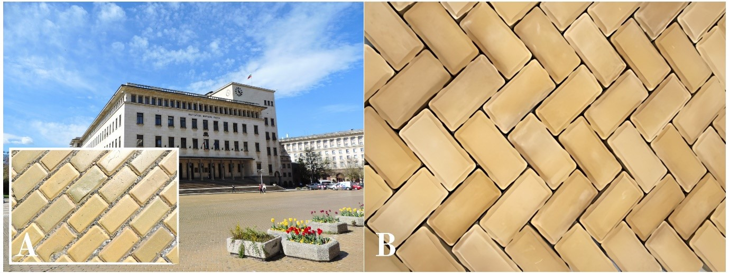

**Figure 1: Yellow pavers from Sofia city center (A) and yellow pavers from the pilot series (B).**

***3.2. Microscopic examination***

The microscopically analyzed ceramic samples have a cryptocrystalline structure, the mineral composition is optically indeterminate (Figure 2 a, b) except for the quartz grains present in the composition (Figure 2 c, d). The amount of quartz is about 5% and is up to 250 μm in size. The quartz grains are clear with an angular shape and the larger ones are fractured. The colour of the cryptocrystalline matrix is a uniform yellowish-brown mottled in places with rusty-brown iron hydroxides. Closed micropores up to 300 μm long without orientation are observed, probably due to phase transitions during the synthesis of the material.

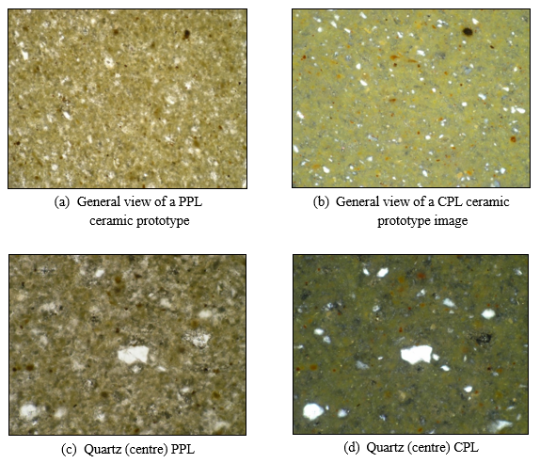

**Figure 2: Petrographic analysis. (a) General view of a PPL (Parallel Polarized Light) ceramic prototype image with width of field of view (FOV) = 3980 μm, (b) General view of a CPL (Crossed Polarized Light) ceramic prototype image FOV=3980 μm, (c) Quartz (centre) PPL, FOV=1980 μm, (d) Quartz (centre) CPL, FOV=1980 μm.**

***3.3. X-ray diffraction of powder samples***

Using powder X-ray diffraction, the mineral phases involved in the composition of the new ceramic product (P1) were determined (Figure 3). The following mineral composition was recorded: wollastonite, diopside (two phases), plagioclase, and quartz. Quantitatively, wollastonite Ca3Si3O9 (42.3%) and the two recorded phases of diopside CaMgSi2O6 (19.4%) and Fe-containing diopside (12.2%) dominate the total composition. Plagioclase CaAl2Si2O8 (21.5%) and quartz SiO2 (4.6%) are in subordinate amounts. The same mineral composition was found in the original articles [3], but in different proportions: diopside (62.0%), palgioclase anorthite (37.0%), quartz (1%) and traces of wollastonite.

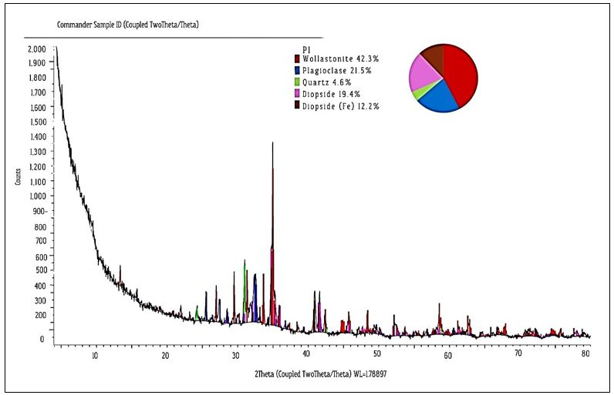

**Figure 3: Powder X-ray diffraction of sample P1 (finished ceramic article).**

***3.4.* *Scanning electron microscope (SEM-EDS) study of metallographic specimens***

Scanning electron microscope examination of polished metallographic specimens of the new ceramics (Figure 4) shows that its predominant mass is composed of wollastonite and diopside (Table 1).

Wollastonite is characterized by crystals that possess idiomorphic to xenomorphic outlines. In addition to larger xenomorphic masses, it is also commonly found as clusters of microcrystals forming larger wollastonite aggregates. Unlike wollastonite, diopside exhibits mostly idiomorphic outlines of its short prismatic, plate-like crystals that have grown in different directions.

Anorthite builds up a cryptocrystalline bulk that includes wollastonite, diopside and quartz.

The quartz in the analyzed section is represented by rounded quartz grains up to about 50 µm in size. Its grains are ‘rimmed’ by a cluster of short prismatic wollastonite microcrystals, which penetrate it in places.

Iron oxides are observed in clusters (up to about 50 µm in size) of multiple globules up to 1 µm in size. Due to their small size, they were only qualitatively analysed.

Also observed in the examined metallographic specimens of the new ceramics are numerous closed micropores with sizes up to 100 µm.

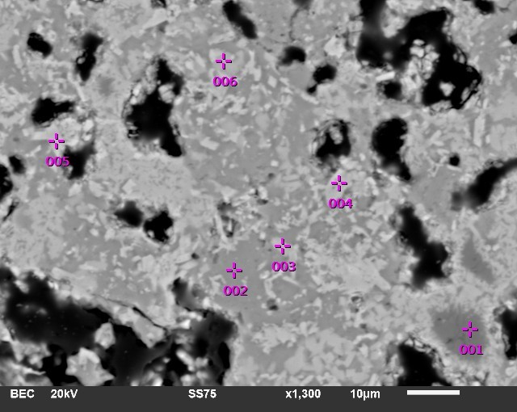

**Figure 4: Backscattered electrons image of a new ceramic product.**

**Table I:** **Chemical composition of quartz, anorthite, wollastonite and diopside obtained by using SEM-EDS analysis.**

|  |  |  |  |  |  |  |
| --- | --- | --- | --- | --- | --- | --- |
|  | **1** | **2** | **3** | **6** | **4** | **5** |
| SiO2 | 100.00 | 48.08 | 53.82 | 53.58 | 44.15 | 40.97 |
| TiO2 | 0.00 | 0.00 | 0.00 | 0.00 | 1.00 | 1.79 |
| Al2O3 | 0.00 | 30.91 | 3.00 | 4.13 | 13.33 | 13.23 |
| FeO | 0.00 | 2.16 | 0.00 | 0.00 | 10.21 | 12.44 |
| MgO | 0.00 | 0.00 | 1.31 | 0.91 | 6.70 | 7.17 |
| CaO | 0.00 | 17.17 | 40.28 | 40.91 | 20.46 | 23.71 |
| Na2O | 0.00 | 0.70 | 0.00 | 0.00 | 0.20 | 0.32 |
| K2O | 0.00 | 0.98 | 1.60 | 0.47 | 3.95 | 0.38 |
| Ʃ | 100.00 | 100.00 | 100.01 | 100.00 | 100.00 | 100.01 |
|  | *quartz* | *anorthite* | *wollastonite* | *wollastonite* | *diopside* | *diopside* |

Figure 5 shows a triple diagram of pyroxenes composition.

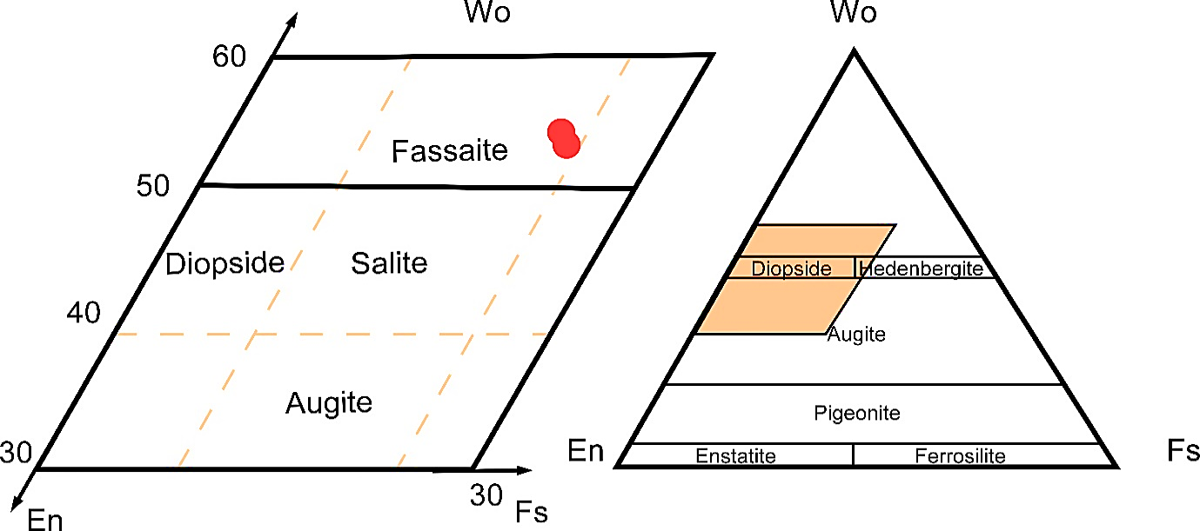

**Figure 5: Triple diagram (Wo-En-Fs) of pyroxenes composition [12], [13].**

The percentage contents of the major oxides for the different mineral phases – quartz, anorthite, wollastonite and diopside – are presented in Table 1. The composition of diopside corresponds to the fassaite type according to the nomenclature of pyroxenes [13], placed on a triangular diagram with end members wollastonite, enstatite, and ferrosilite (Figure 5). This mineral composition corresponds to that of the original yellow pavers [11].

***3.5. Tomographic analysis***

The computed tomography method was used to obtain information about the volume of the material as well as to calculate the porosity. A 3D X-ray micro-tomograph SkyScan 1272 was used to perform a tomographic examination of an irregularly shaped specimen with approximate dimensions of 12 x 13 x (11 mm wide at its widest part and 3.5 mm wide at its narrowest part). The selected scan settings were as follows: source voltage 100 kV, source current 100 µA, pixel size 16,1999 µm, Cu filter 0,11mm, resolution: 1632 x 1092 pxl, full rotation of the specimen with 0,4º rotation step. After scanning, a reconstruction of the specimen was performed (using NRecon software), in which the resulting X-ray projections were “assembled” to produce a digital model of the specimen. Using CTVox software, a visualisation of the specimen has been obtained, so that it can be viewed from all sides and sections in different cross-sections can be made. CTAn software was used to calculate various geometric parameters, in this case yielding data on closed, open and total porosity, pore diameters and their percentage distribution in the specimen volume. Figure 6a shows visualizations of the specimen rotating along its vertical axis

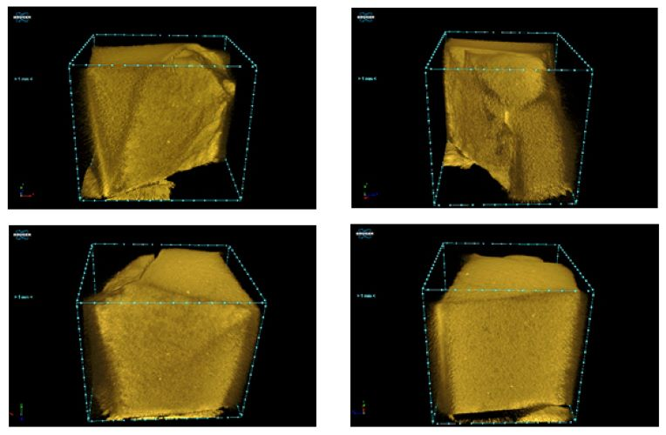

**Figure 6: Visualizations of the specimen rotating along its vertical axis.**

Figure 7 shows longitudinal cross-sections of the scanned specimen. Pores limited in size and frequency (the darker patches) as well as particles denser than the parent material (lighter in color) are observed.

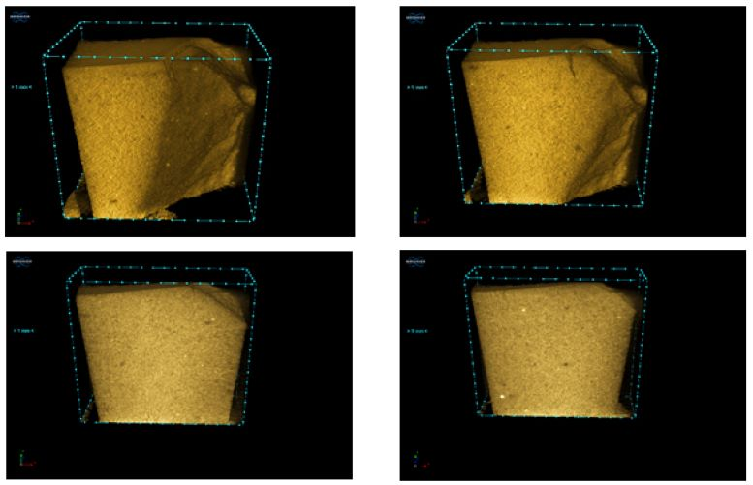

**Figure 7: Longitudinal cross-sections of the specimen.**

In Figure 8 are shown cross-sectional sections of the specimen. Single pores as well as denser particles are visualized here as well.

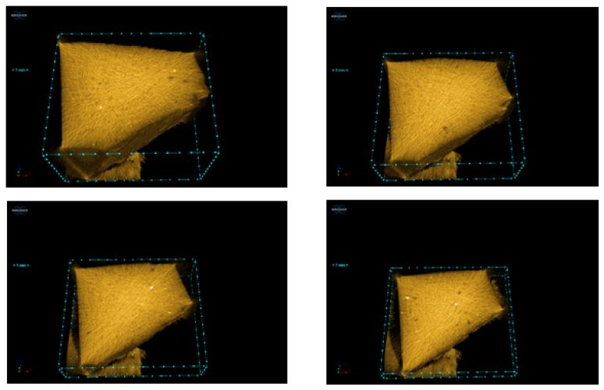

**Figure 8: Cross-sectional sections of the specimen.**

Percentage of closed and open pores, general porosity and pore diameters are shown in Tables 2 and 3*.*

**Table II: Percentage of closed pores.**

|  |  |  |
| --- | --- | --- |
| **Pore type** | **%** | **Pore size, mm** |
| Closed | 0.249 | Mininum average diameter 0.0324 |
| Maximum average diameter 0.259 |
| Average diameter 0.146 |

**Table III:** **Amount of pores.**

|  |  |
| --- | --- |
| **Average pore diameter, mm** | **Percentage of sample volume, %** |
| 0.0324 | 29.53 |
| 0.0648 | 44.33 |
| 0.0972 | 14.02 |
| 0.013 | 7.18 |
| 0.162 | 2.72 |
| 0.194 | 0.47 |
| 0.227 | 1.05 |
| 0.259 | 0.7 |

Figure 9 visualizes the dense particles in the specimen in the minimum intensity mode of the projections – a mode in which information about the less dense part of the specimen, in this case the base material, is lost, while the particles with the highest densities are highlighted and visualized.

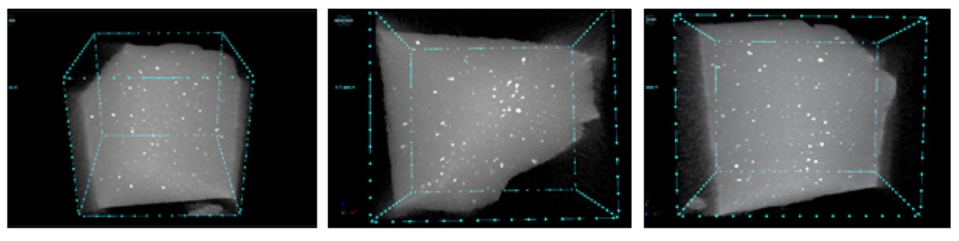

**Figure 9: Visualization of dense particles in minimum intensity mode at different spatial orientation of the specimen.**

Thirty cross-sectional measurements of particle diameters were made, with the following results: mean diameter 0.0816 mm; maximum diameter 0.177 mm; minimum diameter 0.0248 mm.

# CONCLUSIONS

The results can be summarized in the following conclusions:

* Macroscopically, the pilot series of yellow paving stones fully matches the colour characteristics of the most common yellow pavers layed in the streets in Sofia’s central urban area;
* Microscopically, the ceramics is cryptocrystalline with a presence of individual quartz grains injected into the main mass;
* During the firing of the primary material, the formation of different mineral phases occurs: of pyroxene (diopside of the fassaite type), wollastonite and anorthite, which are the product of solid state reactions between carbonates and clay minerals;
* The mineral phase diopside of the fassaite type, which has been registered, determines the yellow colouring of the ceramics without further staining;
* The presence of a higher percentage of wollastonite is a favourable factor contributing to better physico-mechanical properties of the new ceramics;
* The quantitative content of closed pores in the overall volume of the ceramic article is minimal. Their presence improves tribological performance;
* Based on the mineralogical and structural characteristics, we can conclude that the pilot series of yellow pavers has similar characteristics to those of the original ones. Further studies of the physical and mechanical properties will complement the analyses carried out here, enabling the absolute characterization of the new ceramics products.

**REFERENCES**

1. Pristavova S, Marinova K. 2024. Rocks and buildings in the Sofia City center – a geological and historical city tour. Geologica Balcanica 53 (3), 13–21. doi.org/10.52321/GeolBalc.53.3.13.
2. Boyadjieva E. 2012. Yellow Paving Stones - Ceramics, Aesthetics, Symbolism (in Bulgarian).

<https://web.archive.org/web/20120211010330/http://www.sofia.bg/j_paveta.asp>

1. Kostov-Kytin V, Nikolov A, Velyanova G, Tsvetanova L, Karamanov A. 2024. Preliminary studies of Bulgarian natural raw materials as possible sources for the synthesis of high-quality ceramics of the “yellow” pavers type - REVIEW OF THE BULGARIAN GEOLOGICAL SOCIETY, vol. 85, part 2, 2024, p. 3–18. doi.org/10.52215/rev.bgs.2024.85.2.3
2. Gacheva M, Lakov L, Toncheva K. 2019. Technology for production and experimental furnace for hitting of article”Yellow Bricks”. – NDT DAYS: Vol. II, Issue 2, 169–172.
3. Mutafchieva G, Lakov L, Aleksandrova M, Peev G. 2022. Technology for production of reduced yellow paving stones on the basis of modified marl clay from the Alexandra quarry, the village of Lovets, Bulgaria (Part 1). – Machines. Technologies. Materials., 16, 3, 96–99.
4. Mutafchieva G, Lakov L, Aleksandrova M, Gacheva M, Peev G, Mihaylov D. 2022b. Development and production of molding equipment and plastic masses using new compounding formulations, plastic pressing, drying, hightemperature liquid-phase synthesis and properties of a prototype batch of “yellow” paving stones. – Industry 4.0, 7, 6, 228–231.
5. Mutafchieva G, , Lakov L, Peev G, Mihaylov D. 2023. Results from the plastic pressing of experimental ceramic pavers of “yellow” paving stone type. – Innovations, 11, 1, 34–36.
6. Lakov L, Toncheva K, Jivov B, Gacheva M. 2022. Technical project for creating a business plan for the construction of a technological line and a plant for the production of yellow pavers. – International Journal NDT Days, 5, 1.
7. Lakov L, Encheva S, Tsonev P, Jivov B, Aleksandrova M, Toncheva K. 2018. PRODUCTION OF PROTOTYPES of “yellow paving stones” in Bulgaria PART I: Physic AL and chemical properties. Journal of Chemical Technology and Metallurgy, 53, 6, 1144-1149.
8. Munsell soil color charts. 2000. Munsell Color, gretagmacbeth.
9. Enchev S, Petrov P, Yanakieva D, Lakov L, Yankova K. 2016. Why are the yellow bricks yellow? GEOSCIENCES, 23-24.
10. Minguzzi V, Morandi N, Nannetti MC, Pirani R, Poppi L. (1976-77) Mineralogy and geochemistry of the contact minerals in the Predazzo-Monzoni area. Part II: the Predazzo fassaite and revision of the fassaite crystal-chemistry. Miner Petrogr Acta 21: 189–219.
11. Morimoto N. (1988) The Nomenclature of Pyroxenes. Mineralogical Magazine, 52, 425-433.