**OPEN ACCESS *Journal***



***Of Modern Engineering Research (IJMER)***

**Wireless Sensor Network Dependable Monitoring For Urban Air Quality**

Dr.N.Srinivas1, M.Premalatha2, B .Shiva Darshan3,A.Vijay Kumar4 and Ch.Shiva Reddy5

*1Associate Professor,Department of Electronics & Communication Engineering, Guru Nanak Institute of Technology, Hyderabad, India.*

*2Assistant Professor,Department of Electronics & Communication Engineering, Guru Nanak Institute of Technology, Hyderabad, India.*

*3Department of Electronics & Communication Engineering, Guru Nanak Institute of Technology, Hyderabad, India.*

*4Department of Electronics & Communication Engineering, Guru Nanak Institute of Technology, Hyderabad, India.*

*5Department of Electronics & Communication Engineering, Guru Nanak Institute of Technology, Hyderabad, India.*

*Corresponding Author e mail : [1](mailto:-arzavvsswamy1962@gmail.com)[nsrinivas.gnit@gmail.com](mailto:-arzavvsswamy1962@gmail.com)*

*2premalatham.ecegnit@gniindia.org*

*3shivamudhiraj1878@gmail.com*

*4vijaykumarakiti341@gmail.com*

*5shivareddy18011@gmail.com*



***Abstract****:This paper introduces an Internet of Things (IoT)-enabled cost-effective wireless sensor network featuring novel dependable strategies aimed at enhancing reliability in the surveillance of air quality within suburban regions. The system incorporates sensor units for router communications, emphasizing energy efficiency through dynamic conservation techniques.To evaluate the system's performance, we employed rigorous analyses based on reliability functions and mean time to failure metrics. Our findings indicate that the proposed monitoring network achieves a high level of availability, surpassing an 80% survival probability over a minimum 72-hour operational period. This level of reliability is crucial for continuous and uninterrupted monitoring of air quality, especially during critical events or emergencies. The results demonstrate the system's feasibility by showcasing strong correlations with established benchmark monitoring stations. Notably, Pearson's coefficients of 0.903 for PM2.5 and 0.817 for PM10 highlight the accuracy and consistency of our data collection methods.*

*Overall, our paper presents a comprehensive solution for wireless air quality monitoring in suburban areas. By combining IoT capabilities, dependable schemes, energy-saving* s*trategies, and rigorous performance evaluations, we offer a reliable and cost-effective system that can contribute significantly to environmental monitoring and public health management in urban settings.*

***Keywords****: Internet of Thing, dynamic conservation .*

Date of Submission: 22-03-2024 Date of acceptance:

# INTRODUCTION

Wireless sensor networks have emerged as a powerful tool for monitoring urban air quality due to their ability to provide real-time data on pollutant levels and environmental conditions. In urban areas, where air pollution poses significant health risks and environmental challenges, the deployment of wireless sensor networks offers a reliable and efficient solution for monitoring and managing air quality.By leveraging wireless sensors strategically placed throughout the city, authorities can gather continuous and accurate data on air pollutants such as particulate matter, nitrogen dioxide, and ozone. This real-time monitoring capability enables prompt detection of pollution events, identification of pollution sources, and assessment of air quality trends over time.

Moreover, the data collected through wireless sensor networks can be transmitted wirelessly to a central monitoring station, enabling stakeholders to access timely and relevant information on air quality conditions. This data accessibility facilitates informed decision-making, policy development, and targeted interventions to improve air quality and protect public health in urban areas.

In conclusion, the introduction of wireless sensor networks for monitoring urban air quality represents a significant advancement in environmental monitoring technology. By harnessing the capabilities of wireless sensors, cities can establish dependable air quality monitoring systems that enhance environmental sustainability, promote public health, and support evidence-based decision-making for air quality management.

# EXISTING SYSTEM

Wireless sensor networks play a vital role in monitoring urban air quality due to their ability to provide real-time data collection and analysis. In the context of air quality monitoring, these sensors are designed to detect pollutants such as carbon monoxide, sulfur dioxide, and particulate matter, which are common in urban environments and can have detrimental effects on public health and the environment.

The existing system of wireless sensor networks for urban air quality monitoring is designed to continuously collect data on air pollutants at various locations within a city. These sensors are equipped with technology to measure pollutant levels and transmit this data wirelessly to a central monitoring station. This real-time data allows authorities to monitor air quality trends, identify pollution hot spots, and take timely actions to address any issues that arise.

Moreover, wireless sensor networks offer cost-effective solutions for air quality monitoring. Compared to traditional monitoring methods that rely on a limited number of stationary monitoring stations, deploying a network of wireless sensors can provide more comprehensive coverage at a lower cost. This affordability makes it feasible for cities with budget constraints to implement effective air quality monitoring systems.

Overall, the use of wireless sensor networks for urban air quality monitoring offers a scalable, efficient, and data-driven approach to addressing environmental challenges. By leveraging the power of technology and data analytics, cities can enhance their air quality monitoring systems and work towards creating healthier and more sustainable urban environments.

# PROPOSED SYSTEM

Wireless sensor networks play a crucial role in monitoring urban air quality through a proposed system that aims to enhance the existing monitoring infrastructure. These networks consist of interconnected sensors strategically placed throughout urban areas to collect real-time data on air pollutants like carbon monoxide, sulfur dioxide, and particulate matter. The proposed system aims to improve the accuracy and efficiency of air quality monitoring by utilizing advanced sensor technology and data analysis techniques.

The proposed system for monitoring urban air quality using wireless sensor networks involves deploying a network of sensors across the city to capture detailed information on pollutant levels. These sensors are equipped with technology to measure air quality parameters and transmit this data wirelessly to a central monitoring station. By leveraging the capabilities of these sensors, the proposed system aims to provide high-resolution data that can help identify pollution hotspots and trends in air quality.

One of the key advantages of the proposed system is its ability to offer real-time monitoring and data analysis. By continuously collecting data on air pollutants, city officials can promptly respond to changes in air quality and implement targeted interventions to mitigate pollution levels. Additionally, the system can facilitate data analysis and predictive modeling, enabling researchers and policymakers to gain insights into air quality patterns and develop effective strategies for improving urban air quality.

In conclusion, the proposed system for monitoring urban air quality using wireless sensor networks offers a scalable, efficient, and data-driven approach to addressing air quality challenges in urban environments. By leveraging the capabilities of sensor technology and data analytics, cities can enhance their air quality monitoring systems and work towards creating healthier and more sustainable urban environments.

1. **METHODOLOGY**

The methodology for utilizing wireless sensor networks to monitor urban air quality involves a systematic approach to data collection, analysis, and interpretation. This methodology aims to ensure the reliability and accuracy of the air quality monitoring system by following a structured process.

The first step in the methodology is the deployment of a network of sensors strategically placed throughout the urban area. These sensors are designed to measure various air pollutants and environmental parameters continuously. The placement of sensors is crucial to ensure adequate coverage and capture representative data on air quality across different locations within the city.

Once the sensors are deployed, the next step involves data collection and transmission. The sensors collect real-time data on pollutant levels and environmental conditions, which is then transmitted wirelessly to a central monitoring station. This continuous data collection process enables city officials and researchers to monitor air quality trends and identify potential pollution sources or hotspots.

Overall, the methodology for utilizing wireless sensor networks to monitor urban air quality is a comprehensive and systematic process that involves sensor deployment, data collection, validation, and analysis. By following this methodology, cities can establish robust air quality monitoring systems that contribute to public health protection and environmental sustainability.

# FIGURES

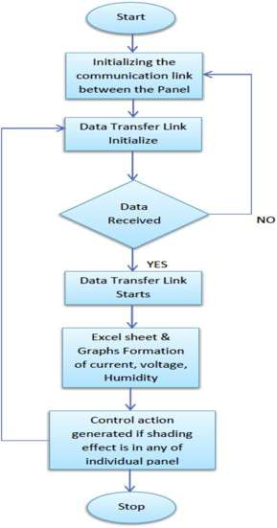

**Figure 1. Flowchart of Working**

# BLOCK DIAGRAM

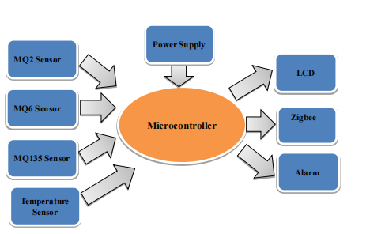

**Figure 2. Block diagram**

**Microcontroller**

**Power Supply**

**ZIGBEE**

**PC**

**Figure 3.Monitoring Section**

# APPLICATIONS

* Public Health Monitoring
* Environmental Regulation Compliance
* Urban Planning and Infrastructure Development
* Traffic Managemenet and Transportation planning
* Community Engagement And Education
* Emergency Response and Disaster Management
* Roadside Pollution Monitoring

# HARDWARE DETAIL

Hardware details of wireless sensor networks for monitoring urban air quality, it's essential to understand the components that make up these systems.

Wireless sensor networks consist of various hardware components that work together to collect, process, and transmit data on urban air quality. The key hardware details of these networks include sensors, nodes, communication modules, and data processing units.

Sensors are the heart of wireless sensor networks for air quality monitoring. Different types of sensors are used to detect specific pollutants such as carbon monoxide, sulfur dioxide, and particulate matter. These sensors measure pollutant concentrations and environmental parameters like temperature and humidity, providing crucial data for assessing air quality.

Communication modules enable wireless connectivity within the sensor network. These modules facilitate the transmission of data between sensor nodes, allowing for real-time monitoring of air quality across different locations in the urban area. Communication protocols such as Zigbee, LoRa, or Wi-Fi are commonly used to establish reliable communication links in wireless sensor networks.

Data processing units play a vital role in handling the large volume of data generated by sensors in urban air quality monitoring. These units process and analyze sensor data to extract meaningful insights, identify pollution trends, and generate actionable information for decision-makers. Data processing units may include microcontrollers, processors, and storage devices to manage data effectively.

In summary, the hardware details of wireless sensor networks for monitoring urban air quality encompass sensors, nodes, communication modules, and data processing units that work in synergy to create a robust monitoring system. These components form the foundation of dependable air quality monitoring solutions in urban environments.

# DESCRIPTION OF SOFTWARE

Software aspect of wireless sensor networks for monitoring urban air quality, it's crucial to understand the role that software plays in processing, analyzing, and visualizing the data collected by the sensors.

The software used in these networks includes data processing algorithms, data visualization tools, and communication protocols. Data processing algorithms are essential for interpreting the raw sensor data, identifying patterns, and generating meaningful insights regarding air quality levels. These algorithms help in detecting pollution trends, forecasting air quality changes, and providing actionable information for decision-makers.

Data visualization tools are used to present the processed data in a user-friendly format, such as graphs, charts, and maps. Visualization tools enable stakeholders to easily interpret the air quality data, track pollution levels over time, and make informed decisions based on the visual representations of the data.

Communication protocols are another critical aspect of the software in wireless sensor networks. These protocols govern how data is transmitted between sensor nodes, ensuring reliable and efficient communication within the network. By using robust communication protocols, data can be transmitted securely and in a timely manner, enabling real-time monitoring of urban air quality.

In summary, the software components in wireless sensor networks for monitoring urban air quality play a vital role in processing, analyzing, and visualizing sensor data. These software tools are essential for making sense of the vast amount of data collected by sensors and turning it into actionable insights for improving air quality in urban areas.

# SIMULATION RESULT



**Table.1 The six standard pollutants and their health effects**

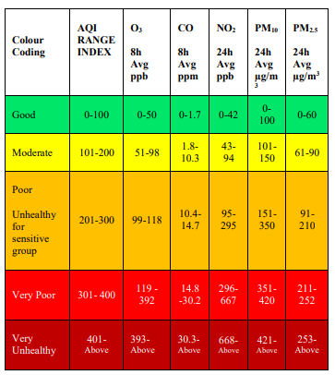

**Table.2 Air Quality Index (Indian Standards) Sub-index**

Air Quality Index, sub-categories proposed by IITM (MoES) for the Indian standards. Each group corresponds to the various levels of health risks.

• Good: Air quality is good and no health hazard when the AQI value is between 0 to 50

• Moderate: Air quality is acceptable and can cause respiratory problems to those who are sensitive to ozone or particle pollutants when the AQI value is in the range of 51- 100.

• Unhealthy: Only Sensitive group will experience health effects when the AQI value is in the range of 101-150.

• Unhealthy: Every person will experience the risk of health concerns, and the sensitive group will have serious health issues when AQI is between 150 – 200.

• Very Unhealthy: Poses severe health problems to all when AQI value is in the range of 201 - 300.

•Hazardous: AQI values above 300 represent acute health effects; it's a health emergency condition.

# SCHEMATIC DIAGRAMS

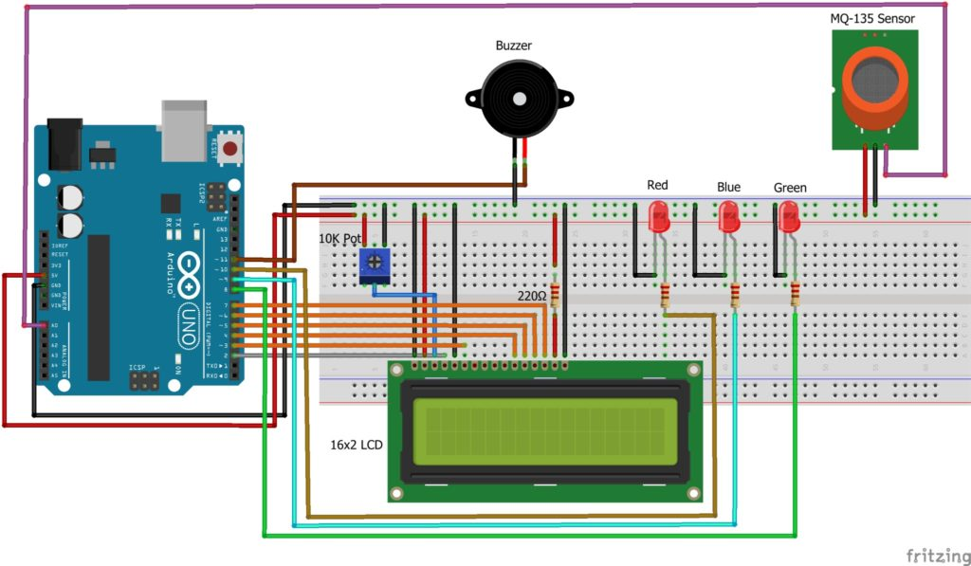

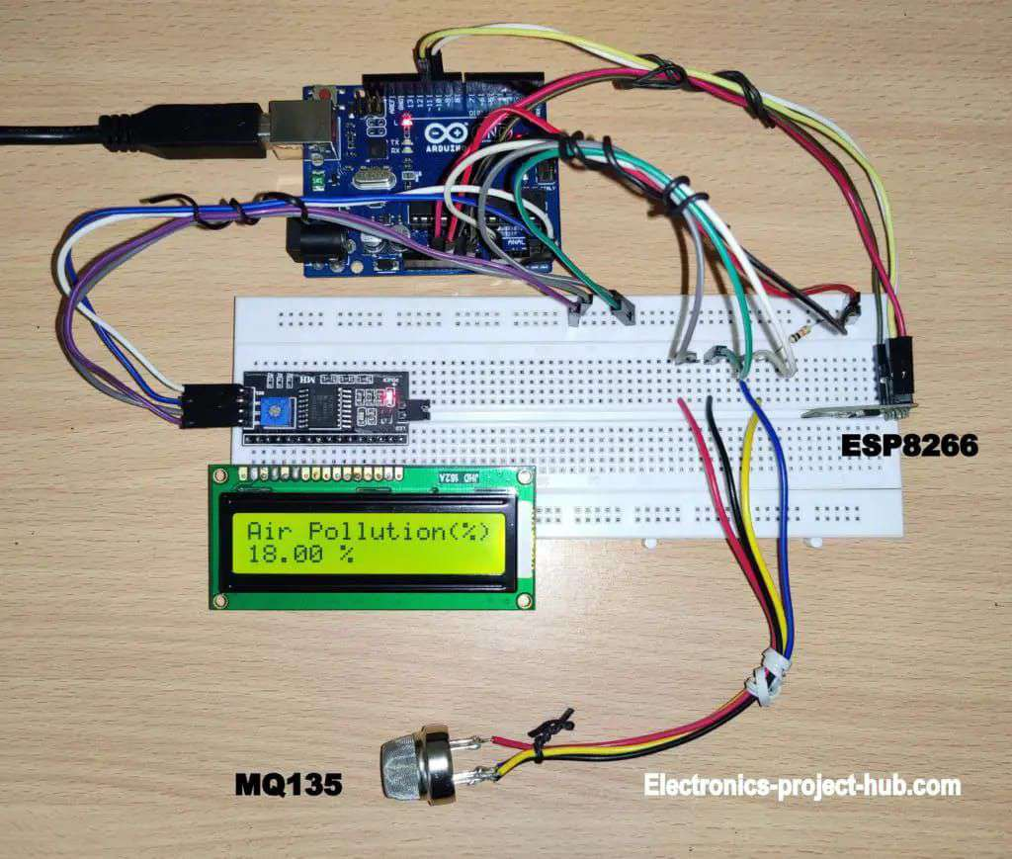

**Figure 4. Hardware**

**CONCLUSION**

The project aims to address the common issue of forgetting keys or accidentally getting locked out of one's home. In such scenarios, gaining access can be challenging. The proposed solution offers a keyless entry system to alleviate these concerns while enhancing security.

By implementing a keyless entry system, individuals can access their homes without the need for traditional keys. This is particularly beneficial in situations where keys are forgotten or misplaced. Additionally, the system provides a secure alternative to conventional locks, reducing the risk associated with physical keys being lost or stolen. Project likely incorporates advanced technologies such as electronic locks, password or PIN-based entry, or even biometric authentication for enhanced security. The integration of such features not only ensures convenient access but also enhances the overall safety of the home.

In summary, the keyless entry system serves as a practical and secure solution to the common problem of forgetting keys or accidentally getting locked out. It introduces modern and reliable methods of access control, providing individuals with a more convenient and secure means of entering their homes. In conclusion, the microcontroller-based OTP Lock for an integrated home security system offers a promising solution to enhance access control and safeguard residential spaces. While this technology provides advanced security features, it is crucial to address existing vulnerabilities and continuously improve the system's overall resilience. The proposed enhancements, including advanced encryption, biometric authentication, continuous security audits, and physical security measures, contribute to fortifying the system against cyber threats and unauthorized access. Implementing two-factor authentication, secure firmware updates, and multi-user permission controls further elevate the system's security posture. However, it's essential to recognize that security is an ongoing process, and staying vigilant against emerging threats is paramount. Regular updates, user education on secure practices, and collaboration with cybersecurity experts are key elements in maintaining the effectiveness of the microcontroller-based OTP Lock. In deploying and utilizing this technology, a balanced approach that considers both the hardware and software aspects, as well as the human factor, will contribute to a robust and reliable home security solution. As advancements in technology continue, adapting the system to incorporate the latest security standards and practices will ensure its relevance and effectiveness in safeguarding homes in the ever-evolving landscape of security challenges.

##### **ACKNOWLEDGMENT**

This project acknowledges the inspiration, drive, and technical assistance provided by numerous individuals. Without their help and guidance, this project would not have come to fruition.We are immensely thankful to all the individuals whose dedication and support helped turn our idea into a tangible, impact application.

# **REFERENCES**

[01] P. Rathore, A. S. Rao, S. Rajasegarar, E. Vanz, J. Gubbi, and M. Palaniswami, ‘‘Real-time urban microclimate analysis using Internet of Things,’’ IEEE Internet Things J., vol. 5, no. 2, pp. 500–511, Apr. 2018.

[02] N. Tcholtchev and I. Schieferdecker, ‘‘Sustainable and reliable information and communication technology for resilient smart cities,’’ Smart Cities,vol. 4, no. 1, pp. 156–176, Jan. 2021.

[03] D.-I. Curiac, C. Volosencu, D. Pescaru, L. Jurca, and A. Doboli, ‘‘Redundancy and its applications in wireless sensor networks: A survey,’’ WSEAS Trans. Comput., vol. 8, no. 4, pp. 705–714, 2009.

[04] K.-C. Chu, D.-J. Horng, and K.-C. Chang, ‘‘Numerical optimization of theenergy consumption for wireless sensor networks based on an improvedant colony algorithm,’’ IEEE Access, vol. 7, pp. 105562–105571, 2019.Access, vol. 7, pp. 145667–145676, 2019.

[05]<https://ieeexplore.ieee.org/document/9756011/>

[06]https://www.researchgate.net/publication/322089252_Issues_of_using_wireless_sensor_network_to_monitor_urban_air_quality