Optimization of *Pichia pastoris* Genomic DNA Extraction Methods and PCR Systems

Xiaonan Ju, Boyu Jia, Guiwei Sun, Huan Wang, Qian Li

*School of Life and Health, Dalian University, China*

*Corresponding Author: Qian Li, liqian@dlu.edu.cn*

*ABSTRACT: The non-conventional yeast Pichia pastoris is not only an important protein expression system but has recently gained attention as a chassis cell for cellular factories due to its methanol utilization capabilities. Therefore, optimizing the efficiency of its basic molecular biology operations is crucial. Genomic PCR plays a fundamental role in experimental studies, with yeast cell wall disruption being a critical step in extracting genomic DNA. This study draws upon various yeast genomic extraction protocols, utilizing five different methods for P. pastoris DNA extraction: NaOH, LiAc, LiCl, glass bead disruption, and direct cell wall lysis using lyticase. These methods were optimized during the study. The extracted DNA was amplified using three different enzyme systems: Taq, ExTaq, and PrimeStar, to evaluate the effects of polymerase fidelity and amplification efficiency on genomic DNA. Additionally, three sets of primers were designed to amplify products of varying lengths, allowing us to examine the PCR preferences concerning product size. Through comprehensive comparison, this study aims to provide a fast, efficient, and cost-effective PCR system for P. pastoris genomic DNA.*

***KEY WARDS:*** *Pichia pastoris, genomic DNA extraction, PCR system optimization, cell wall disruption*

---------------------------------------------------------------------------------------------------------------------------------------

Date of Submission: xx-xx-xxxx Date of acceptance: xx-xx-xxxx

---------------------------------------------------------------------------------------------------------------------------------------

# INTRODUCTION

Yeast, a simple eukaryote, has long been a subject of extensive research due to its rapid growth, ease of cultivation, and straightforward genetic manipulation [1]. Among them, *Pichia pastoris*, a non-conventional yeast, has attracted significant attention as an important recombinant protein expression system [2; 3]. It can correctly translate and post-translationally modify foreign eukaryotic genes, while also secreting many protein products, facilitating their purification [4; 5]. With the advancement of synthetic biology, *P. pastoris* has emerged as a key microbial chassis organism for cell factories, as it can utilize methanol as a sole carbon source [6].

Genomic PCR is fundamental in molecular biology, consisting of two key steps: DNA extraction and amplification. The main challenge in yeast DNA extraction is the disruption of the cell wall, which directly affects extraction efficiency. In this study, we used several yeast genomic extraction methods reported in the literature, such as the glass bead[7], LiAc [8], and NaOH methods [9]. The NaOH method leverages the strong alkaline environment to solubilize and denature proteins, disrupt the cell and nuclear membranes, and inactivate nucleases, releasing DNA without affecting its primary structure. The LiAc method, on the other hand, uses LiAc and SDS to temporarily permeabilize the yeast cell, allowing DNA to pass freely. SDS, an anionic detergent, removes contaminant proteins, while ethanol precipitates and concentrates the DNA. LiCl follows a similar principle to LiAc. The glass bead method, a physical approach, disrupts the cell wall through mechanical friction during high-speed shaking. Lyticase, an enzyme capable of hydrolyzing fungal cell walls, was also tested, with an optimized protocol for direct genomic extraction in this study.

In the PCR amplification step, we evaluated the efficiency of different commercial DNA polymerases, including Taq, ExTaq[10], and PrimeStar (Takara), which represent varying levels of fidelity and amplification efficiency. By comparing DNA extraction and amplification efficiencies, this study provides valuable insights for optimizing genomic PCR in *Pichia pastoris* for synthetic biology research.

# MATERIAL AND METHODS

* 1. ***Strain and Medium***

*Pichia pastoris* strain GS115 was obtained from our laboratory's collection. The YPD medium (w/v) contained 1% yeast extract, 2% peptone, and 2% glucose. For solid media, 2% agar was added.

* 1. ***Primers***

The primers used in this study are listed in Table 1.

***Table I*. Primers**

|  |  |
| --- | --- |
| Primer | Sequence（5’-3’） |
| RPL4IBt-Ⅱ3-F | AAACATATAGCCATGGTTATTATCGATATTGTTTTTTC |
| RPL4IBt-Ⅱ3-R | GGCTAGCATTATGGTTGCAACTCATCATTC |
| HB-Ⅱ3-F | TTGCAACCATAATGCTAGCCTAGTTGTC |
| HB-Ⅱ3-R | GGATCCCCGGGTACCGAGCTAATGCAGATTCTGAGACTAC |
| ZwfI-F | AACATCAAAACTCGAATGACCGATACGAAAGCCG |
| ZwfI-R | TCGATAATAACCATGTTACATCTTGTGCAGCACATCGG |

* 1. ***Yeast Culture Method***

A 50 µL aliquot of *Pichia pastoris* GS115 liquid seed culture was inoculated into 5 mL of YPD medium and incubated at 30°C with shaking at 180 rpm overnight (~12 hours). When the OD600 of the culture reached approximately 1, cells were harvested for genomic DNA extraction.

* 1. ***Genomic DNA Extraction Methods***

NaOH Method: Cells were harvested from 200 µL of culture and resuspended in NaOH solution for genomic DNA extraction.

LiAc Method: Cells were treated with LiAc and SDS solution followed by ethanol precipitation to extract genomic DNA.

LiCl Method: The same steps as the LiAc method, but using LiCl instead of LiAc.

Glass Bead Method: Cells were disrupted using glass beads with vigorous shaking to break the cell wall.

Lyticase Method: Cells were treated with lyticase and incubated at 30°C for direct genomic extraction.

* 1. ***PCR Conditions***

PCR amplification was carried out using Taq, ExTaq, and PrimeStar polymerases (Takara). Reaction conditions for Taq/ExTaq: 94°C for 5 min, followed by 30 cycles of 94°C for 30 s, 55°C for 30 s, and 72°C for 1 min/kb. For PrimeStar: 98°C for 20 s, 55°C for 5–15 s, and 72°C for 5 s/kb, with 30–35 cycles. PCR products were analyzed by 1% agarose gel electrophoresis.

# Results and Discussion

In this study, five methods for extracting genomic DNA from *P. pastoris* were employed, including the NaOH method, LiAc method, LiCl method, glass bead method, and Lyticase method. The primary difference between these methods lies in how they break the yeast cell wall. The genomic DNA extracted by each method was subjected to PCR amplification using enzymes with varying fidelity and amplification efficiency. Considering the bias in amplification efficiency for different fragment lengths, three sets of primers were selected to amplify products of approximately 500 bp, 1 kb, and 1.5 kb. The amplification efficiency under different conditions was evaluated through agarose gel electrophoresis.

As shown in Figure 1, using the NaOH method, clear bands were observed in lanes 1, 3, 4, and 6, while no results were obtained in lanes 2, 5, and 7-9. This indicates that both Taq polymerase and ExTaq polymerase successfully amplified small fragments (500 bp) and large fragments (1500 bp), with Taq polymerase showing superior performance compared to ExTaq polymerase. However, neither enzyme produced results for the medium fragment (1000 bp), and Prime Star polymerase failed to generate any amplification. Therefore, the NaOH method is best paired with Taq polymerase, while Prime Star polymerase is not suitable for this method.

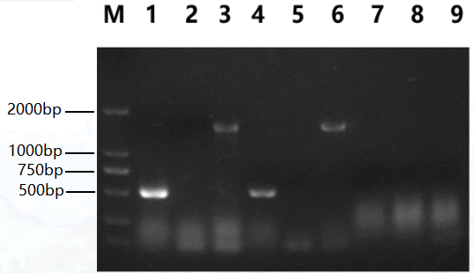

**Figure 1: PCR amplification results of *P. pastoris* genomic DNA extracted using the NaOH method.**

M: DL2000 marker; 1-3: amplification of 506 bp, 1000 bp, and 1515 bp fragments using Taq polymerase; 4-6: amplification using ExTaq polymerase; 7-9: amplification using Prime Star polymerase.

As illustrated in Figures 2 and 3, the electrophoresis results from the LiCl and LiAc methods were identical. Taq polymerase exhibited good amplification efficiency for the 500 bp fragment, while ExTaq polymerase amplified all three fragment sizes, outperforming Taq polymerase. Prime Star polymerase produced no amplification. These findings suggest that ExTaq polymerase is optimal for use with these two DNA extraction methods, followed by Taq polymerase, while Prime Star polymerase is not suitable.

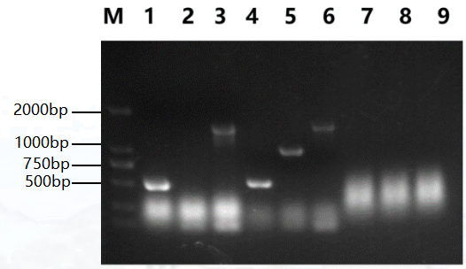

**Figure 2: PCR amplification results of *P. pastoris* genomic DNA extracted using the LiAc method.** M: DL2000 marker; 1-3: amplification of 506 bp, 1000 bp, and 1515 bp fragments using Taq polymerase; 4-6: amplification using ExTaq polymerase; 7-9: amplification using Prime Star polymerase.

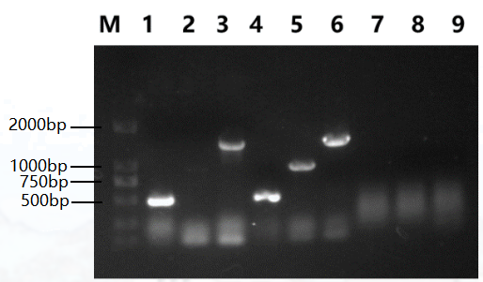

**Figure 3: PCR amplification results of *P. pastoris* genomic DNA extracted using the LiCl method.** M: DL2000 marker; 1-3: amplification of 506 bp, 1000 bp, and 1515 bp fragments using Taq polymerase; 4-6: amplification using ExTaq polymerase; 7-9: amplification using Prime Star polymerase.

Figure 4 shows that when using the glass bead method to extract genomic DNA, Taq polymerase only amplified the 500 bp fragment, while ExTaq polymerase stably amplified fragments of all three sizes, demonstrating no length preference. Prime Star polymerase failed to produce any amplification. Thus, ExTaq polymerase is recommended for use with this extraction method, while Prime Star polymerase is not suitable.

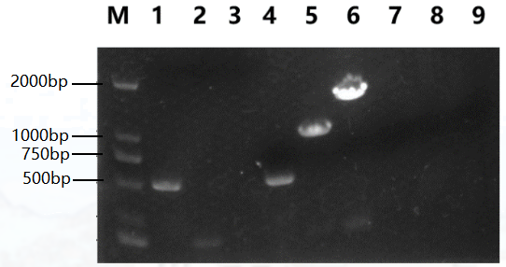

**Figure 4: PCR amplification results of *P. pastoris* genomic DNA extracted using the glass bead method.**

M: DL2000 marker; 1-3: amplification of 506 bp, 1000 bp, and 1515 bp fragments using Taq polymerase; 4-6: amplification using ExTaq polymerase; 7-9: amplification using Prime Star polymerase.

As shown in Figure 5, when using the Lyticase direct lysis method for genomic DNA extraction, only Prime Star polymerase produced amplification for the 500 bp fragment, while no amplification was observed with other enzymes. This result suggests that the cell wall was not fully disrupted using this method.

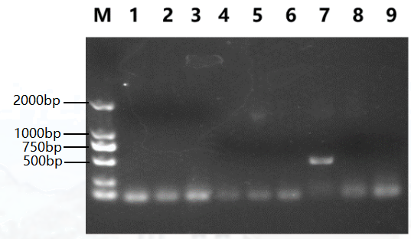

**Figure 5: PCR amplification results of *P. pastoris* genomic DNA extracted using the Lyticase direct lysis method.**

M: DL2000 marker; 1-3: amplification of 506 bp, 1000 bp, and 1515 bp fragments using Taq polymerase; 4-6: amplification using ExTaq polymerase; 7-9: amplification using Prime Star polymerase.

***Table II*. Evaluation of the Effectiveness of Different Genomic DNA Extraction Methods and DNA Polymerase Combinations**

Extraction Method

|  |  |  |  |  |  |
| --- | --- | --- | --- | --- | --- |
| Polymerase | NaOH | LiAc | LiCl | Glass Bead | Lyticase Direct Lysis |
| Taq Polymerase | ⭐⭐⭐ | ⭐⭐ | ⭐⭐⭐ | ⭐⭐ | ⭐ |
| Ex Taq Polymerase | ⭐⭐ | ⭐⭐⭐ | ⭐⭐⭐ | ⭐⭐⭐ | ⭐ |
| Prime Star Polymerase | ⭐ | ⭐ | ⭐ | ⭐ | ⭐⭐ |

Note: More stars indicate higher amplification efficiency.

By comparing Figures 1-5, it is evident that the LiCl and LiAc extraction methods are simpler, faster, more efficient, and more cost-effective than other methods. Among them, the LiCl method yielded the clearest and brightest electrophoresis bands with minimal tailing, making it the most effective method for extracting *Pichia pastoris* genomic DNA (Table 2). The NaOH method, while straightforward, can serve as a secondary option. Although the Lyticase direct extraction method is simple to use, its extraction efficiency is poor, and the required lytic enzymes are costly, so it is not recommended. The glass bead method, which involves numerous steps and toxic reagents, is time-consuming and should be used with caution.

# Conclusion

The LiCl method combined with either ExTaq or Taq polymerase provides the highest amplification efficiency for *P. pastoris* genomic DNA PCR, making it suitable for daily research needs in the laboratory.

**REFERENCES**

[1]. Lian, J., HamediRad, M., and Zhao, H. (2018). "Advancing Metabolic Engineering of Saccharomyces cerevisiae Using the CRISPR/Cas System." Biotechnology Journal, 13(9), e1700601.

[2]. Karbalaei, M., Rezaee, S. A., and Farsiani, H. (2020). "*Pichia pastoris*: A highly successful expression system for optimal synthesis of heterologous proteins." Journal of Cellular Physiology, 235(9), 5867-5881.

[3]. Lin-Cereghino, J., Naranjo, C. A., and Lin-Cereghino, G. P. (2022). "Competent Cell Preparation and Transformation of *Pichia pastoris*." Methods in Molecular Biology (New York), 2513, 113-120.

[4]. Mastropietro, G., Aw, R., and Polizzi, K. M. (2021). "Expression of proteins in *Pichia pastoris*." Methods in Enzymology, 660, 53-80.

[5]. Barone, G. D., Emmerstorfer-Augustin, A., Biundo, A., Pisano, I., Coccetti, P., Mapelli, V., and Camattari, A. (2023). "Industrial Production of Proteins with *Pichia pastoris-Komagataella phaffii*." Biomolecules, 13(3).

[6]. Hou, R., Gao, L., Liu, J., Liang, Z., Zhou, Y. J., Zhang, L., and Zhang, Y. (2022). "Comparative proteomics analysis of *Pichia pastoris* cultivating in glucose and methanol." Synthetic and Systems Biotechnology, 7(3), 862-868.

[7]. Dederich, D. A., Okwuonu, G., Garner, T., Denn, A., Sutton, A., Escotto, M., Martindale, A., Delgado, O., Muzny, D. M., Gibbs, R. A., and Metzker, M. L. (2002). "Glass bead purification of plasmid template DNA for high throughput sequencing of mammalian genomes." Nucleic Acids Research, 30(7), e32.

[8]. Lõoke, M., Kristjuhan, K., and Kristjuhan, A. (2011). "Extraction of genomic DNA from yeasts for PCR-based applications." Biotechniques, 50(5), 325-8.

[9]. Refaya, A. K., Ramanujam, H., Ramalingam, M., Rao, G. V. S., Ravikumar, D., Sangamithrai, D., Shanmugam, S., and Palaniyandi, K. (2022). "Tuberculosis caused by Mycobacterium orygis in wild ungulates in Chennai, South India." Transboundary and Emerging Diseases, 69(5), e3327-e3333.

[10]. Kim, K., Bazarragchaa, M., Brenner, C. H., Choi, B. S., and Kim, K. Y. (2015). "Extensive evaluation of DNA polymerase performance for highly degraded human DNA samples." Forensic Science International, 251, 171-8.