**Non-contact Displacement Measurement Sensor Using Image Processing Technique**

Ahmed Noshy1*, Ezzeldin Kamel2, Ayman Hussein Hosny3

*1 Ph.D. Student, Structural Engineering Department, Ain Shams University, Cairo, Egypt.*

*2 Associate Professor, Construction Research Institute, National Water Research Center, Egypt.*

*3 Professor, Structural Engineering Department, Ain Shams University, Cairo, Egypt.*

*\*Corresponding author: ahmed_noshy@nwrc.gov.eg*

***ABSTRACT****: Engineers can execute timely structural repairs and maintenance if they have a complete understanding of a structure's behaviour based on accurate displacement measurements. In this study, sophisticated methods were used to create algorithms for motion recognition based on artificial targets fixed on the structure surface were tracked using image processing technologies. A few lab tests were conducted to confirm the suggested algorithm's validity. The usefulness of image processing techniques in measuring structural displacements under static and dynamic loads was evaluated experimentally in comparison to more conventional approaches like acceleration sensors and linear variable differential transformers (LVDTs).*

*Finally, the suggested approach offers low-cost, simple implementation, precise displacement data in real-time, and the ability to measure displacement for several targets with a single camera. This makes it a potentially useful non-contact sensor for predicting structural displacement measurements in the field and in laboratories. It can get around problems that other traditional displacement sensors have.*

***KEYWORDS:*** Structural displacement measurement, Traditional displacement sensors, Image processing technique, Static and dynamic loads.

--------------------------------------------------------------------------------------------------------------------------------------

Date of Submission: xx-xx-xxxx Date of acceptance: xx-xx-xxxx

---------------------------------------------------------------------------------------------------------------------------------------

# INTRODUCTION

Structural health monitoring has several techniques like visual inspections, and the use of displacement sensors to track the structural displacements, which play a pivotal role in understanding how a structure responds to external forces, environmental conditions, and dynamic loads. When engineers have a thorough grasp of a structure's behavior and can detect displacement accurately, they can do repairs and maintenance in a timely manner. In structural design codes such as (AASHTO, 2012), (Eurocode, 2003), and (ECP203, 2018), the displacement data are immediately utilized as a safety index.

Numerous studies, encompassing laboratory experiments and on-site tests, have been undertaken to examine and analyze the behavior of structural elements. These studies typically utilize a variety of sensors and diverse methods to comprehensively displacements and deformations that are comprehensively reviewed (Ma et al., 2023). Upon review, these sensors can be categorized as either (1) contact or (2) non-contact types, depending on the accessibility of the displacement measurement point.

Contact displacement sensors are in direct physical contact with the object they are measuring, making them suitable for applications where precise and accurate measurements are required. Linear variable differential transformers (LVDTs) as contact sensors widely used for displacement measurement, offer high measurement accuracy (Joshi & Harle, 2017; Nassif et al., 2005), but limited range used for measuring small linear displacements and are not suitable for measuring larger deformations or rotations, required physical installation onto the structure which can be time-consuming and expensive, only one-dimensional data output which can limit their utility for complex monitoring applications, and one sensor measure the displacement for only one target, and high cost for multi-point's displacement.

The vibrations of structures are commonly measured by accelerometers as contact sensors. By integrating acceleration measurements twice, displacement is readily estimated (Gomez et al., 2018; Hong et al., 2013). Accelerometers have several benefits, including the ability to measure extremely small changes in acceleration over a wide frequency range, and the ability to detect possible problems early. The drawbacks of accelerometers that need to be physically installed include their sensitivity to outside noise, which can affect their accuracy. Additionally, some accelerometers have limited frequency ranges, making them unsuitable for measuring high-frequency vibrations or sudden movements. Finally, the calibration of accelerometers is necessary on a regular basis to ensure that they are providing accurate measurements, which can take time and require specialized equipment (Haritos, 2009).

To overcome previous traditional sensor challenges, a non-contact displacement sensor based on image processing was developed. The system consists of a camera for recording videos and a zoom lens for far targets, and they are fixed on a tripod for stability. The camera is connected to a computer responsible for running the displacement measurement algorithm by image processing the recorded video. According to (Xu & Brownjohn, 2018) review, there are three primary steps for any image processing algorithm as shown in Figure 1, and their common methods.

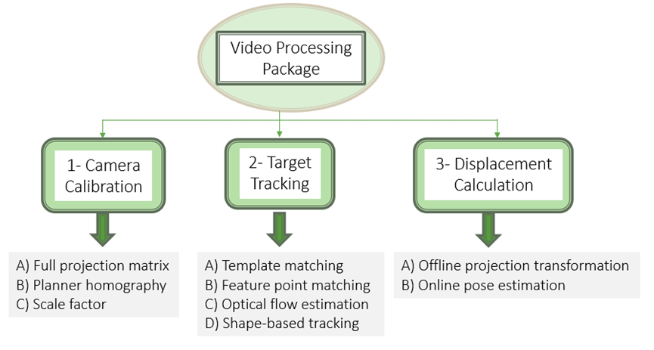

**Figure 1. Video-processing procedures for structural displacement measurement**

Any recorded video consists of numerous sequential frames; the target is recognized and its initial coordinates are determined at the first frame; any target tracking method then records the change in target coordinates frame by frame and estimates the displacement in pixels. The displacement in pixel units is finally translated to the physical displacement in mm or cm by camera calibration. Smartphones were used by Kromanis & Kripakaran, 2021 to take pictures of a timber beam that was being tested for load. Based on the information gathered, target locations were determined and displacements were computed.

In this study, two laboratory tests are conducted and recorded using one phone camera. The image processing algorithm based on target tracking included template matching, displacement calculation by offline projection transformation, and scale factor technique used for camera calibration which equals the ratio between the physical length of the artificial target (aruco) on the object surface and the corresponding physical length and pixel length at the image plane. The first test is to validate the developed displacement measurement algorithm using a constant-speed tension machine. The second test is to validate the developed displacement measurement algorithm to detect and track multi-points at the same time under static and dynamic loading and compare the results with the displacement estimated by traditional sensors.

# Testometric Tensile Test

This experiment aims to validate the developed displacement measurement algorithm with a constant speed tension Testometric machine M500/50CT. Testometric machine is usually used to estimate the tensile force –strain curve for different tested samples such as Geo-membrane or plastic glued joints with the application of tensile force to the specimen under a specific strain rate by controlling the speed of movable machine jaw (Suder et al., 2020). The artificial target was fixed in a movable jaw for detection and tracking as shown in Figure 2 to estimate the jaw displacement during operation under two speeds. In the first cycle, the speed was 60 cm/minute up and down; in the second cycle, the speed was 100 cm/minute up and down.

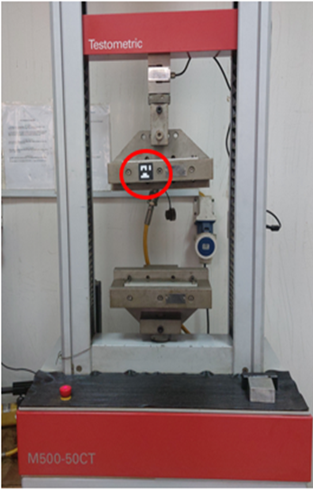

**Figure 2. Testometric machine (M500/50CT) and the artificial target fixed in the movable jaw**

As shown in Figure 3 the vertical displacement time relation under the two cycles is deduced after estimating the artificial target coordinates frame by frame using image processing technique. Converting the displacement-time relation to a velocity-time relation by derivation of the displacement function concerning time. The estimated speed from the displacement derivative agrees with the adjusted movable machine jaw speed under two cycles, 60 cm/minute and 100 cm /minute.

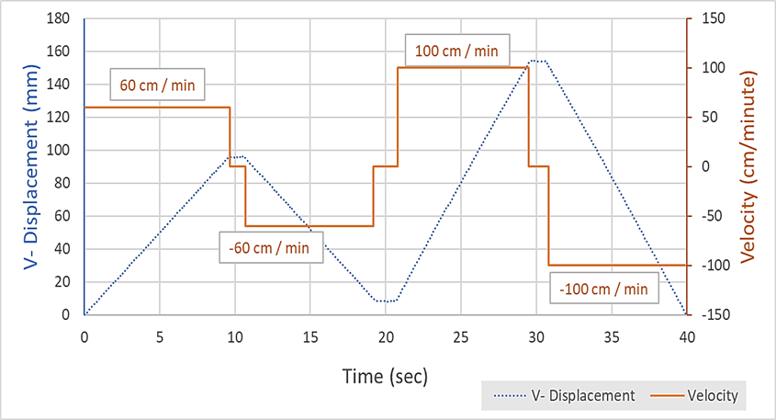

**Figure 3. Vertical displacement and Velocity-time relation using image processing technique**

# Flexible Steel Beam Test

This experiment aims to validate the developed displacement measurement algorithm to detect and track multi-points at the same time under static and dynamic loading considered one of the image processing technique advantages compared with other traditional sensors. At this test, a smartphone camera was used with a resolution of 4k (3840 * 2160) refers to the pixel count contained in an image. The frame rate was 30 frames per second (FPS). The scaling factor for the vision sensor was determined to be 0.5mm/pixel, and the corresponding measurement accuracy (resolution) was ± 0.25 mm.

First, a random vertical displacement was applied at the mid-span of a simply supported beam as shown in Figure 4, and the vertical displacement was estimated at the mid-span of the beam using LVDT and image processing technique as displacement measurement sensors which appears to be a great agreement as shown in Figure 5.

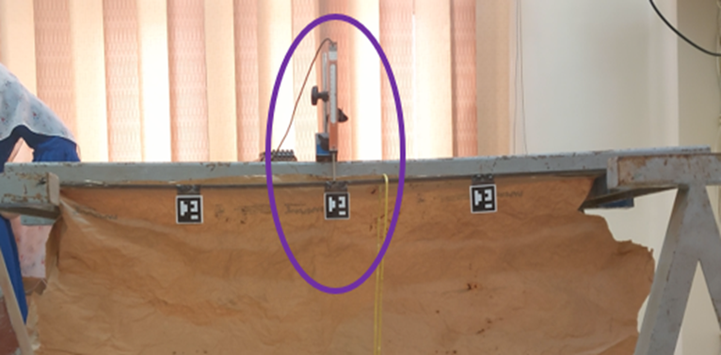

**Figure 4. Vertical displacement was applied at the mid-span of a sample**

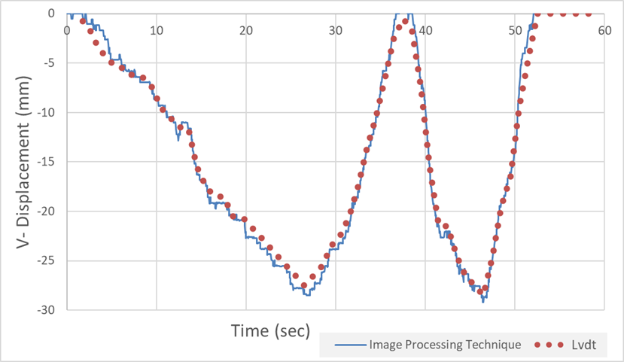

**Figure 5. Vertical displacement-time relation using LVDT and image processing technique**

Then, as shown in Figure 6 the beam was subjected to static loads gradually (4, 2, 2, 2, 2, 2, and 1) kg respectively, and by using the image processing technique multi points were detected and tracked to estimate the vertical displacement of them at the same time during loading and unloading. The vertical displacement time history is shown in Figure 7, the vertical displacement of the 2nd target is the maximum value, and the vertical displacement time history of the 1st target is the same as the vertical displacement time history of the 3rd target due to the locations.

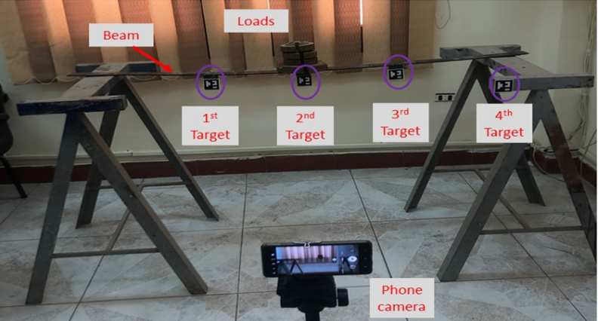

**Figure 6. Beam subjected to gradual static loads**

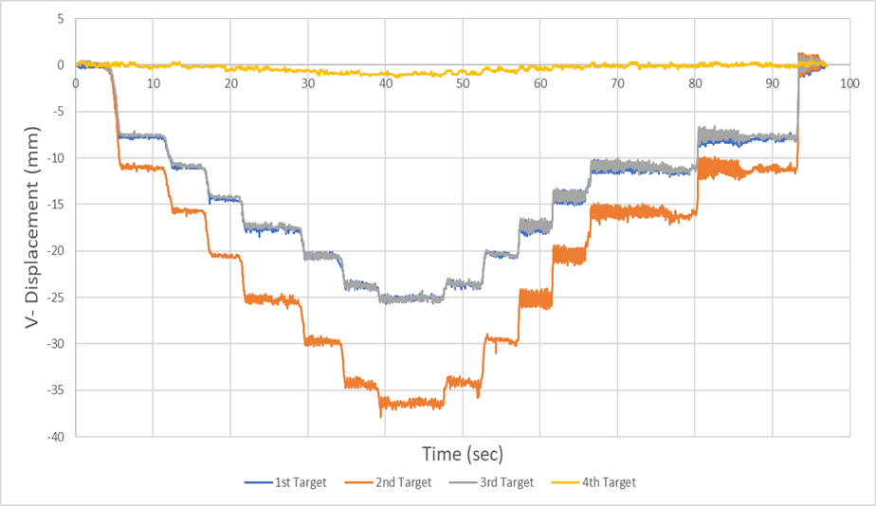

**Figure 7. Vertical displacement time history**

Finally, as shown in Figure 8 the beam was subjected to impact load. One of the image technique advantages is the ability to estimate the dynamic response for multi-points. The vertical displacement time history for each target was estimated under free vibration by using only one smartphone camera as shown in Figure 9.

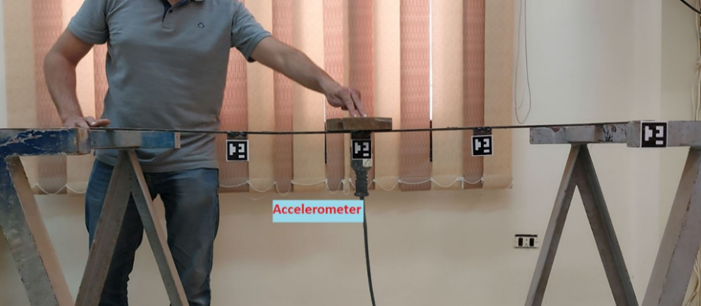

**Figure 8. Beam subjected to an impact load**

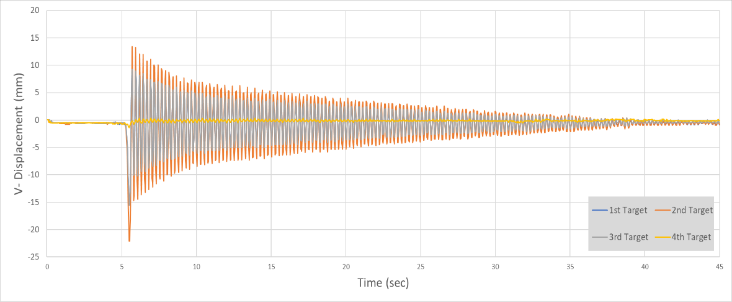

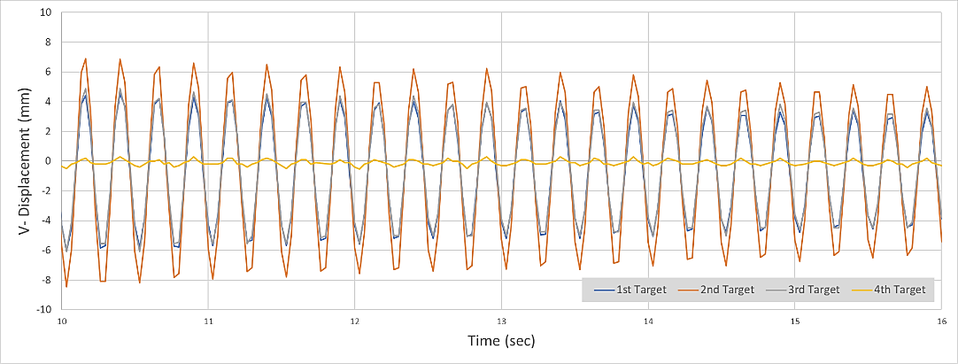

**Figure 9. Vertical displacement time history**

The vertical displacement time history for target no 2 under the free vibration using the image processing technique and its corresponding PSD amplitude was compared with the acceleration time history estimated from the accelerometer for the same point and its corresponding PSD amplitude as shown in Figure 10. Both power spectral density (PSD) charts have the same dominant frequency of 4 Hz. This confirms that the image processing technique can achieve the same dynamic measurement performance as the conventional accelerometer.

|  |  |
| --- | --- |
| a) |  |
| b) |  |

**Figure 10 Frequency estimated from a) displacement time history, b) acceleration**

# Conclusion

As a result of this study, the following conclusions were drawn:

* The image processing technique is a valid approach to estimating the deformation of structures under static and dynamic loads.
* The image processing technique is a promising non-attached sensor for estimating deformations or accelerations, especially for inaccessible structures.
* Using a smartphone’s camera could replace many LVDTs or accelerometers at different laboratory tests.

**REFERENCES**

1. *1991-2, E. N. (2003). Eurocode 1: Actions on structures–Part 2: Traffic loads on bridges. In CEN-European Committee for Standardization.*
2. *AASHTO, L. (2012). AASHTO LRFD bridge design specifications. American Association of State Highway and Transportation Officials, Washington, DC.*
3. *Committee, E. C. P. (2018). Egyptian Code for Design and Construction of Concrete Structures (ECP 203-2018). Housing and Building National Research Center: Cairo, Egypt.*
4. *Gomez, F., Park, J., & Spencer Jr, B. F. (2018). Reference‐free structural dynamic displacement estimation method. Structural Control and Health Monitoring, 25(8), e2209.*
5. *Haritos, N. (2009). Low-cost accelerometer sensors-applications and challenges. Australian Earthquake Engineering Society Conference.*
6. *Hong, Y. H., Lee, S. G., & Lee, H. S. (2013). Design of the FEM-FIR filter for displacement reconstruction using accelerations and displacements measured at different sampling rates. Mechanical Systems and Signal Processing, 38(2), 460–481.*
7. *Joshi, S., & Harle, S. M. (2017). Linear variable differential transducer (LVDT) & its applications in civil engineering. Int. J. Transp. Eng. Technol, 3(4), 62.*
8. *Kromanis, R., & Kripakaran, P. (2021). A multiple-camera position approach for accurate displacement measurement using computer vision. Journal of Civil Structural Health Monitoring, 11(3), 661–678.*
9. *Ma, Z., Choi, J., & Sohn, H. (2023). Structural displacement sensing techniques for civil infrastructure: A review. Journal of Infrastructure Intelligence and Resilience, 2(3), 100041.*
10. *Nassif, H. H., Gindy, M., & Davis, J. (2005). Comparison of laser Doppler vibrometer with contact sensors for monitoring bridge deflection and vibration. NDT & E International, 38(3), 213–218.*
11. *Xu, Y., & Brownjohn, J. M. W. (2018). Review of machine-vision-based methodologies for displacement measurement in civil structures. Journal of Civil Structural Health Monitoring, 8, 91–110****.***