**Optimization of Dual Plasmid Transformation Conditions for Large Plasmids in Escherichia coli**

Xin Qiu, Chengxiang Yang, Dapeng Wei, Xunlin Li, Qian Li

*School of Life and Health, Dalian University, China*

*Corresponding Author: Qian Li, liqian@dlu.edu.cn*

*ABSTRACT: Transformation of plasmid DNA into Escherichia coli is a common technique in molecular biology; however, the efficiency of transformation for large plasmids and co-transformation of multiple plasmids remains a challenge. As genetic editing techniques continue to advance, metabolic pathway reconstruction is becoming a routine approach, increasing the demand for multi-plasmid transformation over single-plasmid transformation. In this study, we compared and refined different transformation methods, focusing on optimizing conditions for dual plasmid co-transformation of large plasmids into chemically competent and electroporated E. coli BL21(DE3) cells. We examined factors including plasmid concentration, heat-shock duration, and the number of heat-shock cycles. Additionally, the feasibility of triple plasmid transformation was tested. Results indicated that the optimal conditions for dual plasmid transformation included a plasmid concentration of 300 ng/μL, a 42°C heat-shock time of 60 seconds, and a single heat-shock cycle. Furthermore, the chemical transformation of large plasmids in a triple plasmid system proved to be feasible.*

***KEY WARDS: Plasmid co-transformation; Escherichia coli; competent cell preparation; chemical transformation; electroporation***

---------------------------------------------------------------------------------------------------------------------------------------

Date of Submission: xx-xx-xxxx Date of acceptance: xx-xx-xxxx

---------------------------------------------------------------------------------------------------------------------------------------

# INTRODUCTION

*Escherichia coli* has become the most widely used bacterial strain for cloning and transformation due to its simple structure and well-characterized genetic background.[1-3] Specifically, *E. coli* BL21(DE3) is commonly employed as a host for the expression of heterologous genes[4]. Studying the preparation of competent cells and transformation efficiency of this strain is of practical significance.[5-7]

Competent cells are induced by chemical or physical methods to uptake DNA molecules from their surroundings, allowing them to express foreign genetic traits.[8, 9] The underlying principle involves altering the permeability of the cell membrane through physical or chemical treatments,[10] which create pores in the membrane. These pores facilitate the entry of foreign genes or plasmids into the cells, which are then recovered in a suitable medium. Once the cells repair their membranes, they express the genetic traits of the transformed DNA.

Building cellular factories to produce bioactive substances has both theoretical and practical significance. For example, substances such as artemisinin and other natural products, which were traditionally extracted from plants, can now be produced at kilogram scales using microbial cell factories.[11] *E. coli* is a particularly important chassis cell for this purpose, and plasmids are essential tools for metabolic pathway engineering.[12] Constructing efficient cellular factories often requires editing and recombining multiple genes, necessitating a simple and effective platform for multi-plasmid transformation. Despite this need, specialized methods for transforming large fragments and multiple plasmids are lacking, and existing laboratory techniques generally exhibit low transformation efficiency. Current transformation experiments with competent *E. coli* cells typically involve single plasmids of relatively small fragment sizes, and the foreign genes introduced are relatively simple. As metabolic pathway engineering becomes more routine, the co-transformation of multiple plasmids will have broader applications.

In this study, we compared and optimized various transformation methods, including chemical transformation and electroporation, for dual plasmid co-transformation into *E. coli* BL21(DE3) cells using large plasmids. Specifically, we evaluated the transformation of plasmids E3N (10910 bp), RPNP (6788 bp), and pUC19 to determine the suitability of *E. coli* BL21(DE3) competent cells for co-transformation of large plasmids. Additionally, we explored the optimal preparation method for chemically competent cells, tested dual plasmid transformation with large fragments, and optimized plasmid concentration and heat-shock parameters. We also assessed the feasibility of triple plasmid transformation under similar conditions. Furthermore, we verified the use of electroporated *E. coli* BL21(DE3) competent cells for dual plasmid transformation, providing reference conditions for future studies on large fragment and multi-plasmid co-transformation.

# MATERIAL AND METHODS

* 1. ***Strains and Plasmids***

*E. coli* BL21(DE3) was preserved in our laboratory. pUC19 was purchased from Takara. Plasmids E3N (10,910 bp), RPNP (6,788 bp), and CBA (6,282 bp) were constructed in-house.

* 1. ***Preparation of E. coli BL21(DE3) Competent Cells***

An overnight culture of *E. coli* BL21(DE3) was inoculated into 50 mL of liquid LB medium and incubated at 37°C and 180 rpm until the OD600 reached 0.3. The cells were then centrifuged at 4,000 rpm for 10 minutes at 4°C, and the supernatant was discarded. The pellet was resuspended in 20 mL of 0.1 mol/L MgCl₂ solution, followed by centrifugation. The supernatant was discarded again, and the cells were resuspended in 1 mL of a solution containing 15% glycerol and 0.1 mol/L CaCl₂. The competent cells were aliquoted into tubes (100 μL per tube), frozen in liquid nitrogen, and stored at -80°C.

* 1. ***Chemical Transformation of E. coli BL21(DE3) with Single Plasmid***

To verify the transformation efficiency, 1 μL of 0.1 ng/μL pUC19 plasmid DNA was added to *E. coli* BL21(DE3) competent cells. The mixture was incubated on ice for 30 minutes, followed by heat shock at 42°C for 60 seconds. The cells were then placed on ice for 3 minutes, followed by the addition of 900 μL of LB medium. After recovery at 37°C for 60 minutes, the cells were centrifuged, and 100 μL of the supernatant was plated on LB agar containing ampicillin. Colonies were counted to calculate the transformation efficiency.

* 1. ***Electroporation of E. coli BL21(DE3) with Dual Plasmids***

Dual plasmid transformation using E3N and RPNP plasmids was performed via electroporation following standard protocols. Briefly, cells were washed with ice-cold deionized water and resuspended in an ice-cold 10% glycerol solution. Fifty μL aliquots of competent cells were mixed with 1–5 μL of plasmid DNA and electroporated at 2.5 kV. The cells were immediately recovered in LB medium for 1 hour and plated for selection. Various concentrations (500 ng/μL to 0.1 ng/μL) of the mixed plasmid solution were used, and a concentration of 0.1 ng/μL of pUC19 plasmid DNA served as a control. The transformation efficiency was calculated based on colony counts, and colony PCR was used to verify the accuracy of the transformed colonies.

* 1. ***Analysis of Transformation Efficiency***

The number of transformants was counted after 16 hours of incubation at 37°C, and transformation efficiency was calculated based on the number of colonies obtained per microgram of plasmid DNA used.

# RESULTS AND DISCUSSIONS

* 1. ***Verification of Single Plasmid Transformation Using Chemically Competent E. coli BL21(DE3) Cells***

The results of single plasmid transformation using chemically competent *E. coli* BL21(DE3) cells are shown in Figure 1. When *E. coli* BL21(DE3) cells without pUC19 plasmid were plated on LB solid medium, normal growth was observed, and no other bacterial contamination was detected. After transforming *E. coli* BL21(DE3) cells with the pUC19 plasmid and plating them on LB agar containing ampicillin (Amp), successful growth of numerous transformants was observed. No colonies grew on the LB agar containing Amp when *E. coli* BL21(DE3) cells without the pUC19 plasmid were plated. These results indicate that the *E. coli* BL21(DE3) competent cells prepared in our lab were not contaminated with other bacterial strains, did not exhibit Amp resistance, and had high transformation efficiency. Therefore, the chemically prepared competent cells can meet the requirements for subsequent experiments.

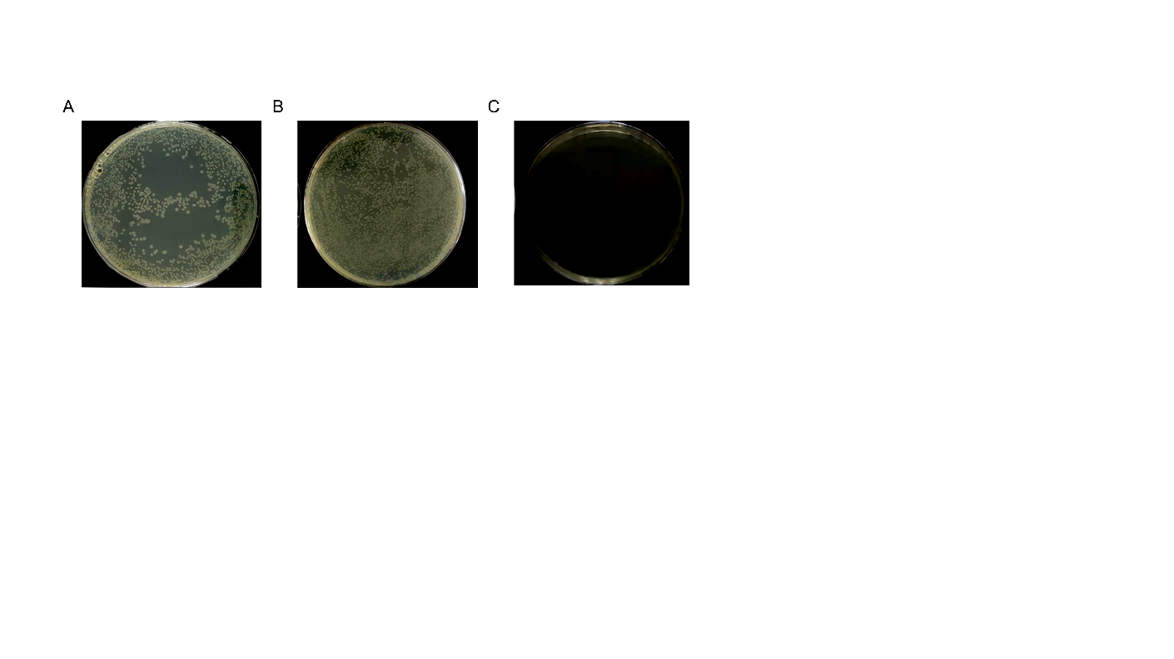

**Figure 1:** **Verification of single plasmid transformation. (A) Growth results of non-transformed pUC19 cells plated on LB medium. (B) Growth results of pUC19-transformed cells plated on LB medium containing ampicillin. (C) Growth results of non-transformed pUC19 cells plated on LB medium containing ampicillin.**

* 1. ***Optimization of Dual Plasmid Transformation System Using Chemically Competent E. coli BL21(DE3) Cells***

To optimize dual plasmid transformation conditions for large plasmids, we tested E3N and RPNP plasmids at various concentrations: 500 ng/μL, 300 ng/μL, 100 ng/μL, 50 ng/μL, 10 ng/μL, 1 ng/μL, and 0.1 ng/μL. In parallel, a control group using pUC19 plasmid DNA at 0.1 ng/μL was set up. The transformation efficiencies are shown in Figure 2A. Under the experimental conditions, single plasmid transformation of pUC19 was achieved easily, with an efficiency of 1.65×10⁷ cfu/μg. However, the efficiency of dual plasmid transformation for the larger E3N and RPNP plasmids was significantly lower, and a positive correlation between plasmid concentration and transformation efficiency was observed. At 300 ng/μL, the efficiency reached 3.28×10³ cfu/μg. This demonstrates that dual plasmid transformation using large plasmids in chemically competent *E. coli* BL21(DE3) cells is feasible and can achieve relatively high efficiency. Colony PCR was used to verify the accuracy and positive rates of the transformants at a dual plasmid concentration of 300 ng/μL. As shown in Figures 2B-C, both E3N and RPNP transformants had a 100% positive rate. Although the transformation efficiency at 500 ng/μL was higher, the increased plasmid consumption makes 300 ng/μL the optimal concentration.



**Figure 2:** **Transformation results using chemically competent BL21(DE3) cells. (A) Transformation efficiencies at different plasmid concentrations. (B) Agarose gel electrophoresis of colony PCR for E3N transformants. Marker: DL 2000; lanes 1–14: E3N transformants; lane 15: non-transformed BL21(DE3) control. (C) Agarose gel electrophoresis of colony PCR for RPNP transformants. Marker: DL 2000; lanes 1–14: RPNP transformants; lane 15: non-transformed BL21(DE3) control. (D) Transformation efficiency at different heat-shock durations at 42°C. (E) Colony PCR validation of different heat-shock conditions. a：Agarose gel electrophoresis of colony PCR for E3N transformants b：Agarose gel electrophoresis of colony PCR for RPNP transformants Marker: DL 2000; lanes 1–8: experimental group transformants; lanes 9–16: control group 1 transformants; lanes 17–24: control group 2 transformants. (F) Transformation efficiency at different numbers of 42°C heat-shock cycles.*Chemical Transformation of E. coli BL21(DE3) with Single Plasmid***

Under the experimental conditions using chemically competent *E. coli* BL21(DE3) cells, the duration of heat-shock at 42°C significantly impacted transformation efficiency. Previous studies suggest that a heat-shock time of 60 seconds provides optimal transformation efficiency, while others have suggested 90 seconds. In our study, as shown in Figure 2D, a 60-second heat-shock at 42°C resulted in the highest transformation efficiency, reaching 3.45×10³ cfu/μg. Eight transformant colonies from each group (with varying heat-shock times and control groups) were randomly selected and subjected to colony PCR, confirming a 100% positive rate for both E3N and RPNP plasmid transformants (Figure 2E).

To investigate the effect of multiple heat-shock cycles, one group was subjected to a single 60-second heat-shock, while another group was subjected to two cycles: 60 seconds of heat-shock, followed by a 1-minute incubation on ice, and then another 60-second heat-shock. A control group using pUC19 plasmid DNA at 0.1 ng/μL was also tested. As shown in Figure 2F, a single 60-second heat-shock cycle at 42°C yielded the best transformation efficiency, reaching 1.65×10⁷ cfu/μg. Additional heat-shock cycles did not improve transformation efficiency.

* 1. ***Verification of Triple Plasmid Transformation Using Chemically Competent E. coli BL21(DE3) Cells***

Based on the optimized conditions for dual plasmid transformation, we performed triple plasmid transformation using a concentration of 300 ng/μL for each plasmid and a heat-shock duration of 60 seconds. Colony PCR was used to validate the accuracy and positive rate of the transformants. As shown in Figure 3, all transformants were verified to be positive for the three plasmids, with a 100% positive rate. This indicates that triple plasmid transformation using chemically competent *E. coli* BL21(DE3) cells is feasible.



**Figure 3. Agarose gel electrophoresis of colony PCR for triple plasmid transformants. Marker: DL 2000; lane 1: E3N transformant plasmid; lane 2: CBA transformant plasmid; lane 3: RPNP transformant plasmid.**

* 1. ***V*** ***Verification of Dual Plasmid Transformation Using Electroporation***

For dual plasmid transformation using electroporation, we tested various concentrations of the E3N and RPNP plasmid mix: 500 ng/μL, 300 ng/μL, 100 ng/μL, 50 ng/μL, 10 ng/μL, 1 ng/μL, and 0.1 ng/μL. A control group using pUC19 plasmid DNA at 0.1 ng/μL was also included. As shown in Figure 4, the transformation efficiency reached 7.03×10² cfu/μg at a plasmid concentration of 300 ng/μL, and colony PCR verified a 100% positive rate. However, transformation efficiency decreased at the higher plasmid concentration of 500 ng/μL, suggesting that electroporation is more sensitive to plasmid concentration. These results demonstrate that dual plasmid transformation using large plasmids in *E. coli* BL21(DE3) cells by electroporation is feasible, with 300 ng/μL being the optimal plasmid concentration for high transformation efficiency.

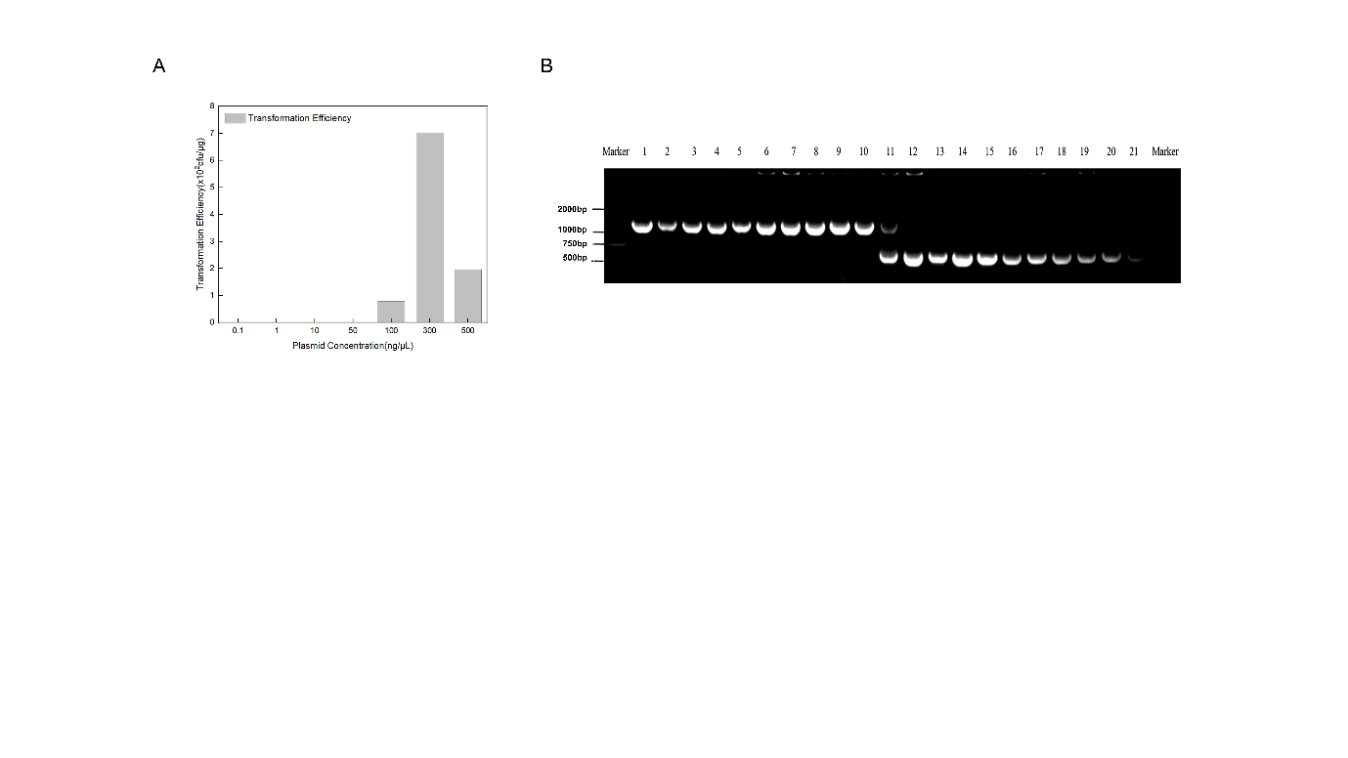

**Figure 4:** **Results of dual plasmid transformation using electroporation. (A) Effect of plasmid concentration on transformation efficiency. (B) Agarose gel electrophoresis of colony PCR for transformants. Marker: DL 2000; lanes 1–10: E3N transformants; lane 11: dual plasmid transformant; lanes 12–21: RPNP transformants.**

Cloning and expression of foreign genes are among the most commonly used techniques in genetic engineering.[13, 14] The preparation of competent *E. coli* cells for foreign gene transformation is a fundamental method in molecular biology. Producing efficient and stable competent cells is critical for subsequent gene cloning and expression experiments. [15, 16]In this study, we compared and optimized various methods for preparing *E. coli* BL21(DE3) competent cells, focusing on dual plasmid transformation using both chemical transformation and electroporation. We identified optimal plasmid concentrations, heat-shock durations, and heat-shock cycles for dual plasmid transformation and validated the feasibility of triple plasmid transformation. These findings provide a solid foundation for future molecular biology experiments.

# CONCLUSIONS

The optimal conditions for dual plasmid transformation of large plasmids into *E. coli* BL21(DE3) cells using chemical transformation include a plasmid concentration of 300 ng/μL, a heat-shock time of 60 seconds at 42°C, and a single heat-shock cycle. The optimal plasmid concentration for electroporation was also found to be 300 ng/μL. Furthermore, triple plasmid transformation using chemically competent cells is feasible.

**REFERENCES**

[1] P.K. Ajikumar, W.H. Xiao, K.E. Tyo, Y. Wang, F. Simeon, E. Leonard, O. Mucha, T.H. Phon, B. Pfeifer, G. Stephanopoulos, Isoprenoid pathway optimization for Taxol precursor overproduction in Escherichia coli, Science (New York, N.Y.), 330 (2010) 70-74.

[2] H. Yim, R. Haselbeck, W. Niu, C. Pujol-Baxley, A. Burgard, J. Boldt, J. Khandurina, J.D. Trawick, R.E. Osterhout, R. Stephen, J. Estadilla, S. Teisan, H.B. Schreyer, S. Andrae, T.H. Yang, S.Y. Lee, M.J. Burk, S. Van Dien, Metabolic engineering of Escherichia coli for direct production of 1,4-butanediol, Nature chemical biology, 7 (2011) 445-452.

[3] L. Zhou, D.D. Niu, K.M. Tian, X.Z. Chen, B.A. Prior, W. Shen, G.Y. Shi, S. Singh, Z.X. Wang, Genetically switched D-lactate production in Escherichia coli, Metabolic engineering, 14 (2012) 560-568.

[4] W.T. Chan, C.S. Verma, D.P. Lane, S.K. Gan, A comparison and optimization of methods and factors affecting the transformation of Escherichia coli, Bioscience reports, 33 (2013).

[5] N. Itoh, T. Kouzai, Y. Koide, Efficient transformation of pseudomonas strains with pNI vectors by electroporation, Bioscience, biotechnology, and biochemistry, 58 (1994) 1306-1308.

[6] K.C. Murphy, Use of bacteriophage lambda recombination functions to promote gene replacement in Escherichia coli, Journal of bacteriology, 180 (1998) 2063-2071.

[7] Y. Wang, D. Wei, X. Zhu, J. Pan, P. Zhang, L. Huo, X. Zhu, A 'suicide' CRISPR-Cas9 system to promote gene deletion and restoration by electroporation in Cryptococcus neoformans, Sci Rep, 6 (2016) 31145.

[8] W.J. Dower, J.F. Miller, C.W. Ragsdale, High efficiency transformation of E. coli by high voltage electroporation, Nucleic acids research, 16 (1988) 6127-6145.

[9] D. Hanahan, Studies on transformation of Escherichia coli with plasmids, Journal of molecular biology, 166 (1983) 557-580.

[10] M. Mandel, A. Higa, Calcium-dependent bacteriophage DNA infection, Journal of molecular biology, 53 (1970) 159-162.

[11] V.J. Martin, D.J. Pitera, S.T. Withers, J.D. Newman, J.D. Keasling, Engineering a mevalonate pathway in Escherichia coli for production of terpenoids, Nature biotechnology, 21 (2003) 796-802.

[12] A.L. Lindahl, M.E. Olsson, P. Mercke, O. Tollbom, J. Schelin, M. Brodelius, P.E. Brodelius, Production of the artemisinin precursor amorpha-4,11-diene by engineered Saccharomyces cerevisiae, Biotechnology letters, 28 (2006) 571-580.

[13] T. Ellis, T. Adie, G.S. Baldwin, DNA assembly for synthetic biology: from parts to pathways and beyond, Integrative biology : quantitative biosciences from nano to macro, 3 (2011) 109-118.

[14] N.E. Sanjana, O. Shalem, F. Zhang, Improved vectors and genome-wide libraries for CRISPR screening, Nature methods, 11 (2014) 783-784.

[15] S.N. Cohen, DNA cloning: a personal view after 40 years, Proceedings of the National Academy of Sciences of the United States of America, 110 (2013) 15521-15529.

[16] J. Ren, S. Karna, H.M. Lee, S.M. Yoo, D. Na, Artificial transformation methodologies for improving the efficiency of plasmid DNA transformation and simplifying its use, Appl Microbiol Biotechnol, 103 (2019) 9205-9215.