**NAVIGATING CHALLENGES AND PROSPECTS IN THE RENEWABLE ENERGY NEXUS**

**K.J. Saravanaraj, L. Gerardo, S. Sivamani\***

***College of Engineering and Technology, University of Technology and Applied Sciences, Salalah, Oman***

*Corresponding author: sivmansel@gmail.com

**ABSTRACT:**

This comprehensive review explores the renewable energy nexus, examining its scope, limitations, synergies, trade-offs, environmental and socio-economic impacts, challenges, and promising prospects. Environmental impacts reveal the positive contributions of renewable technologies, including greenhouse gas reduction, improved air quality, and biodiversity preservation. Socio-economic benefits, such as job creation and community empowerment, underscore the nexus's potential for inclusive development. Challenges, including intermittency, environmental footprints, and initial costs, are addressed, emphasizing the need for ongoing innovation. Future prospects remain bright, driven by technological advancements, decreasing costs, and heightened global awareness of climate change. The findings underscore the importance of collaborative efforts to overcome challenges and harness the full potential of the renewable energy nexus for a cleaner, more resilient future.

***Keywords:*** Renewable energy nexus, environmental impacts, socio-economic benefits, challenges, prospects,

**INTRODUCTION:**

Renewable energy sources harness natural, replenishable resources to generate clean and sustainable power. Solar energy, derived from the sun's radiation, utilizes photovoltaic cells to convert sunlight into electricity and solar thermal systems to generate heat [1]. Wind power harnesses the kinetic energy of moving air through wind turbines, transforming it into electrical energy [2]. Hydropower relies on the gravitational force of flowing or falling water to generate electricity, while biomass utilizes organic materials such as wood, agricultural residues, and waste to produce heat and power [3]. Geothermal energy taps into the Earth's internal heat by harnessing steam or hot water from within the Earth's crust for electricity generation or direct heating. These diverse renewable sources contribute to mitigating climate change, reducing dependence on finite fossil fuels, and fostering a sustainable energy future with lower environmental impact and enhanced energy security [4]. Figure 1 represents various sources of renewable energy.

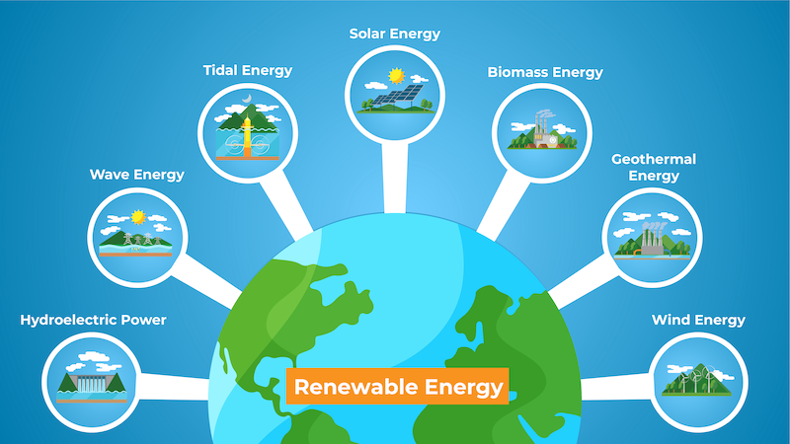

**Figure 1. Sources of renewable energy**

This comprehensive review explores the renewable energy nexus, examining its scope, limitations, synergies, trade-offs, environmental and socio-economic impacts, challenges, and promising prospects.

**RENEWABLE ENERGY NEXUS:**

The renewable energy nexus refers to the interconnected and interdisciplinary approach to addressing sustainable energy solutions. It involves the seamless integration of various renewable energy sources such as solar, wind, hydropower, biomass, and geothermal energy. This holistic perspective recognizes the interdependencies, synergies, and trade-offs among these sources, emphasizing the need for technological innovations, policy frameworks, and economic considerations [5]. The renewable energy nexus aims to balance environmental, socio-economic, and technological dimensions, fostering a comprehensive strategy to propel the transition towards clean and sustainable energy systems on a global scale [6]. A multidisciplinary approach in renewable energy is crucial due to the complex and interconnected nature of energy systems (Figure 2). Firstly, renewable energy solutions involve diverse technologies, such as solar, wind, and bioenergy, requiring expertise from various scientific and engineering disciplines for optimal integration [7]. Secondly, a holistic perspective is essential to address environmental impacts, considering biodiversity, land use, and carbon footprints. Collaboration between ecologists, environmental scientists, and engineers is vital for sustainable practices. Moreover, the social and economic dimensions of renewable energy necessitate insights from sociology, economics, and policy studies. Job creation, community engagement, and equitable access to energy are significant aspects that require a multidisciplinary lens to develop inclusive and just energy transitions [8].

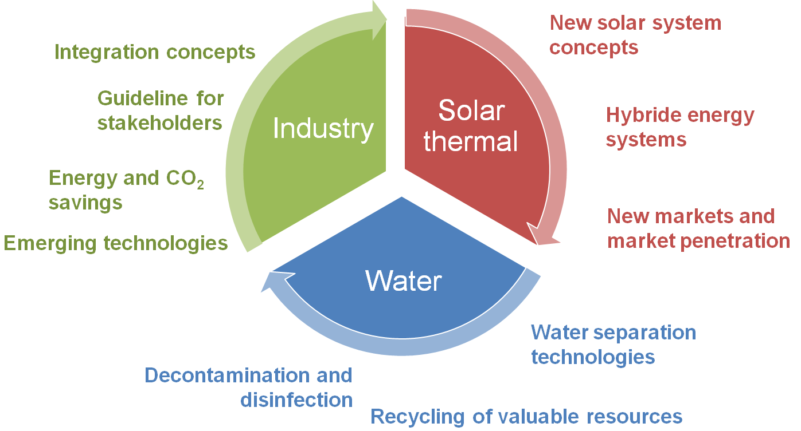

**Figure 2. Multidisciplinary nature of renewable energy nexus**

**SCOPE AND LIMITATIONS OF MULTIDISCIPLINARY APPROACH IN RENEWABLE ENERGY NEXUS:**

**Scope:**

The multidisciplinary approach in renewable energy expands the scope for comprehensive solutions through collaboration among diverse fields. It facilitates the integration of technologies by combining expertise from engineering, materials science, and computer science. This synergy enhances the efficiency and applicability of renewable energy systems [9]. Environmental sustainability benefits from the collaboration of ecologists, environmental scientists, and engineers, enabling a holistic understanding of ecological impacts and the development of mitigation strategies [10]. Policymakers, economists, and legal experts working together can create robust regulatory frameworks and incentive structures to promote renewable energy adoption. The social and economic dimensions are addressed through collaboration between sociologists, economists, and engineers, ensuring that renewable energy projects consider community needs and promote equitable access. Furthermore, advancements in energy storage and grid management benefit from the fusion of engineering, computer science, and economics expertise, driving innovation and overcoming technical challenges [11].

**Limitations:**

Despite its advantages, the multidisciplinary approach faces challenges. Communication barriers arise due to differing terminologies among disciplines, potentially impeding effective collaboration. Resource and time constraints may hinder the coordination of multidisciplinary efforts, as integrating diverse perspectives requires substantial investment. Resistance to interdisciplinary thinking from professionals rooted in specific disciplines can limit the seamless integration of ideas. There is a risk of oversimplifying complex issues when seeking common ground between diverse disciplines, potentially overlooking critical nuances [12]. Additionally, disciplinary biases may impact decision-making, with certain perspectives receiving disproportionate emphasis. Awareness of these limitations is crucial for successful implementation, requiring effective communication, adequate resources, and a commitment to overcoming disciplinary barriers to achieve sustainable and impactful multidisciplinary solutions in renewable energy [13].

**SYNERGIES AND TRADE-OFFS OF RENEWABLE ENERGY NEXUS**

**Synergies:**

The multidisciplinary approach to the renewable energy nexus is a powerful strategy that brings together experts from various fields to address the complex challenges associated with sustainable energy solutions. One of the notable synergies lies in technology integration. Engineers collaborate with materials scientists, computer scientists, and environmental experts to optimize the efficiency and reliability of renewable energy technologies. This collaboration not only enhances the performance of individual technologies but also fosters the development of innovative solutions that can overcome technological barriers. For example, the integration of materials science in solar cell development has led to more efficient and cost-effective photovoltaic systems [14].

**Trade-offs:**

The multidisciplinary approach of renewable energy nexus also entails trade-offs. Communication challenges often arise due to the diverse terminologies used across different disciplines. Engineers may struggle to convey technical intricacies to ecologists, and vice versa, leading to misunderstandings and potentially limiting the effectiveness of collaborative efforts. Bridging these communication gaps requires a concerted effort to establish a shared language and understanding. Another trade-off involves resource and time constraints [15]. Coordinating the efforts of professionals from various disciplines can be resource-intensive and time-consuming. While the benefits of a comprehensive approach are substantial, the investment required for effective collaboration may strain limited resources and extend project timelines. Balancing these constraints is essential to ensure that the multidisciplinary approach remains practical and feasible. Furthermore, there is a risk of oversimplification when seeking common ground between diverse disciplines [16].

Complex issues, such as the environmental impact of renewable energy projects, may be oversimplified to facilitate interdisciplinary understanding. While simplification is necessary for effective communication, it is crucial to avoid overlooking critical nuances that could impact the success and sustainability of renewable energy solutions. Disciplinary biases also present a challenge, as professionals may prioritize their specific expertise over broader considerations. For instance, engineers may focus primarily on technological advancements without fully considering the environmental or social implications. Overcoming these biases requires a commitment to holistic problem-solving and a recognition of the importance of diverse perspectives in creating well-rounded solutions [17].

**SUSTAINABLE SOLUTIONS FOR RENEWABLE ENERGY NEXUS:**

### Sustainability refers to the balance between the environment, equity, and economy. Figure 3 exhibits the multidisciplinary nature of sustainability.

**Environmental impacts:**

The renewable energy nexus has substantial positive environmental impacts compared to conventional energy sources. By significantly reducing greenhouse gas emissions, renewable energy technologies contribute to mitigating climate change. Solar and wind power have minimal air and water pollution during operation, leading to improved air quality and reduced strain on ecosystems [18]. Additionally, the utilization of renewable resources, such as sunlight, wind, and water, helps preserve biodiversity by minimizing habitat disruption and land-use change associated with traditional energy extraction. While there are challenges such as the environmental footprint of manufacturing and decommissioning processes, the overall environmental benefits position the renewable energy nexus as a crucial driver for sustainable development [19].

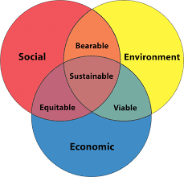

**Figure 3. Multidisciplinary nature of sustainability**

**Socio-economic impacts:**

The socio-economic impacts of the renewable energy nexus extend beyond environmental considerations [20]. One of the most significant positive aspects is job creation. The renewable energy sector, encompassing manufacturing, installation, maintenance, and research, generates employment opportunities, contributing to economic growth. Moreover, renewable energy projects often empower local communities by providing them with a stake in energy production through community-owned initiatives. Improved energy access is another socio-economic benefit, as renewable technologies can be deployed in remote or off-grid areas, promoting inclusivity. However, challenges exist, such as the potential for job displacement in traditional energy sectors and the need for skill transitions. Addressing these challenges requires strategic policies that prioritize a just transition to a renewable energy-based economy, ensuring both environmental sustainability and socio-economic well-being [21].

**CHALLENGES AND FUTURE PROSPECTS OF RENEWABLE ENERGY NEXUS:**

**Challenges:**

The renewable energy nexus faces several challenges that need to be addressed for its widespread adoption. Intermittency and variability in energy production, particularly with solar and wind sources, pose challenges to grid stability and reliability. Energy storage technologies are critical to mitigating this challenge but are still evolving and face economic and technical constraints [22]. Another hurdle involves the environmental impact of certain technologies, such as the land-use requirements for bioenergy and potential impacts on ecosystems. Additionally, the initial high costs of renewable energy infrastructure, though decreasing, remain an obstacle, particularly in developing regions. Addressing these challenges requires concerted efforts in technological innovation, policy frameworks, and international collaboration.

**Future prospects:**

Despite challenges, the future prospects of the renewable energy nexus are promising. Continued advancements in technology, particularly in energy storage, smart grids, and next-generation renewable technologies, will enhance the reliability and efficiency of renewable energy systems. The decreasing costs of renewable technologies make them increasingly competitive with traditional sources, fostering greater global adoption. Robust policy support, including incentives, subsidies, and carbon pricing, can accelerate the transition to renewable energy. Furthermore, the growing awareness of climate change and the imperative for sustainable practices are driving a shift towards renewable solutions. The integration of digital technologies, artificial intelligence, and data analytics into energy systems holds the potential to optimize renewable energy production, distribution, and consumption, paving the way for a cleaner, more sustainable, and technologically advanced energy future [23].

**CONCLUSION:**

The renewable energy nexus, characterized by its multidisciplinary approach, presents both challenges and promising prospects. The environmental impacts are largely positive, with renewable technologies reducing greenhouse gas emissions, minimizing air and water pollution, and preserving biodiversity. Socio-economic benefits include job creation, community empowerment, and improved energy access. However, challenges such as intermittency, environmental footprints, and initial costs persist. The future prospects are optimistic, driven by ongoing technological advancements, decreasing costs, and increasing global awareness of climate change. Continued innovation in energy storage, smart grids, and policy frameworks is essential for overcoming challenges and realizing a sustainable and technologically advanced energy future. In conclusion, the multidisciplinary approach in the renewable energy nexus offers synergies that can drive innovation, optimize technologies, and address complex challenges. However, it comes with trade-offs, including communication challenges, resource constraints, the risk of oversimplification, and disciplinary biases. Successfully navigating these trade-offs demands effective communication, resource management, and a commitment to a shared vision of sustainable and inclusive energy solutions. The collaborative efforts of professionals from diverse backgrounds are essential for overcoming these challenges and advancing the transition to a cleaner and more sustainable energy future.

**REFERENCES:**

1. Chanchangi, Y. N., Adu, F., Ghosh, A., Sundaram, S., & Mallick, T. K. (2023). Nigeria's energy review: Focusing on solar energy potential and penetration. *Environment, Development and Sustainability*, *25*(7), 5755-5796.
2. Khan, Z., & Rehan, M. (2016). Harnessing airborne wind energy: prospects and challenges. *Journal of Control, Automation and Electrical Systems*, *27*, 728-740.
3. Rahman, A., Farrok, O., & Haque, M. M. (2022). Environmental impact of renewable energy source based electrical power plants: Solar, wind, hydroelectric, biomass, geothermal, tidal, ocean, and osmotic. *Renewable and Sustainable Energy Reviews*, *161*, 112279.
4. Avci, A. C., Kaygusuz, O., & Kaygusuz, K. (2020). Geothermal energy for sustainable development. *Journal of Engineering Research and Applied Science*, *9*(1), 1414-1426.
5. Yuan, M. H., & Lo, S. L. (2022). Principles of food-energy-water nexus governance. *Renewable and Sustainable Energy Reviews*, *155*, 111937.
6. Ofori, E. K., Hayford, I. S., Nyantakyi, G., Tergu, C. T., & Opoku-Mensah, E. (2023). Synerging Sustainable Development Goals—can clean energy (green) deliver UN-SDG geared towards socio-economic-environment objectives in emerging BRICS?. *Environmental Science and Pollution Research*, *30*(43), 98470-98489.
7. Erdiwansyah, Mahidin, Husin, H., Nasaruddin, Zaki, M., & Muhibbuddin. (2021). A critical review of the integration of renewable energy sources with various technologies. *Protection and control of modern power systems*, *6*, 1-18.
8. Liu, J., Mooney, H., Hull, V., Davis, S. J., Gaskell, J., Hertel, T., ... & Li, S. (2015). Systems integration for global sustainability. *Science*, *347*(6225), 1258832.
9. Yildiz, Ö., Rommel, J., Debor, S., Holstenkamp, L., Mey, F., Müller, J. R., ... & Rognli, J. (2015). Renewable energy cooperatives as gatekeepers or facilitators? Recent developments in Germany and a multidisciplinary research agenda. *Energy Research & Social Science*, *6*, 59-73.
10. Kabisch, N., Frantzeskaki, N., Pauleit, S., Naumann, S., Davis, M., Artmann, M., ... & Bonn, A. (2016). Nature-based solutions to climate change mitigation and adaptation in urban areas: perspectives on indicators, knowledge gaps, barriers, and opportunities for action. *Ecology and society*, *21*(2).
11. Gür, T. M. (2018). Review of electrical energy storage technologies, materials and systems: challenges and prospects for large-scale grid storage. *Energy & Environmental Science*, *11*(10), 2696-2767.
12. Lewis, L. K. (2006). Collaborative interaction: Review of communication scholarship and a research agenda. *Annals of the International Communication Association*, *30*(1), 197-247.
13. Girvan, E. J., Gion, C., McIntosh, K., & Smolkowski, K. (2017). The relative contribution of subjective office referrals to racial disproportionality in school discipline. *School psychology quarterly*, *32*(3), 392.
14. Tabor, D. P., Roch, L. M., Saikin, S. K., Kreisbeck, C., Sheberla, D., Montoya, J. H., ... & Aspuru-Guzik, A. (2018). Accelerating the discovery of materials for clean energy in the era of smart automation. *Nature reviews materials*, *3*(5), 5-20.
15. McInerney, S. J., Khakipoor, B., Garner, A. M., Houette, T., Unsworth, C. K., Rupp, A., ... & Niewiarowski, P. H. (2018). E2bmo: Facilitating user interaction with a biomimetic ontology via semantic translation and interface design. *Designs*, *2*(4), 53.
16. Asgari, Z., & Rahimian, F. P. (2017). Advanced virtual reality applications and intelligent agents for construction process optimisation and defect prevention. *Procedia engineering*, *196*, 1130-1137.
17. Bruine de Bruin, W., & Morgan, M. G. (2019). Reflections on an interdisciplinary collaboration to inform public understanding of climate change, mitigation, and impacts. *Proceedings of the National Academy of Sciences*, *116*(16), 7676-7683.
18. Mohsin, M., Kamran, H. W., Nawaz, M. A., Hussain, M. S., & Dahri, A. S. (2021). Assessing the impact of transition from nonrenewable to renewable energy consumption on economic growth-environmental nexus from developing Asian economies. *Journal of environmental management*, *284*, 111999.
19. Jager, H. I., Efroymson, R. A., & McManamay, R. A. (2021). Renewable energy and biological conservation in a changing world. *Biological Conservation*, *263*, 109354.
20. Wang, X. C., Jiang, P., Yang, L., Van Fan, Y., Klemeš, J. J., & Wang, Y. (2021). Extended water-energy nexus contribution to environmentally-related sustainable development goals. *Renewable and Sustainable Energy Reviews*, *150*, 111485.
21. Urmee, T., & Md, A. (2016). Social, cultural and political dimensions of off-grid renewable energy programs in developing countries. *Renewable Energy*, *93*, 159-167.
22. Gür, T. M. (2018). Review of electrical energy storage technologies, materials and systems: challenges and prospects for large-scale grid storage. *Energy & Environmental Science*, *11*(10), 2696-2767.
23. Foster, E., Contestabile, M., Blazquez, J., Manzano, B., Workman, M., & Shah, N. (2017). The unstudied barriers to widespread renewable energy deployment: Fossil fuel price responses. *Energy Policy*, *103*, 258-264.