Empowering Students of Engineering and Technology
With Entrepreneurial Aspirations and Knowledge:
Opportunities and Challenges
​Empowering Students of Engineering and Technology With Entrepreneurial Aspirations and Knowledge: Opportunities and Challenges,
Sunil A. Bakhru
Research Scholar, G H Patel Post Graduate Institute of Business Management,
S. P. University, Vallabh Vidyanagar, Anand, Gujarat, India, 388120.
sabakhru97@gmail.com, 9913737060

Yogesh C. Joshi (Guide)
Dean, Faculty of Management, Director and Professor,
GH Patel PG Institute of Business Management,
Sardar Patel University, Vallabh Vidyanagar, Anand, Gujarat, India, 388120 joshiyogesh_2000@yahoo.com, 09825048463

Abstract:
The importance of Engineering and Technology cannot be over-emphasized in the development of a nation. However, most engineering and technology students have never been exposed to subjects on entrepreneurship and hence have very little understanding of how even a small business venture can be started, made profitable, and sustained. They do not have the necessary confidence to convert their bright technological idea into an innovative product. Eventually, due to such reasons, their innovativeness gets dampened, and they have to be happy as mere job seekers and be technically good at their jobs. World over entrepreneurship is considered as one of the most powerful engines of economic growth, contributing greatly towards the economic advancement of a nation and for poverty alleviation. By providing basic knowledge and understanding of entrepreneurial subjects, many of engineering students can be developed into technical- entrepreneurs, ready to launch their bright ideas in the form of industry or socially useful products. This will not only reduce the unemployment problem but will also give a good thrust to innovations and the R & D landscape of the nation.
Keywords: Entrepreneurship subjects, Industry-Academia Interaction, Mandatory Industry Internships, Major Projects, Minor Projects, Mandatory Industry Internships.

I Introduction and the research problem:
India has more than 3300-degree engineering institutions. Nearly 8 lakh students pass out each year completing their UG and PG degree courses (2020, AICTE dashboard). The table-1, shows as a quick glance the summary of intake, pass-out and placed students’ data of the years 2014 to 2018, made available at the AICTE’s dashboard.
Table-1: Engineering students’ data for four successive academic years 2014 – 2018
Sr. No. | Number of: | 2014-15 | 2015-16 | 2016-17 | 2017-18
1 | Engineeringand Technology Institutions | 3488  (2328)* | 3461  (2306) | 3393  (2338) | 3326  (2138)
2 | Faculties | 4,43,924  (54,213) | 4,57,295  (54,213) | 4,54,406  (47,426) | 3,63,744  (47426)
3 | Actual Intake  -UG Students | 7,50,320 | 7,85,500 | 8,54,893 | 8,75,234
4 | Passed  -UG Students | 7,38,600 | 7,98,072 | 7,87,595 | 7,60,420
5 | Placed-  -UG Students | 3,43,291 | 3,63,796 | 3,61,888 | 3,35,418
6 | For UG  (Placed / Passed) % | 46.47 | 45.58 | 45.94 | 46.47
7 | Actual Intake  -PG Students | 1,22,662 | 90,299 | 69,399 | 68,696
8 | Passed  -PG Students | 84,066 | 86,430 | 70,486 | 55,635
9 | Placed  -PG Students | 22,935 | 22,874 | 19,295 | 15,819
10 | For PG  (Placed / Passed) % | 27.28 | 26.46 | 27.37 | 28.43

* The data wherever shown in brackets refers to that of post graduate case only.

From the data of the table, following observations are obvious:
- Approximately only 46 percent of the students passing out with UG degrees get placed at the campus interviews.
- Approximately only 27 percent of the students passing out with PG degrees get placed at the campus interviews.
These observations convey a rather disturbing fact: that a very large number of students at UG and even more so at PG level remain unemployed for a long time.

The research Problem:
For quite some years, the main reason for this gap observed from table -1, between the number of engineers produced by the engineering institutions and those getting employment, is attributed to the lack of “industry readiness” of the outgoing engineering graduates. It also leads to quite a few questions such as what care that needs to be taken by the institutions to see that their passing out engineering graduates are industry ready, and whether there are any established good practices, which if followed, would generally result in an industry ready and employable pool of engineering graduates. However, even if all the engineering graduates were to be prepared by their respective institutions, in an industry ready manner, would they all still get jobs - is an important question one should carefully consider from this study.
The aim of this paper is to focus on the last question, while hoping that we have sufficiently good mechanisms in place to address the earlier situations. This is not difficult to verify as AICTE regulations have made accreditation a mandatory procedure for all engineering colleges, (NBA- National Board of Accreditation), the purpose of which is to ensure delivery of good quality engineering graduates by the engineering institutes. These considerations are still listed in the first place, only to emphasize that efforts for making engineering graduate better prepared for the industry should be treated as an essential prerequisite for preparing good entrepreneurs. And students should be motivated to keep both the options job and entrepreneurship, ready for themselves so as to make the best of all the opportunities they would come across.

II Literature Review:

We see a lot of scholarly work in this direction. Following are some good and relevant papers in the study area shading light on the need, recent developments and further directions, while also touching on relevant issues and way outs.
​​ Raval, D. (2016) observes that India has a huge population of 1.3 billion people, next only to China and with 28 percent of these people in the age between 10 to 24 the country has 367 million young​ people that are either at the start of their careers or​ will be starting soon.This makes it very important for the nation, that it provide​s for​ education, support, and facilities​ that can help guide this large and young segment of​ the population towards careers in entrepreneurship​ and to help them build and grow their businesses.

​ NayanaTara, N.S.Sanath Kumar (2016) the authors stress the need for scaling up ​focused efforts to enhance skill development in India, ​as the country is becoming a knowledge based economy, through the creation of a professional skilled workforce. ​Various Governmental efforts, especially in the recent past, in the arena of skill development through various schemes and programmes​ and the challenges ​faced are discussed. ​How to effectively implement such programs are ​probed through a detailed interview with S. Ramadorai, Chairman, National Skill Development Agency, Government of India & National Skill Development Corporation; former CEO, MD and Vice Chairman, Tata Consultancy Services.

​Srivardhini K.Jha​ (2018). takes stock of Indian startup ecosystem in the context of its meteoric rise in recent years. Several positive aspects of the ecosystem have been identified— number of opportunities to explore, availability of good venture funding, and a young, educated workforce. However, the ecosystem should focus on value creation , educate its young entrepreneurs, and study even from the failures. It ​should also ensure that the startup movement is inclusive.

As per the study of Sorina Moica , Teodor Socaciu, Elena Harpa (2012 December) entrepreneurship is a crucial engine for innovation, job creation and economic growth. Entrepreneurship promotes the transformation of innovative ideas into successful businesses, enhances competitiveness and can raise the personal potential of individuals. Education and qualification plays a vital role in the building up of necessary skills for developing an entrepreneurial society. In order to transform a business idea into a successful start-up it is necessary to combine creativity and innovation with a solid business education.

Dwivedi, A.K., Tiwari (2013). The authors emphasizes the need for Entrepreneurship development programmes as an answer to glaring problems of unemployment and poverty to ensure Inclusive Growth in the country. The author stresses that the entrepreneurs are not born but can be created and through this paper deals with the following three issues: firstly, it sets out the reasons why promoting entrepreneurship is a force of economic change that must take place if business communities are to survive; secondly, it deals with what strategies are needed in order to create an environment conducive to entrepreneurship training and teaching; and thirdly, it considers the prospective role of entrepreneurship development (ED) institutions in training the entrepreneurs in this reform era.

Panigrahi Ashok, Joshi Vijay. (2016, April-September). The authors stress the importance of entrepreneurship education towards economic development of a country. The importance of entrepreneurship education arises because of increasing unemployment and under employment in developing countries. The authors highlight that every year thousands of graduates are passing out from various institutions of our country and remain as literate unemployed because they lack the required skill as per the industry standard and ultimately become a burden for the society instead of economically contributing to the society and nation.
Badariah Hj Din et al. (2016) present the outcome of their study with the observations that entrepreneurship education programmes reduce the level of unemployment, lead to higher earnings create higher job satisfaction and enhance life status. Many universities around the world are strengthening their entrepreneurship education programmes to create more young entrepreneurs in the future. The study suggests that the entrepreneurial skills and activities can be very much enhanced through entrepreneurship education

RehmanAnisur, Yasir Arafat Elahi. (2012, October). The authors explain the evolution of entrepreneurship education in India. They discuss the importance and role of entrepreneurship in Indian economy, and discuss the challenges with regard to the role of educational programs and the delivery systems for disseminating these entrepreneurship education programs. The authors further try to explain the role of B-schools in shaping and nurturing of future entrepreneurs in India suggesting the steps that should be taken by B-schools towards promotion of entrepreneurship education.
Basu Rituparna. (2014). The author observes that the study of entrepreneurial aspects as a prerequisite for management education and research seems indispensable when specifically catering to the growing entrepreneurial intent in developing economies. This approach necessitates a compulsory initiation of entrepreneurship courses early in the curricula of contemporary business schools. In this context, her article aims to qualitatively review the current entrepreneurship education regime in India to propose an effective ecosystem for integrating and promoting entrepreneurship education as fundamental to mainstream business education in India.
Slinger Jansen, Tommy van de Zande , Sjaak Brinkkempe , Erik Stam, Vasudeva Varma et al. (2015). The authors note that the universities across the world are increasingly trying to become more entrepreneurial, in order to stay competitive, generate new sources of income through licensing or contract research, and follow policy guidelines from governments. The authors suggest that universities have to stimulate entrepreneurship to their students, while noting that there is no evaluated theory on how to encourage students to become entrepreneurs. The authors present three case studies of entrepreneurial encouragement offerings applied at MIT in the United States, IIIT in India, and Utrecht University in the Netherlands.
Aileen Huang-Saad, Cheryl Bodnar, and Adam Carberry (2020) have studied the growth of entrepreneurship education and have seen a significant growth in recent years under engineering curricula. This growth is due in part to technology continuing to drive innovation and the economy. Today’s engineers need to be entrepreneurial in their thinking and actions to effectively contribute to the advancement of technological innovations.
Kauffman Panel on Entrepreneurship Curriculum in Higher Education (2008) reports that “entrepreneurship is higher education’s authentic and natural ally” and that our nation’s future significantly depends on our nurturing that alliance. We hope this report is a meaningful step in that direction.
Bekki, J. M., Huerta, M., London, J. S., Melton, D., Vigeant, M., & Williams, J. M. (2018) lay out the case for why entrepreneurial mindset is beneficial for engineering students as individuals, their communities, their companies, and their nations. They make a case for systemic change by embedding entrepreneurial mindset in the undergraduate engineering curriculum. They note that technical education of engineers has undergone significant changes in response to industry demands. Technical education empowers a graduate with problem framing and problem-solving skills, he / she also needs to be prepared with “professional skills”. They point out that entrepreneurial mindset and education helps in developing such skills and in furthering their ability to design for the end user and work on interdisciplinary teams. Making an important study, they state that inclusion of entrepreneurial mindset in engineering curriculums not only helps them with learning and practice of these professional skills, but also makes them see the relevance of their study. They also observe and state that most entrepreneurship training involves some form of experiential learning and entrepreneurial educational approaches align well with the engineering design process and show positive impact in diversity and retention among women and under-represented groups in engineering.
III Addressing the Problem - Can it be turned into an opportunity?
Something that table-1 cannot convey is the fact that it is not possible to accurately predict the total engineering jobs that would be generated, for a country as vast as ours. So there will always be either oversupply or undersupply of engineers. If we have an unemployment issue of engineers, then it should simply convey that somewhere in the recent past, we would have deliberately chosen the oversupply path hoping that it will be in the larger good of the nation. The over-supply of engineers is indeed a big problem. It is a problem as engineers do not get jobs for a long time, many settle for non-engineering jobs and there is a huge waste of the national talent pool. Not getting a matching job weakens the moral strength of the youth. This can also reflect in any job that he/she would eventually do or in his/her behaviour towards others in the society, and many engineers eventually may not get any job at all, even a mismatching job for a long time. However the same oversupply issue can become an opportunity both for the engineering students and for the engineering colleges if, there is a mechanism to ensure that engineering students are made industry ready to the extent possible and also prepared to take up entrepreneurship. Focusing on the entrepreneurial part as said before, it should indeed be possible for the engineering institutions to motivate students to consider entrepreneurship.

All good engineering institutes have an Entrepreneurship Development Cell (EDC). The role of which should start from bringing this awareness to the students, that even if they are fully industry ready - which they must strive for, there is no assurance that they will get a good job or a job of their liking, looking at the oversupply of engineers as indicated by Table 1. The engineering institutions should introduce subjects on entrepreneurship in the degree program schemes. The students should be encouraged to think of the entrepreneurial route to give market-ready shape to their bright technological ideas, once such ideas are lab-ready. Subjects such Design Engineering should also be introduced in the engineering schemes, to kindle innovativeness in to the students and the need to make the technology products as user friendly as possible. In case there are difficulties in introducing such subjects in the degree curriculums due to the issues of faculty shortage or such, the institutes can still encourage students to make use of (NPTEL) MOOCs through the self-learning route, with just required mentoring support and by augmenting such subjects with BE / ME program schemes.

The literature study also points in the same direction, that entrepreneurship is the key solution to unemployment (Dwivedi, A.K. 2013), higher job satisfaction (Badariah Hj Din et al. 2016), economic development of the nation (Panigrahi Ashok, 2016), making students more innovative (Sorina Moica, 2012) and empathetic to the needs of the society. Expert lectures by entrepreneurs working successfully in society go a long way in kindling such aspirations in students.

Students should be motivated to take up their minor projects at design engineering subject level and final year major projects level, as their engineering cum entrepreneurial projects and to develop a proof of concept at the college level. Students should be made aware of the possible advantages of becoming an entrepreneur at a very young age when it is much easier to learn, try and even absorb a possible shock if the idea does not do well in the market, and very low associated risks with trial entrepreneurial ventures at their young age and more so with institutional support.

Next, there are many good schemes by State and Central Governments which encourage “Start-Up” ventures to promising candidates including young engineers. Engineering students have already gone through the demanding grind of passing out many engineering subjects. With a small number of additional subjects on entrepreneurship, they form the most appropriate pool of candidates for taking up “technical-entrepreneurship” or just technopreneurship. Students who already have developed a good proof of concept level prototype projects form the right set of candidates. Engineering colleges should encourage their promising passing out graduates who have done well at the projects to avail the benefit of such good schemes by the state or central governments.

Almost all the steps listed above exist in reality. Many times it is just a question of awareness or kindling of inspiration (Bekki, J. M., Huerta, M., London, J. S., Melton, D., Vigeant, M., & Williams, J. M. 2018).

Further time has come for engineering institutions to consider introducing a “One Year Post Graduate Diploma in Techno-premiership Management”. A student would be offered such a diploma, if he / she continues to work on his shortlisted major final year lab-ready project to make it a market-ready project and also completes a certain number of courses from the domain of entrepreneurship management, in a stipulated time – with due extensions in deserving cases. It can be seen here that the proposed move shows possibility of a great synergy between the existing BE program with the proposed diploma.

At this point, it is important to highlight the role of two good practices that, from a few years have been given a lot of weight-age at engineering institutions, mainly to make the students industry ready, but these practices also go a long way, in firing entrepreneurial aspirations in students.

These practices are:
      - Mandatory Internships of engineering students.
      - Mandatory exhibition of major project undertaken during final year, towards its completion stage i.e. towards the end of the academic year.

Appendix-1: Students’ Feedback on Requesting_Your_Valuable_Opinion: Developing a Basic Entrepreneurship Development Model for Higher Technical Education shows results of feedback collected from nearly 90 respondents under a pilot study undertaken by the authors in this direction.

IV Difficulties, solutions and opportunities in trying the proposed solutions.
- Getting sufficient faculties may be a problem in the beginning years. However MOOCs can offer a big solution, hugely reducing this problem, requiring only mentoring or coordinating faculties.

- Incubation laboratory space would be required at all the engineering departments of the engineering institutes, for prototype development of the minor / major projects. This can of course be possible, through existing good schemes by state and central governments. Such labs will be useful for the very undergraduate/post graduate programs also.

- A shift in the Vision (and possibly Mission) statements of the engineering institutions (Slinger Jansen, Tommy van de Zande , Sjaak Brinkkempe , Erik Stam, Vasudeva Varma et al. 2015). The discussion so far suggests that engineering institutions will need to motivate engineering students to consider entrepreneurship as an alternate career option. Traditionally engineering institutions have always focused on preparing their students for providing technological solutions and not products. This can also be verified by the vision statements by even the best of the technical institutes. Presented below are vision statements of best technological institutes of India - IIT-Bombay and IISc-Bangalore respectively. They are also compared against the vision statement of a highly acclaimed B School of India - IIM Bangalore

  - Vision Statement - IIT Bombay: To be a leading global technology university that provides a transformative education to create leaders and innovators, and generates new knowledge for society and industry.

  - Vision Statement -IISc Bangalore: IISc aims to be among the world’s foremost
academic institutions, through the pursuit of research excellence and the promotion of innovation, by offering world class education to train future leaders in science and technology and by applying science and technology breakthroughs for India’s wealth creation and social welfare.

  - Vision Statement: IIM Bangalore: Our vision is to be a global, renowned academic institution fostering excellence in management, innovation and entrepreneurship for business, government and society.

This point needs to be discussed at the institute level and even at the AICTE level, and it can clearly make a shift in the whole treatment of engineering and technology subjects.

- Although B schools are doing a good job of preparing (post graduate) managers in entrepreneurship management, engineering institutes offering a one year diploma in entrepreneurship management –even in collaboration with management schools, can take this advantage to a large number engineering students, who stand to get immense value addition by being trained as technopreneurs.
V Benefits and Conclusions:
Through this paper, it has been shown that it should be possible for the engineering institutes to make the students see the advantages of being ready both for the job and for the entrepreneurship option. Students can be motivated and guided through a few basic courses in entrepreneurship integrated well with engineering curriculums, and encouraging students to take their minor and major projects as their trial entrepreneurial endeavours. Engineering institutions can also consider starting a one year Post Graduate Diploma in Entrepreneurship Management to further enable students to make it a viable career option. This approach can take time initially. However very soon, it should be able to make them realize the advantages. Such steps can go a long way in boosting innovations and developments starting from the engineering colleges ending at preparing quality technopreneurs, affecting the huge spectrum of industries micro-small-medium and even large on its way, also hugely reducing the unemployment problem. The feedback from the students comes in great agreement with the desired outcomes, as can be seen at Appendix-1.

VI References:

AICTE. https://www.facilities.aicte-india.org/dashboard/pages/dashboardaicte.php

Aileen Huang-Saad, Cheryl Bodnar, and Adam Carberry (2020). Examining Current Practice in
Engineering Entrepreneurship Education, Entrepreneurship Education and Pedagogy 2020, Vol. 3(1) 4–13. DOI: 10.1177/2515127419890828 journals.sagepub.com/home/eex

Badariah Hj Din et al. (2016). The Effectiveness of the Entrepreneurship Education Program in
Upgrading Entrepreneurial Skills among Public University Students. Procedia - Social and Behavioral Sciences 224 (2016) 117 – 123. doi: 10.1016/j.sbspro.2016.05.413

BasuRituparna. (2014). Entrepreneurship Education in India: A Critical Assessment and a
Proposed Framework. Technology Innovation Management Review, 4(8). pp. 5–10. http://timreview.ca/article/81

Bekki, J. M., Huerta, M., London, J. S., Melton, D., Vigeant, M., & Williams, J. M.
(2018).Opinion: Why EM? The potential benefits of instilling an entrepreneurial mindset.
Advances in Engineering Education, 7(1), 8.

Centre for Entrepreneurship Development, Gujarat: https://ced.gujarat.gov.in/?lang=Gujarati

Colin Jones, Jack English. (2004). A contemporary approach to entrepreneurship education,
Education + Training, Vol. 46 No. 8/9. pp. 416-423, ISSN 0040-0912. DOI 10.1108/00400910410569533

Dwivedi, A.K. and Tiwari, M. Int. J. (2013). An analytical study on institutionalizing
entrepreneurship in India. Business Continuity and Risk Management. Vol. 4, No. 2. pp. 108–127

Deepak Pandit & Maheshkumar P. Joshi & Shalini Rahul Tiwari, 2018. Examining Entrepreneurial Intention
in Higher Education: An Exploratory Study of College Students in India, The Journal of Entrepreneurship, Entrepreneurship Development Institute of India, vol. 27(1), pages 25-46, March.

Kauffman Panel on Entrepreneurship Curriculum in Higher Education. (2008). Entrepreneurship in
American higher education. Kansas City, MO: Kauffman Foundation. https://www.kauffman.org/-/media/kauffman_org/research-reports-and-covers/2008/07/entrep_high_ed_report.pdf

NBA- National Board of Accreditation: https://www.nbaind.org/

NayanaTara, N.S.Sanath Kumar, Skill development in India. (2016):: In conversation with S.
Ramadorai, Chairman, National Skill Development Agency & National Skill Development Corporation; former CEO, MD and Vice Chairman, Tata Consultancy Services, ​IIMB Management Review​ Volume 28, Issue 4, December 2016, Pages 235-243

National Science & Technology Entrepreneurship Development Board
(NSTEDB): http://nstedb.com/

Panigrahi Ashok, Joshi Vijay. (2016, April-September). Entrepreneurship Education and
Economic Development -An Indian Perspective. Indian Journal Of Rural And Urban Development, Vol. 5, Issue – 1. ISSN 2249-7285, SSRN: https://ssrn.com/abstract=2863818

Panda Abinash, Gupta Rajen K. (2014). Making academic research more relevant: A few
suggestions. IIMB Management Review. Vol 26. 156 to 169https://doi.org/10.1016/j.iimb.2014.07.008

Raval, D. (2016). Q&A. What is the Role of Higher Education Institutions in Promoting
Entrepreneurship in India? Technology Innovation Management Review, 6(5): 24–26.
http://timreview.ca/article/988

Rehman Anisur, Yasir Arafat Elahi. (2012, October). Entrepreneurship Education in India – Scope,
challenges and Role of B-schools in Promoting Entrepreneurship Education. International Journal of Engineering and Management Research, Vol. 2, Issue-5. ISSN No.: 2250-0758. Pages: 5-14

Scheme for Assistance to Research & Development Activities: https://ic.gujarat.gov.in/scheme-for-
assistance-to-research-development-activities.aspx

Slinger Jansen, Tommy van de Zande , Sjaak Brink kempe , Erik Stam, Vasudeva Varma et al.
(2015). How education, stimulation, and incubation encourage student entrepreneurship:
Observations from MIT, IIIT, and Utrecht University. The International Journal of Management Education. Vol. 13,20165, 170-181

​Srivardhini K.Jha​ (2018). ​Entrepreneurial ecosystem in India: Taking stock and looking ahead​, ​
IIMB Management Review​, Volume 30, Issue 2, June 2018, Pages 179-188​ https://doi.org/10.1016/j.iimb.2018.04.002

Steven P Campbell, Angela K Fuller, David AG Patrick. (2005). Looking beyond research in
doctoral education. Front Ecol Environ. 3(3): pp-153–160

Sorina Moica , Teodor Socaciu, Elena Harpa (2012 December). Model Innovation System
for Economical Development using Entrepreneurship Education. Procedia Economics and Finance 3:521–526. DOI: 10.1016/S2212-5671(12)00190-6

Appendix-1:
Requesting_Your_Valuable_Opinion: Developing a Basic Entrepreneurship Development Model for Higher Technical Education.
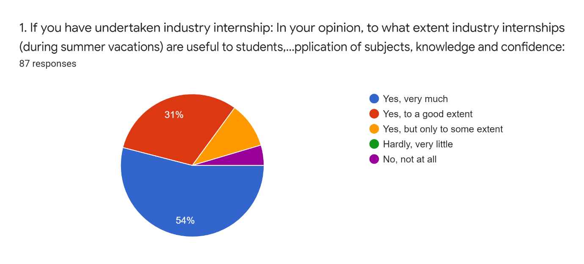
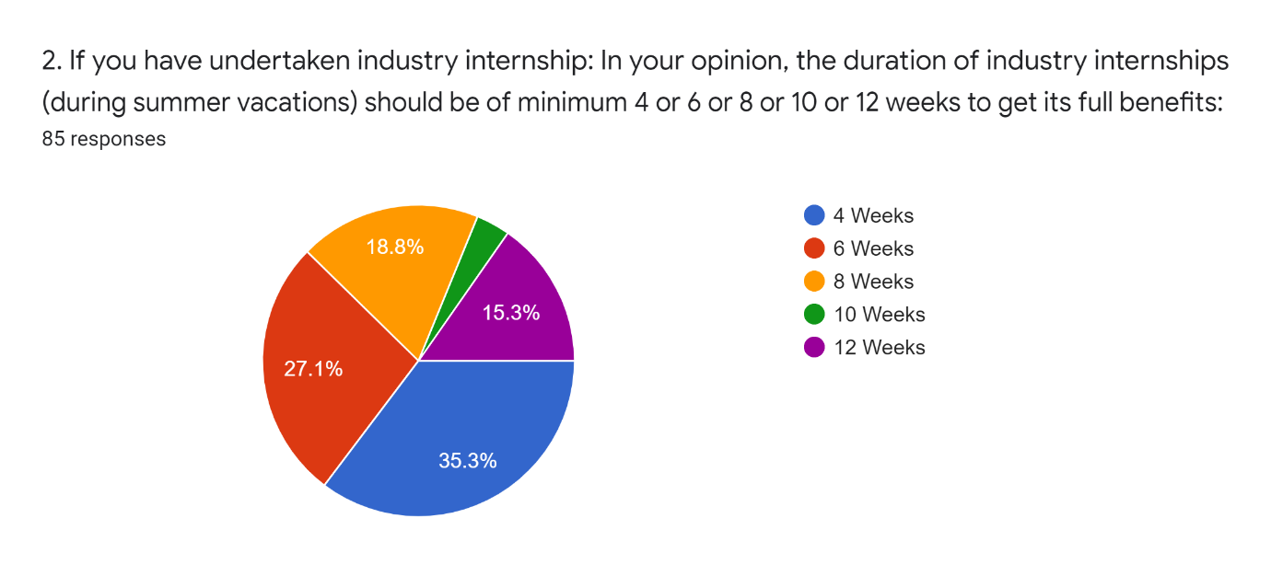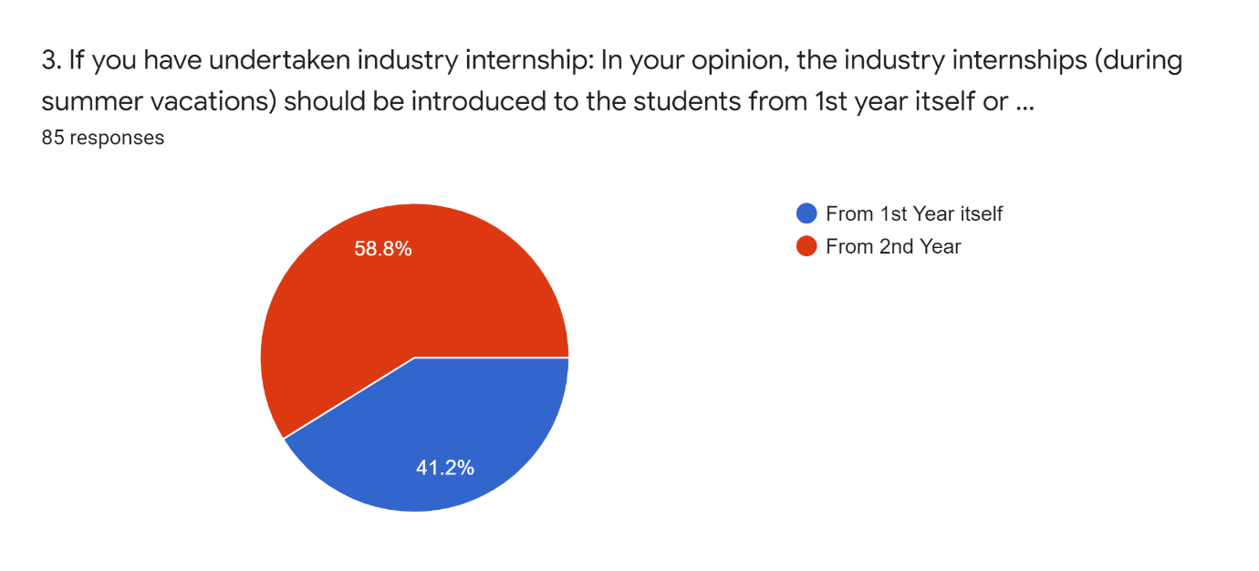
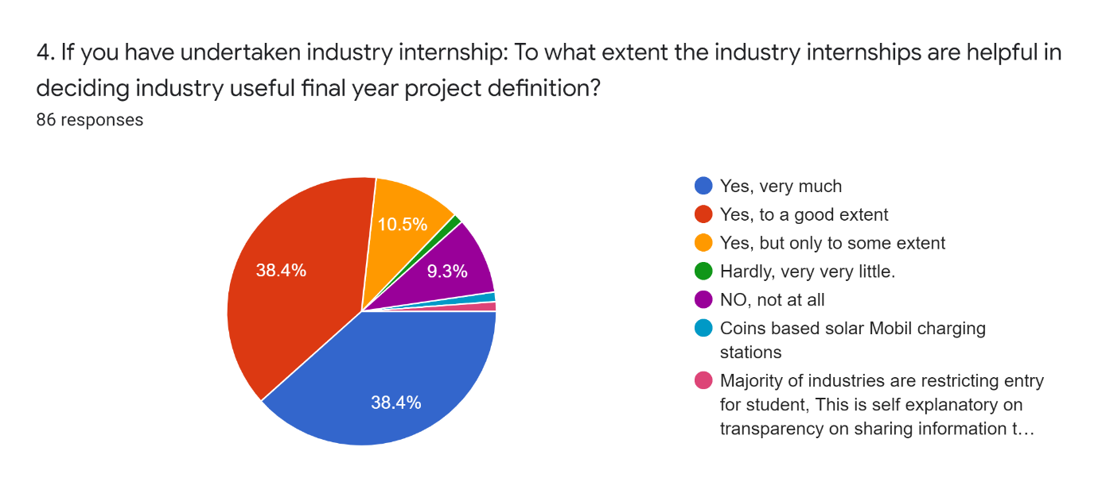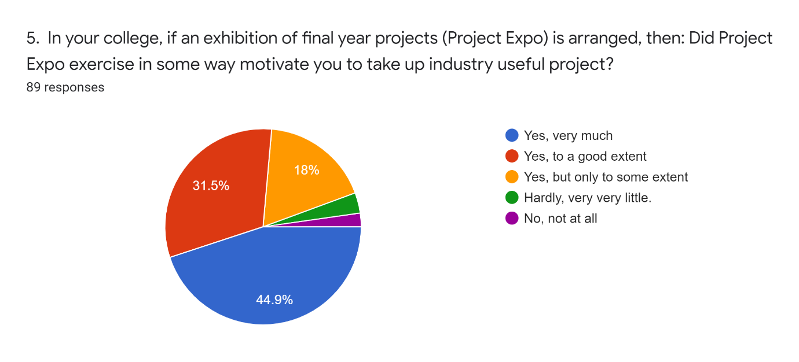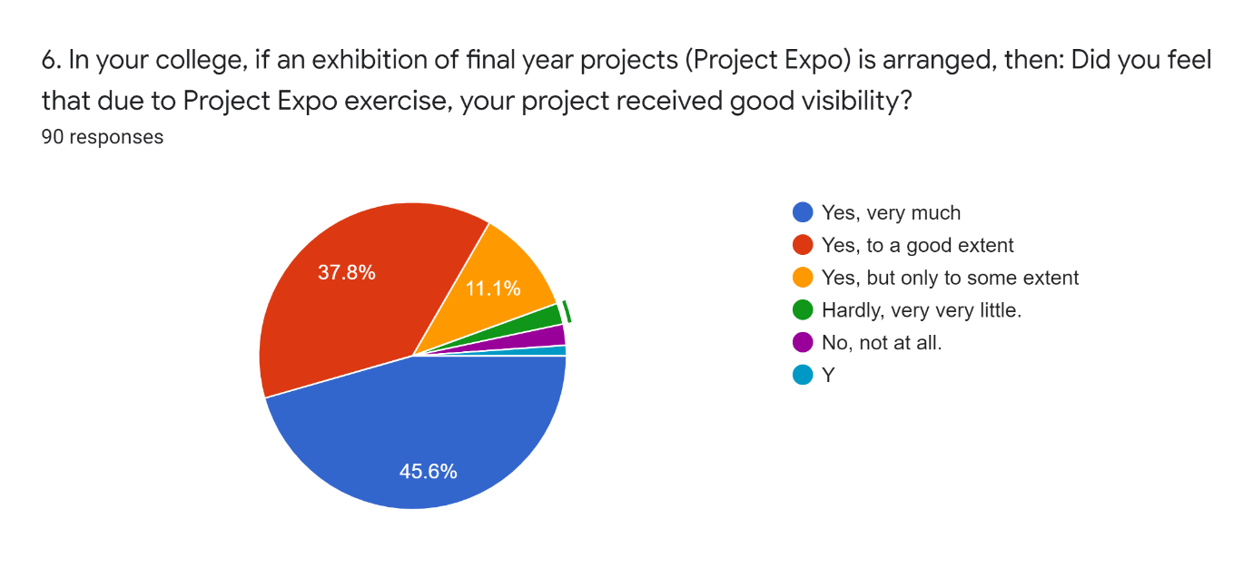
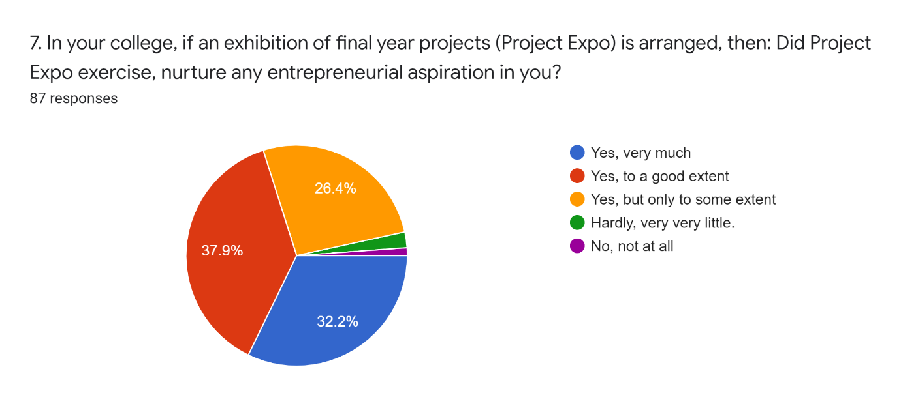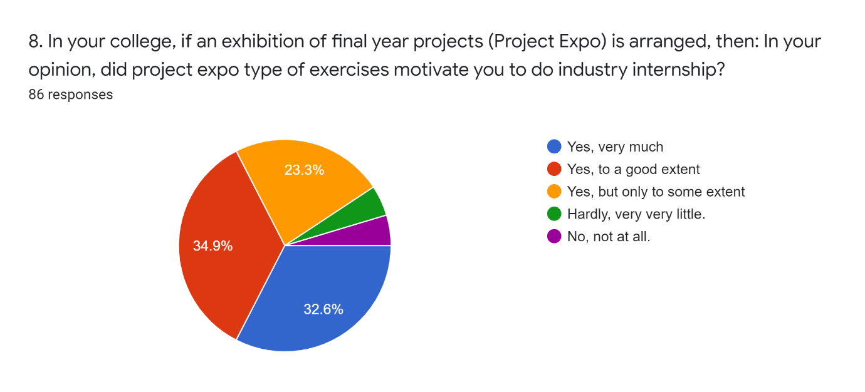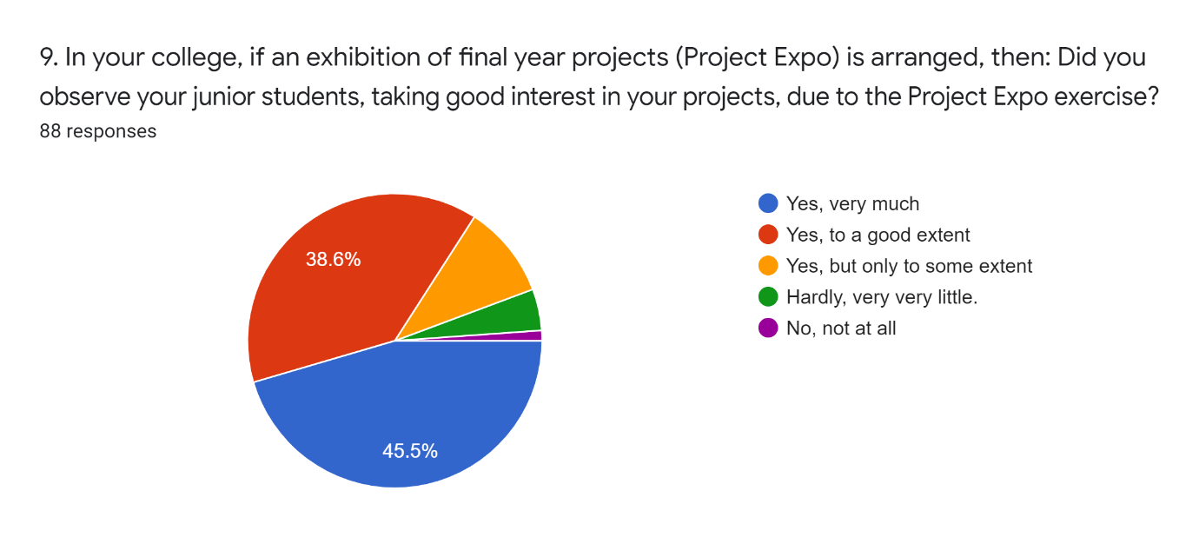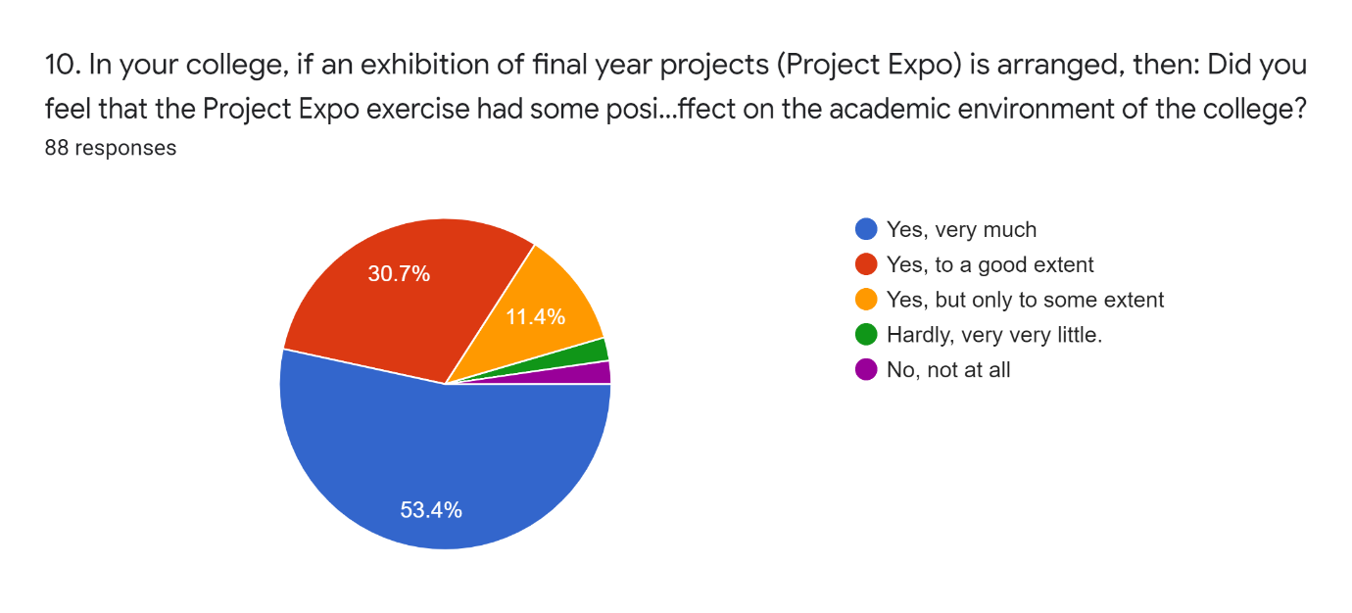
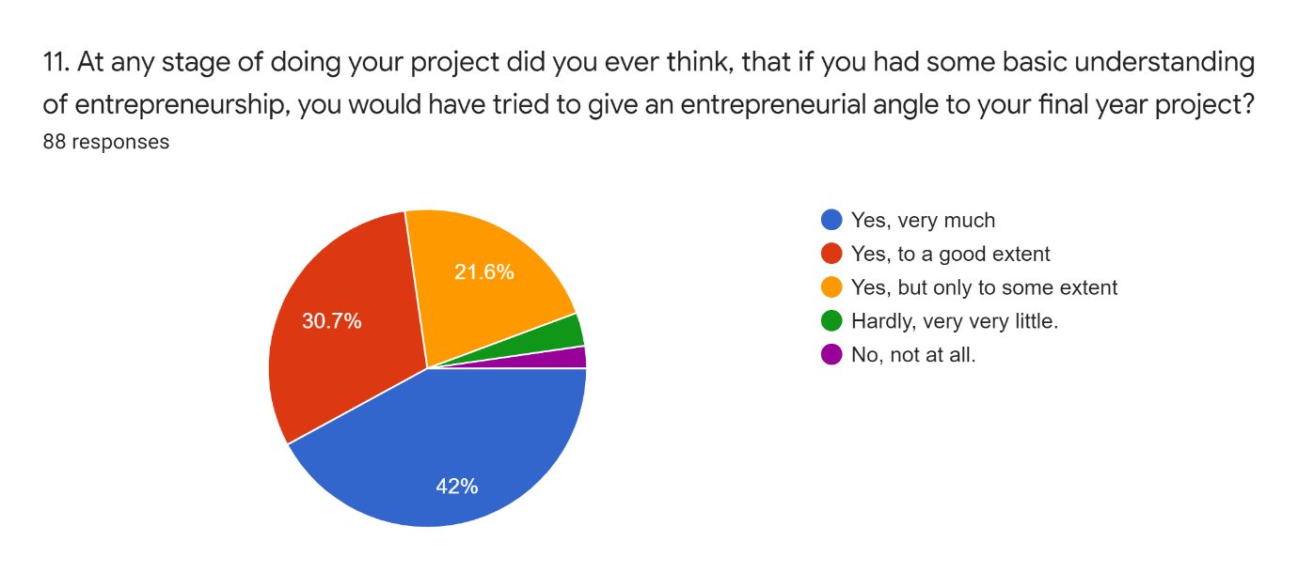

--------------------------------------------------------------------------------------------------------------
End of Appenendix-1

